**MINISTRY OF EDUCATION AND SCIENCE**

**OF THE REPUBLIC OF KAZAKHSTAN**



FACULTY OF INFORMATION TECHNOLOGIES

COMPUTER ENGINEERING DEPARTMENT

**Web Technologies**

**Project**

**“Personal Blog”**

Done by:

Batraliyeva Zarina

Almaty – 2018

**Introduction**

The purpose of the project is to create a website that will be a prototype of such sites to create blogs as Blogger, WordPress or Tumblr. System should include such points as creating profile, add comments and posts with multimedia. The task requires using the skills obtained during laboratory and practical classes.

The main requirement is design the intranet with the help of knowledge in Web sphere, that involves react.js library, html, css and so on.

**Objectives of the Project**

**Aim:** design the website to create a blog.

**The main components used are:**

Atom

TopCoder UML Tool

**Development and programming**

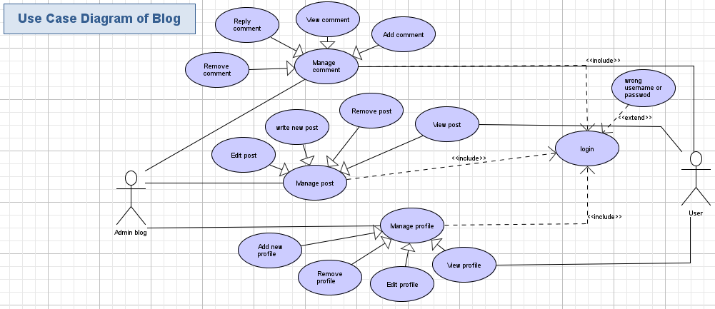Fig.1 Use Case Diagram

First of all, I designed “Use case” diagram for my project, which shows the relationship between the users and the different use cases in which the users are involved. There are 2 actors in my system: Admin and User. Admin is inherited from basic actor User.

Via the website,

* without authorization users can
* view profiles and posts of other users
* add comments and remove them
* with authorization users can
* Create, edit and remove profile
* admin is allowed to add, remove, update users and change users’ password

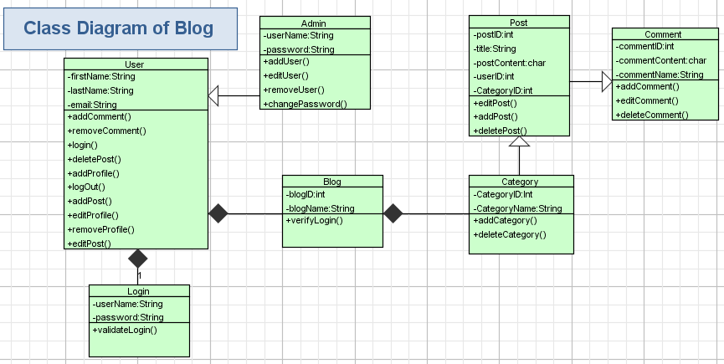Next stage of the work is detailed development of class diagram.

Fig.2 Class Diagram

**Checklist**

|  |  |
| --- | --- |
| users can | |
| * view profiles and posts of other users |  |
| * add comments and remove them |  |
| * Create, edit and remove profile |  |
| admin is allowed to add, remove, update users and change users’ password |  |

**Conclusion**

**will be updated…**

**References**

Java API. https://docs.oracle.com/javase/7/docs/api/

Shamoi P. Object-Oriented Programming and design. Almaty, 2013