Embedded Systems Programming

Phase A Report

Zach Bayler

4/13/2023

Introduction:

The goal of phase a of this project is to create an Arduino shield that behaves as a kitchen timer. The code is written and run by the Arduino Uno and the kitchen timer is a separate PCB that mounts onto the Arduino. This phase was completed with significant guidance and resources provided by Professor Martins.

Notes:

* The code included was mostly my own while using the base pin layout provided. Additionally, I used the provided code to interact with the timer.
* PCB layout and routing is more difficult than I imagined and I expected it to be hard. On top of everything, it’s supposed to look organized.
* Made a github account and started learning how to use it.
* The code performs all of the desired functions, but once it reaches the end and the buzzer goes off, it has to be forcibly reset to restart.
* Learned about the % operator and how useful it is in scaling down a number to a cyclical set of outputs.
* I created the gerber files, but not sure if that was correct.

Code Flow Chart:

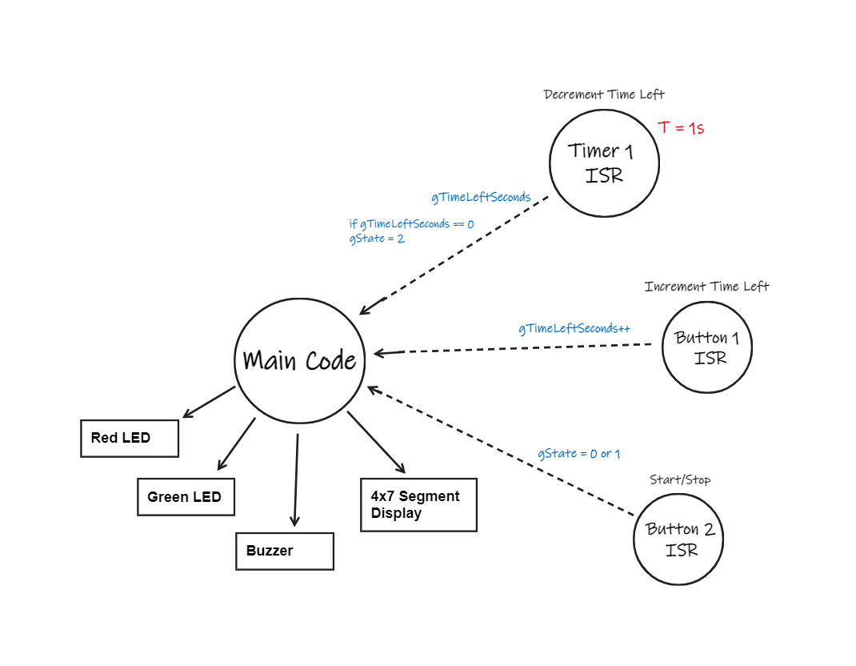

PCB Design:

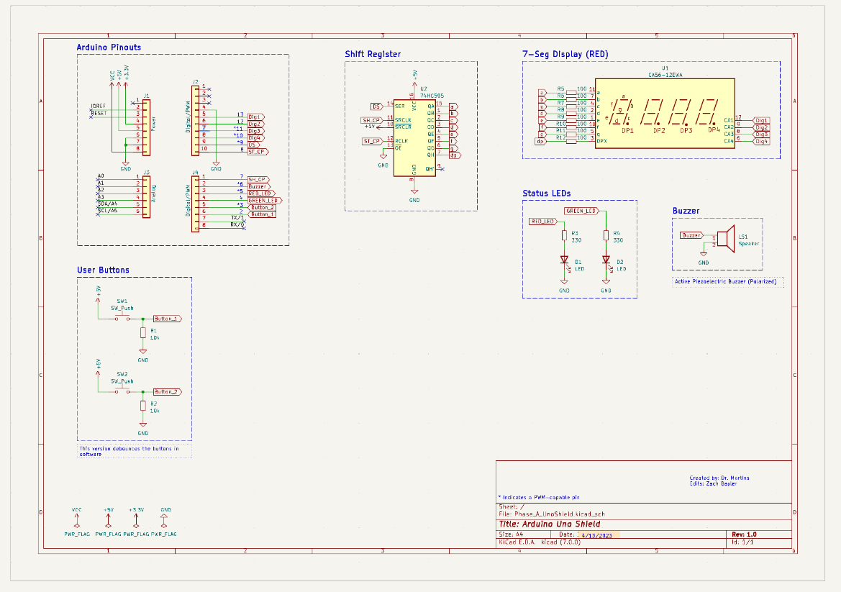

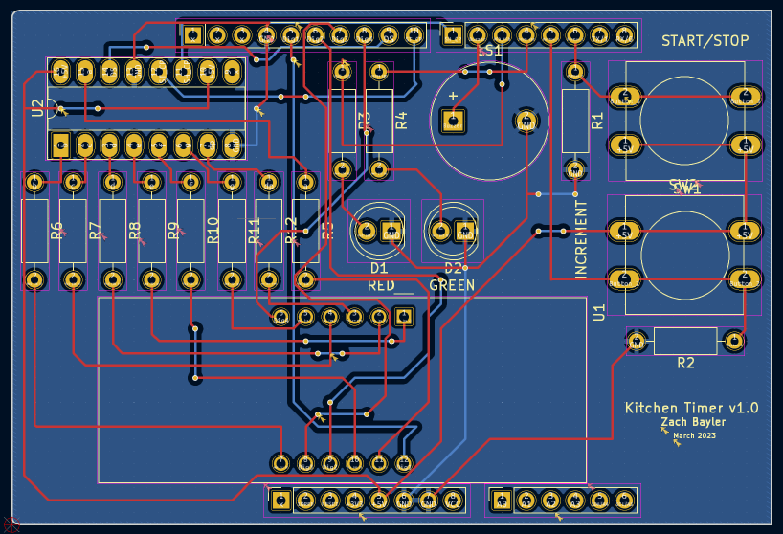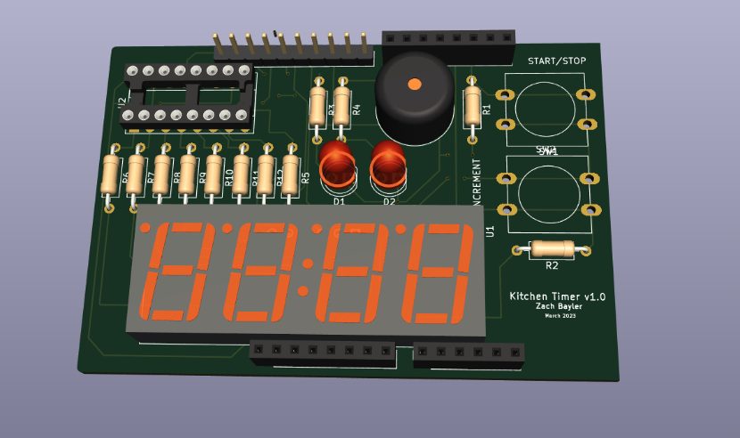

Actual PCB (provided by Dr. Martins):

