Software Requirements Specification
For
Smart Home Automation System
Version 1.3.1
Prepared by Team Beta
University of Texas at Dallas
Feb 12th 2013
Table of Contents
Table of Contents ii
Revision History iv
1. Introduction 1
1.1 Purpose 1
1.2 Document Conventions 1
1.3 Intended Audience and Reading Suggestions 1
1.4 Product Scope 2
1.5 References 2
2. Overall Description 3
2.1 Product Perspective 3
2.2 Product Functions 5
2.3 User Classes and Characteristics 6
2.4 Operating Environment 6
2.5 Design and Implementation Constraints 6
2.6 User Documentation 7
2.7 Assumptions and Dependencies 7
3. External Interface Requirements 7
3.1 User Interfaces 7
3.2 Hardware Interfaces 7
3.3 Software Interfaces 8
3.4 Communications Interfaces 8
4. System Features 9
4.1 Air Conditioner/Heater Monitor and Control 9
4.2 Lights Monitor and Control 9
4.3 Power outlets Monitor and Control 10
4.4 Water Heater Monitor and Control 10
4.5 Lawn Sprinklers Monitor and Control 11
4.6 Doors/Windows Monitor and Control 11
4.7 Bath/shower Monitor and Control 12
4.8 Power and Water Usage Report 12
4.9 Security System/Detectors Monitor and Control 12
4.10 Stove Monitor and Control 13
4.11 User Login/Update 13
4.12 Add/Delete Users 14
5. Nonfunctional Requirements 14
5.1 Performance Requirements 14
5.2 Safety Requirements 15
5.3 Enhance-ability 15
5.4 Robustness 15
5.5 Responsiveness 15
5.6 Reusability 15
5.7 User friendliness 15
5.8 Modifiability 15
5.9 Adaptability 16
5.10 Portability 16
5.11 Security Requirements 16
5.12 Business Rules 16
6. Other Requirements 16
Appendix A: Glossary 16
Appendix B: Analysis Models 16
Appendix C: To Be Determined List 16

Revision History
Name | Date | Reason For Changes | Version
Bocong Zhao | 2/2/2013 | Initial draft | 1.0
Qiong Wang | 2/3/2013 | Update the requirements | 1.1.0
Manjit Singh | 2/4/2013 | Update the requirements | 1.1.1
Bocong Zhao | 2/8/2013 | Update the requirements | 1.2
Qiong Wang | 2/10/2013 | Update section 2, 4, 5 | 1.3
Qiong Wang | 2/12/2013 | Update section 4 | 1.31
Bocong Zhao | 2/12/2013 | Update section 3 | 1.32

Introduction

Purpose
This document completely describes the system in terms of functional and nonfunctional requirements and serves as a contractual basis between the client and the developers for the Smart Home Automation System.

Document Conventions
1. When writing this document it was inherited that all requirements have the same priority.
2. First there is presented an overall view about SHAS and then all features and functions are analysis in detail.

Intended Audience and Reading Suggestions
This document is intended for
- Developers: in order to be sure they are developing the right project that fulfills requirements provided in this document.
- Testers: in order to have an exact list of the features and functions that have to respond according to requirements and provided diagrams.
- Users: in order to get familiar with the idea of the project and suggest other features that would make it even more functional.
- Documentation writers: to know what features and in what way they have to explain. What security technologies are required, how the system will response in each user’s action.
- Advanced end users, end users/desktop and system administrators: in order to know exactly what they have to expect from the system, right inputs and outputs and response in error situations.
This requirement document contains general information about SHAS, main classes and use cases, functions, features and special technologies. It describes in detail all that SHAS needs to work properly and with safety.
The rest of the document is divided into chapters for better understanding.
Part 1 gives a general description of Smart Home Automation System (SHAS).
Part 2 gives an overall description of SHAS
Part 3 describes about the user, communication, hardware, software interfaces.
Part 4 gives the detailed description of system features and use cases.
Part 5 describes non-functional requirements of the system.

Product Scope
Smart Home Automation System (SHAS) is an intelligent monitoring and control system that monitors and controls various “smart” appliances and devices throughout an enabled house. The system supports the communication and integration of heterogeneous devices and services. While SHAS’s role is to intelligently monitor and control a house, the controls and metrics are focused on maximizing energy efficiency.

References
IEEE std. 830-1993: IEEE Recommended Practice for Software Requirements Specifications.

Overall Description

Product Perspective
The smart home automation system monitor and control many devices such as water heater, lawn sprinklers, washer, dryer, dishwasher, water meter, bath/shower, electric meter, lighting, smart power outlets, stove and windows/doors. The homeowner interacts with SHAS through an Internet enabled web browser or a mobile smartphone. SHAS communicates with the devices to set and control the various parameters set forth by the homeowner. Look at the Figure 2.1

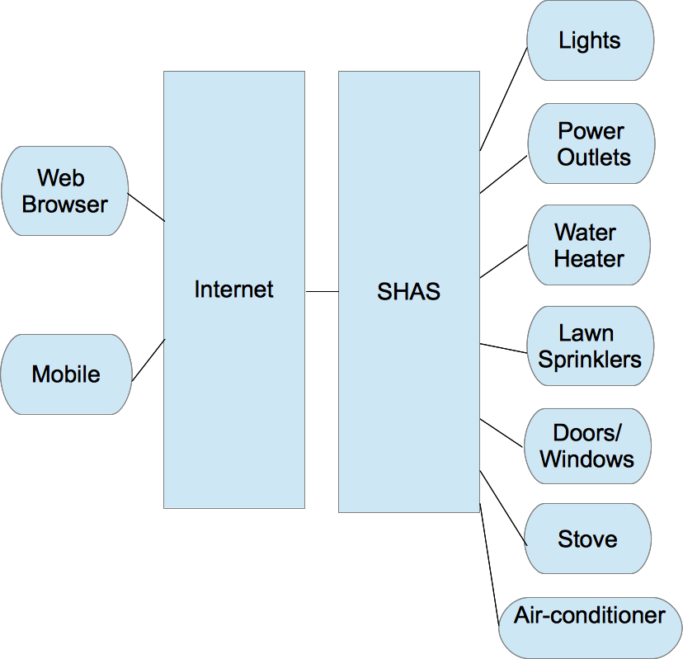

Figure 2.1 SHAS perspective structure

Product Functions
SHAS provide the users with the following functions:
Air Conditioner/Heater Monitor and Control
SHAS monitors the air conditioner/heater, turn on/off the air conditioner/heater based on the user preset value and the outside temperature. SHAS turns off the air conditioner when nobody is at home.
Lights Monitor and Control
SHAS sensors and adjust lighting whenever someone enters or exit a room. Less lighting is required when natural sunlight is available.
Power outlets Monitor and Control
SHAS monitors each power outlet’s energy consumption and disconnect them if it has gone beyond a preset threshold.
Water Heater Monitor and Control
SHAS turns water heater on only during peak hours when it is likely to be used.
Lawn Sprinklers Monitor and Control
SHAS monitors recent precipitation levels to determine if lawn sprinklers should run or not.
Doors/Windows Monitor and Control
SHAS monitors doors and windows and alert user if they are open
Daily Power and Water Usage Report
SHAS monitors daily power and water usage in order to give reports to the homeowners while suggesting ways to better conserve their personal usages.
User Login/Update
SHAS provides a web access to allow user monitor and interact with the various appliances and devices
Stove Monitor and Control
SHAS monitors and controls to ensure that stove is turned off when it is empty or has been left on an abnormal amount of time.

User Classes and Characteristics
End users/Desktop: users with no particular knowledge on computer programming. They just use the system to do what they want.
System administrators: administrators are working on computers that support a lot of accounts and personal data for other users. The administrator can distribute the authority to other users.

Operating Environment

Web Browser
SHAS involves several PCs and Laptops with web browsers supported to Java. The minimum hardware requirements include a machine with 256 MB RAM, Mouse, Keyboard, 1MB VGA Card running an operating system.
Operating System: 32-bit MS Windows (95/98), 32-bit MS Windows (NT/2000/XP), All 32-bit MS Windows (95/98/NT/2000/XP), Win2K, WinXP, Microsoft Windows Server 2003.
Software required to this system is basically a client PC or laptop with proper configured Internet Explorer 7.0 or newer version and Firefox 3.5 or newer version or the Chrome and Safari

Mobile
Operating System: IOS 6.0
Browser: Safari

Design and Implementation Constraints
The goal of the web application is to be platform independent on the client side wherever possible. Therefore, the web applications will be implemented to run on the server side as much as possible. Also, it is required to test the application using different platforms, connection speeds, screen settings, colors/graphics, and browsers.
Database Design: The database structure should be as complete as possible during the design stage but there should be a room for modification without a large overhaul during later phases.
The system shall be in compliance with all Accessibility, Web Design, and Security policies applicable.
As part of standard operating procedures, a testing plan will be documented during the Design phase. The testing plan will be based on user roles, modules or use cases, required tasks and expected outcomes.

User Documentation
TBD
<List the user documentation components (such as user manuals, on-line help, and tutorials) that will be delivered along with the software. Identify any known user documentation delivery formats or standards.>

Assumptions and Dependencies
- We assume all sensors are in position.
- We assume the motion sensor in bath/shower could distinguish people movement and running water

<List any assumed factors (as opposed to known facts) that could affect the requirements stated in the SRS. These could include third-party or commercial components that you plan to use, issues around the development or operating environment, or constraints. The project could be affected if these assumptions are incorrect, are not shared, or change. Also identify any dependencies the project has on external factors, such as software components that you intend to reuse from another project, unless they are already documented elsewhere (for example, in the vision and scope document or the project plan).>

External Interface Requirements
The user should be simple and easy to understand and use. Also be an interactive interface .The system should prompt for the user and administrator to login to the application and for proper input criteria.

User Interfaces
The user interface will be a web-based interface with administrator. User can access the system by web browser which the mobile phone has the browser application.

Hardware Interfaces
Server Side
- Operating System : Window 7
- Processor : Intel Chipset
Client Side
- Operating System : Window XP, Window Vista or Window 7
- Browser : Internet Explorer 6 and above. Firefox or Google Chrome.
- Memory : 1 GB

Software Interfaces
Database
- MySql Server version 5 or above.
Web Server
- Apache Server version 2.2.6
Programming Languages
- Javascript
- Java
- JSP

Communications Interfaces
- Web-accessible HTTP interface for user interaction
- Connection to MySQL Database for configuration

System Features

Air Conditioner/Heater Monitor and Control

Description and Priority
Monitor the air conditioner/heater, turn on/off the air conditioner/heater based on the user preset time and the outside temperature. Turn off the air conditioner when nobody is at home.

Stimulus/Response Sequences
- User sets the temperature that he/she feels comfortable. User sets the time that he/she wants the air conditioner/heater turn on.
- When somebody is at home, system shall compares the outside temperature and the inside temperature.
- If outside is cold and inside temperature is lower than the preset value, turn on the heater.
- If outside is hot and inside temperature is higher than the preset value, turn on the air conditioner.
- If nobody at home, turn off the air conditioner/heater.
- System turns on the air conditioner/heater according to user preset value.
- System detects there is nobody at home, turn off the air conditioner/heater.

Functional Requirements
- System shall let user configure/modify the preset temperature
- System shall let user configure/modify the preset time
- System shall alert the user when input value is an invalid one.
- The control of temperature is room independent
- System shall detect the outside temperature.

Lights Monitor and Control

Description and Priority
Adjust lighting whenever someone enters or exit a room. Less lighting is required when natural sunlight is available.

Stimulus/Response Sequences
- User enters a room
- System turns on the lights of that room, and remain the light level
- System detects there is no one in the room.
- Turn off the lights of that room certain period of time after user exits if the light is on.

Functional Requirements
- System shall let user configure/modify the period of time that he/she wants the lights on after he/she exits the room (default 5 minutes)
- The control of lights is room independent
- System shall let user configure/modify the light level of each room (
- reading level
- natural sunlight level
- dim (.25 natural)
- off )

Power outlets Monitor and Control

Description and Priority
Monitor each power outlet’s energy consumption and disconnect them if it has gone beyond a preset threshold.

Stimulus/Response Sequences
- User sets the threshold
- If the energy consumption of a specific power outlet has gone beyond the threshold, alert the user. No user response in certain time, disconnect the power outlet.

Functional Requirements
- System shall let user configure/modify the no-responding time (default 30 minutes).
- System shall alert user and the alert shall indicate which power outlet has gone beyond the threshold.

Water Heater Monitor and Control

Description and Priority
Turn water heater on only during peak hours when it is likely to be used.

Stimulus/Response Sequences
- User sets the time that he/she wants the water heater on/off
- Turn on the water heater according to the preset time.
- Turn off the water heater according to the preset time.

Functional Requirements
- System shall let user configure/modify the start/stop time (default 6:00 – 8:00 am, 5:00 – 10:00 pm)

Lawn Sprinklers Monitor and Control

Description and Priority
System monitors recent precipitation levels to determine if lawn sprinklers should run or not.

Stimulus/Response Sequences
- User sets the level of sprinkler he/she wants to run based on the precipitation level
- System checks the precipitation level and decides which level the sprinkler is on.

Functional Requirements
- System shall let user configure/modify the number of sprinklers for each precipitation level (default: 0.1in, full sprinkle; .1-.2in, .75; .2-.3in, .5; .3-.4in, .25; >.4in, no sprinkle).
- System shall detect the precipitation level per day (default time: 2am).

Doors/Windows Monitor and Control

Description and Priority
Monitor doors and windows and alert user if they are open

Stimulus/Response Sequences
- User sets the maximum time that a door/window can keep open
- User sets the alert occur time if a door/window is open
- If door/window is open for certain amount time(which is equal to alert occur time), alert user and indicate which door/window is open
- If the open time reaches to maximum time, close the door.

Functional Requirements
- System shall let user configure/modify the maximum time (default 30 minutes) and alert occur time (default 20 minutes)
- System shall alert user the door/window is open when alert time is due, and alert shall indicate which door/window is open
- System shall close the door when maximum time is due and no response from the user.

Bath/shower Monitor and Control

Description and Priority
SHAS will set bath and shower to predefined temperatures according to homeowner’s preferences.

Stimulus/Response Sequences
- User sets the preferred temperature for bath/shower.
- System shall heat the water to preset temperature after the water heater is on

Functional Requirements
- System shall let user configure/modify preferred temperature
- System shall heat the water to the temperature that user preset.

Power and Water Usage Report

Description and Priority
Monitor power and water usage in order to generate daily/weekly/monthly reports of power and water usage and give suggestions to better conserve their personal usages.

Stimulus/Response Sequences
- User wants to view the power and water usage report
- System shows the power and water usage report for each devices per day/week/month

Functional Requirements
- System shall keep previous 12 months usage data
- System shall collect usage data for each device and updates the usage report daily, and generate the reports weekly/monthly

Security System/Detectors Monitor and Control

Description and Priority
SHAS shall monitor and alert homeowner if security system or a detector has been activated.

Stimulus/Response Sequences
- SHAS monitors the security system, smoke detector, carbon monoxide detector and natural gas detector.
- If a security alarm has been breached, system will contact police immediately and then alert user.
- If any detector (smoke/carbon monoxide/natural gas) is triggered, it will contact fire department 1 minute later.
- User wants to watch the footage of security cameras located inside the house
- System will provide the access to those cameras

Functional Requirements
- SHAS shall contact police and alert homeowners if the security system has been activated.
- SHAS shall contact fire department and alert homeowners if any monitored detector has been activated.
- SHAS shall support a remote web view of cameras located inside the house.

Stove Monitor and Control

4.9.1 Description and Priority
Monitor and control to ensure that stove is turned off when it is empty or has been left on an abnormal amount of time.

Stimulus/Response Sequences
- The SHAS checks whether the stove is turned off.
- If the stove is not turned off, alert the user. No user response in 5 minutes, turn off the stove.

Functional Requirements
- System shall let user configure/modify the no-responding time
- Alert shall indicate which stove is still on

Washer/Dryer monitor and control

Description and Priority
SHAS shall monitor washer and dryer to optimize the amount of water used.

Stimulus/Response Sequences
- SHAS checks if washer/dryer is on or not
- SHAS monitors the load in washer and dryer
- If the washer/dryer is on, SHAS optimizes the amount of water being used depending on load size.

Functional Requirements
- SHAS shall detect if washer/dryer is on
- SHAS shall detect the load size of washer/dryer and then decide the amount of water being used

Dish washer Monitor and Control

Description and Priority
SHAS shall monitor dishwasher to determine if the appliance is still running and optimize water depending on load size.

Stimulus/Response Sequences
- SHAS checks if dishwasher is on or not
- SHAS monitors the load in dishwasher
- If the dishwasher is on, SHAS optimizes the amount of water being used depending on load size.
- If the dishwasher is on, SHAS monitors how much time remains

Functional Requirements
- SHAS shall detect if dishwasher is on
- SHAS shall detect the load size of dishwasher and then decide the amount of water being used
- SHAS shall monitors how much time remains if dishwasher is on

User Login/Update

Description and Priority
System provides a web access to allow user monitor and interact with the various appliances and devices

Stimulus/Response Sequences
- User inputs the username and password
- If the information are correct, login successfully; if information are invalid, alert user
- User changes the password
- System alert user when the change of password operation succeeded/failed

Functional Requirements
- System shall provide a login access
- System shall validate the username and password
- System shall allow user to change password

Add/Delete Users

Description and Priority
Add/delete user by administrator of the system.

Stimulus/Response Sequences
- Administrator wants to add user.
- Administrator fills in all required information and add new user successfully.
- Administrator wants to delete existed user.
- Warn administrator if he/she really wants to delete the user, if yes, remove the user from the system, if no, the deletion operation is cancelled and no one is removed from the system.

Functional Requirements
- System shall distinguish the normal user from the user with administration authorization (administrator)
- System shall allow administrator to add/delete user.
- System shall alert administrator before deleting.

Nonfunctional Requirements

Performance Requirements
The system should have efficient performance. The implementation of the software should lead to desirable time and space complexities. i.e. the amount of time required for the system to function and deliver the output and the amount of memory required is as less as possible.
When the user log in the system, the system responds are no more than 5 seconds. And when monitor and control each device, the respond of device are no more than 5 seconds.

Safety Requirements
In case the user forgets or loses the Password, the administrators can find the password by security questions. The customer shall change the password.

Enhance-ability
The enhancement of the system should be possible by supporting the addition of new modules or new features. Some of these features include: allowing the user to add the user to control the SHAS.

Robustness
The system should be robust enough to cope well with variations (sometimes unpredictable variations) in its operating environment with minimal damage, alteration or loss of functionality. For example, it should be able to support a maximum amount of operating the SHAS. The user shall control the multiple system at the same time. However the system must not crash or exhibit any unexpected behavior.

Responsiveness
The responsiveness of an interactive system describes how quickly it responds to user input. SHAS should not take too long to process the input entered by the user. The software system should be as responsiveness as possible.

Reusability
Reusability is always a preferred feature in a software system. As mentioned earlier, this software is being developed as a precursor for the web search so the software should be designed such that the modules can be directly reused for the next software implementation.

User friendliness
The system needs to be user friendly. Since the web browser interface is being supported, the system should be implemented in such a way that the user interfaces is as simple and uncluttered as possible

Modifiability
Change in data representation:
The system should be able to store the data as lines or words and in any suitable format.
Change in processing algorithms:
The system should be able to be modified such that it can process one line at a time or after all lines are read.

Adaptability
The system should be flexible so that it is able to adapt new features and requirements. The software should be able to support these changes.

Portability
The system should be portable. We should be able to reuse the existing code instead of creating new code when moving software from an environment to another. The system should be capable to run on various browsers on different operating systems.

Security Requirements
TBD

Business Rules
- Administrator – Administrator can perform all functionalities.
- User – User can perform all functionalities except for add/delete users.

Other Requirements
TBD
<Define any other requirements not covered elsewhere in the SRS. This might include database requirements, internationalization requirements, legal requirements, reuse objectives for the project, and so on. Add any new sections that are pertinent to the project.>
Appendix A: Glossary
<Define all the terms necessary to properly interpret the SRS, including acronyms and abbreviations. You may wish to build a separate glossary that spans multiple projects or the entire organization, and just include terms specific to a single project in each SRS.>
Appendix B: Analysis Models
<Optionally, include any pertinent analysis models, such as data flow diagrams, class diagrams, state-transition diagrams, or entity-relationship diagrams.>
Appendix C: To Be Determined List
<Collect a numbered list of the TBD (to be determined) references that remain in the SRS so they can be tracked to closure.>
closure.>

