1)
DRUM TRANSCRIPTION FROM POLYPHONIC MUSIC WITH RECURRENT NEURAL NETWORKS - Richard Vogl, 1,2 Matthias Dorfer, 1 Peter Knees - 2017
[Datasets: 1) IDMT-SMT-Drums; 2) ENST-Drums]
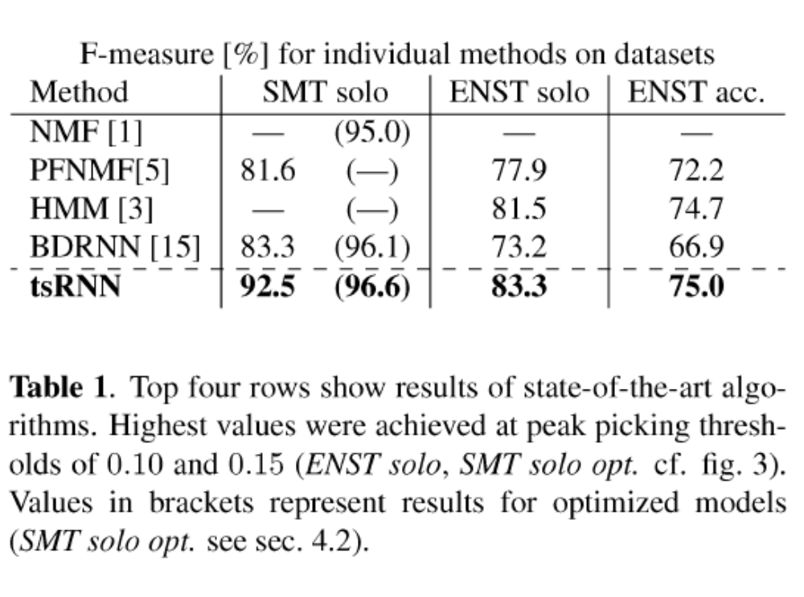
- NMF [1] = Christian Dittmar and Daniel Gärtner, "Real-time transcription and separation of drum reeordings based on NMF deeomposition," in Proc 17th 1nternational Conference on Digital Audio Effects, Erlangen, Germany, Sept. 2014.
- PFNMF[5] = Chih-Wei Wu and Alexander Lereh, "Drum tran seription using partially fixed non-negative matrix faetorization
with template adaptation," in Proc 16th 1nternational Society for Music 1nformation Retrieval Conference, Malaga, Spain, Oet. 2015.
- HMM[3] = Jouni Paulus and Anssi Klapuri, "Drum sound deteetion in polyphonie musie with hidden markov models," EURAS1P Journal on Audio, Speech, and Music Processing, 2009.
- BDRNN [15] = Carl SouthalI, Ryan Stables, and Jason Hockman, "Automatie drum transcription using bidireetional reeurrent neural networks," in Proc 17th International Society for Music Information Retrieval Conference, New York, NY, USA, Aug. 2016.

→ Best with ENST dataset solo/accompaniment.:
tsRNN (this paper) or HMM [3]

Architecture:
tsRNN (Time shift RNN):
<168 node input layer with same size input data vectors> – [Connection is densely (every node connected to all other nods)] – <First recurrent layer consisting of 50 gated recurrent units (GRUs)> – [Connection is densely] <Second recurrent layer consisting of 50 gated recurrent units (GRUs)> – [Connection is densely] – <Dropout layer with dropout rate r_d = 0.3> – <Output layer with three nodes (for the three instrument classes) with Sigmoid transfer function> (Special case is the time shift of the onsets before training and shifting it back afterwards)

HMM (Hidden Markov Model) [3]: Architecture not that clear in the paper. Seems to be complicated. Also see next page/paper!
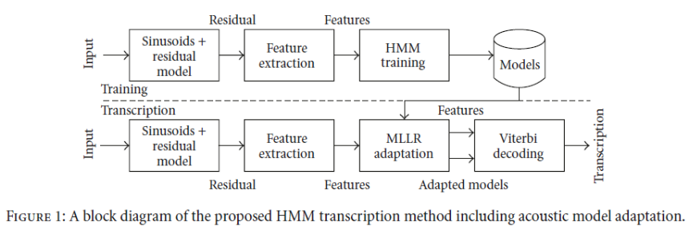

2)
Automatic drum transcription with convolutional neural networks - Céline Jacques, Axel Roebel, Feb 2019
[Datasets: 1) RWC; 2) ENST-Drums]
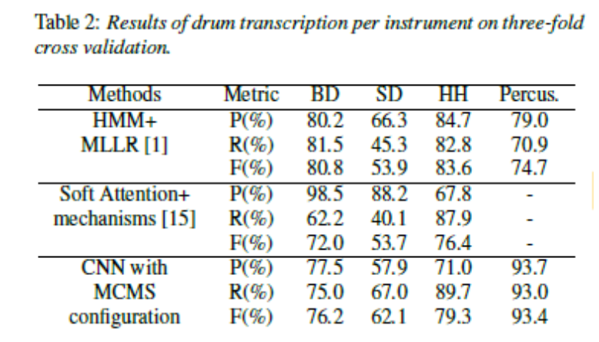

Table 2 shows the results for three individually trained CNNs for every instrument (BD,SD,HH). The CNN with MCMS configuration (multi channel mel spectrogram) gets the best F-measures in general, but the HMM+MLLR from Paulus [1] is better. Although the percussive onset („Percus.“ in table) is better with the CNN
So they normalized the signal over time to get the results in Table 4:

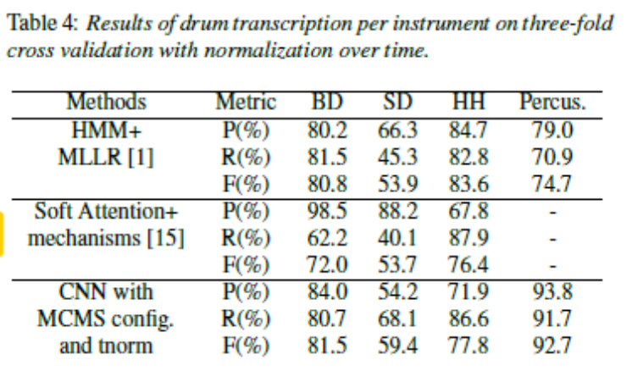
Here the F-measure is better for BD and SD but lower for HH. That's why the CNN with MCMS configuration and time normalization is the better than the HMM+MLLR from Paulus[1].

- HMM+MLLR [1] = Jouni Paulus and Anssi Klapuri, “Drum sound detection in polyphonic music with hidden markov models,” EURASIP Journal on Audio, Speech, and Music Processing, 2009.
- Soft Attention+mechanisms [15] = Carl Southall, Nicholas Jillings, Ryan Stables, and Jason Hockman, “Adtweb: An open source browser based automatic drum transcription system,” Proceedings of the 18th International Society for Music Information Retrieval Conference (ISMIR), 2017.

→ Best with ENST dataset:
CNN with MCMS configuration (used an onset detection function (ODF))

Architecture:
CNN with MCMS configuration and tnorm:
input data contains (three for MCMS) mel frequency spectrogram data
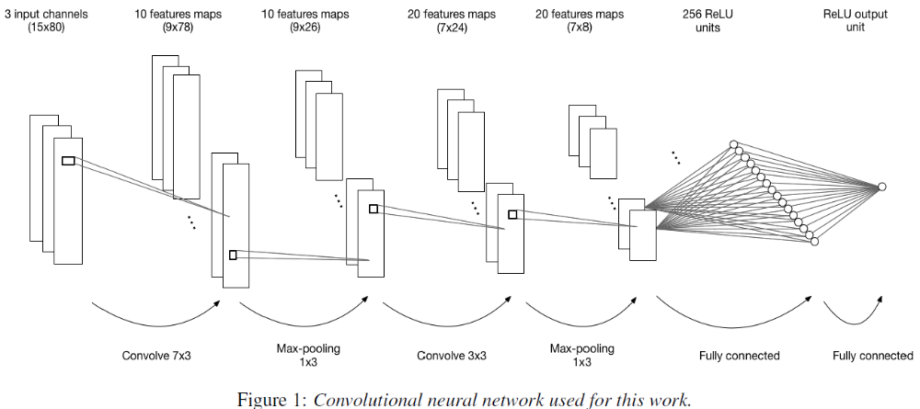
3)
TOWARDS MULTI-INSTRUMENT DRUM TRANSCRIPTION – Richard Vogl, Gerhard Widmer, Peter Knees, 2018
[Datasets: 1) ENST-Drums; 2) MDB-Drums; 3) RBMA13]

Paper investigates ADT for more than the three basic drum sound (BD,HH,SD).

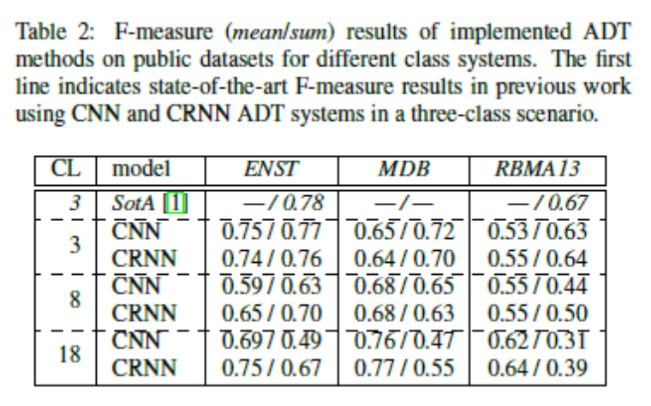
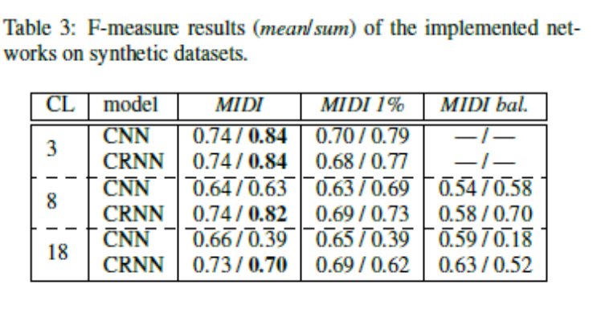

More than three instruments get worser results. But it's mandatory for us??
This paper seems to be the state of the art for more drum instruments at the moment. Take this then?

Architecture: CRNN has the better results.
