Executive Summary
This report outlines key performance indicators for the second fiscal quarter.
Notice: Projections are subject to quarterly audit.
Financial Highlights
Metric | Q1 Actual | Q2 Actual | YoY Growth
Revenue | $1.2M | $1.5M | +25%
Net Margin | 22% | 27% | +500 bps
Customer Retention | 94.2% | 96.1% | +1.9%

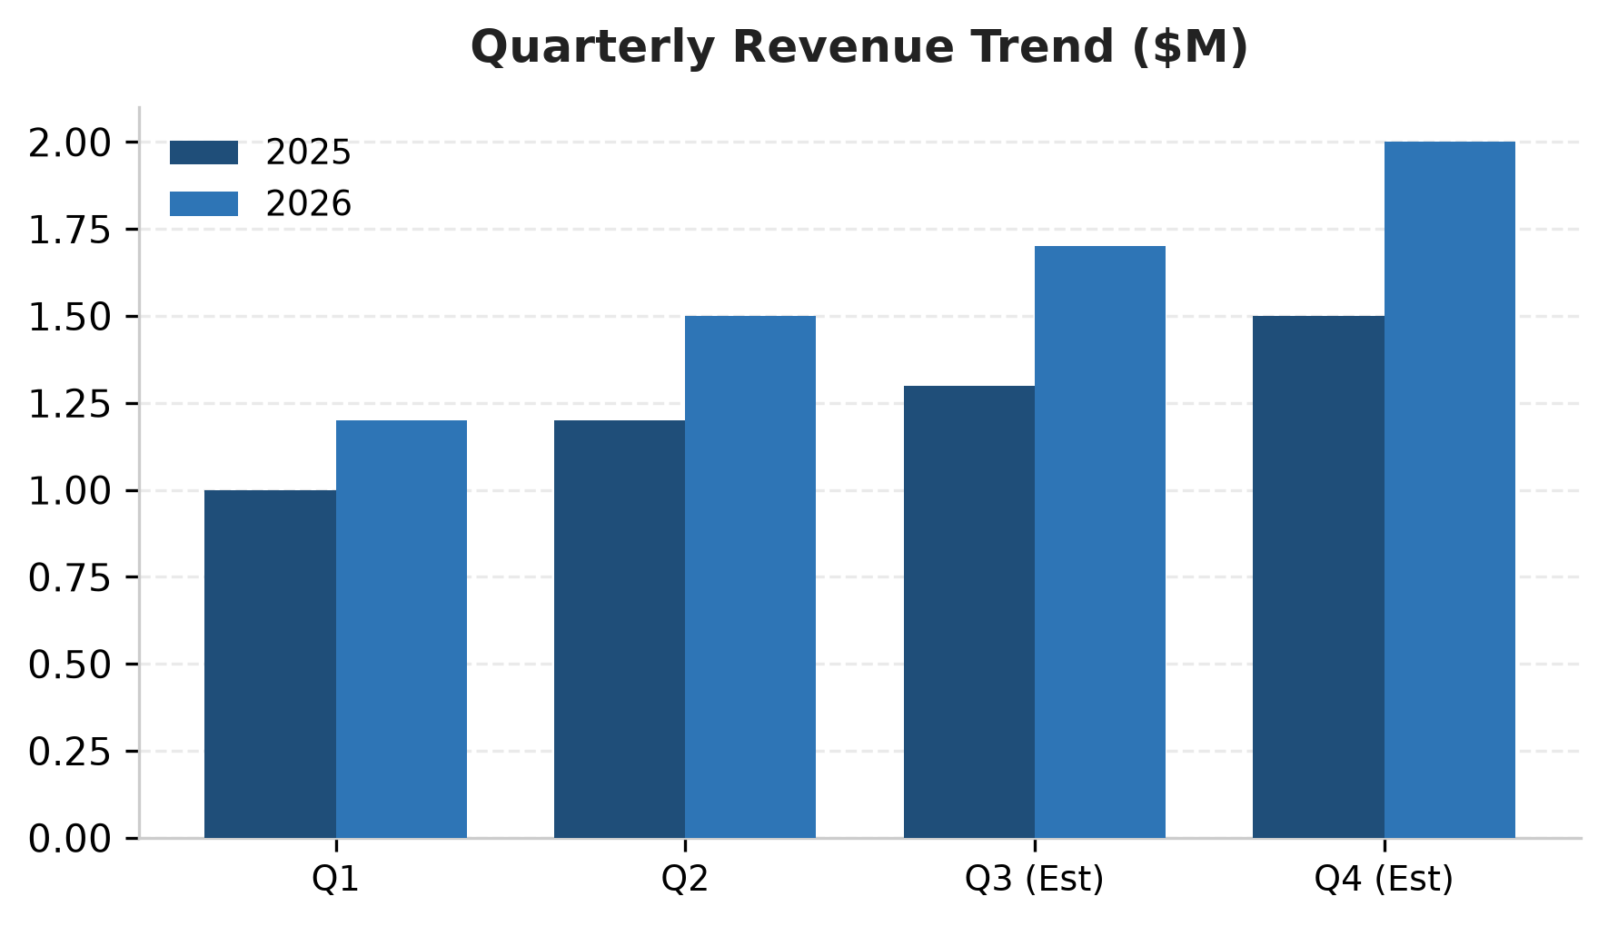
Key Strategic Priorities:
- Expand enterprise sales channel
- Optimize cloud compute expenditures

