Name Period RAW Score $×4=$ SCORE (out of 100)
Unit 1 TEST
PROBLEM 1: $ABCD$ is a parallelogram. Trapezoid $AEFB$ is congruent to trapezoid $CFED$. $G$ is the midpoint of $\overline{EF}$.
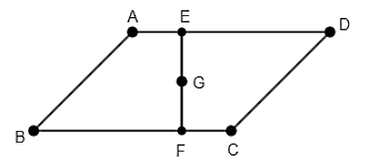
Select all the ways we could describe the rigid transformation that takes $AEFB$ to $CFED$.
(TWO POINTS – ½ point deducted for each incorrect selection)
- Reflect $AEFB$ across line $EF$.
- Rotate $AEFB$ $180°$ counterclockwise around point $G$.
- Rotate $AEFB$ $90°$ clockwise around point $G$.
- Translate $AEFB$ by the directed line segment from $F$ to $E$, and then reflect across line $FE$.
- Translate $AEFB$ by the directed line segment from $F$ to $E$, and then rotate $180°$ clockwise around point $E$.
PROBLEM 2: Describe a sequence of TWO specific rigid motion transformations that takes $∆ABC$ onto $∆A'B'C'$.
(TWO POINTS)
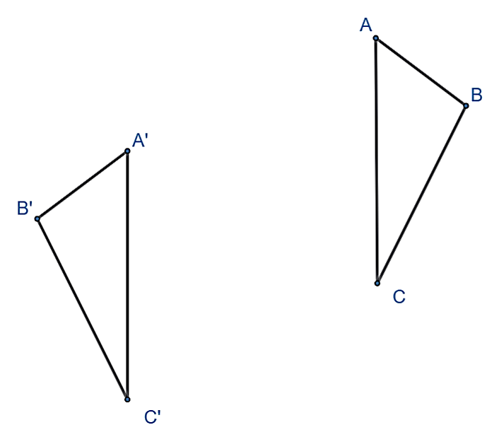
TRANSFORMATION #1:
TRANSFORMATION #2:
PROBLEM 3: Regular hexagon $ABCDEF$ is inscribed in a circle with center $H$.
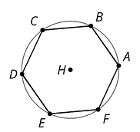
- Which segment is the image of $\overline{BC}$ after a $120°$ counterclockwise rotation about point $H?$
(ONE POINT)
- Which segment is the image of $\overline{BC}$ after a reflection over $\overset{⃡}{CF}$?
(ONE POINT)
PROBLEM 4: Complete this problem on the graph provided.
- Draw the image of quadrilateral $ABCD$ after a translation that takes $A$ to$A'$.  Label the image $A'B'C'D'$.  (ONE POINT) | 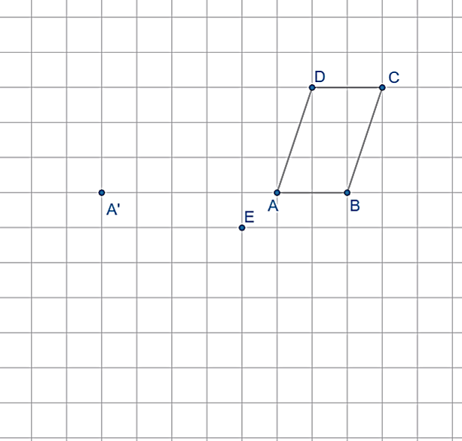
- Draw the image of quadrilateral $ABCD$ after a rotation $90°$ clockwise around point $E$.
Label the image $A''B''C''D''$.
(ONE POINT)

- How do line segments $\overline{AA'}, \overline{BB’}, \overline{CC’}$ and $\overline{DD’}$ compare?
(ONE POINT)

PROBLEM 5: A figure is translated four units left and five units down. A student makes the following four claims. Decide if the claim is a TRUE or FALSE statement. Place and X in the appropriate column for each statement.
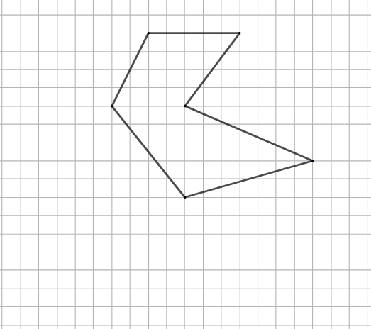
(FOUR POINTS)
 | TRUE | FALSE
CLAIM 1: The angle measures in the translated figure are different from the original figure.
CLAIM 2: All points on the original figure and their images lie on lines that are parallel to each other.
CLAIM 3: The translated figure has the same side lengths as the original figure.
CLAIM 4: To fully describe this transformation, you must specify a center point and a direction.

PROBLEM 6: Select all figures with two or more lines of symmetry.
(TWO POINTS – ½ point deducted for each incorrect selection)
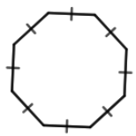 | 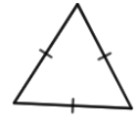 | 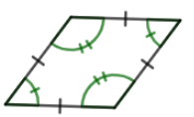 | 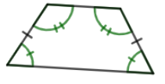 | 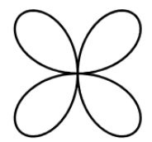
PROBLEM 7: Select all figures with $180°$ rotation symmetry.
(THREE POINTS – ½ point deducted for each incorrect selection)
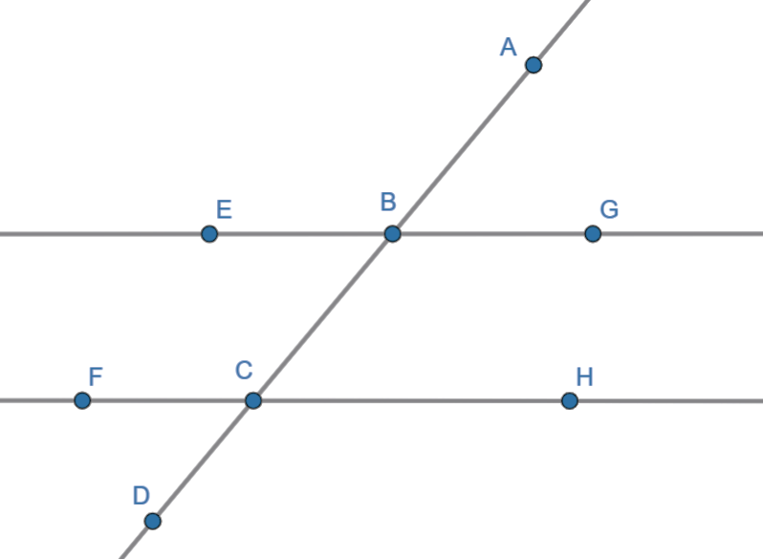
PROBLEM 8: In the diagram, $\overset{⃡}{EG}$ and $\overset{⃡}{FH}$ are parallel.
- Select all of the angles that are congruent to $∠ABE$.
(THREE POINTS – ½ point deducted for each incorrect selection)
- $∠EBC$ | - $∠GBC$ | - $∠ABG$ | - $∠BCF$
- $∠BCH$ | - $∠HCD$ | - $∠FCD$ | - $∠EBG$
- Write an equation that represents the relationship between $∠FCD$ and $∠HCD$.  (ONE POINT) | - Which angle is an alternate interior angle to$∠EBC?$  (ONE POINT)
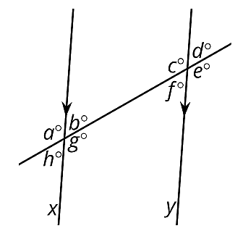  PROBLEM 9: Lines $x$ and $y$ are parallel. Write an equation that represents the relationship between $h$ and $c$.  EQUATION: __________________________________  (ONE POINT)  How do you know this equation is always true?  (ONE POINT) | PROBLEM 10: Lines $a$and $b$ are parallel.  Explain why $m∠1+m∠2=m∠7$.  (ONE POINT)  

