# ENSF607 Lab 2 Deliverable 2

Group: Riley Berry and Zachary Graham

# Task 4-5 Combined output and screenshots

## Default screen

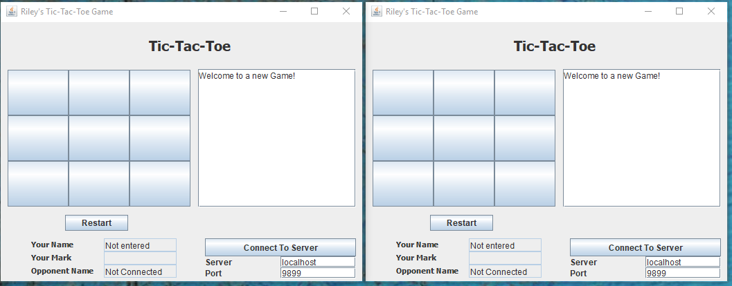

## Invalid port/server entry

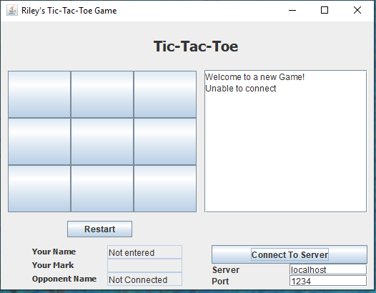

## Name request

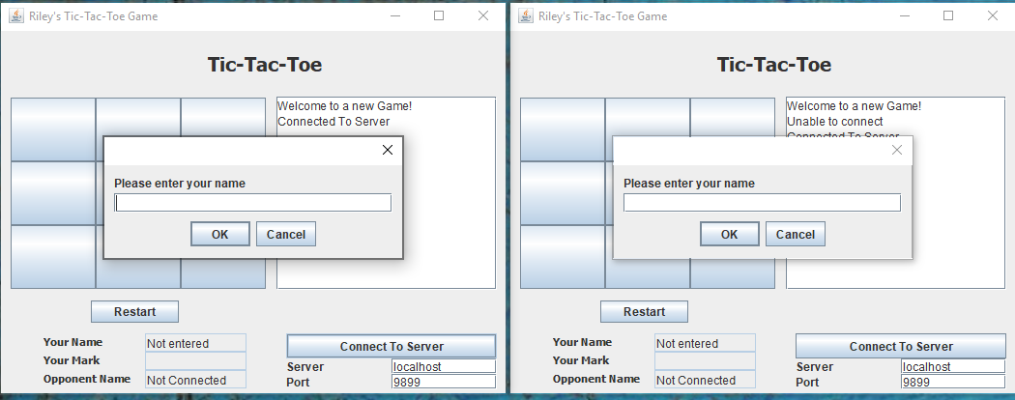

## Game updated with opponent

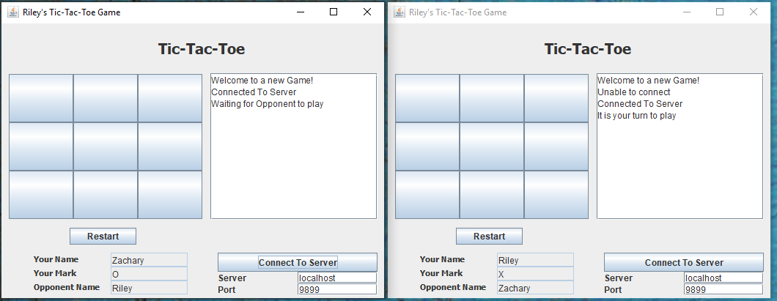

## Some moves being played (With some invalid move messages)

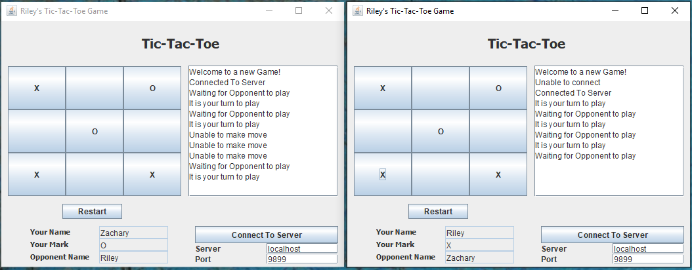

## Restart request

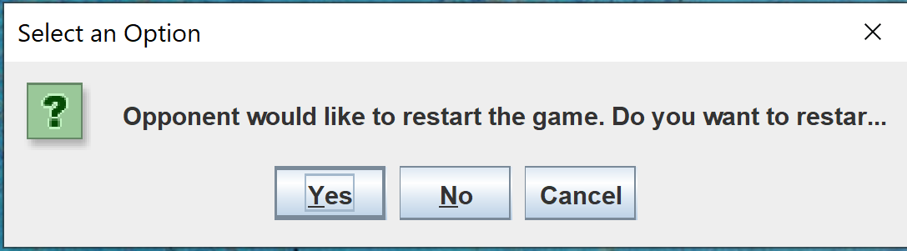

(opponent gets first move after restart request)

## End of game message

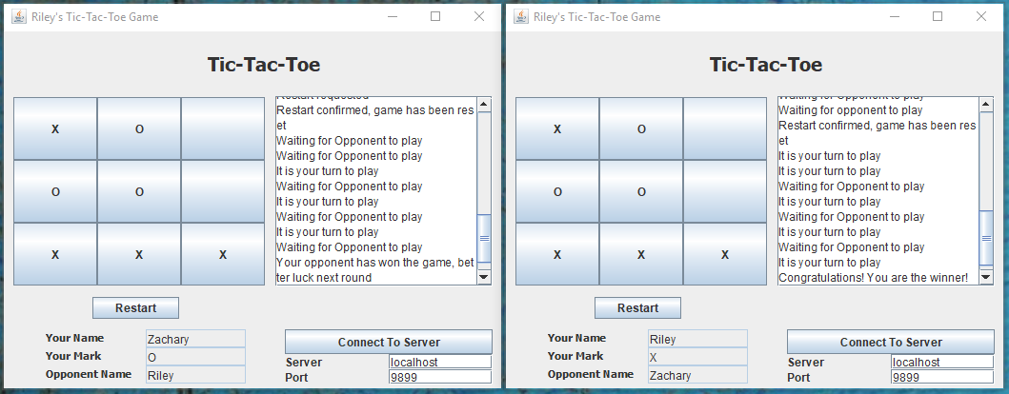

## Server messages

Below are the messages sent from the server to the back end display

Server started

Connection accepted from first player

Connection accepted from second player

Game controller started

Note: title updated after output screenshots were taken

# Task 6 Code Output and Screenshots:

## Connection:

The server thread pool has a max size of three threads. When clients attempt to connect, the following windows are displayed:

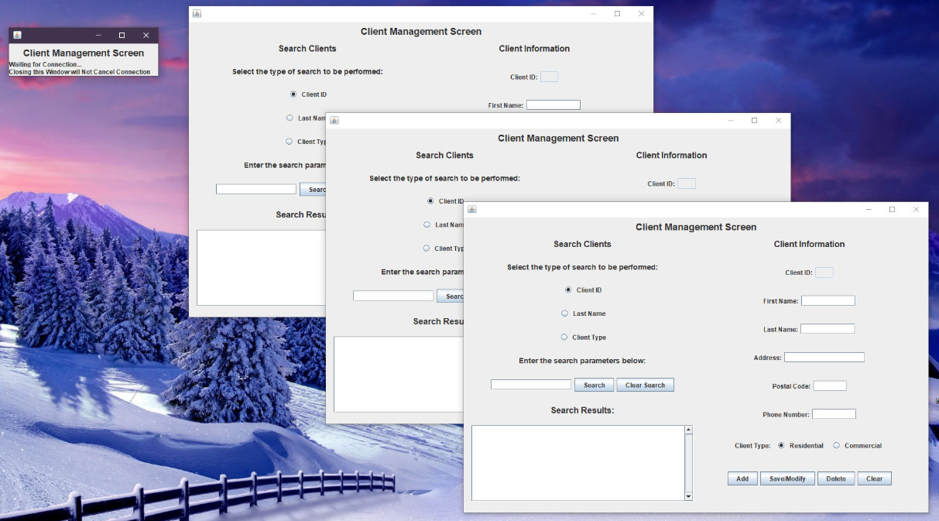

Figure 1. 4 Clients open simultaneously

If one of the connected clients is closed, the unconnected client will automatically connect:

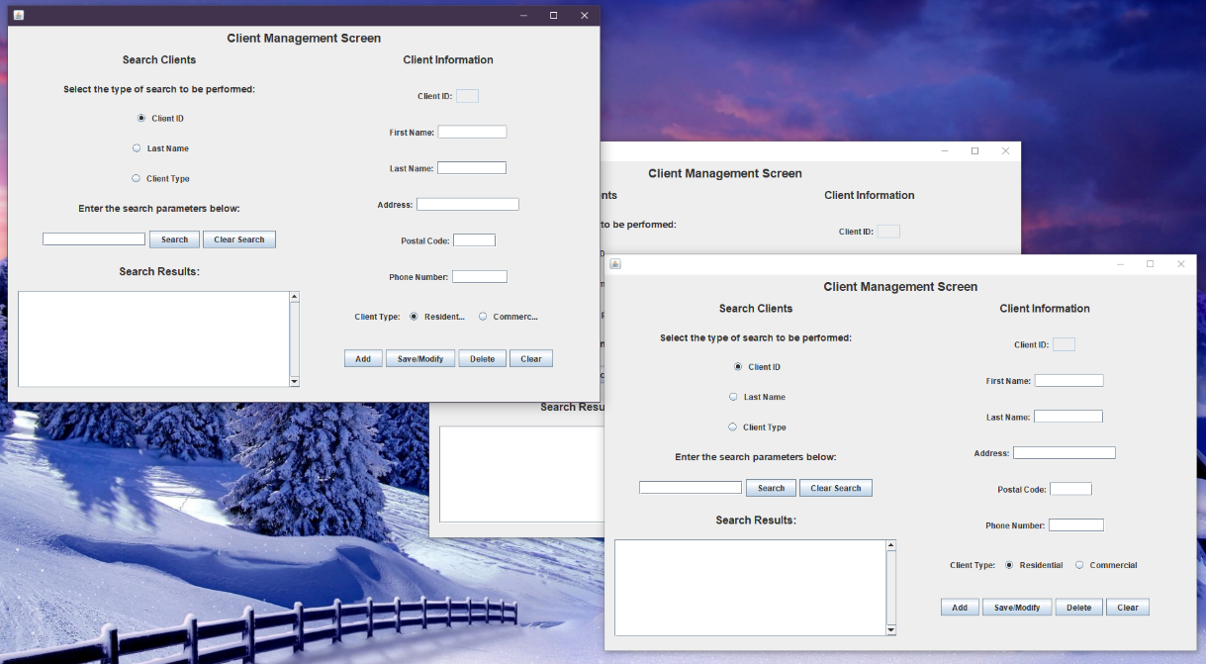

Figure 2. One client closed allows the 4th client to connect.

## Client – Server Functionality:

Searching a client by type in one window and clicking on the client populates the client information box with their information:

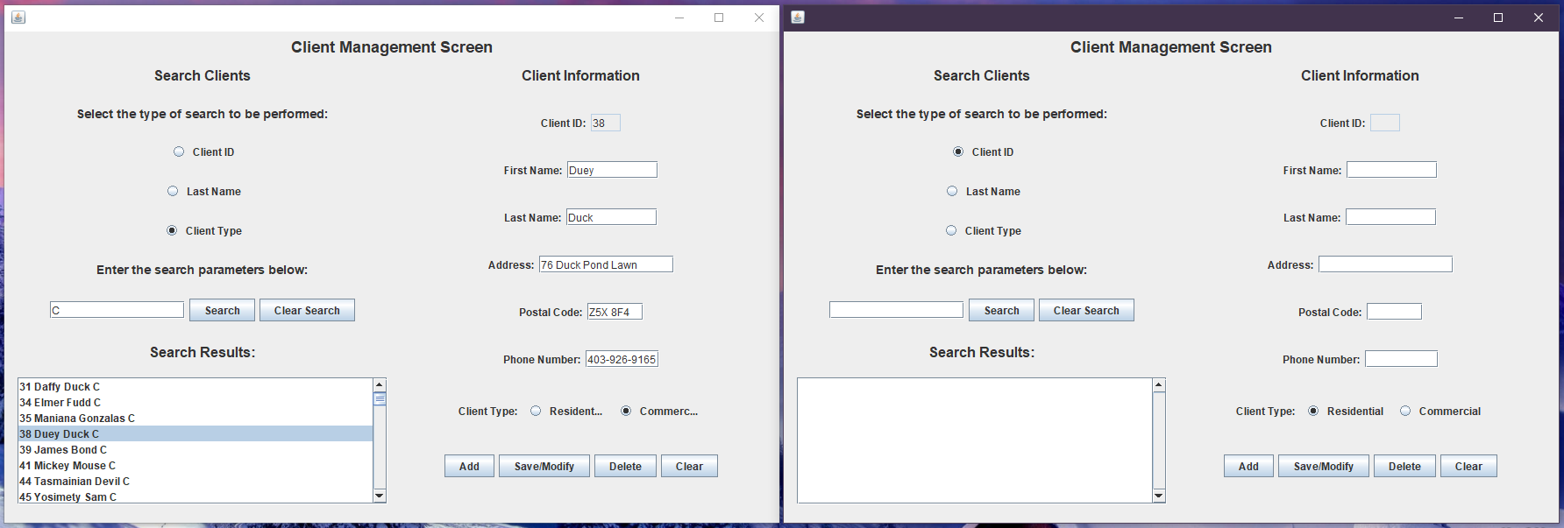

Figure 3. Searching a client using the UI returns a list of customers from the database.

Updating the information of that client and clicking save/modify, and then searching for that client in the second window:

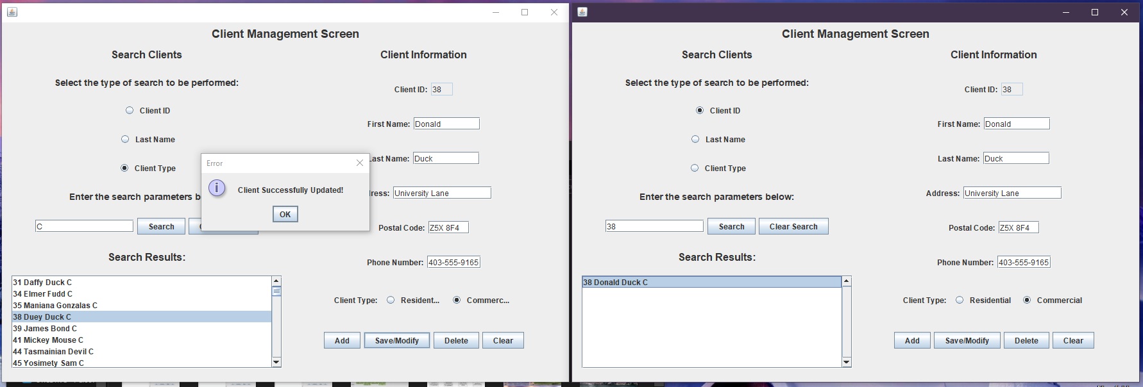

Figure 4. When a customer is updated in one client window, the changes are reflected in a search done by another client.

Using the second window to further modify the client and then save as a new client and search with the first window:

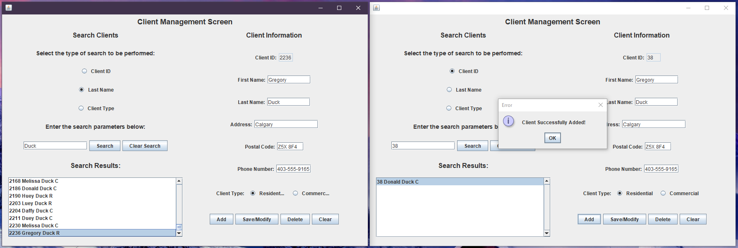

Figure 5. When a customer is added in one client window, they can be found in a search done by another client.

Deleting Client 38 in the first window and attempting to search for the client in the second window:

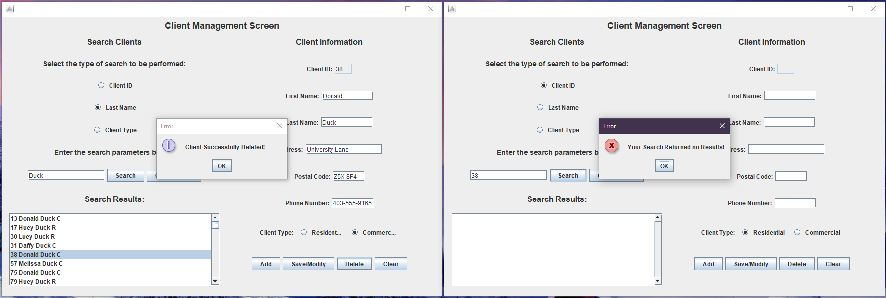

Figure 6. When a customer is deleted in one client window, they no longer appear in a search done by another client.

## Other functionality: (Taken from ENSF 593 Lab 8 Report)

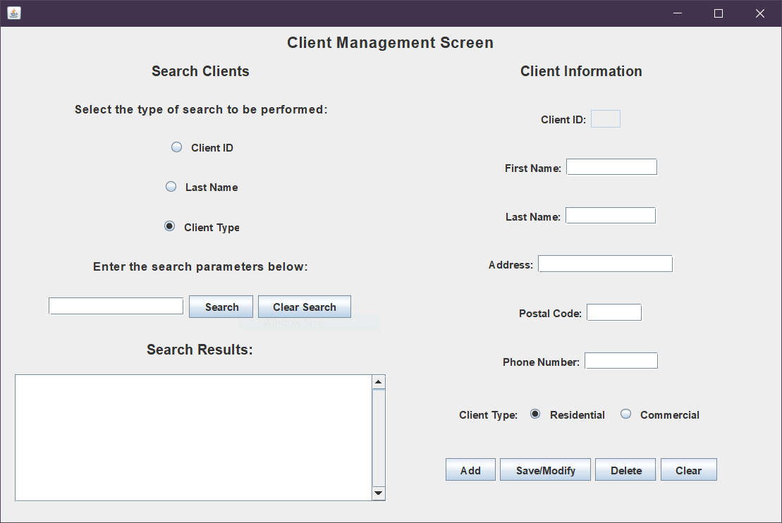

Figure . Client Management Screen when the program is first run.

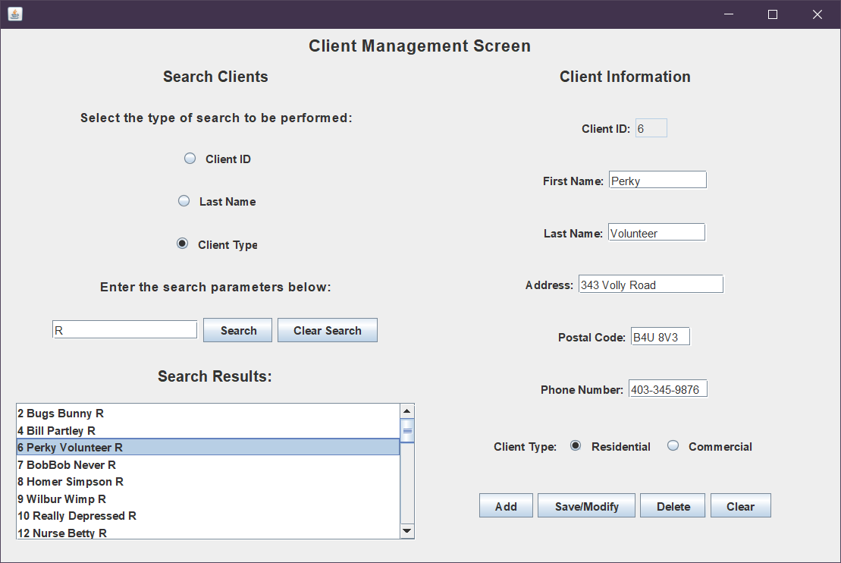

Figure . Client Management Screen after conducting a Client Type search with keyword ‘R’. The search results window is populated with all residential type clients in the database. Client number 6 has been pressed and their information is being displayed in the Client Information panel.

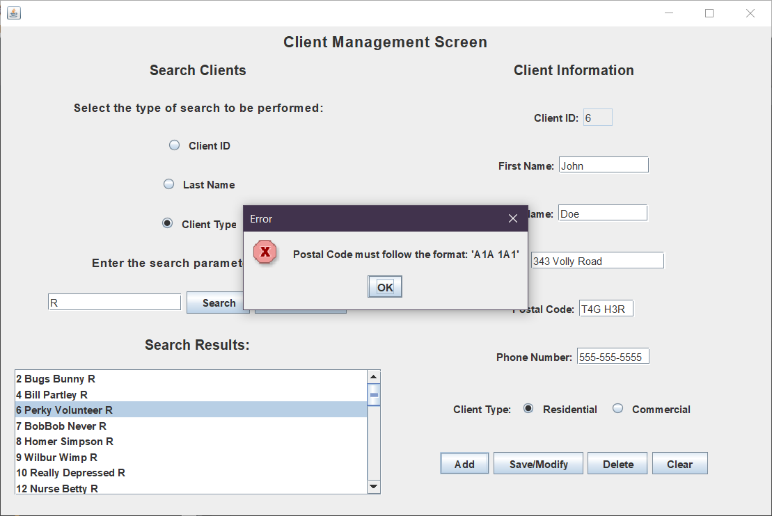

Figure . Screen after pressing add with an invalid postal code. The error message would also be displayed if save/modify were pressed.

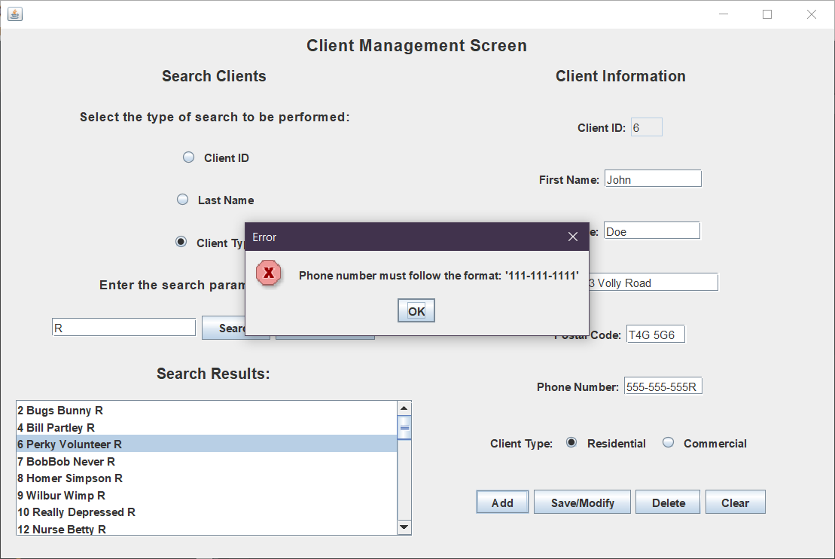

Figure . Screen after pressing add with an invalid phone number. The error message would also appear if save/modify were pressed.

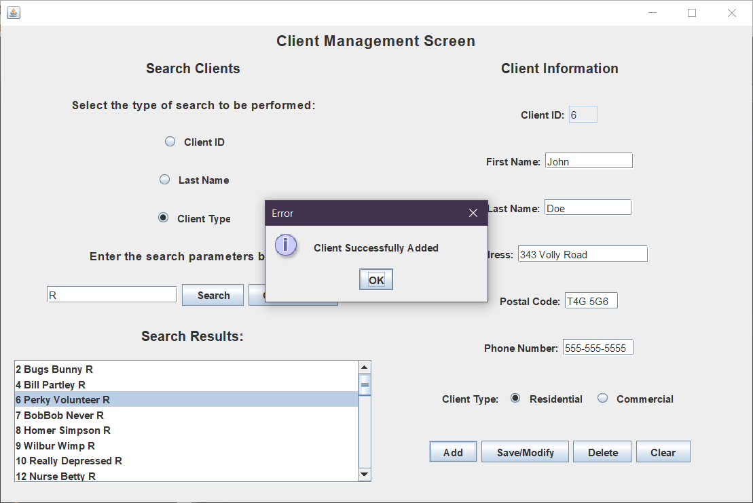

Figure . Screen after pressing the add button when all client information text fields contain valid parameters.

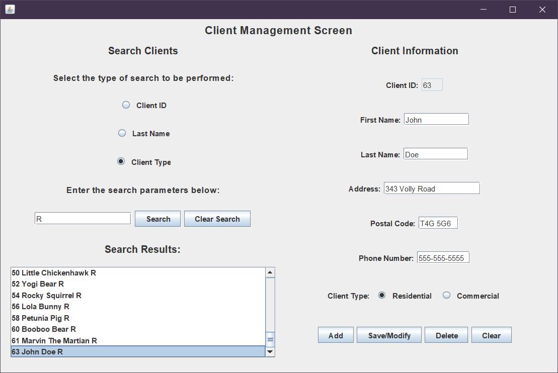

Figure . Reconducting the search now displays the added client at the bottom of the list. Their ID number is the next sequential number in the database and is not defined by the user. The Client ID field in general is not editable. A client can only be edited by first selecting them from the search box and the save/modify button updates the information that pertains to the client ID in the client information panel.

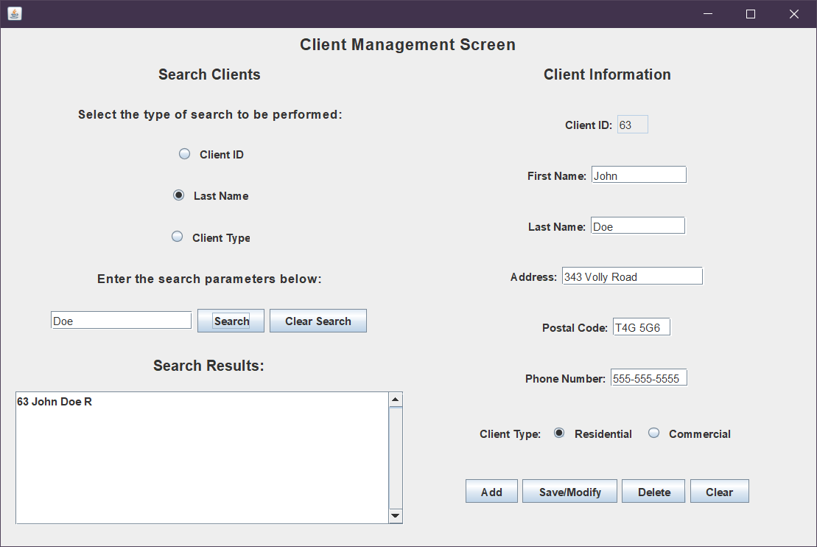

Figure . Conducting a search with the last name type and entering Doe brings up a search result for our newly added client.

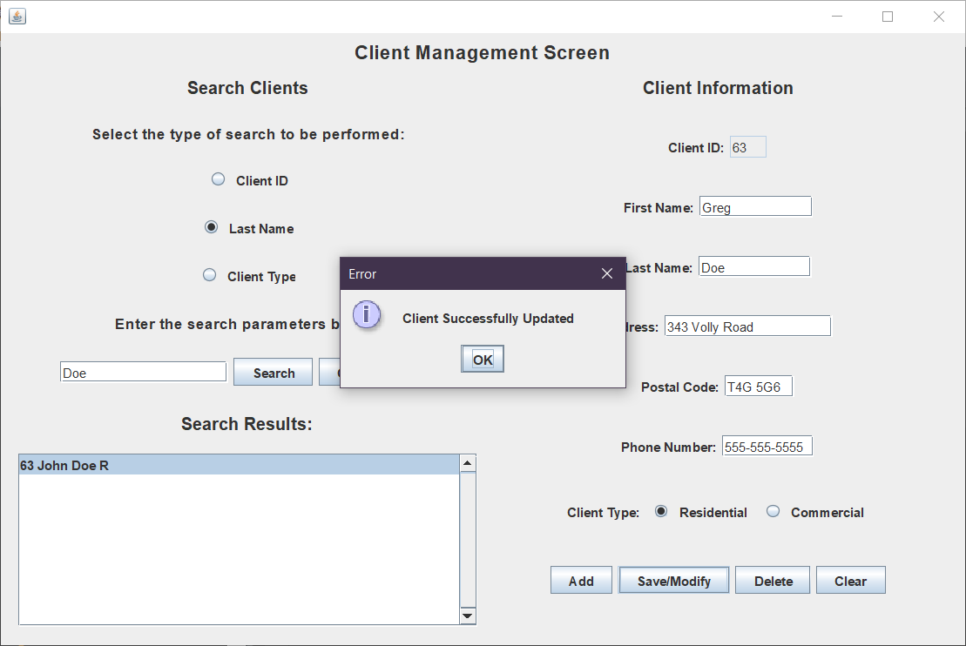

Figure . Selecting the client populates the text fields in the client information panel with that client’s info. Changing the first name to Greg and pressing Save/Modify shows this screen. Client 63 is updated so that the first name is now Greg instead of John.

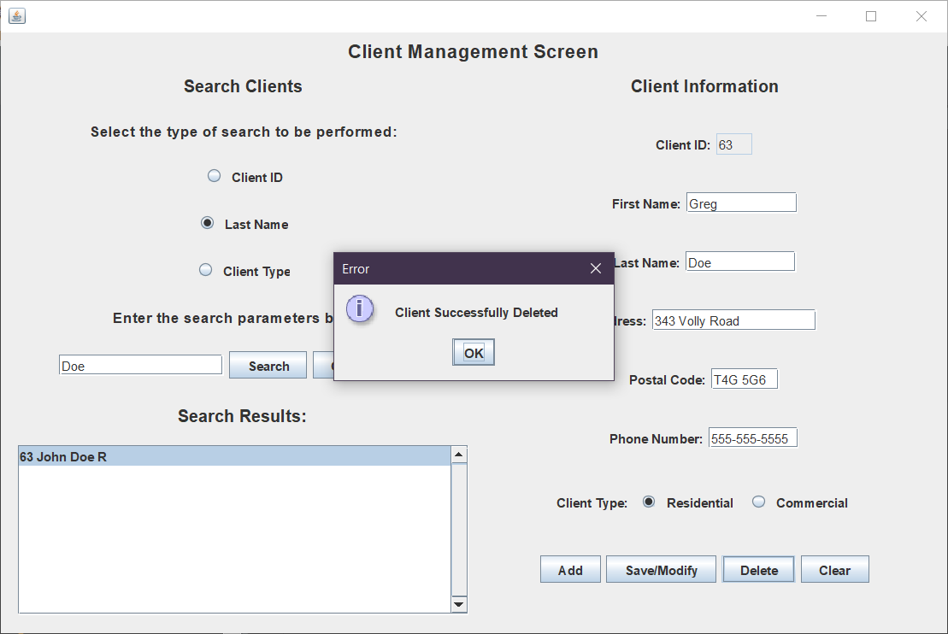

Figure . Pressing delete client will delete the client whose ID matches the ID that is currently displayed in the Client Information panel.

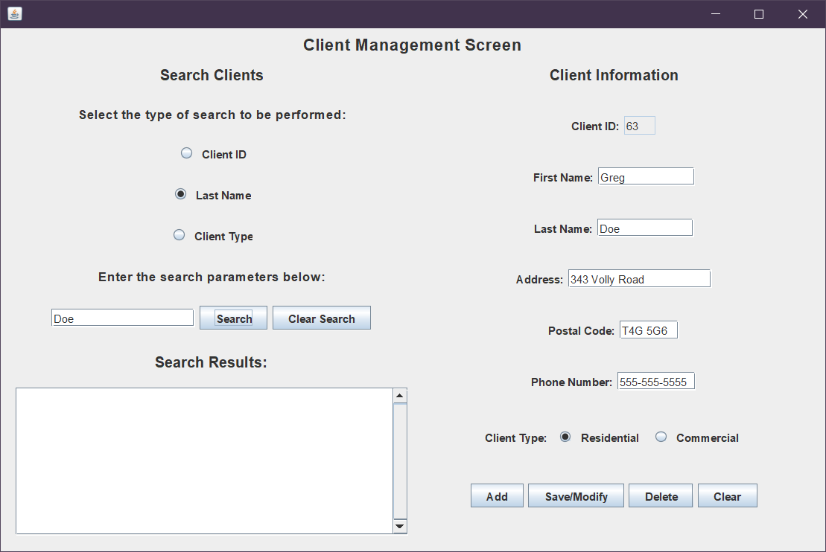

Figure . Pressing search in the search clients panel with the last name Doe now brings up zero results because the client has been deleted. However, their information remains in the client information panel if the delete was done erroneously so that the client can be re-added.

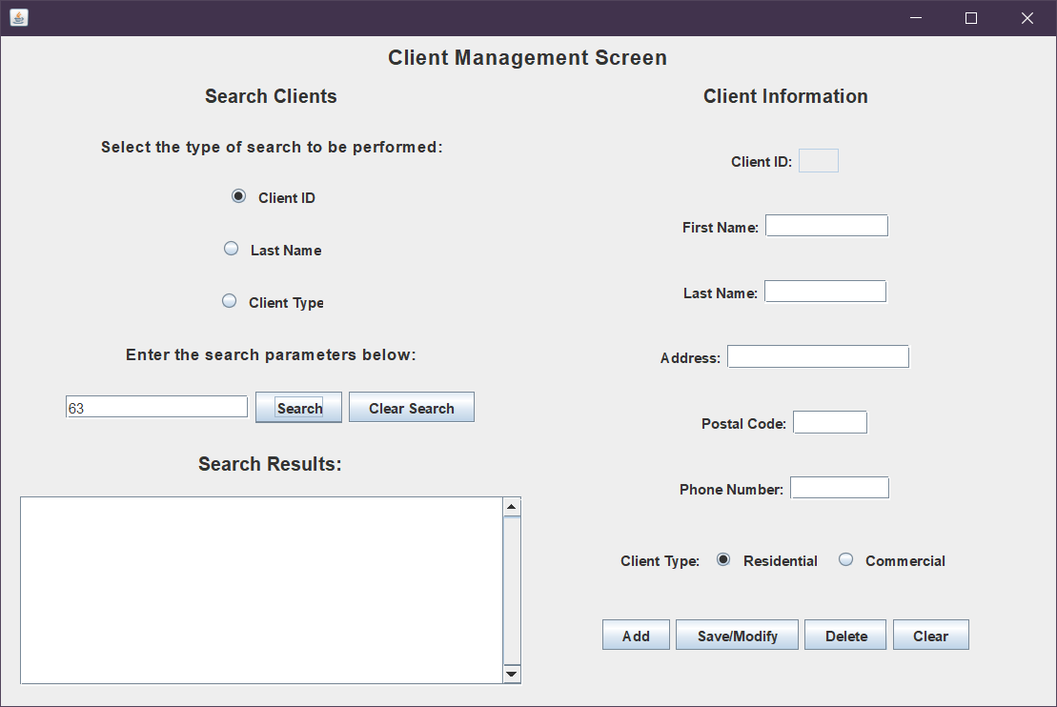

Figure . Pressing Clear in the client information panel deletes the text in all of the text fields.