《数据库原理》实验报告
题目：实验二、创建数据库及表、完整性约束 | 学号：201921121017 | 成  绩
班级：计算1911 | 日期：2021/5/6 | 成  绩
姓名：曾炳辉 | 指导老师：林颖贤 | 成  绩

- 实验目的：
- 掌握如何创建数据库和表的方法
- 掌握如何使用完整性约束的方法
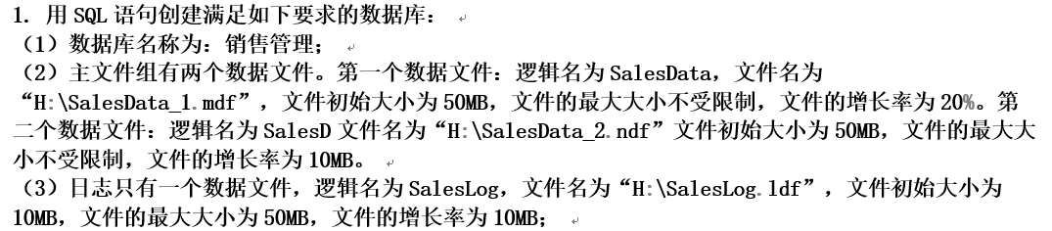
小结：
我采用，先创建后修改的方式

CREATE TYPE Telephone from varchar(11) not null

小结：
创建以后不需要再次执行此命令，需要把这行注释掉，否则会发生重复报错。

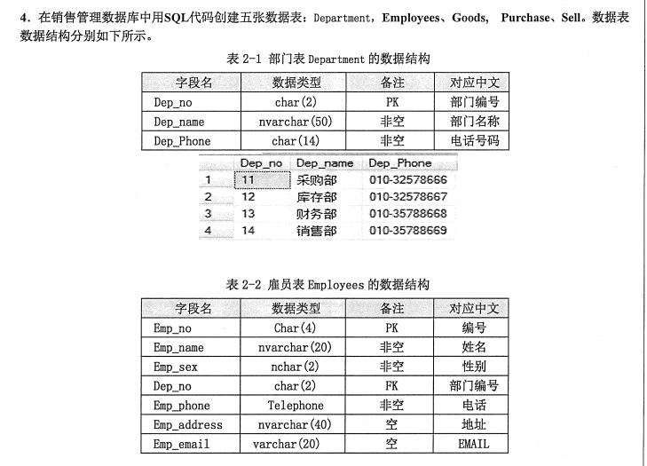
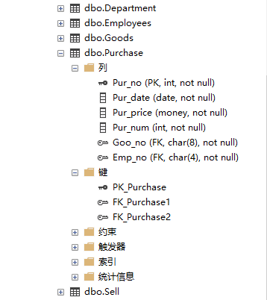
（详细代码见附录）

小结：利用修改语句，把所有的char(255)改成指导书上对应的数据类型，同时，创建主键和外键，以及约束。有些数据不合理，把数据类型做修改。

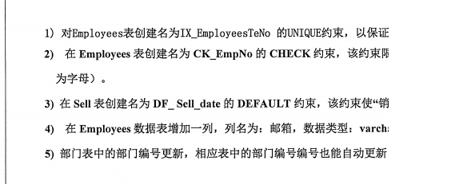
--5.1
if not exists(select * from sysobjects where name='IX_EmployeesTeNo' and xtype='UQ')
alter table Employees add constraint IX_EmployeesTeNo unique (Empp_phone)

--5.2
if not exists(select * from information_schema.constraint_column_usage where CONSTRAINT_NAME='CK_EmpNo' )
alter table Employees with check add constraint CK_EmpNo
check
not for replication --当复制代理在表中插入或更新数据时，禁用该约束。
(Emp_no like '[0-9][0-9][0-9][0-9]');

--5.3
if not exists (select * from sysobjects where name='DF_Sell_date' and xtype='D')
alter table Sell add constraint DF_Sell_date default(getdate()) for Sell_date

--5.4
if not exists(select * from syscolumns where id=object_id('Employees') and name='邮箱')
begin
ALTER TABLE Employees ADD 邮箱 varchar(20)
if not exists(select * from sysobjects where name='UN_postcode' )
alter table Employees with nocheck add constraint UN_postcode unique(邮箱)
end




小结：
学会创建UNIQUE约束、CHECK约束、DEFAULT约束、唯一约束

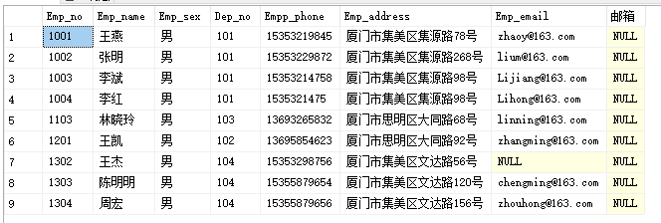
--6
if not exists (select * from sysobjects where name='Employees2')
select * into Employees2 from Employees where Employees.Emp_sex='男'
select * from Employees2

小结：
生成新表：直接将数据插入新表（表为未存在）

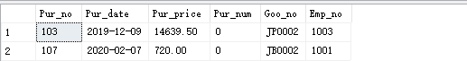
--8
if exists (select * from sysobjects where name='Purchase_bak')
drop table Purchase_bak
select * into Purchase_bak from Purchase where 1=2
insert into Purchase_bak select * from Purchase where Pur_num =0
select * from Purchase_bak

小结：
生成新表：先复制表的结构，再将数据插入该表（表为已存在）

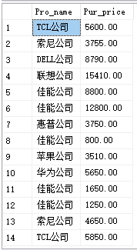-->>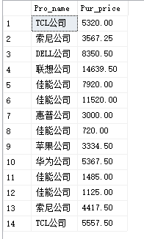
--9
if not exists (select * from sysobjects where name='StartPurchase')
select * into StartPurchase from Purchase
select * from StartPurchase
select Goods.Pro_name,StartPurchase.Pur_price
from Goods,StartPurchase
where Goods.Goo_no=StartPurchase.Goo_no
if exists (select *from Purchase where Pur_no='100' and Pur_price=5600)
begin
update Purchase
set Pur_price = Pur_price *(
case
when Goods.Pro_name='佳能公司' then 0.9
else
case when Goods.Pro_name='惠普公司' then 0.8
else 0.95
end
end
)
from Goods
where Goods.Goo_no=Purchase.Goo_no
end
select Goods.Pro_name,Purchase.Pur_price
from Goods,Purchase
where Goods.Goo_no=Purchase.Goo_no

小结：
核心在于update，而update中的核心在于case

创建触发器，在Sell表插入的时候，如果插入数据的销售数量小于0，插入不成功。
--创建触发器，在Sell表插入的时候，如果插入数据的销售数量小于0，插入不成功。
alter trigger Lab2_Trigger
on Sell for insert
as
declare @num int
set @num=(select inserted.Sell_num from inserted)
if @num<0
begin
print('ERROR: Sell_num <0')
rollback
end
go
insert into Sell values('A1001', '2019/11/18',6000, -10 ,'JY0001' ,'1301')

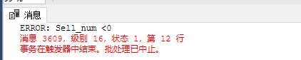
小结：
重新熟悉了一下触发器的写法

二、实验使用环境：
SQL server 2012
三、实验内容与完成情况：
总体实验基本完成。第二个没有完成，出题那个出了一个触发器。

四、出现的的问题及解决方案（列出遇到的问题和解决办法，列出没有解决的问题）
问题①：Telephone已存在
解决①：我是把所有语句写在一起，每次写一些然后测试所有。创建后，把Telephone的声明注释掉就好。

问题②：修改数据类型失败。
解决②：指导书的数据类型和表格的实际数据有冲突（不止一个），得把数据类型开大一点。（这数据太邪恶了）

问题③：有重复键
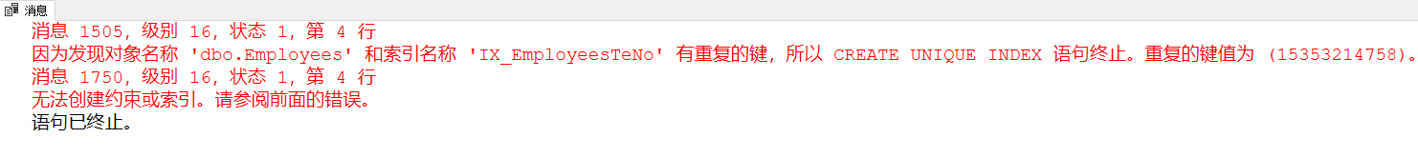
解决③：判断先有没存在
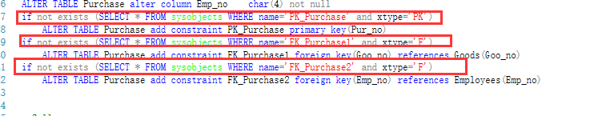

五、实验总结
本次实验的数据的处理有两种方法：①先插后改：先将所有数据插入，再将数据类型用alter修改；②先建后插：先将所有的表的结构用create建立好，再将数据用insert插入。我做之前先对比了一下工作量：①中的alter工作量和②中的create差不多，相当于②多出insert五个表所有的数据，②这工作量比①打得多。所以我选择①先插后改。实验前先考虑了一下，让我省了大量的工作量。
本次实验中，我所有的命令语句只在三个文件中，可以重复运行，得益于判断语句如：
先判断有没有约束，没有才建立约束。虽然多了一句if语句，但是可以把所有的建立约束的语句放在一起执行也不会出现问题。如：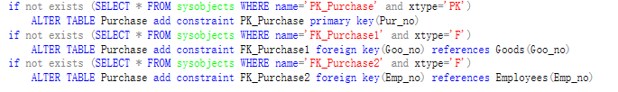
如果只有2、4、6行的代码，下次运行的时候，还得先drop约束才能建立约束。
- 附录
源码：
Lab2_start.sql：对表的数据类型进行修改、增加主外键
--Department
ALTER TABLE Department alter column Dep_no char(3) not null
ALTER TABLE Department alter column Dep_name nvarchar(50) not null
ALTER TABLE Department alter column Dep_Phone char(14) not null
if not exists (SELECT * FROM sysobjects WHERE name='PK_Department' and xtype='PK')
ALTER TABLE Department add constraint PK_Department primary key(Dep_no)

--Employees
--CREATE TYPE Telephone from varchar(11) not null
ALTER TABLE Employees alter column Emp_no char(4) not null
ALTER TABLE Employees alter column Emp_name nvarchar(20) not null
ALTER TABLE Employees alter column Emp_sex nchar(2) not null
ALTER TABLE Employees alter column Dep_no char(3) not null
ALTER TABLE Employees alter column Empp_phone Telephone
ALTER TABLE Employees alter column Emp_address nvarchar(40) not null
ALTER TABLE Employees alter column Emp_email varchar(20)
if not exists (SELECT * FROM sysobjects WHERE name='PK_Employees' and xtype='PK')
ALTER TABLE Employees add constraint PK_Employees primary key(Emp_no)
if not exists (SELECT * FROM sysobjects WHERE name='FK_Employees' and xtype='F')
ALTER TABLE Employees add constraint FK_Employees foreign key(Dep_no) references Department(Dep_no)

--Goods
ALTER TABLE Goods alter column Goo_no char(8) not null
ALTER TABLE Goods alter column Goo_name nvarchar(40) not null
ALTER TABLE Goods alter column Pro_name nvarchar(20) not null
if not exists (SELECT * FROM sysobjects WHERE name='PK_Goods' and xtype='PK')
ALTER TABLE Employees add constraint PK_Goods primary key(Goo_no)

--Purchase
ALTER TABLE Purchase alter column Pur_no int not null
ALTER TABLE Purchase alter column Pur_price money not null
ALTER TABLE Purchase alter column Pur_num int not null
ALTER TABLE Purchase alter column Pur_date date not null
ALTER TABLE Purchase alter column Goo_no char(8) not null
ALTER TABLE Purchase alter column Emp_no char(4) not null
if not exists (SELECT * FROM sysobjects WHERE name='PK_Purchase' and xtype='PK')
ALTER TABLE Purchase add constraint PK_Purchase primary key(Pur_no)
if not exists (SELECT * FROM sysobjects WHERE name='FK_Purchase1' and xtype='F')
ALTER TABLE Purchase add constraint FK_Purchase1 foreign key(Goo_no) references Goods(Goo_no)
if not exists (SELECT * FROM sysobjects WHERE name='FK_Purchase2' and xtype='F')
ALTER TABLE Purchase add constraint FK_Purchase2 foreign key(Emp_no) references Employees(Emp_no)

--Sell
ALTER TABLE Sell alter column Sell_no char(10) not null
ALTER TABLE Sell alter column Sell_num int not null
ALTER TABLE Sell alter column Sell_date date
ALTER TABLE Sell alter column Sell_prices money not null
ALTER TABLE Sell alter column Goo_no char(8) not null
ALTER TABLE Sell alter column Emp_no char(4) not null
if not exists (SELECT * FROM sysobjects WHERE name='FK_Sell1' and xtype='F')
ALTER TABLE Sell add constraint FK_Sell1 foreign key(Goo_no) references Goods(Goo_no)
if not exists (SELECT * FROM sysobjects WHERE name='FK_Sell2' and xtype='F')
ALTER TABLE Sell add constraint FK_Sell2 foreign key(Emp_no) references Employees(Emp_no)
if not exists(select * from sysobjects where name='check_Sell')
begin
alter table Sell
with check --该约束是否应用于现有数据，with check表示应用于现有数据，with nocheck表示不应用于现有数据
add constraint check_Sell
check
not for replication --当复制代理在表中插入或更新数据时，禁用该约束。
(Sell_no like '[A-Z,a-z]%');
end

Lab2_query.sql:增加约束，查询、数据更新、备份
--5.1
if not exists(select * from sysobjects where name='IX_EmployeesTeNo' and xtype='UQ')
alter table Employees add constraint IX_EmployeesTeNo unique (Empp_phone)

--5.2
if not exists(select * from information_schema.constraint_column_usage where CONSTRAINT_NAME='CK_EmpNo' )
alter table Employees with check add constraint CK_EmpNo
check
not for replication --当复制代理在表中插入或更新数据时，禁用该约束。
(Emp_no like '[0-9][0-9][0-9][0-9]');

--5.3
if not exists (select * from sysobjects where name='DF_Sell_date' and xtype='D')
alter table Sell add constraint DF_Sell_date default(getdate()) for Sell_date

--5.4
if not exists(select * from syscolumns where id=object_id('Employees') and name='邮箱')
begin
ALTER TABLE Employees ADD 邮箱 varchar(20)
if not exists(select * from sysobjects where name='UN_postcode' )
alter table Employees with nocheck add constraint UN_postcode unique(邮箱)
end

--6
if not exists (select * from sysobjects where name='Employees2')
select * into Employees2 from Employees where Employees.Emp_sex='男'
select * from Employees2

--8
if exists (select * from sysobjects where name='Purchase_bak')
drop table Purchase_bak
select * into Purchase_bak from Purchase where 1=2
insert into Purchase_bak select * from Purchase where Pur_num =0
select * from Purchase_bak

--9
if not exists (select * from sysobjects where name='StartPurchase')
select * into StartPurchase from Purchase
select * from StartPurchase
select Goods.Pro_name,StartPurchase.Pur_price
from Goods,StartPurchase
where Goods.Goo_no=StartPurchase.Goo_no
if exists (select *from Purchase where Pur_no='100' and Pur_price=5600)
begin
update Purchase
set Pur_price = Pur_price *(
case
when Goods.Pro_name='佳能公司' then 0.9
else
case when Goods.Pro_name='惠普公司' then 0.8
else 0.95
end
end
)
from Goods
where Goods.Goo_no=Purchase.Goo_no
end
select Goods.Pro_name,Purchase.Pur_price
from Goods,Purchase
where Goods.Goo_no=Purchase.Goo_no

Lab2_trigger.sql：创建一个触发器
--创建触发器，在Sell表插入的时候，如果插入数据的销售数量小于0，插入不成功。
alter trigger Lab2_Trigger
on Sell for insert
as
declare @num int
set @num=(select inserted.Sell_num from inserted)
if @num<0
begin
print('ERROR: Sell_num <0')
rollback
end
go
insert into Sell values('A1001', '2019/11/18',6000, -10 ,'JY0001' ,'1301')

