有一图书管理系统，根据需求分析，得到如下ER图“

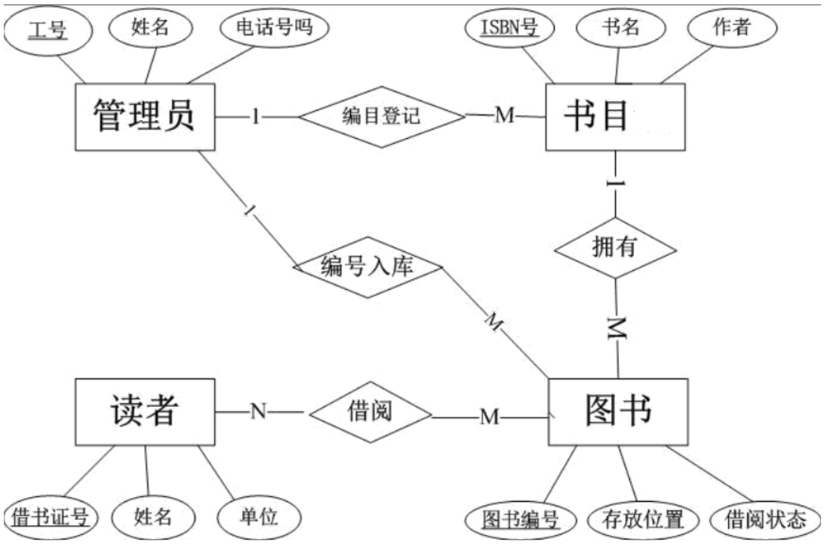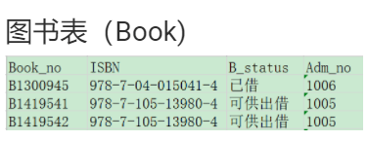

部分表数据如下：

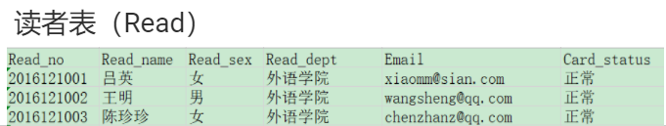

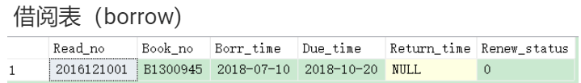

**用SQL代码完成下列功能：**

**1. 先备份一张借阅表，表名为: Borrow_bak。删除借阅表中的所有记录。创建一个触发器, 名为：Tri_InsterBorrow。**

**当向借阅表插入一条记录时, 先检查借书证号的状态是否为挂失, 如果为挂失拒绝借书，如果所借的图书编号状态为已借，显示‘该书已被借’。 否则自动修改图书表中的图书状态，把'未借'改成'已借'。**

create trigger Tri_InsterBorrow

on dbo.Borrow for insert

as

--select *

--from inserted i

print('run is success!')

declare @Rno char(10)

declare @Bno char(10)

set @Rno=(select i.Read_no from inserted i)

set @Bno=(select i.Book_no from inserted i)

if (select r.Card_status from dbo.Reader r where r.Read_no=@Rno ) like '挂失'

begin

print('卡丢失，借书失败')

rollback

end

else if (select b.B_status from dbo.Book b where b.Book_no=@Bno ) like '已借'

begin

print('书已经被借，借书失败')

rollback

end

else

begin

print('借书成功')

update dbo.Book set B_status = '已借' where Book_no=@Bno

end

go

--drop table dbo.Book

--drop table dbo.Borrow

--select * into dbo.Book

--from dbo.Book_bak

--select * into dbo.Borrow

--from Borrow_bak

insert into dbo.Borrow values ('2016811002','B1547939','2020-03-14 00:00:00.000','2020-12-14 00:00:00.000',NULL,1 )

insert into dbo.Borrow values ('81099','B1300945','2020-03-14 00:00:00.000','2020-12-14 00:00:00.000',NULL,1 )

insert into dbo.Borrow values ('81099','B1547939','2020-03-14 00:00:00.000','2020-12-14 00:00:00.000',NULL,1 )

delete from dbo.Borrow where Read_no='81099'

三种情况：

①卡丢失：

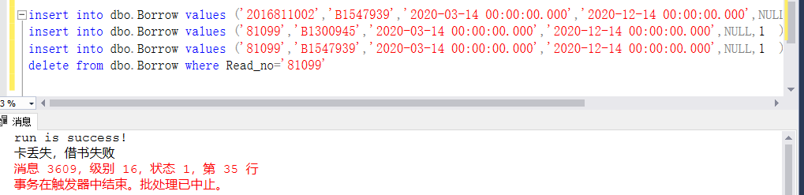

②书已经被借走

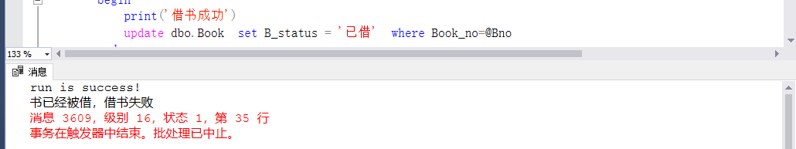

③借书成功：

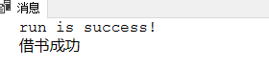

**2.   创建触发器, 如果修改归还日期，自动更新图书表中借阅状态，把已借改为未借, 同时判断是否该超期，**

**如果超期，将读者卡号，图书编号，罚款金额追加到罚款表。**

create trigger Tri_updateBorrow

on dbo.Borrow for update

as

print('run is success!')

update dbo.Borrow set Due_time = dateadd (month,(case when len(Read_no)<6 then 3 else 1 end)*(case when Renew_status = 1 then 2 else 1 end ),Borr_time)

declare @Rno char(10)

declare @Bno char(10)

declare @Dtime datetime

declare @Ntime datetime

set @Rno=(select i.Read_no from inserted i)

set @Bno=(select i.Book_no from inserted i)

set @Dtime =(select b.Due_time from dbo.Borrow b where @Bno=b.Book_no)

if DATEDIFF(day,@Dtime,GETDATE()) >0

begin

--罚款表

--0.5*DATEDIFF(day,@Dtime,GETDATE())

if not exists(select * from sysobjects where name='罚款表')

begin

create table 罚款表 (

Read_no varchar(15) not null,

TheMoney int not null

)

end

if exists(select * from 罚款表 f where f.Read_no=@Rno )

begin

update 罚款表 set TheMoney=TheMoney+0.5*DATEDIFF(day,@Dtime,GETDATE()) where Read_no=@Rno

end

else

begin

insert into 罚款表 values(@Rno,0.5*DATEDIFF(day,@Dtime,GETDATE()))

end

print('runIF is success!')

end

go

--drop table dbo.Borrow

--select * into dbo.Borrow

--from Borrow_bak

update dbo.Borrow set Borr_time ='2021-03-14' where Book_no='B1300945'

update dbo.Borrow set Borr_time ='2020-03-14' where Book_no='B1481537'

update dbo.Borrow set Return_time =GETDATE() where Book_no='B1300945'

update dbo.Borrow set Return_time =GETDATE() where Book_no='B1481537'

select *

from 罚款表

drop table 罚款表

**两个测试数据：  
一个超期，一个没有超期**

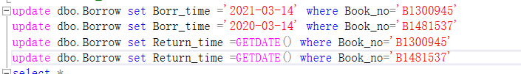 **运行结果：**

