Tutorial 3 (18&19 Nov)

1. RP vowel inventory:

/ ɪ ɒ ɑː æ aɪ aɪə aʊ aʊə ɔː ɔɪ ɔɪə e

ə eə eɪ eɪə əʊ əʊə ɜː iː ɪə ʊ uː ʊə ʌ/

* 1. How many monophthongs, diphthongs, and triphthongs are there in RP?

monophthong: ɪ (sit) ɒ (hot) ɑː (car) æ (bad) ɔː (call) e (bed) ə (schwa, about) ɜː (her) iː (see) ʊ (book) uː (cool) ʌ (cut)

diphthong: aɪ (‚i‘) aʊ (house) ɔɪ (boy) eə (air) eɪ (‘a’) əʊ (oh) ɪə (ear) ʊə (tour)

triphthong: aɪə (fire) aʊə (hour) ɔɪə (lawyer) eɪə (player) əʊə (lower)

* 1. Which of the monophthongs are long? ː long

1.3 Match the **short** vowels and their respective positions in the vowel chart.

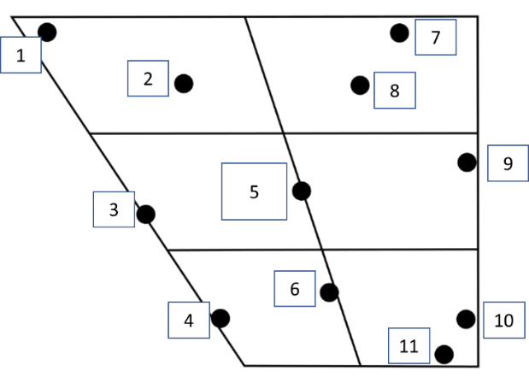

/ɪ/: 2 (near-close front unrounded vowel)

/ɒ/: 10 (open back rounded vowel)

/æ/: 4 (near-open front unrounded vowel)

/e/: 3 (close-mid front unrounded vowel)

/ə/: 5 (mid central vowel aka schwa)

/ʊ/: 8 (near-close back rounded vowel)

/ʌ/: 6 (open-mid central/near-back unrounded vowel)

1. Describe the following consonants in terms of voicing, place of articulation, and manner of articulation. What are their relevant articulators in the diagram below?

e.g. /b/: voiced bilabial plosive (a)

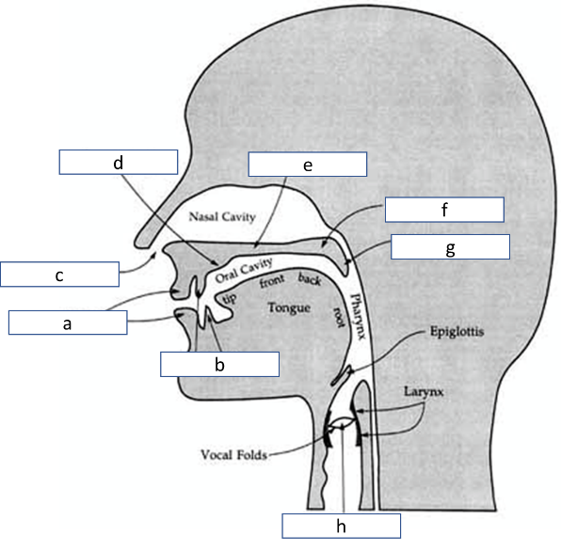

**/ p m g v** **θ t** **ʃ** **ʧ /**

/p/ voiceless bilabial plosive (a)

/m/ voiced bilabial nasal (a+c)

/g/ voiced velar plosive (f, velum)

/v/ voiced labiodental fricative (a+b)

/θ/ (‘th’ as in three) voiceless dental fricative (b) (interdental)

/t/ voiceless alveolar plosive (d, alveolar ridge)

/ ʃ/ (‘sh’) voiceless postalveolar/ palato-alveolar fricative (between d and e)

/ ʧ/ (‘ch’) voiceless postalveolar/ palato-alveolar affricate (between d and e)

1. Transcribe the following words phonemically in RP (optional: including the syllable boundary and stress). e.g. linguist /ˈlɪŋ.ɡwɪst/

***compare extra present***

Hint: / e ə ɪ k m n p r s t z/

compare: /kəmˈpeə/

extra: /ˈek.strə/ (maximum onset principle)

present (n.): /ˈprez.ənt/ or /ˈprez.n̩t/ (syllabic nasal)

present (v.): /prɪˈzent/