Tutorial 4 (25&26 Nov)

Morphology:

1. List the morphemes in the words below. For each morpheme, is it free or bound? If it is a bound morpheme, is it derivational or inflectional?

e.g. dogs

{dog}: free

{-s}: bound, inflectional (plural s)

***higher sharpeners unaffordable incompletion***

|  |
| --- |
| higher  {high}: free  {-er}: bound, inflectional (comparative high to higher)  sharpeners  {sharp}: free  {-en}: bound, derivational (to v.)  {-er}: bound, derivational (to n.)  {-s}: bound, inflectional (plural s)  unaffordable  {un-}: bound, derivational (change the meaning to the negative one)  {afford}: free  {-able}: bound, derivational (to adj.) vs {able}: free  incompletion  {in-}: bound, derivational (change the meaning to negative)  {complete}: free  {-ion}: bound, derivational (to n.) |

1. For each word below, draw a word tree.

e.g. lecture ppt06

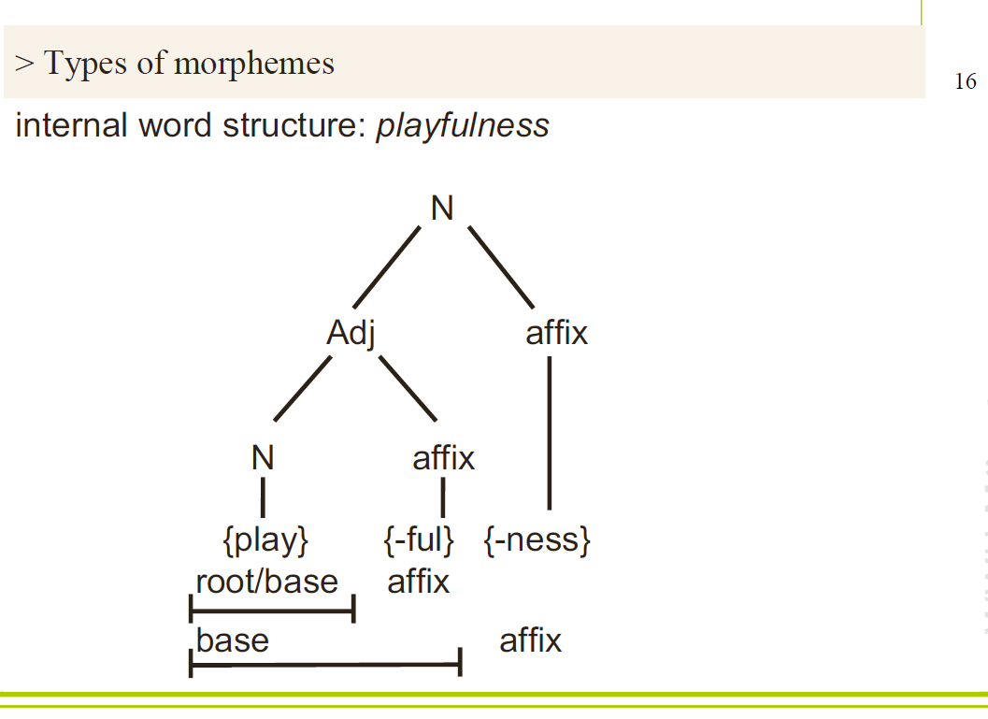

***-carelessness***

***-independently***

***-antidisestablishmentarianism (meaning opposition to the belief that there should not be an official relationship between a country's government and its national Church)***

<https://yohasebe.com/rsyntaxtree/>

|  |
| --- |
| Root: care (n.).  Care can be v. or n.  N + {-less}: negation, without care  e.g. fearless, restless, pointless |

|  |  |
| --- | --- |
| Root: depend (v.)  {in-}: opposition, negation  e.g. insufficient, inadequate, inappropriate  {in-} + Adj.  independ {in-} + v. wrong! | Root: establish (v.)  <https://en.wikipedia.org/wiki/Antidisestablishmentarianism_(word)> |