Tutorial 7 (16&17 Dec)

Syntax

1. Describe the following elements. (Hint: What is the word class, type of phrase, clause, and sentence? Start with the highest possible structural level.)
   1. the Det
   2. book NP🡪N
   3. the book NP🡪Det N
   4. 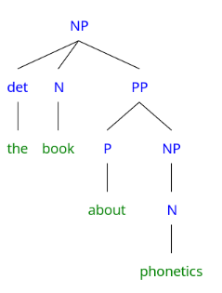the book about phonetics   
      NP🡪 Det N PP  
      PP🡪P NP  
      NP🡪N

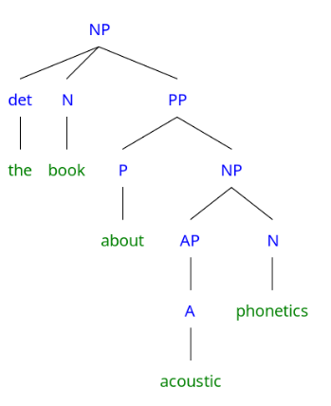

* 1. 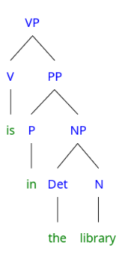the book about acoustic phonetics  
     NP🡪 Det N PP  
     PP🡪 P NP  
     NP🡪 AP N  
     AP🡪 A
  2. 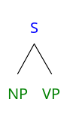the book about acoustic phonetics is in the library  
     simple sentence: one main clause  
     S🡪NP VP (this NP is same as e)  
     VP🡪V PP  
     PP🡪P NP  
     NP🡪Det N
  3. the book about acoustic phonetics is in the library and I will borrow it tomorrow  
     compound sentence: two main clauses joint by coordinating conj.

S🡪S1 conj S2 (this S1 same as f)

S2🡪NP VP   
NP🡪pro  
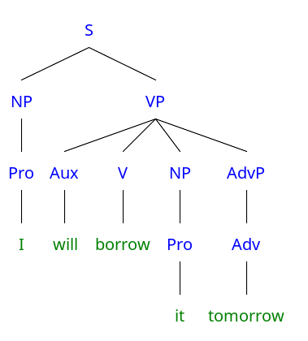VP🡪 AUX V NP AdvP  
NP🡪pro  
AdvP🡪Adv

* 1. the book about acoustic phonetics is in the library and I will borrow it tomorrow if I have time  
     compound-complex sentence: 2 main clauses + 1 subordinate clause  
     I have time   
     S🡪NP VP  
     NP🡪pro  
     VP🡪V NP  
     NP🡪N

1. *“The boy watched a very funny movie.”*

Explainwhy “*the boy”* is a constituent but not *“the”* and *“boy”* respectively*.*

Explain why “*a very funny movie*” is a constituent but not *“very funny movie”* and *“movie”* respectively.

Lecture notes 08 slides 12-14  
Substitution test

Movement test  
Coordination test  
stand-alone-test