Tutorial 8 (13&14 Jan )-Syntax II

Form

1. Explain why the following sentences are structurally ambiguous. (Hint: structural analysis)
   1. She killed the man with the tie.
   2. We met a german history teacher.
   3. I found this book about women’s questions in Ireland.

Function

1. Identify the functional categories of the constituents in the following sentences (Hint: use brackets to mark the constituents and write the appropriate symbols below them).
   1. She killed the man with the tie.
   2. We met a german history teacher.
   3. I found this book about women’s questions in Ireland.
   4. I will keep the present.  
      I will keep warm.  
      They kept in the shade.  
      Please keep me a seat.  
      He kept his father busy.  
      Liz keeps her passport in her purse.
2. Analyze the syntactic function of the constituent(s) in ***bold*** ***italics***.   
   (extracted from Mair 2015, Practice Unit 5)
   1. She used to make a living ***giving English lessons***.
   2. ***What you need*** is a good rest.
   3. I'm looking for a book ***to consult on weak-stress forms in English***.
   4. We're all waiting ***for the crew to open the door***.
   5. This won't prevent you ***falling asleep in his classes***.
   6. ***Old people living alone and dying of hypothermia*** is a bloody shame.
   7. ***Old people living alone*** are the group most at risk.
   8. Who would want ***there*** to be another war?
   9. That was the ***wrong*** solution to advocate.

Tutorial 8 (13&14 Jan )-Syntax II

Form

1. Explain why the following sentences are structurally ambiguous. (Hint: structural analysis)
   1. She killed the man with the tie. (PP)  
      Version1: the man wore the tie  
      the man with the tie NP🡪 Det N PP  
      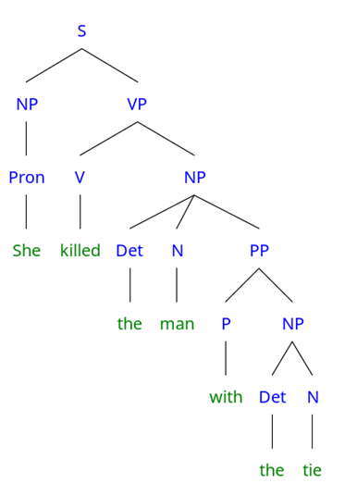  
        
      Version2: murdered with the tie  
      killed the man with the tie VP🡪 V NP PP  
        
      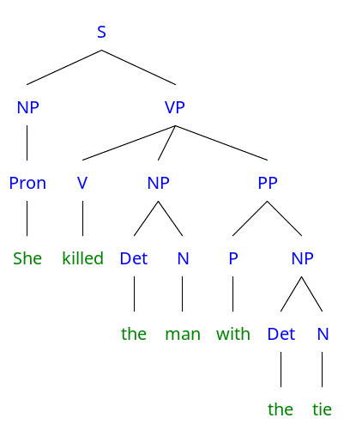
   2. We met a german history teacher. (AP)  
      Version1: someone who teaches german history  
      a german history teacher NP🡪 Det NP N

german history NP🡪 AP N

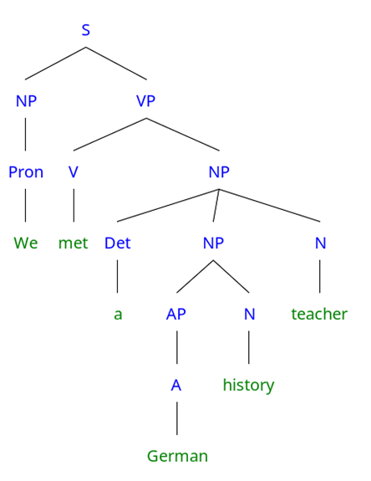  
  
Version2: a german person who teaches history  
a german history teacher NP🡪 Det AP N N (compound noun: endocentric A+B=B)

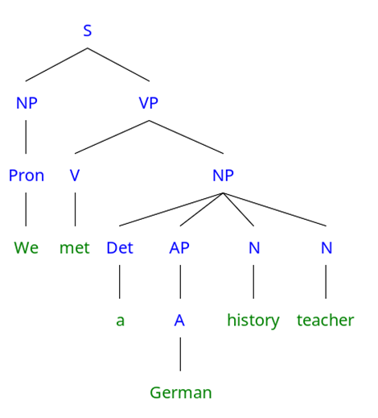

* 1. I found this book about women’s questions in Ireland. (PP)  
     Version1: the book was found in Ireland  
     found this book about women’s questions in Ireland VP🡪 V NP PP

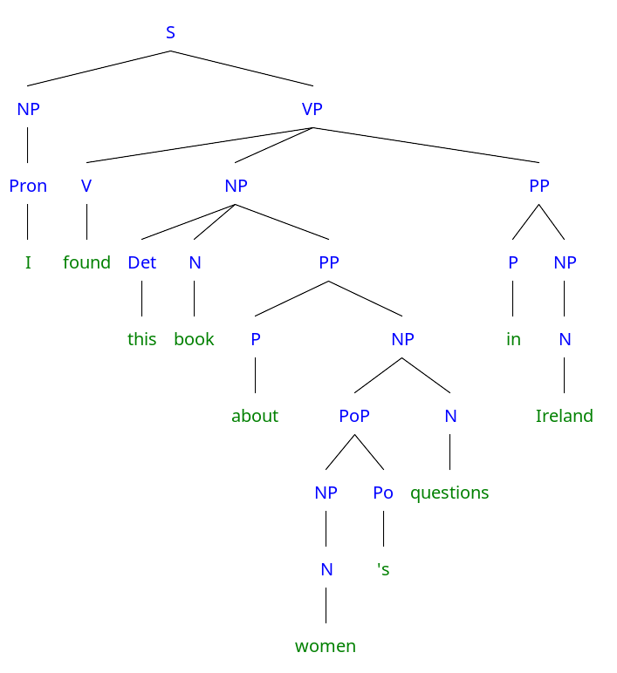

Version2: the women are in Ireland  
women’s questions in Ireland NP🡪 PoP N PP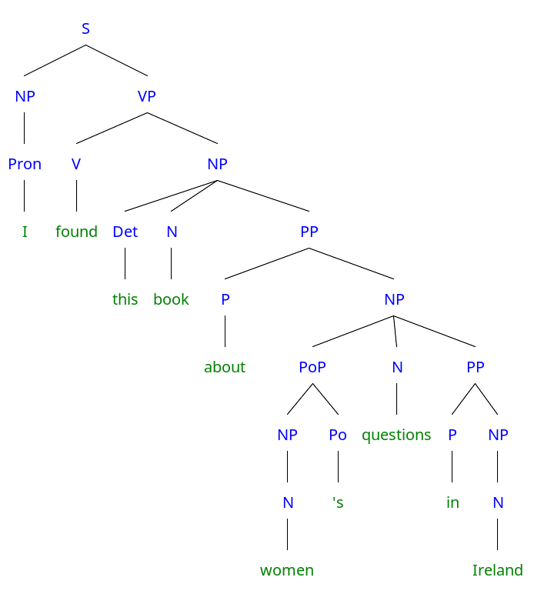

Function

1. Identify the functional categories of the constituents in the following sentences (Hint: use brackets to mark the constituents and write the appropriate symbols below them).
   1. She killed the man with the tie.  
      Version1: the man wore the tie

[She] [killed] [the man with the tie].  
SVO (O: the man with the tie)  
with the tie: post-modifier of the head noun (man)  
  
Version2: murdered with the tie

[She] [killed] [the man] [with the tie]  
SVOA (O: the man) (A: adverbial of manner)

* 1. [We] [met] [a german history teacher].  
     Version1: someone who teaches german history  
     SVO  
     german: pre-modifier of the head noun (history)  
       
     Version2: a german person who teaches history  
     SVO

german: pre-modifier of the head endoncentric compound noun (teacher)

* 1. I found this book about women’s questions in Ireland.  
     Version1: the book was found in Ireland

[I] [found] [this book about women’s questions] [in Ireland]  
SVOA (adverbial of place)  
  
Version2: the women are in Ireland  
[I] [found] [this book about women’s questions in Ireland].  
SVO (O: this book about women’s questions in Ireland)

* 1. I will keep the present. SVO (will: modal auxiliary)  
     I will keep warm. SVCs (subject complement)  
     They kept in the shade. SVA (adverbial of place)  
     Please keep me a seat. AVOiOd (subject is hidden, the subject is you or whoever the listener is. Oi: indirect object (usually the receiver) Od: direct object)  
     He kept his father busy. SVOCo (object complement)  
     Liz keeps her passport in her purse. SVOA

1. Analyze the syntactic function of the constituent(s) in ***bold*** ***italics***.   
   (extracted from Mair 2015, Practice Unit 5)
   1. She used to make a living ***giving English lessons***. non-finite adverbial clause of manner
   2. ***What you need*** is a good rest. finite subject clause
   3. I'm looking for a book ***to consult on weak-stress forms in English***. non-finite relative clause with a purpose meaning
   4. We're all waiting ***for the crew to open the door***. non-finite object clause
   5. This won't prevent you ***falling asleep in his classes***. non-finite object clause
   6. ***Old people living alone and dying of hypothermia*** is a bloody shame. non-finite subject clause
   7. ***Old people living alone*** are the group most at risk. noun phrase subject old people post-modified by non-finite relative clause
   8. Who would want ***there*** to be another war? existential there
   9. That was the ***wrong*** solution to advocate. pre-modifier of the head noun solution