3RRR Robot Platform Manual

By Gan Tao

Any Question Please Email to:
taogan@eng.buffalo.edu

Feb. 28 2004

Buffalo
N.Y.

Open the file which contain programs and run the rrrproject3.m.
Or you can set the MATLAB path to the file enclosing all the programs and type “rrrproject” at the command window.

- Then you can see the figure below.

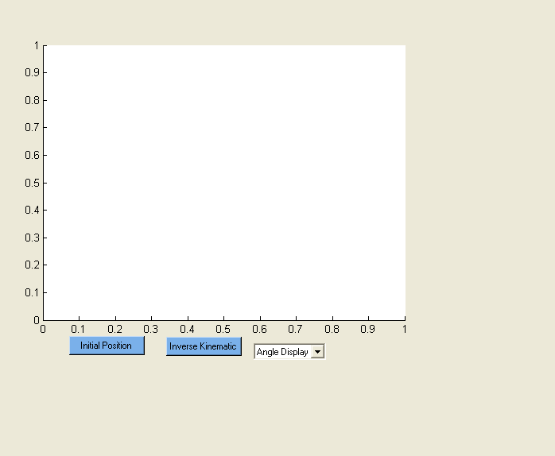

- If it is the first time to run it or you have cleared the work space of MATLAB, you should click the button “Initial Position” for initializing the robot’s data.

- Otherwise, if you click the button “Inverse Kinematic” without setting the initial data, you will get the warning blew.

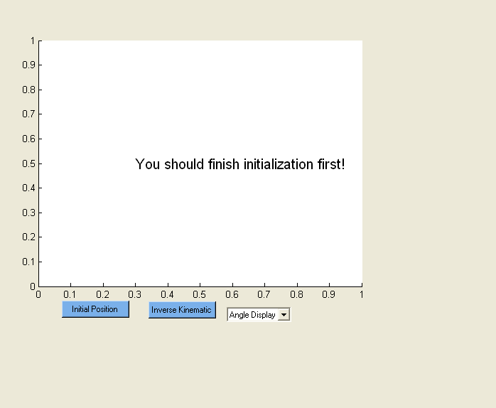

- Ok. Supposing everything goes well, it will show you the figure blew.
You can easily set each variable and the robot will be demonstrated every time you do the change.

Now you probably will have some doubt about what each of the variable stand for.
Don’t worry. Let me give you an idea about it.

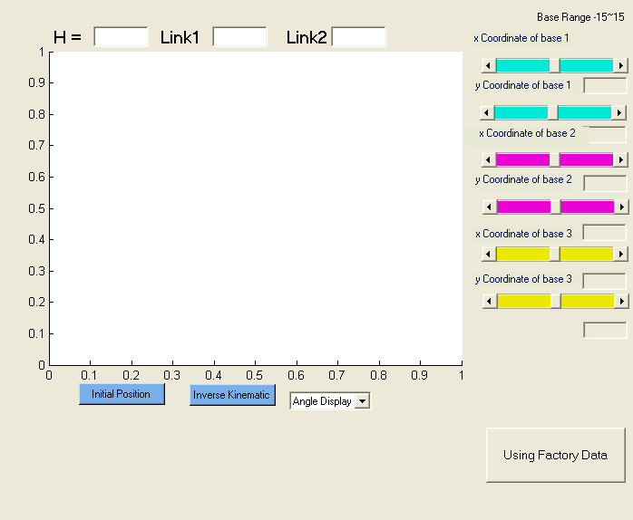

- The problem will become straightforward when you click the “Using Factory Data”.
The following body will be illustrated.

Yes, “H” stands for the length of the moving platform; “Link1” gives you the length from “Base” to the first join; “Link2” presents the length from first join to second join.

For your convenience, the sliders are added to show what the result is when you modify the bases. Of course, if you know exactly the coordinate of each base, what you should do is just fill them in the blank which blew each slider.

By the way, if you do click the “Using Factory Data”, the program
will use the default data which are illustrated on the figures. The thing
is data can be adjusted if you don’t satisfied by the data.

In the following steps, some sample will be given to you.

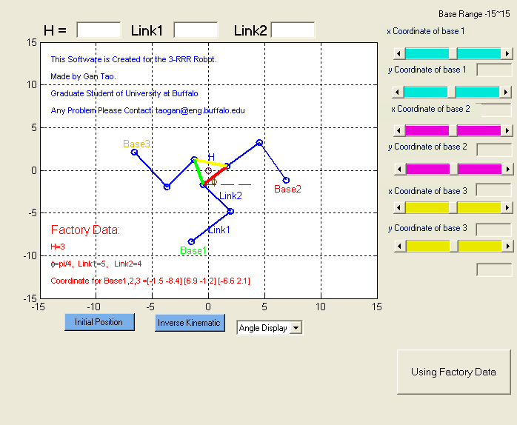

- In the case, I want my base 1 to be (5, -8). Then what I should do is to set “x Coordinate of base 1” 5; set “y Coordinate of base 1” -8.
The same steps you can follow to set “Base 2” and “Base3”.

Notices: If the input is out of range, it will display warning “The input
is out of range. Try again!”

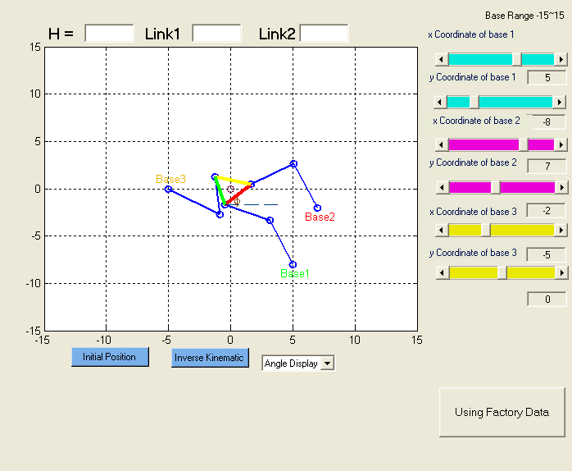

8. Probably, you also want to set your own “H” and “Link1”, “Link2”.

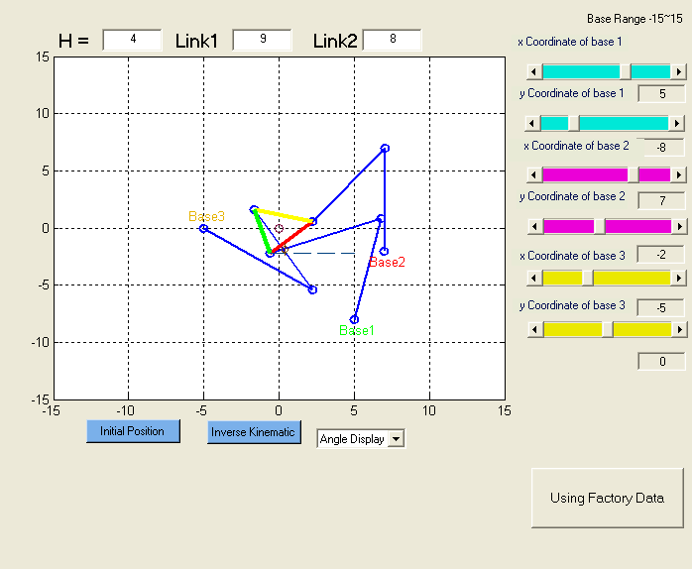

- One of the things you may interest may be the angle of every link of the robot.
This software provides you a convenient way to show them. What you have to do is to select the pull-down menu from “Angle Display” to “Absolute Angle”. Then every time you move the robot or change the variables the angles will be changed automatically.
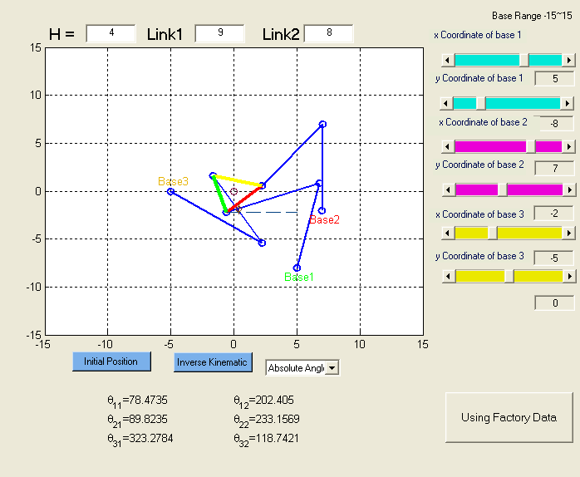

- Ok. Now do some final regulations for the robot. Actually, you can come back to the initialized status at any time.

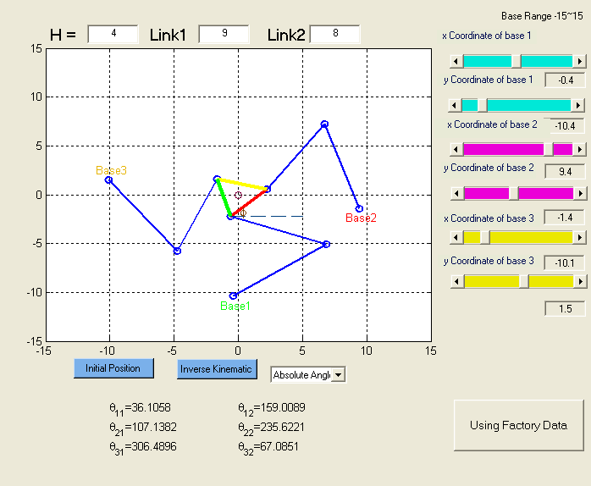

- After all set the things we need, we now could click the “Inverse Kinematic” button for inverse kinematics. It will give you a figure below.
Notice that the leg1 which based on the Base1 (green).

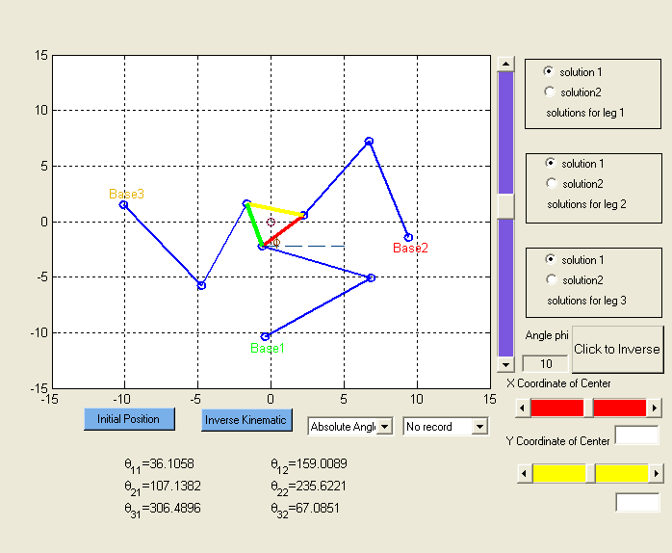

- As we known, there are two configurations of each leg for every position of end effecter. So we can have solution 1 or solution 2 for each leg. That is to say we have 8 different solutions for every EE (end effecter) configuration.

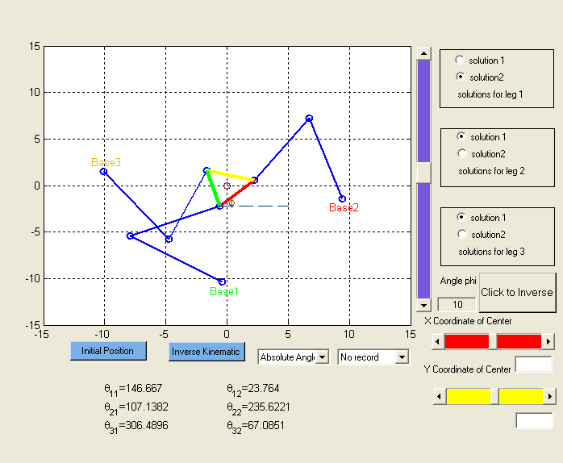

- Then you may find some beautiful blue slider on the right side of the display part. That’s the Φ which corresponding the angle between the red line and the horizontal line. Also two way are available to set the value of Φ.
One is slider and another is blank.
Now let us set it to 0 degree as follow.
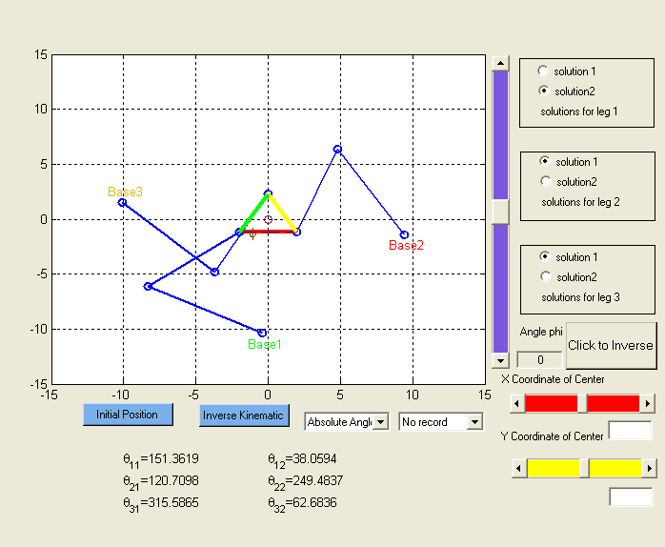

- Now it is the show time!!!
Click the “Click to Inverse” button. The string will change to “Point” that mean you can give the point of the EE.

How to give the point!?

That’s a good question.

One way is to use the sliders and blanks.

Another way is just to click the work space directly.

Then the robot will finish the reconfiguration automatically.

Have fun!!

Notice: Before the program finish the calculation; don’t do any click on the work space.

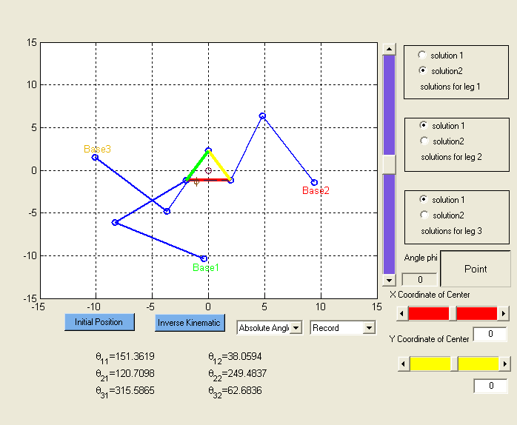

14. For example, if you know exactly the coordinate (5,5), then you just have to fill the blanks with 5 and 5. Then it will display the following figure.
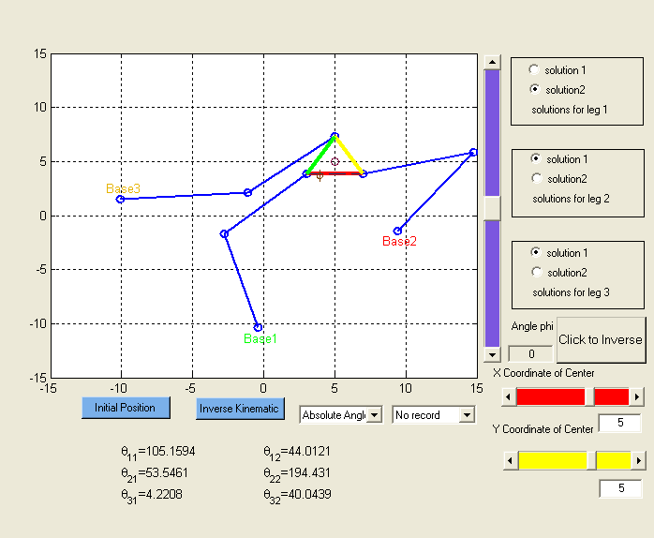

- Or use the “Point”; That is to say click one point in the work space then it will do the reconfiguration automatically.

If you are using the E-version of the manual, you can see the movie below.

- Of course, those two methods will give you the same result as you see below.

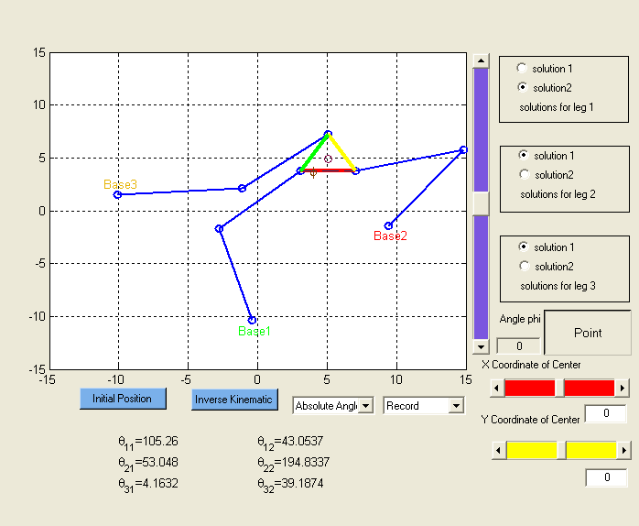

17. Another method to do the Inverse kinematics is to use “Path” function. You should click the “Point” again until it displays the “Path”. Then push the left button of your mouse; do NOT release it until you finish the whole path drawing; The EE will then follow the path you defined and do the reconfiguration automatically.

Notice: Do not do anything until the program done the whole calculation.

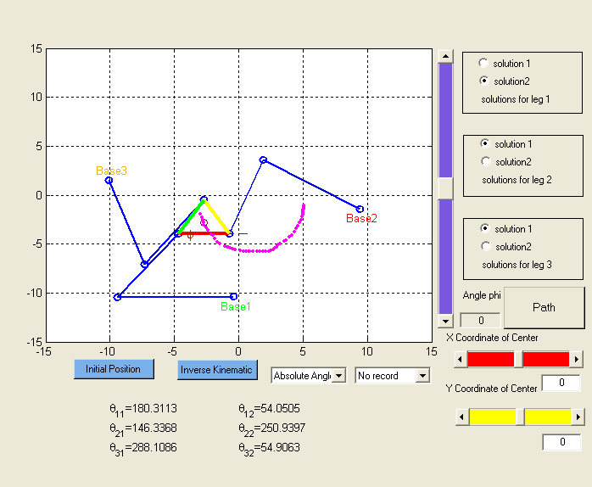

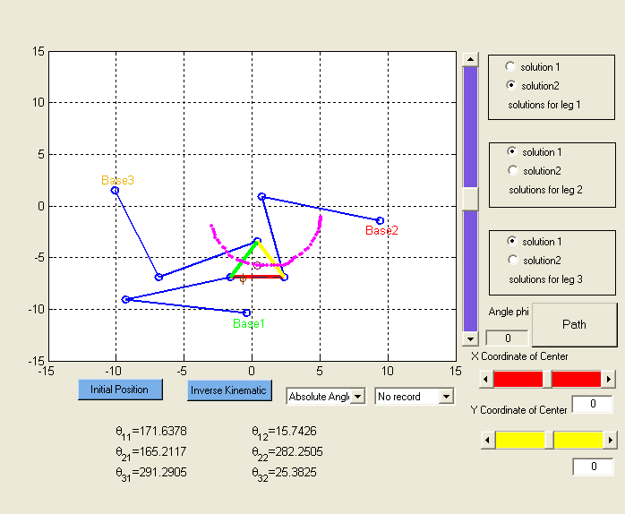

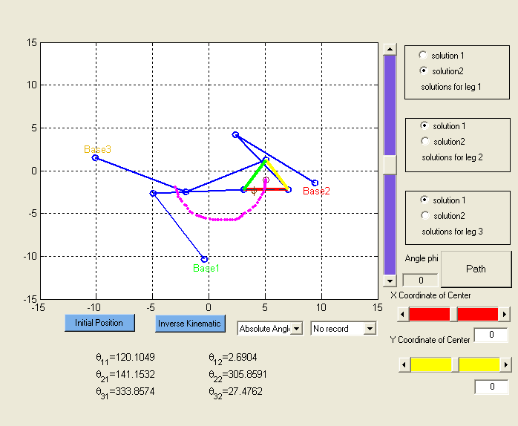

- If you are using the E-manual version, you can see the following movie to demonstrate the “Path” function.

If you want to generate a movie for the “path” or “point” track function, just change the “No record” to “Record” then draw the path or click the position which you want the robot to be.

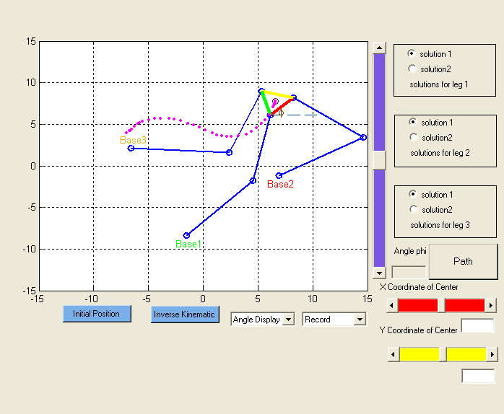

- One of the important aspects is what will happen if robot faces the singularity.
It will display the warning “You faced a singularity. Please change the variables to solve it”.
If it is in the “Path” function, it will stop at the singularity point which faced and continue to do the reconfiguration at the first point which do not have the singularity.

If you are using the E-manual version, you can see the following movie to demonstrate the “singularity” solution.

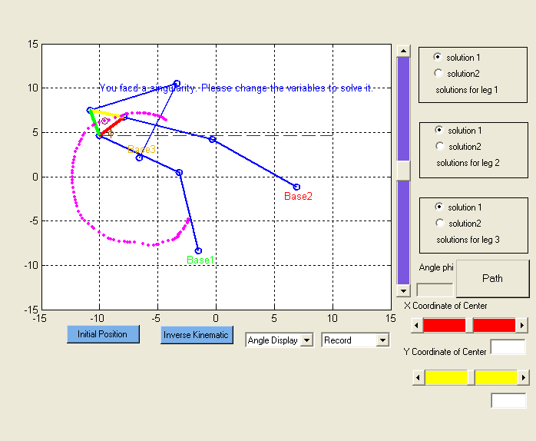

- Here is some demo about the “Path” function.
If you are using the E-manual version, you can see the following movie to demonstrate the “Path” function.

Have fun!

