User manual for
SAM
Spectral Derivatives
Programmed in Matlab

Programing : Sigal Saar
Algorithm : Sigal Saar and Parta Mitra

Version 1

Loading sound data: Sound data are defined as a file of digital sound or a vector of sound located in the Matlab environment.
To load a sound vector, call the function:
sam(sound_vector , sampling frequency).
To load a sound file, call the function sam() , then click the “Open” button and chose the file.

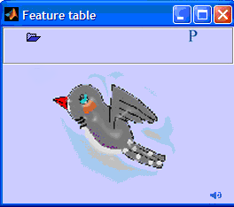

The Matlab command window is accessible during the operation of the programs. The user can run the spectral derivatives function in addition to continues work in the command window.

Once the data has been opened, two windows appear, the left window represents the spectral derivatives of the song, and the right window presents the features of a chosen segment.

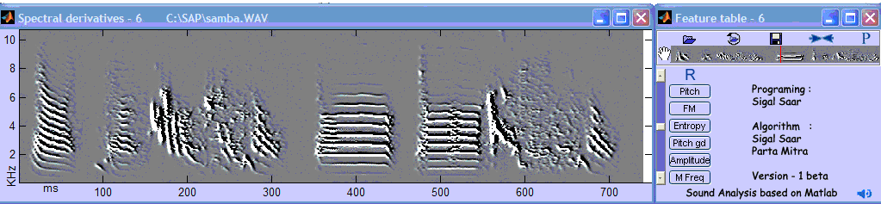

Alignment: In the initial position of the right and left windows, they are adjacent to one another. The user can change that by dragging the windows to a new position. Pushing the “Align” button , located in the right window, aligns them together again. Once a new sound file is opened, it’s spectral derivatives are aligned one on top of the other. Up to 3 spectral derivatives figures are presented at once without overlaps.

Choosing a sound segment: A segment is defined, and marked, by a clicking the segment boundaries on the spectral derivatives image. A third click clears the bounding lines. Once the segment has been defined, its mean features are presented in the right panel. Since variance can be larger than can be presented in the text box, hovering over the desired text box will present the complete result.

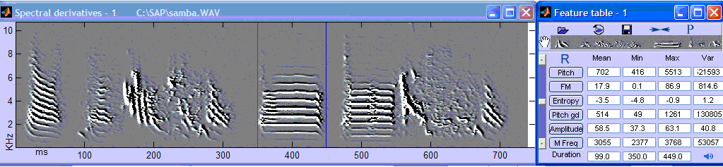
Plotting the features: A continues normalized representation of the features can be plotted on top of the spectral derivatives image by clicking on the feature name, located at the right window. The feature button and the feature plot will be colored in similar colors, a second click on the feature button delete the specific feature plot and button color. The “Clear” button clears the all features plots and buttons.

Amplitude is normalized according to the maximum and minimum amplitude in the song
FM is normalized such that the highest possible FM in the plot is 90 degrees and the lowest is 0
Entropy is normalized such that the highest possible FM in the plot is 0 and the lowest is -10
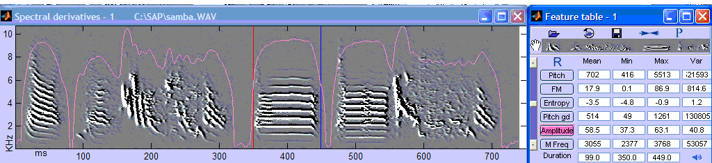

Rhythm : the Rhythm button , located in the right window, enables the user to look at the rhythms of the song. Pressing on the rhythm button starts a input dialog, the user is asked to chose the features that rhythms would be calculated on. The default is all the rhythms. The spectral estimates of rhythms are being done for each feature individually, and than summed together.

Panning : The presented image might present only a portion of the song. A “Pan” button is located in the right window. The first press on the “Pan” button enables panning the x axis of the image. A second press on the “Pan” button terminates the ability to pan, and enables defining a segment. While in panning mode, double click on the spectral derivatives initiate panning using the mouse, while the next double click stops it.
Fast Panning: A click on the image on the right window center the spectral derivatives on the location of the mouse click.

Storing: The features of a defined segment can be saved in a structure by clicking on the “store” button which is located in the left window. The first click on the “Store” button initiates a graphical user interface to choose the directory of the saved mat file of the stored structure. After choosing the directory, another graphical user interface is presented that enables choosing a name for the saved file and adding a descriptive comment. This step finalizes the storing. The second time the “Store” button is pressed only the second graphical user interface is presented. Changing the saving path and file name can be done by changing the file path or file name located in the upper text box. The structure can be uploaded using the Matlab command window.

The stored variables are the features, the duration, time boundaries of chosen interval, the image of the spectral derivatives within that interval and its axes.

Playing a song/part of a song. Pressing the “Play” button causes the song to be played, or if a segment of the song has been chosen, that segment will be played.

The Parameters button , located in the right window, enables the user to change the parameters that are used to calculate the spectral derivatives and features. After pressing the “Parameters” button a graphic user interface appears. The GUI presents the current parameters, and enables changing or initializing them (lower row). The following GUI enables the user to determine the location of the parameters mat file. The parameters should to be saved at the directory where the spectral derivatives function is located, or at a directory, which is part of the Matlab path, that has a higher priority.

Plotting/hiding the axes: The parameters button enables changing the default values of the axes button (plotted or hidden axes). The x axies units is in milliseconds while the y axis units is KHz.

Opening an additional sound file: Multiple sessions of the spectral derivatives function can be opened at the same time. The session can be called either from the command prompt or from the graphic user interface. The right and left windows share similar figure index. If the sound data was opened directly from a file using the graphic user interface, the file name and path will be indicated in the title of the left window. After a song has been chosen the user can open a file in a new figure or in the same figure .

Threshold on the amplitude of the signal can expedite calculations. You can change the parameter of the threshold by clicking on the parameter button. Than change the bottom row 'Detection of silence low amplitude threshold?'.

Reading saved data:
The data that the user saves is saved in a structure called add_record.
To access the data type add_record(entry number).feature
Viewing the structure field can be done by typing add_record
To plot the image of the segment use plot_segment(entry number)

The comment field can be used to automate searching through entries.

tmp_entry=add_record(find(length(add_record.comment)==13));
Chosen_entry= tmp_entry (find(min(add_record.comment==’First Sylable’)));

