**AR-11, Change of Address**

[**http://www.uscis.gov/ar-11**](http://www.uscis.gov/ar-11)

All non-U.S. citizens (aliens) who are **required to be registered are also required to keep the USCIS informed of their current address**. This is particularly important when you have filed an application or petition for a benefit under the Immigration and Nationality Act and expect notification of a decision on that application.

If you came reported a local address at your visa interview that is DIFFERENT from your current/upcoming local address, you need to change your address with USCIS.

**How Do I Report My Change of Address?**

* **Online**:<https://egov.uscis.gov/coa/displayCOAForm.do>

OR

* **Download and Mail to USCIS:** <http://www.uscis.gov/sites/default/files/files/form/ar-11.pdf>

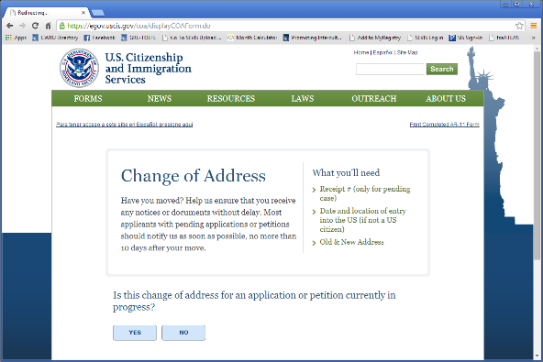 **Step 1:** Is this a change of address for an application or petition currently in progress

**Answer**: NO

**Step 2**: Fill out address, entry, school information, etc.

**Old address - use CWRU’s address:**

10900 Euclid Avenue, Cleveland, OH 44106

**Step 3:** In the future, be sure to update your address in the CWRU Student Information System (SIS)

**Penalties for Failure to Comply**

A willful failure to give written notice to the USCIS of a change of address within 10 days of moving to the new address is a misdemeanor crime. If convicted, you (or parent or legal guardian of an alien under age 14 who is required to give notice) can be fined up to $200 or imprisoned up to 30 days, or both. The alien may also be subject to removal from the United States. (INA § 266(b)). Compliance with the requirement to notify the USCIS of any address changes is also a condition of your stay in the United States. Failure to comply could also jeopardize your ability to obtain a future visa or other immigration benefit.