[Insert Cover Letter here]

Relating lesion time, size, and distribution to motor deficits in a model of brain network development
Sree Varier¹, MSc; Rob Forsyth² MD(?); Marcus Kaiser^{1,2,3}, PhD
1 School of Computing Science, Newcastle University, United Kingdom
2 Institute of Neuroscience, Newcastle University, United Kingdom
3 Department of Brain and Cognitive Sciences, Seoul National University, Korea
Dr Marcus Kaiser
School of Computing Science
Newcastle University
Claremont Tower,
Newcastle upon Tyne, NE1 7RU,
United Kingdom
m.kaiser@ncl.ac.uk

Acknowledgements
M.K. was supported by WCU program through the National Research Foundation of Korea funded by the Ministry of Education, Science and Technology (R32-10142), the Royal Society (RG/2006/R2) and the CARMEN e-science project (www.carmen.org.uk) funded by EPSRC (EP/E002331/1). M.K. and S.V. were supported by EPSRC (EP/G03950X/1).

Conflict of Interest
No conflict of interest.

[Insert Title of Article]
[Insert Running Cover Title <50 characters]
Number of Tables [Insert itemized list of number of tables]

Number and Types of Figures [Insert itemized list of number and types of figures]
Key Words: [Insert MeSH Keywords 3-5]
Manuscript word count: [Insert word count for entire manuscript]

[Insert Abstract here, <250 words]
Background and Purpose
[Insert Abstract Background and Purpose here]
Methods
[Insert Abstract Methods here]
Results
[Insert Abstract Results here]
Conclusions
[Insert Abstract Conclusions here]

Materials and Methods
A computational model of the sensory-motor cortex developed in the past was implemented here, for evaluating the effect of lesion during development. The model represents an arm moving in three-dimensional space. The arm itself is composed of an upper arm and a lower arm, with two pairs of muscles moving the upper arm and a third pair controlling the lower arm ¹.

The computational model
The computational model consists of a four-layered, closed loop neural network (Figure 1). There are two cortical layers, denoted MI and PI, representing the primary motor cortex and the proprioceptive cortex respectively. The cortical layers are hexagonally connected to six neighbours in the same layer within a radius of 1. Additionally, each element in PI influences its corresponding element in MI and other elements within a radius of 4. The motor layer holds the activations of each of the six muscles and the proprioceptive input layer stores the corresponding length and tension of the muscles, representing the position of the arm ¹. Activation flows sequentially through all the layers forming a closed, self-organizing loop. The change in activation in each layer is computed using the following equation (details in Reference¹):
where;
a_{k}(t) – activation of element k at time t
in_{k}(t) – activation received from other elements
ext_{k}(t) – external input received by element k
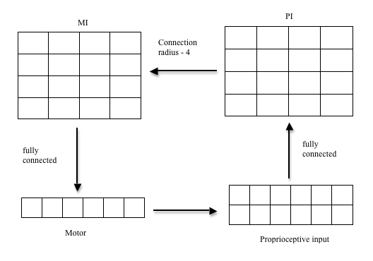
Figure 1. Four-layered computational model.

The model is initialized with random inter-cortical weights (between 0.1 and 1) and activation is set to zero in all the layers. The stimulus is provided in the form of an input patch (0.9 unit strength) to the MI layer, representing activation received from other areas of the brain. The activation in each layer is allowed to stabilize over 120 iterations and then learning is applied to the inter-cortical weights by adjusting weights using a Hebbian like rule. The intra-cortical weights remain constant throughout learning.

This motor model emulates the self-organization observed in the cortex during development, with appearance of topographic maps over time and Mexican-hat patterns of activity. The model therefore provides an ideal tool for exploring the effects of age-related lesions in the motor cortex and the subsequent recovery. Here we have tested the model for a range of lesion sizes introduced during the course of development. The model was tested for focal as well as diffuse lesions.

Focal lesions
We chose sizes ranging from 1% to 16% of the total size of the primary motor cortex layer implemented as a rectangular patch. Each of these lesions was introduced at various time stages from 10% to 80% of the total time required for learning (800 cycles) in the corresponding intact model. One lesion parameter set comprises all possible combinations of sizes and stages, totaling to twenty-five. Computationally, a lesion is introduced by setting the activation in the affected cells to zero and severing all associated incoming and outgoing weights. We wanted to examine the recovery potential exhibited by the various stages of development, hence following lesion, the training of the network was continued as before, for the same number of cycles as the intact model. An intact model was run as a control for each lesion parameter set. This permits comparisons for each of the stage and size combinations, without influences of random initializations. The lesion parameter set was tested against various initializations of the intact model and also for various positions of lesions, with similar results.

Diffuse lesions
In addition to focal lesions, we also tested the model for effects of diffuse lesions, which are commonly observed in traumatic head injuries. To enable comparisons between focal and diffuse lesions, the total size of lesion was kept the same. Cortical elements were removed at random to simulate multi-focal lesion in the primary motor cortex. The same lesion parameter set as for the focal lesion was used.

Results
In this study we examined the effects of focal lesions of various sizes introduced during different time points in development at several spatial positions within the primary motor cortex (MI). In addition, the impact of focal lesions was compared against that of diffuse or multi-focal lesions of identical sizes.
Intact model
We began with an implementation of the intact model as described ¹. The model involves randomizations at the beginning of the learning cycles and in order to enable comparison of results, an intact model with its associated parameters was used as control for every set of focal and diffuse lesion simulations. Based on the time-course of muscle activation (Figure 2) it was observed that 800 cycles of learning was sufficient for achieving self-organization. The muscle activation followed a logistic (sigmoid) learning curve and converged to the maximum value around this time. The organization happening during development is apparent from the maps before and after the learning phase (see example for the extensor in Figure 3). Similar map reorganization is observed for all the muscles. Lateral competition produces a Mexican hat pattern of activity in the cortex as in biological systems (Figure 4). This involves the formation of a central region of high excitation followed by a surrounding region of low excitation. Figure 4 shows the one dimensional Mexican hat pattern observed at the end of training. The two elements in the centre have high activation while the adjacent elements have a near zero activation. Similar effects are visible along the other dimension of the motor cortex layer.
Figure 2. Time-course of muscle activation. Change in the activation of Extensor muscle as training proceeds. Other muscles also exhibit a similar growth curve.
Figure 3 (A-B). MI Extensor maps before, time-step zero (A) and after, time-step 800 (B) training (threshold 0.15). The elements in the MI layer that influence the Extensor muscle, as determined by above threshold values of corresponding weights.

Figure 4. Mexican hat pattern of cortical activation after training. Central region constituted of elements 19 and 20 along row ten of primary motor cortex (MI) which have a high activation with near zero activation in adjacent neighbours 1 and 18.

We simulated rectangular shaped lesions of sizes ranging from 1 to 16 percent of the total number of neurons in the motor cortex. For this particular model, this corresponds to inactivating 4 to 64 elements. Lesions were introduced at 10, 20, 40, 60 and 80 percent of the total development time (800 cycles) required for learning. For estimating recovery and judging performance, activation of the muscles at each time-step of learning after lesion was compared to the corresponding intact value. The mean of the percentage difference from intact activation was used as a measure of comparing the deviations from the intact. A value closer to zero was considered to be a better sign of recovery. Tests for all five lesion sizes and five time stages, resulting in 25 lesion configurations, were repeated for five different instantiations of the intact model, so that results would be free from influences of random initializations. In addition the focal lesions were simulated in five different spatial positions within the motor cortex (MI).

Focal lesions
Our analysis reveals that spatial positions of focal lesions or random initializations do not contribute qualitatively to the results. The two primary parameters influencing the recovery are the size of lesion and its time of onset (Figure 4). Predictably, the size of lesion is negatively correlated to recovery (Figure 4B). In terms of the time of onset, lesions introduced during later stages in development show greater recovery than those introduced at early stages (Figure 4A). Hence effects of lesions are countered better by more mature systems than those in nascent stages.
Figure 4 (A-D). Mean percentage deviation from intact plotted against age and size, for Focal and Diffuse lesions. Mean of percentage deviation from intact at each time-step after lesion, plotted against age of focal (A) and diffuse lesion (C). Variation in percentage deviation with size of focal (B) and diffuse (D) lesion.
Diffuse lesions
Diffuse lesions were simulated by randomly selecting neuron elements in the motor cortex and clamping their activation at zero. In addition the weights from and to the elements were also severed. To enable comparisons with focal lesions, the total number of affected elements was kept the same as in a focal lesion. Diffuse lesions are influenced by time and size of lesion in the same manner as focal lesions (Figure 4 C and D), however larger sized diffuse lesions introduced in the early stages result in greater deficit than equivalent focal lesions.

The activation present in the muscles was plotted at each time step to observe changes at the local level (Figure 5). A visual comparison shows increased fluctuations in muscle activations, which are not seen in the intact model (Figure 5C). In the case of early lesions, the entropy introduced into the system becomes more obvious only at the later stages of development, producing deep fluctuations in the activation. [[Interesting! Maybe Rob has some ideas whether this can be observed in young patients in that the deficit after early lesions occurs later on!!!]] A similar pattern is observed with diffuse lesions.
Figure 5 (A-C): Stage specific time-course of muscle activation for lesion of size 16%.
Stage at which lesion is introduced is identified in the title and represented by the dashed line in the plots.

Although the introduction of a lesion is not reflected as a discernible plunge in the activation curve, there is a visible dip when the difference in activation from intact is plotted at each time step (Figure 6). Figure 6 (A-B) depict fluctuations with respect to intact, in extensor activations in focal and diffuse lesions for a size of 16%, introduced after 60% of growth has occurred. This comparison also identifies a difference in the effect of focal and diffuse lesion of identical size. It can be seen that diffuse lesions (black curve), particularly at the early stages of development, are more potent than focal lesions (blue curve). They lead to a more significant variation from intact in the time period following the lesion, possibly owing to the relatively higher number of connections affected. In later lesions, effects of focal and diffuse lesions are less variable. Similar results are observed for all sizes of lesions.

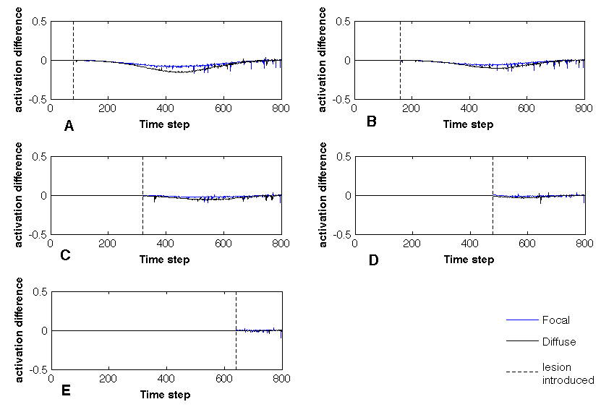

Figure 6 (A-E). Deviation of Extensor activation from intact plotted against time-course of development for focal (blue) and diffuse (black) lesions. A lesion of size 16% introduced after 80 (A), 160 (B), 320 (C), 480 (D) and 640 (F) time steps. The dashed line represents introduction of lesion. [[Interesting! So diffuse lesions have a more severe effect than focal lesions if they are applied early on. Again, there is a time delay between the lesion and the performance effect. Rob: any clinical data on such differences in patients? One problem with reviewers could be whether there is still a dip for subplot E. Given the decreasing dip size and the resolution of the plot it is difficult to tell whether there is one. A possible solution would be to have an inset plot for part E where you zoom into the shown curve to show a higher resolution figure (maybe also for subplot D. In addition, you could just change the Y-axis to scale to +- 0.2 instead of 0.5 (maybe the other changes are not necessary then). ]]

Discussion
[Insert Discussions here]
[[Let’s see what Rob can say about the clinical predictions…]]

References
1. Chen. Y, Regiia. JA. Alignment of coexisting cortical maps in a motor control model. Neural Computation. 1996;8:731-755

Tables
[Insert Tables here]

Figure Legends
[Insert Figure Legends here]

Figures
[Insert Figures here]

