[1]*Abstract* –The actuators are widely used in our daily lives. In this article, a model was built using MATLAB and FEMM in order to analyse the characterization of an actuator and different analyzing methods. The principle of a short-stroke ferromagnetic actuator is discussed and 4 different modelling approaches used to model the actuator are compared in this technical note. We find the FE with non-linear materials produces the most accurate results.

B. Zhang(1975667), W. Du

Electromagnetic Characterisation of a Short-Stroke Ferromagnetic Actuator Technical Note

# Introduction

This technical note calculates the winding resistance and winding inductance of a Short-Stroke Ferromagnetic Actuator depicted in Fig. 1, the force imparted on the Armature and four different modelling approaches used i.e. analytical equivalent circuit without considering air-gap fringing, analytical equivalent circuit with air-gap fringing, FEMM with linear materials and FEMM with non-linear materials.[1]. The modelling method we are discussing in this technical note is Finite Element Method Magnetic (FEMM), which plays a critical role in electromagnetic discipline. MATLAB and FEMM are used for more precise and faster calculations.

# Winding resistance

## The Winding resistance calculated by FEMM

FEMM and MATLAB can be used readily calculate the winding resistance. This can be achieved by using the **mo_getcircuitproperties()** command to calculate the coil current and coil voltage ***.*** Then use (1) to calculate the winding resistance from the simulation.

（1）

According to the data we collected from FEMM model,

Another approach could be used to calculate the winding resistance. (2) could be used to find the active length into the paper.

(2)

Due to the fact that only part of the coil are modeled in FEMM model, the real winding resistance through our CAD model need to be found which is shown in Fig. 1 [1] and the model used in FEMM is shown in Fig. 2. It can be readily seen that in our FEMM model, the model itself is a 2D model. Thus, the more than a half of the coil is not considered when the result from FEMM is used to calculate the winding resistance. In the light of this, we need to use CAD model to calculate the actual winding resistance.

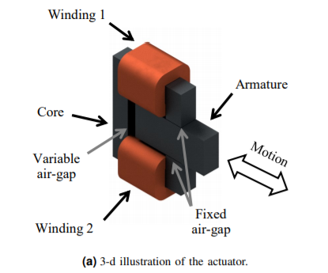

Fig. 1. The CAD model of the actuator used for calculating the winding resistance.

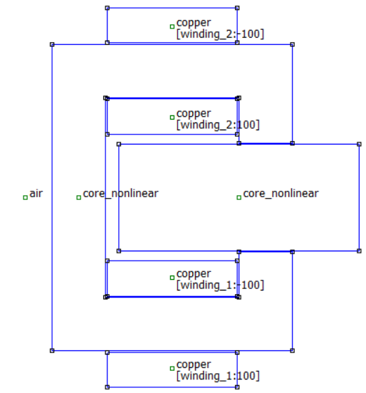

Fig. 1. The FEMM model of the actuator used for calculating the winding resistance.

# winding inductance

Please use automatic hyphenation and check your spelling. Additionally, be sure your sentences are complete and that there is continuity within your paragraphs. Check the numbering of your graphics (figures and tables) and make sure that all appropriate references are included.

## Template

This document may be used as a template for preparing your technical work. When you open the file, select "Page Layout" from the "View" menu (View | Page Layout), which allows you to see the footnotes. You may then type over sections of the document, cut and paste into it (Edit | Paste Special | Unformatted Text), and/or use markup styles. The pull-down style menu is at the left of the Formatting Toolbar at the top of your Word window (for example, the style at this point in the document is "Text"). Highlight a section that you want to designate with a certain style, then select the appropriate name on the style menu.

## Format

If you choose not to use this document as a template, prepare your technical work in single-spaced, double-column format, on paper A4 (21x29.7 centimeters). Set top and bottom margins to 17 millimeters and left and right margins to about 17 millimeters. Do not violate margins (i.e., text, tables, figures, and equations may not extend into the margins). The column width is 85 millimeters. The space between the two columns is 5 millimeters. Paragraph indentation is 6 millimeters. Use full justification. Use either one or two spaces between sections, and between text and tables or figures, to adjust the column length.

## Typefaces and Sizes

Please use a proportional serif typeface such as Times Roman or Times New Roman and embed all fonts. (See your software’s “Help” section if you do not know how to embed fonts.) Table I provides samples of the appropriate type sizes and styles to use.

TABLE I

Samples of Times Roman Type Sizes and Styles Used for Formatting a ICEM Technical Work

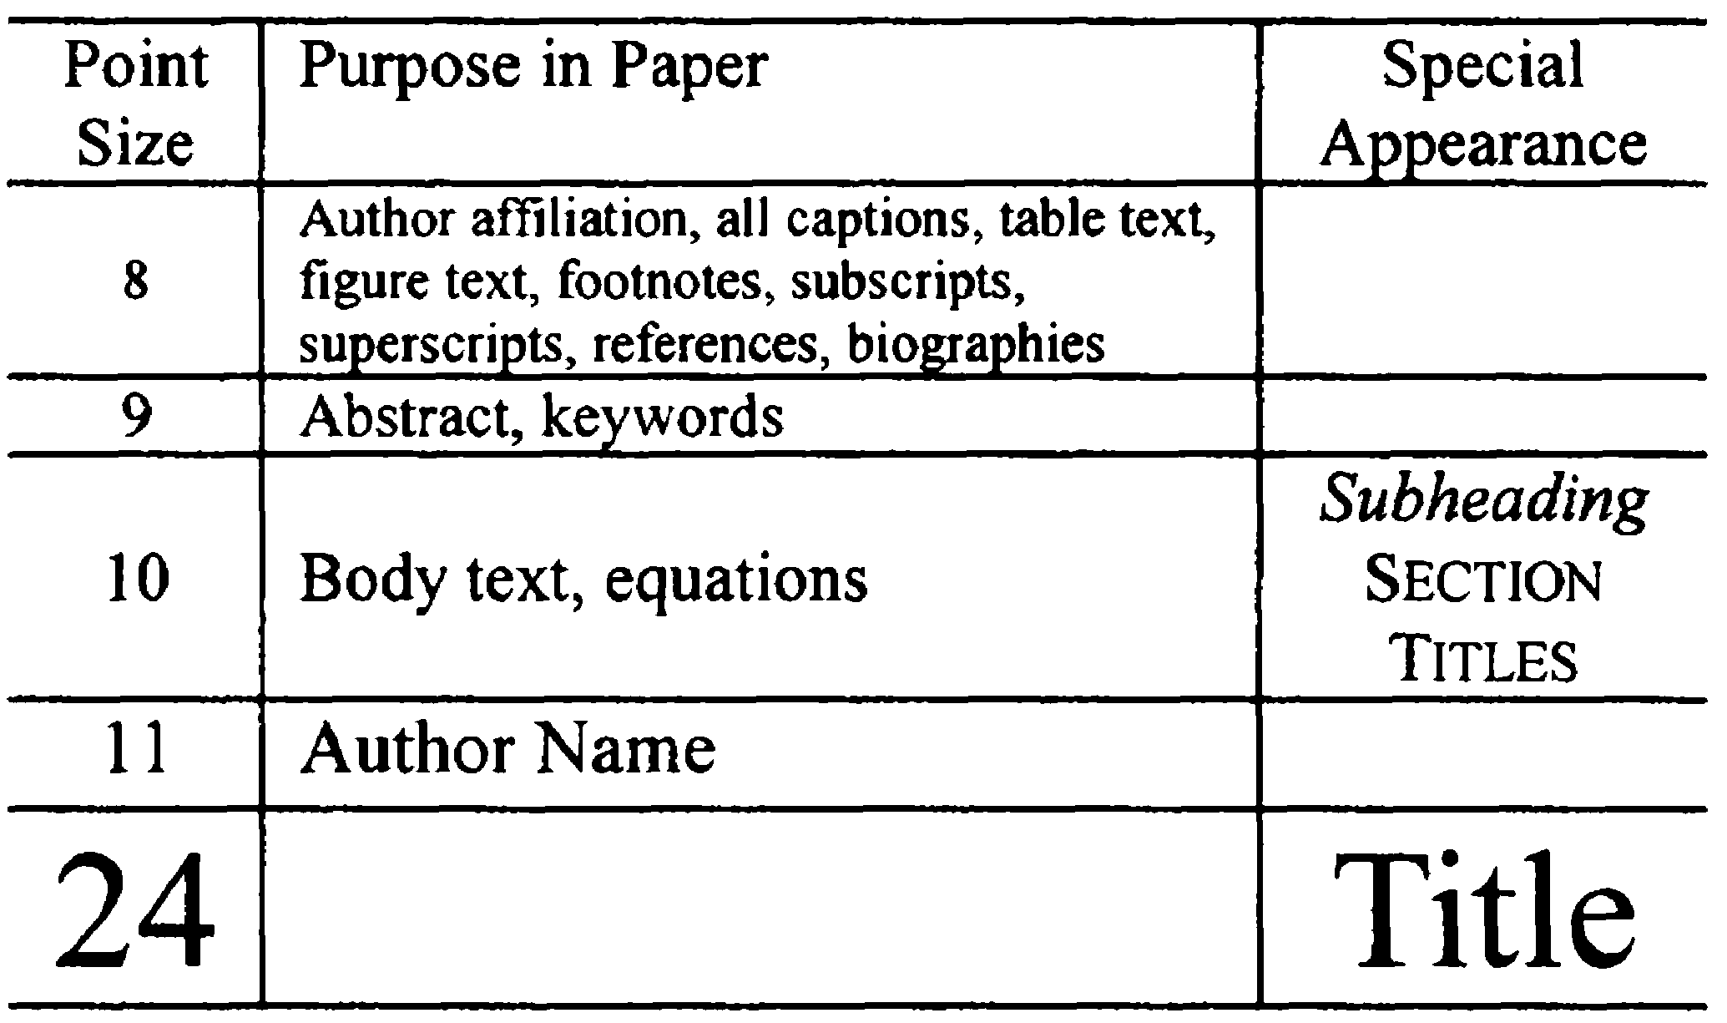

## Section Headings

A primary section heading is enumerated by a Roman numeral followed by a period and is centered above the text. A primary heading should be in capital letters.

A secondary section heading is enumerated by a capital letter followed by a period and is flush left above the section. The first letter of each important word is capitalized and the heading is italicized.

A tertiary section heading is enumerated by an Arabic numeral followed by a parenthesis. It is indented and is followed by a colon. The first letter of each important word is capitalized and the heading is italicized.

A quaternary section heading is rarely necessary, but is perfectly acceptable if required. It is enumerated by a lowercase letter followed by a parenthesis. It is indented and is followed by a colon. Only the first letter of the heading is capitalized and the heading is italicized.

## Figures and Tables

Figure axis labels are often a source of confusion. Try to use words rather than symbols. As an example, write the quantity "Magnetization," or "Magnetization, *M*," not just "*M*." Put units in parentheses. Do not label axes only with units. As in Fig. 1, write "Magnetization (kA/m)" or "Magnetization (kA·m-1)," not just "kA/m." Do not label axes with a ratio of quantities and units. For example, write "Temperature (K)," not "Temperature/K." Figure labels should be legible, approximately 8- to 10-point type.

Large figures and tables may span both columns, but may not extend into the page margins. Figure captions should be below the figures; table captions should be above the tables. Do not put captions in "text boxes" linked to the figures. Do not put borders around your figures.

All figures and tables must be in place in the text near, but not before, where they are first mentioned. Use the abbreviation "Fig. 1," even at the beginning of a sentence.

Digitize your tables and figures. To insert images in Word, use Insert | Picture | From File.

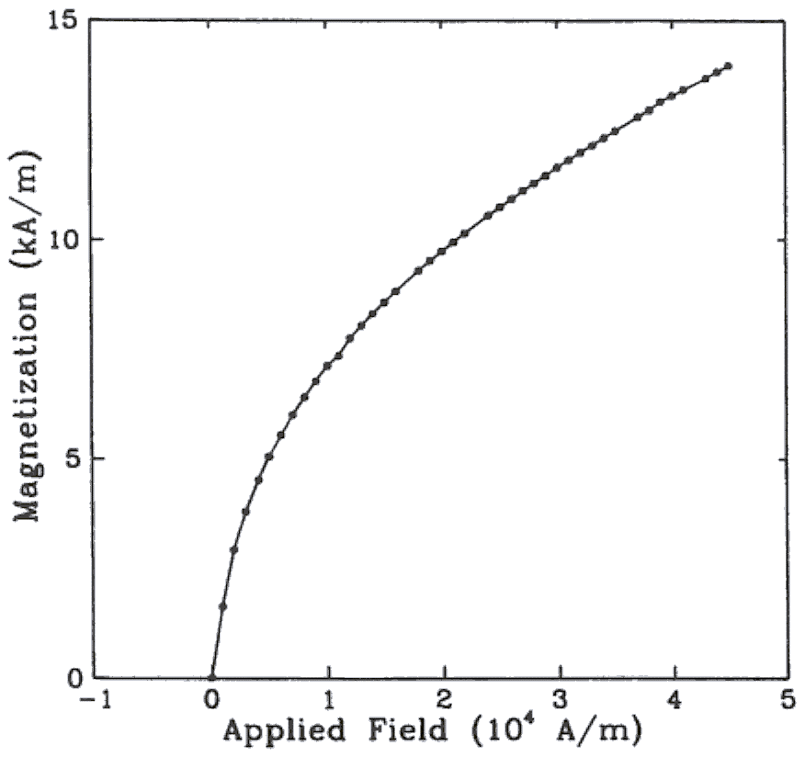

Fig. 1. Magnetization as a function of applied field. (Note that "Fig." is abbreviated and there is a period after the figure number followed by two spaces.)

## Numbering

Number reference citations consecutively in square brackets [1]. The sentence punctuation follows the brackets [2]. Multiple references [2], [3] are each numbered with separate brackets [1]-[3]. Refer simply to the reference number, as in [3]. Do not use "Ref. [3]" or "reference [3]" except at the beginning of a sentence: "Reference [3] shows….".

Number footnotes separately with superscripts (Insert | Footnote). Place the actual footnote at the bottom of the column in which it is cited. Do not put footnotes in the reference list. Use letters for table footnotes.

Check that all figures and tables are numbered correctly. Use Arabic numerals for figures and Roman numerals for tables.

Appendix figures and tables should be numbered consecutively with the figures and tables appearing in the rest of the paper. They should not have their own numbering system.

## Units

Metric units are preferred in light of their global readership and the inherent convenience of these units in many fields. In particular, the use of the International System of Units (“Système International d'Unités” or SI Units) is advocated. This system includes a subsystem of units based on the meter, kilogram, second, and ampere (MKSA). British units may be used as secondary units (in parentheses). An exception is when British units are used as identifiers in trade, such as 3.5-inch disk drive.

## Abbreviations and Acronyms

Define less common abbreviations and acronyms the first time they are used in the text (starting in the introduction and not before). Abbreviations such as IEEE, SI, MKS, CGS, AC, DC, and *rms* do not have to be defined. Do not use abbreviations in the title.

## Math and Equations

Use either the Microsoft Equation Editor or the *MathType* commercial add-on for MS Word for all math objects in your paper (Insert | Object | Create New | Microsoft Equation *or* MathType Equation). "Float over text" should *not* be selected.

To make your equations more compact, you may use the solidus ( / ), the exp function, or appropriate exponents. Italicize Roman symbols for quantities and variables, but not Greek symbols. Use a long dash rather than a hyphen for a minus sign. Use parentheses to avoid ambiguities in denominators.

Number equations consecutively with equation numbers in parentheses flush with the right margin, as in (1). Be sure that the symbols in your equation have been defined before the equation appears or immediately following.

where *IF* is the fault current.

Use "(1)," not "Eq. (1)" or "equation (1)," except at the beginning of a sentence: "Equation (1) is .…".

# Appendix

Appendixes, if needed, appear before the acknowledgment.

# Acknowledgment

The following is an example of an acknowledgment. Please note that financial support should be acknowledged in the unnumbered footnote on the title page.

The authors gratefully acknowledge the contributions of I.X. Austan, A.H. Burgmeyer, C.J. Essel, and S.H. Gold for their work on the original version of this document.

# References

References are important to the reader. Therefore, each citation must be complete and correct. There is no editorial check on references. An incomplete or wrong reference will be published unless caught by a reviewer and will detract from the authority and value of the paper. References should be readily available publications.

List only one reference per reference number. If a reference is available from two sources, each should be listed as a separate reference. Give all authors' names; do not use *et al.*

Samples of the correct formats for various types of references are given below (please do give only what is available at the international level with database or web accesses). References in languages other than English are strongly discouraged.

1. N. Simpson, “Electromagnetic characterization of a short-stroke ferromagnetic actuator: Part a,” 2019.
2. E. H. Miller, "A note on reflector arrays," *IEEE Trans. Antennas Propagat.*, to be published.
3. R. J. Vidmar. (1992, Aug.). On the use of atmospheric plasmas as electromagnetic reflectors. *IEEE Trans. Plasma Sci.* [Online]. *21(3)*, pp. 876-880.

Available: http://www.halcyon.com/pub/journals/21ps03-vidmar

1. E. Clarke, *Circuit Analysis of AC Power Systems*, vol. I. New York: Wiley, 1950, p. 81.
2. G. O. Young, "Synthetic structure of industrial plastics," in *Plastics*, 2nd ed., vol. 3, J. Peters, Ed. New York: McGraw-Hill, 1964, pp. 15-64.
3. J. Jones. (1991, May 10). *Networks*. (2nd ed.) [Online]. Available: http://www.atm.com
4. E. E. Reber, R. L. Mitchell, and C. J. Carter, "Oxygen absorption in the Earth's atmosphere," Aerospace Corp., Los Angeles, CA, Tech. Rep. TR-0200 (4230-46)-3, Nov. 1968.
5. S. L. Talleen. (1996, Apr.). The Intranet Architecture: Managing information in the new paradigm. Amdahl Corp., Sunnyvale, CA. [Online]. Available: http://www.amdahl.com/doc/products/bsg/intra/ infra/html
6. D. Ebehard and E. Voges, "Digital single sideband detection for interferometric sensors," presented at the 2nd Int. Conf. Optical Fiber Sensors, Stuttgart, Germany, 1984.
7. Process Corp., Framingham, MA. Intranets: Internet technologies deployed behind the firewall for corporate productivity. Presented at INET96 Annual Meeting. [Online].

Available: http://home.process.com/ Intranets/wp2.htp

1. J. L. Alqueres and J. C. Praca, "The Brazilian power system and the challenge of the Amazon transmission," in *Proc. 1991 IEEE Power Engineering Society Transmission and Distribution Conf.*, pp. 315-320.
2. S. Hwang, "Frequency domain system identification of helicopter rotor dynamics incorporating models with time periodic coefficients," Ph.D. dissertation, Dept. Aerosp. Eng., Univ. Maryland, College Park, 1997.
3. *IEEE Guide for Application of Power Apparatus Bushings*, IEEE Standard C57.19.100-1995, Aug. 1995.
4. G. Brandli and M. Dick, "Alternating current fed power supply," U.S. Patent 4 084 217, Nov. 4, 1978.

# Biographies

A technical biography for each author must be included. It should begin with the author’s name (as it appears in the byline). Please do try to finish the two last columns on the last page at the same height. The following is an example of the text of a technical biography:

**Nikola Tesla** was born in Smiljan in the Austro-Hungarian Empire, on July 9, 1856. He graduated from the Austrian Polytechnic School, Graz, and studied at the University of Prague.

His employment experience included the American Telephone Company, Budapest, the Edison Machine Works, Westinghouse Electric Company, and Nikola Tesla Laboratories. His special fields of interest included high frequency.

Tesla received honorary degrees from institutions of higher learning including Columbia University, Yale University, University of Belgrade, and the University of Zagreb. He received the Elliott Cresson Medal of the Franklin Institute and the Edison Medal of the IEEE. In 1956, the term "Tesla" (T) was adopted as the unit of magnetic flux density in the MKSA system. In 1975, the Power Engineering Society established the Nikola Tesla Award in his honor. Tesla died on January 7, 1943.

1.