Cross-cohort definition and multi-omic characterization of a six-gene vasculogenic-mimicry-associated epithelial programme in intrahepatic cholangiocarcinoma

Authors: Bowen Zheng, Guanghua Xie, Depei Kong, Jianlei Chen, Ye Wang, Hao Li*

Affiliation: Division of Hepatobiliary Pancreatic Surgery, The Affiliated Hospital of Yanbian University, Yanji 133000, China

Author emails and ORCID iDs: Bowen Zheng (13803722355@163.com; ORCID: 0009-0006-8304-7905); Guanghua Xie (ghxie@ybu.edu.cn; ORCID: 0000-0002-6461-6707); Depei Kong (18764537280@163.com; ORCID: 0009-0008-1904-7198); Jianlei Chen (chenjl421@163.com; ORCID: 0009-0007-5316-856X); Ye Wang (mercy9909@163.com; ORCID: 0009-0000-1282-6123); Hao Li (lih@ybu.edu.cn; ORCID: 0009-0007-7394-1273).

*Corresponding author: Hao Li (lih@ybu.edu.cn).

Manuscript type: Research article (computational multi-omic analysis)

Keywords: intrahepatic cholangiocarcinoma; vasculogenic-mimicry-associated state; single-cell RNA sequencing; proteogenomics; tumour microenvironment; somatic alteration

Abstract
Vasculogenic mimicry (VM) is a morphological and perfusion-based phenotype, but it is unknown whether intrahepatic cholangiocarcinoma (iCCA) contains a related malignant-epithelial transcriptional programme. We prespecified six anchors (CDH5, EPHA2, MCAM, MMP2, MMP9 and LAMC2) and analysed three heterogeneous iCCA single-cell cohorts using patient-level coverage summaries and paired patient-or-library pseudobulk contrasts, alongside three bulk cohorts and matched multi-omic tumours. A triple-consensus score identified the programme in operationally malignant epithelial cells. The two multi-patient cohorts showed patient coverage, whereas the single-patient cohort provided feasibility evidence. A constrained receiver-side SecAct analysis narrowed 657 signature groups to 30 with external patient-by-state myeloid source-RNA compatibility. PLAU/SERPINE1, compatible with a C1QC-TAM stress-associated state, remained an exploratory ecological candidate. Global FDR, random-gene-set, published-programme and leave-one-anchor-out analyses calibrated the six-gene coordinate. In 208 matched OEP001105 tumours, RNA and total-protein programme scores were concordant (Spearman rho = 0.709, P = 4.17 × 10−33), providing cross-layer support within a well-characterised cohort. Treatment response, robust survival, BTC spatial, dual virtual perturbation and CRISPR analyses did not support clinical or causal use. The six-gene score provides a reproducible molecular coordinate for comparing VM-associated epithelial states across iCCA cohorts and prioritising testable epithelial–myeloid and tissue-level hypotheses. It should not be interpreted as evidence of VM morphology, secretion, causal communication, treatment resistance or clinical prediction.

Introduction
Intrahepatic cholangiocarcinoma (iCCA) is marked by epithelial plasticity, extracellular-matrix remodelling and a complex immune–stromal environment. Single-cell and proteogenomic studies have documented substantial variation in malignant epithelial programmes and immune niches between patients [1,2]. Several malignant epithelial states may coexist within one lesion and differ across patients. This complexity limits single-marker interpretation and can confuse tumour-intrinsic signals with changes in tissue composition. Molecular states therefore need to be defined within malignant cells and assessed across patients and cohorts.

Vasculogenic mimicry (VM) is a useful test case. Classical VM describes extracellular-matrix-rich, vessel-like channels formed in part by tumour cells and distinct from conventional endothelial vessels [3]. In iCCA, RNF213 has been linked experimentally to local invasion, but a single gene does not define VM [4]. Studies in other solid tumours associate VM-related programmes with hypoxia, matrix remodelling, endothelial-like plasticity and therapy response [5,6–10]. They do not establish a patient-covered malignant-epithelial state in iCCA. Endothelial, motility or matrix-remodelling transcripts may instead reflect invasion, wound responses, endothelial admixture or stromal composition, and cannot by themselves identify a perfused VM structure.

Single-cell, spatial and proteogenomic studies now describe epithelial, fibroblast, endothelial and myeloid diversity in iCCA, including subtype-linked and tumour-edge ecosystems [1,11–14]. Treatment-oriented profiling also links divergent chemotherapy trajectories with distinct tumour and microenvironmental programmes [15]. OEP001105 connects molecular subtypes to RNA, protein, phosphoprotein and clinical measurements [2], while spatial studies describe leading-edge CAF, endothelial and macrophage arrangements [11,12]. These datasets answer different questions. Spatial colocalisation does not establish communication, bulk expression does not resolve cellular source, and matched proteomics within one project is not independent replication. Whether a prespecified VM-associated epithelial programme persists across iCCA cohorts, has a source-compatible microenvironmental context and extends beyond RNA remains unresolved.

We addressed this question with a patient-aware multi-omic analysis centred on six prespecified anchors: CDH5, EPHA2, MCAM, MMP2, MMP9 and LAMC2. In three iCCA single-cell cohorts, we required concordant UCell, AUCell and module-score calls, together with CNV and endothelial-control sensitivities, to define the VM-associated epithelial programme. Receiver-side SecAct was then inferred from patient/library pseudobulk contrasts. We retained only source members with state-restricted RNA expression in myeloid states represented across patients. GSE201425 provided an external source-RNA compatibility audit through identity transfer and patient-by-state pseudobulk. We next tested directional consistency in three bulk cohorts, including composition and MMP2-removal sensitivities, and examined RNA–protein, phosphopeptide and WES/CNV matching in OEP001105. Treatment-response, survival, BTC spatial, virtual-perturbation and pharmacogenomic analyses set the limits of interpretation. The study asks which components of a VM-associated programme are consistently observed and which still require experimental testing in iCCA.

Methods

Study design and claim boundary

We performed a retrospective computational multi-omic analysis using de-identified public iCCA and BTC datasets. The primary object was a prespecified VM-like malignant-epithelial transcriptional state defined by six anchors (CDH5, EPHA2, MCAM, MMP2, MMP9 and LAMC2). Throughout, VM-like denotes a transcriptomic state only. It is not synonymous with morphological vasculogenic mimicry, a perfused channel, tumour-autonomous blood supply, secretion, intercellular communication, treatment resistance, prognosis or a druggable dependency. The analysis plan, source tables and scripts were frozen before manuscript drafting. Positive and negative analyses were retained regardless of direction.

Public datasets and cohort inclusion

Single-cell state definition used GSE138709, GSE181878 and GSE125449, containing four, one and ten patients, respectively. GSE189903 supplied a myeloid/stromal reference for fine-state definition and constrained source-RNA analysis. GSE201425 supplied an external immune-enriched iCCA identity-transfer audit. Bulk directional analyses used tumour samples from GSE32225 (149 tumours), GSE107943 (30 tumours) and GSE26566 (104 tumours). OEP001105/CPTAC supplied matched RNA, total-protein, phosphopeptide, WES and discrete-CNV layers. GSE255058 was used for a prespecified treatment-response audit (nine responders and nine non-responders), GSE244807 for an outcome sensitivity audit, and GSE316402 for a BTC spatial extrapolation audit. Public cell-line RNA, CRISPR and PRISM resources were used only for exploratory pharmacogenomic associations. We audited eligibility and sample identifiers from GEO, BioStudies or project records; no private clinical records were used.

Single-cell preprocessing, quality control and doublets

Raw or author-provided count matrices were imported per library with sample and patient metadata preserved. Quality-control thresholds were fixed before doublet calling and are enumerated in Supplementary Table S1. For GSE138709, library-specific lower limits were the maximum of 200 genes or the library-specific 1st percentile for detected genes and the maximum of 500 UMIs or the 1st percentile for total UMIs; mitochondrial and high-count/gene values above the 99.5th percentile were reviewed before the pre-doublet filter. GSE181878 used library-specific minimum UMI/gene/maximum mitochondrial thresholds of 250/140/15% (ICCB), 900/150/60% (ICCP) and 1,200/200/80% (ICCT). GSE125449 used 700 UMIs, 500 genes and library-specific mitochondrial ceilings of 10–70%. Doublets were called independently within each library using scDblFinder [16]; called doublets were removed before strict downstream filtering. The number of input cells, singlets, doublets and retained cells was recorded for every library. Cells without a valid patient or library identifier were excluded. Cell-level tables were retained as source data; inferential contrasts used patient-level summaries where possible or paired patient-or-library pseudobulks, and libraries were not interpreted as independent patients.

Ambient-RNA correction with SoupX or DecontX was considered during audit but was not applied to the primary analyses because the public inputs available for several cohorts were filtered matrices without empty-droplet counts or raw background reads. The resulting limitation was addressed only with epithelial/CNV classification, endothelial-control exclusion and composition-sensitive score analyses; these steps reduce but do not quantify ambient contamination.

Batch-aware integration, clustering and annotation

Within each cohort, highly variable genes were selected after library-aware normalisation. Principal-component representations were integrated with Harmony [17], followed by shared-neighbour graph construction, Leiden clustering and UMAP visualisation. We assigned cell identities using canonical lineage markers, module scores and available author annotations. Myeloid and stromal compartments were then isolated and reclustered at prespecified resolutions. Wilcoxon marker rankings supported annotation and were interpreted descriptively, not as independent validation. Regulatory activity analyses used SCENIC/AUCell concepts [18,19].

Operational malignant epithelial definition and CNV sensitivity

Malignant epithelial cells were operationally defined by concordant epithelial-lineage identity, an aneuploid/CNV context relative to normal references and exclusion of endothelial-control admixture. CNV profiles were inferred with infercnvpy using alternative normal reference sets [20]. Cells that failed epithelial identity or were flagged by the endothelial-control rule were not included in the VM-like state definition. Because inferred CNV is an expression-derived surrogate, this rule was treated as an operational classification and not as a pathology gold standard.

VM-like scoring and triple-consensus rule

For each cell or bulk sample, expression values were standardised within the relevant layer and averaged across six anchors, requiring at least four measured anchors. We calculated UCell [21], AUCell [18] and a six-gene module score independently. Within each cohort, a cell was labelled triple-consensus VM-associated only if all fixed scores exceeded their 80th-percentile cut-offs and no endothelial negative-control score exceeded its 90th percentile. The control panel comprised PECAM1, VWF, KDR, EMCN, RAMP2, EGFL7, PLVAP and CA4 when measured. Supplementary Table S2 reports the cohort-specific score rule, missing-anchor handling and retained fractions. Patient coverage was summarised as the number and fraction of retained malignant epithelial cells meeting the consensus rule. Single-cell counts were not treated as independent patient replicates.

Patient-level and pseudobulk analyses

For each cohort, we aggregated malignant epithelial cells by patient or library and, where applicable, VM-high versus VM-low state. Raw UMI counts were summarised as pseudobulk profiles and analysed with edgeR [22]. GSE138709 contributed five paired libraries from four patients (ten pseudobulks; design ~ sample_id + vm_group; minimum VM-high count, eight cells). GSE125449 contributed five paired libraries from five of ten patients (ten pseudobulks; design ~ library_id + vm_group; a VM-high group required at least five cells). filterByExpr used min.count=10, followed by TMM normalisation, robust dispersion estimation, robust quasi-likelihood fitting and a VM-high coefficient test. These paired contrasts provide within-library state associations; they do not estimate independent patient-level effects. We compared effect directions across cohorts. Coverage plots show individual patients; point size indicates retained-cell number and does not replace the patient-level sample size.

Myeloid and stromal state coverage

Fine states were retained for state-specific analyses only when at least 20 high-confidence cells were present in each of the three GSE189903 reference patients. The four eligible states were C1QC_TAM_stress_associated, FCGR3A_macrophage_like, HLAII_APC_like and IL1B_CCL3_inflammatory_monocyte_like. Mixed-lineage or low-coverage clusters were excluded. Patient coverage, state stability and marker support were reported before any source-RNA prioritization.

Constrained receiver-side SecAct

Receiver-side activity was inferred from patient/library-level edgeR contrasts between VM-high and VM-low malignant epithelial pseudobulks using the SecAct pan-cancer signature collection [23]. SecAct.activity.inference was run with 1,000 gene-label permutations using the CPU-only backend and a fixed random-number method. Related signatures were collapsed with the official cluster_signatures procedure at a 0.9 similarity threshold, yielding 657 nonredundant groups. A group was retained for cross-cohort consideration only when its receiver z score was positive and its nominal permutation P value was below 0.05 in both the discovery and external single-cell cohorts. This 657→249 step was nominal and sequential, with no global FDR at this discovery filter; permutation P values do not quantify patient-level uncertainty. The subsequent 66→30 restrictions were exploratory and selection-dependent. SecAct activity is an inferred downstream transcriptional association and does not measure protein secretion, receptor engagement or communication.

For robustness auditing, we recalculated BH-FDR over all 657 groups within each receiver-side cohort. Fisher's method was used only to combine the two cohort-level P values in a sensitivity analysis. Published-programme benchmarks used MSigDB Hallmark 2020 Hypoxia, Epithelial Mesenchymal Transition, Angiogenesis, Inflammatory Response and TGF-beta Signaling gene sets. None entered the VM-state discovery rule. We did not treat literature-derived VM gene lists as a gold standard. No consensus cross-cancer VM transcriptomic signature exists, and published VM studies usually use morphology or experiment-specific marker panels. The null benchmark comprised 500 six-gene sets sampled with seed 20260901. Each anchor was matched to a non-anchor gene from the same within-cohort decile of mean log1p(CP10K) expression. Detection rate, variance, pathway membership and gene reuse were not matched or excluded. This was an expression-matched calibration null, not a complete biological null. We reported the observed standardised difference, Hedges g with 95% confidence interval, the empirical two-sided P value (1 + number of random absolute effects at least as large as observed)/(500 + 1), and the complete random-effect distribution. Leave-one-anchor-out scores removed one anchor at a time and reported cohort- and patient-level directions under fixed original labels. Leave-one-cohort-out summaries were descriptive because only two receiver-side single-cell cohorts and three bulk cohorts were available.

State-restricted source-RNA compatibility and GSE201425 transfer

Candidate source members were evaluated in the four eligible GSE189903 myeloid states. A member had to reach at least 1 CPM in every reference patient pseudobulk and have a mean log1p(CPM) at least ln(2) higher than in every other stable myeloid state. Tissue factor (F3) was excluded a priori because it is membrane-associated and unsuitable as a soluble-ligand interpretation. In GSE201425, fixed centroids derived from GSE189903 were transferred to tissue cells from two iCCA patients; PBMC cells were excluded from inference. A state was considered externally supported only when at least 20 high-confidence transferred cells were present in each patient. Source members were then aggregated by patient and state for the same CPM restriction rule. With two patients and no VM-high/VM-low condition, this was an external RNA-compatibility audit without formal differential-expression testing or statistical independent validation.

Bulk expression analyses and composition sensitivity

Tumour-only bulk matrices were normalised by platform, then gene-wise standardised to construct equal-weight VM and candidate scores. Candidate-score associations were estimated with HC3-robust ordinary least squares. Primary models adjusted for prespecified pan-myeloid, fibroblast and endothelial expression proxies. We removed proxy genes from the tested candidate score and VM anchors where necessary to avoid direct mathematical overlap. A second sensitivity analysis recalculated the VM score after MMP2 removal. Directional replication was defined before inspection of the third cohort. We used cohort-specific fixed- and random-effects calculations for descriptive comparison. Discovery-inclusive and external-only syntheses were kept separate. The external-only synthesis included two cohorts and standard errors approximated from cohort-level confidence intervals. It was therefore reported as exploratory direction and interval evidence, not confirmatory FDR inference or an individual-participant meta-analysis.

Matched OEP001105 multi-omics

We analysed OEP001105 RNA values as log2(TPM+1) and used total-protein and phosphopeptide abundances without imputation for primary concordance analyses. The matched layers were treated as cross-layer protein-abundance measurements, not single-cell proteomics or independent replication [2]. Within each layer, we standardised and averaged genes to construct programme scores. Strict RNA–protein matching yielded 208 tumours, and RNA–WES/CNV matching yielded 249 tumours. Spearman correlation tested programme- and anchor-level RNA–protein concordance. Phosphopeptide analyses were limited to EPHA2, MCAM and LAMC2, the anchors with available measurements. We did not calculate a complete phospho-VM score or interpret abundance as phosphorylation activation or stoichiometry. Age, sex, AJCC stage, tumour diameter and recorded necrosis were assessed by Spearman, Mann–Whitney or Kruskal–Wallis tests. HC3-robust linear models were used as sensitivity analyses for available surgery-period covariates.

Genomic-context analyses

For WES, synonymous, intronic, UTR, intergenic and flanking variants were excluded before calculating coding nonsynonymous mutation burden; pathway labels were interpreted using canonical cancer-signalling definitions [24]. Prespecified mutation and discrete-CNV events were compared with the RNA VM-like score using Mann–Whitney tests. Continuous mutation burden and the fraction of genes with non-diploid discrete CNV were tested with Spearman correlation. A genome-wide scan was performed over 22,845 nonconstant discrete-CNV genes after technical filtering. Directional checks were repeated in the matched protein score; these checks were within OEP001105 and therefore not independent replication.

Treatment, survival and spatial audits

In GSE255058, we compared the prespecified VM score, PLAU/SERPINE1, IL1A and S100A8/S100A9 control scores between response groups using exact permutation, Mann–Whitney and bootstrap interval procedures. Myeloid-proxy HC3 models were sensitivity analyses. In GSE244807, we fitted one-standard-deviation VM-score Cox models to 230 samples with positive OS and binary death fields. Age-, sex- and tissue-type-adjusted models, a joint model, proportional-hazards diagnostics and tissue-stratified estimates were prespecified. Because specimen type materially changed the estimate, we treated this as an unresolved outcome sensitivity rather than prognostic validation. We analysed GSE316402 Visium sections from six BTC patients for patient-level correlations between VM-like and myeloid-state scores. Spatial-transcriptomics and Seurat localisation frameworks provided methodological precedents [25,26], and sign tests were corrected for multiple comparisons. This BTC analysis was not used to infer iCCA spatial biology.

GRN, virtual perturbation and pharmacogenomic analyses

Cross-cohort ExtraTrees/GENIE3-style models were trained on patient-balanced malignant epithelial expression to rank transcription-factor associations with the six anchors [27]. Counterfactual predictions were obtained by setting a candidate TF expression to zero in the fitted model. As a second algorithm, scTenifoldKnk evaluated network edge-removal perturbations in the available cohorts [28]. A candidate could advance only if prespecified cross-cohort and anchor-level FDR criteria were met in both algorithms; none did. DepMap/CRISPR [29] and PRISM 23Q2 [30] cell-line data were joined to the six-gene score and evaluated with Spearman correlation, BH correction, leave-one-anchor-out sensitivity and permutation tests. The single SF-11 PRISM association was retained as an exploratory single-dose in-vitro observation; no docking, drug recommendation or clinical extrapolation was performed.

Statistical analysis and reproducibility

All tests were two-sided unless an exact directional audit was explicitly specified. Benjamini–Hochberg correction was applied within prespecified testing families. Effect sizes, confidence intervals, sample counts, missingness and negative results were retained in source tables. The repository release includes the manuscript assembly, figure-generation and export scripts with relative project-root discovery or a documented ICCA_VM_PROJECT_ROOT override, a pinned environment specification, fixed random seeds and checksums. Original public data are accessed from their originating repositories and are not redistributed. No high-dimensional prognostic model or post hoc gene selection was performed. All datasets are de-identified public resources used under the conditions of their originating studies; no new human-subject recruitment or identifiable data processing was undertaken.

Results

Cross-cohort definition of a VM-like malignant epithelial state

We evaluated six VM-related anchors (CDH5, EPHA2, MCAM, MMP2, MMP9 and LAMC2) in three iCCA single-cell cohorts. After library-level quality control, doublet removal and epithelial/CNV-based classification, GSE138709 contained 12,447 malignant epithelial cells from four patients, GSE181878 contained 2,840 cells from one patient, and GSE125449 contained 1,888 cells from ten patients. UCell, AUCell and module scores were calculated independently. Cells meeting all three prespecified score rules and the endothelial-control exclusion accounted for 3.99%, 8.03% and 15.57% of the cohorts. In both multi-patient cohorts, these cells occurred in several patients rather than one library. The result identifies a six-gene malignant-epithelial programme compatible with VM biology across heterogeneous iCCA cohorts. GSE181878 supports feasibility only, and the data do not assess vascular morphology or perfusion.

Patient coverage and score concordance

The consensus state was present in all four GSE138709 patients, the GSE181878 patient and most evaluable GSE125449 patients, although its frequency varied. UCell–AUCell correlations were positive in each cohort (rho = 0.495, 0.796 and 0.884, respectively). We therefore retained the triple-consensus rule and patient-level aggregation instead of relying on one score or cell-level P values. VM-high and VM-low malignant-epithelial pseudobulks were used for subsequent receiver-side analyses.

A constrained microenvironmental association emerges from receiver-side SecAct

After collapsing related signatures, SecAct yielded 657 nonredundant groups from patient/library pseudobulk contrasts. Of these, 249 were positive and nominally significant in both single-cell contrasts. Restricting candidates to members expressed across patients and enriched in four eligible GSE189903 myeloid states left 66 groups; 30 retained at least one member with external patient-by-state RNA compatibility. The four reference states met the prespecified 20-cell-per-patient coverage threshold. PLAU/SERPINE1 was compatible with the C1QC-TAM stress-associated state, whereas IL1A and S100A8/S100A9 were compatible with the inflammatory monocyte-like state. EREG and ADAM9 provided additional examples. Because the funnel used sequential nominal permutation thresholds and limited pseudobulks, it ranks ecological associations rather than patient-level effects. It does not measure secretion, receptor engagement, physical communication or directionality.

Independent myeloid identity transfer provides limited source-RNA support

We transferred fixed reference centroids to GSE201425 tissue cells, excluding PBMCs. C1QC_TAM_stress_associated, HLAII_APC_like and IL1B_CCL3_inflammatory_monocyte_like met the high-confidence threshold in both iCCA patients. FCGR3A_macrophage_like did not and served only as an exclusion comparator. In the three supported states, 30 of 66 candidate groups contained at least one member meeting the two-patient CPM and state-restriction rule. With two patients and no VM-high/VM-low epithelial condition, GSE201425 provides a source-RNA compatibility check, not a differential-expression or independent-validation dataset.

Directional replication in three bulk cohorts

We tested prespecified candidate scores in tumour-only bulk samples from GSE32225 (n = 149), GSE107943 (n = 30) and GSE26566 (n = 104). Six groups retained the same direction in all three cohorts. PLAU/SERPINE1 coefficients were 0.312, 0.590 and 0.545, and remained positive after MMP2 removal (0.352, 0.510 and 0.434). IL1A and S100A8/S100A9 were also positive in every cohort. LAMB2/VEGFB and EREG were more heterogeneous or imprecise, while Group 014 (ECM1/FN1/SPARC/VCAN) reversed direction in GSE26566 and was not retained in the core interpretation. Composition-proxy adjustment and MMP2 removal did not change the direction of the main candidates. The two-cohort external synthesis is exploratory because its standard errors were reconstructed from cohort-level confidence intervals. Bulk data support directional consistency, but cannot identify cellular source.

Robustness benchmarks and cohort exclusion

Across all 657 SecAct groups, 247 had positive direction and BH-FDR < 0.05 in both receiver-side cohorts, close to the 249 selected by the original nominal P < 0.05 rule. Fisher combination identified 299 groups in a sensitivity analysis. These counts remain selection-dependent because the receiver contrasts used limited patient/library pseudobulks. The six-anchor score exceeded every one of 500 matched random six-gene sets for the VM-high versus VM-low standardised difference in GSE138709 and GSE125449 (empirical two-sided P = 0.001996 for each; Hedges g = 1.677 and 3.289). Hallmark EMT, Hypoxia, Inflammatory Response and TGF-beta scores showed smaller effects in both cohorts. Angiogenesis was inconsistent and reversed in GSE125449. Leave-one-anchor-out correlations with the full score ranged from 0.820 to 0.999 in GSE138709 and 0.651 to 0.999 in GSE125449. Each omission retained positive effects in all estimable patients (4/4 and 8/8, respectively), although EPHA2 and LAMC2 omissions caused the largest cohort-specific reductions. After removal of GSE32225, GSE107943 or GSE26566, 6/7, 6/7 and 7/7 bulk groups retained their direction; Group 014 was the unstable exception. These analyses calibrate the molecular coordinate, but do not establish morphology, causality or clinical validation.

Matched proteomic concordance is the strongest orthogonal support

Strict RNA–total-protein matching in OEP001105 yielded 208 tumours. The six-anchor RNA programme score correlated with the total-protein score (Spearman rho = 0.709, P = 4.17 × 10−33). All six anchors had positive RNA–protein correlations after within-pair BH correction, ranging from rho = 0.208 for MMP9 to rho = 0.806 for MCAM. Phosphopeptide measurements were available only for EPHA2, MCAM and LAMC2, so their RNA–phosphopeptide relationships were shown individually. CDH5, MMP2 and MMP9 were unavailable. We did not calculate a complete phospho-VM score or interpret abundance as phosphorylation activation. Age, sex, AJCC stage, tumour diameter and recorded necrosis showed no robust association with the RNA score after prespecified correction, and HC3 models explained little variance. The matched dataset therefore supports RNA–protein concordance within one project, not independent replication or clinical independence.

Association-only genomic context

Among 249 RNA–WES/CNV-matched tumours (204 with complete genomic feature data), nonsynonymous mutation burden and the fraction of genes with non-diploid discrete CNV were inversely associated with the RNA VM-like score. Four prespecified events showed directional associations. KRAS mutation was associated with a higher score (median difference, +0.373), whereas BAP1 mutation (−0.284), MYC gain (−0.673) and MCL1 gain (−0.370) were associated with lower scores. Matched protein-score checks retained these directions. These data support genomic context, not genetic drivers. A genome-wide scan of 22,845 nonconstant discrete-CNV genes identified no BH-FDR-positive association.

Prespecified negative endpoint audits

The treatment-response audit included nine responders and nine non-responders in GSE255058. Neither the VM score nor PLAU/SERPINE1, IL1A or S100A8/S100A9 differed after exact permutation, bootstrap or myeloid-adjusted HC3 analyses. In GSE244807, an unadjusted OS association in 230 evaluable samples (HR, 1.247 per standard deviation; P = 0.0109) was attenuated after tissue-type adjustment (HR, 0.979; P = 0.835) and joint adjustment (HR, 0.958; P = 0.676). Tissue-stratified estimates were also non-robust. In the BTC spatial audit (six patients and 12 sections), patient-level VM-like and myeloid-state score correlations were small and unsupported by corrected sign tests. Finally, cross-cohort ExtraTrees counterfactuals and scTenifoldKnk perturbations did not nominate a dual-algorithm upstream target. CRISPR analyses yielded no FDR-positive dependency. The sole PRISM signal, SF-11, remained a single-dose in-vitro association without clinical interpretability.

Evidence boundary

Together, these data define a patient-covered VM-like epithelial transcriptional state with cross-cohort bulk directionality, constrained myeloid source-RNA compatibility and matched RNA–protein concordance. The genomic results provide association-only context. Treatment, survival, spatial and perturbational audits do not support a validated mechanism, prognostic tool, resistance biomarker or therapeutic recommendation. The appropriate output is a multi-omic, hypothesis-generating framework that prioritises experimentally testable relationships.

Discussion

A bounded multi-omic state, not a completed vasculogenic-mimicry mechanism

The study supports a narrower conclusion than a conventional vasculogenic-mimicry claim. A prespecified six-gene programme (CDH5, EPHA2, MCAM, MMP2, MMP9 and LAMC2) was observed in operationally malignant epithelial cells across three iCCA single-cell cohorts containing four, one and ten patients. The multi-patient cohorts establish patient coverage; the single-patient cohort establishes feasibility. Bulk cohorts retained directional support, and OEP001105 showed matched RNA–protein concordance. The programme also had a constrained microenvironmental and genomic context. It can therefore be used as a hypothesis-generating molecular coordinate for VM-associated epithelial biology, without implying a perfused VM channel, tumour-autonomous blood supply, secretion, cell–cell communication, treatment resistance or clinical prediction.

The distinction matters because “vasculogenic mimicry” covers several non-equivalent phenomena. Classical VM studies rely on tissue morphology and function, including patterned extracellular-matrix-rich channels, red-blood-cell-containing spaces or perfusion unexplained by endothelial vessels [3]. Our contribution is to provide a molecular coordinate that can be tested against those phenotypes in future tissue studies. A transcriptional resemblance to endothelial, matrix-remodelling or motility programmes may be related to VM, but does not measure it: CDH5 or EPHA2 cannot by themselves separate malignant plasticity from endothelial admixture, and MMP2, MMP9 and LAMC2 may also reflect invasion, wound responses or stromal composition. The epithelial/CNV definition and endothelial-control sensitivity reduce these alternatives while leaving morphology and function as the decisive next tests.

Positioning relative to direct VM and iCCA literature

Our analysis complements direct mechanistic studies in cholangiocarcinoma. Previous CCA/iCCA studies link molecules such as SLPI and RNF213 to vasculogenic mimicry or vascular-like plasticity [4,31], and provide experimental perturbation that is absent here. They do not test whether a predefined multi-gene state occurs across patients, persists across single-cell cohorts or aligns with tumour-level proteomics. The present study addresses those questions. It is neither the first VM study in iCCA nor a substitute for morphology-based validation.

The iCCA single-cell and spatial literature supports a cell-state formulation, but also shows why marker interpretation is difficult. Existing atlases identify epithelial, fibroblast, endothelial and myeloid diversity, including CAF-, endothelial- and macrophage-rich leading-edge regions [1,11–14]. A bulk signal may arise from a malignant epithelial programme, changing cell composition or a shared tissue-remodelling response. We therefore used patient-aware pseudobulk analyses, cross-cohort direction checks and composition-proxy sensitivities. Residual confounding remains possible, but the approach makes the inferential unit explicit and avoids treating cell counts as patient replication.

Other iCCA studies reach the same interpretive boundary from different directions. Enhancer profiling has identified aetiology-linked therapeutic vulnerabilities without defining a shared VM-like epithelial state [32]. Fibroblast-derived lysyl oxidase promotes oxidative phosphorylation and stemness in cholangiocarcinoma [33]. Bile-acid-driven CAF activation, macrophage reprogramming and CD5L-positive macrophage states can each contribute to treatment-relevant phenotypes [34,35–37]. Such observations make a causal sender–receiver axis plausible, but do not establish one. Our source-RNA filter therefore ranks compatible ecological contexts instead of assigning a causal niche.

What the constrained microenvironmental signal means and does not mean

The leading exploratory observation linked the epithelial programme to receiver-side activity signatures compatible with RNA expression in defined myeloid states. PLAU/SERPINE1 was prioritised because its members were compatible with the C1QC-TAM stress-associated state, remained positive in all bulk cohorts and persisted after MMP2 removal from the VM score. Plasminogen activation, extracellular-matrix turnover and stress-associated macrophage programmes can coexist in invasive tumour niches. The same pattern could also reflect inflammatory or wound-remodelling programmes, epithelial expression of these genes or residual differences in tumour purity.

SecAct is used here to prioritise candidates under these uncertainties. Receiver-side activity came from epithelial pseudobulk contrasts, whereas source compatibility came from state-restricted RNA in myeloid pseudobulks. This separation gives a practical experimental sequence: first measure PLAU/SERPINE1 and S100A8/S100A9 in sorted epithelial and myeloid compartments, then test spatial proximity and receptor-level activity, and finally perturb the axis in an organoid–macrophage system. GSE201425 supported three myeloid identities, but included only two patients and no VM-high/VM-low epithelial condition. Thus PLAU/SERPINE1 remains a testable ecological association rather than a demonstrated secreted ligand axis; induction, secretion, receptor engagement and behavioural effects require independent spatial, protein-level and perturbational evidence.

Orthogonal proteomic support strengthens the state, not the mechanism

RNA–total-protein concordance in 208 matched OEP001105 tumours was the strongest orthogonal observation. It supports a tumour-level molecular correlate of the six-gene score, although it is cross-layer evidence from one project rather than independent validation. All six anchors had concordant RNA–protein directions, with different effect sizes. This supports programme-level summaries while retaining anchor-level results. EPHA2, MCAM and LAMC2 also had phosphopeptide measurements, but missing anchors and absent stoichiometric information rule out a complete phospho-programme.

OEP001105 does not provide independent patient replication because RNA, protein, phosphopeptide and genomic measurements came from the same project. Nevertheless, the concordance identifies a measurable tumour-level correlate that can be carried into a future independent proteomic cohort. Shared tumour purity, technical normalisation or stable tissue composition may contribute to the signal, and available surgery-period covariates were insufficient to establish clinical independence. The result is orthogonal molecular support within a well-characterised cohort, not proof of a functional vascular phenotype.

Genomic associations are context, not upstream explanation

The genomic results place the state in a second molecular context. KRAS-mutant tumours had higher VM-like scores, whereas BAP1 mutation, MYC gain, MCL1 gain and global mutation/CNV burden had lower scores. Matched protein checks retained these directions. The pattern may reflect distinct genomic ecologies rather than a universal response to genomic instability. It is consistent with molecularly heterogeneous iCCA, in which large-duct and small-duct lineages, chromatin regulators, MAPK alterations and stromal programmes coexist [38–41,42].

Organoid multi-omics, whole-exome sequencing, DNA-methylation profiling and single-cell chromatin mapping support biologically distinct iCCA subgroups and regulatory contexts [38–41]. Other studies link KRAS-dependent phenotypes, mast-cell interactions, exosomal signals and immune-regulatory pathways to specific cholangiocarcinoma programmes [43–46]. These reports support biological heterogeneity, but do not test the prespecified six-anchor state or establish the associations observed here as drivers.

These events should not be called drivers. The associations are observational, come from one multi-omic project and may be structured by subtype, purity or treatment selection. No gene was FDR-positive in the genome-wide discrete-CNV scan, which weakens a simple copy-number-driver model. A higher score may mark a permissive cellular context rather than initiate the state, while an inverse association may reflect lineage composition. Longitudinal sampling, isogenic perturbation or genetically matched organoids would be needed to establish direction. The data describe genomic context, not upstream regulation.

Negative endpoints define the current use-case

The negative audits define how the coordinate should be used now. The small GSE255058 cohort did not link the prespecified state to treatment response, the unadjusted GSE244807 OS association disappeared after tissue-type adjustment, and the BTC spatial extrapolation did not recover a patient-level neighbourhood signal. Dual-algorithm virtual perturbation did not nominate a cross-cohort upstream target, CRISPR found no FDR-positive dependency, and the SF-11 PRISM association was limited to a single dose in cell lines. Together, these results preserve the coordinate as a comparison and prioritisation tool while preventing its relabelling as a resistance biomarker, causal regulator or drug target.

Current therapeutic integration reviews and spatial multimodal risk-stratification studies also emphasize that molecular context and tissue organization matter for clinical interpretation [47,48]. Neither study supplies a validation cohort for the present score, so they are contextual rather than confirmatory evidence.

The negative findings do not exclude clinical or spatial relevance. GSE255058 is small and processed, GSE244807 mixes specimen types, GSE316402 is BTC rather than iCCA, and cell-line pharmacology lacks a tumour microenvironment. These constraints specify the next validation requirements rather than invalidate the state: a treatment-naïve iCCA cohort with response or survival, spatially resolved malignant-cell identity, and a functional model that measures matrix organisation and endothelial-marker exclusion.

Limitations and a concrete rescue path

Direct morphology and perfusion measurements are the main missing evidence, and they define a concrete three-step rescue path. First, multiplex immunofluorescence or imaging mass cytometry should pair the six-gene score with PAS-positive/endomarker-negative patterns, endothelial-marker exclusion and perfusion tracing. Second, spatially resolved malignant-cell identity should test whether a C1QC-TAM/PLAU/SERPINE1-compatible niche is physically localised in iCCA rather than in BTC extrapolation. Third, organoid–macrophage co-culture with PLAU/SERPINE1 and S100A8/S100A9 perturbation should measure matrix organisation, endothelial-marker exclusion and epithelial behaviour. Publicly recomputable iCCA spatial data are unavailable, so the BTC spatial audit remains an extrapolation check rather than a negative iCCA result.

Some analyses cannot provide validation with the public inputs available here. SoupX/DecontX requires empty-droplet or raw-background information that is absent from the relevant filtered matrices. A formal patient-level SecAct permutation framework is poorly identified when one cohort contains one patient and paired contrasts include only four GSE138709 patients and five eligible GSE125449 patients. GSE201425 has two patients and no VM-high/VM-low condition, so it cannot provide an independent patient-level test. We also found no large, openly recomputable iCCA cohort with harmonised RNA, treatment exposure and robust outcome data. These are limits of the available data, not of the methods themselves.

The existing matrices did support calibration analyses. We added global FDR reporting across SecAct candidates, random-gene-set and published-programme benchmarks, leave-one-anchor-out analyses and leave-one-cohort-out stability summaries. These checks improve calibration and transparency and make the coordinate portable to future cohorts, but cannot replace morphology, patient-level power or an independent clinical cohort.

Clinical inference is limited for the same reason. No public cohort provided a large baseline iCCA RNA matrix with treatment exposure, response and robust follow-up for a prespecified model. The survival analysis was sensitive to specimen type, and the treatment-response cohort was underpowered. A small preregistered external study with treatment-naïve samples, explicit specimen metadata and patient-level response or survival would be more informative than a higher-dimensional model in the same data. Causal inference is also unavailable. Source-RNA compatibility is not secretion, matched protein abundance is not intercellular transfer, and virtual perturbation is not gene editing. Secretome or targeted proteomics, receptor-level assays, organoid–macrophage co-culture, CRISPR or Perturb-seq, and rescue experiments are logical next tests. PLAU/SERPINE1 should be assessed alongside S100A8/S100A9 and composition controls to distinguish a general inflammatory programme from a VM-specific axis.

Public-cohort heterogeneity also remains unavoidable. Platforms, tissue types, normalisation scales and annotation conventions differ across datasets. GSE201425 contributes only two patients, and OEP001105 is one proteogenomic project. Fixed anchors, patient-level aggregation, cross-cohort direction checks, missingness audits and negative controls reduce these problems and provide a transparent template for an independent matched cohort, but cannot recreate one. Reporting source tables and non-significant analyses is therefore essential to the result.

Implications

The analysis yields a ranked set of experimentally testable relationships, not a diagnostic score or treatment recommendation. The six-gene state offers a common coordinate for comparing malignant epithelial programmes across iCCA datasets. The myeloid analysis identifies where source-state measurements may help, the matched proteome provides a tumour-level correlate, and genomic analyses show that prevalence varies with lineage and alteration context. These observations can guide sample selection, compartment isolation and perturbation design.

For computational studies of heterogeneous cancers, the sequence matters: define the state before inspecting outcomes, use patients rather than cells as the inferential unit, test composition and specimen-type alternatives, and retain negative endpoints. The present framework separates observed patterns from hypotheses. The next experiment should test whether the VM-associated transcriptional programme corresponds to a morphological and functional phenotype in tissue space.

Data availability
All analyses use de-identified public resources. Accession-level source datasets, cohort eligibility records and sample-selection tables are listed in Supplementary Tables S1–S3 and the machine-readable repository inventory. Public raw and processed data remain available from GEO, BioStudies, BioSino/NODE accession OEP001105 and the originating repositories under their respective access conditions. The manuscript release includes final figures, supplementary figures, supplementary tables, panel-level source data, analysis provenance scripts, execution manifests and a source-data policy; it is archived at Zenodo (release v1.0.5; concept DOI: 10.5281/zenodo.22255463).

Code availability
The repository release contains analysis provenance scripts, panel-level source data, execution manifests, fixed random seeds and a pinned environment specification. The full upstream raw-data processing workflow is not redistributed; provenance scripts that require frozen project result tables are labelled accordingly. Code and release materials are available at https://github.com/zbwcc00/icca-vm-associated-epithelial-programme (release v1.0.5; Zenodo concept DOI: 10.5281/zenodo.22255463).

Ethics statement
This study used de-identified public data generated under the ethics approvals of the originating studies. No new human samples, interventions or identifiable clinical data were collected by the authors.

Author contributions
Bowen Zheng: Conceptualization, Methodology, Software, Validation, Formal analysis, Investigation, Data curation, Visualization, Writing – original draft. Guanghua Xie: Methodology, Data curation, Validation, Resources, Writing – review & editing. Depei Kong: Data curation, Validation, Investigation, Resources, Writing – review & editing. Jianlei Chen: Software, Formal analysis, Visualization, Data curation. Ye Wang: Resources, Data curation, Validation, Writing – review & editing. Hao Li: Supervision, Project administration, Writing – review & editing, Final approval of the manuscript. All authors read and approved the final manuscript.

Funding
This research received no specific grant from any funding agency in the public, commercial or not-for-profit sectors.

Competing interests
The authors declare no competing interests.

Acknowledgements
None.

AI assistance disclosure
Language and structure were assisted by an AI system under human author supervision. All analyses, source data, statistical results, interpretations and final claims require author verification before submission. The AI system is not an author.

Figure legends

Figure 1. Study design and evidence boundary

The study maps a prespecified six-gene VM-like malignant-epithelial transcriptional state across public intrahepatic cholangiocarcinoma (iCCA) datasets. The workflow proceeds from cross-cohort single-cell state definition to patient-level microenvironmental association, bulk directional consistency, and matched RNA–protein, phosphopeptide and genomic-context analyses in OEP001105. Arrows indicate analytical integration, not causal signalling. VM-like denotes a transcriptional state only; no morphological vasculogenic-mimicry channel, perfusion, secretion, cell–cell communication or therapeutic effect is inferred.

Figure 2. Cross-cohort definition and patient coverage of the VM-associated malignant epithelial programme

(A) Cohort overview and operational definition showing patients, operationally malignant epithelial cells and triple-consensus cells in GSE138709 (four patients), GSE181878 (one patient) and GSE125449 (ten patients). The prespecified anchors are CDH5, EPHA2, MCAM, MMP2, MMP9 and LAMC2. (B) Malignant-epithelial embeddings, with consensus cells highlighted. (C) UCell and AUCell scores; the six-gene module score entered the consensus rule but is not plotted. Correlations describe concordance among retained malignant epithelial cells. (D) Patient-level coverage, with one point per patient and point size indicating operationally malignant epithelial-cell number. Triple-consensus cells meet all UCell, AUCell and module-score rules after endothelial-control exclusion. These data identify a recurrent epithelial transcriptional programme compatible with VM biology, but do not assess morphological VM or blood flow.

Figure 3. Constrained receiver-side associations and myeloid source-RNA compatibility

(A) Fine myeloid states in the GSE189903 reference, with the four states meeting the prespecified patient-coverage threshold shown: C1QC_TAM_stress_associated, FCGR3A_macrophage_like, HLAII_APC_like and IL1B_CCL3_inflammatory_monocyte_like. (B) State coverage across the three reference patients; eligibility required at least 20 high-confidence cells per patient. (C) SecAct restriction funnel: 657 nonredundant pan-cancer signature groups, 249 positive in both discovery and external single-cell contrasts using nominal permutation thresholds, 66 containing a state-restricted myeloid-source member, and 30 with external patient-by-state RNA compatibility. Receiver-side activity used patient/library pseudobulk contrasts and 1,000 gene-label permutations; the funnel is sequential and hypothesis-generating. The nominal funnel itself does not provide global FDR or patient-level uncertainty; global-FDR recalculation is shown separately in Fig. S15. (D) External fixed-centroid identity transfer in GSE201425. C1QC_TAM_stress_associated, HLAII_APC_like and IL1B_CCL3_inflammatory_monocyte_like were supported in both iCCA patients; FCGR3A_macrophage_like was retained as an exclusion-only comparator. (E) Twelve representative groups are displayed by the minimum cross-cohort receiver z score. PLAU/SERPINE1 is shown as an exploratory ecological candidate because its source members were compatible with the C1QC-TAM state, not because it is a demonstrated ligand axis. Source-RNA compatibility does not prove protein secretion, ligand–receptor binding, spatial colocalisation or cell–cell communication.

Figure 4. Directional consistency of bulk associations and composition sensitivity

(A) Cohort-specific HC3-robust regression coefficients for six groups with the same direction in GSE32225 (149 tumours), GSE107943 (30 tumours) and GSE26566 (104 tumours), with discovery-inclusive fixed-effect summaries. Coefficients represent associations between standardised candidate scores and the VM-associated programme score. (B) Coefficients after adjustment for pan-myeloid, fibroblast and endothelial expression proxies, and after MMP2 removal from the programme score. (C) Discovery-inclusive and external-only effect syntheses are shown separately. External-only estimates combine GSE107943 and GSE26566 and are exploratory because standard errors were reconstructed from cohort-level confidence intervals. PLAU/SERPINE1 remained positive in all cohorts. S100A8/S100A9 is an inflammatory comparison axis. Group 014 (ECM1/FN1/SPARC/VCAN) failed the third-cohort direction criterion and is not interpreted centrally. Bulk mixtures cannot establish cellular source or causality.

Figure 5. Matched RNA–protein concordance with limited phosphopeptide and clinical covariate readouts

(A) RNA and total-protein programme scores in 208 strictly matched OEP001105 iCCA tumours. Scores are means of within-layer standardised anchor values (Spearman rho = 0.709, P = 4.17 × 10−33). (B) Gene-level RNA–protein correlations for all six anchors (n = 208; all Benjamini–Hochberg FDR < 0.05; rho range, 0.208–0.806). (C) RNA–phosphopeptide abundance correlations for EPHA2, MCAM and LAMC2, the anchors with available readouts. CDH5, MMP2 and MMP9 are unavailable. A complete phospho-VM score was not calculated, and abundance was not interpreted as phosphorylation activation or stoichiometry. (D) Available surgery-period covariates in 255 RNA samples showed no robust association with the RNA programme score after prespecified multiple-testing correction. OEP001105 provides cross-layer concordance within one project, not independent cohort replication or clinical independence.

Figure 6. Association-only genomic context of the VM-associated epithelial programme

(A) Associations between the RNA VM-like score and coding nonsynonymous mutation burden or the fraction of genes with non-diploid discrete CNV in the 249-sample RNA–WES/CNV set. Burden calculations used the 204 samples with complete genomic data. Both burden measures were inversely associated with the RNA VM-like score. (B) Prespecified event comparisons: KRAS mutation was associated with a higher score, whereas BAP1 mutation, MYC gain and MCL1 gain were associated with lower scores. (C) Directional checks in matched total-protein scores used 204 tumours with available protein scores and retained the RNA direction for all events and burden measures. (D) Genome-wide discrete-CNV scan across 22,845 nonconstant genes; no association met BH-FDR < 0.05. Genomic results are association-only, do not identify drivers or therapeutic vulnerabilities, and are not independent of the OEP001105 multi-omic cohort.

Supplementary Figure S1. Single-cell library quality and doublet audit

Per-library input cells, retained singlets, called doublets and doublet rates are shown for the three single-cell cohorts. scDblFinder was applied per library before strict QC. Values are library-level descriptive quantities; no patient-level inference is based on doublet counts.

Supplementary Figure S2. CNV reference and malignant-epithelial annotation sensitivity

CNV summaries under alternative normal references, epithelial-lineage marker support and endothelial-control exclusion are displayed. The operational malignant epithelial label combines epithelial identity, CNV context and exclusion of endothelial admixture; it is not a histopathologic gold standard.

Supplementary Figure S3. VM-score concordance and consensus frequencies

Pairwise Spearman correlations among UCell, AUCell and module scores are shown for each cohort, together with the fraction of triple-consensus cells and the endothelial-control flag fraction. Frequencies are descriptive and are not treated as independent biological replicates.

Supplementary Figure S4. Myeloid and stromal state coverage

Fine-state cell counts and patient coverage are shown for all audited GSE189903 subclusters. States failing the 20-cell-per-patient rule or showing mixed-lineage contamination were excluded from state-specific SecAct source analysis.

Supplementary Figure S5. External patient-by-state source-RNA audit

Among 66 state-restricted SecAct groups, 30 had at least one member passing the external patient-by-state RNA compatibility rule, 28 were tested without a passing member, and 8 were indeterminate because members were linked only to a nonreplicated source state. This audit has two patients and no VM-high/VM-low condition; no formal P value is reported.

Supplementary Figure S6. External GSE201425 myeloid identity-transfer support

Fixed-centroid reference transfer in two iCCA patients is summarized. Three states passed the requirement of at least 20 high-confidence cells in each patient; FCGR3A_macrophage_like did not. The result supports identity transfer and state coverage only, not differential expression or communication.

Supplementary Figure S7. Full bulk candidate audit

All prespecified candidate groups are shown with cohort-specific coefficients, composition-adjusted estimates, MMP2-removal sensitivity and discovery-inclusive versus external-only synthesis. The figure preserves candidates that are directionally inconsistent, heterogeneous or otherwise non-actionable.

Supplementary Figure S8. Cross-omic programme availability

Availability, missingness and programme-level correlations are displayed for RNA, total protein and phosphopeptide layers. The VM RNA–protein programme correlation is based on 208 matched tumours; unavailable phosphopeptides are not imputed into a complete phospho-programme.

Supplementary Figure S9. Clinical covariate audit

Age, sex, AJCC stage, tumour diameter and recorded necrosis were tested against the RNA VM-like score in 255 samples and, where applicable, in the strictly matched 208-sample multi-omic subset. All prespecified tests are shown with BH-adjusted values. This is a covariate audit, not a prognostic model.

Supplementary Figure S10. Prespecified genomic feature audit

Mutation and CNV event frequencies, RNA effects, matched-protein directional checks and burden associations are displayed for the complete prespecified genomic feature family. The genome-wide discrete-CNV scan yielded no BH-FDR-positive gene.

Supplementary Figure S11. Treatment-response negative audit

In GSE255058 (9 responders and 9 non-responders), the prespecified VM-like score, PLAU/SERPINE1, IL1A and S100A8/S100A9 controls did not support a treatment-response association. Myeloid-adjusted HC3 estimates and exact permutation results are shown. This small processed-FPKM cohort does not support a resistance claim.

Supplementary Figure S12. Overall-survival sensitivity audit

In GSE244807, 230 of 246 samples had positive OS and binary death fields. The univariable VM score association (HR 1.247 per 1-SD, P=0.0109) was not robust to tissue-type adjustment (HR 0.979, P=0.835) or joint adjustment (HR 0.958, P=0.676). Proportional-hazards diagnostics and tissue-stratified estimates are shown. No independent prognostic claim is made.

Supplementary Figure S13. BTC spatial extrapolation audit

Six BTC patients and 12 Visium sections were evaluated for patient-level correlations between VM-like scores and four myeloid states. Sign tests were not significant after correction. Because the cohort is BTC rather than iCCA, these results are reported only as a negative extrapolation audit.

Supplementary Figure S14. Virtual perturbation and pharmacogenomic audit

Cross-cohort ExtraTrees counterfactual TF zeroing and scTenifoldKnk network perturbation did not yield a dual-algorithm, cross-cohort upstream candidate. DepMap/CRISPR analyses had no FDR-positive dependency; PRISM identified only the single-dose in-vitro association with SF-11. These analyses nominate no validated target or clinical drug recommendation.

Supplementary Figure S15. SecAct global-FDR and VM-score robustness benchmarks

(A) Global BH-FDR and Fisher-combination sensitivity across 657 SecAct groups. (B) Published Hallmark programme correlations with the six-anchor expression score. (C) Leave-one-anchor-out correlations in GSE138709 and GSE125449. (D) Bulk leave-one-cohort-out directionality. The benchmark includes 500 fixed-seed, expression-decile-matched random six-gene sets. The six-anchor effect exceeded every null set in both cohorts (empirical two-sided P = 0.001996). Supplementary Table S4 gives random-effect distributions, Hedges g intervals and patient-level anchor-ablation directions. These checks calibrate the score and its sensitivity; they do not establish morphological VM specificity, independent patient-level validation or causality.

Supplementary materials guide
Supplementary Figures S1–S15 provide quality-control, scoring, source-RNA, bulk, multi-omic, genomic, treatment-response, survival, spatial, robustness and virtual-perturbation audits. Their exact panel descriptions and limitations are included in the Figure legends section above. Supplementary source tables, panel-level source data and the claim-level evidence audit are included in the versioned public repository release (https://github.com/zbwcc00/icca-vm-associated-epithelial-programme, v1.0.5; Zenodo concept DOI: 10.5281/zenodo.22255463).

References
1. Xia T, Li K, Niu N, Shao Y, Ding D, Thomas DL, et al. Immune cell atlas of cholangiocarcinomas reveals distinct tumor microenvironments and associated prognoses. Journal of hematology & oncology. 2022;15(1):37. doi:10.1186/s13045-022-01253-z
2. Dong L, Lu D, Chen R, Lin Y, Zhu H, Zhang Z, et al. Proteogenomic characterization identifies clinically relevant subgroups of intrahepatic cholangiocarcinoma. Cancer cell. 2022;40(1):70-87.e15. doi:10.1016/j.ccell.2021.12.006
3. Maniotis AJ, Folberg R, Hess A, Seftor EA, Gardner LM, Pe'er J, et al. Vascular channel formation by human melanoma cells in vivo and in vitro: vasculogenic mimicry. The American journal of pathology. 1999;155(3):739-52. doi:10.1016/S0002-9440(10)65173-5
4. Chiablaem K, Jinawath A, Nuanpirom J, Arora JK, Nasaree S, Thanomchard T, et al. Identification of RNF213 as a Potential Suppressor of Local Invasion in Intrahepatic Cholangiocarcinoma. Laboratory investigation; a journal of technical methods and pathology. 2024;104(7):102074. doi:10.1016/j.labinv.2024.102074
5. Wei X, Chen Y, Jiang X, Peng M, Liu Y, Mo Y, et al. Mechanisms of vasculogenic mimicry in hypoxic tumor microenvironments. Molecular cancer. 2021;20(1):7. doi:10.1186/s12943-020-01288-1
6. Zheng N, Zhang S, Wu W, Zhang N, Wang J. Regulatory mechanisms and therapeutic targeting of vasculogenic mimicry in hepatocellular carcinoma. Pharmacological research. 2021;166:105507. doi:10.1016/j.phrs.2021.105507
7. Morales-Guadarrama G, García-Becerra R, Méndez-Pérez EA, García-Quiroz J, Avila E, Díaz L. Vasculogenic Mimicry in Breast Cancer: Clinical Relevance and Drivers. Cells. 2021;10(7). doi:10.3390/cells10071758
8. Cannell IG, Sawicka K, Pearsall I, Wild SA, Deighton L, Pearsall SM, et al. FOXC2 promotes vasculogenic mimicry and resistance to anti-angiogenic therapy. Cell reports. 2023;42(8):112791. doi:10.1016/j.celrep.2023.112791
9. Zhang J, Ouyang F, Gao A, Zeng T, Li M, Li H, et al. ESM1 enhances fatty acid synthesis and vascular mimicry in ovarian cancer by utilizing the PKM2-dependent warburg effect within the hypoxic tumor microenvironment. Molecular cancer. 2024;23(1):94. doi:10.1186/s12943-024-02009-8
10. Luo Y, Yang Z, Yu Y, Zhang P. HIF1α lactylation enhances KIAA1199 transcription to promote angiogenesis and vasculogenic mimicry in prostate cancer. International journal of biological macromolecules. 2022;222(Pt B):2225-2243. doi:10.1016/j.ijbiomac.2022.10.014
11. Zuyin L, Zhao L, Qian C, Changkun Z, Delin M, Jialing H, et al. Single-Cell and Spatial Transcriptomics Delineate the Microstructure and Immune Landscape of Intrahepatic Cholangiocarcinoma in the Leading-Edge Area. Advanced science (Weinheim, Baden-Wurttemberg, Germany). 2025;12(7):e2412740. doi:10.1002/advs.202412740
12. Fan G, Tao C, Li L, Xie T, Tang L, Han X, et al. The co-location of MARCO+ tumor-associated macrophages and CTSE+ tumor cells determined the poor prognosis in intrahepatic cholangiocarcinoma. Hepatology (Baltimore, Md.). 2025;82(1):25-41. doi:10.1097/HEP.0000000000001138
13. Jiang H, Gao B, Meng Z, Wang Y, Jiao T, Li J, et al. Integrative multi-omics analysis reveals the role of tumor-associated endothelial cells and their signature in prognosis of intrahepatic cholangiocarcinoma. Journal of translational medicine. 2024;22(1):948. doi:10.1186/s12967-024-05750-2
14. Xun Z, Wang H, Xuan Z, Xiong K, Zhang N, Long J, et al. Spatiotemporal landscape of intrahepatic cholangiocarcinoma liver metastasis at the single-cell level. Hepatology (Baltimore, Md.). 2025;. doi:10.1097/HEP.0000000000001641
15. O'Rourke CJ, Salati M, Rae C, Carpino G, Leslie H, Pea A, et al. Molecular portraits of patients with intrahepatic cholangiocarcinoma who diverge as rapid progressors or long survivors on chemotherapy. Gut. 2024;73(3):496-508. doi:10.1136/gutjnl-2023-330748
16. Germain PL, Lun A, Garcia Meixide C, Macnair W, Robinson MD. Doublet identification in single-cell sequencing data using scDblFinder. F1000Research. 2021;10:979. doi:10.12688/f1000research.73600.2
17. Korsunsky I, Millard N, Fan J, Slowikowski K, Zhang F, Wei K, et al. Fast, sensitive and accurate integration of single-cell data with Harmony. Nature methods. 2019;16(12):1289-1296. doi:10.1038/s41592-019-0619-0
18. Van de Sande B, Flerin C, Davie K, De Waegeneer M, Hulselmans G, Aibar S, et al. A scalable SCENIC workflow for single-cell gene regulatory network analysis. Nature protocols. 2020;15(7):2247-2276. doi:10.1038/s41596-020-0336-2
19. Aibar S, González-Blas CB, Moerman T, Huynh-Thu VA, Imrichova H, Hulselmans G, et al. SCENIC: single-cell regulatory network inference and clustering. Nature methods. 2017;14(11):1083-1086. doi:10.1038/nmeth.4463
20. Chen X, Fang LT, Chen Z, Chen W, Wu H, Zhu B, et al. A benchmarking study of copy number variation inference methods using single-cell RNA-sequencing data. Precision clinical medicine. 2025;8(2):pbaf011. doi:10.1093/pcmedi/pbaf011
21. Andreatta M, Carmona SJ. UCell: Robust and scalable single-cell gene signature scoring. Computational and structural biotechnology journal. 2021;19:3796-3798. doi:10.1016/j.csbj.2021.06.043
22. Robinson MD, McCarthy DJ, Smyth GK. edgeR: a Bioconductor package for differential expression analysis of digital gene expression data. Bioinformatics (Oxford, England). 2010;26(1):139-40. doi:10.1093/bioinformatics/btp616
23. Ru B, Gong L, Yang E, et al. Inference of secreted protein signaling activities in intercellular communication. Nature Methods. 2026;23(8):1553-1563. doi:10.1038/s41592-026-03172-0
24. Sanchez-Vega F, Mina M, Armenia J, Chatila WK, Luna A, La KC, et al. Oncogenic Signaling Pathways in The Cancer Genome Atlas. Cell. 2018;173(2):321-337.e10. doi:10.1016/j.cell.2018.03.035
25. Ståhl PL, Salmén F, Vickovic S, Lundmark A, Navarro JF, Magnusson J, et al. Visualization and analysis of gene expression in tissue sections by spatial transcriptomics. Science (New York, N.Y.). 2016;353(6294):78-82. doi:10.1126/science.aaf2403
26. Satija R, Farrell JA, Gennert D, Schier AF, Regev A. Spatial reconstruction of single-cell gene expression data. Nature biotechnology. 2015;33(5):495-502. doi:10.1038/nbt.3192
27. Huynh-Thu VA, Irrthum A, Wehenkel L, Geurts P. Inferring regulatory networks from expression data using tree-based methods. PloS one. 2010;5(9). doi:10.1371/journal.pone.0012776
28. Osorio D, Zhong Y, Li G, Xu Q, Yang Y, Tian Y, et al. scTenifoldKnk: An efficient virtual knockout tool for gene function predictions via single-cell gene regulatory network perturbation. Patterns (New York, N.Y.). 2022;3(3):100434. doi:10.1016/j.patter.2022.100434
29. Meyers RM, Bryan JG, McFarland JM, Weir BA, Sizemore AE, Xu H, et al. Computational correction of copy number effect improves specificity of CRISPR-Cas9 essentiality screens in cancer cells. Nature genetics. 2017;49(12):1779-1784. doi:10.1038/ng.3984
30. Corsello SM, Nagari RT, Spangler RD, Rossen J, Kocak M, Bryan JG, et al. Discovering the anti-cancer potential of non-oncology drugs by systematic viability profiling. Nature cancer. 2020;1(2):235-248. doi:10.1038/s43018-019-0018-6
31. Chueajedton K, Chueaiphuk C, Inpad J, Kumphune S, Kaewkong W, Surangkul D. Secretory leukocyte protease inhibitor (SLPI) promotes cholangiocarcinoma progression via inflammation-associated and vasculogenic mechanisms. PLOS One. 2026;21(1):e0340763. doi:10.1371/journal.pone.0340763
32. Hong JH, Yong CH, Heng HL, Chan JY, Lau MC, Chen J, et al. Integrative multiomics enhancer activity profiling identifies therapeutic vulnerabilities in cholangiocarcinoma of different etiologies. Gut. 2024;73(6):966-984. doi:10.1136/gutjnl-2023-330483
33. Lewinska M, Zhuravleva E, Satriano L, Martinez MB, Bhatt DK, Oliveira DVNP, et al. Fibroblast-Derived Lysyl Oxidase Increases Oxidative Phosphorylation and Stemness in Cholangiocarcinoma. Gastroenterology. 2024;166(5):886-901.e7. doi:10.1053/j.gastro.2023.11.302
34. Xu L, Zhang Y, Lin Z, Deng X, Ren X, Huang M, et al. FASN-mediated fatty acid biosynthesis remodels immune environment in Clonorchis sinensis infection-related intrahepatic cholangiocarcinoma. Journal of hepatology. 2024;81(2):265-277. doi:10.1016/j.jhep.2024.03.016
35. Huang F, Liu Z, Song Y, Wang G, Shi A, Chen T, et al. Bile acids activate cancer-associated fibroblasts and induce an immunosuppressive microenvironment in cholangiocarcinoma. Cancer cell. 2025;43(8):1460-1475.e10. doi:10.1016/j.ccell.2025.05.017
36. Chen M, Zhao S, Xie X, Wang J, Su M, Zhang L, et al. Role of Tunneling Nanotubes in Arachidonic Acid Transfer and Macrophage Function Reprogramming in Intrahepatic Cholangiocarcinoma. Advanced science (Weinheim, Baden-Wurttemberg, Germany). 2025;12(35):e00148. doi:10.1002/advs.202500148
37. Lu JC, Wu LL, Sun YN, Huang XY, Gao C, Guo XJ, et al. Macro CD5L+ deteriorates CD8+T cells exhaustion and impairs combination of Gemcitabine-Oxaliplatin-Lenvatinib-anti-PD1 therapy in intrahepatic cholangiocarcinoma. Nature communications. 2024;15(1):621. doi:10.1038/s41467-024-44795-1
38. Lee HS, Han DH, Cho K, Park SB, Kim C, Leem G, et al. Integrative analysis of multiple genomic data from intrahepatic cholangiocarcinoma organoids enables tumor subtyping. Nature communications. 2023;14(1):237. doi:10.1038/s41467-023-35896-4
39. Zhou ZJ, Ye YH, Hu ZQ, Hou YR, Liu KX, Sun RQ, et al. Whole-exome sequencing reveals genomic landscape of intrahepatic cholangiocarcinoma and identifies SAV1 as a potential driver. Nature communications. 2024;15(1):9960. doi:10.1038/s41467-024-54387-8
40. Liao H, Chen X, Wang H, Lin Y, Chen L, Yuan K, et al. Whole-Genome DNA Methylation Profiling of Intrahepatic Cholangiocarcinoma Reveals Prognostic Subtypes with Distinct Biological Drivers. Cancer research. 2024;84(11):1747-1763. doi:10.1158/0008-5472.CAN-23-3298
41. Craig AJ, Silveira MAD, Ma L, Revsine M, Wang L, Heinrich S, et al. Genome-wide profiling of transcription factor activity in primary liver cancer using single-cell ATAC sequencing. Cell reports. 2023;42(11):113446. doi:10.1016/j.celrep.2023.113446
42. Chen Z, Gao J, Li Z, Ma D, Wang Y, Cheng Q, et al. Integrative analysis reveals different feature of intrahepatic cholangiocarcinoma subtypes. Liver international : official journal of the International Association for the Study of the Liver. 2024;44(9):2477-2493. doi:10.1111/liv.16015
43. Keggenhoff FL, Castven D, Becker D, Stojkovic S, Castven J, Zimpel C, et al. PARP-1 selectively impairs KRAS-driven phenotypic and molecular features in intrahepatic cholangiocarcinoma. Gut. 2024;73(10):1712-1724. doi:10.1136/gutjnl-2023-331237
44. Shi A, Liu Z, Fan Z, Li K, Liu X, Tang Y, et al. Function of mast cell and bile-cholangiocarcinoma interplay in cholangiocarcinoma microenvironment. Gut. 2024;73(8):1350-1363. doi:10.1136/gutjnl-2023-331715
45. Shu L, Li X, Liu Z, Li K, Shi A, Tang Y, et al. Bile exosomal miR-182/183-5p increases cholangiocarcinoma stemness and progression by targeting HPGD and increasing PGE2 generation. Hepatology (Baltimore, Md.). 2024;79(2):307-322. doi:10.1097/HEP.0000000000000437
46. Qiu X, Yang S, Wang S, Wu J, Zheng B, Wang K, et al. M6A Demethylase ALKBH5 Regulates PD-L1 Expression and Tumor Immunoenvironment in Intrahepatic Cholangiocarcinoma. Cancer research. 2021;81(18):4778-4793. doi:10.1158/0008-5472.CAN-21-0468
47. Merters J, Lamarca A. Integrating cytotoxic, targeted and immune therapies for cholangiocarcinoma. Journal of hepatology. 2023;78(3):652-657. doi:10.1016/j.jhep.2022.11.005
48. Gan X, Dong W, You W, Ding D, Yang Y, Sun D, et al. Spatial multimodal analysis revealed tertiary lymphoid structures as a risk stratification indicator in combined hepatocellular-cholangiocarcinoma. Cancer letters. 2024;581:216513. doi:10.1016/j.canlet.2023.216513

Figures

Figure 1. Study design and evidence boundary
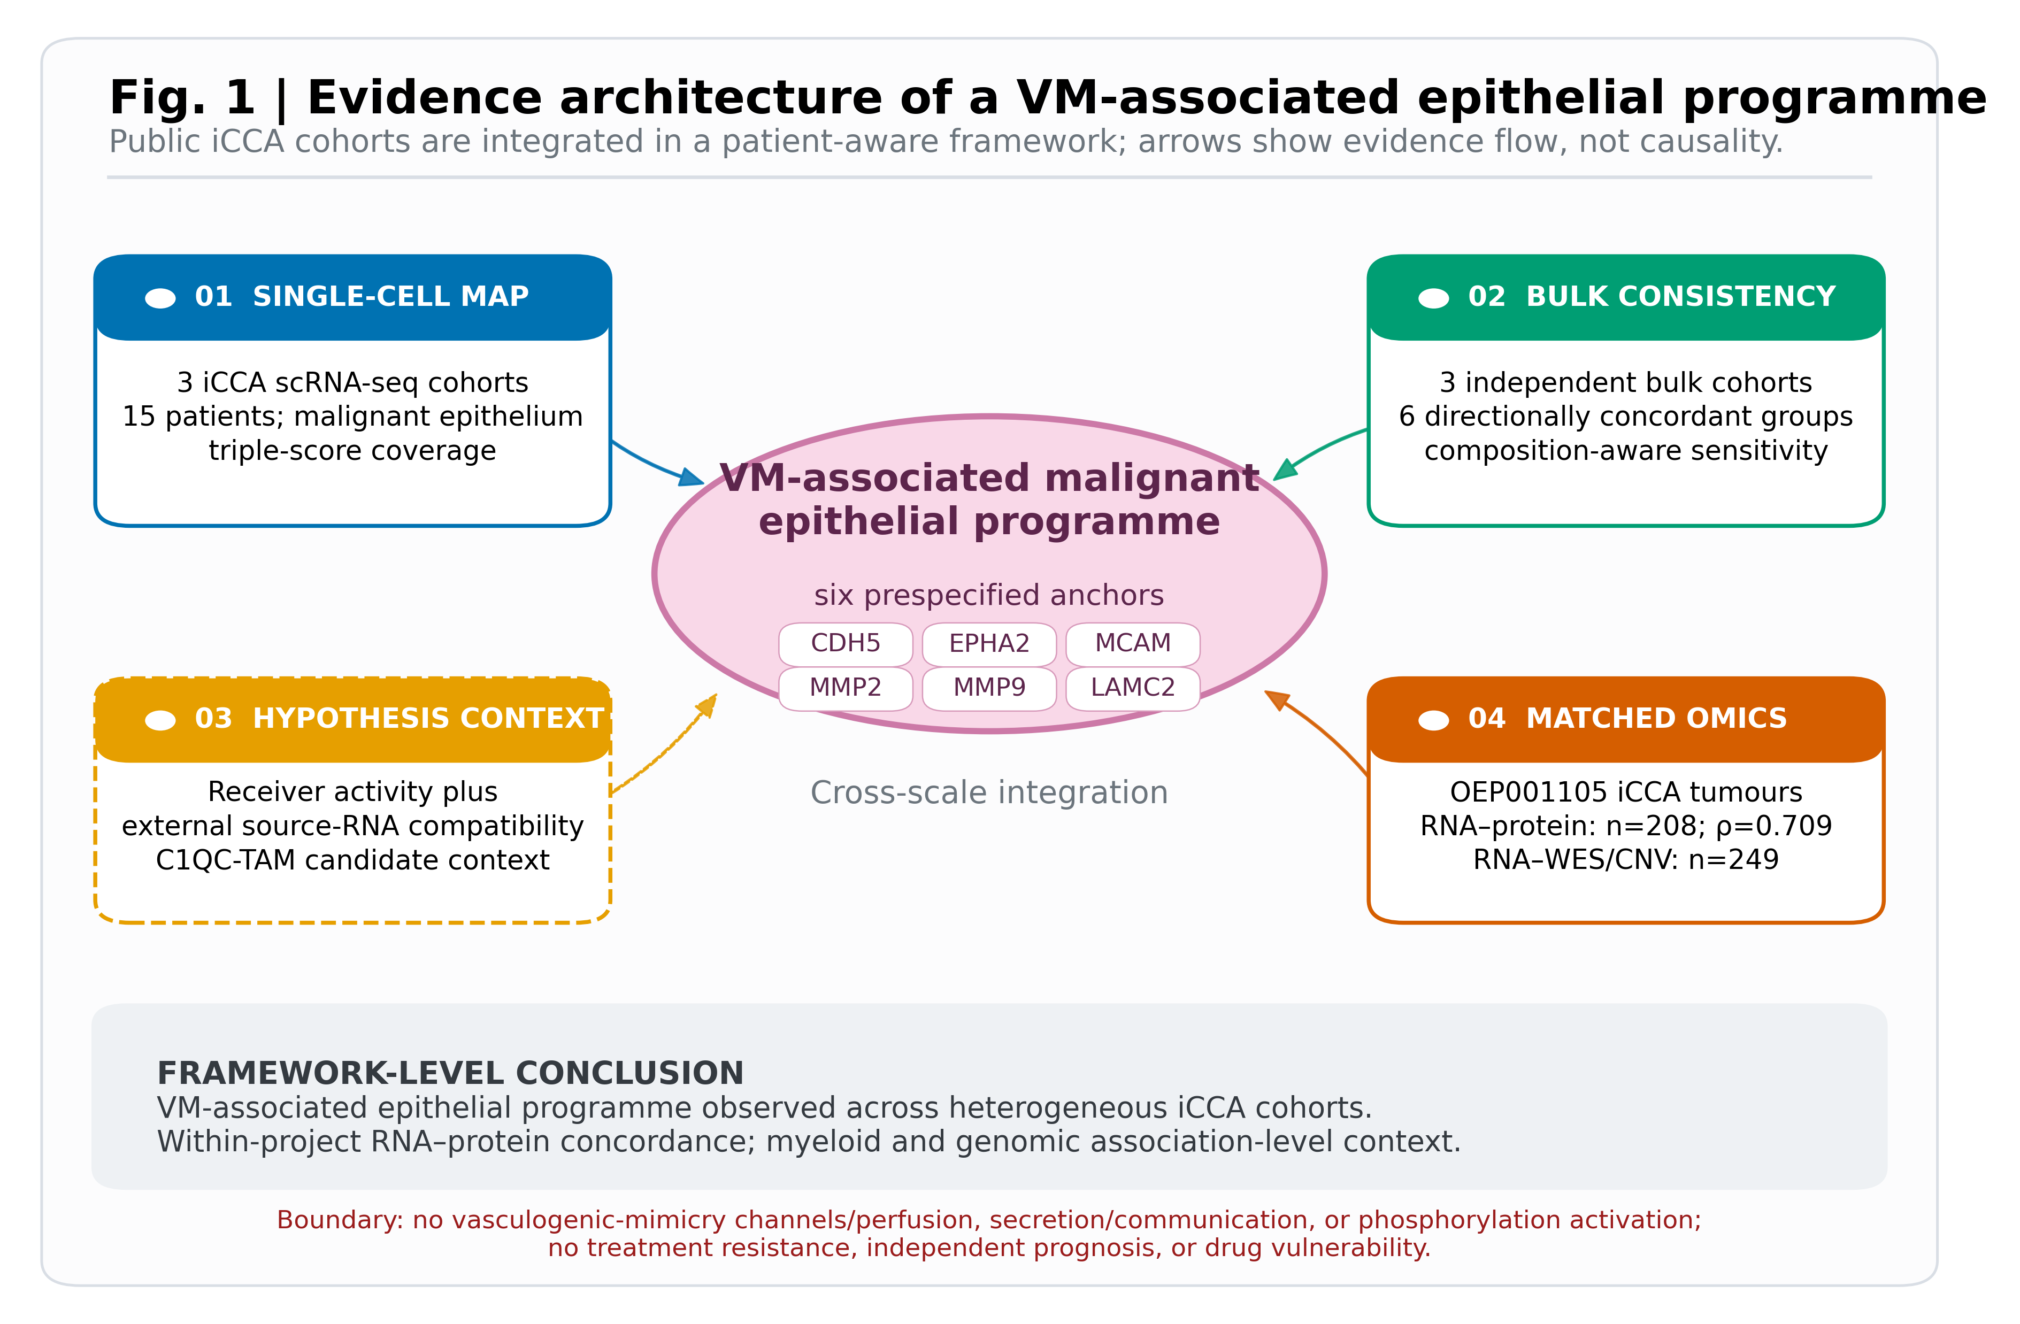

Figure 2. Cross-cohort definition and patient coverage
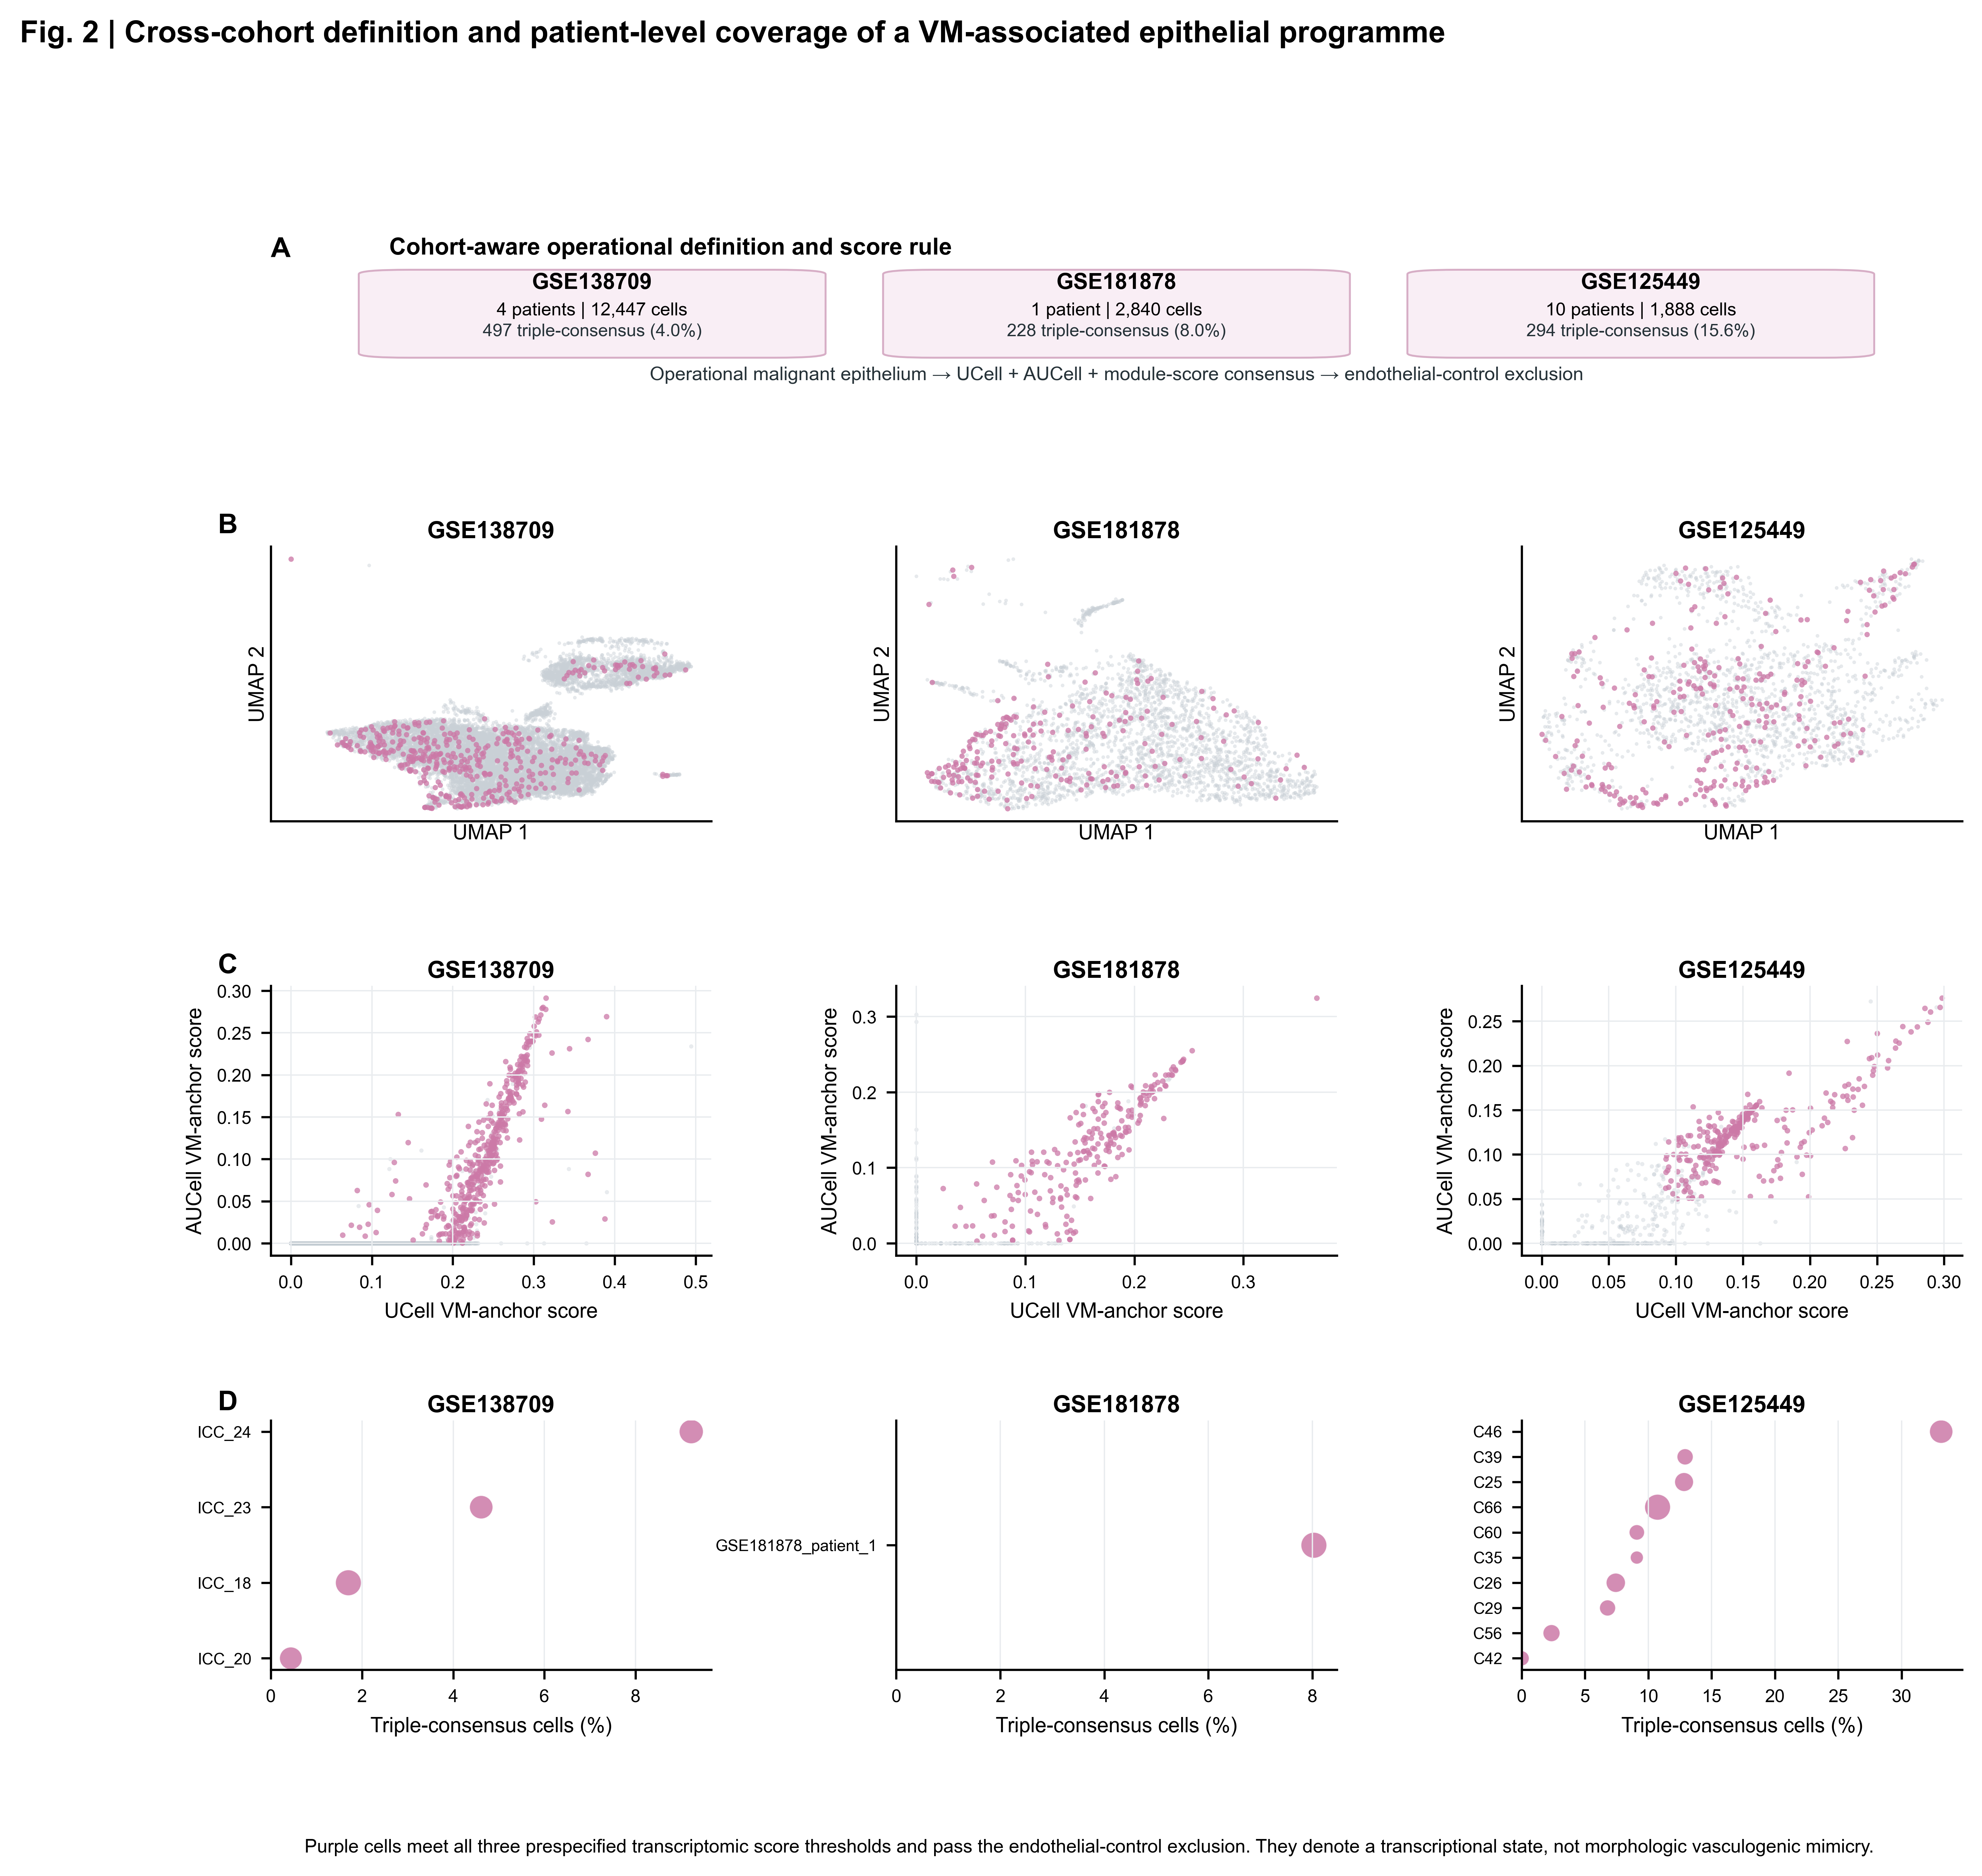

Figure 3. Constrained receiver-side associations

Figure 4. Directional replication of bulk associations
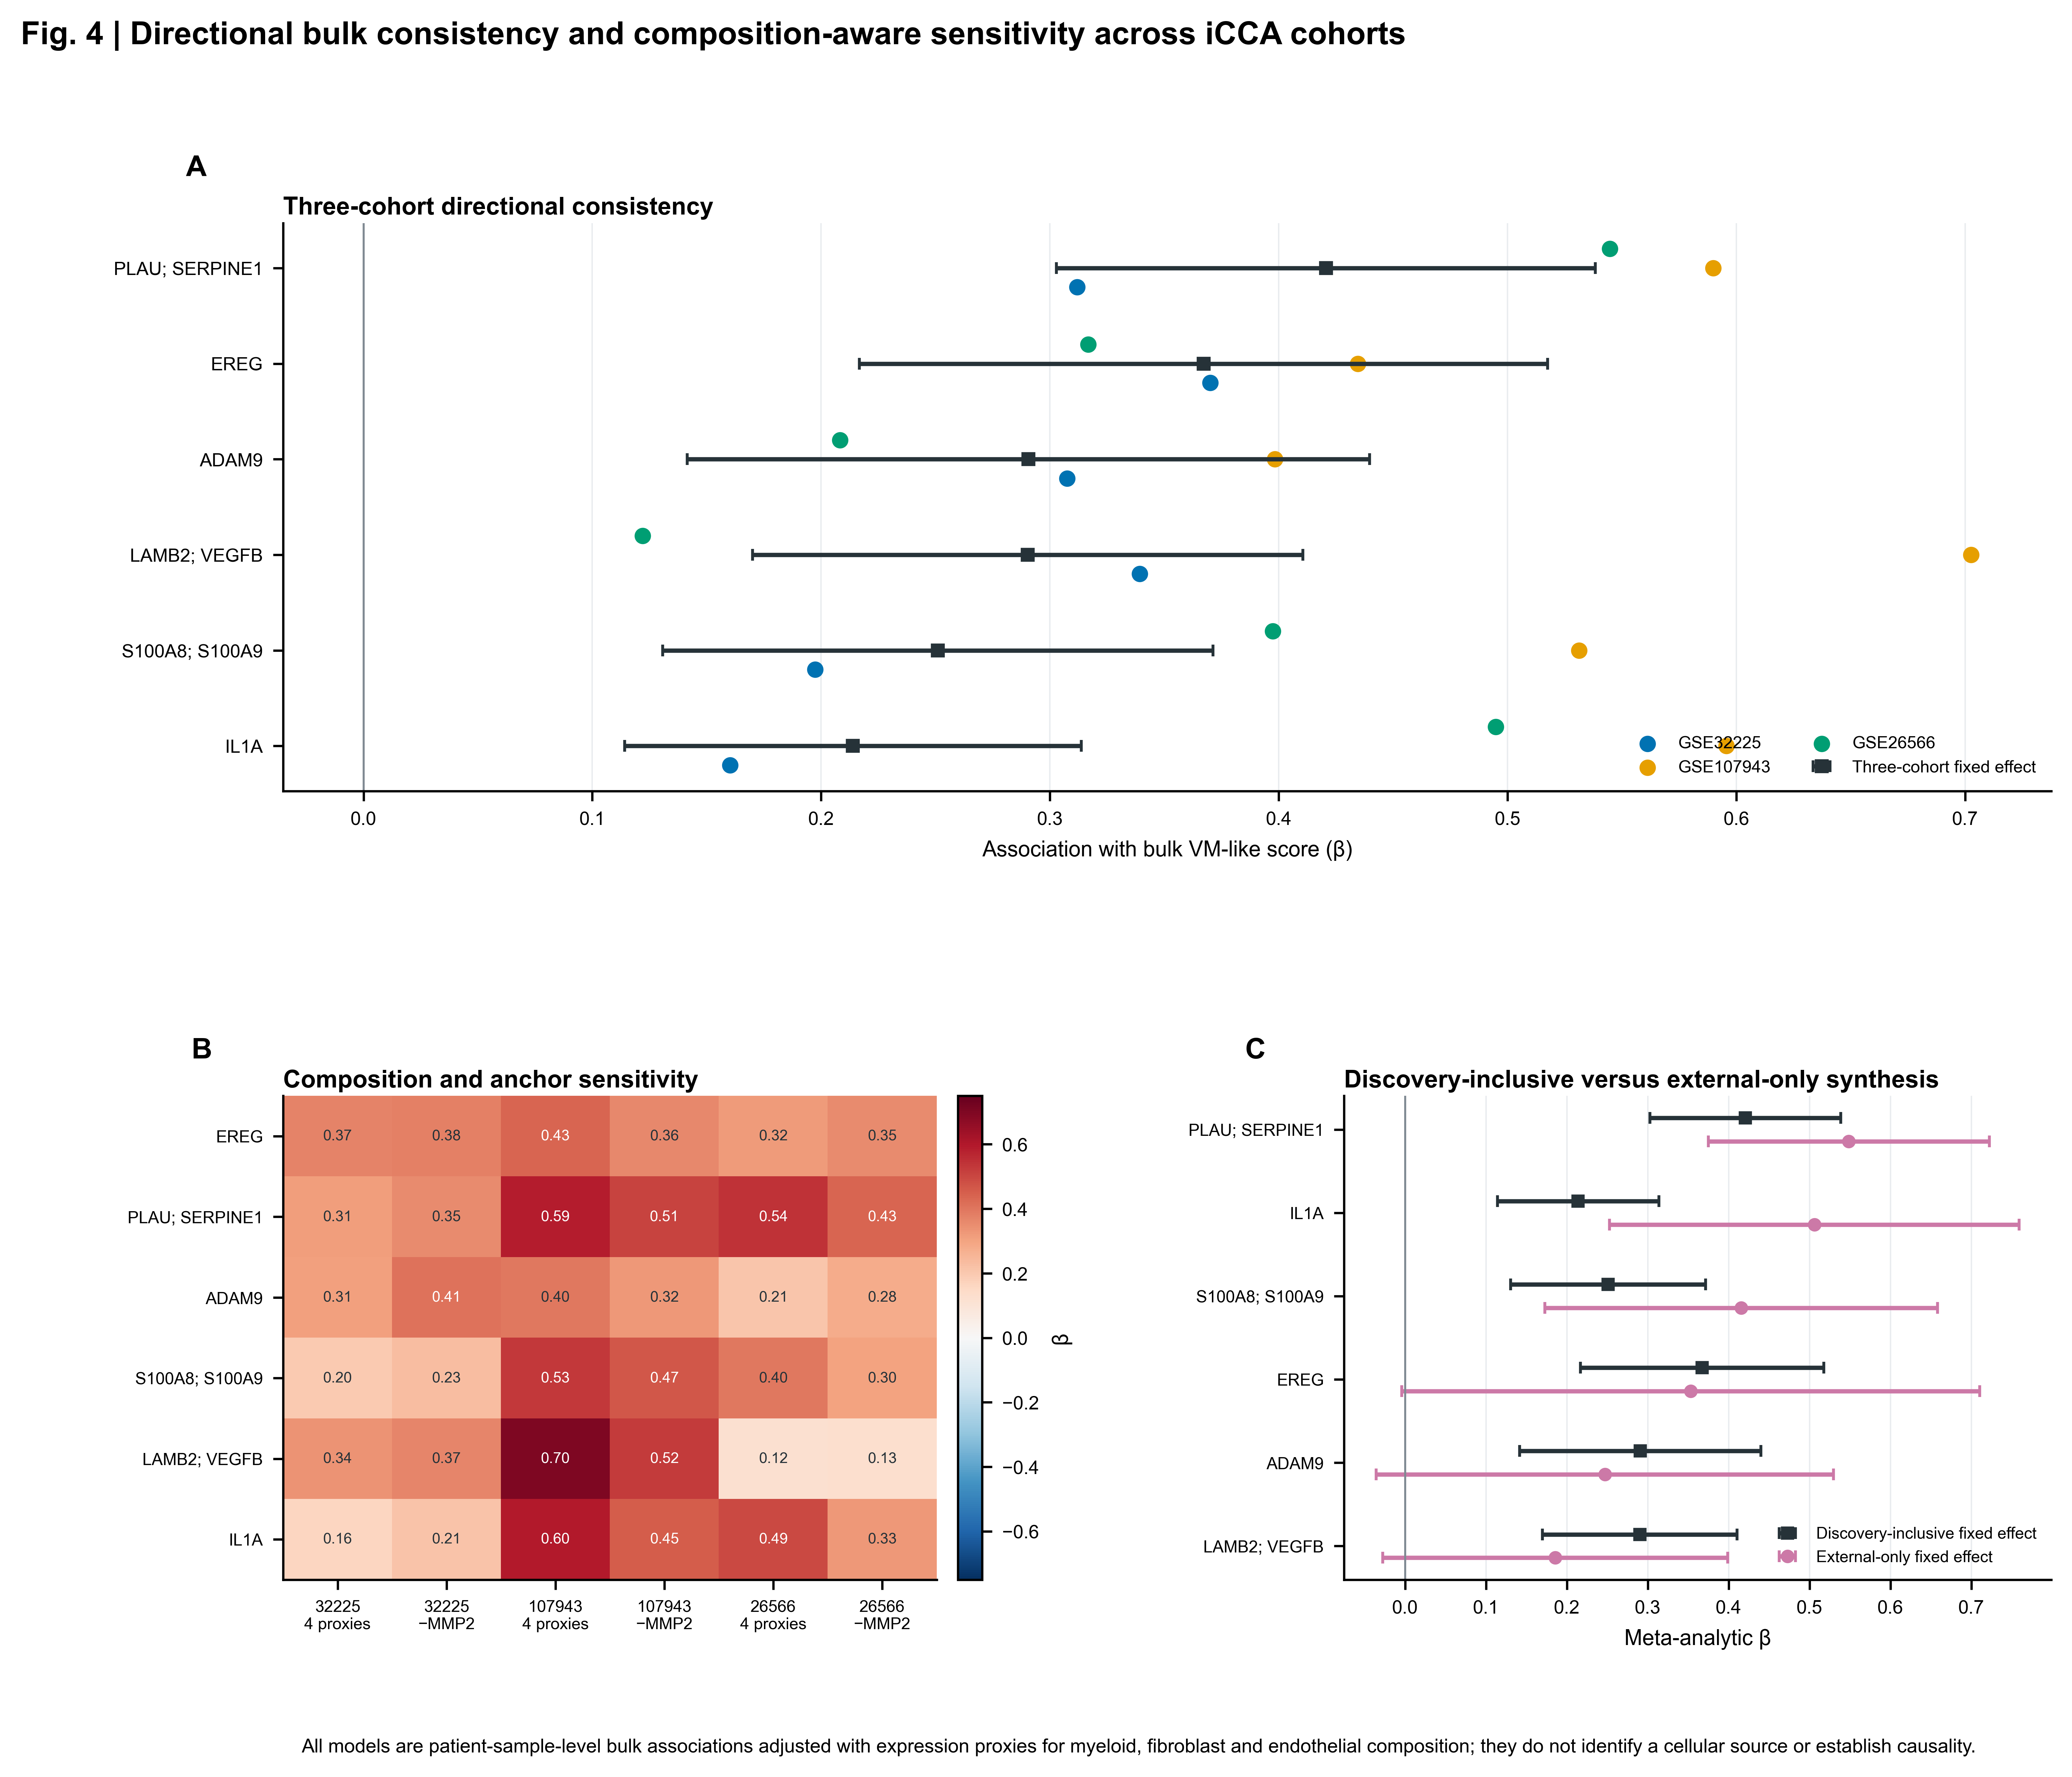

Figure 5. Matched RNA–protein concordance
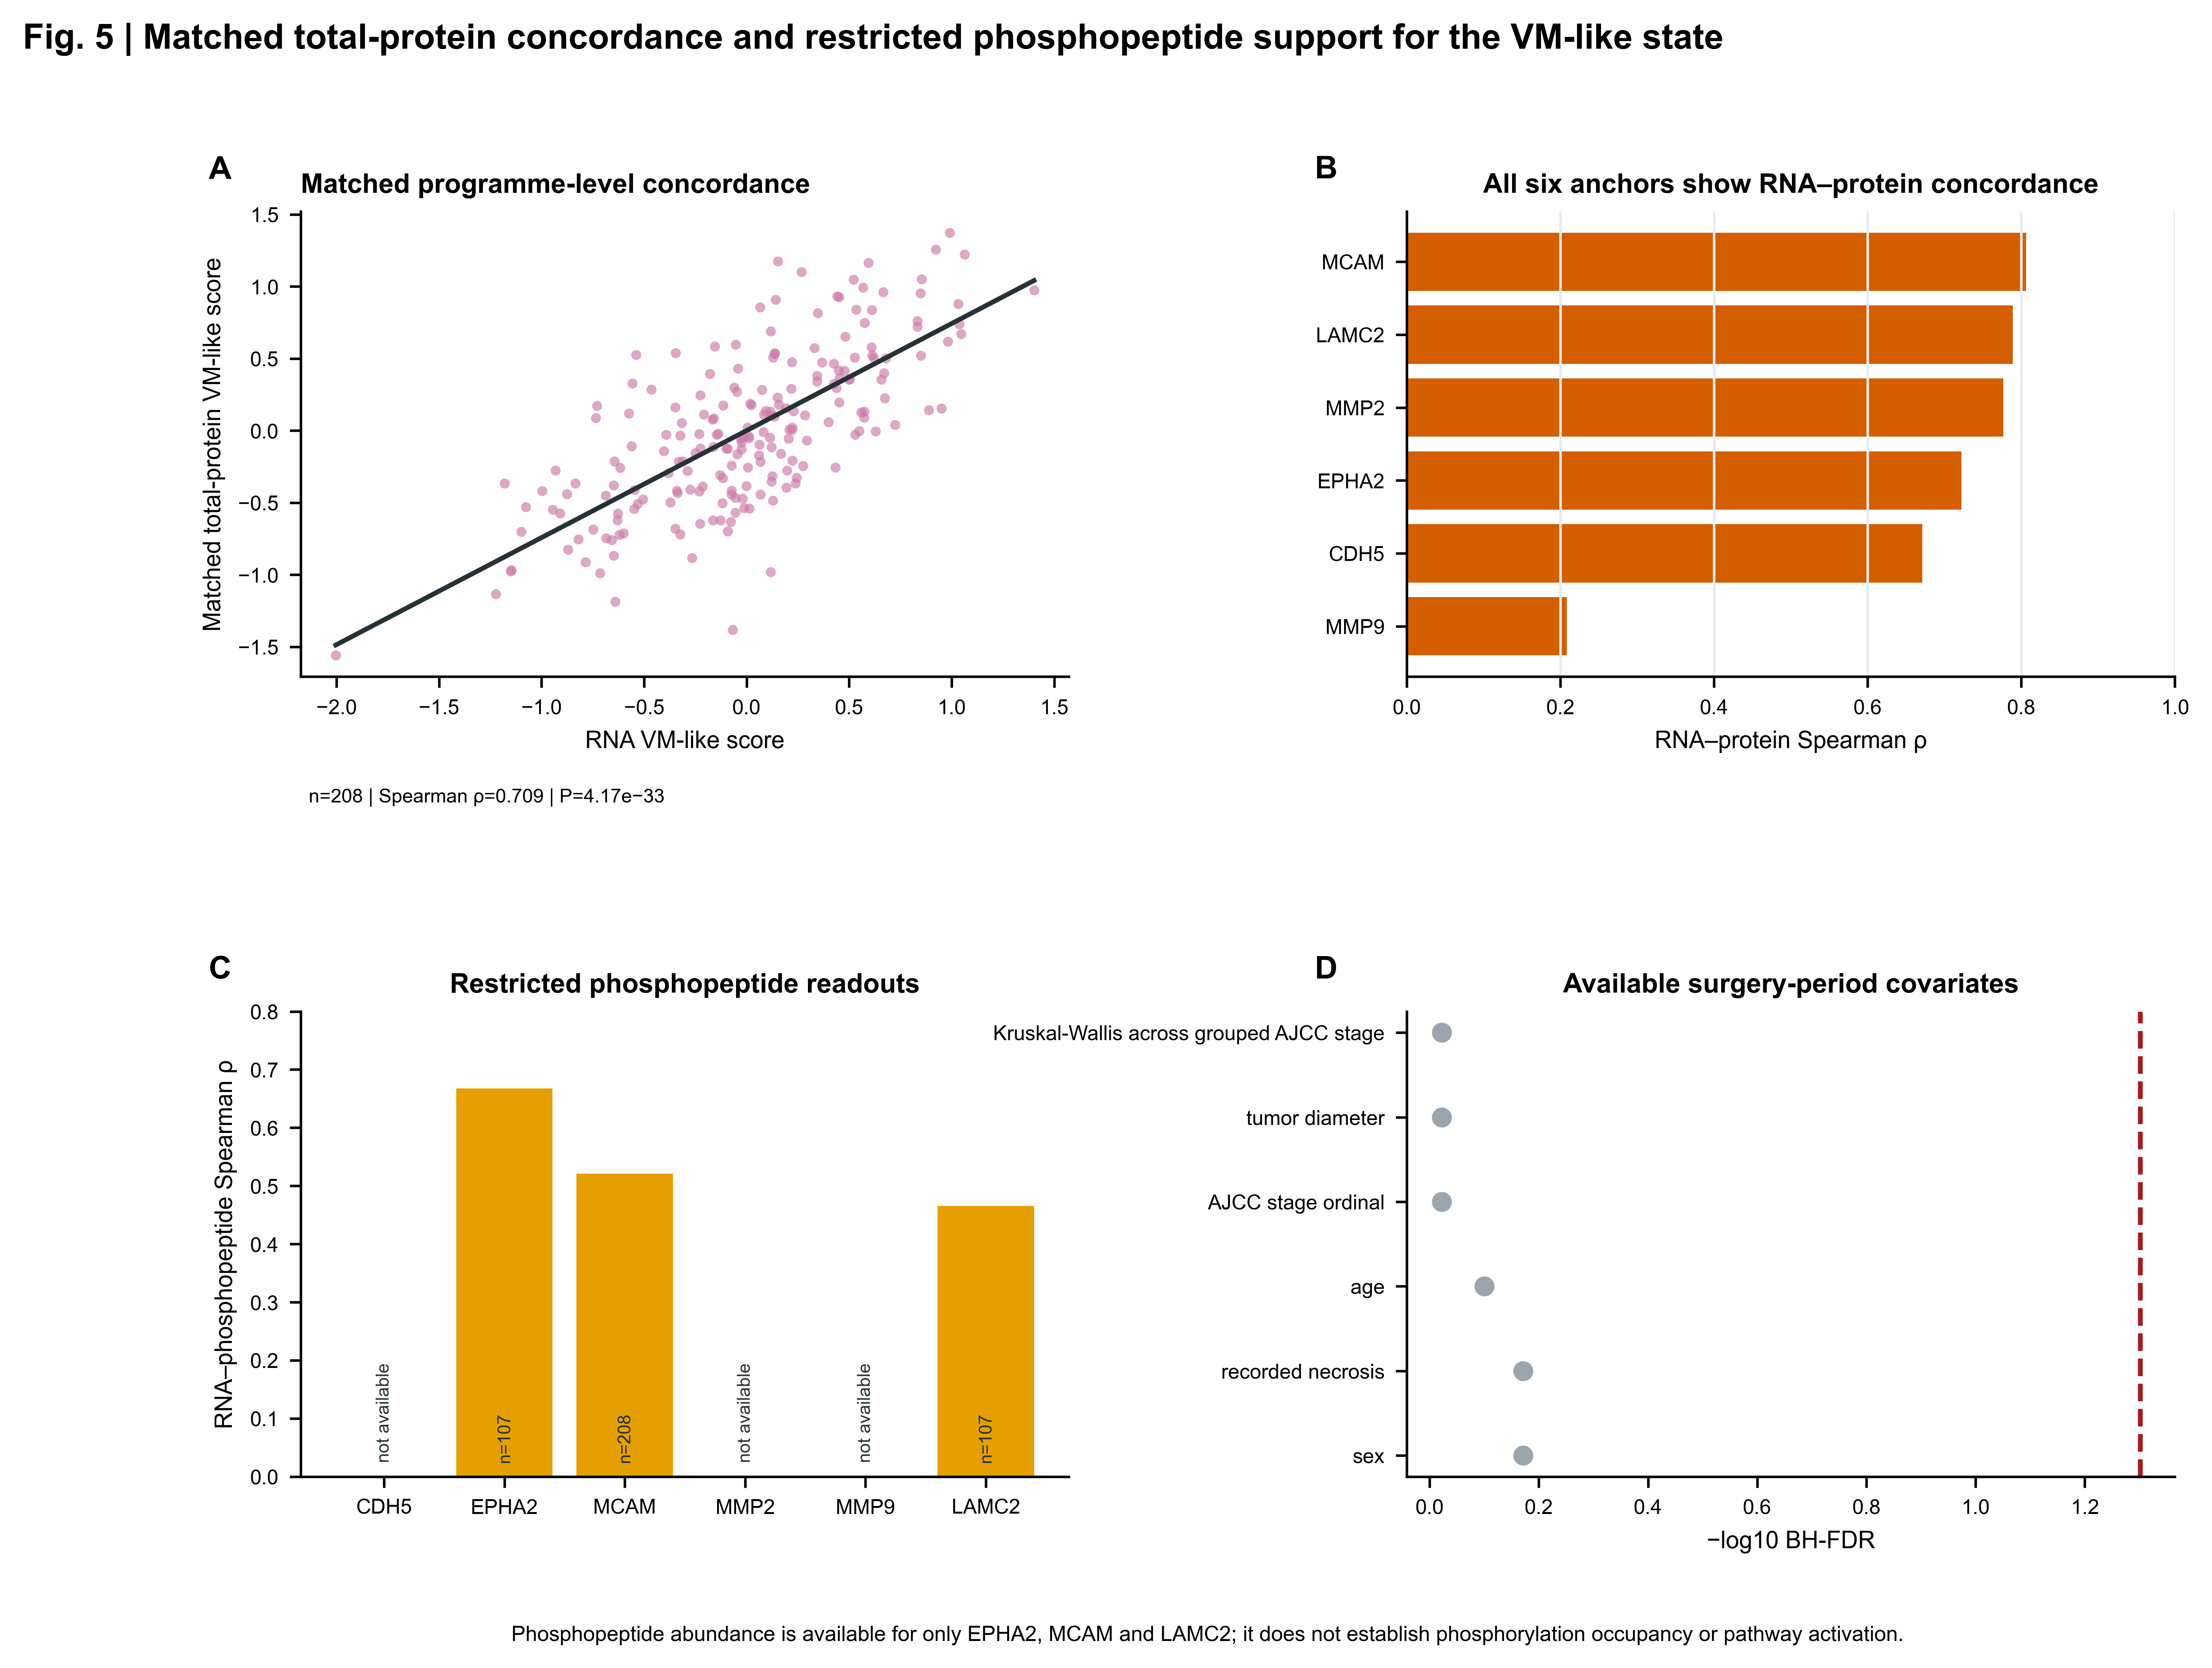

Figure 6. Association-only genomic context
