AI-Based-Quality-Check-On-Project-Code-And-Architecture - Software Design Document (SDD)
Version: v2.2
Date: 24 March 2026
Document History
Version | Date | Author | Reviewer | Changes
V0.1 | 2026-02-07 | BaiXuan Zhang | Dr. Siraprapa | Initial draft
V0.2 | 2026-02-13 | BaiXuan Zhang | Dr. Siraprapa | Added system architecture, database schema, component design
V0.3 | 2026-02-16 | BaiXuan Zhang | Dr. Siraprapa | Added security design, deployment architecture, complete database design, API specs, architecture diagrams
V0.4 | 2026-02-19 | BaiXuan Zhang | Dr. Siraprapa | Completed RBAC component design, updated technology stack, added ADR-005, aligned with enterprise_rbac_auth implementation
V0.5 | 2026-03-24 | BaiXuan Zhang | Dr. Siraprapa | Aligned architecture description, deployment wording, security controls, and ADR decisions with the implemented project baseline
V2.2 | 2026-03-24 | BaiXuan Zhang | Dr. Siraprapa | Standardized metadata, corrected formatting artifacts, and aligned the SDD with the repository baseline and template structure.

Contents
AI-Based Reviewer on Project Code and Architecture - Software Design Document (SDD) 1
1. Introduction 4
1.1 Purpose 4
1.2 System Overview 4
1.3 Design Principles 5
1.4 Scope 6
2. System Architecture 7
2.1 Logical Architecture 7
2.2 Application Module Architecture 9
2.3 Data Flow Diagram 11
2.4 Design Constraints 14
3. Database Design 20
3.1 Entity Relationship Diagram (ERD) 20
3.2 Data Dictionary 31
4. Detailed Design 44
4.1 Class Diagram (if Object-Oriented) 44
The system's class structure is divided into seven functional domains to keep each diagram readable. In a full diagram-supported version of this document, each domain has its own class diagram showing class attributes, method signatures, and inter-class relationships. The textual summary below captures the same information. 44
4.1.3 Code Analysis Domain 46
4.2 Component Design 50
4.2.4 Authorization Middleware 54
4.3 Core Algorithm Designs 62
4.4 Global Exception Handling Architecture 64
4.5 Detailed Security Design 66
4.6 Deployment and Network Architecture 69
4.7 Performance Optimisation Design 71
4.8 Maintainability and Observability Design 74
4.9 Architecture Decision Records (ADR) 76
ADR-001: Modular Service Architecture 77
ADR-002: Neo4j for Dependency Graphs 77
ADR-003: Multiple LLM Provider Support with Automatic Fallback 78
ADR-004: JWT for Stateless Authentication 78
ADR-005: Five-Role RBAC System 78
ADR-006: Celery with Redis for Asynchronous Task Processing 79
ADR-007: PostgreSQL as Primary Relational Database 79
5. Interface Design 80
5.1 Wireframes / Mockups 80
5.2 API Endpoints 83

1. Introduction
This section explains the purpose of the design document, the system it describes, and the principles that guided its structure. Readers who are new to software documentation can treat it as the executive summary of how the platform is designed and why its major architectural choices were made.

1.1 Purpose
This Software Design Document (SDD) describes the complete architectural and detailed design of AI-Based-Quality-Check-On-Project-Code-And-Architecture, a web application that automatically reviews software code and analyzes software architecture.
The document is intended to serve as the definitive technical reference for everyone involved in building, maintaining, or evaluating the system, including developers, architects, testers, and technical reviewers. It translates the high-level requirements captured in the Software Requirements Specification (SRS) into concrete design decisions: how the system is structured, how its parts communicate, how data is stored, and how security and performance goals are achieved.
In plain terms: if the SRS describes what the system must do, this SDD describes how it is built to do it.

1.2 System Overview
AI-Based-Quality-Check-On-Project-Code-And-Architecture is a browser-based software quality platform implemented as a Next.js frontend plus a FastAPI backend, with Redis-backed background processing and separate PostgreSQL and Neo4j persistence for transactional and graph-oriented data.
The system combines three advanced technologies:
Abstract Syntax Trees (AST) - a technique for parsing source code into a structured tree that represents the code's logical structure, making it possible to analyse the code programmatically rather than as raw text.
Graph Databases (Neo4j) - a specialised database optimised for storing and querying networks of relationships; here used to map out which parts of the codebase depend on which other parts.
Large Language Models (LLMs) - AI models such as OpenAI GPT-4 and Anthropic Claude that can read code, understand its intent, and generate human-readable review comments.

Core Capabilities
Capability | Description
Repository Onboarding and Access Control | Users authenticate, connect GitHub repositories, manage project access, and configure analysis prerequisites through secured API and UI flows.
Automated Pull Request Review | Pull request events or manual triggers collect diff context, parse changed code, invoke configured analysis logic, and store structured review feedback.
Architecture Analysis and Drift Detection | Dependency structures are stored in Neo4j and analysed for circular dependencies, layer violations, and structural drift indicators.
Project Analytics Dashboard | Aggregated review and architecture data is exposed as dashboard metrics, issue summaries, and high-level quality indicators.
Auditability and Settings Governance | Administrative changes, security-sensitive operations, and project access updates are traceable through audit logs and settings APIs.

1.3 Design Principles
The following principles guided every design decision in this document. When trade-offs were required, these principles provided the criteria for choosing between alternatives. The design principles of this platform emphasise separation of concerns, secure-by-default behavior, explainable analysis flow, controlled integration with external services, and maintainability across the project lifecycle. In practice, this means that user interaction, business logic, background analysis, and data storage should remain distinguishable in the design, and no major feature should depend on hidden assumptions that future maintainers would struggle to discover.
Principle | What It Means in Practice
Modularity | The system is divided into logical modules and worker responsibilities with clearly defined boundaries. A change to one module should not require unrelated changes elsewhere in the platform.
Scalability | Every service that handles stateless requests (i.e., requests that do not require server-side memory of previous interactions) can be replicated horizontally - meaning more instances are added when load increases, without redesigning the system.
Resilience | The system degrades gracefully when components fail. For example, if the primary LLM provider is unavailable, the system automatically falls back to an alternative provider rather than failing completely.
Security | Security is applied in multiple independent layers (Defence in Depth). A failure in one layer does not expose the entire system.
Maintainability | Code is written with clarity and comprehensive documentation as first-class requirements. Automated testing and structured logging reduce the time needed to diagnose and fix problems.
Performance | The system is designed to meet specific measurable targets: API responses within 500 ms (95th percentile), analysis completion within 2 minutes for repositories up to 50,000 lines of code.

1.4 Scope
This SDD covers the following design concerns. Each is addressed in the numbered section shown:
Design Topic | Covered In
System architecture and tier structure | Section 2
Application module catalog and interaction patterns | Section 2
Data flow through the system | Section 2
Design constraints (technical, performance, security, scalability, compliance) | Section 2
Database schemas and data models (PostgreSQL and Neo4j) | Section 3
Class diagrams and domain models | Section 4
Core component specifications and module-level APIs | Section 4
Core algorithm designs (cycle detection, complexity, drift, quality score) | Section 4
Exception handling architecture | Section 4
Security architecture (authentication, authorisation, encryption, OWASP) | Section 4
Deployment and network topology | Section 4
Performance optimisation (caching, indexing, async processing) | Section 4
Observability design (logging, metrics, health checks) | Section 4
Architecture Decision Records (ADR-001 through ADR-007) | Section 4
User interface screens and API endpoint catalogue | Section 5
This document does not cover: project scheduling or timelines (see Project Plan), functional requirements (see SRS), test cases or test execution (see Test Plan / Test Record), change history of requirements (see Change Request log), or traceability matrices (see Traceability Record).

2. System Architecture
This section describes how the system is structured at a high level - how it is divided into layers and services, how those services communicate, and what the overall flow of data looks like. It also documents the constraints that shaped the architectural choices.

2.1 Logical Architecture
The system is organised into four horizontal tiers (layers), each with a distinct responsibility. This separation ensures that changes in one tier do not cascade unnecessarily into others. The logical architecture divides the system into presentation, application, asynchronous analysis, and data-management concerns. This separation keeps user-facing requests responsive while allowing heavier tasks such as code parsing, dependency analysis, and AI-assisted review to continue in the background. It also makes the platform easier to understand because each part of the design has a clear purpose rather than sharing unrelated responsibilities.

2.1.1 Tier Overview
The top tier provides the frontend interface used to navigate projects, view results, and manage settings. The application tier exposes APIs, applies business rules, and enforces identity and permission checks. The worker tier carries out longer-running tasks such as repository analysis and graph updates. The data tier stores transactional system records in PostgreSQL and structural code relationships in Neo4j. This tiered design improves clarity, controllability, and future extensibility.
Tier | Technologies | Responsibilities
Presentation Layer | Next.js, React, TypeScript, Tailwind CSS, data-visualization components | Renders dashboards, project screens, architecture pages, review detail views, and settings flows.
API and Orchestration Layer | FastAPI, Pydantic, endpoint routers, auth dependencies | Validates requests, enforces authentication/authorisation, exposes REST APIs, and coordinates analysis workflows.
Analysis and Integration Layer | Python services, AST parsers, architecture analyser modules, GitHub integration, provider abstraction, optional background workers | Runs code review, dependency extraction, architecture analysis, repository sync, and analytics aggregation.
Persistence and Infrastructure Layer | PostgreSQL, Neo4j, Redis, Docker Compose, health/metrics middleware | Stores transactional data, graph relationships, cache/queue state, and deployment/runtime configuration.

2.2 Application Module Architecture
Within the application stack, the system is organised as a small number of logical modules inside one primary FastAPI service plus asynchronous analysis workers. This matches the current repository implementation more closely than a large distributed service topology and keeps the academic deployment easier to understand, test, and reproduce.

2.2.1 Service Catalog
The service catalog should describe the major building blocks in operational language. Authentication services establish identity and session trust, project services manage repositories and membership, analysis services orchestrate code review and architecture workflows, graph components manage dependency data, and audit or metrics services preserve evidence about what happened in the system. This style of description makes the architecture easier to understand for readers who are not inspecting implementation code directly.
Service Name | Technology | Port | Responsibility | Depends On
Web Frontend | Next.js / React | 3000 | User interface for authentication, project management, review inspection, architecture graphs, and analytics. | Backend API
Primary API Service | FastAPI | 8000 | Main REST API for auth, repository management, reviews, architecture, analytics, settings, and audit access. | PostgreSQL, Redis, Neo4j
Authentication and RBAC Module | FastAPI + auth services | Integrated | Registration, login, token handling, role checks, project access, user administration. | PostgreSQL, Redis
GitHub Integration Module | FastAPI endpoints + GitHub API client | Integrated | Repository connection, webhook validation, pull request sync, repository listing, status checks. | GitHub API, PostgreSQL
Code Review Module | Python analysis services | Integrated | Review trigger/status/detail/comment APIs and orchestration of code review generation. | GitHub Integration, PostgreSQL
Architecture Module | Python graph analysis services | Integrated | Branch architecture retrieval, dependency graphs, diagram generation, architecture overview. | Neo4j, PostgreSQL
Project Analytics Module | Python aggregation services | Integrated | Dashboard metrics, issue summaries, architecture-analysis summaries, trend data. | PostgreSQL, review/architecture data
Background Analysis Worker | Python worker process / queue consumer | N/A | Executes long-running sync, parsing, and model-driven analysis workloads asynchronously. | Redis, GitHub, LLM providers
Operational Services | Health, monitoring, metrics middleware | Integrated | Health probes, Prometheus-style metrics, slow-query monitoring, startup validation. | All runtime dependencies

2.2.2 Service Communication Patterns
Services communicate using three distinct patterns, chosen by response urgency. Fast user actions (for example sign-in and dashboard viewing) run in direct request-response mode for immediate feedback. Heavier jobs (for example pull-request analysis, webhook-triggered processing, and graph rebuilds) run asynchronously through queues and workers, so users do not have to wait while expensive computation finishes in the background.
Pattern | Used For | Technology
Synchronous request/response | Authentication, settings updates, project CRUD, fetching analytics or graph data | HTTP/JSON over FastAPI endpoints
Queued asynchronous execution | Long-running repository sync, pull-request analysis, provider calls, heavy graph processing | Redis-backed queue / worker pattern
Webhook-driven event intake | GitHub pull-request and repository events | GitHub Webhooks to FastAPI webhook endpoints

2.3 Data Flow Diagram
The following walkthrough traces a complete Pull Request review cycle from the moment a developer opens a PR on GitHub to the moment the AI-generated comments appear on that PR. The core data flow begins when a user request or GitHub event enters the system. The application layer validates the request, retrieves or updates project state, and decides whether the action can complete immediately or must be handed off to a worker. Background processing then gathers repository context, performs analysis, stores findings, and exposes the final result back through the interface or integration channel. Explaining this flow makes it much easier to understand how multiple services cooperate to produce one user-visible outcome.

2.3.1 Pull Request Review Flow
Note: The diagram image referenced in the original document is preserved below as a step-by-step description for textual clarity. In the pull request review flow, the system first confirms that the event belongs to a known and authorized project. It then fetches the relevant code changes, derives structural context such as syntax trees or dependency information, and passes prepared context to the review logic. After the analysis is completed, findings are categorised, stored, and returned either to GitHub or to the application dashboard so the result is visible in the same review workflow that triggered it.
Step | Actor / Component | Action
1 | GitHub or User Trigger | A pull request is opened/updated or an authorized user requests analysis manually.
2 | Webhook / API Layer | The backend validates the trigger, identifies the project and PR context, and records an analysis request.
3 | Repository Integration Logic | Changed files, metadata, and repository context are fetched from GitHub or cached project state.
4 | Parsing and Review Logic | Changed files are parsed, code entities are extracted, and provider-driven review logic prepares structured findings.
5 | Architecture Logic | Dependency graph context and structural rules are evaluated to detect architectural issues and summary metrics.
6 | Persistence Layer | Review summaries, comments, architecture results, and status updates are written to PostgreSQL and Neo4j as appropriate.
7 | Frontend / Consumer | Users open the dashboard, review detail, or architecture view to inspect results and next actions.
8 | Audit and Monitoring | Security-relevant or administrative actions are logged and runtime metrics remain available for diagnostics.

2.3.2 Component Interaction Summary
The diagram shown in the SDD illustrates the request flows between the frontend, the primary API service, the background analysis workers, and the supporting data stores described in Section 2.2.1. Key interaction paths include:
- Frontend <-> API Gateway -> Auth Service (for all authenticated requests)
- Frontend <-> API Gateway -> Project Manager (for repository operations)
- Frontend <-> API Gateway -> Analysis Service (to trigger or query analyses)
- GitHub -> Webhook Handler -> Redis -> Celery Workers (a pull-request event enters the system and is queued for background analysis)
- Celery Workers <-> Neo4j (workers read and update architecture relationships between code modules)
- Celery Workers <-> LLM APIs (workers request AI review reasoning and convert responses into structured findings)
- Celery Workers <-> GitHub API (workers fetch pull-request changes and publish review comments back to GitHub)

2.3.3 Data Flow Diagram (DFD)
Pull Request Review Flow:
1. GitHub sends a webhook when a pull request is created or updated.
2. The webhook handler verifies the event and places an analysis task into Redis.
3. A background worker retrieves the pull-request code changes from GitHub.
4. The AST parser converts modified files into machine-readable code structure.
5. The graph analysis step queries Neo4j to understand existing architecture relationships.
6. The LLM service sends code and architecture context to the AI provider for reasoning.
7. The system standardizes the AI findings, assigns severity levels, and stores results in PostgreSQL.
8. Review comments are posted back to the pull request in GitHub.
9. The dependency graph is updated in Neo4j to reflect the latest code structure.
10. The frontend dashboard shows the new results so users can review them immediately.
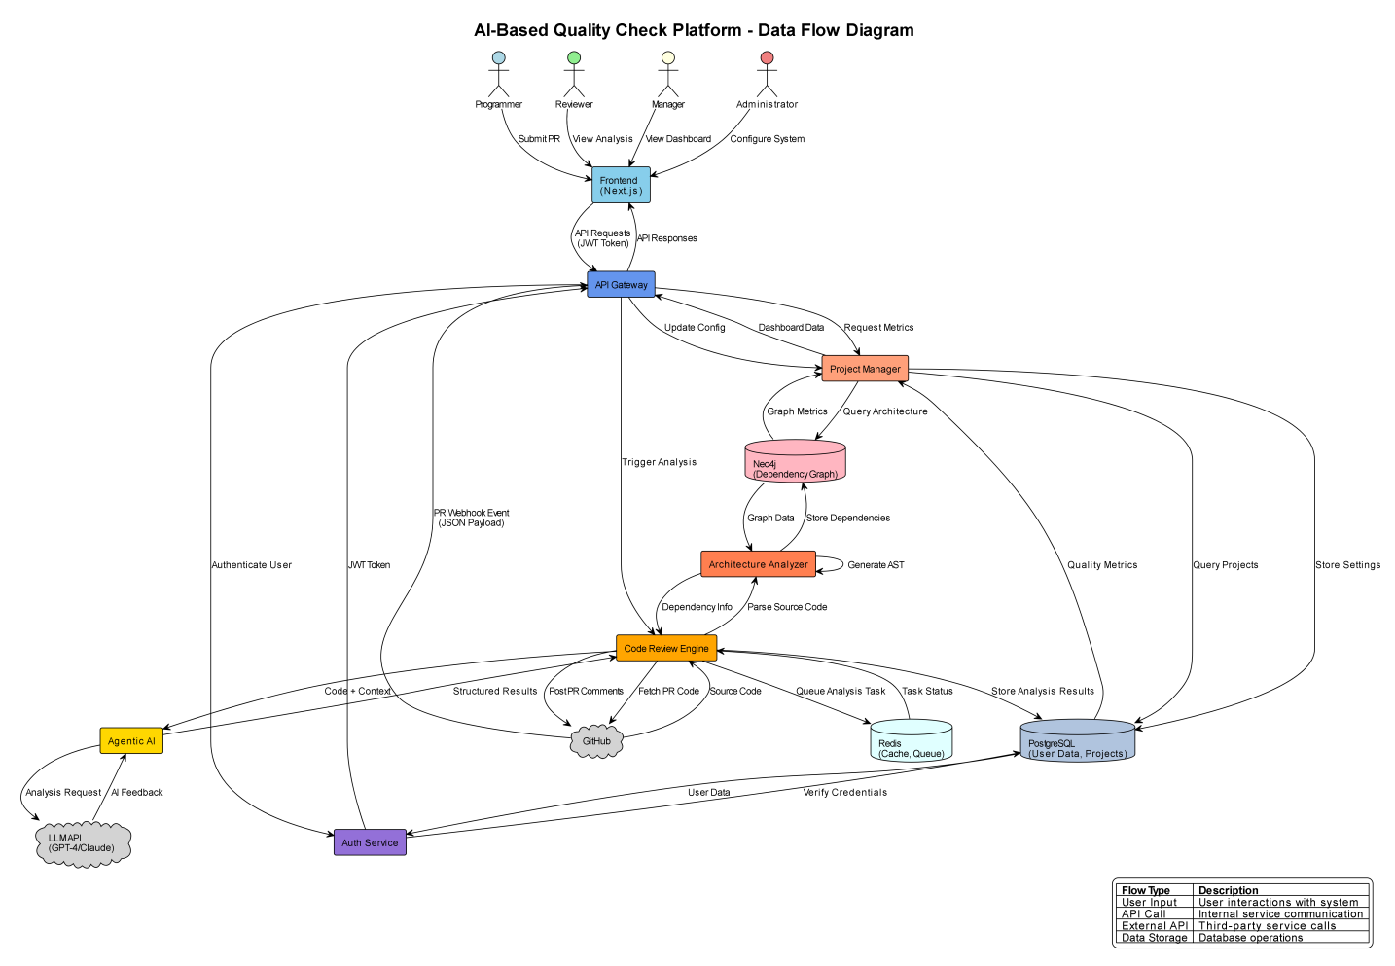

2.3.4 Component Interaction Diagram
The component interaction view should show how the frontend, API layer, worker processes, databases, and external services collaborate during common workflows. It is especially useful for understanding which parts of the platform are trusted entry points, which parts process background tasks, which dependencies can fail independently, and where the final result of each interaction becomes visible to the user or administrator.
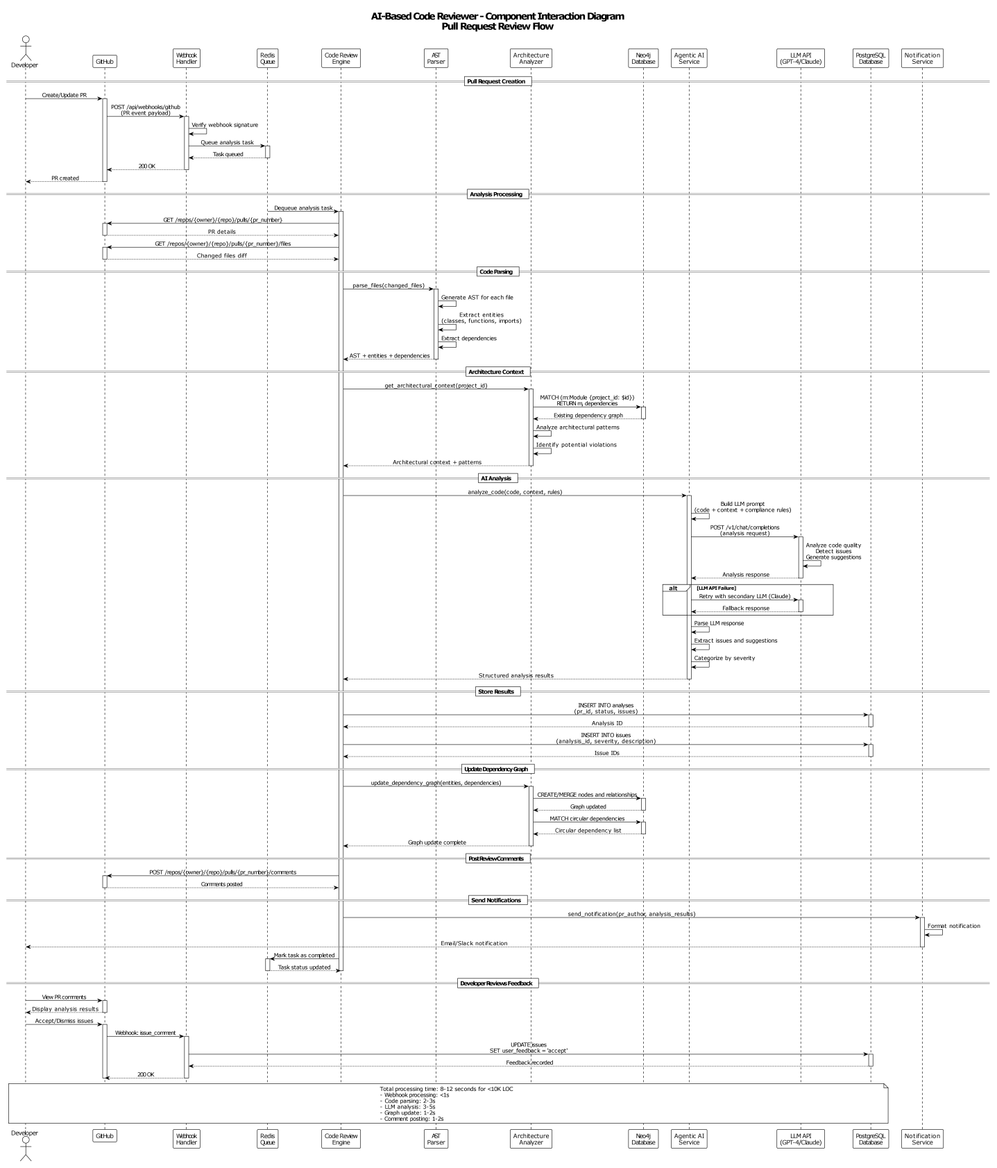

2.4 Design Constraints
The following constraints were non-negotiable requirements that directly shaped the architecture. Each constraint is documented with the rationale and its design implication so that future maintainers understand why choices were made. The design is influenced by technical, operational, and project-management limits rather than by idealised conditions. Because the platform integrates external providers, must remain deployable in a practical academic environment, and needs to be documented clearly for review, the architecture has to balance capability with clarity. These constraints explain why the design prefers controlled modularity and observable workflows over unnecessary complexity.

2.4.1 Technical Constraints
Technical constraints include reliance on GitHub as the primary source-control integration, dependence on external LLM providers for AI reasoning, a Docker-oriented runtime model, and the combined use of relational and graph data stores. These constraints directly shape the architecture by encouraging explicit service boundaries, configurable integrations, and infrastructure choices that can be reproduced during testing and review.
Constraint | Requirement | Rationale | Design Implication
Programming Environment | Python 3.11+ backend and TypeScript-based frontend | Matches repository implementation and available tooling | Shared contracts remain language-neutral at the API boundary
Relational Persistence | PostgreSQL stores users, projects, pull requests, review state, sessions, and audit records | Strong transactional consistency for business data | Migrations and indexed lookup paths are required
Graph Persistence | Neo4j stores dependency-oriented structures for architecture workflows | Efficient graph traversal and relationship queries | Architecture endpoints must tolerate temporary graph-store unavailability
Queue and Cache | Redis supports caching and background execution coordination | Reduces latency and decouples heavy analysis from request latency | Requests degrade gracefully if Redis is unavailable
Provider Integration | LLM providers are configurable per environment/user settings | Supports fallback and cost control | Review logic separates orchestration from provider-specific details
Deployment Model | Docker-based local and staging deployment | Matches repeatable academic submission environment | Documentation and health checks assume containerized startup

2.4.2 Performance Constraints
Performance constraints require the system to remain practical for interactive use while handling potentially expensive operations such as code parsing, graph analysis, and AI calls. The design should therefore avoid blocking user-facing workflows unnecessarily, reuse prepared context where sensible, and separate heavy processing from requests that need immediate response.
Metric | Target | Design Implication
API Response Time | P95 < 500 ms (GET), < 1 s (POST) | Caching strategy, database query optimisation, and connection pooling required
Analysis Processing Time | < 2 minutes for repositories ≤ 50,000 lines of code | Parallel processing, incremental analysis (only re-analyse changed files), and efficient AST parsing
Concurrent Dashboard Users | 100 simultaneous users | Stateless services, horizontal scaling, WebSocket connection management
Concurrent Analysis Jobs | 10 simultaneous jobs | Worker pool sizing, per-worker resource limits, queue management
Database Query Performance | < 100 ms for 95 % of queries | Proper indexing, query optimisation, read replicas for reporting
Graph Traversal Performance | < 5 seconds for graphs with ≤ 1,000 nodes | Graph algorithm optimisation, result caching, pagination of large results

2.4.3 Security Constraints
Security constraints require trusted authentication, consistent authorisation checks, safe token handling, protected configuration, secure webhook validation, and audit visibility for sensitive actions. The design must assume that input can be malformed or hostile and that access to project data should always be restricted by role and project scope rather than by trust in the client alone.
Constraint | Requirement | Design Implication
Authentication | JWT-based with 24-hour token expiry | Stateless authentication; token refresh mechanism; secure httpOnly cookie storage
Authorisation | RBAC with 5 defined roles | Permission-checking middleware on every request; role hierarchy enforcement; audit logging
Data Encryption | TLS 1.3 in transit; AES-256 at rest | SSL certificate management; database encryption configuration; key rotation policy
Password Policy | Minimum 8 characters, complexity rules, bcrypt hashing (cost factor 12) | Password validation at input; secure hashing; account lockout after 5 failed attempts
API Rate Limiting | 100 requests per minute per authenticated user | Rate-limiter middleware backed by Redis token-bucket counter; 429 responses when exceeded
Input Validation | All user inputs validated and sanitised | Pydantic models for all request schemas; SQL injection prevention via ORM; XSS protection via output encoding
Audit Logging | All security-relevant events logged immutably | Append-only audit table; no UPDATE or DELETE permitted; 7-year retention

2.4.4 Scalability Constraints
Scalability in this context means that the platform should cope with more repositories, more analyses, and larger stored histories without needing a fundamental redesign. The architecture therefore separates user requests from worker workloads, keeps graph operations distinct from ordinary transactional data, and uses service boundaries that can be expanded or tuned independently if needed later.
Constraint | Requirement | Design Implication
Horizontal Scaling | Linear scaling up to 50 analysis workers | Stateless service design; shared-nothing architecture; distributed caching
Database Scaling | Support up to 10 million analysis records | Table partitioning strategy; archival process; query optimisation
Graph Database Scaling | Support up to 1 million nodes per project | Graph partitioning by project; index optimisation; query result caching
Storage Scaling | Support up to 1 TB of analysis data | Shared artefact storage or exported report storage may be attached for large files; PostgreSQL stores metadata and operational records only
Network Bandwidth | Support 100 Mbps sustained throughput | CDN for static assets; response compression; efficient serialisation formats

2.4.5 Compliance Constraints
Compliance constraints arise from the need to support disciplined engineering documentation, auditability, and evidence-based review. The design should therefore preserve enough metadata and system history to explain what happened during important workflows and to keep the running system aligned with requirements, test records, and traceability artifacts.
Standard | Requirement | Design Implication
GDPR / CCPA (Data Privacy) | User consent management; right to data export; right to deletion; data minimisation | Data export API; deletion workflow; PII minimisation in logs
SOC 2 Type II / OWASP Top 10 (Security) | Security controls; penetration testing; vulnerability scanning; audit trail | See Section 4.5 for detailed OWASP mapping
WCAG 2.1 Level AA (Accessibility) | Keyboard navigation; screen reader support; colour contrast; ARIA labels | Frontend must pass automated and manual accessibility audits
ISO/IEC 25010 (Software Quality) | Quality metrics calculation; compliance reporting; automated checks | Metrics Service computes and reports quality dimensions defined by the standard
ISO/IEC 23396 (Architecture Quality) | Layer validation; dependency analysis; architectural drift detection | Architecture Analyser enforces layer rules and detects drift against baseline

2.4.6 Operational Constraints
Operational constraints include manageable setup, reproducible deployment, understandable troubleshooting, and a supportable container footprint. These requirements influence the design strongly because a system that is difficult to start, monitor, or diagnose becomes much harder to validate and maintain, even if its internal logic is technically sound.
Constraint | Requirement | Design Implication
Availability | 99.5 % uptime (≤ 43.8 hours downtime per year) | Multi-Availability-Zone deployment; health checks; automatic failover; graceful degradation
Backup | Daily full backup; hourly incremental backup | Automated backup scripts; 30-day retention; tested restore procedures
Monitoring | Real-time metrics and alerting | Prometheus metrics; Grafana dashboards; PagerDuty integration
Deployment | Zero-downtime deployments | Blue-green deployment strategy; rolling updates; database migration strategy
Disaster Recovery | Recovery Time Objective (RTO): 4 hours; Recovery Point Objective (RPO): 1 hour | Multi-region backup; documented recovery runbook; quarterly DR drills

3. Database Design
This section describes how data is stored. The system uses two databases: PostgreSQL for structured transactional data (users, projects, analyses, etc.) and Neo4j for the code dependency graph. Understanding when each database is used and how their schemas are structured is essential for anyone who needs to query, extend, or migrate the system's data.

3.1 Entity Relationship Diagram (ERD)
The diagrams referenced in the original SDD visually show the relationships described below. The textual description that follows is sufficient to understand the data model even without the diagrams. The database design uses two complementary models because the project stores two different kinds of knowledge. PostgreSQL captures structured operational records such as users, projects, pull requests, analyses, and audit events. Neo4j captures relationships between code entities so the system can ask structural questions that are awkward to express in ordinary relational form. This combination allows the platform to stay practical for application behavior while also supporting architecture analysis.

3.1.1 PostgreSQL Entity Relationships
The relational data model consists of the following main entities and their relationships:
Entity | Relates To | Relationship | Meaning
User | Project | 1 -> many | A user can own or participate in multiple projects.
User | Session | 1 -> many | A user may have multiple active or historical sessions.
User | AuditLog | 1 -> many | Security and administrative actions are traceable to users when applicable.
Project | ProjectMember / Invitation | 1 -> many | Project access may be granted directly or through invitations.
Project | PullRequest | 1 -> many | Each connected repository project can contain multiple pull requests.
PullRequest | CodeReview | 1 -> many | A pull request can have one or more review runs.
PullRequest | ArchitectureAnalysis | 1 -> many | A pull request can also trigger architecture analysis results.
CodeReview | ReviewComment | 1 -> many | Each review run stores structured comments and metadata.

- Users (one-to-many with Projects)
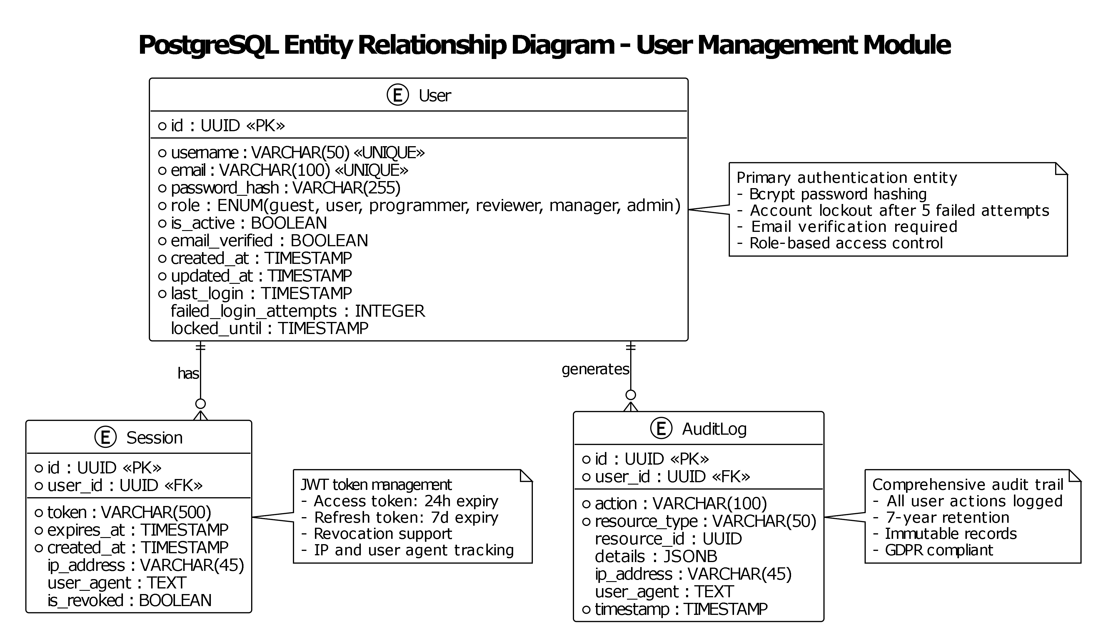

- Projects (one-to-many with Repositories)
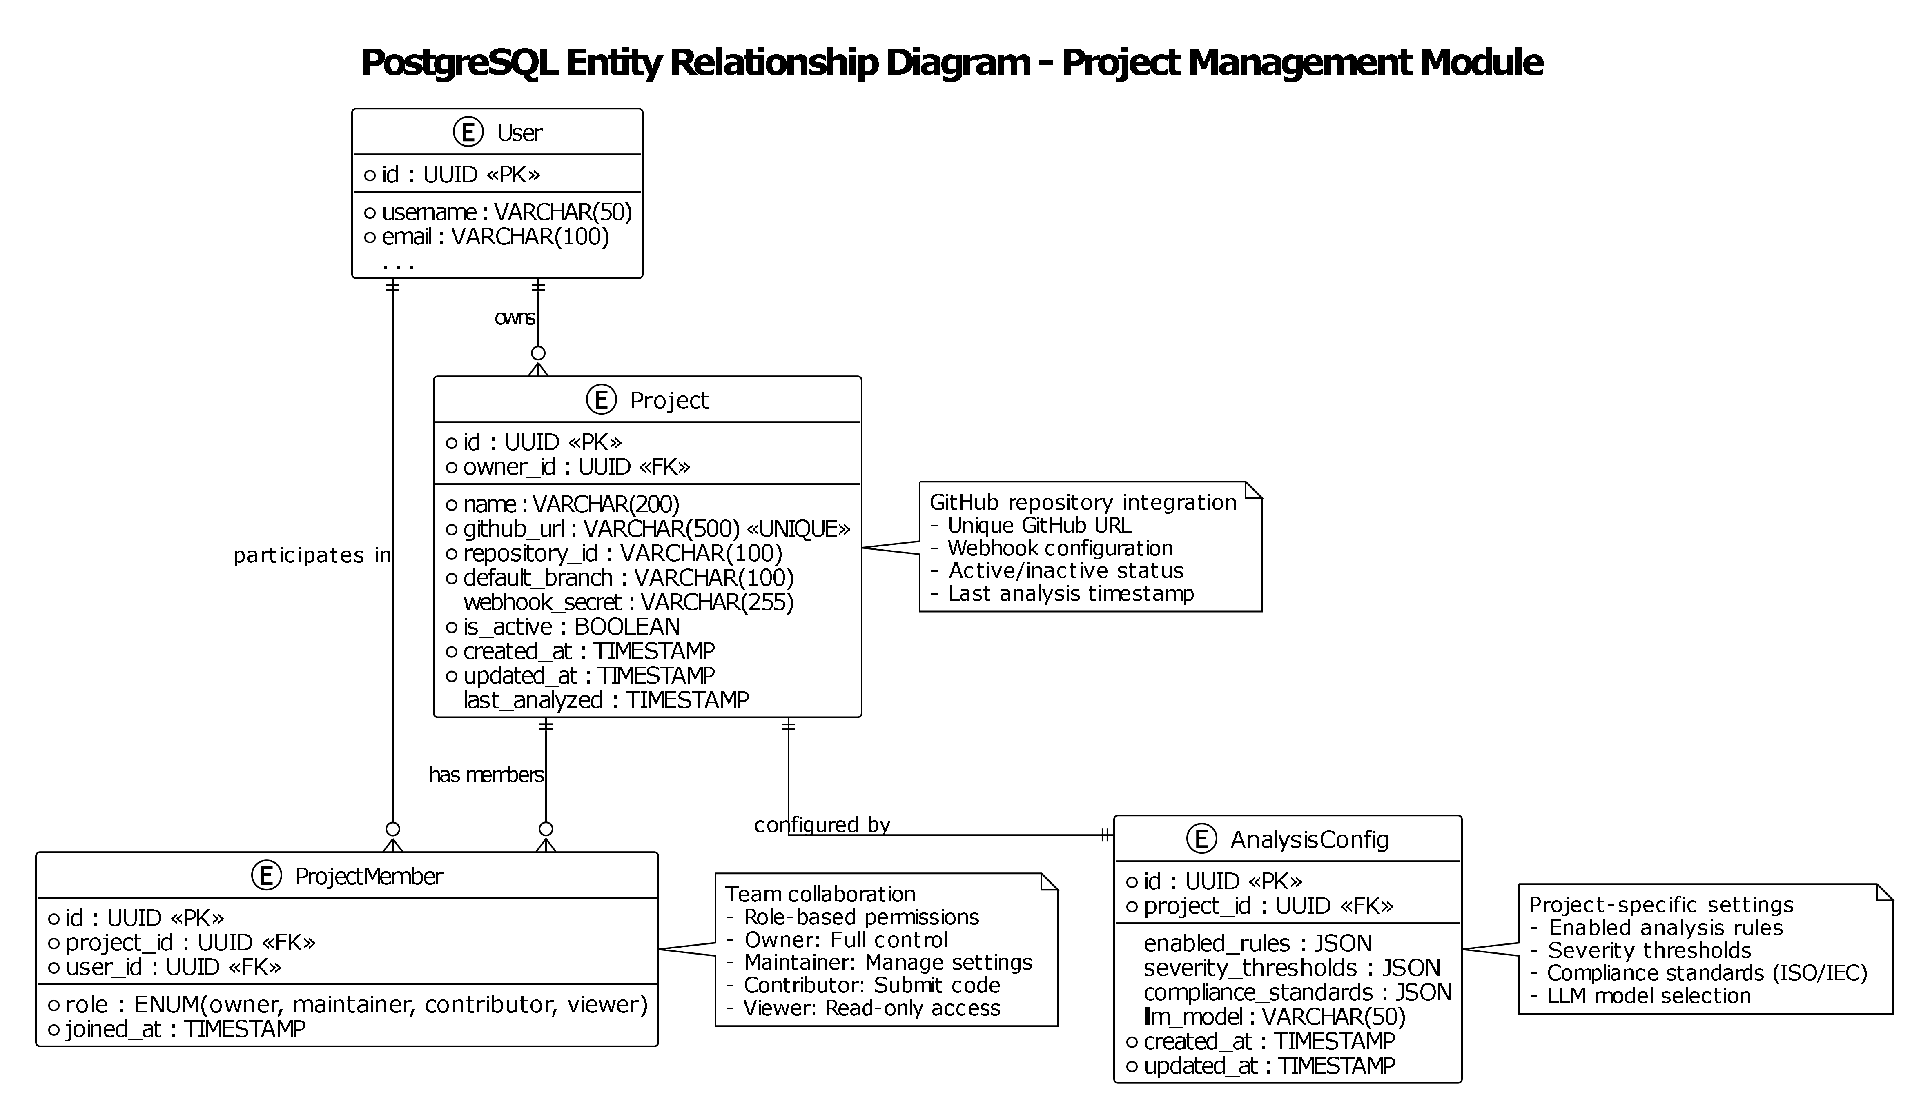

- Repositories (one-to-many with PullRequests)
- PullRequests (one-to-many with AnalysisResults)
- AnalysisResults (one-to-many with Issues)
- Issues (detected code issues)
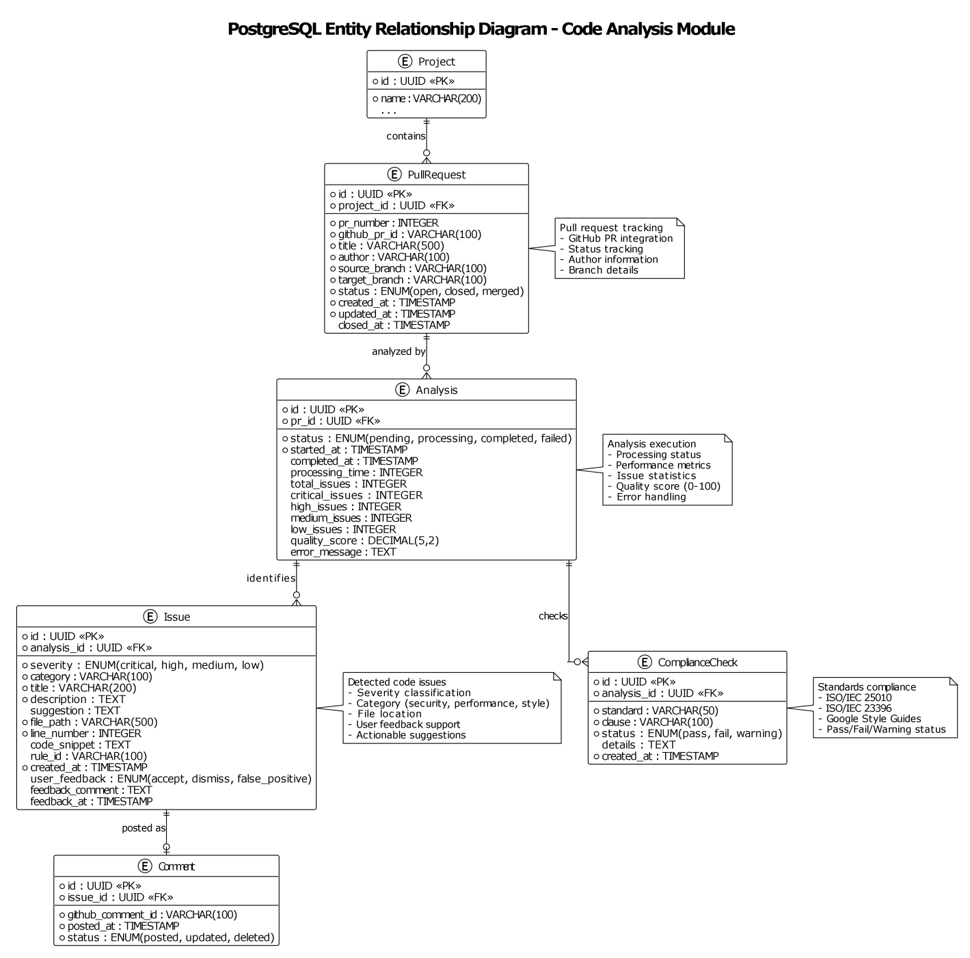

- AuditLogs (system activity tracking)
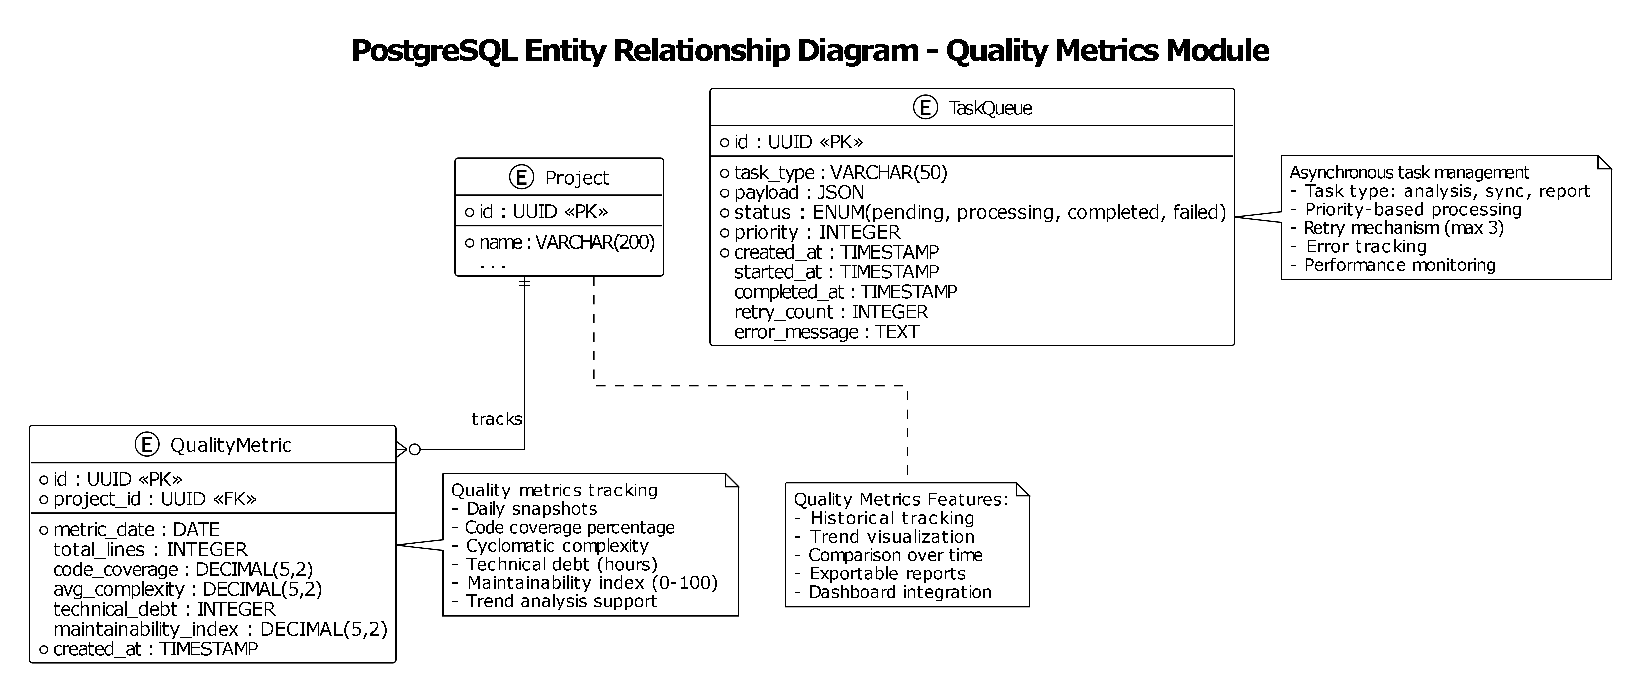

3.1.2 Neo4j Graph Entity Model
The graph database stores the code structure as a directed graph. Nodes represent code entities; edges (relationships) represent how those entities interact.
Node Type | Represents | Example
Module | A source code file or package | auth_service.py, utils/validators.py
Class | A class definition within a module | class AuthService, class UserRepository
Function | A function or method definition | def login(), async def analyze_pr()

Relationship Type | Direction | Meaning
DEPENDS_ON | Module -> Module | Module A imports or otherwise depends on Module B
CALLS | Function -> Function | Function A calls Function B
INHERITS | Class -> Class | Class A extends or implements Class B
CONTAINS | Module -> Class, Class -> Function | Structural containment (a class is defined inside a module; a method is defined inside a class)

- Module nodes (represents code modules/packages)
- Class nodes (represents classes)
- Function nodes (represents functions/methods)
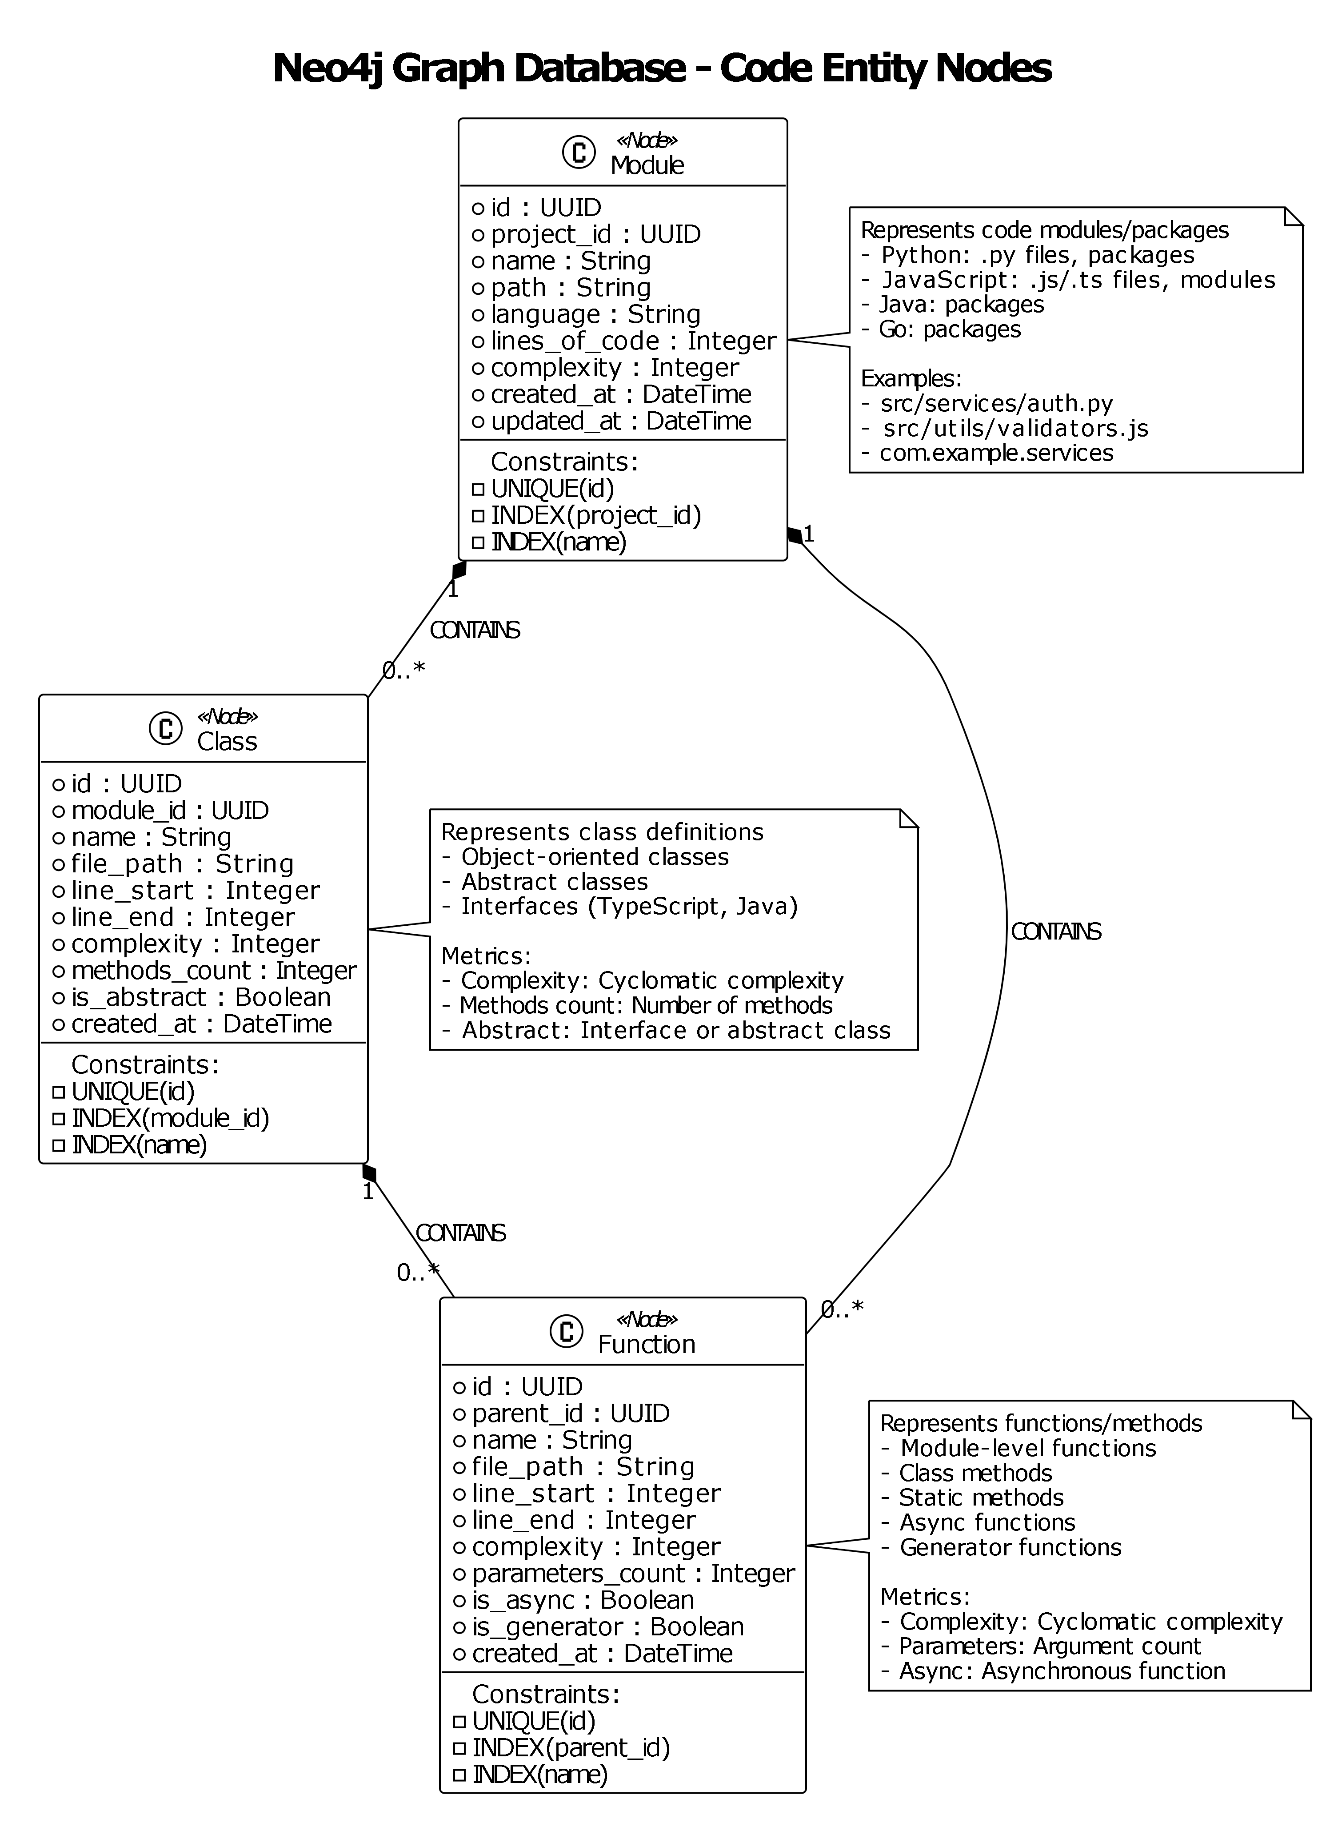

- DEPENDS_ON relationships (dependency edges)
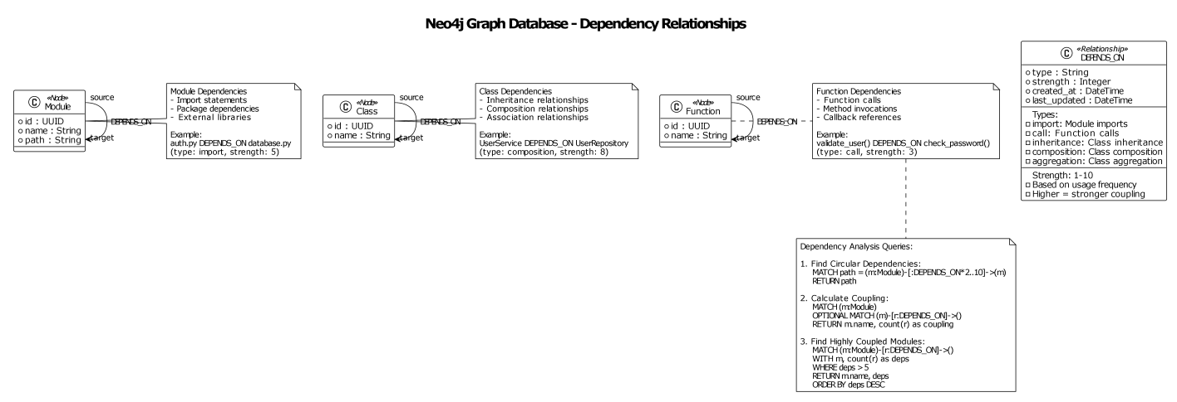

- CALLS relationships (function call edges)
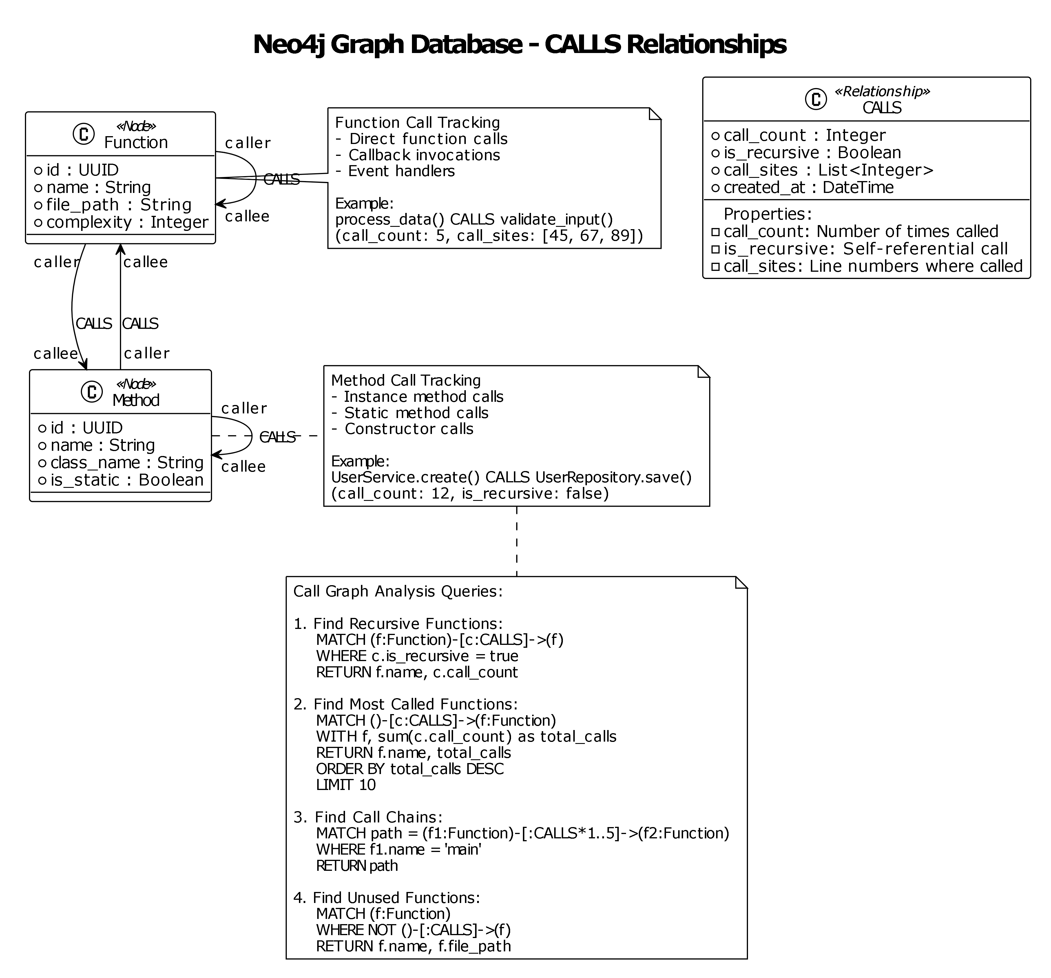

- INHERITS relationships (inheritance edges)
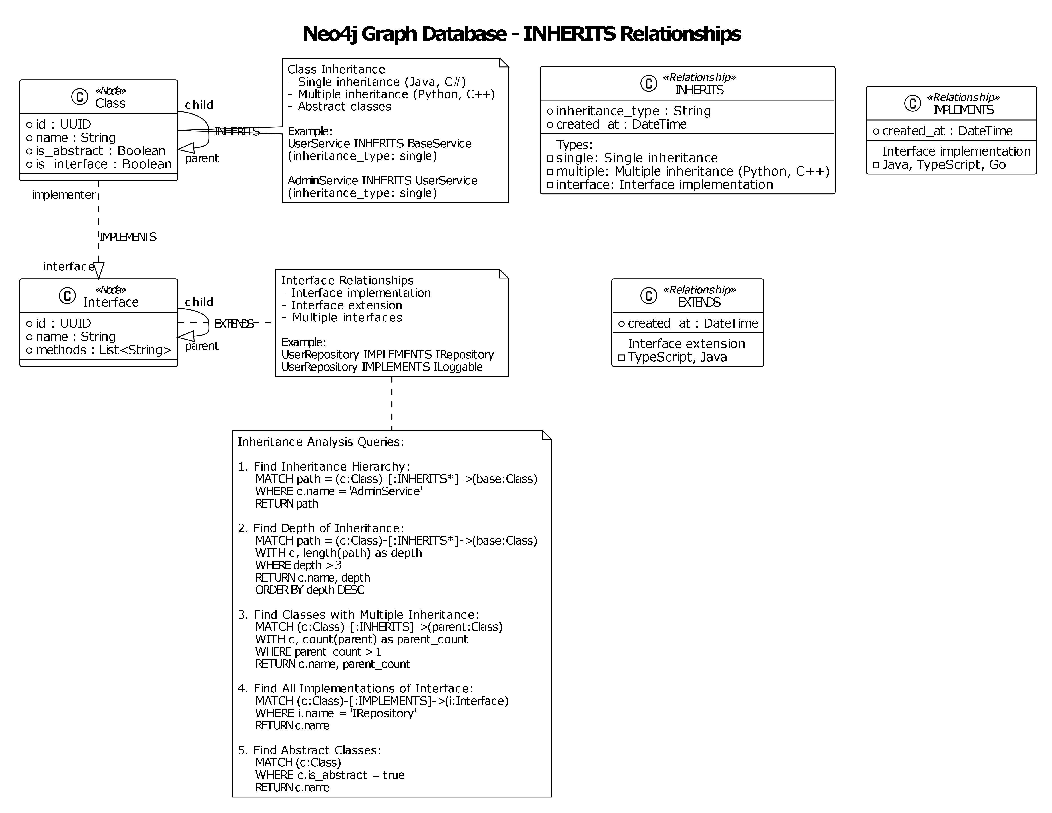

- Complete Graph Model
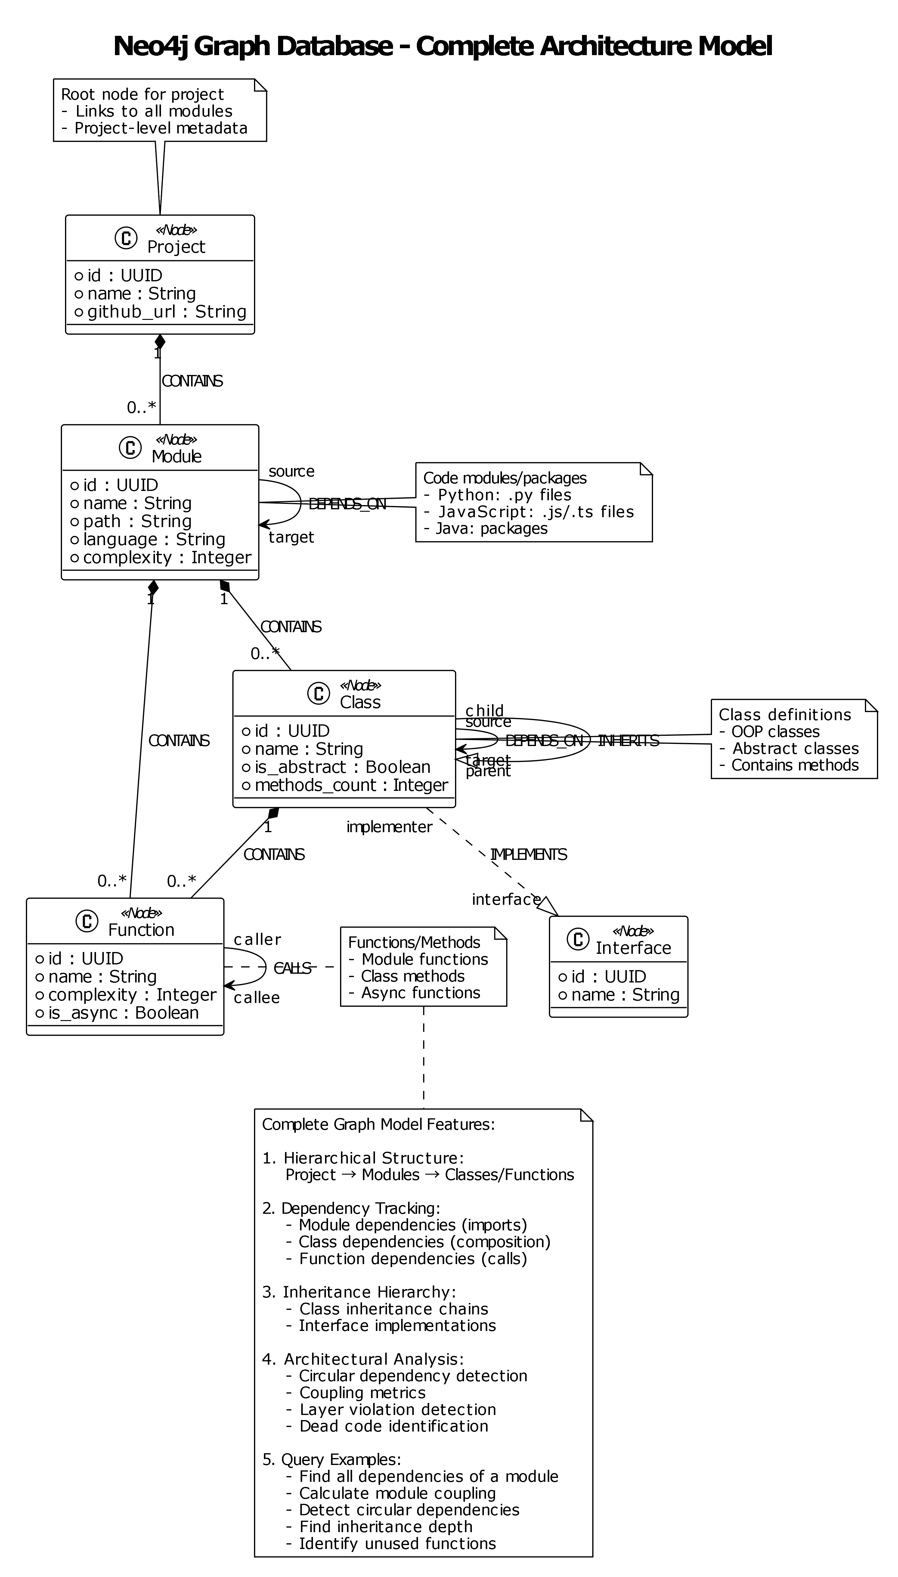

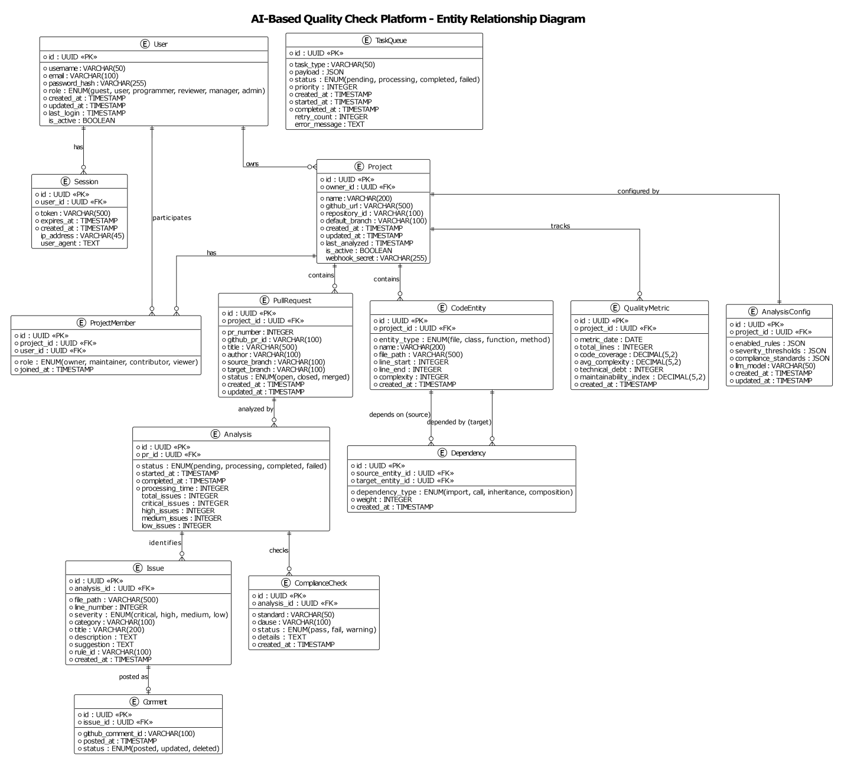

3.2 Data Dictionary
This subsection provides a detailed description of every table in the PostgreSQL database and every node/relationship type in the Neo4j graph database. For each table, all columns are listed with their data type, constraints, and a plain-English description of what the column holds.

3.2.1 PostgreSQL: Users Table
Stores one record per registered user. This is the central identity table; almost all other tables reference it. The Users table is the root identity table for the application and therefore supports authentication, ownership, project membership, and audit attribution. A clear description of this table is important because many later records derive meaning from which user performed an action or owns a particular project relationship.
Column | Type | Constraints | Description
id | UUID | Primary key | Unique user identifier.
email | VARCHAR(255) | UNIQUE, NOT NULL | Primary login identifier stored per user.
password_hash | VARCHAR(255) | NOT NULL | Credential stored only as a secure hash.
role | ENUM | NOT NULL | Primary system role such as ADMIN, MANAGER, REVIEWER, PROGRAMMER, or VISITOR.
full_name | VARCHAR(255) | NULLABLE | Display name for UI and audit context.
github_username | VARCHAR(255) | NULLABLE | Optional GitHub identity reference.
github_token | VARCHAR(500) | NULLABLE | Optional GitHub token or connection credential reference.
is_active | BOOLEAN | DEFAULT TRUE | Soft-activation flag for account management.
created_at | TIMESTAMP | DEFAULT NOW() | Account creation time.
updated_at | TIMESTAMP | DEFAULT NOW() | Last profile update time.
Indexes: email (for login lookup), username (case-insensitive, for lookup), role (for bulk permission queries).

3.2.2 PostgreSQL: Sessions Table
Tracks active authentication sessions. Storing sessions in the database enables the system to detect suspicious simultaneous logins and supports forced logout.
Column | Type | Constraints | Description
id | UUID | Primary Key, auto-generated | Unique identifier for this session record.
user_id | UUID | Foreign Key -> users(id), CASCADE DELETE | The user who owns this session.
access_token | VARCHAR(500) | NOT NULL | The JWT access token issued to the client.
refresh_token | VARCHAR(500) | NULLABLE | A longer-lived token that the client can use to obtain a new access token without re-authenticating.
expires_at | TIMESTAMP | NOT NULL | When the access token expires. Must be after created_at.
created_at | TIMESTAMP | DEFAULT NOW() | When the session was created.
ip_address | VARCHAR(45) | NULLABLE | The client's IP address at the time of login. Stored for security auditing.
user_agent | TEXT | NULLABLE | The client's browser or application identifier. Stored for security auditing.
is_revoked | BOOLEAN | DEFAULT FALSE | If TRUE, the session has been manually invalidated (e.g., the user logged out, or an admin force-revoked all sessions).
Indexes: user_id (to find all sessions for a user), access_token (for fast token validation), expires_at (for cleaning up expired sessions).

3.2.3 PostgreSQL: Projects Table
Stores one record per GitHub repository connected to the platform. Each project corresponds to exactly one GitHub repository. The Projects table is the organizational anchor for repository-specific work. It stores the metadata needed to identify a connected repository, associate it with an owner or team, manage analysis behavior, and distinguish one project's history from another's. A clear project anchor is essential because many later records, such as pull requests, analyses, and memberships, only make sense when tied back to the correct project.
Column | Type | Constraints | Description
id | UUID | Primary key | Unique project identifier.
owner_id | UUID | FK -> users.id | User who owns the project.
name | VARCHAR(255) | NOT NULL | Display name used in project lists and dashboards.
description | TEXT | NULLABLE | Project description and business context.
github_repo_url | VARCHAR(500) | UNIQUE, NULLABLE | Repository URL associated with the project.
github_connection_type | ENUM | DEFAULT https | Configured connection method such as https, ssh, or cli.
github_ssh_key_id | UUID | NULLABLE | Optional key reference for SSH-based repository access.
language | VARCHAR(50) | NULLABLE | Primary repository language or analysis hint.
is_active | BOOLEAN | DEFAULT TRUE | Active project flag.
created_at | TIMESTAMP | DEFAULT NOW() | Project creation time.
updated_at | TIMESTAMP | DEFAULT NOW() | Last project update time.
Indexes: owner_id, github_url, is_active.

3.2.4 PostgreSQL: Project Members Table
Records which users have been granted access to which projects, and in what role. This table supports collaborative team workflows where multiple people work on the same project.
Column | Type | Constraints | Description
id | UUID | Primary Key, auto-generated | Unique membership record identifier.
project_id | UUID | Foreign Key -> projects(id), CASCADE DELETE | The project to which access has been granted.
user_id | UUID | Foreign Key -> users(id), CASCADE DELETE | The user who has been granted access.
role | VARCHAR(20) | NOT NULL, CHECK constraint | The user's role within this specific project. One of: owner, maintainer, contributor, viewer.
joined_at | TIMESTAMP | DEFAULT NOW() | When the membership was created (i.e., when the user was added to the project).
Constraints: UNIQUE(project_id, user_id) - a user can only appear once per project. Indexes: project_id, user_id.

3.2.5 PostgreSQL: Pull Requests Table
Records each GitHub Pull Request that has been submitted for analysis. The platform mirrors key PR metadata here so that it does not need to re-query the GitHub API for display purposes.
Column | Type | Constraints | Description
id | UUID | Primary key | Internal pull-request record identifier.
project_id | UUID | FK -> projects.id | Project to which the pull request belongs.
author_id | UUID | NULLABLE FK -> users.id | Platform user mapped to the PR author when known.
github_pr_number | INTEGER | NOT NULL | Pull request number from GitHub.
title | VARCHAR(512) | NOT NULL | Pull request title.
description | TEXT | NULLABLE | Pull request body or summary text.
branch_name | VARCHAR(256) | NULLABLE | Source branch name.
commit_sha | VARCHAR(64) | NULLABLE | Relevant commit identifier for analysis.
status | ENUM | NOT NULL | Review lifecycle status such as pending, analyzing, reviewed, approved, rejected, or merged.
risk_score | INTEGER/FLOAT | NULLABLE | Aggregate risk or severity indicator.
analyzed_at | TIMESTAMP | NULLABLE | Timestamp when analysis completed or updated.
reviewed_at | TIMESTAMP | NULLABLE | Timestamp when review result was finalised.
Constraints: UNIQUE(project_id, pr_number). Indexes: project_id, status, author.

3.2.6 PostgreSQL: Analyses Table
Records each analysis job. A single Pull Request may be analysed multiple times (e.g., once per new commit push). This table stores the overall job status and aggregate counts. The Analyses table stores one record for each meaningful analysis run so that the platform can track status, timestamps, result counts, and history over time. This table is important because it separates the idea of a pull request from the idea of an execution event, allowing the system to compare repeated analyses of the same PR as the code evolves.
Column | Type | Constraints | Description
id | UUID | Primary key | Unique code-review record identifier.
pull_request_id | UUID | FK -> pull_requests.id | Associated pull request.
status | ENUM | NOT NULL | Review execution state such as pending, in_progress, completed, or failed.
summary | JSONB | NULLABLE | Structured summary returned by the review pipeline.
error | TEXT | NULLABLE | Error message captured when a review fails.
started_at | TIMESTAMP | NOT NULL | Start time for the review run.
completed_at | TIMESTAMP | NULLABLE | Completion time for the review run.
Indexes: pr_id, status, completed_at.

3.2.7 PostgreSQL: Issues Table
Stores every individual code issue detected during an analysis. This is the most detailed table in the system, as it records precise location, severity, and fix suggestions for each problem found.
Column | Type | Constraints | Description
id | UUID | Primary key | Unique review comment identifier.
review_id | UUID | FK -> code_reviews.id | Parent review record.
file_path | VARCHAR(1024) | NOT NULL | File associated with the finding.
line_number | INTEGER | NULLABLE | Approximate or exact impacted line number.
message | TEXT | NOT NULL | Human-readable finding description.
severity | VARCHAR(32) | NOT NULL | Severity level such as info, low, medium, high, or critical.
category | VARCHAR(64) | NULLABLE | Finding category such as security, performance, maintainability, or architecture.
rule_id | VARCHAR(128) | NULLABLE | Internal rule or provider-generated identifier.
rule_name | VARCHAR(256) | NULLABLE | Display name for the rule or pattern.
suggested_fix | TEXT | NULLABLE | Suggested remediation text.
iso_25010_characteristic | VARCHAR(128) | NULLABLE | Optional quality attribute mapping.
owasp_reference | VARCHAR(128) | NULLABLE | Optional OWASP reference for security findings.
created_at | TIMESTAMP | NOT NULL | Creation timestamp.
Indexes: analysis_id, severity, category, file_path.

3.2.8 PostgreSQL: Quality Metrics Table
Stores one snapshot of quality metrics per project per day. This table enables trend analysis - for example, showing whether test coverage has been improving or declining over the past three months.
Column | Type | Constraints | Description
id | UUID | Primary key | Unique architecture-analysis identifier.
pull_request_id | UUID | FK -> pull_requests.id | Pull request associated with the analysis.
status | ENUM | NOT NULL | Architecture analysis execution state.
summary | JSONB | NULLABLE | Aggregated architecture result and metrics.
error | TEXT | NULLABLE | Failure detail when analysis cannot complete.
started_at | TIMESTAMP | NOT NULL | Analysis start time.
completed_at | TIMESTAMP | NULLABLE | Analysis completion time.
Constraints: UNIQUE(project_id, metric_date) - only one snapshot per project per day. Indexes: project_id, metric_date.

3.2.9 PostgreSQL: Audit Logs Table
An immutable, append-only record of every security-relevant action performed in the system. Once written, rows in this table are never updated or deleted. This guarantees a tamper-evident audit trail for compliance and security investigation purposes.
Column | Type | Constraints | Description
id | UUID | Primary key | Unique architecture-violation identifier.
analysis_id | UUID | FK -> architecture_analyses.id | Parent architecture-analysis record.
type | VARCHAR(64) | NOT NULL | Violation type such as circular_dependency, layer_violation, or dependency_rule_violation.
component | VARCHAR(256) | NOT NULL | Primary impacted component.
related_component | VARCHAR(256) | NULLABLE | Secondary component or conflicting dependency.
message | TEXT | NOT NULL | Violation explanation.
severity | VARCHAR(32) | NOT NULL | Severity level for the structural issue.
file_path | VARCHAR(1024) | NULLABLE | Optional file reference.
line_number | INTEGER | NULLABLE | Optional line reference.
Immutability Enforcement: The API layer returns HTTP 403 Forbidden for any attempt to call UPDATE or DELETE on this table. Indexes: user_id, action, timestamp, (resource_type, resource_id) composite.

3.2.10 Neo4j: Node Properties
Each node type in the graph database has a defined set of properties. Node types correspond to structural elements of the source code.

Module Node - Represents a source code file or package
Column | Type | Constraints
id | UUID | Primary key
user_id | UUID | NULLABLE FK -> users.id
action | ENUM / VARCHAR(100) | NOT NULL
entity_type | VARCHAR(100) | NOT NULL
entity_id | UUID | NOT NULL / NULLABLE by event
changes | JSONB | NULLABLE
ip_address | INET / VARCHAR | NULLABLE
user_agent | TEXT | NULLABLE
timestamp | TIMESTAMP | DEFAULT NOW()

Class Node - Represents a class definition
Property | Type | Description
id | UUID | Unique identifier
module_id | UUID | The ID of the Module node that contains this class
name | String | The class name
file_path | String | Source file path
line_start | Integer | The line number where the class definition begins
line_end | Integer | The line number where the class definition ends
complexity | Integer | Total cyclomatic complexity of all methods in the class
methods_count | Integer | Number of methods defined in the class
is_abstract | Boolean | Whether the class is abstract (cannot be instantiated directly)

Function Node - Represents a function or method definition
Property | Type | Description
id | UUID | Unique identifier
parent_id | UUID | The ID of the containing Module or Class node
name | String | The function or method name
file_path | String | Source file path
line_start | Integer | Start line number
line_end | Integer | End line number
complexity | Integer | Cyclomatic complexity of this function
parameters_count | Integer | Number of input parameters
is_async | Boolean | Whether this is an asynchronous function (async def in Python)

3.2.11 Neo4j: Relationship Properties
Relationship properties add meaning to the graph beyond simple connectivity. They can describe the kind of dependency observed, where it originated, how strong or direct the relationship is, and whether it has architectural significance for drift detection or impact analysis. This detail is important because the platform is expected to explain why a structural issue matters, not only report that a connection exists.
Relationship | Direction | Key Properties | Description
DEPENDS_ON | Module -> Module | type, strength, last_seen | Represents import or dependency relationships in the code graph.
CALLS | Function -> Function | call_sites, frequency | Represents function or method invocation relationships when derived.
CONTAINS | Container -> Child | kind | Represents structural ownership such as module-to-class or class-to-method.
IMPLEMENTS / INHERITS | Class -> Interface/Class | inheritance_type | Represents object-oriented hierarchy when available from parsed code.

3.2.12 Neo4j: Common Query Patterns
The following query patterns are the backbone of the architectural analysis features. They are executed by the Architecture Analyzer service using the Cypher query language. The most important graph queries involve finding cycles, tracing cross-layer calls, identifying highly connected nodes, and locating structures that violate an expected architectural rule. These query patterns are central to the system's value because they turn raw dependency relationships into findings that developers and reviewers can understand and act upon during design and pull request review.
Query Pattern | Purpose | Approach
Circular Dependency Detection | Find all modules that form dependency cycles (A depends on B which depends on A, etc.). | Traverse DEPENDS_ON relationships using Johnson's algorithm; find elementary cycles of length 2 - 10 within a project's subgraph.
Module Coupling Calculation | Identify the most tightly coupled modules (those with the most incoming and outgoing dependencies). | Count incoming and outgoing DEPENDS_ON edges per module; rank by total coupling score.
Layer Violation Detection | Find dependencies that skip architectural layers (e.g., a UI module directly importing from the database layer). | Match DEPENDS_ON edges where the source module's path pattern matches a higher layer and the target matches a lower layer, without an intermediate service-layer edge.
Dependency Graph Export | Export the full dependency graph for visualization in the frontend. | Collect all Module nodes and their DEPENDS_ON targets; serialize as a JSON graph for D3.js rendering.

4. Detailed Design
This section provides the in-depth specification of every major component, module, and algorithm in the system. It covers class structure, service APIs, algorithm logic, exception handling, security implementation, deployment topology, performance tuning, observability instrumentation, and the architectural decision records that document why each major design choice was made.

4.1 Class Diagram (if Object-Oriented)

The system's class structure is divided into seven functional domains to keep each diagram readable. In a full diagram-supported version of this document, each domain has its own class diagram showing class attributes, method signatures, and inter-class relationships. The textual summary below captures the same information.

4.1.1 User Management Domain
- Model classes: User, Session, AuditLog - each maps to the corresponding PostgreSQL table.
- Service classes: AuthService (login/logout/token management), JWTManager (token creation and validation), PasswordHasher (bcrypt), PermissionChecker (delegates to RBACService).
- Repository classes: UserRepository, SessionRepository - abstract all database access for the domain.
- DTOs (Data Transfer Objects): RegisterDTO, LoginDTO, UserProfile, TokenPayload - define the shape of data sent between layers.
- Purpose: Handles all authentication, authorisation, session management, and audit logging.
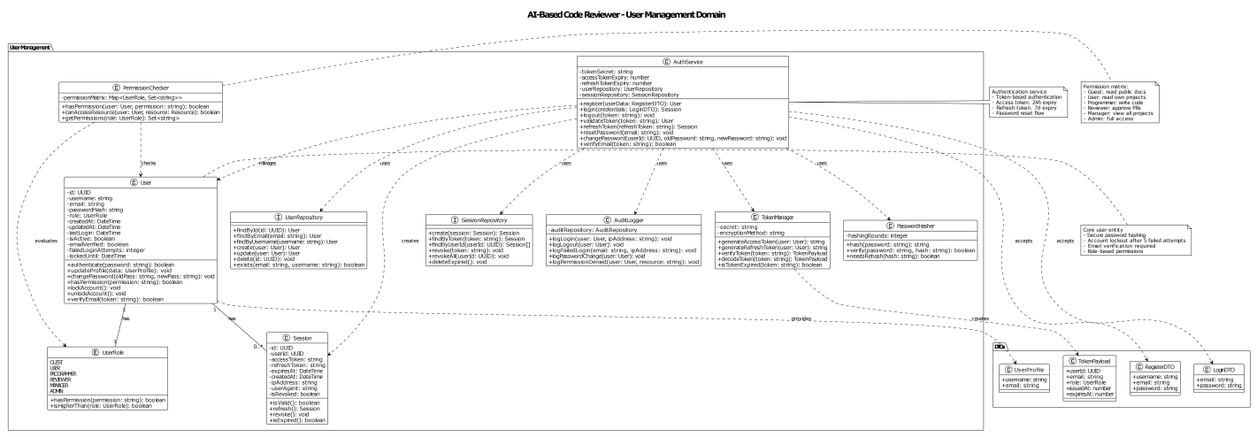
- Components: User, Session, AuthService, JWTManager, PasswordHasher, PermissionChecker
- Repositories: UserRepository, SessionRepository
- DTOs: RegisterDTO, LoginDTO, UserProfile, TokenPayload
- Purpose: Authentication, authorization, session management, audit logging

4.1.2 Project Management Domain
- Model classes: Project, ProjectMember, AnalysisConfig.
- Service classes: ProjectService (CRUD), WebhookService (GitHub webhook registration and validation), ConfigService (analysis rule configuration).
- Repository classes: ProjectRepository, ConfigRepository.
- DTOs: CreateProjectDTO, UpdateProjectDTO, ProjectConfig, QualityMetrics.
- Purpose: Manages GitHub repository connections, team membership, and analysis configuration.
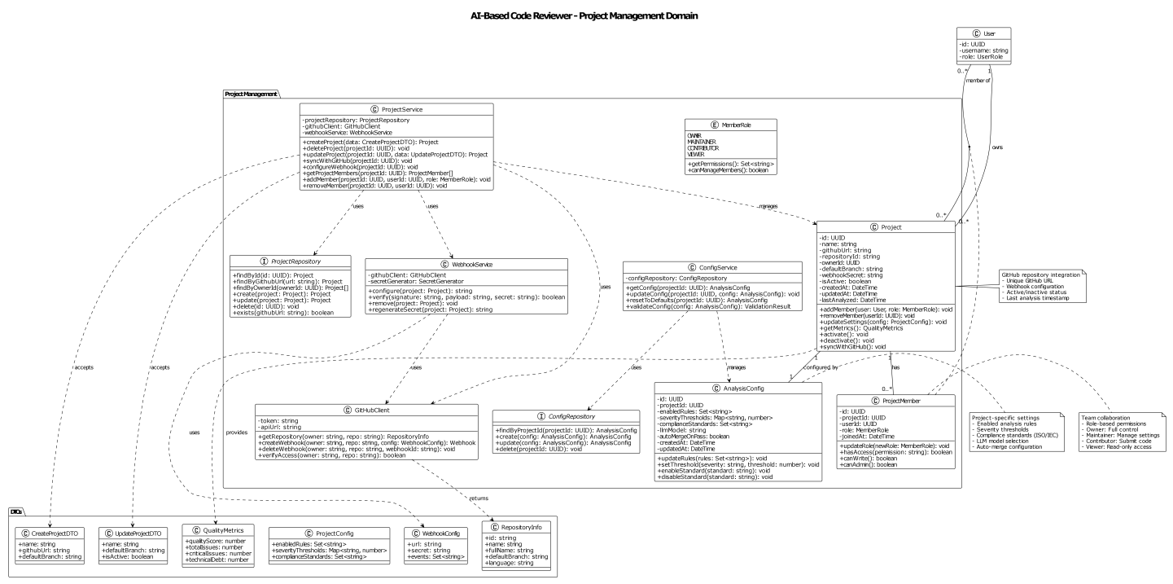
- Components: Project, ProjectMember, ProjectService, WebhookService, AnalysisConfig, ConfigService
- Repositories: ProjectRepository, ConfigRepository
- DTOs: CreateProjectDTO, UpdateProjectDTO, ProjectConfig, QualityMetrics
- Purpose: GitHub repository integration, team collaboration, project configuration

4.1.3 Code Analysis Domain
- Model classes: PullRequest, Analysis, Issue, Comment.
- Service classes: CodeReviewEngine (orchestrates analysis), ParserService (delegates to AST parser), IssueDetector (applies rules and AI results).
- Repository classes: AnalysisRepository, IssueRepository, CommentRepository.
- DTOs: AnalysisReport, IssueContext, ValidationResult, ComparisonResult.
- Purpose: Orchestrates PR analysis, issue detection, code review, and posting comments to GitHub.
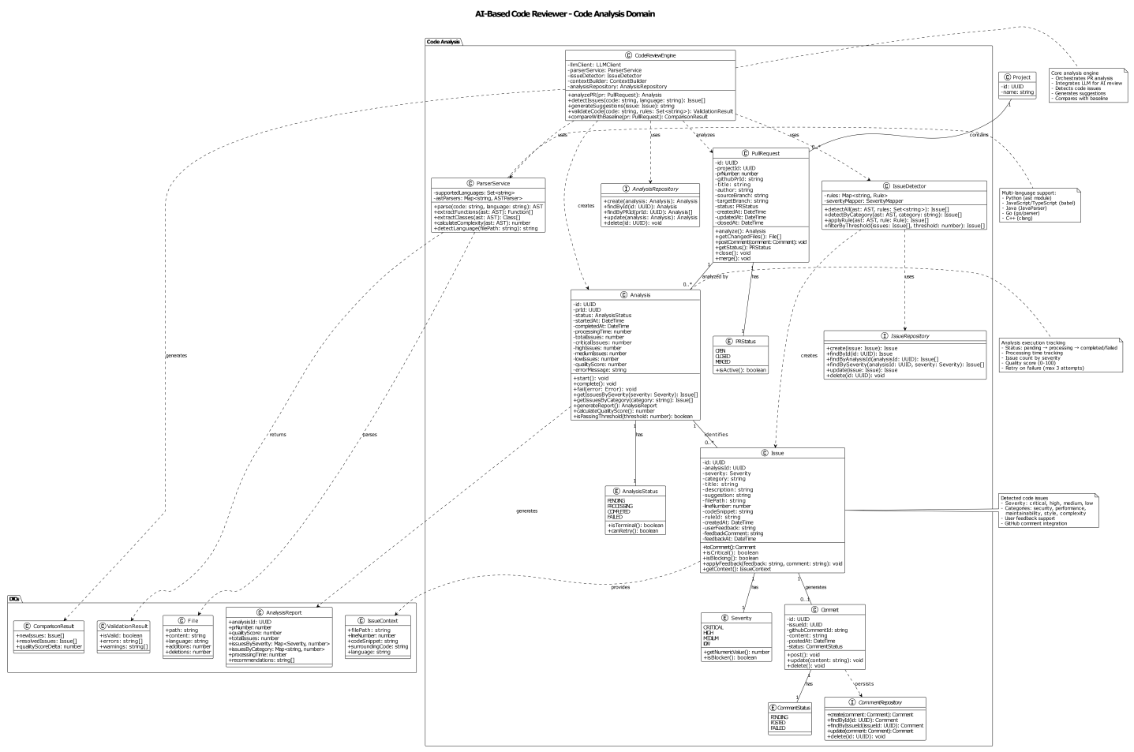
- Components: PullRequest, Analysis, Issue, Comment, CodeReviewEngine, ParserService, IssueDetector
- Repositories: AnalysisRepository, IssueRepository, CommentRepository
- DTOs: AnalysisReport, IssueContext, ValidationResult, ComparisonResult
- Purpose: PR analysis, issue detection, code review, GitHub comment integration

4.1.4 Architecture Analysis Domain
- Model classes: CodeEntity (module/class/function), Dependency.
- Service classes: ArchitectureAnalyzer (top-level orchestration), ASTParser (source code parsing), GraphBuilder (Neo4j operations), CircularDependencyDetector (cycle finding), LayerAnalyzer (layer rule enforcement).
- Repository classes: EntityRepository, DependencyRepository.
- DTOs: EntityMetrics, CouplingMetrics, DriftReport, GraphVisualization, Violation.
- Purpose: Builds the dependency graph, detects circular dependencies and layer violations, computes architectural drift.
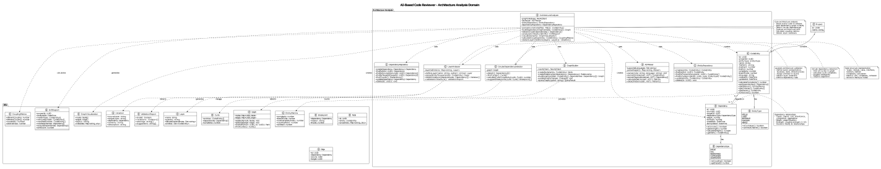
- Components: CodeEntity, Dependency, ArchitectureAnalyzer, ASTParser, GraphBuilder, CircularDependencyDetector, LayerAnalyzer
- Repositories: EntityRepository, DependencyRepository
- DTOs: EntityMetrics, CouplingMetrics, DriftReport, GraphVisualization, Violation
- Purpose: Code structure analysis, dependency graph, circular dependency detection, layer validation

4.1.5 AI Integration Domain
- Model classes: AgenticAI (top-level AI coordinator), LLMClient (provider abstraction), ContextBuilder (assembles prompt context), PromptManager (template management), ResponseParser (extracts structured data from LLM output), EmbeddingService, VectorStore.
- Support classes: RateLimiter, CacheManager, TokenCounter.
- DTOs: AIAnalysis, ReviewComment, CodeSuggestion, Pattern, Context, LLMResponse.
- Purpose: Manages LLM integration, AI-powered code review, semantic search, and prompt engineering.
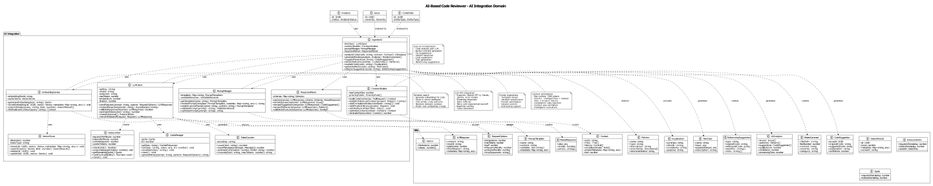
- Components: AgenticAI, LLMClient, ContextBuilder, PromptManager, ResponseParser, EmbeddingService, VectorStore
- Support: RateLimiter, CacheManager, TokenCounter
- DTOs: AIAnalysis, ReviewComment, CodeSuggestion, Pattern, Context, LLMResponse
- Purpose: LLM integration, AI-powered code review, semantic search, prompt management

4.1.6 Quality Metrics Domain
- Model classes: QualityMetric, ComplianceCheck.
- Service classes: MetricsService (orchestration), MetricCalculator, ComplexityCalculator, CoverageCalculator, TechnicalDebtCalculator.
- Analysis classes: MetricsAggregator, TrendAnalyzer, DashboardBuilder.
- Repository classes: MetricsRepository, ComplianceRepository.
- DTOs: MetricDelta, MetricTrend, Dashboard, Report, ComparisonReport.
- Purpose: Computes quality metrics, verifies compliance, generates trend data and dashboards.
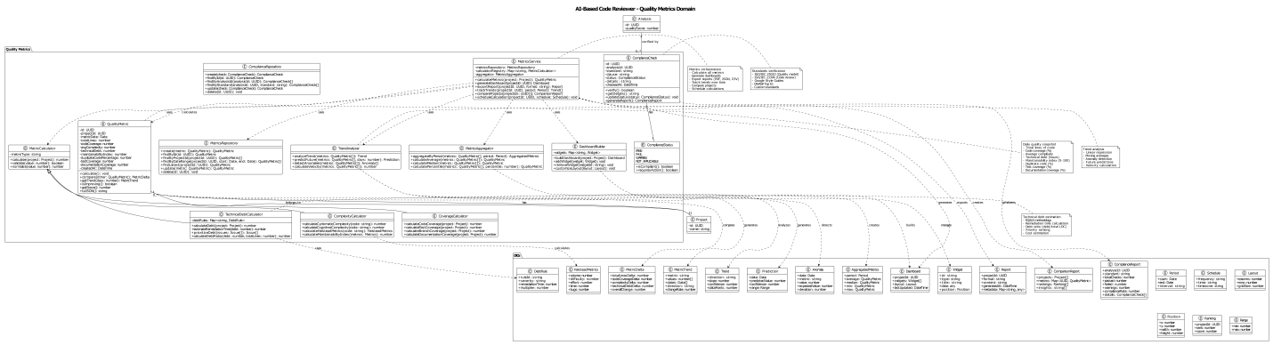
- Components: QualityMetric, ComplianceCheck, MetricsService, MetricCalculator, ComplexityCalculator, CoverageCalculator, TechnicalDebtCalculator
- Analysis: MetricsAggregator, TrendAnalyzer, DashboardBuilder
- Repositories: MetricsRepository, ComplianceRepository
- DTOs: MetricDelta, MetricTrend, Dashboard, Report, ComparisonReport
- Purpose: Quality metrics calculation, compliance verification, trend analysis, dashboard generation

4.1.7 Infrastructure Domain
- Client classes: GitHubClient, Neo4jClient, RedisClient, PostgreSQLClient, TaskQueue.
- Service classes: EmailService, LoggerService, MonitoringService, CacheService, FileStorageService.
- Support classes: WebhookHandler, RateLimiter, ConfigurationManager.
- DTOs: PRData, File, WebhookConfig, Node, Relationship, Task, HealthStatus.
- Purpose: Provides all external integrations, database client abstractions, the Celery task queue, monitoring, and caching.
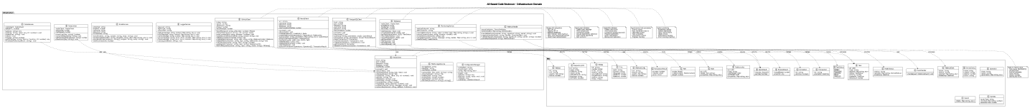
- Components: GitHubClient, Neo4jClient, RedisClient, PostgreSQLClient, TaskQueue
- Services: EmailService, LoggerService, MonitoringService, CacheService, FileStorageService
- Support: WebhookHandler, RateLimiter, ConfigurationManager
- DTOs: PRData, File, WebhookConfig, Node, Relationship, Task, HealthStatus
- Purpose: External integrations, database clients, task queue, monitoring, caching

4.1.8 Complete Class Diagram
The complete class diagram should show how models, services, repositories, DTOs, integration clients, and supporting utilities relate to one another without collapsing all concerns into a single layer. The purpose of the full diagram is to demonstrate that the implementation structure supports the logical architecture described earlier and that important concerns such as access control, data movement, and external integration remain organised.

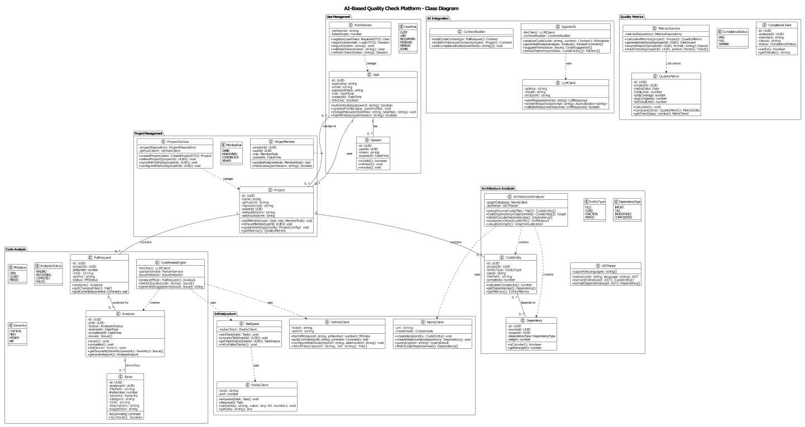

4.2 Component Design
This section provides implementation-level specifications for each major service and module, including their public interfaces, algorithms, and design decisions. Component design explains how each major service behaves internally and how it collaborates with the rest of the platform. At this level, the document should describe responsibilities, inputs, outputs, dependencies, error handling, and major design assumptions. This is the level of detail that future maintainers need when they are changing behavior rather than only trying to understand the high-level concept of the system.

4.2.1 Authentication Service
The Authentication Service is responsible for managing user identity: verifying credentials, issuing JWT tokens, and tracking active sessions. The authentication service is responsible for validating credentials, issuing tokens, maintaining session state, and contributing to the audit trail when security-relevant actions occur. A strong authentication design does more than allow login; it also supports logout, session refresh, failure handling, and the clear separation of identity verification from later role-based authorisation checks.
Attribute | Value
Technology | FastAPI, PyJWT, bcrypt, SQLAlchemy
Implementation file | enterprise_rbac_auth/services/auth_service.py
Design pattern | Stateless - all methods are @staticmethod; no instance state

Method Specifications
Method | Signature | Description
hash_password | (password: str) -> str | Hashes a plain-text password using bcrypt with a newly generated salt and cost factor 12. The result is stored in the database. The original password is never stored.
verify_password | (password: str, password_hash: str) -> bool | Checks whether a plain-text password matches a stored bcrypt hash. Returns True if they match, False otherwise.
generate_token | (user_id, username, role) -> str | Creates a signed JWT containing: user_id, username, role, issued-at (iat), expiry (exp = iat + 24h), and a unique token ID (jti) for future revocation support.
validate_token | (token: str) -> Optional[TokenPayload] | Decodes and validates a JWT. Returns the decoded payload if valid and not expired; returns None if the token is expired, tampered with, or otherwise invalid.
refresh_token | (token: str) -> Optional[str] | Issues a new token if the current token is within its final 10-minute validity window. This allows the client to seamlessly refresh without re-authenticating.
login | (db, username, password, ip_address, device_info) -> AuthResult | Verifies credentials, creates a Session record in PostgreSQL, updates last_login, and returns the new JWT. Returns a generic error message on failure to prevent username enumeration attacks.
logout | (db, user_id, token) -> bool | Marks the specified Session as revoked (is_revoked = True) so that subsequent requests with the same token are rejected.
invalidate_all_user_sessions | (db, user_id) -> bool | Marks all active sessions for the user as revoked. Used when a user changes their password or their account is deactivated.

4.2.2 RBAC Service
The Role-Based Access Control (RBAC) Service determines what each user is permitted to do. Think of it as the system's permission gatekeeper.
Attribute | Value
Technology | SQLAlchemy, Python Enum
Implementation file | enterprise_rbac_auth/services/rbac_service.py
Role hierarchy | ADMIN > MANAGER > REVIEWER > PROGRAMMER > VISITOR

Permission Matrix
A tick (✓) means the role has the permission. Empty cells mean the permission is not granted.
Permission | ADMIN | MANAGER | REVIEWER | PROGRAMMER | VISITOR
CREATE_USER | X
VIEW_USERS | X
UPDATE_USER | X
CREATE_PROJECT | X | X |  | X
VIEW_PROJECTS | X | X | X | X | X
UPDATE_PROJECT | X | X |  | X
VIEW_REVIEWS | X | X | X | X | X
MODIFY_REVIEW | X |  | X | X
EXPORT_REPORT | X | X | X
MODIFY_CONFIG | X
VIEW_CONFIG | X | X | X | X
GRANT_PROJECT_ACCESS | X |  |  | Owner only

Method Specifications
Method | Signature | Description
has_permission | (db, user_id, permission) -> bool | Looks up the user's system-wide role and checks whether that role includes the requested permission.
get_role_permissions | (role) -> list[Permission] | Returns the full list of permissions granted to a given role.
can_access_project | (db, user_id, project_id, permission) -> bool | Checks project-level access: ADMIN always returns True; the project owner always returns True; other users need an explicit ProjectAccess grant.
grant_project_access | (db, project_id, user_id, granted_by) -> bool | Creates a ProjectAccess record. Only the ADMIN or the project owner may call this method.
revoke_project_access | (db, project_id, user_id, revoked_by) -> bool | Deletes a ProjectAccess record. Only the ADMIN or the project owner may call this method.
assign_role | (db, user_id, new_role, assigned_by) -> bool | Updates the user's role. Only ADMIN may assign roles. The change takes effect immediately.
validate_role | (role: str) -> bool | Checks whether a string is a valid role name (i.e., it exists in the Role enum).

4.2.3 Audit Service
The Audit Service records every security-relevant action, creating an immutable trail for compliance investigation and security analysis. All writes to the audit log are append-only - no row is ever modified or deleted.
Attribute | Value
Technology | SQLAlchemy, PostgreSQL JSONB
Implementation file | enterprise_rbac_auth/services/audit_service.py
Immutability enforcement | The API layer returns HTTP 403 Forbidden for any UPDATE or DELETE operation on the audit_logs table.

Logged Action Codes
Category | Action Codes
Authentication | LOGIN, LOGOUT, LOGIN_FAILED
User Management | CREATE_USER, UPDATE_USER, DELETE_USER, UPDATE_USER_ROLE
Project Management | CREATE_PROJECT, UPDATE_PROJECT, DELETE_PROJECT
Access Control | GRANT_ACCESS, REVOKE_ACCESS
Analysis | TRIGGER_ANALYSIS, VIEW_ANALYSIS
Configuration | UPDATE_CONFIG

4.2.4 Authorization Middleware
The Authorization Middleware intercepts every incoming HTTP request before it reaches a route handler. It validates the JWT token, loads the user from the database, and checks that the user has the necessary role or permission for the requested operation.
Attribute | Value
Technology | FastAPI dependency injection, PyJWT
Implementation file | enterprise_rbac_auth/middleware/auth_middleware.py

Middleware Decision Flow
- Request arrives -> middleware extracts the Bearer token from the Authorization header.
- If no token or invalid format -> return HTTP 401 Unauthorized.
- validate_token() decodes the JWT. If expired or tampered -> return HTTP 401 Unauthorized.
- Load the corresponding user record from PostgreSQL. If user.is_active = FALSE -> return HTTP 401 Unauthorized.
- Check the required role or permission via RBACService. If denied -> return HTTP 403 Forbidden.
- If all checks pass -> inject the authenticated user object into the request context and forward to the route handler.

Dependency Function | Description
get_current_user(token, db) | FastAPI dependency that validates the token and returns the active User object. Used by all authenticated endpoints.
require_role(required_role) | Dependency factory that enforces a minimum role level. Returns a dependency function that fails with 403 if the user's role is below the required level.
require_permission(permission) | Dependency factory that enforces a specific permission. More granular than require_role.
require_project_access(permission) | Dependency factory that enforces project-level access by calling RBACService.can_access_project().

4.2.5 Architecture Evaluation Tools
This is a set of static analysis tools that run against the codebase to detect architectural compliance violations. They can be executed in the CI pipeline or on demand.
Attribute | Value
Technology | Python ast module, NetworkX (graph algorithms), pytest
Implementation directory | tools/architecture_evaluation/

Module File | Responsibility
layer_analyzer.py | Detects layer violations by analysing import path patterns. Uses the layer definitions table below to classify each module.
integration_analyzer.py | Builds a complete in-memory dependency graph from the codebase and applies circular dependency detection.
system_inspector.py | Inspects the running system for compliance with the defined architectural constraints (used in integration tests).
models.py | Defines the data models used by the tools: LayerViolation, CircularDependency, ArchitectureReport.

Layer Classification Rules
Layer Name | Import Path Patterns | Allowed Dependencies
frontend presentation | frontend/src/app/, frontend/src/components/ | frontend hooks/lib and backend APIs only
api endpoints | backend/app/api/v1/ | services, schemas, models, auth dependencies
service layer | backend/app/services/, backend/app/auth/services/ | models, schemas, database adapters, provider clients
persistence / infrastructure | backend/app/database/, backend/app/models/, backend/app/middleware/ | external runtimes and shared utilities; no frontend dependency
A violation occurs when a module in a higher layer (e.g., presentation) directly imports from a lower layer (e.g., data) without passing through the intermediate service layer.

4.2.6 AST Parser Module
The AST (Abstract Syntax Tree) Parser converts raw source code into a structured tree representation, making it possible to analyse the code programmatically. Think of an AST as a diagram that shows the logical structure of code - every function, class, loop, and condition becomes a node in the tree.
Attribute | Value
Module path | services/code-review-engine/src/parsers/ast_parser.py
Dependencies | Python ast (for Python code), tree-sitter (for multi-language support); internal: models.code_entity, utils.language_detector
Supported languages | Python, JavaScript, TypeScript, Java, Go

Public Interface
Method | Signature | Description
parse | (code: str, language: str) -> AST | Parses the provided source code string into an AST. Raises SyntaxError if the code is invalid; raises UnsupportedLanguageError if the language is not supported.
extract_entities | (ast: AST) -> List[CodeEntity] | Traverses the AST and extracts all code entities (classes, functions, variables) with their metadata (name, location, complexity).
extract_dependencies | (ast: AST) -> List[Dependency] | Traverses the AST to find all import statements, function calls, and inheritance declarations, returning them as typed Dependency objects.

Processing Algorithm
- Detect the programming language if not explicitly specified (by file extension or content heuristics).
- Select the appropriate parser engine: the Python ast module for Python files; tree-sitter for other languages.
- Parse the source code into an AST. Catch and annotate syntax errors rather than aborting entirely, so that partially valid files still yield some analysis results.
- Traverse the AST to extract entities (classes, functions, methods, module-level variables).
- Traverse the AST again to extract dependencies (import statements, function call sites, inheritance declarations).
- Calculate cyclomatic complexity and nesting depth for each function.
- Return the complete structured AST with attached metadata.

Error Handling
- Syntax errors: Return a partial AST with error annotations at the problematic node. Analysis continues on the valid portions of the file.
- Unsupported language: Raise UnsupportedLanguageError with a list of supported languages in the message.
- Parsing timeout (> 30 seconds): Abort and return a timeout error. Prevents the system from hanging on pathologically large or complex files.

Performance Considerations
- Parsed ASTs are cached by the SHA-256 hash of the source file content, so unchanged files are not re-parsed on subsequent analyses.
- For large files, only the changed sections (as indicated by the Git diff) are parsed incrementally.
- AST traversal depth is limited to prevent stack overflow on deeply nested code.

4.2.7 Dependency Graph Builder Module
The Dependency Graph Builder takes the structured output of the AST Parser (a list of code entities and their dependencies) and persists this information into Neo4j, building the live dependency graph that powers architectural analysis.
Attribute | Value
Module path | services/architecture-analyzer/src/graph/graph_builder.py
Dependencies | Neo4j Python driver; internal: models.code_entity, models.dependency, database.neo4j_client

Public Interface
Method | Signature | Description
build_graph | (project_id: UUID, entities: List[CodeEntity], dependencies: List[Dependency]) -> GraphMetrics | Builds the complete dependency graph for a project from scratch. Returns metrics including node and edge counts and build duration.
update_graph | (project_id: UUID, changed_files: List[str], entities: List[CodeEntity], dependencies: List[Dependency]) -> GraphMetrics | Incrementally updates the graph for the files changed in a pull request. Significantly faster than a full rebuild for large repositories.
delete_entities | (project_id: UUID, file_paths: List[str]) -> int | Removes all nodes and relationships associated with deleted files. Returns the number of deleted nodes.

Build Algorithm
- Open a Neo4j transaction.
- For each entity, execute a CREATE OR MERGE node operation (MERGE ensures idempotency - running the same build twice does not create duplicate nodes).
- For each dependency, execute a CREATE OR MERGE relationship operation.
- Create indexes on project_id, entity name, and file path to support fast querying.
- Calculate graph metrics (node count, edge count, graph density).
- Commit the transaction. If any step fails, roll back entirely to maintain consistency.
- Return the metrics.

Transaction Management
- All writes are wrapped in explicit Neo4j transactions for atomicity.
- Operations are batched in groups of 1,000 to balance performance and memory usage.
- Transient failures (e.g., brief network interruption) are retried up to 3 times with exponential backoff (1 s, 2 s, 4 s).

4.2.8 Circular Dependency Detector Module
This module identifies circular dependencies in the codebase - situations where Module A depends on Module B which depends back on Module A (directly or through a chain of other modules). Circular dependencies are a significant architectural problem because they create tight coupling that makes the codebase harder to understand, test, and modify.
Attribute | Value
Module path | services/architecture-analyzer/src/analysis/circular_dependency_detector.py
Dependencies | NetworkX (graph algorithms); internal: database.neo4j_client, models.circular_dependency
Algorithm | Johnson's Algorithm for finding all elementary cycles in a directed graph

Public Interface
Method | Signature | Description
detect_cycles | (project_id: UUID, max_cycle_length: int = 10) -> List[CircularDependency] | Detects all circular dependency cycles in the project's dependency graph. Returns them sorted by severity (most severe first).
analyze_cycle_impact | (cycle: CircularDependency) -> CycleImpact | For a given cycle, calculates its severity, identifies the weakest dependency link (the best place to break the cycle), and generates a suggested fix.

Algorithm Steps (Johnson's Algorithm)
- Query Neo4j to retrieve all DEPENDS_ON relationships for the project. Build an in-memory directed graph using NetworkX.
- Apply Johnson's algorithm to find all elementary cycles (cycles where no node is visited more than once).
- Filter out cycles longer than max_cycle_length (default: 10 modules) to keep results actionable.
- For each detected cycle: compute a severity score based on cycle length and the coupling strength of the participating modules; identify the weakest dependency (lowest strength score) as the suggested break point; generate a plain-language remediation suggestion.
- Sort cycles by severity in descending order (most critical first).
- Return the list of CircularDependency objects.

Performance Characteristics
- Time complexity: O((n + e)(c + 1)) where n = nodes, e = edges, c = number of cycles.
- Practical limit: Graphs with fewer than 10,000 nodes and 100,000 edges.
- Early termination: If more than 100 cycles are detected, the algorithm stops and reports the first 100 (sorted by severity). A warning is added to the report.
- Graph structure is cached between analyses and invalidated only when the graph changes, avoiding redundant Neo4j queries.

4.2.9 LLM Integration Module
The LLM Integration Module abstracts the communication with external AI providers (OpenAI, Anthropic) behind a unified interface. It handles prompt construction, provider selection, rate limiting, error recovery, and response parsing.
Attribute | Value
Module path | services/agentic-ai/src/clients/llm_client.py
Supported providers | OpenAI GPT-4 (primary), Anthropic Claude 3.5 Sonnet (secondary), Azure OpenAI (tertiary), rule-based fallback (no LLM)
Dependencies | openai Python SDK, anthropic Python SDK; internal: models.llm_request, models.llm_response, utils.rate_limiter

Public Interface
Method | Signature | Description
analyze_code | (code: str, context: ArchitecturalContext, analysis_type: AnalysisType) -> LLMAnalysis | Sends the code and its architectural context to the LLM and returns a structured list of detected issues with severity levels, categories, and fix suggestions.
generate_fix_suggestion | (issue: Issue, code_context: str) -> FixSuggestion | Given a specific issue and the surrounding code, asks the LLM to generate a concrete code fix with an explanation.

Prompt Engineering Strategy
Prompts are structured in five layers to maximise the quality and consistency of LLM responses:
- System Prompt: Establishes the LLM's role as an expert code reviewer with knowledge of software architecture and the project's compliance standards.
- Context Injection: Provides architectural context - the module's layer, its dependencies, any known violations, and the average complexity of the project.
- Code Snippet: The actual code to review, with line numbers and file path.
- Analysis Instructions: Specifies the analysis type (security / performance / architecture / style), severity thresholds, and required output format (JSON array of issues).
- Few-Shot Examples: 2 - 3 examples of well-structured issue reports are included at the end of the prompt to guide the model towards consistent output format.

Provider Fallback Chain
Priority | Provider | Rationale
1 (Primary configurable) | OpenAI-compatible provider | Stable structured responses for review workflows and strong model quality.
2 (Secondary configurable) | Anthropic-compatible provider | Fallback or alternate reasoning path with good code understanding.
3 (Optional extension) | DeepSeek-compatible provider | Cost-flexible alternate provider where supported by configuration.
4 (Local/offline option) | Ollama or rule-based fallback | Supports local experimentation or degraded operation when hosted providers are unavailable.

Rate Limits and Error Handling
Error Condition | Response
Request timeout (> 30 s) | Retry once; if still timing out, fall back to next provider in chain.
Rate limit exceeded | Queue the request in Redis; retry after the backoff period. Return HTTP 429 if queue depth exceeds 100 pending requests.
Invalid / unparseable response | Log the error; return an empty analysis result with an error flag so that the overall analysis job can continue.
API key invalid or revoked | Alert the operations team; disable the affected provider; route all traffic to the next provider in the fallback chain.

4.2.10 Architectural Drift Detection Module
Architectural drift occurs when a codebase gradually deviates from its intended design. This module detects that drift by comparing the current state of the dependency graph against a previously saved baseline snapshot.
Attribute | Value
Module path | services/architecture-analyzer/src/analysis/drift_detector.py
Dependencies | Internal: database.neo4j_client, models.architecture_baseline, models.drift_report

Public Interface
Method | Signature | Description
detect_drift | (project_id: UUID, baseline_id: UUID) -> DriftReport | Compares the current architecture against the specified baseline and returns a report describing what has changed, any new violations, and a numeric drift score.
create_baseline | (project_id: UUID, description: str) -> ArchitectureBaseline | Captures the current state of the dependency graph as a named baseline. The system retains the last 10 baselines per project.

Drift Detection Algorithm
- Load the baseline architecture snapshot (stored as compressed JSON in PostgreSQL).
- Load the current architecture from Neo4j.
- Compare module lists: identify new modules, removed modules, and modified modules.
- Compare dependency lists: identify new dependencies (potential coupling increase), removed dependencies (potential breaking changes), and strengthened dependencies.
- Detect layer violations: find any DEPENDS_ON edges that skip architectural layers or reverse the allowed direction.
- Compute the drift score using the weighted formula below.
- Generate plain-language remediation recommendations.
- Return the DriftReport.

Drift Score Formula
The drift score is a number from 0 (no drift) to 100 (maximum drift). Higher scores indicate that the codebase has diverged significantly from its baseline.
drift_score = (
new_dependencies_weight * new_deps_count + # weight = 1
removed_dependencies_weight * removed_deps_count + # weight = 2
layer_violations_weight * violations_count + # weight = 5
circular_dependencies_weight * cycles_count # weight = 10
) / total_modules * 100

Baseline Storage
- Baselines are stored as compressed JSON in PostgreSQL (gzip for payloads > 1 MB).
- Each baseline contains: the list of modules, the list of dependencies, the layer definitions, and the capture timestamp.
- The system retains the 10 most recent baselines per project. Older ones are automatically archived.

4.3 Core Algorithm Designs
This section describes in precise terms the key algorithms that power the system's analysis capabilities. Each algorithm is explained in plain language first and then in formal pseudocode. The core algorithms in this project are what turn static data into actionable insight. They include structural analysis of source code, cycle detection, quality scoring, rule-based architecture checks, and the preparation of context for AI-assisted review. Documenting these algorithms matters because users and reviewers should be able to understand where the platform's findings come from and why particular issues are highlighted.

4.3.1 Circular Dependency Detection - Johnson's Algorithm
Johnson's algorithm finds all elementary cycles (loops) in a directed graph. An elementary cycle is a closed path where no node is visited more than once. In this system, each node is a code module and each edge is a dependency relationship.
In plain terms: the algorithm asks, starting from each module, is it possible to follow dependency arrows and eventually return to the same module? If yes, that's a circular dependency.
function find_all_cycles(graph G, max_length):
cycles = []
for each strongly_connected_component SCC in G:
if |SCC| == 1 and no self-loop: continue // trivial component
subgraph = induced_subgraph(G, SCC)
for each vertex v in subgraph:
blocked = empty_set()
blocked_map = {}
circuit(v, v, blocked, blocked_map, [v], cycles, max_length)
return rank_by_severity(cycles)

function circuit(start, current, blocked, blocked_map, path, cycles, max_length):
if len(path) > max_length: return false
blocked.add(current)
cycle_found = false
for each neighbor of current:
if neighbor == start:
cycles.append(copy(path)) // found a cycle
cycle_found = true
elif neighbor not in blocked:
if circuit(start, neighbor, blocked, blocked_map, path + [neighbor], cycles, max_length):
cycle_found = true
if cycle_found: unblock(current, blocked, blocked_map)
else: add current to blocked_map[neighbor] for each neighbor
return cycle_found

4.3.2 Cyclomatic Complexity Calculation - McCabe's Algorithm
Cyclomatic complexity is a measure of how many independent execution paths exist through a function. A function with no branches (no if/while/for) has complexity 1. Each decision point adds 1. Higher complexity means the function is harder to test and understand.
Formula: M = E − N + 2P, where E = edges in the control-flow graph, N = nodes, P = connected components (usually 1).
Interpretation guide:
Complexity Range | Risk Level | Action
1 - 10 | Low | No action required
11 - 20 | Moderate | Consider refactoring into smaller functions
21 - 50 | High | Refactoring strongly recommended
51+ | Very High | Must refactor before merge (flagged as critical issue)

4.3.3 Layer Violation Detection Algorithm
The system enforces a strict four-layer architecture: Presentation -> Application -> Domain -> Infrastructure. A dependency from a higher layer directly to a lower-than-adjacent layer is a violation.
Layer | Path Patterns | Allowed to depend on
1 - Presentation | api/, routes/ | Application layer only
2 - Application | services/ | Domain layer and Infrastructure layer
3 - Domain | models/, database/ | Infrastructure layer only
4 - Infrastructure | External libs, DB clients | Nothing (leaf layer)
Two violation types are detected: UPWARD_DEPENDENCY (a lower layer depending on a higher one - e.g., a database model importing a service function) and LAYER_SKIP (skipping an intermediate layer - e.g., a UI route directly importing a database model). UPWARD_DEPENDENCY is flagged as HIGH severity; LAYER_SKIP as MEDIUM.

4.3.4 Code Quality Score Formula
The overall quality score is a weighted average of five measurable dimensions. The score ranges from 0 (worst) to 100 (best).
Dimension | Weight | What is Measured
Test Coverage | 30 % | Percentage of code executed by automated tests
Complexity | 25 % | Inverse of average cyclomatic complexity (lower complexity -> higher score)
Code Duplication | 20 % | Inverse of the percentage of duplicated code blocks
Issue Density | 15 % | Inverse of a weighted count of detected issues per 1,000 lines of code
Documentation | 10 % | Percentage of public functions and classes with docstrings
Issue density is weighted by severity: critical issues count 10×, high 5×, medium 2×, low 1×. This ensures that a few critical issues have a larger negative impact than many minor style suggestions.

4.3.5 LLM Prompt Engineering Algorithm
Each prompt sent to the LLM is dynamically constructed by the ContextBuilder class. The prompt follows a structured template designed to produce consistent, parseable JSON output.
The response parsing pipeline: (1) extract the JSON block from the LLM response, (2) validate it against the expected schema, (3) filter out issues with confidence score below 0.7, (4) deduplicate similar issues (cosine similarity > 0.9), (5) rank by severity and confidence, (6) return the top 20 issues.

4.4 Global Exception Handling Architecture
Robust exception handling is critical for a system that integrates with multiple external APIs (GitHub, LLM providers, Neo4j). This section describes the exception hierarchy, handling strategy at each layer, and the standard error response format returned to API clients.

4.4.1 Exception Hierarchy
All application exceptions inherit from BaseApplicationException, which carries an HTTP status code, an error type code, and a human-readable message. This makes it straightforward to map any exception to a standard HTTP response.
BaseApplicationException
├── AuthenticationException
│ ├── InvalidCredentialsException
│ ├── TokenExpiredException
│ ├── TokenInvalidException
│ └── AccountLockedException
├── AuthorizationException
│ ├── InsufficientPermissionsException
│ └── ResourceAccessDeniedException
├── ValidationException
│ ├── InvalidInputException
│ ├── SchemaValidationException
│ └── BusinessRuleViolationException
├── ResourceException
│ ├── ResourceNotFoundException
│ ├── ResourceAlreadyExistsException
│ └── ResourceConflictException
├── ExternalServiceException
│ ├── GitHubAPIException
│ ├── LLMAPIException
│ ├── DatabaseException
│ └── CacheException
├── AnalysisException
│ ├── ParsingException
│ ├── AnalysisTimeoutException
│ └── UnsupportedLanguageException
└── SystemException
├── ConfigurationException
├── InternalServerException
└── ServiceUnavailableException

4.4.2 HTTP Status Code Mapping
HTTP status code mapping should make the API predictable by distinguishing successful reads, accepted background jobs, invalid requests, authentication failures, permission failures, missing resources, and internal processing problems. Consistent status mapping makes the system easier to test, easier to integrate with, and easier to troubleshoot because clients can respond correctly to different classes of outcome.
HTTP Status | Exception Type
400 Bad Request | ValidationException, InvalidInputException
401 Unauthorized | AuthenticationException, TokenExpiredException
403 Forbidden | AuthorizationException, InsufficientPermissionsException
404 Not Found | ResourceNotFoundException
409 Conflict | ResourceConflictException, ResourceAlreadyExistsException
422 Unprocessable Entity | SchemaValidationException (Pydantic validation errors)
429 Too Many Requests | RateLimitExceededException
500 Internal Server Error | InternalServerException, SystemException
502 Bad Gateway | ExternalServiceException (upstream failure)
503 Service Unavailable | ServiceUnavailableException
504 Gateway Timeout | AnalysisTimeoutException

4.4.3 Standard Error Response Format
All error responses follow a consistent JSON structure. This allows clients to handle errors programmatically without parsing free-text messages.
{
"error": {
"type": "RESOURCE_NOT_FOUND",
"message": "Project with ID 'abc-123' was not found.",
"details": {
"resource_type": "project",
"resource_id": "abc-123"
},
"request_id": "req_7f8a9b2c",
"timestamp": "2026-02-20T10:30:00Z",
"documentation_url": "https://docs.example.com/errors/resource-not-found"
}
}

4.4.4 Retry and Circuit Breaker Strategy
To handle transient failures (e.g., brief network interruptions when calling GitHub or LLM APIs), the system implements two resilience patterns:
Retry with Exponential Backoff
Requests to external services are retried up to 3 times. The delay between retries doubles each time (1 s -> 2 s -> 4 s) to avoid overwhelming a service that is struggling. Only transient error types (ConnectionError, TimeoutError, ServiceUnavailableException) trigger retries.
Circuit Breaker
The circuit breaker pattern prevents cascading failures when an external service is consistently unavailable. When 5 consecutive failures are detected, the circuit 'opens': subsequent requests fail immediately without attempting to call the service, giving it time to recover. After 60 seconds, the circuit enters a 'half-open' state and allows one test request through. If that succeeds, the circuit closes (normal operation resumes); if it fails, the circuit opens again.

4.5 Detailed Security Design
Security is implemented in six independent layers. A failure in any one layer does not expose the system, because the remaining layers continue to provide protection. The security design should explain how authentication, authorisation, validation, token handling, protected configuration, audit logging, and safe integration with external services work together across the whole platform. Security is strongest when these controls reinforce one another rather than existing as disconnected features, because the system must remain safe even when individual inputs, events, or dependencies behave unexpectedly.

4.5.1 Security Layers Overview
Security in this platform should be layered. Identity verification controls access at the front door, authorisation controls what actions are permitted after sign-in, validation and sanitisation protect internal processing from unsafe input, protected storage reduces exposure of sensitive data, and audit logging preserves visibility when important actions occur. The purpose of layering is to reduce reliance on any single protective mechanism.
Layer | Controls | Technology
1 - Network Security | Reverse-proxy access control, TLS 1.3 encryption of all traffic, and host-level firewall rules | Nginx or equivalent reverse proxy, TLS certificates, operating-system firewall
2 - API Gateway Security | Rate limiting (100 req/min per user), request size limits (10 MB max), IP whitelisting (optional) | Kong / Nginx
3 - Authentication & Authorisation | JWT token validation, RBAC permission checking, session management | FastAPI middleware, PyJWT, bcrypt
4 - Application Security | Input validation, SQL injection prevention, XSS protection, CSRF protection | Pydantic models, SQLAlchemy ORM, bleach library
5 - Data Security | Encryption at rest where supported, encryption in transit (TLS 1.3), secret isolation, and key rotation procedures | Environment-managed secrets, PostgreSQL safeguards, Fernet symmetric encryption
6 - Monitoring & Audit | Security event logging, intrusion detection, immutable audit trail (7-year retention) | ELK Stack, Prometheus, Grafana, PagerDuty

4.5.2 Password Security
Password handling should rely on strong one-way hashing, safe verification routines, and workflows that reduce the value of stolen credentials. Password data must never be stored or logged in plain text, and sign-in behavior should make repeated guessing more difficult while still preserving a usable experience for legitimate users.
Policy Item | Requirement | Implementation
Hashing algorithm | bcrypt with cost factor 12 (2^12 = 4,096 iterations) | The bcrypt library is used; each password gets a unique random salt
Minimum length | 8 characters | Validated by Pydantic model with constr(min_length=8)
Complexity | Must contain uppercase, lowercase, digit, and special character | Validated by regex in the RegisterRequest Pydantic model
Common password check | Rejected if found in the common password list | Checked against COMMON_PASSWORDS set at registration time
Account lockout | 5 failed login attempts -> 15-minute lockout | failed_login_attempts counter in the users table; locked_until timestamp set on lockout
Password history | Last 5 passwords cannot be reused | Hashed history stored separately; checked on password change

4.5.3 JWT Token Security
JWT-based access control should use signed tokens with limited lifetimes and consistent server-side verification. Refresh behavior should be designed to reduce the impact of token theft, and sensitive routes should never trust a token simply because it exists; they must also verify integrity, expiry, and the user context represented inside the token.
Token Property | Value | Rationale
Algorithm | HS256 (HMAC-SHA256) | Industry-standard symmetric signing; sufficient for internal service tokens
Access token expiry | 24 hours | Short enough to limit exposure if a token is leaked
Refresh token expiry | 7 days | Allows seamless re-authentication without frequent logins
Token storage (client) | httpOnly cookie | Prevents JavaScript access, protecting against XSS attacks
Token revocation | JTI (unique token ID) stored in Redis blacklist | Enables immediate revocation on logout or security incident
Payload contents | user_id, username, role, iat, exp, jti | Minimal payload; no sensitive data in the token body

4.5.4 OWASP Top 10 Protection Mapping
Mapping the design against common OWASP-style risks helps show that the platform was designed with recognised security failure patterns in mind. Relevant areas include access control, injection, insecure design, sensitive-data exposure, unsafe deserialisation or input handling, and weak logging or monitoring. This mapping helps reviewers connect abstract controls in the design to concrete security concerns.
OWASP Risk | Protection Mechanism | Implementation Detail
A01: Broken Access Control | JWT authentication plus RBAC and project-access checks | Protected endpoints use auth dependencies and access-control services before returning sensitive data.
A02: Cryptographic Failures | Password hashing, TLS deployment, secret management discipline | Credentials are hashed and secrets are supplied through configuration rather than hard-coded values.
A03: Injection | Schema validation, ORM usage, output sanitisation | User input is validated by schema logic and persisted via structured database access patterns.
A04: Insecure Design | Explicit requirement-to-design traceability and architecture review | High-risk workflows are documented in SRS/SDD/Test artefacts before final acceptance.
A05: Security Misconfiguration | Secure defaults, rate limiting, health checks, configuration validation | Startup and runtime checks surface missing or risky configuration states.
A09: Security Logging and Monitoring Failures | Audit logs and metrics | Security-relevant actions and operational signals are captured for review and debugging.

4.6 Deployment and Network Architecture
The deployment architecture should show how the frontend, API service, background workers, Redis, PostgreSQL, and Neo4j are arranged in a containerized environment and how traffic flows between them. The network design should minimise exposed surfaces, keep internal dependencies behind controlled boundaries, and make it easy to understand which services are public entry points and which exist only for internal coordination.

4.6.1 Production Environment Topology
The production-like validation environment is deployed as a containerized stack on hosted Linux infrastructure to minimise setup complexity and keep the academic project reproducible. Incoming traffic passes through a reverse proxy with TLS termination and is routed to the frontend and FastAPI services, while PostgreSQL, Redis, and Neo4j run as isolated supporting services on the same validated network boundary.
Component | Service | Configuration
Reverse proxy / entry point | Docker-exposed frontend/backend ports or optional external proxy | Routes browser traffic to frontend and API services in a reproducible development/staging setup.
Frontend | Next.js application | Runs on port 3000 and communicates with backend APIs using configured environment variables.
Backend API | FastAPI application | Runs on port 8000 with auth, review, architecture, analytics, and monitoring routes.
PostgreSQL | Relational persistence | Stores users, projects, pull requests, reviews, sessions, and audit records.
Neo4j | Graph persistence | Stores dependency relationships and architecture-oriented structures.
Redis | Cache / queue runtime | Supports caching, rate limiting support data, and asynchronous workload coordination.

4.6.2 Network Security Configuration
All services run inside a segmented container network with separate ingress, application, and data-service boundaries to enforce network segmentation:
Subnet Tier | Contains | Accessible From
Application network | Frontend, backend, optional worker containers | Developer machine or staging host
Data network | PostgreSQL, Neo4j, Redis containers/services | Backend and worker services only
External providers | GitHub API and configured LLM providers | Outbound connections from backend/worker runtime
Security Group rules ensure the principle of least-privilege networking: each layer only accepts traffic from the layer directly above it, and each layer can only initiate connections to the layer directly below it.

4.6.3 Container Resource Limits
Container resource limits should prevent one expensive analysis workload from consuming so much CPU or memory that the rest of the platform becomes unstable. These limits are especially important in a mixed workload system where interactive requests and background processing share infrastructure, because predictable behavior depends on preventing unbounded resource competition.
Service Type | CPU Request | Memory Request | CPU Limit | Memory Limit
Frontend (Next.js) | 0.25 core | 256 MiB | 1 core | 1 GiB
Backend API (FastAPI) | 0.50 core | 512 MiB | 2 cores | 2 GiB
Analysis Worker | 1 core | 1 GiB | 4 cores | 4 GiB
Neo4j | 1 core | 1 GiB | 2 cores | 4 GiB
PostgreSQL / Redis | 0.25 core | 256 MiB | 1 core | 1 GiB

4.7 Performance Optimisation Design
Performance optimisation should focus on reducing avoidable repeated work, choosing efficient data access paths, and moving expensive processing away from the interactive request path whenever possible. The goal is not to make the design overly complex for speed alone, but to keep the platform responsive and stable while preserving the clarity needed for maintenance and review.

4.7.1 Multi-Level Caching Strategy
Cache Level | What Is Cached | TTL | Technology
UI-side request cache | Short-lived dashboard and graph fetches | Client/session dependent | Frontend data-fetch layer
API response cache | Frequently requested read-only project summaries | 1-5 minutes | Redis
Queue/result cache | Background task state and transient result lookups | Task-lifecycle dependent | Redis
Provider response cache | Repeat analysis context where safe and configured | Environment dependent | Redis or in-process cache
AST / parsed artefact cache | Parsed file structures for repeated operations in a single analysis cycle | Until source changes | Worker memory

Cache Invalidation Strategy
- Time-based: Each cache entry expires after its TTL.
- Event-based (write-through): When a resource is modified (e.g., a project is updated), its cache entry is immediately invalidated. This prevents stale data in the UI.
- Manual: Administrators can clear specific cache keys via a management API endpoint - useful for debugging or forcing a refresh after a deployment.

4.7.2 Database Indexing Strategy
The following indexes are created at database initialisation time. They are critical for meeting the < 100 ms query performance target. The indexing strategy should prioritise the columns most often used to look up projects, pull requests, analyses, issues, memberships, and audit history. Appropriate indexes help keep dashboards, result retrieval, and reporting queries efficient even as the project stores more historical data. In the graph layer, practical query design also matters because architecture analysis depends on traversing relationships in a predictable way.
Table | Index | Reason
users | email, github_username | Authentication and account lookup
projects | owner_id, github_repo_url, is_active | Project listing and duplicate repository checks
pull_requests | project_id, status, github_pr_number | Pull request retrieval and status tracking
code_reviews / architecture_analyses | pull_request_id, status | Review/analysis status polling and dashboard aggregation
review_comments / architecture_violations | review_id or analysis_id, severity, category/type | Finding filtering and summary queries
audit_logs | user_id, action, timestamp | Audit filtering and chronological review
project_accesses / project_members | project_id, user_id | Permission checks and team-management queries

4.7.3 Connection Pooling Configuration
Database connection pools are pre-sized to handle the expected load without exhausting database connections. The following SQLAlchemy configuration is used: Connection pooling improves efficiency by reusing database connections instead of repeatedly opening and closing them for each request or worker task. In a system that performs many short-lived operations across API and background services, pooling helps reduce overhead and supports more stable performance under moderate concurrency.
Parameter | Value | Meaning
pool_size | 20 | Maximum number of persistent connections maintained in the pool
max_overflow | 10 | Additional connections allowed above pool_size during peak load
pool_timeout | 30 s | Maximum time to wait for a connection from the pool before raising an error
pool_recycle | 3,600 s | Connections are closed and re-opened after 1 hour to prevent stale connections
pool_pre_ping | True | Before returning a connection from the pool, sends a lightweight "ping" query to verify it is still alive

4.7.4 Asynchronous Task Queue Configuration
Code analysis is a CPU-intensive operation that can take minutes. Running it synchronously in an API request would time out. The Celery task queue decouples task submission from task execution: The task queue should be configured with clear timeout, retry, and concurrency behavior so that long-running jobs do not block user interaction and failures remain understandable. Good queue configuration is important because background analysis is central to the project; if queued work becomes unreliable or opaque, the user experience and testability of the whole system both decline.
Parameter | Value | Rationale
Broker | Redis | Already part of the runtime stack and suitable for lightweight queue coordination.
Concurrency per worker | 2-4 tasks depending on host size | Balances CPU-intensive analysis work with memory usage.
Prefetch multiplier | 1 | Prevents a single worker from monopolising queued jobs.
Task hard limit | 600 s | Bounds runaway analysis tasks and keeps the system recoverable.
Result backend | Redis or persisted status tables | Supports status polling from frontend/API.

4.8 Maintainability and Observability Design
Maintainability and observability ensure that the system remains understandable after initial development. Code and service boundaries should be clear enough that future changes can be made with confidence, while runtime signals such as logs, metrics, and health checks should make it possible to diagnose system behavior without deep reverse engineering.

4.8.1 Structured Logging
All services emit logs in structured JSON format. Each log entry includes a standard set of fields that make it easy to filter, search, and correlate events across services: Structured logging should capture events in a consistent machine-readable format that includes timestamp, service context, request or job identity, severity, and enough metadata to understand what the system was trying to do. This makes debugging and audit review much easier than relying on free-form text logs alone.
Log Field | Description | Example Value
timestamp | ISO 8601 UTC timestamp | "2026-02-20T10:30:00.123Z"
level | Log level | "INFO", "WARNING", "ERROR", "CRITICAL"
service | Name of the emitting service | "code-review-engine"
message | Human-readable description of the event | "Analysis started"
request_id | Unique ID for the HTTP request (for tracing across services) | "req_7f8a9b2c"
user_id | UUID of the acting user (if available) | "550e8400-e29b-41d4-a716"
pr_id | UUID of the pull request being processed (where applicable) | "660e9511-f30c-52e5-b827"
duration_ms | Duration of the operation in milliseconds (where applicable) | "1234"

Log Aggregation and Retention
Log Type | Retention Period | Storage
Application logs (INFO and above) | 90 days | Elasticsearch (ELK Stack)
Security audit logs | 7 years | PostgreSQL audit_logs table (immutable) plus scheduled backup archive
Debug logs | 7 days | Elasticsearch

4.8.2 Metrics and Alerting
The system exposes Prometheus-format metrics from every service. Grafana dashboards provide real-time visualization. Alerts are routed to the on-call engineer via PagerDuty. Metrics and alerts should cover request performance, queue backlog, task failure rates, external integration errors, authentication anomalies, and major business-level counts such as completed analyses. These signals help the project detect not only complete failure, but also gradual degradation or unusual behavior that may threaten reliability or trust in the platform.
Metric | Type | Labels | What It Measures
http_requests_total | Counter | method, route, status | Total API requests served.
http_request_duration_seconds | Histogram | route, method | Latency distribution for API responses.
analysis_jobs_total | Counter | status, analysis_type | Total queued and completed review/architecture jobs.
active_analysis_jobs | Gauge | analysis_type | Current number of in-flight analysis workloads.
database_connectivity | Gauge | service | Current health/connectivity state for PostgreSQL, Neo4j, and Redis.
audit_events_total | Counter | action | Security-sensitive and governance event volume.
frontend_dashboard_refresh_total | Counter | project_id optional | Dashboard and analytics refresh activity where instrumented.

Alerting Rules
Alert | Threshold | Action
High API error rate | > 5% 5xx responses for 5 minutes | Investigate backend logs and failing dependency health
Slow critical routes | P95 latency > 2 s for 10 minutes | Inspect database, queue backlog, and slow-query stats
Queue backlog growth | Analysis queue remains above operational threshold | Scale worker capacity or reduce provider bottlenecks
Dependency unhealthy | Health endpoint reports degraded or unhealthy dependency | Restore dependency or switch to degraded mode
Security-sensitive anomaly | Repeated failed login or permission-denied spikes | Review audit logs and rate-limiting status

4.8.3 Health Check Endpoints
Every service exposes three standard health-check endpoints for use by container health checks and operational monitoring: Health checks should provide a quick way to determine whether the application is running and whether its most important dependencies are reachable. Basic liveness checks show that a service process exists, while deeper readiness checks can verify database, queue, and integration availability. This distinction is useful during deployment, restart, and troubleshooting.
Endpoint | Probe Type | Passes When
GET /health | Liveness | The application process is reachable and returns an overall health object.
GET /health/ready | Readiness | Required dependencies for serving traffic are available enough for normal operation.
GET /health/live | Additional liveness | The API runtime remains responsive during orchestration checks.

4.9 Architecture Decision Records (ADR)
Architecture Decision Records (ADRs) document significant design choices, the context that led to them, the alternatives that were considered, and the trade-offs accepted. They exist so that future team members understand not just what was built, but why.

ADR-001: Modular Service Architecture
Field | Detail
Status | Accepted
Context | The system needs to support independent scaling, deployment, and development of different functional areas (authentication, code analysis, architecture analysis, metrics). Using a single deployable unit (a monolith) would mean that scaling one component requires scaling everything.
Context | The system needs clear separation between authentication, repository management, code review, architecture analysis, and analytics processing. A purely monolithic implementation would make it harder to reason about background analysis responsibilities and scale long-running jobs independently.
Decision | Adopt a modular service architecture composed of a primary FastAPI application, supporting analysis workers, and dedicated data services, as documented in Section 2.2.
Rationale | Keeps the deployed system simple while still separating responsibilities, allows asynchronous workers to scale independently from the web API, and matches the current repository structure used in the project.
Trade-offs | Positive: simpler deployment, clearer repository alignment, and independent scaling of long-running analysis workers. Negative: some coupling remains inside the primary backend service. Mitigation: keep strong module boundaries, typed service contracts, and structured observability.

ADR-002: Neo4j for Dependency Graphs
Field | Detail
Status | Accepted
Context | Dependency relationships between code entities (modules, classes, functions) are inherently graph-structured. Representing them in a relational database requires recursive CTEs or multiple self-joins, which are slow and hard to maintain.
Decision | Use Neo4j as a dedicated graph database for storing and querying the code dependency graph.
Rationale | O(1) relationship traversal (vs. O(n) in relational); native graph algorithms (shortest path, cycle detection); Cypher query language is expressive and readable; built-in graph visualization.
Trade-offs | Positive: fast graph queries, natural data model. Negative: additional infrastructure to manage; Cypher learning curve. Mitigation: use managed Neo4j Aura service; provide pre-written Cypher query templates.
Alternatives Rejected | PostgreSQL with recursive CTEs (correct but slow for deep traversals); a generic managed graph database service (more abstraction but weaker fit for the current academic stack).

ADR-003: Multiple LLM Provider Support with Automatic Fallback
Field | Detail
Status | Accepted
Context | LLM APIs are external services with availability constraints and rate limits. Depending on a single provider creates a single point of failure for the core review functionality.
Decision | Support three LLM providers (OpenAI GPT-4, Anthropic Claude 3.5, Azure OpenAI) with automatic fallback, plus a rule-based fallback for complete provider unavailability.
Rationale | Higher availability; cost flexibility (cheaper models for simpler analyses); enterprise compliance (Azure for data residency requirements).
Trade-offs | Positive: resilience, cost control, quality flexibility. Negative: more complex integration; response formats differ between providers. Mitigation: abstract the LLM client interface; normalise all responses to the same internal schema.
Alternatives Rejected | Single provider (simpler but high availability risk); self-hosted models (lower cost but requires ML infrastructure investment).

ADR-004: JWT for Stateless Authentication
Field | Detail
Status | Accepted
Context | The system runs multiple instances of each API service behind a load balancer. Session-based authentication requires a shared session store, adding complexity and a potential bottleneck.
Decision | Use JWT (JSON Web Tokens) for authentication with 24-hour access token expiry and a 7-day refresh token.
Rationale | Stateless: no server-side session storage; horizontally scalable without shared state; industry-standard with wide library support.
Trade-offs | Positive: horizontal scalability; no session database required. Negative: tokens cannot be revoked before expiry without a blacklist. Mitigation: 24-hour expiry limits exposure; Redis-backed JTI blacklist enables immediate revocation when needed.
Alternatives Rejected | Session-based authentication (requires shared session store, does not scale horizontally without additional infrastructure).

ADR-005: Five-Role RBAC System
Field | Detail
Status | Accepted
Context | Different users of the platform have different needs: some only need to read results, others need to configure projects, and administrators need full control. A simple admin/user binary model cannot express this nuance.
Decision | Implement a five-role RBAC system: ADMIN, MANAGER, REVIEWER, PROGRAMMER, VISITOR.
Rationale | Granular control for different user types; supports organizational hierarchies; enforces the principle of least privilege; provides clear role assignments for compliance reporting.
Trade-offs | Positive: flexible, auditable, compliance-ready. Negative: more complex than a two-role model. Mitigation: clear documentation and a permission matrix (see Section 4.2.2).
Alternatives Rejected | Two-role system (too coarse for enterprise use); Attribute-Based Access Control / ABAC (too complex for current requirements and team familiarity).

ADR-006: Celery with Redis for Asynchronous Task Processing
Field | Detail
Status | Accepted
Context | Code analysis jobs can take several minutes. Running them synchronously in an API request would cause request timeouts and a poor user experience.
Decision | Use Celery with Redis as the message broker for all asynchronous task processing.
Rationale | Celery is the de-facto standard for Python task queues; Redis provides the required in-memory speed; the combination is battle-tested in production environments; integrates natively with FastAPI.
Trade-offs | Positive: non-blocking API; horizontal worker scaling; built-in retry logic and monitoring. Negative: additional infrastructure (Redis); debugging distributed tasks is harder than debugging synchronous code. Mitigation: Flower dashboard for task monitoring; comprehensive task-level logging.
Alternatives Rejected | A cloud queue plus serverless functions (more operational indirection and vendor-specific setup); background threads (do not scale across multiple container instances).

ADR-007: PostgreSQL as Primary Relational Database
Field | Detail
Status | Accepted
Context | The system requires a reliable, ACID-compliant database for all transactional data: user accounts, project configurations, analysis results, and audit logs.
Decision | Use PostgreSQL 13+ as the primary relational database.
Rationale | ACID compliance guarantees data integrity; JSONB support provides flexible schema for audit log details and analysis results; mature ecosystem with excellent tooling; no vendor lock-in; proven reliability at scale.
Trade-offs | Positive: strong consistency, rich feature set, open-source. Negative: vertical scaling has limits (mitigated by read replicas for reporting workloads). Mitigation: connection pooling, read replicas, query optimisation.
Alternatives Rejected | MySQL (less feature-rich JSON support); MongoDB (no ACID guarantees for transactional data); Amazon Aurora (vendor lock-in; higher cost).

5. Interface Design
This section describes the user-facing interfaces of the system: the web application screens that users interact with, and the machine-facing API endpoints that the frontend (and any third-party integrations) call. This overview explains how the design document connects internal system structure to user-facing interaction. It helps the reader understand that the interface is not a cosmetic layer, but the point where architecture, permissions, analysis output, and project workflows become visible and usable.

5.1 Wireframes / Mockups
The following describes the main screens of the web application. Detailed wireframes are maintained separately in the UI design artefacts. The descriptions below define the functional requirements of each screen from a design perspective. Wireframes and mockups are used to communicate layout intent, navigation flow, and the relative importance of different information areas before or alongside implementation. They help explain how technically complex outputs, such as review findings or architecture graphs, should be presented in a way that users can interpret quickly.

5.1.1 Dashboard (Home Screen)
The Dashboard is the first screen a user sees after logging in. It provides an at-a-glance overview of all projects and recent activity. The home dashboard should summarise project health in a way that lets users orient themselves immediately. It should highlight connected repositories, recent analysis runs, important findings, and visible trends so that a user can understand what needs attention without navigating through multiple technical screens first. A well-designed dashboard turns complex backend state into a clear working overview.
UI Element | Description
Project Cards | One card per connected repository, showing: project name, last analysis date, overall quality score (colour-coded: green ≥ 80, yellow ≥ 60, red < 60), and count of open critical issues.
Recent Analyses Feed | A chronological list of the 10 most recent analysis jobs across all projects, with links to individual analysis results.
Quick Actions | Buttons to: connect a new repository, trigger a manual analysis on any project, and navigate to the settings page.
Aggregate Metrics | Across all projects: total pull requests analysed this month, total issues detected, total issues resolved, and average quality score.

5.1.2 Repository Management Screen
Allows users to connect GitHub repositories, configure analysis settings, and manage team access. The repository management screen should support onboarding, status inspection, configuration, and access review for connected repositories. Because repository setup is a gateway activity for the rest of the platform, the screen should make trust state, webhook condition, project ownership, and analysis readiness easy to understand even for someone who is not familiar with the underlying integration details.
UI Element | Description
Repository List | Table of all connected repositories with columns: Name, GitHub URL, Status (active/inactive), Last Analysed, Team Size. Supports sorting and filtering.
Connect Repository Button | Opens a modal to enter a GitHub repository URL and configure the webhook. Shows validation feedback in real time.
Repository Detail Panel | Clicking a repository expands a panel showing: analysis configuration (which rules are enabled, which LLM model is used), team members with their roles, and a toggle to activate/deactivate the repository.
Team Management | Within the detail panel, an admin or manager can add users by email, assign them a project role, and remove them.

5.1.3 Analysis Results Viewer
The primary screen where developers review AI-generated feedback on their pull request. The analysis results viewer should organise findings by severity, category, location, and explanation so that users can move efficiently from summary to action. It should also help users distinguish between urgent issues, architectural concerns, and improvement suggestions, because useful analysis depends as much on presentation and interpretation as on backend detection logic.
UI Element | Description
Issue Summary Bar | Counts of Critical, High, Medium, and Low issues displayed as colour-coded badges. Clicking a badge filters the list below to show only that severity.
Issue List | Expandable list of all detected issues. Each issue shows: severity badge, category, title, file path + line number, and the AI-generated fix suggestion. The developer can mark each issue as Accepted, Dismissed, or False Positive.
Code View | Clicking an issue opens a diff view of the affected file, with the problematic line highlighted and an inline annotation.
Quality Score Panel | Displays the overall quality score for this analysis as a circular gauge, with a breakdown by dimension (test coverage, complexity, etc.).
Analysis History | A tab showing the history of all analyses for this pull request, with timestamps and quality score trend.

5.1.4 Architecture View (Dependency Graph Visualiser)
An interactive diagram of the codebase's dependency structure, powered by D3.js. The architecture view should make structural complexity understandable by offering filtering, drill-down, and context for why particular nodes or relationships matter. Instead of presenting the dependency graph as a confusing mass, the view should help users find cycles, cross-layer dependencies, and tightly coupled areas that may create long-term maintenance risk.
UI Element | Description
Graph Canvas | The main visualization area, rendering modules as circular nodes and dependencies as directed arrows. Node size reflects the module's line count; arrow thickness reflects dependency strength.
Highlight Controls | Checkboxes to highlight: circular dependencies (red), layer violations (orange), highly coupled modules (yellow), and recently changed modules (blue).
Filter Panel | Filter the graph to show only a specific architectural layer, a specific file path pattern, or modules changed in a specific date range.
Detail Panel | Clicking a node shows: module name, layer classification, lines of code, cyclomatic complexity, list of all incoming and outgoing dependencies.
Zoom and Pan | Standard D3.js pan-and-zoom interactions. A minimap in the corner shows the current viewport within the full graph.
Drift Overlay | A toggle to overlay the difference between the current graph and the selected baseline, showing added and removed dependencies in distinct colours.

5.1.5 Metrics Dashboard
Shows quality metric trends over time for a selected project. The metrics dashboard should present trend-oriented information such as issue counts, quality movement, analysis frequency, and architecture health indicators over time. This allows users to go beyond single-event review and understand whether the codebase is improving, remaining stable, or accumulating technical debt and structural risk.
UI Element | Description
Date Range Selector | Allows the user to select a time range (last 7 days, 30 days, 90 days, or a custom range) for all charts on the page.
Quality Score Trend | Line chart showing the daily overall quality score over the selected date range.
Test Coverage Trend | Line chart showing daily test coverage percentage.
Complexity Trend | Line chart showing average cyclomatic complexity per day.
Issue Volume Stacked Bar Chart | Stacked bar chart showing the daily count of issues by severity level.
Technical Debt Estimate | Area chart showing the estimated hours of technical debt over time.
Compliance Checklist | A table showing the status of each ISO/IEC 25010 quality characteristic (conformant / partially conformant / non-conformant) based on the most recent analysis.

5.1.6 Settings Screen
Allows users to configure their personal preferences and (for administrators) system-wide settings. The settings screen should present configuration options such as provider selection, webhook behavior, thresholds, access controls, and other project-level preferences in a clear and controlled way. Good settings design reduces operational mistakes and helps reviewers understand which behaviors are configurable and which are fixed by the system baseline.
UI Element | Description
Profile Settings | Update display name, email address, and password. Shows last login time and active sessions; allows the user to revoke individual sessions.
Notification Preferences | Toggle email notifications for: analysis completed, new critical issues found, weekly quality report.
Analysis Rules Configuration (Admin / Manager) | Enable or disable specific static analysis rules and compliance checks per project. Configure severity thresholds.
LLM Model Selection (Admin) | Choose the primary LLM provider and model. View current rate limit usage. Enable or disable the fallback chain.
User Management (Admin only) | List all users, create new users, update roles, deactivate accounts.
Audit Log Viewer (Admin / Manager) | Searchable, filterable view of the audit_logs table. Export to CSV.

5.2 API Endpoints
The system exposes a RESTful HTTP API. All endpoints require a valid JWT Bearer token in the Authorization header except where noted. All requests and responses use JSON encoding. The API version prefix is /api/v1/.

5.2.1 Authentication Endpoints
Authentication endpoints should define the external interface for login, logout, token refresh, and related identity operations. Their design should include strict validation, clear success and error behavior, and audit visibility because they control entry to the whole platform and therefore influence both usability and security posture.
Method | Endpoint | Auth Required | Description
POST | /api/v1/auth/register | No | Create a user account with email, password, and profile data.
POST | /api/v1/auth/login | No | Authenticate and obtain access token/session details.
POST | /api/v1/auth/logout | Yes | Invalidate the active session or token context.
POST | /api/v1/auth/refresh | Yes | Refresh access credentials for an active session.
GET | /api/v1/auth/me | Yes | Return the current authenticated user profile.

5.2.2 User Management Endpoints (Admin only)
Administrative user-management endpoints should support controlled viewing and modification of user and role information without exposing these capabilities to ordinary project members. Because these routes influence permissions and access scope, they should be guarded carefully and documented clearly enough that later testing and review can verify their expected restrictions.
Method | Endpoint | Description
POST | /api/v1/rbac/users/ | Create a managed user account (admin-controlled flow).
GET | /api/v1/rbac/users/ | List managed users.
GET | /api/v1/rbac/users/{user_id} | Retrieve a specific user account.
PUT | /api/v1/rbac/users/{user_id}/role | Update a user role.
DELETE | /api/v1/rbac/users/{user_id} | Deactivate or remove a managed user account.

5.2.3 Project Endpoints
Project endpoints should manage repository onboarding, project retrieval, settings updates, membership control, and other lifecycle actions associated with a repository as a managed analysis target. They represent the operational interface through which a code repository becomes a project inside the platform.
Method | Endpoint | Required Permission | Description
POST | /api/v1/rbac/projects/ | CREATE_PROJECT | Create a project and configure repository connection details.
GET | /api/v1/rbac/projects/ | VIEW_PROJECTS | List accessible projects.
GET | /api/v1/rbac/projects/{project_id} | VIEW_PROJECT | Retrieve project details.
PUT | /api/v1/rbac/projects/{project_id} | UPDATE_PROJECT | Update editable project fields.
DELETE | /api/v1/rbac/projects/{project_id} | DELETE_PROJECT | Deactivate or remove a project.
POST | /api/v1/rbac/projects/{project_id}/access | UPDATE_PROJECT | Grant project access to another user.
DELETE | /api/v1/rbac/projects/{project_id}/access/{user_id} | UPDATE_PROJECT | Revoke project access.

5.2.4 Analysis Endpoints
Analysis endpoints should allow the frontend or authorized clients to start reviews, query background-job status, retrieve stored findings, and compare results where needed. These endpoints are especially important because they bridge the gap between user intent and the heavier asynchronous processes that produce the system's core value.
Method | Endpoint | Required Permission | Description
POST | /api/v1/code-review/trigger | VIEW_PROJECT / project access | Trigger a code review for a selected PR or repository context.
GET | /api/v1/code-review/{pr_id}/status | VIEW_PROJECT | Fetch current code-review status.
GET | /api/v1/code-review/{review_id} | VIEW_PROJECT | Retrieve a review summary.
GET | /api/v1/code-review/{review_id}/comments | VIEW_PROJECT | List structured review comments.

5.2.5 Architecture Graph Endpoints
Architecture graph endpoints should provide structured access to dependency nodes, relationships, summaries, and drift findings so that the frontend can support visual exploration without exposing raw database complexity directly to users. A well-designed endpoint layer makes the graph understandable and safely consumable by the interface.
Method | Endpoint | Required Permission | Description
GET | /api/v1/architecture/{project_id}/branches | VIEW_PROJECT | List project branches available for architecture browsing.
GET | /api/v1/architecture/{project_id}/branches/{branch_id}/architecture | VIEW_PROJECT | Return branch-level architecture data.
GET | /api/v1/architecture/dependencies/{project_id} | VIEW_PROJECT | Return dependency graph data for a project.
GET | /api/v1/architecture/architecture/{analysis_id} | VIEW_PROJECT | Return a stored architecture analysis result.
POST | /api/v1/architecture/diagram/generate | VIEW_PROJECT | Generate diagram-oriented output from architecture context.
GET | /api/v1/architecture/overview/{project_id} | VIEW_PROJECT | Return project architecture overview metrics.

5.2.6 Metrics Endpoints
Metrics endpoints should expose the data needed for dashboards and reporting views, including trend summaries, counts by severity or category, and project-level quality indicators. A clean metrics API helps the interface remain readable and keeps analytical information available in a reusable, testable form.
Method | Endpoint | Required Permission | Description
GET | /api/v1/projects/{project_id}/analytics | VIEW_PROJECT | Return aggregate project analytics.
GET | /api/v1/projects/{project_id}/issues | VIEW_PROJECT | Return issue summary for the project.

5.2.7 Webhook Endpoint
The webhook endpoint should validate the source and integrity of incoming GitHub events, normalise relevant payload data, and trigger downstream processing only when the event belongs to a configured and trusted project. Because this route accepts external input into the system, its design must be especially careful about trust validation, idempotency, and failure visibility.
Method | Endpoint | Auth Required | Description
POST | /api/v1/webhooks/github | GitHub HMAC signature | Receives GitHub webhook events and routes them into the analysis workflow.

5.2.8 System Endpoints
System endpoints should provide operational support information such as service health, readiness state, or version information needed during deployment and maintenance. Although these endpoints are not the centre of the user experience, they are essential for reliable operation and for understanding the condition of the running platform during testing or troubleshooting.
Method | Endpoint | Auth Required | Description
GET | /health | No | Overall health endpoint exposed by the application root service.
GET | /health/ready | No | Readiness probe for dependency-aware traffic checks.
GET | /health/live | No | Liveness probe for process-level availability.

