AI-Based-Quality-Check-On-Project-Code-And-Architecture - Software Requirement Specification (SRS)
Version: v2.2
Date: 24 March 2026
Document History
Version | Date | Author | Reviewer | Changes
V0.1 | 2026-02-07 | BaiXuan Zhang | Dr. Siraprapa | Initial draft
V0.2 | 2026-02-13 | BaiXuan Zhang | Dr. Siraprapa | Complete revision with proposal alignment, added use cases
V0.3 | 2026-02-16 | BaiXuan Zhang | Dr. Siraprapa | Added NFR, completed all use cases, added RTM, API specs
V0.4 | 2026-02-19 | BaiXuan Zhang | Dr. Siraprapa | Added acceptance criteria, appendices, and aligned role definitions with the RBAC implementation.
V0.5 | 2026-03-24 | BaiXuan Zhang | Dr. Siraprapa | Aligned scope, deployment baseline, NFR wording, and use-case content with the current project implementation.
V2.2 | 2026-03-24 | BaiXuan Zhang | Dr. Siraprapa | Normalized structure, repaired malformed requirement tables, and standardized the document against the approved template.

Contents
AI-Based Reviewer on Project Code and Architecture - Software Requirement Specification (SRS) 1
1. Introduction 3
2. Overall Description 4
2.2 User Characteristics 5
3. User Requirement Specification (URS) 7
4. Software Requirement Specification (SRS) 8
5. Non-Functional Requirements (NFR) 10
5.1 Performance Requirements 10
5.2 Security Requirements 10
5.3 Availability and Reliability 11
5.4 Usability Requirements 11
5.5 Maintainability Requirements 12
5.6 Compatibility Requirements 13
5.7 Compliance Requirements 14
6. Specific Requirements (Use Cases) 14
6.1 Use Case Diagram 14
6.2 Use Case Descriptions 18
6.3 Activity Diagram 28
7. Data Validation Rules 36
7.1 User Input Validation 36
7.2 Business Logic Validation 36
7.3 Data Sanitization Rules 38
8. Acceptance Criteria 38
8.1 Feature Acceptance Criteria 38
9. Appendices 40

1. Introduction
This introduction presents the SRS as the formal statement of what the platform is expected to do and how its quality should be judged. It gives the reader a clear starting point before moving into detailed functional and non-functional requirements.

1.1 Purpose
This Software Requirements Specification (SRS) defines the baseline functional and non-functional requirements for AI-Based-Quality-Check-On-Project-Code-And-Architecture, a web platform for repository onboarding, automated pull request review, architecture analysis, analytics, and governed access control.
This document serves as the single source of truth for scope, requirement identifiers, acceptance criteria, validation rules, and quality targets used by the design, test, and traceability documents.

1.2 Scope
This SRS covers the baseline behavior of AI-Based-Quality-Check-On-Project-Code-And-Architecture across authentication, repository onboarding, automated review, architecture visualization, analytics, and governance workflows.
Core Functionality: connect GitHub repositories, review pull requests automatically, map how code modules depend on each other, and present clear results in a secure web portal. Internally, this uses AST parsing and LLM-assisted analysis, but users mainly experience it as faster and more consistent review support.
User Requirements: secure access control, actionable review feedback, architecture exploration, project analytics, and auditable administrative governance.
- Key Features Description:
  - Feature #1: Code Review - automated pull-request analysis with stored findings, severity classification, and status tracking.
  - Priority: Must Have
  - Feature #2: Graph-based Architecture Analysis - stores module relationships as a dependency graph, shows branch-level architecture views, and detects structural problems such as circular dependencies or architecture drift over time.
  - Priority: Must Have
  - Feature #3: Authenticated System - secure login with signed tokens (JWT), role-based access control (RBAC), project-level permission boundaries, and audit trails for sensitive actions.
  - Priority: Must Have
  - Feature #4: Project Analytics and Governance - dashboard summaries, settings management, and administrative oversight.
  - Priority: Should Have

1.3 Acronyms and Definitions
The terms collected in this section make the rest of the document easier to read by translating abbreviations and project-specific language into plain meaning. This is important because the same requirement must be interpreted consistently by technical readers, project supervisors, and any external reviewer who may not work with software engineering terminology every day.

1.3.1 Acronyms
Acronyms such as API, AST, JWT, RBAC, LLM, and PR should be read as short labels for larger technical ideas that appear repeatedly throughout the project. Listing them in one place helps prevent confusion and makes later requirement statements easier to follow, especially when a reader is trying to understand the system from the outside rather than from inside the codebase.

1.3.2 Definitions
Definitions in this document should focus on the practical meaning of project terms such as pull request review, architectural drift, dependency graph, analysis run, audit trail, and project member role. Explaining these terms clearly helps readers understand what kind of problem the system solves and how the project team interprets important concepts during design, development, and testing.

2. Overall Description
This overview gives a product-level explanation of the system before the document moves into detailed requirement statements. It helps readers understand the kind of platform being built, the problem it addresses, and the environment in which it is expected to operate.

2.1 Product Perspective
AI-Based-Quality-Check-On-Project-Code-And-Architecture is a browser-based application for engineering teams that connect GitHub repositories, analyze pull requests with AI-assisted review logic, inspect architecture graphs, and monitor project quality through a secured dashboard.
- Frontend Layer: Next.js/React application delivering responsive dashboards, review views, architecture pages, and settings screens.
- Backend API Layer: FastAPI services providing authentication, repository management, review retrieval, architecture endpoints, analytics aggregation, audit access, and settings management.
- Data Persistence Layer: PostgreSQL stores standard business records (users, projects, analyses), Neo4j stores the architecture relationship graph, and Redis helps with short-lived cache and background task coordination.
- Analysis and Integration Layer: repository sync, parsing, provider-driven review logic, architecture analysis, and dashboard aggregation services operate behind the API layer.
- Integration Layer: GitHub webhooks notify the platform when pull requests change, and the system can post review feedback back to GitHub through the REST API. OAuth 2.0 is used for secure repository authorization, and webhook signatures are verified so the system only accepts trusted events.

2.2 User Characteristics
The platform defines five user roles arranged in a permission hierarchy from lowest to highest access. Every role inherits the permissions of all roles below it, with the Administrator having full system access. The expected users of this platform include developers, reviewers, project maintainers, and administrators who may have different levels of technical depth and different goals. The interface and workflow design therefore need to support both detailed technical investigation and quick understanding of project status, review findings, and access-controlled project operations.
Role | Access Level | Responsibilities
Visitor | Read-only on explicitly shared content | Views approved projects and selected analysis results after authentication.
Programmer | Create/update own projects and review-related actions | Connects repositories, triggers analysis, reviews findings, and resolves pull-request issues.
Reviewer | Analysis review and technical validation access | Inspects review comments, architecture violations, and project-level quality signals.
Manager | Project oversight and reporting access | Monitors dashboards, compares project metrics, and exports quality summaries.
Administrator | Full system administration | Manages users, roles, settings, providers, project access, and audit oversight.

2.3 Constraints
The requirements in this document are shaped by practical constraints such as Docker-oriented deployment, GitHub-focused integration, reliance on external AI providers, limited project time, and the need to keep the platform understandable for evaluation. These limits matter because they explain why version 1.0 focuses on a controlled feature set instead of trying to include every possible collaboration, hosting, or model-training feature.

2.3.1 Technical Constraints
- The system must integrate with the GitHub REST API v3 and GitHub webhooks.
- Source code analysis must support Python, JavaScript, TypeScript, Java, and Go.
- The system must operate within the rate limits imposed by external APIs (GitHub, OpenAI, Anthropic).
- The front-end must support modern browsers: Chrome 90+, Firefox 88+, Safari 14+, Edge 90+.
- All services must be containerized using Docker 20.10+ and deployable through Docker Compose or an equivalent container runtime on a hosted Linux environment.

2.3.2 Regulatory Constraints
- User personal data must be handled in compliance with GDPR (EU) and CCPA (California).
- Enterprise deployments must comply with SOC 2 Type II security controls.
- All web-facing endpoints must implement OWASP Top 10 security controls.
- Audit logs must be retained for a minimum of seven years to satisfy compliance requirements.
- The user interface must meet WCAG 2.1 Level AA accessibility standards.

2.3.3 Business Constraints
- The initial release must support up to 100 concurrent users.
- Automated analysis must complete within 2 minutes for repositories containing fewer than 50,000 lines of code.
- The system must achieve a 99.5% uptime SLA.
- The initial release must provide an English-language interface; internationalisation is deferred to a future release.

3. User Requirement Specification (URS)
User requirements describe what end-users need to be able to do with the system, expressed as user stories with measurable acceptance criteria. Each requirement is mapped to a Feature and given a priority label.

ID | Priority | User Story | Acceptance Criteria
Registration validates required fields, stores only hashed passwords, assigns a least-privilege default role, and redirects the user to sign in.
URS-02 | Must Have | As a registered user, I want to log in and maintain a secure session so that I can use protected project features. | Valid credentials issue tokens, invalid credentials fail safely, sessions can be refreshed and revoked, and auth events are audit-logged.
URS-03 | Must Have | As a programmer, I want to connect a GitHub repository so that pull requests and repository metadata can be analysed. | Repository URLs are validated, duplicate onboarding is prevented, sync settings are stored securely, and webhook/sync registration succeeds.
Analysis can be triggered reliably, findings include severity and remediation, results map to affected files or modules, and feedback state can be reviewed later.
URS-05 | Must Have | As a reviewer or manager, I want to inspect dependency graphs and architectural drift so that I can understand structural risk. | Graphs persist project context, violations are highlighted, affected components are inspectable, and the architecture view supports filtering and navigation.
Dashboards aggregate quality signals, summaries refresh without full re-analysis, exports are available, and trend views support decision-making.
URS-07 | Must Have | As an administrator, I want to manage roles, settings, and audit evidence so that governance and compliance remain controlled. | Privileged actions are restricted, sensitive changes are logged, user and project access can be administered, and audit evidence remains reviewable.

4. Software Requirement Specification (SRS)
URS-01: Visitor shall be able to register using username, email, and password.
SRS-001: The system shall validate registration input and create a user account with securely hashed credentials.
Acceptance Criteria: required fields are validated; passwords are stored using bcrypt; the account is created with a least-privilege default role; the user is redirected to the sign-in flow after successful registration.
URS-02: Registered users shall be able to sign in and maintain a secure authenticated session.
SRS-002: The system shall authenticate users and enforce role-based access control across protected resources.
Acceptance Criteria: valid credentials issue access and refresh tokens; invalid credentials are rejected without leaking sensitive detail; login and logout events are audit-logged; unauthorized operations are blocked by role or permission.
URS-03: Programmers shall be able to connect and synchronize GitHub repositories.
SRS-003: The system shall connect GitHub repositories using validated repository settings and authorized credentials.
Acceptance Criteria: repository URLs are validated; supported credentials are stored securely; duplicate onboarding is prevented; webhook or sync configuration is completed successfully.
SRS-004: The system shall synchronize repository metadata, branches, and pull requests from GitHub.
Acceptance Criteria: latest branches and pull requests are fetched; synchronization status is recorded; manual re-sync is supported; GitHub API errors are handled gracefully.
URS-04: Programmers and reviewers shall receive automated review feedback for pull requests.
SRS-005: The system shall parse supported source files into abstract syntax trees and dependency metadata.
Acceptance Criteria: Python, JavaScript, TypeScript, Java, and Go are supported; imports, functions, classes, and call relationships are extracted; syntax errors are handled gracefully; parse diagnostics are recorded.
SRS-006: The system shall orchestrate AI-assisted pull-request analysis and produce actionable findings.
Acceptance Criteria: code context is sent to configured providers; timeout and retry rules are enforced; provider failover is supported when available; findings are classified by severity and category.
SRS-007: The system shall publish review results with file, line, severity, and remediation guidance.
Acceptance Criteria: comments map to changed files or modules; summaries are queryable through the UI and API; results are stored for later comparison; users can accept or dismiss feedback.
URS-05: Reviewers and managers shall be able to inspect dependency graphs and architecture drift.
SRS-008: The system shall persist dependency graphs in Neo4j and maintain project-level architecture history.
Acceptance Criteria: graph nodes and relationships carry project and branch context; graph queries return efficiently; analysis timestamps are retained; historical comparisons are supported.
SRS-009: The system shall detect architectural drift, circular dependencies, and layer violations.
Acceptance Criteria: dependency cycles and skip-level dependencies are flagged; impacted components are listed; severity is stored with each violation; remediation notes can be attached to findings.
SRS-010: The system shall render interactive architecture visualizations and supporting metrics.
Acceptance Criteria: zoom, pan, and filter interactions are supported; typical project graphs load efficiently; violations are highlighted; visual evidence can be exported for reporting.
URS-06: Managers shall be able to view dashboards and exportable quality metrics.
SRS-011: The system shall present dashboards for code quality, architecture health, and project activity.
Acceptance Criteria: issue counts, severities, and trend data are aggregated; dashboards refresh without full re-analysis; summaries are exportable; metrics endpoints require authentication.
URS-07: Administrators shall be able to manage roles, settings, and audit evidence.
SRS-012: The system shall manage users, roles, settings, and audit evidence through governed administrative workflows.
Acceptance Criteria: five baseline roles are supported; sensitive changes are audit-logged; privileged actions are restricted; audit history and provider settings are reviewable.
SRS-013: The system shall enforce security and compliance checks during review and administrative operations.
Acceptance Criteria: input validation and sanitization are applied; tokens and secrets are protected; rate limiting and access checks are enforced; compliance status is exposed in review outputs.
SRS-014: The system shall provide reliable background processing for queued analysis tasks.
Acceptance Criteria: analysis requests are accepted asynchronously; task status transitions are persisted; transient failures are retried with bounded backoff; task progress is visible to the UI.
SRS-015: The system shall provide health, monitoring, and operational endpoints required for deployment support.
Acceptance Criteria: health checks and key metrics are exposed; readiness reflects dependent service state; Docker-based staging deployment is supported; operational events are logged for troubleshooting.
SRS-016: The system shall verify architectural compliance against ISO/IEC 23396-oriented rules and internal architecture constraints.
Acceptance Criteria: layered architecture constraints are validated; separation of concerns is checked; interface contracts are reviewed where defined; architecture anti-patterns are reported.
SRS-017: The system shall support configurable coding-standard validation aligned with language-specific style guides.
Acceptance Criteria: rule sets are configurable; naming and documentation checks are supported; language-specific standards can be applied; violations are surfaced in review summaries.

5. Non-Functional Requirements (NFR)

5.1 Performance Requirements
The system shall respond quickly enough for ordinary interactive use, especially for sign-in, dashboard access, project navigation, and result retrieval. Pull request analysis and architecture processing may run asynchronously because they involve parsing code, calling external services, and updating graph data, but the platform shall still provide clear progress status and shall avoid blocking unrelated user actions while background work is in progress.

5.2 Security Requirements
The system shall require authenticated access for protected functions, enforce role-based permissions at both the API and user-interface level, protect credentials and tokens, verify trusted webhook events, and record important security-relevant actions in an audit trail. Users shall not be able to view or modify projects outside their assigned permissions, and unsafe input shall not be trusted simply because it is technically well formed.
ID | Requirement | Implementation | Verification
NFR-005 | Strong authentication controls | Password complexity, secure hashing, token expiry, logout invalidation, failed-login protection | Security tests and auth unit tests
NFR-006 | Least-privilege authorisation | RBAC, project-level access control, protected endpoints, permission-aware UI rendering | Unit tests, property tests, and system tests
NFR-007 | Protection of sensitive data | TLS-protected deployment, hashed passwords, guarded secrets, masked logs, secure provider-key handling | Security review and configuration inspection
NFR-008 | Input validation and sanitisation | Schema validation, URL validation, output escaping, request throttling, secure ORM/database usage | OWASP-style security scenarios and validation tests
NFR-009 | Comprehensive audit logging | Authentication events, access changes, project changes, provider setting changes, and analysis actions are logged | Audit service tests and filtered log review
NFR-010 | Vulnerability management | Periodic dependency review plus API and configuration security testing | Security scan record and manual review

5.3 Availability and Reliability
The system shall remain usable in the supported deployment environment, preserve important project and analysis records across service restarts, and handle dependency failures in a controlled and visible way. If GitHub or an external AI provider becomes temporarily unavailable, the platform shall fail gracefully, preserve relevant state where possible, and make the reason for interruption understandable to the user or operator.

5.4 Usability Requirements
The system shall present analysis findings, project status, and configuration information in a way that users can understand without manually tracing backend data or raw logs. Labels, severity markers, summaries, and navigation flow shall help both technical and less technical users identify what happened, why it matters, and where they should look next in order to act on the result.
ID | Requirement | Criteria | Validation
NFR-015 | Usable and responsive interface | Desktop-first layout with working core flows on standard laptop browser widths; clear loading and error states | UI walkthrough and system tests
NFR-016 | Complete technical documentation | SRS, SDD, test plan, test record, and RTM remain aligned with current baseline | Document review
NFR-017 | Understandable onboarding | A new project can be connected using documented steps without hidden configuration | Scenario walkthrough
NFR-018 | Actionable feedback messages | Errors and findings clearly state what happened, why it matters, and what the user should do next | User-facing review of sample outputs

5.5 Maintainability Requirements
The system shall be structured in a way that supports later modification, debugging, and documentation alignment. Code should remain separated by concern, configuration should be readable, major behavior should be explainable through design artifacts, and the relationship between requirements, implementation, and tests should remain clear enough that future updates can be made without uncontrolled side effects.
ID | Requirement | Implementation | Verification
NFR-019 | Maintainable codebase | Critical modules have automated tests, clear boundaries, and documented API contracts | Coverage reports and code review
NFR-020 | Modular architecture | Frontend, API, background work, and persistence are separated into clearly defined modules/services | Architecture review and traceability mapping
NFR-021 | Operational observability | Health endpoints, metrics, structured logs, and monitoring utilities available | Monitoring and deployment review
NFR-022 | Repeatable deployment | Application can be started using documented Docker-based configuration | Deployment validation

5.6 Compatibility Requirements
The system shall operate within the supported containerized environment and remain compatible with the project's selected browser, runtime, and service versions. Compatibility matters because the platform should not be validated only on the original developer machine; it should remain understandable and runnable in other controlled environments used for testing, review, or demonstration.
Category | Requirement | Supported Versions | Testing
Browser Compatibility | Support current major Chromium, Firefox, Edge, and Safari releases used for academic review | Chrome 120+, Firefox 120+, Edge 120+, Safari 17+ | Cross-browser smoke testing
Programming Languages | Analyse representative Python, JavaScript, TypeScript, Java, and Go repositories | Python 3.x, JS/TS modern syntax, Java 11+, Go 1.20+ | Language parsing and analysis tests
Integration | Integrate with GitHub, PostgreSQL, Neo4j, Redis, and supported LLM providers | GitHub REST API, PostgreSQL 15+, Neo4j 5+, Redis 7+, OpenAI/Anthropic-compatible APIs | Integration tests and staging validation

5.7 Compliance Requirements
The system shall support the evidence and governance needs of the project by preserving audit information, keeping document alignment possible, and producing outputs that can be linked back to approved requirements and tests. In this academic context, compliance means supporting disciplined software engineering practice rather than claiming formal industry certification.
ID | Requirement | Standard | Audit Frequency
NFR-026 | Data handling shall support account deletion/export workflows where implemented | Project privacy handling and academic data minimisation | Per milestone review
NFR-027 | Security controls shall align with common secure coding practice | OWASP Top 10, least privilege, secure secret handling | Per test cycle
NFR-028 | Accessibility and readability should be considered in UI design | WCAG-oriented navigation and semantic structure where practical | Before final submission

6. Specific Requirements (Use Cases)

6.1 Use Case Diagram
The use case model should include the main actors who interact with the platform, such as developers, project members, administrators, and reviewers. Key interactions include signing in, connecting repositories, receiving or triggering analysis, viewing AI review feedback, inspecting dependency relationships, and managing project access. Representing these actions together makes it easier to see how the platform supports the full workflow rather than isolated screens.

6.1.1 Feature 1
Feature 1 is AI-assisted pull request review. When a pull request is opened or updated, the system shall collect the relevant code changes, analyse them with structural context, and generate review comments or summaries that point out likely quality, maintainability, or security concerns. The feature is successful when the feedback is attached to the correct review context and is understandable enough that a developer can decide what to fix or inspect more closely.
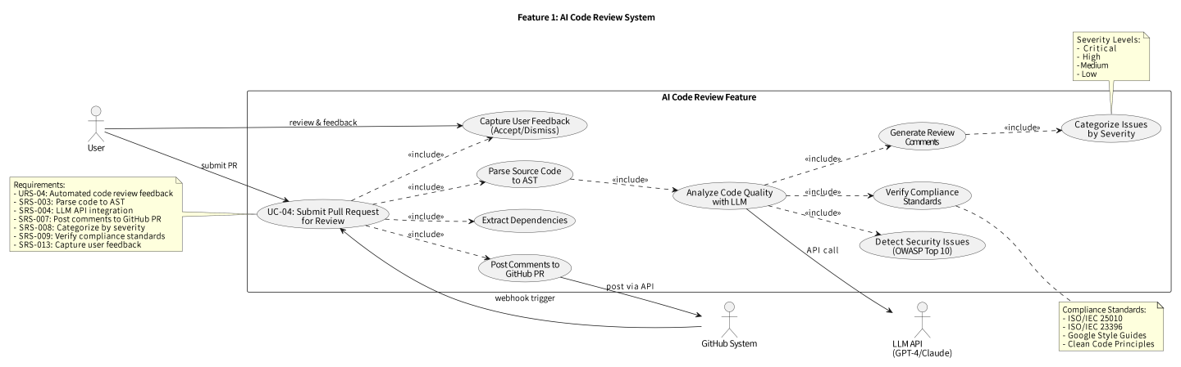

6.1.2 Feature 2
Feature 2 is architecture analysis. The system shall inspect dependencies between modules, classes, functions, or packages and identify patterns such as circular dependencies, cross-layer violations, or unusually tight coupling. The output shall help users understand not just that a problem exists, but where it exists in the structure of the codebase and why it is relevant to long-term maintainability.
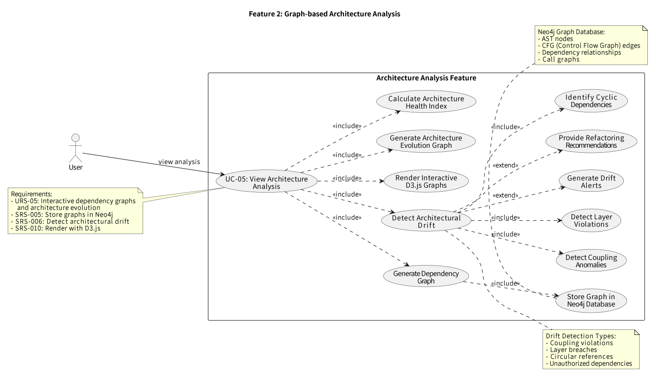

6.1.3 Feature 3
Feature 3 is authentication and controlled access. The system shall identify users, manage secure sessions, restrict actions according to role, and provide administrators with controlled visibility over user and project access. The feature is successful when users can perform the actions appropriate to their role without exposing protected data or management functions to unauthorized accounts.
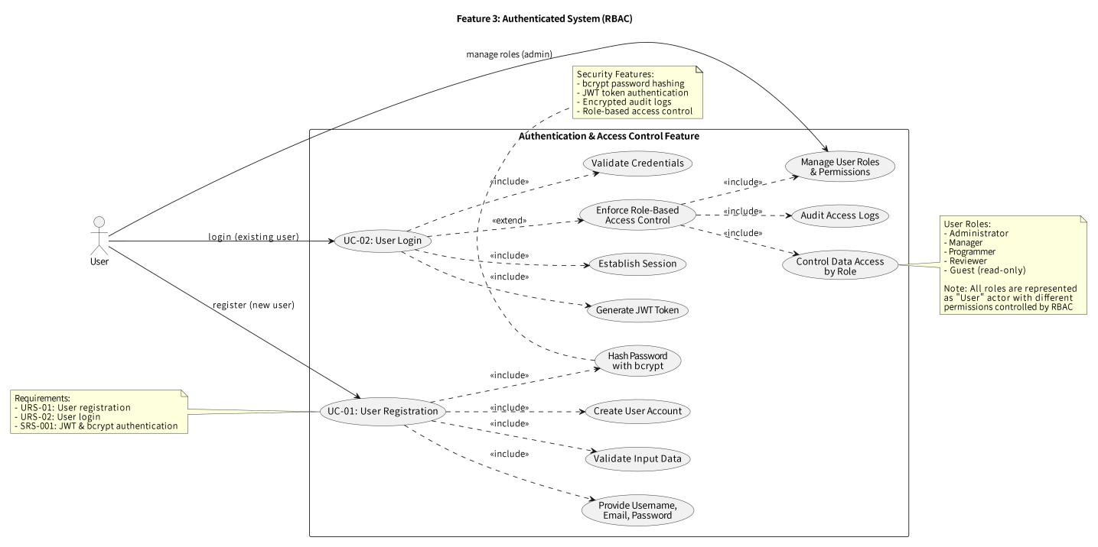

6.1.4 Feature 4
Feature 4 is project and repository management. The system shall allow users to connect repositories, manage project-specific settings, review analysis history, and coordinate access to the correct project members. This feature supports the practical lifecycle of using the platform, because analysis is only valuable when repositories can be managed in a stable and controlled way.
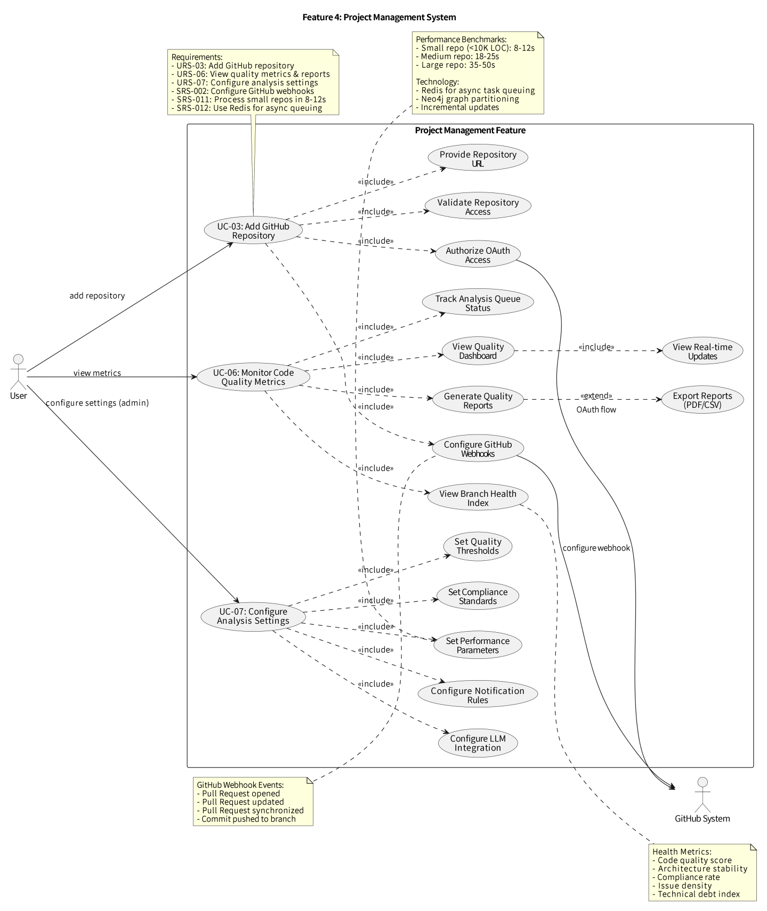

6.2 Use Case Descriptions

UC-01 User Registration
Use Case ID |  | UC-01
Use Case Name |  | User Registration
Created By | BaiXuan Zhang | BaiXuan Zhang |  | BaiXuan Zhang
Date Created | 07/02/2026 | 24/03/2026 |  | 24/03/2026
Actors | Visitor
Description | Allows a new user to create an account before accessing repository onboarding, review, and architecture features.
Trigger | Visitor opens the registration screen and submits a new account request.
Preconditions | 1. Visitor is not currently authenticated. 2. Registration endpoint is available.
Use Case Input Specification
Input | Type | Constraint |  | Example
Email | String | Valid email format and unique in system |  | student@example.com
Password | String | Minimum 8 characters with mixed character classes |  | SecurePass123!
Full Name | String | 1-255 visible characters |  | BaiXuan Zhang
Postconditions | User account is created, password is hashed, and the user is routed to the login flow.
Normal Flows | Visitor |  | System
 | 1. Visitor enters registration data. 2. Visitor submits the form. |  | 1. System displays the form. 2. System validates fields. 3. System hashes the password and stores the user record. 4. System assigns the default least-privilege role. 5. System confirms success and redirects to login.
Alternative Flow | If the email already exists, the system rejects the request and asks the visitor to use a different email or log in instead.
Exception Flow | If validation fails or storage is unavailable, the system returns a clear error without creating a partial account.
Note | Registration does not depend on GitHub integration; repository access is configured after login.

UC-02: User Login
Use Case ID |  | UC-02
Use Case Name |  | User Login
Created By | BaiXuan Zhang | BaiXuan Zhang |  | BaiXuan Zhang
Date Created | 07/02/2026 | 24/03/2026 |  | 24/03/2026
Actors | Visitor, Registered User
Description | Allows a registered user to authenticate and receive an active application session.
Trigger | User opens the login screen or is redirected there after registration.
Preconditions | 1. User account already exists. 2. User is not already logged in.
Use Case Input Specification
Input | Type | Constraint |  | Example
Email | String | Must match a registered account |  | student@example.com
Password | String | Must match stored credential hash |  | SecurePass123!
Postconditions | Signed access token and session context are created; audit log captures the login event.
Normal Flows | User |  | System
 | 1. User enters email and password. 2. User submits login request. |  | 1. System validates credentials. 2. System creates access token/session data. 3. System records audit event. 4. System redirects user to dashboard or project list.
Alternative Flow | If credentials are invalid, the system returns a generic authentication failure and may increment failed-attempt counters.
Exception Flow | If token issuance or database access fails, the system returns an authentication error and keeps the user unauthenticated.
Note | Logout and refresh are related flows handled by the authentication subsystem.

UC-03 Add GitHub Repository
Use Case ID |  | UC-03
Use Case Name |  | Connect GitHub Repository
Created By | BaiXuan Zhang | BaiXuan Zhang |  | BaiXuan Zhang
Date Created | 07/02/2026 | 24/03/2026 |  | 24/03/2026
Actors | Programmer, Manager, Administrator
Description | Allows an authorized user to create a project, register a repository, and prepare it for review and architecture analysis.
Trigger | Authorised user chooses to add a new project/repository from the project management interface.
Preconditions | 1. User is authenticated. 2. User has project-creation permission. 3. GitHub credentials or connection details are available.
Use Case Input Specification
Input | Type | Constraint |  | Example
Project Name | String | 3-200 characters |  | AI Review Demo
GitHub Repository URL | URL | Must be a valid GitHub repository URL |  | https://github.com/org/repo
Connection Type | Enum | https / ssh / cli |  | https
Postconditions | Project record is created and repository metadata becomes available for sync and analysis.
Normal Flows | Authorised User |  | System
 | 1. User enters project and repository details. 2. User confirms creation. |  | 1. System validates repository settings. 2. System creates the project. 3. System stores connection metadata. 4. System prepares webhook/sync capability and returns the project record.
Alternative Flow | If a repository is already connected, the system blocks duplicate registration and explains the conflict.
Exception Flow | If connection validation fails, the project is not created and the user receives a targeted error message.
Note | Repository connectivity can later be refreshed or disconnected by an authorized project owner/admin.

UC-04 Submit Pull Request for Review
Use Case ID |  | UC-04
Use Case Name |  | Automated Pull Request Review
Created By | BaiXuan Zhang | BaiXuan Zhang |  | BaiXuan Zhang
Date Created | 07/02/2026 | 24/03/2026 |  | 24/03/2026
Actors | Programmer, Reviewer
Description | Processes a pull request change set and produces structured review feedback with severity and context.
Trigger | A connected repository receives a PR event or the user manually triggers a review from the UI/API.
Preconditions | 1. Repository is connected. 2. Pull request metadata is available. 3. Analysis services are reachable or can degrade safely.
Use Case Input Specification
Input | Type | Constraint |  | Example
Project ID | UUID | Must reference an accessible project |  | project-uuid
Pull Request ID / Number | String/Integer | Must reference an open or analysable pull request |  | 42
Review Scope | default
Postconditions | Review status, findings, and summary are persisted and made available through API/UI views. |  | Review status, findings, and summary are persisted and made available through API/UI views.
Normal Flows | Programmer or GitHub Webhook |  | System
 | 1. System validates the trigger. 2. System fetches code diff/context. 3. System parses changed files and gathers graph context. 4. System invokes configured analysis logic/providers. 5. System stores findings and exposes the review result.
Alternative Flow | If the primary LLM provider is unavailable, the system may switch to a secondary provider or return a degraded but traceable result.
Exception Flow | If repository access or parsing fails, the review is marked failed with diagnostic detail rather than producing partial, silent output.

UC-05 View Architecture Analysis
Use Case ID |  | UC-05
Use Case Name |  | View Architecture Analysis
Created By | BaiXuan Zhang | BaiXuan Zhang |  | BaiXuan Zhang
Date Created | 07/02/2026 | 24/03/2026 |  | 24/03/2026
Actors | Reviewer, Manager, Programmer
Description | Displays dependency structures, branch-level architecture information, and detected structural risks.
Trigger | User opens the architecture area for a selected project or branch.
Preconditions | 1. User is authenticated and has access to the project. 2. Architecture data or baseline information exists.
Use Case Input Specification
Input | Type | Constraint |  | Example
Project ID | UUID | Must reference a project the user can access |  | project-uuid
Branch ID | String | Optional branch selector |  | main
View Filter | JSON / Query | Optional filter set for nodes/edges |  | severity=high
Postconditions | Interactive graph or summary data is displayed for further investigation.
Normal Flows | User |  | System
 | 1. User selects a project or branch. 2. User inspects graph nodes, edges, and issue summaries. |  | 1. System retrieves architecture data. 2. System renders dependency graph and summary metrics. 3. System highlights circular dependencies, drift signals, or hotspots. 4. System lets the user drill into component detail.
Alternative Flow | If detailed graph data is unavailable, the system shows the architecture overview and issue summary so the workflow remains usable.
Exception Flow | If graph retrieval fails, the system reports the error and preserves access to other project analytics.
Note | Architecture results complement code-review findings and may be regenerated independently.

UC-06 Monitor Code Quality Metrics
Use Case ID |  | UC-06
Use Case Name |  | Monitor Project Analytics
Created By | BaiXuan Zhang | BaiXuan Zhang |  | BaiXuan Zhang
Date Created | 07/02/2026 | 24/03/2026 |  | 24/03/2026
Actors | Manager, Reviewer, Administrator
Description | Aggregates project-level quality, issue, architecture, and trend information for decision support.
Trigger | User opens the dashboard or project analytics view.
Preconditions | 1. User is authenticated. 2. Relevant project data exists from one or more completed analyses.
Use Case Input Specification
Input | Type | Constraint |  | Example
Project ID | UUID | Must reference an accessible project |  | project-uuid
Time Window | Query | Optional range or reporting filter |  | last_30_days
Postconditions | Dashboard cards, issue counts, architecture signals, and trend summaries are displayed. | Dashboard cards, issue counts, architecture signals, and trend summaries are displayed. |  | Dashboard cards, issue counts, architecture signals, and trend summaries are displayed.
Normal Flows | System
 | 1. User selects the target project. 2. User reviews metrics and issue summaries. |  | 1. System aggregates code review and architecture data. 2. System builds dashboard metrics. 3. System displays charts and high-level status indicators.
Alternative Flow | If some analysis dimensions are unavailable, the dashboard shows partial data with a clear freshness/status indicator. |  | If some analysis dimensions are unavailable, the dashboard shows partial data with a clear freshness/status indicator.
Exception Flow | If aggregation fails, the system reports the error while keeping the rest of the project accessible.
Note | Analytics support management review; they do not replace the detailed review or architecture views.

UC-07 Configure Analysis Settings
Use Case ID |  | UC-07
Use Case Name |  | Configure Settings and Audit Access
Created By | BaiXuan Zhang | BaiXuan Zhang |  | BaiXuan Zhang
Date Created | 07/02/2026 | 24/03/2026 |  | 24/03/2026
Actors | Administrator
Description | Allows administrators to manage roles, project access, provider settings, and audit visibility.
Trigger | Administrator opens user, project-access, or provider-settings management screens.
Preconditions | 1. User is authenticated as an administrator. 2. Target user, project, or setting exists.
Use Case Input Specification
Input | Type | Constraint |  | Example
Target User / Project | Identifier | Must reference an existing entity |  | user-uuid
Role / Access Change | Enum | Must be a supported value |  | PROGRAMMER
Provider Setting | JSON / Form | Validated before save |  | openai.api_key=***
Postconditions | Updated configuration is stored and an audit record is generated for traceability. | Updated configuration is stored and an audit record is generated for traceability. |  | Updated configuration is stored and an audit record is generated for traceability.
Normal Flows | System
 | 1. Administrator selects the target entity. 2. Administrator applies a change and confirms it. |  | 1. System validates permission and input. 2. System stores the change. 3. System records audit details including actor and action. 4. System confirms success to the administrator.
Alternative Flow | If the selected role or provider setting is invalid, the system rejects the change and explains the validation error. |  | If the selected role or provider setting is invalid, the system rejects the change and explains the validation error.
Exception Flow | If persistence fails, the original configuration remains unchanged and the system returns an error.
Note | This use case covers governance actions, not normal end-user analysis execution.

6.3 Activity Diagram
The main activities in the system include authentication, project onboarding, webhook receipt, background analysis, result storage, and result presentation. These activities should be understood as connected flows rather than independent technical events: a user or external trigger starts the process, the platform validates access and context, analysis work is carried out, and the findings are returned in a form that supports review and decision making.
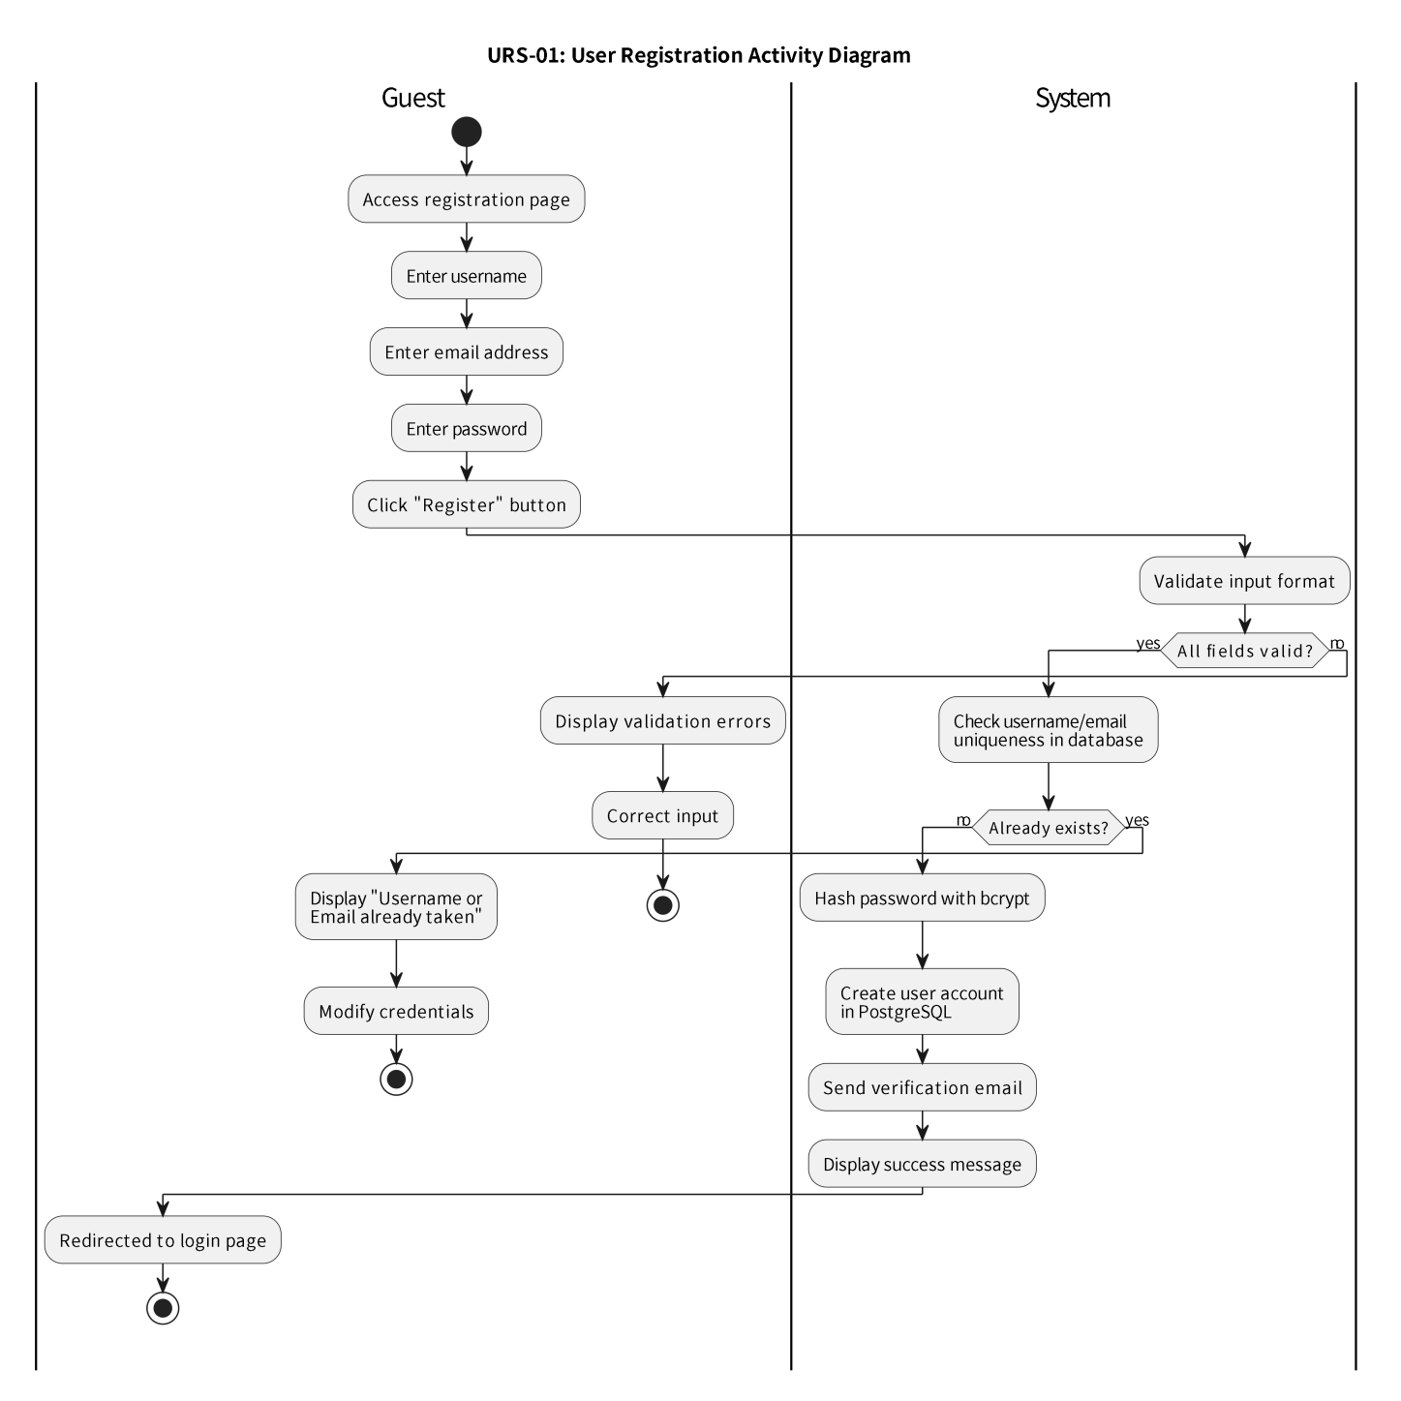
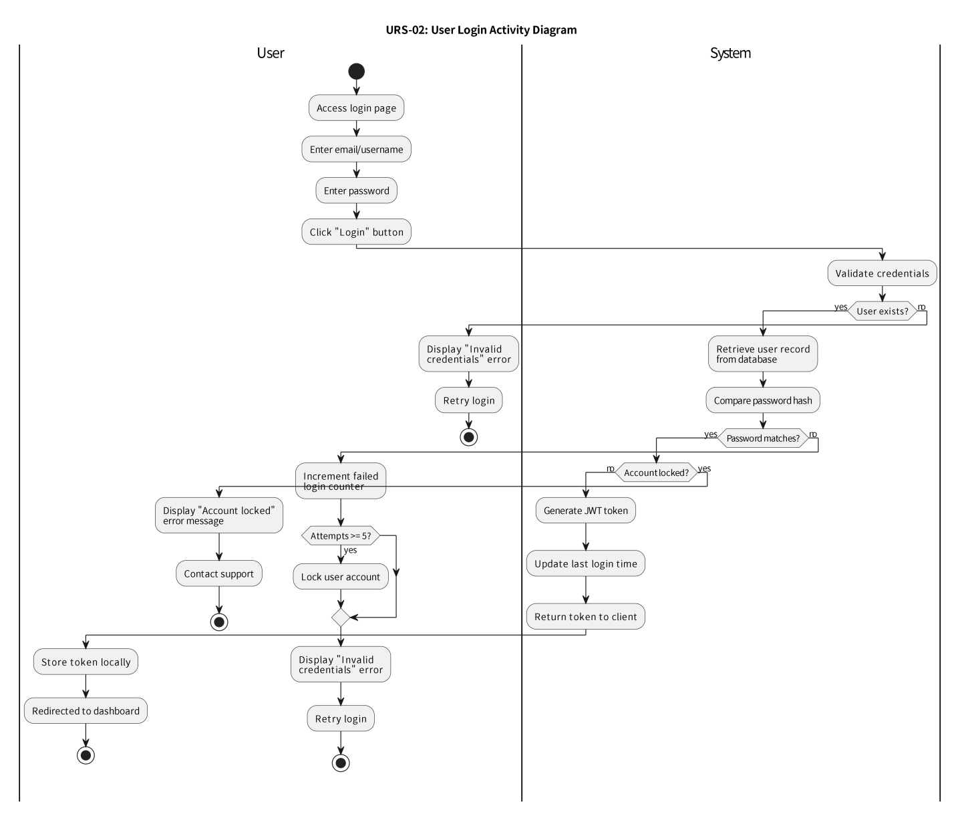
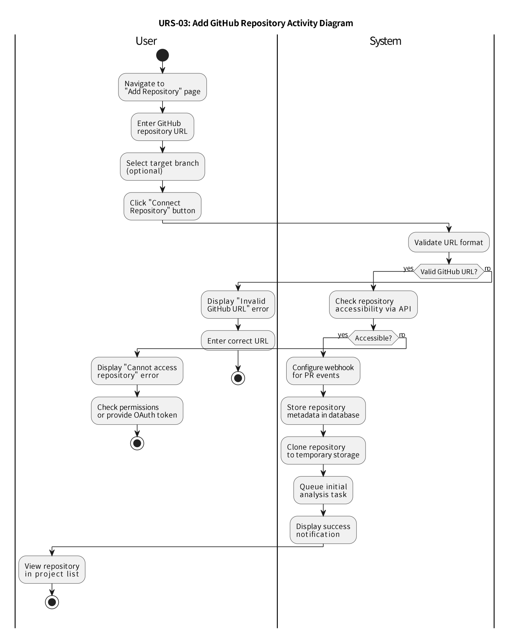
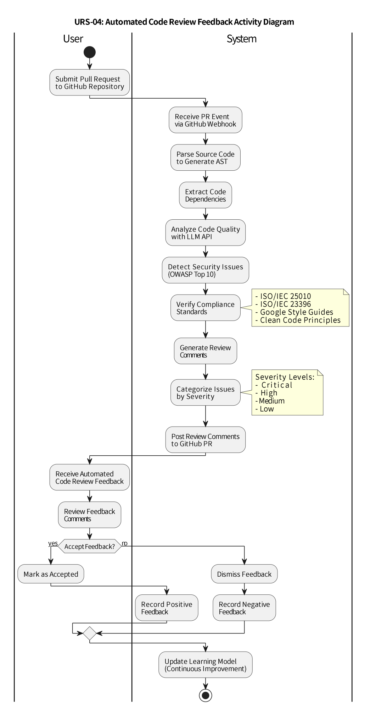

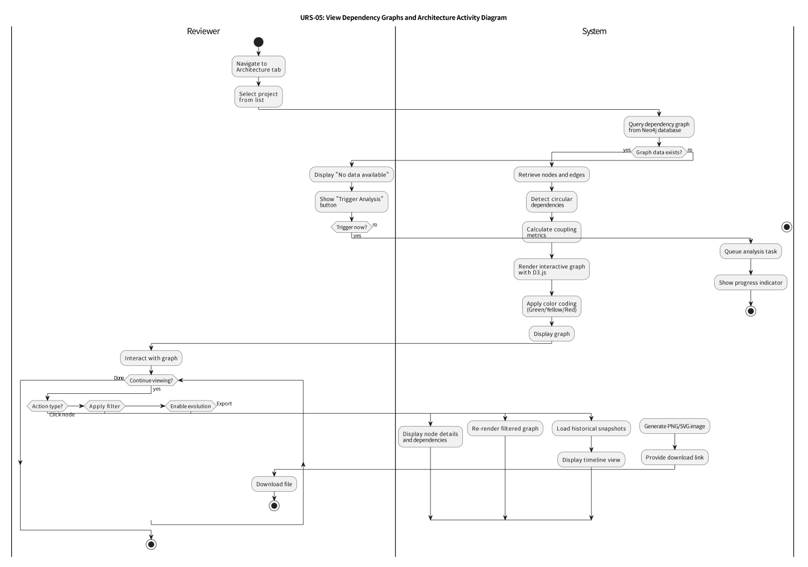
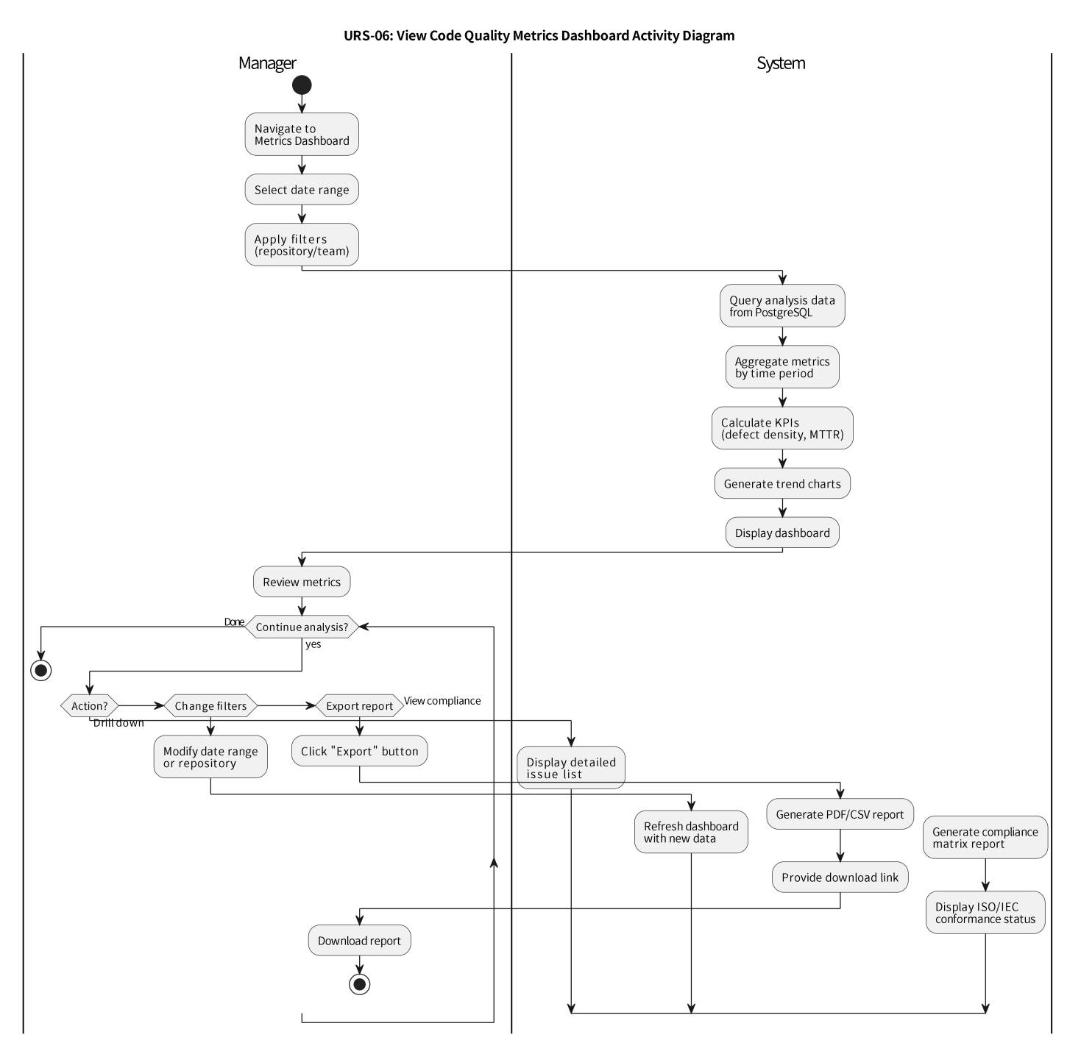
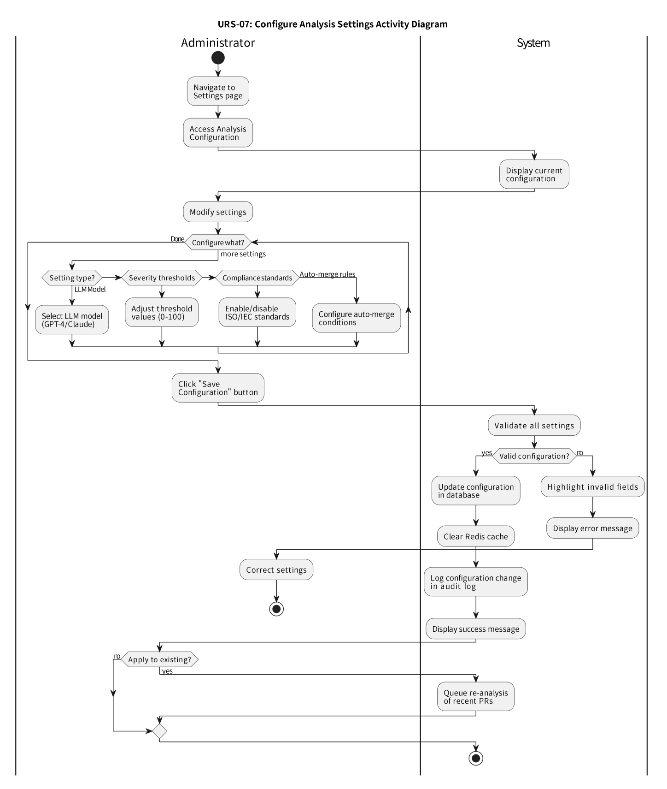

7. Data Validation Rules

7.1 User Input Validation
The system shall check that required fields are present, identifiers refer to permitted resources, values follow expected formats, and text input stays within safe and reasonable limits. When validation fails, the platform shall return a clear error explaining what is wrong so that the user can correct the input without guessing.
Field | Data Type | Validation Rules | Error Message
Username | String | - Length: 3-30 characters; - Alphanumeric and underscore only; - Must start with letter; - Case-insensitive uniqueness | "Username must be 3-30 characters, start with a letter, and contain only letters, numbers, and underscores"
Email | String | - Valid email format; - Max 100 characters; - Case-insensitive uniqueness; - No disposable email domains | "Please enter a valid email address"
Password | String | - Min 8 characters; - Max 128 characters; - At least 1 uppercase; - At least 1 lowercase; - At least 1 number; - At least 1 special char (!@#$%^&*) | "Password must be 8-128 characters with uppercase, lowercase, number, and special character"
GitHub URL | URL | - Format: https://github.com/{owner}/{repo}; - Owner: 1-39 chars, alphanumeric + hyphen; - Repo: 1-100 chars, alphanumeric + hyphen/underscore/dot | "Please enter a valid GitHub repository URL"
Project Name | String | - Length: 3-200 characters; - Alphanumeric, spaces, hyphens, underscores; - Trim whitespace | "Project name must be 3-200 characters"

7.2 Business Logic Validation
The system shall reject requests that are technically well formed but not allowed in the current project state or user context. Examples include attempting to analyse a repository that has not been configured correctly, trying to change settings without the required role, or requesting access to project data that belongs to another team or scope.
Rule ID | Validation Rule | Implementation | Error Handling
BV-01 | Email must be unique across all users | Database unique constraint + application-level check | Return 409 Conflict with message "Email already registered"
BV-02 | Username must be unique (case-insensitive) | Database unique index (lowercase) + application check | Return 409 Conflict with message "Username already taken"
BV-03 | Repository URL must be unique per platform instance | Database unique constraint on github_url | Return 409 Conflict with message "Repository already connected"
BV-04 | User must have GitHub admin access to add repository | GitHub API permission check before webhook creation | Return 403 Forbidden with message "Admin access required"
BV-05 | Analysis cannot be triggered for closed PRs | Check PR status before queuing analysis | Return 400 Bad Request with message "Cannot analyze closed PR"
BV-06 | JWT token must not be expired | Check exp claim in token | Return 401 Unauthorized with message "Token expired"
BV-07 | User role must have required permission for action | RBAC permission matrix check | Return 403 Forbidden with message "Insufficient permissions"
BV-08 | File size must not exceed 10MB for analysis | Check file size before parsing | Skip file with warning "File too large for analysis"
BV-09 | Analysis queue must not exceed 1000 pending tasks | Check queue depth before adding task | Return 429 Too Many Requests with message "Analysis queue full"
BV-10 | Webhook signature must be valid | HMAC-SHA256 verification | Return 401 Unauthorized with message "Invalid webhook signature"

7.3 Data Sanitization Rules
The system shall sanitise or normalise data where necessary before storing or displaying it, especially when content may later appear in dashboards, comments, logs, or browser-rendered views. Sanitisation helps reduce injection risk, keeps stored data more consistent, and protects users from unsafe rendered content that originated outside the trusted core of the application.
Input Type | Sanitization Method | Purpose
User-generated text (comments, descriptions) | HTML entity encoding, strip script tags | Prevent XSS attacks
SQL query parameters | Parameterized queries, ORM escaping | Prevent SQL injection
File paths | Path normalization, directory traversal prevention | Prevent path traversal attacks
GitHub URLs | URL parsing and validation, whitelist domain | Prevent SSRF attacks
JSON payloads | Schema validation, type checking | Prevent injection and type confusion
Code snippets | Syntax highlighting escaping, no execution | Safe display of code

8. Acceptance Criteria

8.1 Feature Acceptance Criteria
Feature 1: Code Review
- System analyzes PR within 30 seconds of creation
- Analysis completes within 2 minutes for repositories < 50K LOC
- Issues are categorized into 4 severity levels
- Comments are posted to GitHub PR with file path and line number
- LLM provides actionable suggestions for each issue
- User can accept/dismiss feedback
- System handles syntax errors gracefully
- When the primary intelligent analysis model is unavailable, the system needs to automatically switch to the backup model to ensure that the code analysis function is not interrupted.
Feature 2: Architecture Analysis
- The system needs to persistently store the code dependency graph, and support fast query and update of the graph.
- Circular dependencies are detected and highlighted
- Graph renders within 5 seconds for < 1000 nodes
- User can zoom, pan, and filter graph
- Layer violations are identified
- Coupling metrics are calculated
- Graph can be exported as PNG/SVG
Feature 3: Authentication System
- User can register with email and password
- Password meets complexity requirements
- Tokens expire after 24 hours
- Refresh tokens work for 7 days
- RBAC enforces permissions
- Account locks after 5 failed attempts
- The system needs to support the integration of third-party identity authentication with GitHub to achieve rapid authorization of repository permissions.
Feature 4: Project Management
- User can add GitHub repository
- Webhook is configured automatically
- Repository list displays quality metrics
- Dashboard shows trends over time
- Settings can be configured per project
- Audit log records all changes

9. Appendices
Appendix A: References
ISO/IEC 25010:2011 - Systems and software Quality Requirements and Evaluation (SQuaRE)
ISO/IEC 23396:2020 - Software and systems engineering - Architectural design
OWASP Top 10 - 2021
GitHub REST API Documentation - https://docs.github.com/en/rest
OpenAI API Documentation - https://platform.openai.com/docs
Neo4j Graph Database Documentation - https://neo4j.com/docs/
JWT RFC 7519 - https://tools.ietf.org/html/rfc7519
Appendix B: Document Conventions
Must Have: Critical requirement for MVP release
Should Have: Important but not critical for MVP
Could Have: Desirable but can be deferred
Won't Have: Out of scope for current release

