AI-Based Reviewer for Project Code and Architecture: A Graph-Augmented Framework for Pull Request Review and Architectural Drift Detection

BaiXuan Zhang  Software Engineering Program  College of Arts, Media and Technology  Chiang Mai University  Chiang Mai, Thailand  Student ID: 652115546 | Siraprapa Wattanakul  College of Arts, Media and Technology  Chiang Mai University  Chiang Mai, Thailand  Project Advisor

Abstract-Modern pull request review is increasingly constrained by repository scale, architectural complexity, and stronger governance expectations. This paper presents AI-Based-Quality-Check-On-Project-Code-And-Architecture, a graph-augmented review framework that combines GitHub event ingestion, abstract syntax tree parsing, dependency-graph modeling, and configurable large language model reasoning to support automated pull request assessment and architectural drift detection. In simpler terms, the platform is designed to help teams review code changes faster while also showing how those changes affect the broader software structure. The prototype integrates a Next.js frontend, a FastAPI backend, PostgreSQL for transactional and governance data, Neo4j for structural relationships, and Redis for transient orchestration. Pull request workflows are triggered by repository activity, enriched with code and project context, and returned as structured findings for developers, reviewers, and managers. In parallel, the platform detects circular dependencies, cross-layer violations, and coupling anomalies while enforcing governed access through role-based authorization and immutable audit logging. The resulting framework provides a practical baseline for studying how AI-assisted review, graph-based architecture analysis, and software quality governance can be combined within a single engineering workflow.
Index Terms-AI-assisted code review, pull request analysis, architectural drift detection, graph databases, software quality governance, large language models, dependency analysis

I. INTRODUCTION
Modern software teams depend on pull request workflows to preserve quality, share knowledge, and reduce regression risk. However, prior work on modern code review shows that review effectiveness depends strongly on change understanding and reviewer context, both of which become harder to sustain as repositories and teams grow [1]. At the same time, research on architecture erosion and architecture consistency shows that implemented structures frequently drift away from intended design decisions during software evolution, creating maintainability and governance risk [2], [3].
This paper addresses the intersection of these problems by presenting a graph-augmented review framework in which pull request analysis is coupled with dependency-aware architectural reasoning and governed project control. Rather than evaluating a code change as isolated text, the proposed workflow enriches review with structural context, repository events, and policy-oriented quality criteria. For readers who are less familiar with software architecture, the main idea is straightforward: the system tries to understand not only what code changed, but also what those changes mean for the shape, safety, and long-term maintainability of the project. The paper makes three main contributions: 1) a practical full-stack architecture for AI-assisted pull request review; 2) an architecture-analysis pipeline centered on graph-based drift detection; and 3) an operational model that integrates access control, auditability, and project-level governance into the same review workflow.

II. RESEARCH CONTEXT AND OBJECTIVES
The research context for this work is a web-based platform intended for programmers, reviewers, managers, and administrators who need faster review cycles without sacrificing traceability, security, or architectural visibility. In many real environments, these concerns are still fragmented across separate tools: code review platforms focus on line-level discussion, architecture tooling focuses on structural inspection, and governance mechanisms are often handled through separate administrative workflows. That fragmentation increases coordination effort and makes it harder to connect review decisions with architectural impact and operational accountability. From a quality perspective, the platform is informed by ISO/IEC 25010:2023, which frames software quality through characteristics such as functional suitability, maintainability, reliability, and security [5]. From a security perspective, the workflow is aligned with the OWASP Top 10:2021 guidance so that review and governance mechanisms remain attentive to common web-application risks [6].
Accordingly, the objective is not merely to automate comments on pull requests, but to embed code review within a broader quality-governance loop. The system is designed to reduce review effort, surface architectural drift earlier in the lifecycle, and preserve operational evidence that can support later validation, auditing, and empirical study. More specifically, the work pursues three linked goals: to provide review output that is structurally informed rather than purely text-based, to make architectural degradation visible during routine development rather than after late refactoring cycles, and to maintain governed project operation through access control, auditability, and reproducible platform state.

III. PROPOSED PLATFORM
A. Architecture Overview
The proposed platform follows a layered, event-driven architecture. The presentation layer is implemented with Next.js to provide dashboards, review summaries, architecture views, and administrative workflows [9]. The application layer is implemented with FastAPI, which offers asynchronous request handling and structured API composition for authentication, repository integration, review orchestration, analytics, and settings management [8]. PostgreSQL stores transactional and governance data, Neo4j stores dependency graphs and baseline relationships, and Redis supports transient coordination for asynchronous analysis. GitHub webhook events act as the primary trigger for repository-driven workflows [7], while Cypher-based graph querying supports structural reasoning over the architecture model [10]. Fig. 1 summarizes how the interface, orchestration layer, review services, and supporting data stores cooperate within one governed pipeline. The figure is intentionally written in plain language so that readers can see how user-facing interaction, control logic, analysis services, and data services fit together without having to inspect the source code.
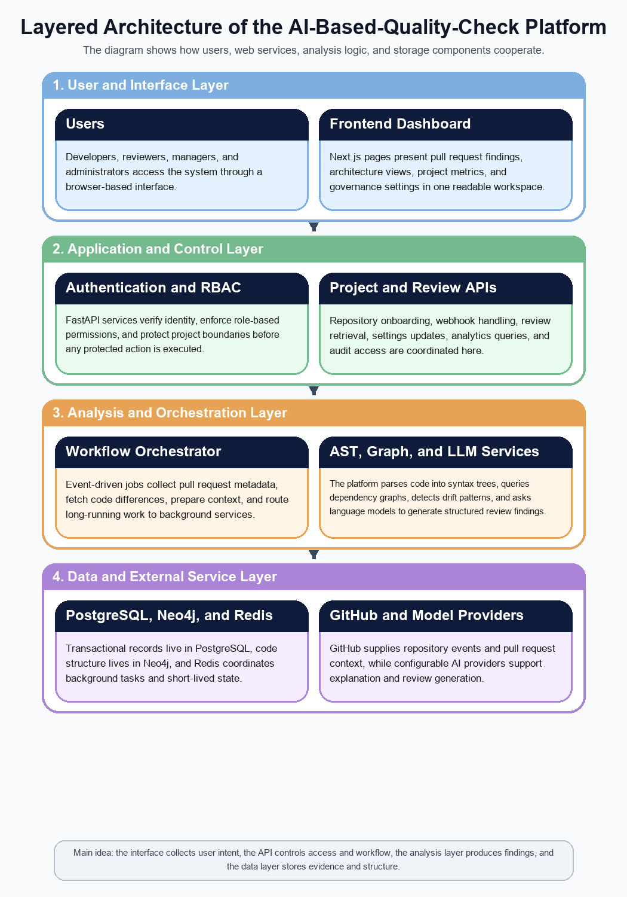
Fig. 1. Layered architecture of the proposed AI-Based quality-check framework, showing interface, control, analysis, and data-service responsibilities.
B. AI-Augmented Pull Request Review
When a connected repository emits a pull request event, the platform validates the webhook payload, acquires the relevant diff and metadata, parses changed files into abstract syntax trees, and packages both local code evidence and project context for the review pipeline. A configurable LLM layer then produces ranked findings with severity labels, rationale, and remediation guidance. The use of large language models in this setting is motivated by broader evidence that sufficiently scaled language models can perform instruction-following and few-shot reasoning over textual inputs [4]. In the proposed workflow, however, model output is grounded in repository metadata, structural context, and downstream governance rules rather than being presented as unconstrained free-form advice. Fig. 2 depicts the event-driven path from pull request creation to structured review output and dashboard publication. To make the process easier to understand, the figure describes the workflow as a sequence of practical steps, from event receipt and context collection to storage and final publication of the results.
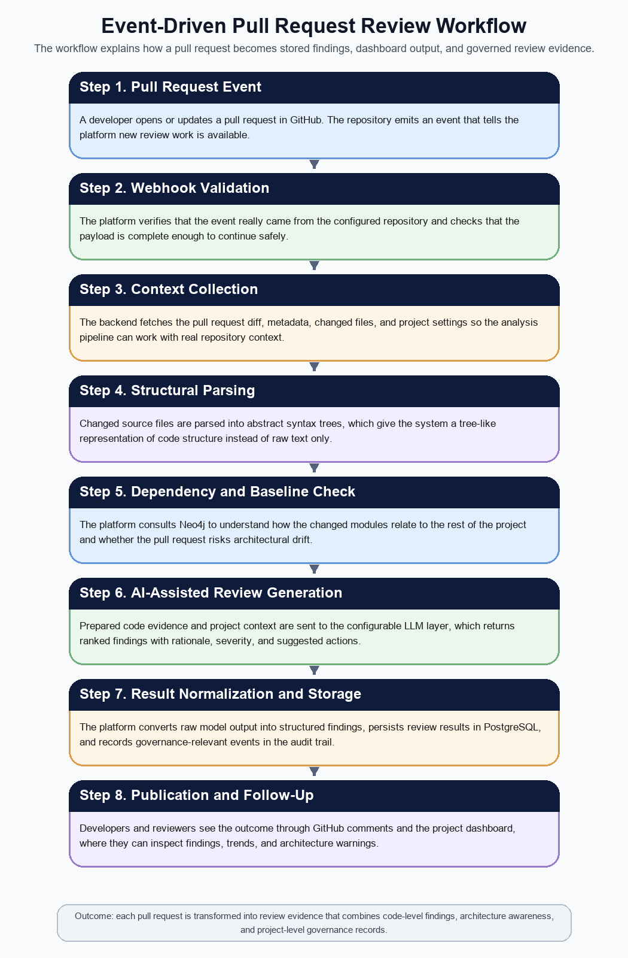
Fig. 2. Event-driven workflow for pull request analysis, structured finding generation, and governed publication of review output.
C. Graph-Based Architecture Analysis
The second core capability is architecture analysis driven by a project-specific dependency graph. Repository parsing extracts modules, classes, functions, and dependency edges, which are persisted in Neo4j for later traversal and comparison. This design choice reflects the literature on architecture erosion and architecture consistency, which emphasizes the importance of detecting drift as software evolves and of maintaining alignment between intended and implemented structures [2], [3]. In practical terms, the dependency graph acts like a map of how different parts of the codebase depend on one another. The platform compares the current graph against expected layering rules and previously captured baselines to identify circular dependencies, unexpected cross-layer calls, coupling anomalies, and other indicators of architectural drift before they become deeply embedded in routine development.
D. Governance, Audit, and Project Control
Beyond analysis quality, the platform is designed for governed operation. Role-based access control separates visitor, programmer, reviewer, manager, and administrator responsibilities, while project onboarding, provider configuration, role changes, and review execution are recorded in an immutable audit trail. This governance layer reflects the dual concern of quality and security: software quality objectives are framed using ISO/IEC 25010 [5], and security-sensitive review criteria are informed by OWASP Top 10 categories such as broken access control, cryptographic failures, and injection risks [6]. In this way, the platform treats review not simply as comment generation, but as a controlled engineering activity with traceable decisions and accountable project state. This matters because organizations often need to know not only what recommendation was made, but also who triggered the review, what settings were active, and how the result entered the project workflow.

IV. IMPLEMENTATION DETAILS
A. Full-Stack Application Layer
The current prototype is realized as a containerized web application. The frontend is built with Next.js, React, and TypeScript to present review results, graph-based architecture views, and project-level metrics within one consistent interaction model [9]. The backend is implemented with FastAPI and organized around endpoint groups for authentication, GitHub integration, pull request review, architecture analysis, analytics, settings, and audit access [8]. This implementation strategy preserves modular boundaries while remaining close to the actual repository structure, thereby reducing unnecessary operational fragmentation and making the prototype easier to reproduce for future experimentation. For readers outside backend engineering, the important point is that the implementation keeps user interaction, analysis logic, and persistent storage clearly separated so the system is easier to reason about and maintain.
B. Persistence and Analysis Services
PostgreSQL is used for transactional consistency, auditable operational records, and project configuration state. Neo4j is reserved for structural analysis because graph traversal is central to dependency reasoning, drift detection, and baseline comparison [10]. Redis is used where low-latency coordination is beneficial, particularly for scheduling analysis jobs and invalidating cached state. The model-facing stage of the pipeline remains provider-abstracted, allowing different OpenAI-compatible or Anthropic-compatible services to be integrated while preserving the same orchestration flow. This separation is important because reasoning capability is model-dependent, whereas workflow control, governance logic, and evidence preservation are platform responsibilities that should remain stable across provider changes. Put differently, the framework is designed so that the review process remains understandable even if the underlying AI provider changes later.
C. Deployment and Operational Baseline
The deployment baseline is intentionally pragmatic. Development and staging environments are containerized, health-checked, and isolated through service boundaries so that the prototype can be reproduced across local machines and hosted Linux environments. This decision keeps the platform portable while maintaining parity between demonstration and validation environments, an important requirement for future empirical evaluation. The operational baseline is also designed to support controlled experimentation: service boundaries make failures easier to localize, database state can be inspected independently of the review interface, and queue-backed analysis workflows make it possible to study processing latency and orchestration behavior without collapsing the application into a purely synchronous request model.

V. EVALUATION FRAMEWORK
The current work presents a research-oriented prototype rather than a completed benchmarking study. Accordingly, the evaluation framework emphasizes measurable operational outcomes, architecture visibility, and governance evidence instead of claiming definitive superiority over existing tools. The framework is intended to support future systematic validation by linking platform mechanisms to observable evidence sources and to outcomes that matter to developers, reviewers, and project managers. Table I summarizes the principal dimensions that should guide that evaluation. These dimensions are described in practical language so that the reader can see not only what should be measured, but also why each measurement matters in everyday development practice.
A. Assessment Dimensions
Evaluation should cover review efficiency, architectural governance, operational traceability, and usability and adoption. Review efficiency can be measured through turnaround time, comment quality, and prioritization consistency. Architectural governance can be assessed through the framework's ability to identify drift patterns before they accumulate into large refactoring episodes. Operational traceability depends on the completeness of audit records, permission boundaries, and reproducibility of review actions. Usability and adoption depend on whether developers, reviewers, and managers can interpret findings, trends, and risk summaries without additional manual correlation and whether those outputs are trusted enough to influence routine practice. Together, these dimensions allow the prototype to be studied not only as a code-analysis tool, but as a governed engineering workflow that links technical insight with operational accountability. In other words, evaluation should show both whether the framework works technically and whether people can use its output in a meaningful way.
B. Target Outcomes
The intended outcomes are shorter review cycles, clearer prioritization of risky pull requests, improved visibility of architectural erosion, and stronger confidence in governed software delivery. In practical terms, the framework should reduce time spent on repetitive inspection, provide earlier correction signals to developers, and support managerial reasoning through quality dashboards and drift indicators rather than anecdotal reporting alone. A successful evaluation should therefore demonstrate not only that the system produces findings, but also that those findings are timely, interpretable, and connected to decision-making in real development workflows. This is especially important for AI-assisted tools, because raw automation alone is not enough if the result is difficult for people to trust or act on.
C. Threats and Limitations
Several limitations remain. LLM output quality may vary by provider, prompt design, and codebase characteristics. Very large monorepositories may stress graph storage and repeated parsing workflows. Teams with strongly manual review cultures may require onboarding and calibration before they trust automated findings. The current paper also presents an implementation and evaluation framework rather than a completed comparative experiment, so claims about measurable productivity gain must be treated as future work rather than final empirical conclusions. These limitations do not invalidate the framework, but they define the main boundary conditions for future experimentation and longitudinal evaluation. They also highlight that the framework should be understood as a carefully structured prototype and research baseline, not as a finished universal solution for every software organization.

VI. DISCUSSION
The main research contribution of the project is its integration strategy. Prior work on code review emphasizes the centrality of reviewer understanding [1], while architecture-consistency research stresses the cost of allowing implemented systems to diverge from intended structures [2], [3]. The proposed framework connects these concerns by treating pull request review, dependency-aware architecture reasoning, and governance evidence as parts of a single operational workflow rather than as separate tools or late-stage audits. This integration matters because review quality is influenced not only by what changed in a pull request, but also by how that change affects structural design and by whether the resulting decision can be traced and governed over time. For readers outside software architecture research, the contribution can be summarized simply: the platform tries to make code review, structure awareness, and governance work together instead of remaining isolated activities.
A further contribution is methodological. The prototype is designed so that requirements, architecture, implementation, and verification artifacts can be traced to one another, which improves reproducibility and makes the system a more credible subject for future empirical study. This traceability is especially valuable when evaluating AI-assisted engineering systems, where explanation quality, governance, and architectural impact matter as much as raw automation speed. In that sense, the project contributes not only a tool concept, but also a structured basis for studying AI-assisted review as a socio-technical workflow with measurable technical and governance dimensions.

VII. CONCLUSION
This paper presented AI-Based-Quality-Check-On-Project-Code-And-Architecture, a graph-augmented framework that combines GitHub-triggered workflow automation, abstract syntax tree parsing, dependency-graph analysis, configurable LLM reasoning, and governed project access. The resulting architecture addresses review workload, architectural drift, and operational traceability within one full-stack system while remaining practical for containerized deployment and future controlled study.
The prototype contributes a practical implementation baseline for future empirical study of AI-assisted pull request review and architecture governance. Subsequent work should focus on controlled evaluation with real repositories, measurement of review-cycle improvements, calibration of model-generated findings, and refinement of explainability techniques for high-severity architectural and security issues. Additional future work should also examine adoption behavior, confidence formation among reviewers, and the trade-off between automated guidance and human oversight in governed software-delivery environments. In short, the paper argues that AI-assisted review becomes more valuable when it is connected to structural reasoning and governance evidence rather than treated as a standalone commenting tool.

TABLE I
EVALUATION DIMENSIONS OF THE PROPOSED PLATFORM
Dimension | Platform Mechanism | Evidence Source | Intended Outcome
Review efficiency | Webhook-triggered analysis, AST parsing, ranked AI findings | Pull request history, review timestamps, and issue logs | Reduced review turnaround time and more consistent triage
Architectural governance | Neo4j dependency graph, drift rules, and architecture baselines | Graph snapshots, drift reports, and architecture dashboards | Earlier detection of structural erosion and rule violations
Operational traceability | RBAC, audit logging, settings management, and project scoping | Audit records, access logs, and settings change history | Explainable and reviewable governance evidence
Usability and adoption | Dashboard summaries, issue explanations, and project analytics | Scenario walkthroughs, stakeholder feedback, and demo sessions | Higher reviewer and manager confidence in automated support

Table I summarizes the proposed validation dimensions and links each dimension to a concrete framework mechanism, evidence source, and intended outcome. This framing helps position the paper as both a system description and a basis for future empirical evaluation.

REFERENCES
[1] A. Bacchelli and C. Bird, "Expectations, Outcomes, and Challenges of Modern Code Review," in Proc. 35th Int. Conf. Softw. Eng. (ICSE), San Francisco, CA, USA, 2013, pp. 712-721, doi: 10.1109/ICSE.2013.6606617.
[2] L. R. De Silva and D. Balasubramaniam, "Controlling Software Architecture Erosion: A Survey," J. Syst. Softw., vol. 85, no. 1, pp. 132-151, Jan. 2012, doi: 10.1016/j.jss.2011.07.036.
[3] N. Ali, S. Baker, R. O'Crowley, S. Herold, and J. Buckley, "Architecture Consistency: State of the Practice, Challenges and Requirements," Empir. Softw. Eng., vol. 23, no. 1, pp. 224-258, 2018, doi: 10.1007/s10664-017-9515-3.
[4] T. Brown et al., "Language Models Are Few-Shot Learners," in Adv. Neural Inf. Process. Syst., vol. 33, 2020, pp. 1877-1901.
[5] ISO/IEC 25010:2023, Systems and Software Engineering - Systems and Software Quality Requirements and Evaluation (SQuaRE) - Product Quality Model, Nov. 2023.
[6] OWASP Foundation, "OWASP Top 10:2021," 2021. [Online]. Available: https://owasp.org/Top10/2021/. Accessed: Mar. 24, 2026.
[7] GitHub Docs, "Webhook Events and Payloads," [Online]. Available: https://docs.github.com/en/webhooks/webhook-events-and-payloads. Accessed: Mar. 24, 2026.
[8] FastAPI, "FastAPI Documentation: First Steps," [Online]. Available: https://fastapi.tiangolo.com/tutorial/first-steps/. Accessed: Mar. 24, 2026.
[9] Vercel, "Next.js Documentation," [Online]. Available: https://nextjs.org/docs. Accessed: Mar. 24, 2026.
[10] Neo4j, Inc., "Cypher Manual," [Online]. Available: https://neo4j.com/docs/cypher-manual/current/. Accessed: Mar. 24, 2026.

