[AI-Based Reviewer on Project Code and Architecture] - Software Design Document (SDD)
Version: [ v0.4]
Date: [Date]
Document History
Version | Date | Author | Reviewer | Changes
V0.1 | 2026-02-07 | BaiXuan Zhang | Dr. Siraprapa | Initial draft
V0.2 | 2026-02-13 | BaiXuan Zhang | Dr. Siraprapa | Added system architecture, database schema, component design
V0.3 | 2026-02-16 | BaiXuan Zhang | Dr. Siraprapa | Added security design, deployment architecture, complete database design, API specs, architecture diagrams
V0.4 | 2026-02-19 | BaiXuan Zhang | Dr. Siraprapa | Completed RBAC component design, updated technology stack, added ADR-005, aligned with enterprise_rbac_auth implementation

Contents
[AI-Based Reviewer on Project Code and Architecture] - Software Design Document (SDD) 1
1. Introduction 4
1.1 Purpose 4
1.2 System Overview 4
1.3 Design Principles 4
1.4 Scope 5
2. System Architecture 5
2.1 Architectural Overview 5
The system implements a multi-tier microservices architecture designed for modularity, scalability, and resilience. The architecture follows industry best practices including separation of concerns, horizontal scaling capability, and high availability patterns. 5
2.2 Logical Architecture 5
2.3 Microservices Architecture 7
Service Catalog 7
Service Communication 8
2.4 Data Flow Diagram (DFD) 8
2.5 Component Interaction Diagram 10
3. Database Design 11
3.1 Entity Relationship Diagram (ERD) 11
3.2 PostgreSQL Schema 20
3.2.1 Users Table 20
3.2.2 Sessions Table 21
3.2.3 Projects Table 22
3.2.4 Project Members Table 23
3.2.5 Pull Requests Table 23
3.2.6 Analyses Table 24
3.2.7 Issues Table 25
3.2.8 Quality Metrics Table 26
3.2.9 Audit Logs Table 27
3.3 Neo4j Graph Database Schema 28
3.3.1 Node Types 28
3.3.2 Relationship Types 29
3.3.3 Common Query Patterns 30
4. Detailed Design 30
4.1 Class Diagram (if Object-Oriented) 30
The system's class structure is organized into modular diagrams by functional domain for improved readability and maintainability. 31
User Management Domain 31
Project Management Domain 31
Code Analysis Domain 32
Architecture Analysis Domain 32
AI Integration Domain 33
Quality Metrics Domain 33
Infrastructure Domain 34
Complete Class Diagram 34
4.2 Core Components 35
4.2.1 Authentication Service 35
4.2.2 RBAC Service 36
4.2.3 Audit Service 38
4.2.4 Authorization Middleware 38
4.2.5 Architecture Evaluation Tools 39
5. Interface Design 40
5.1 Wireframes / Mockups 40
5.2 API Endpoints 40

1. Introduction
This section explains what this document is for, what system it describes, and the guiding principles behind its design. Readers who are new to software documentation can think of this section as the "executive summary" of how the system was designed and why.

1.1 Purpose
This Software Design Document (SDD) describes the complete architectural and detailed design of the AI-Based Reviewer platform — a web application that automatically reviews software code and analyses software architecture.
The document is intended to serve as the definitive technical reference for everyone involved in building, maintaining, or evaluating the system, including developers, architects, testers, and technical reviewers. It translates the high-level requirements captured in the Software Requirements Specification (SRS) into concrete design decisions: how the system is structured, how its parts communicate, how data is stored, and how security and performance goals are achieved.
In plain terms: if the SRS describes what the system must do, this SDD describes how it is built to do it.

1.2 System Overview
The AI-Based Reviewer is a web-based platform that provides intelligent, automated code review and architectural analysis for software development teams. Instead of waiting for a human reviewer, developers can submit a Pull Request (a proposed code change) to GitHub and receive structured, AI-generated feedback within minutes.
The system combines three advanced technologies:
Abstract Syntax Trees (AST) — a technique for parsing source code into a structured tree that represents the code's logical structure, making it possible to analyse the code programmatically rather than as raw text.
Graph Databases (Neo4j) — a specialised database optimised for storing and querying networks of relationships; here used to map out which parts of the codebase depend on which other parts.
Large Language Models (LLMs) — AI models such as OpenAI GPT-4 and Anthropic Claude that can read code, understand its intent, and generate human-readable review comments.

Core Capabilities
Capability | Description
Automated Pull Request Review | When a developer opens or updates a Pull Request on GitHub, the system is automatically triggered. It analyses the changed code and posts structured review comments directly on GitHub — much like a human reviewer would.
Architectural Drift Detection | The system builds a live map of the codebase's architecture (a dependency graph). It can detect when the current codebase has drifted away from the intended design — for example, if a UI component starts calling the database directly, bypassing the business logic layer.
Compliance Verification | The system checks the code against international quality standards (ISO/IEC 25010 for software quality, ISO/IEC 23396 for architectural quality) and reports violations automatically.
Dependency Graph Visualisation | An interactive, browser-based diagram shows the complete dependency relationships between all modules, classes, and functions. Developers can zoom in, filter, and explore the codebase structure visually.
Enterprise-Grade Security | All access is controlled by a five-level Role-Based Access Control (RBAC) system. Every security-relevant action is permanently recorded in an immutable audit log.

1.3 Design Principles
The following principles guided every design decision in this document. When trade-offs were required, these principles provided the criteria for choosing between alternatives.
Principle | What It Means in Practice
Modularity | The system is divided into independent microservices, each with a clearly defined responsibility. A change to one service does not require changes to unrelated services.
Scalability | Every service that handles stateless requests (i.e., requests that do not require server-side memory of previous interactions) can be replicated horizontally — meaning more instances are added when load increases, without redesigning the system.
Resilience | The system degrades gracefully when components fail. For example, if the primary LLM provider is unavailable, the system automatically falls back to an alternative provider rather than failing completely.
Security | Security is applied in multiple independent layers (Defence in Depth). A failure in one layer does not expose the entire system.
Maintainability | Code is written with clarity and comprehensive documentation as first-class requirements. Automated testing and structured logging reduce the time needed to diagnose and fix problems.
Performance | The system is designed to meet specific measurable targets: API responses within 500 ms (95th percentile), analysis completion within 2 minutes for repositories up to 50,000 lines of code.

1.4 Scope
This SDD covers the following design concerns. Each is addressed in the numbered section shown:
Design Topic | Covered In
System architecture and tier structure | Section 2
Microservices catalog and inter-service communication | Section 2
Data flow through the system | Section 2
Design constraints (technical, performance, security, scalability, compliance) | Section 2
Database schemas and data models (PostgreSQL and Neo4j) | Section 3
Class diagrams and domain models | Section 4
Core component specifications and module-level APIs | Section 4
Core algorithm designs (cycle detection, complexity, drift, quality score) | Section 4
Exception handling architecture | Section 4
Security architecture (authentication, authorisation, encryption, OWASP) | Section 4
Deployment and network topology | Section 4
Performance optimisation (caching, indexing, async processing) | Section 4
Observability design (logging, metrics, health checks) | Section 4
Architecture Decision Records (ADR-001 through ADR-007) | Section 4
User interface screens and API endpoint catalogue | Section 5
This document does not cover: project scheduling or timelines (see Project Plan), functional requirements (see SRS), test cases or test execution (see Test Plan / Test Record), change history of requirements (see Change Request log), or traceability matrices (see Traceability Record).

2. System Architecture
This section describes how the system is structured at a high level — how it is divided into layers and services, how those services communicate, and what the overall flow of data looks like. It also documents the constraints that shaped the architectural choices.

2.1 Logical Architecture
The system is organised into four horizontal tiers (layers), each with a distinct responsibility. This separation ensures that changes in one tier do not cascade unnecessarily into others.

2.1.1 Tier Overview
Tier | Technologies | Responsibilities
Presentation Layer  (What the user sees) | React 18, Next.js 14, Tailwind CSS | Renders the user interface in the browser. Provides server-side rendering for fast initial page loads, interactive dashboards for metrics and graph visualisation, real-time updates via WebSocket, and responsive layouts for desktop and mobile. Components: Dashboard UI, Repository Management UI, Analysis Results Viewer, Dependency Graph Visualiser, Settings UI.
Application Layer  (Request handling & orchestration) | FastAPI (Python 3.11+), Pydantic | Exposes the REST API that the frontend calls. Validates all incoming requests, enforces authentication and authorisation, and coordinates between services. Services: Auth Service, Project Manager, Analysis Service.
Service Layer  (Business logic & integrations) | Python 3.11+, Celery (task queue) | Implements the core business logic and integrates with external systems. Runs long-running analysis tasks asynchronously so that API calls return immediately. Components: AST Parser Service, Graph Analysis Service, LLM Integration Service, GitHub Integration Service, Metrics Service.
Data Layer  (Persistence) | PostgreSQL, Neo4j, Redis | PostgreSQL stores all structured transactional data (users, projects, analyses, audit logs). Neo4j stores the code dependency graph (nodes = modules/classes/functions; edges = dependencies/calls/inheritance). Redis acts as both a high-speed cache for frequently-read data and as the message broker for the asynchronous task queue.

2.2 Microservices Architecture
Within the Application and Service layers, the system is further decomposed into nine independently deployable microservices. Each service has a single well-defined responsibility and communicates with others via defined interfaces.

2.2.1 Service Catalog
Service Name | Technology | Port | Responsibility | Depends On
API Gateway | Kong / Nginx | 80 / 443 | Single entry point for all external traffic. Handles TLS termination, request routing to downstream services, and rate limiting (100 req/min per user). | —
Auth Service | FastAPI | 8001 | User registration, login, JWT token issuance and validation, and session lifecycle management. | PostgreSQL, Redis
Project Manager | FastAPI | 8002 | Connecting GitHub repositories to the platform, configuring analysis settings, and managing project team membership. | PostgreSQL, GitHub API
Analysis Service | FastAPI | 8003 | Receiving analysis trigger requests, dispatching async tasks to workers, and aggregating results from workers back into the database. | PostgreSQL, Redis, Analysis Workers
Code Review Engine | Python / Celery Worker | N/A (async) | Parsing source code into ASTs, running static analysis rules, detecting code-level issues, and formatting review comments for GitHub. | LLM API, PostgreSQL
Architecture Analyser | Python / Celery Worker | N/A (async) | Building and updating the dependency graph in Neo4j, detecting circular dependencies, identifying layer violations, and computing drift scores. | Neo4j, PostgreSQL
Agentic AI Service | Python / Celery Worker | N/A (async) | Managing communication with LLM providers (OpenAI, Anthropic), building context-rich prompts, parsing AI responses, and implementing fallback logic. | OpenAI API, Anthropic API
Webhook Handler | FastAPI | 8004 | Receiving GitHub webhook events (PR opened, synchronised, closed) and queuing the corresponding analysis tasks. | Redis, GitHub API
Metrics Service | FastAPI | 8005 | Computing daily quality metric snapshots per project, generating trend reports, and serving dashboard data. | PostgreSQL, Neo4j

2.2.2 Service Communication Patterns
Services communicate using three distinct patterns, chosen based on whether an immediate response is required:
Pattern | Used For | Technology
Synchronous (Request / Response) | Short-lived operations where the caller needs an immediate answer — e.g., login, fetching project metadata, checking analysis status. | REST over HTTP/HTTPS
Asynchronous (Fire and Forget) | Long-running tasks where the caller should not block waiting — e.g., triggering a full code analysis. The task is placed on a queue, a worker picks it up, and the caller polls for the result. | Redis message broker + Celery workers
Event-Driven (Webhook) | Reacting to external events from GitHub — e.g., a new Pull Request was opened. GitHub sends an HTTP POST to the Webhook Handler, which then enqueues an analysis task. | GitHub Webhooks → FastAPI endpoint → Redis queue

2.3 Data Flow Diagram
The following walkthrough traces a complete Pull Request review cycle from the moment a developer opens a PR on GitHub to the moment the AI-generated comments appear on that PR.

2.3.1 Pull Request Review Flow
Note: The diagram image referenced in the original document is preserved below as a step-by-step description for textual clarity.
Step | Actor / Component | Action
1 | GitHub | Developer opens or updates a Pull Request. GitHub sends an HTTP POST webhook event to the platform's Webhook Handler endpoint.
2 | Webhook Handler | Validates the webhook signature (HMAC-SHA256) to confirm the request genuinely came from GitHub. Parses the PR metadata and places an analysis task on the Redis queue.
3 | Analysis Worker (Celery) | Picks up the task from the queue. Calls the GitHub API to retrieve the code diff (the changed lines) for the PR.
4 | Code Review Engine | Parses the modified source files using the AST Parser to produce structured syntax trees. Extracts code entities (classes, functions) and their dependencies.
5 | Architecture Analyser | Queries Neo4j to retrieve the existing dependency graph context for the affected modules. Checks for layer violations and circular dependencies introduced by the change.
6 | Agentic AI Service | Constructs a rich prompt combining: the code snippet, the architectural context, compliance rules, and few-shot examples. Sends the prompt to the LLM API (primary: GPT-4; fallback: Claude 3.5).
7 | Analysis Service | Receives the structured list of issues from the AI response. Categorises each issue by severity (Critical / High / Medium / Low) and stores them in PostgreSQL.
8 | GitHub Integration Service | Posts inline review comments on the Pull Request for each detected issue, using the GitHub API.
9 | Architecture Analyser | Updates the dependency graph in Neo4j to reflect any new or changed relationships introduced by the PR.
10 | Metrics Service | Updates the project's quality metric snapshot with the new analysis results. The frontend dashboard reflects the new data in real time via WebSocket push.

2.3.2 Component Interaction Summary
The diagram originally shown in the SDD illustrates the request flows between the nine microservices described in Section 2.2.1. Key interaction paths include:
·Frontend ↔ API Gateway → Auth Service (for all authenticated requests)
·Frontend ↔ API Gateway → Project Manager (for repository operations)
·Frontend ↔ API Gateway → Analysis Service (to trigger or query analyses)
·GitHub → Webhook Handler → Redis → Celery Workers (event-driven analysis pipeline)
·Celery Workers ↔ Neo4j (dependency graph read/write)
·Celery Workers ↔ LLM APIs (AI-powered review generation)
·Celery Workers ↔ GitHub API (fetching diffs; posting comments)

2.3.3 Data Flow Diagram (DFD)
Pull Request Review Flow:
1. GitHub webhook triggers on PR creation/update
2. Webhook handler receives event and queues analysis task in Redis
3. Analysis worker retrieves code diff from GitHub API
4. AST Parser generates syntax trees for modified files
5. Graph Analysis queries Neo4j for architectural context
6. LLM service sends code + context to AI API for analysis
7. Results are processed, categorized by severity, and stored in PostgreSQL
8. Review comments are posted to GitHub PR
9. Dependency graph is updated in Neo4j
10. Frontend dashboard is updated with new analysis results
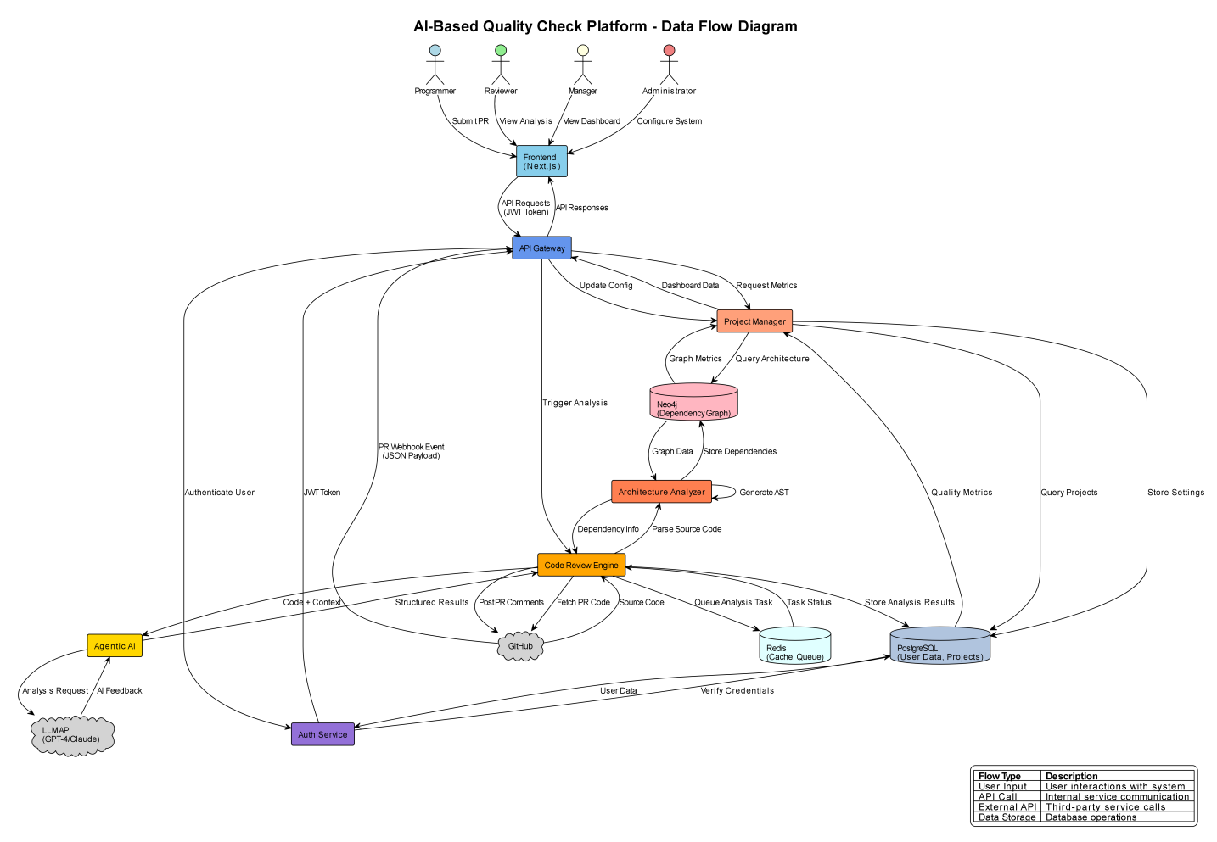

2.3.4 Component Interaction Diagram
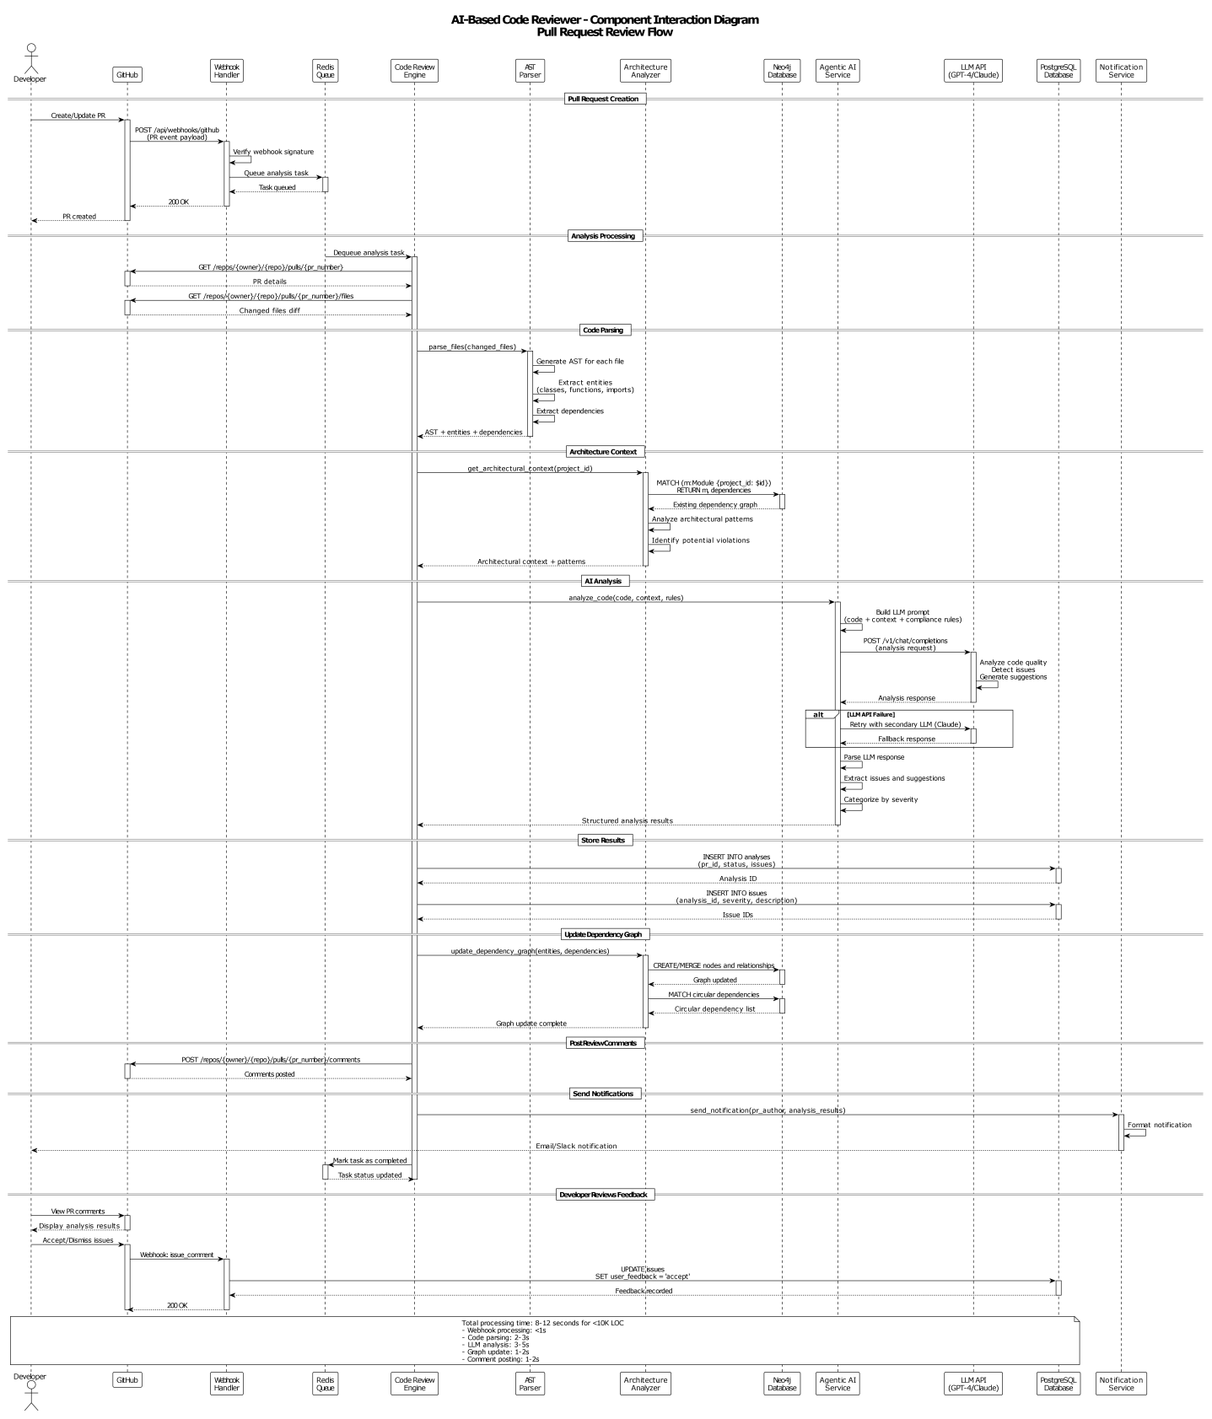

2.4 Design Constraints
The following constraints were non-negotiable requirements that directly shaped the architecture. Each constraint is documented with the rationale and its design implication so that future maintainers understand why choices were made.

2.4.1 Technical Constraints
Constraint | Requirement | Rationale | Design Implication
Programming Language | Python 3.11+ for all backend services | Team expertise; rich ecosystem for AI/ML; native async support | All backend services use Python; consistent dependency management required
Frontend Framework | React 18 with Next.js 14 | Server-side rendering (SSR) for performance; large ecosystem; TypeScript support | Component-based architecture; requires Node.js build pipeline
Relational Database | PostgreSQL 13+ | ACID compliance; JSONB support; mature ecosystem | Requires connection pooling, a migration strategy, and read replicas for reporting queries
Graph Database | Neo4j 4.4+ | Native graph algorithms; Cypher query language; purpose-built for dependency analysis | Requires a separate database instance and graph-specific query optimisation
LLM Providers | OpenAI GPT-4 / Anthropic Claude 3.5 | State-of-the-art code understanding; API availability | Rate limiting, fallback strategy, and API cost management must be designed in
Container Runtime | Docker 20.10+ / Kubernetes 1.21+ | Industry-standard; cloud-agnostic | All services must be containerised; orchestration with health checks required
Message Queue | Redis 6.2+ with Celery | In-memory performance; pub/sub support; widely supported | Redis cluster required for high availability; task serialisation constraints apply

2.4.2 Performance Constraints
Metric | Target | Design Implication
API Response Time | P95 < 500 ms (GET), < 1 s (POST) | Caching strategy, database query optimisation, and connection pooling required
Analysis Processing Time | < 2 minutes for repositories ≤ 50,000 lines of code | Parallel processing, incremental analysis (only re-analyse changed files), and efficient AST parsing
Concurrent Dashboard Users | 100 simultaneous users | Stateless services, horizontal scaling, WebSocket connection management
Concurrent Analysis Jobs | 10 simultaneous jobs | Worker pool sizing, per-worker resource limits, queue management
Database Query Performance | < 100 ms for 95 % of queries | Proper indexing, query optimisation, read replicas for reporting
Graph Traversal Performance | < 5 seconds for graphs with ≤ 1,000 nodes | Graph algorithm optimisation, result caching, pagination of large results

2.4.3 Security Constraints
Constraint | Requirement | Design Implication
Authentication | JWT-based with 24-hour token expiry | Stateless authentication; token refresh mechanism; secure httpOnly cookie storage
Authorisation | RBAC with 5 defined roles | Permission-checking middleware on every request; role hierarchy enforcement; audit logging
Data Encryption | TLS 1.3 in transit; AES-256 at rest | SSL certificate management; database encryption configuration; key rotation policy
Password Policy | Minimum 8 characters, complexity rules, bcrypt hashing (cost factor 12) | Password validation at input; secure hashing; account lockout after 5 failed attempts
API Rate Limiting | 100 requests per minute per authenticated user | Rate-limiter middleware backed by Redis token-bucket counter; 429 responses when exceeded
Input Validation | All user inputs validated and sanitised | Pydantic models for all request schemas; SQL injection prevention via ORM; XSS protection via output encoding
Audit Logging | All security-relevant events logged immutably | Append-only audit table; no UPDATE or DELETE permitted; 7-year retention

2.4.4 Scalability Constraints
Constraint | Requirement | Design Implication
Horizontal Scaling | Linear scaling up to 50 analysis workers | Stateless service design; shared-nothing architecture; distributed caching
Database Scaling | Support up to 10 million analysis records | Table partitioning strategy; archival process; query optimisation
Graph Database Scaling | Support up to 1 million nodes per project | Graph partitioning by project; index optimisation; query result caching
Storage Scaling | Support up to 1 TB of analysis data | Object storage (S3-compatible) for large artefacts; database stores metadata only
Network Bandwidth | Support 100 Mbps sustained throughput | CDN for static assets; response compression; efficient serialisation formats

2.4.5 Compliance Constraints
Standard | Requirement | Design Implication
GDPR / CCPA (Data Privacy) | User consent management; right to data export; right to deletion; data minimisation | Data export API; deletion workflow; PII minimisation in logs
SOC 2 Type II / OWASP Top 10 (Security) | Security controls; penetration testing; vulnerability scanning; audit trail | See Section 4.5 for detailed OWASP mapping
WCAG 2.1 Level AA (Accessibility) | Keyboard navigation; screen reader support; colour contrast; ARIA labels | Frontend must pass automated and manual accessibility audits
ISO/IEC 25010 (Software Quality) | Quality metrics calculation; compliance reporting; automated checks | Metrics Service computes and reports quality dimensions defined by the standard
ISO/IEC 23396 (Architecture Quality) | Layer validation; dependency analysis; architectural drift detection | Architecture Analyser enforces layer rules and detects drift against baseline

2.4.6 Operational Constraints
Constraint | Requirement | Design Implication
Availability | 99.5 % uptime (≤ 43.8 hours downtime per year) | Multi-Availability-Zone deployment; health checks; automatic failover; graceful degradation
Backup | Daily full backup; hourly incremental backup | Automated backup scripts; 30-day retention; tested restore procedures
Monitoring | Real-time metrics and alerting | Prometheus metrics; Grafana dashboards; PagerDuty integration
Deployment | Zero-downtime deployments | Blue-green deployment strategy; rolling updates; database migration strategy
Disaster Recovery | Recovery Time Objective (RTO): 4 hours; Recovery Point Objective (RPO): 1 hour | Multi-region backup; documented recovery runbook; quarterly DR drills

3. Database Design
This section describes how data is stored. The system uses two databases: PostgreSQL for structured transactional data (users, projects, analyses, etc.) and Neo4j for the code dependency graph. Understanding when each database is used and how their schemas are structured is essential for anyone who needs to query, extend, or migrate the system's data.

3.1 Entity Relationship Diagram (ERD)
The diagrams referenced in the original SDD visually show the relationships described below. The textual description that follows is sufficient to understand the data model even without the diagrams.

3.1.1 PostgreSQL Entity Relationships
The relational data model consists of the following main entities and their relationships:
Entity | Relates To | Relationship | Meaning
User | Session | 1 → many | A user can have multiple active sessions (e.g., logged in on multiple devices)
User | AuditLog | 1 → many | Every action a user takes is recorded; a user has many audit log entries
User | Project | 1 → many | A user can own multiple projects
Project | ProjectMember | 1 → many | A project can have multiple team members
Project | PullRequest | 1 → many | A project can have many pull requests submitted for analysis
Project | QualityMetric | 1 → many | Daily quality snapshots are recorded per project
PullRequest | Analysis | 1 → many | Each pull request can be analysed multiple times (e.g., on each new commit push)
Analysis | Issue | 1 → many | Each analysis produces zero or more detected issues

• Users (one-to-many with Projects)
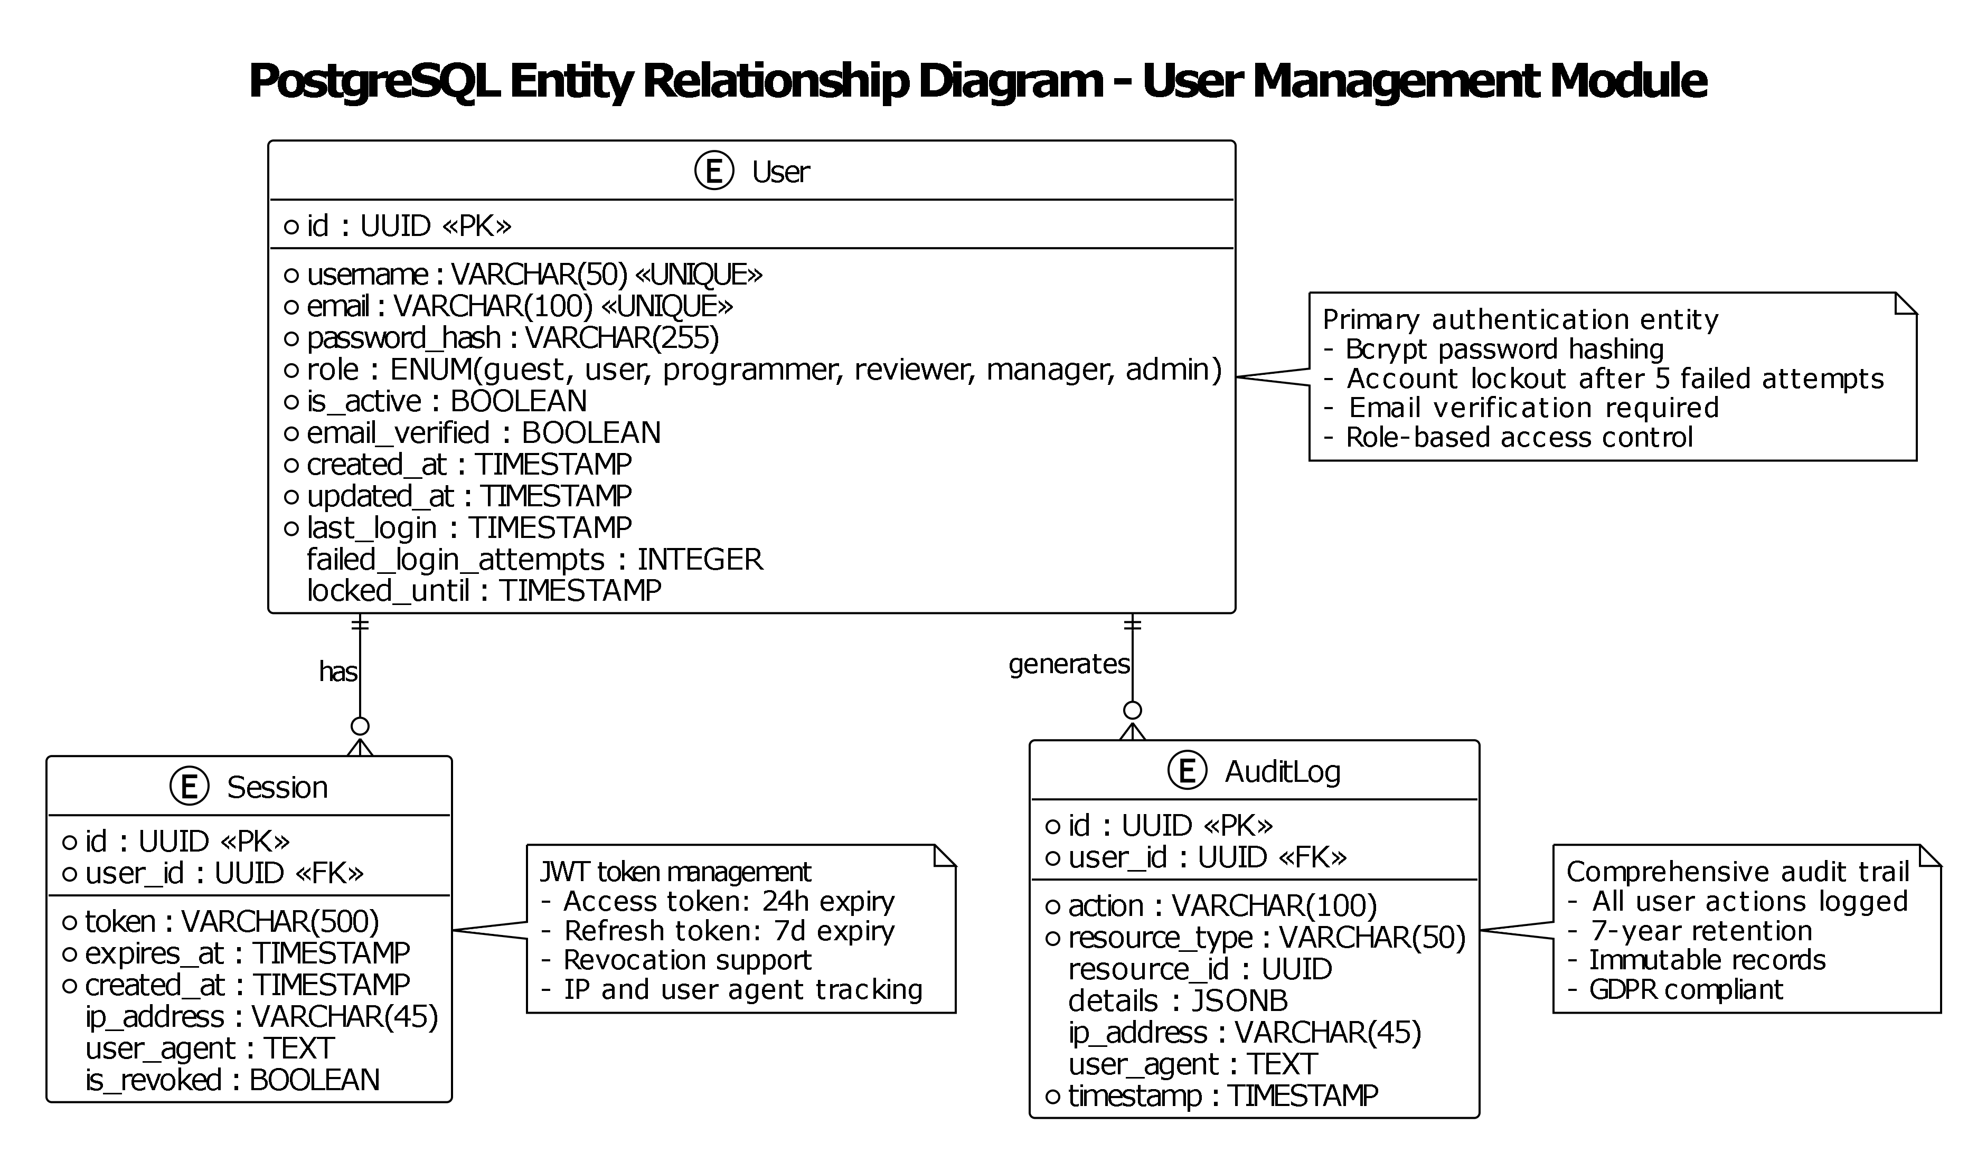

• Projects (one-to-many with Repositories)
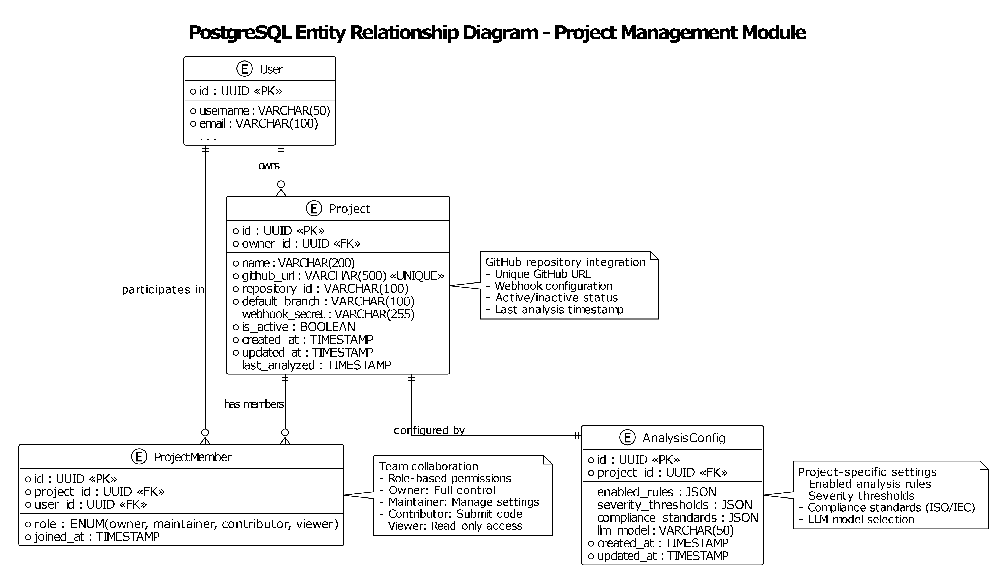

• Repositories (one-to-many with PullRequests)
• PullRequests (one-to-many with AnalysisResults)
• AnalysisResults (one-to-many with Issues)
• Issues (detected code issues)
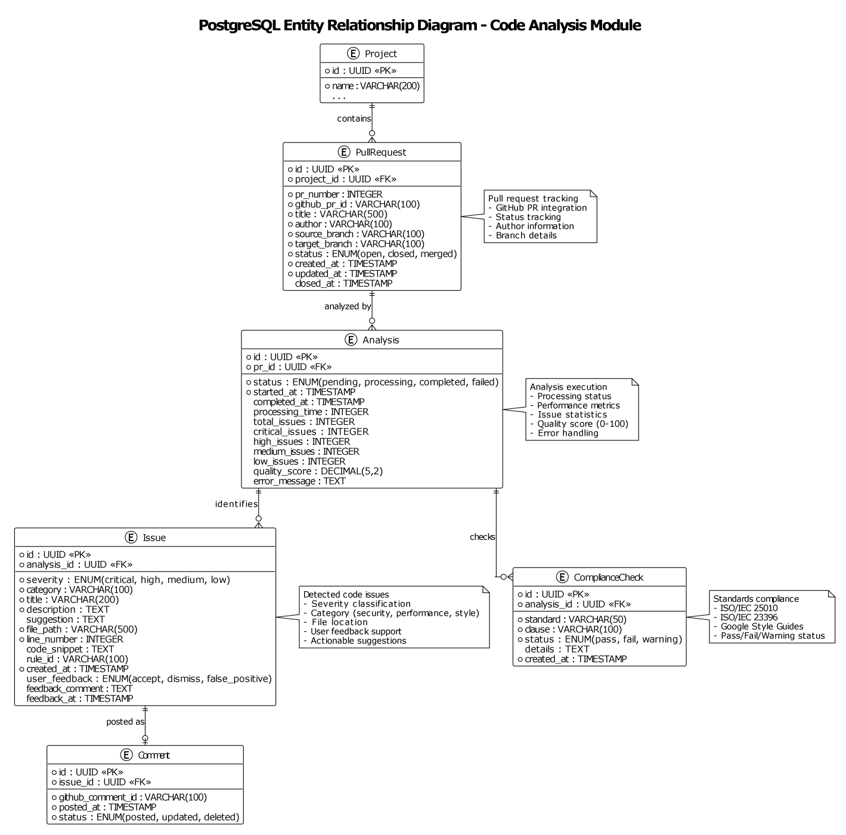

• AuditLogs (system activity tracking)
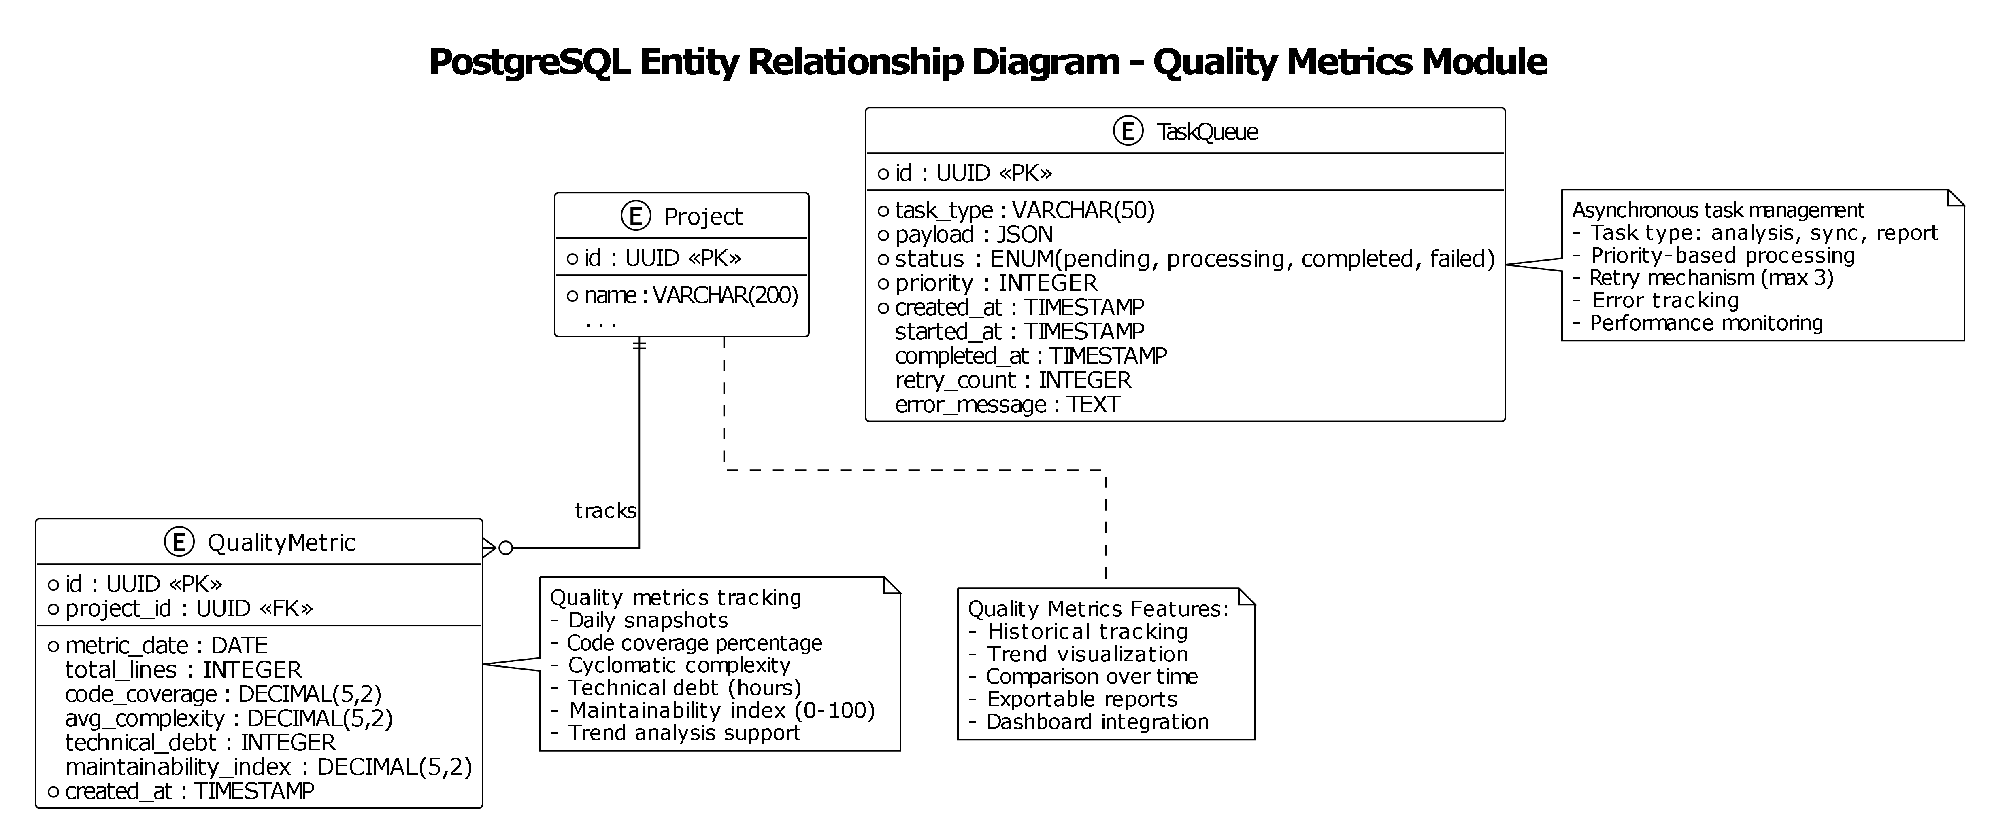

3.1.2 Neo4j Graph Entity Model
The graph database stores the code structure as a directed graph. Nodes represent code entities; edges (relationships) represent how those entities interact.
Node Type | Represents | Example
Module | A source code file or package | auth_service.py, utils/validators.py
Class | A class definition within a module | class AuthService, class UserRepository
Function | A function or method definition | def login(), async def analyze_pr()

Relationship Type | Direction | Meaning
DEPENDS_ON | Module → Module | Module A imports or otherwise depends on Module B
CALLS | Function → Function | Function A calls Function B
INHERITS | Class → Class | Class A extends or implements Class B
CONTAINS | Module → Class, Class → Function | Structural containment (a class is defined inside a module; a method is defined inside a class)

• Module nodes (represents code modules/packages)
• Class nodes (represents classes)
• Function nodes (represents functions/methods)
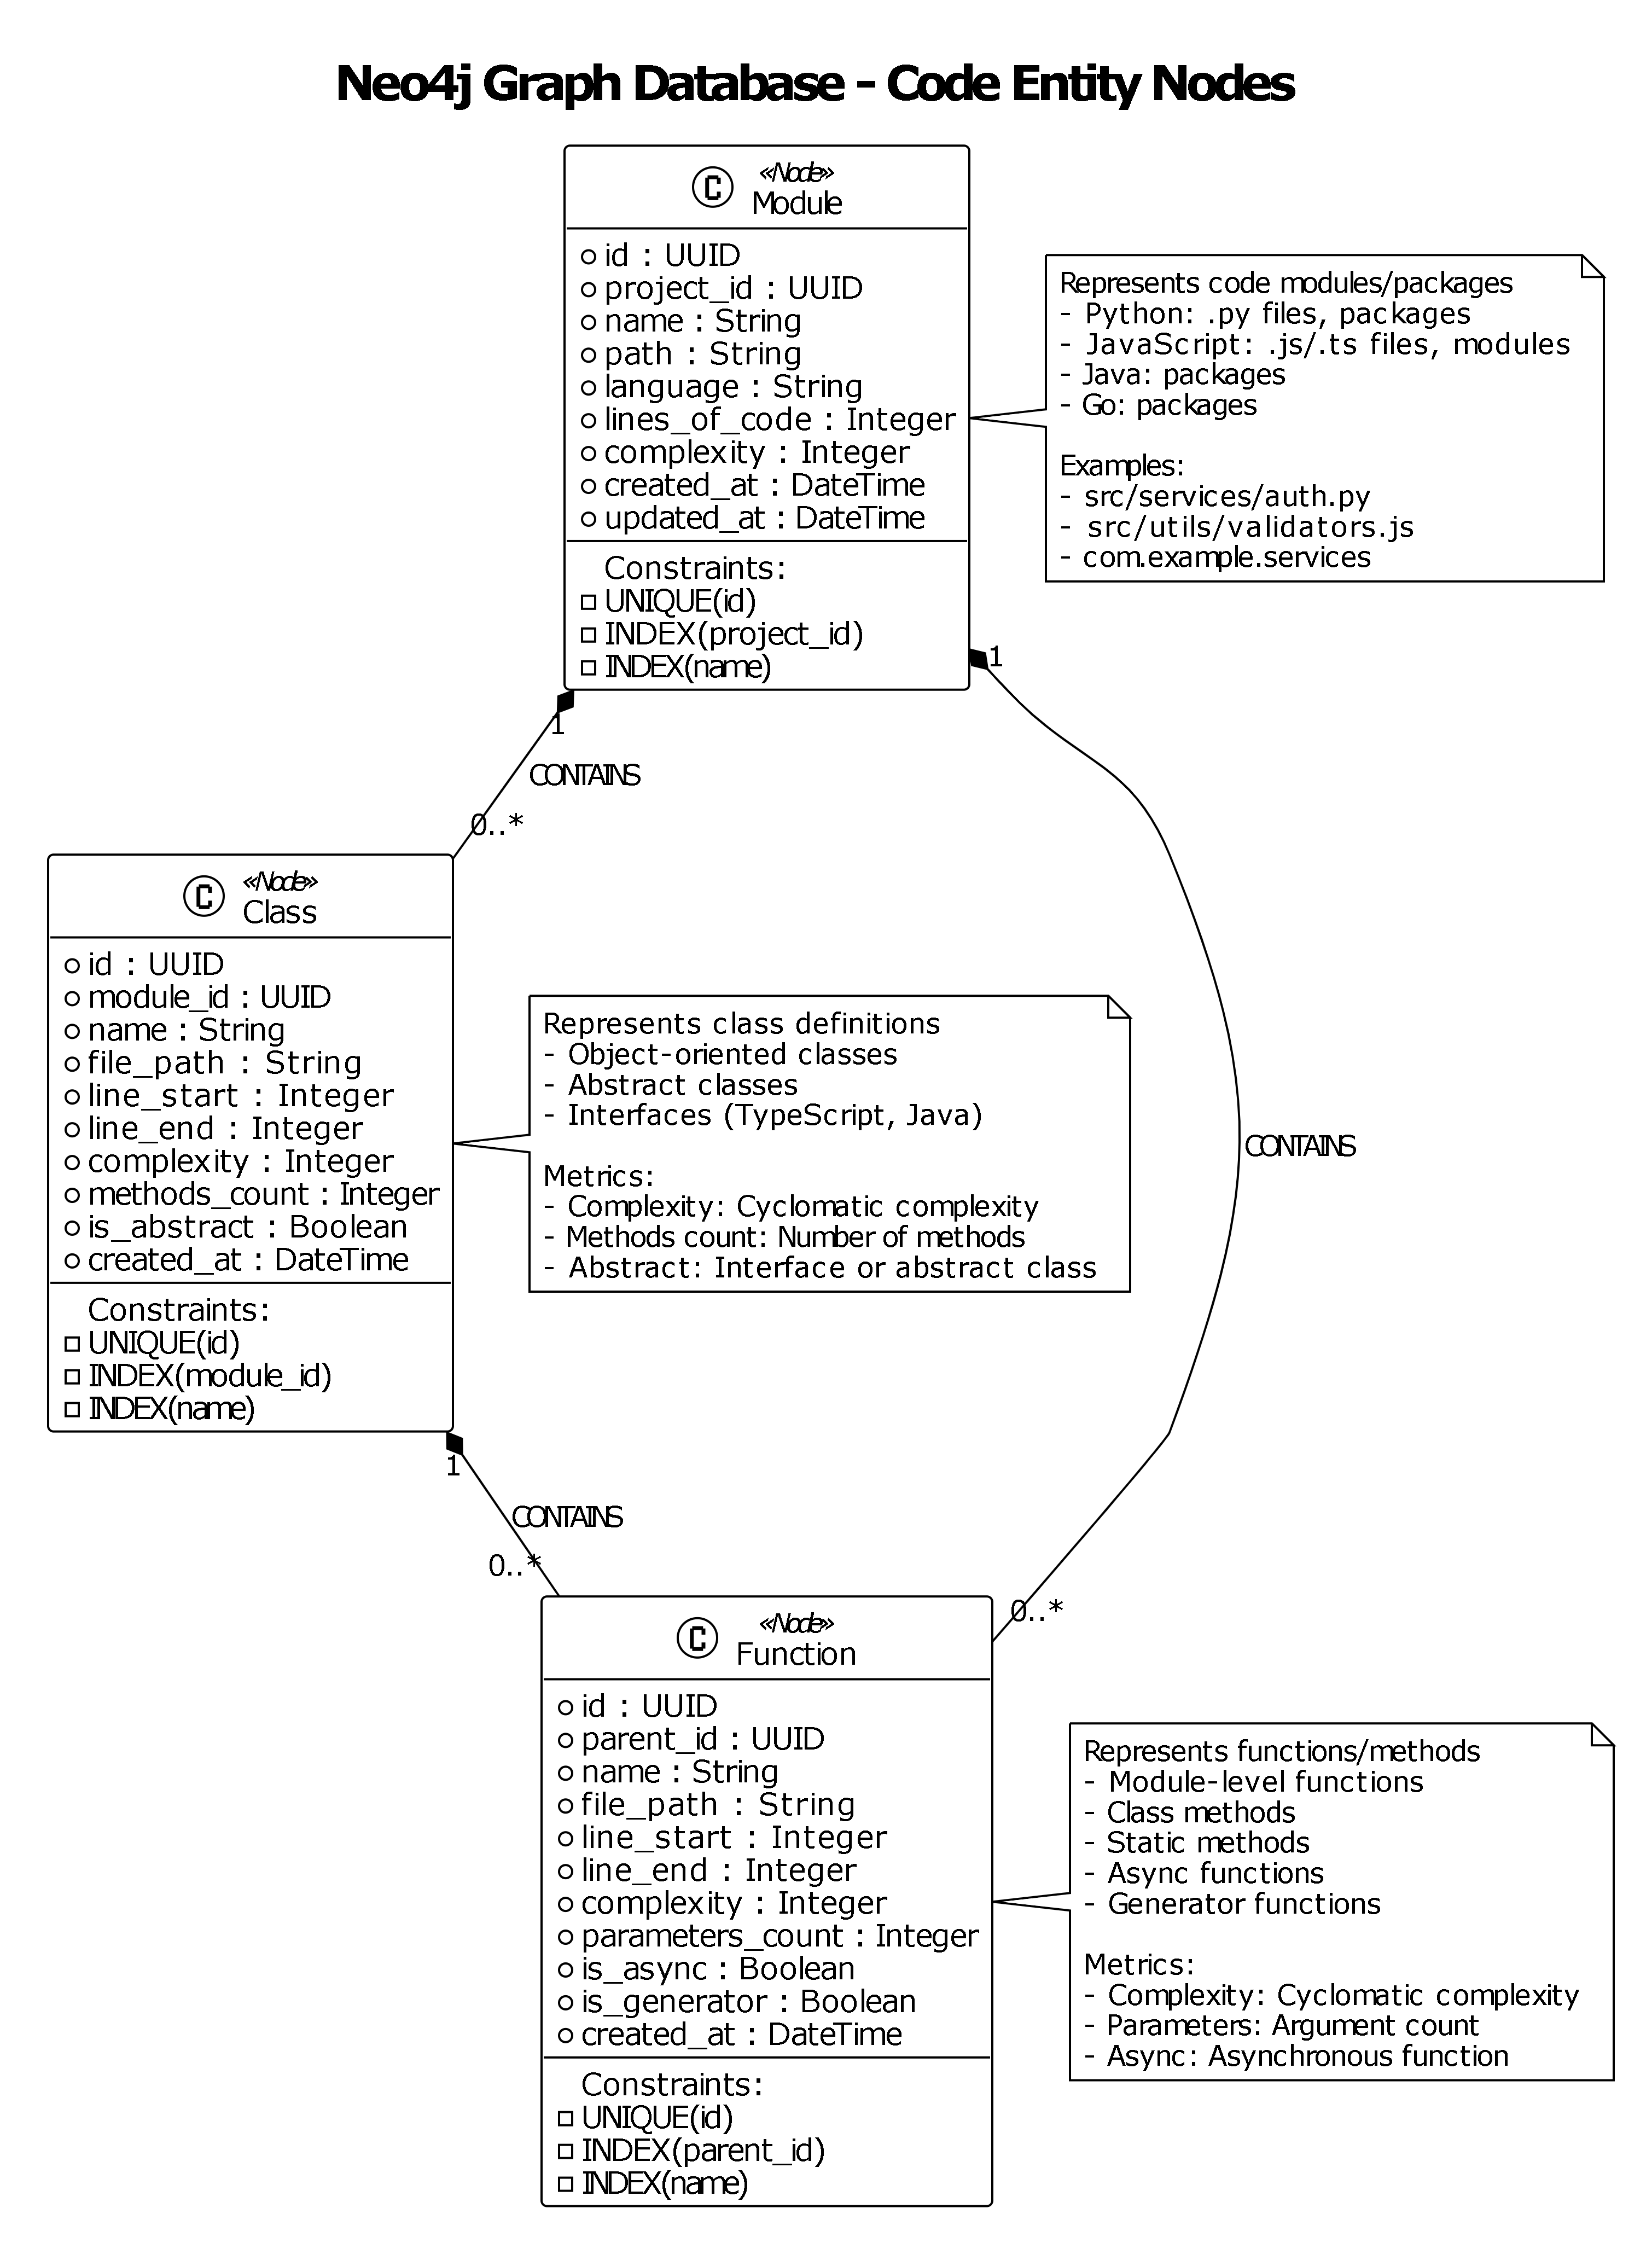

• DEPENDS_ON relationships (dependency edges)
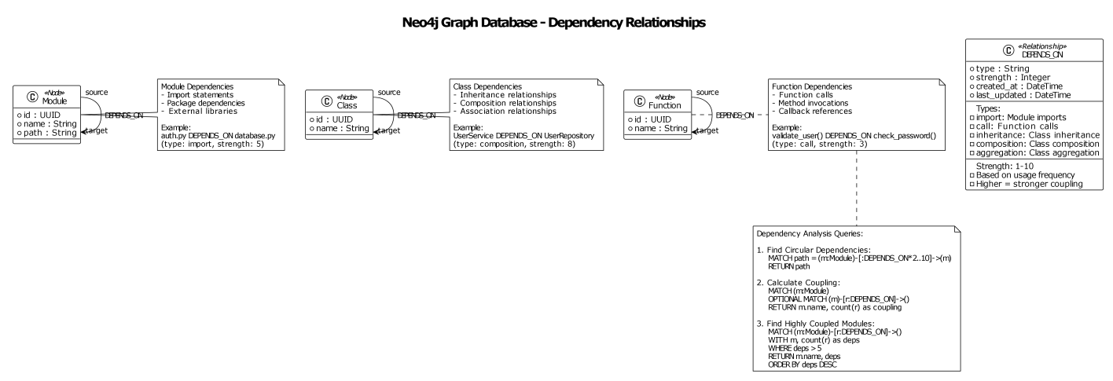

• CALLS relationships (function call edges)
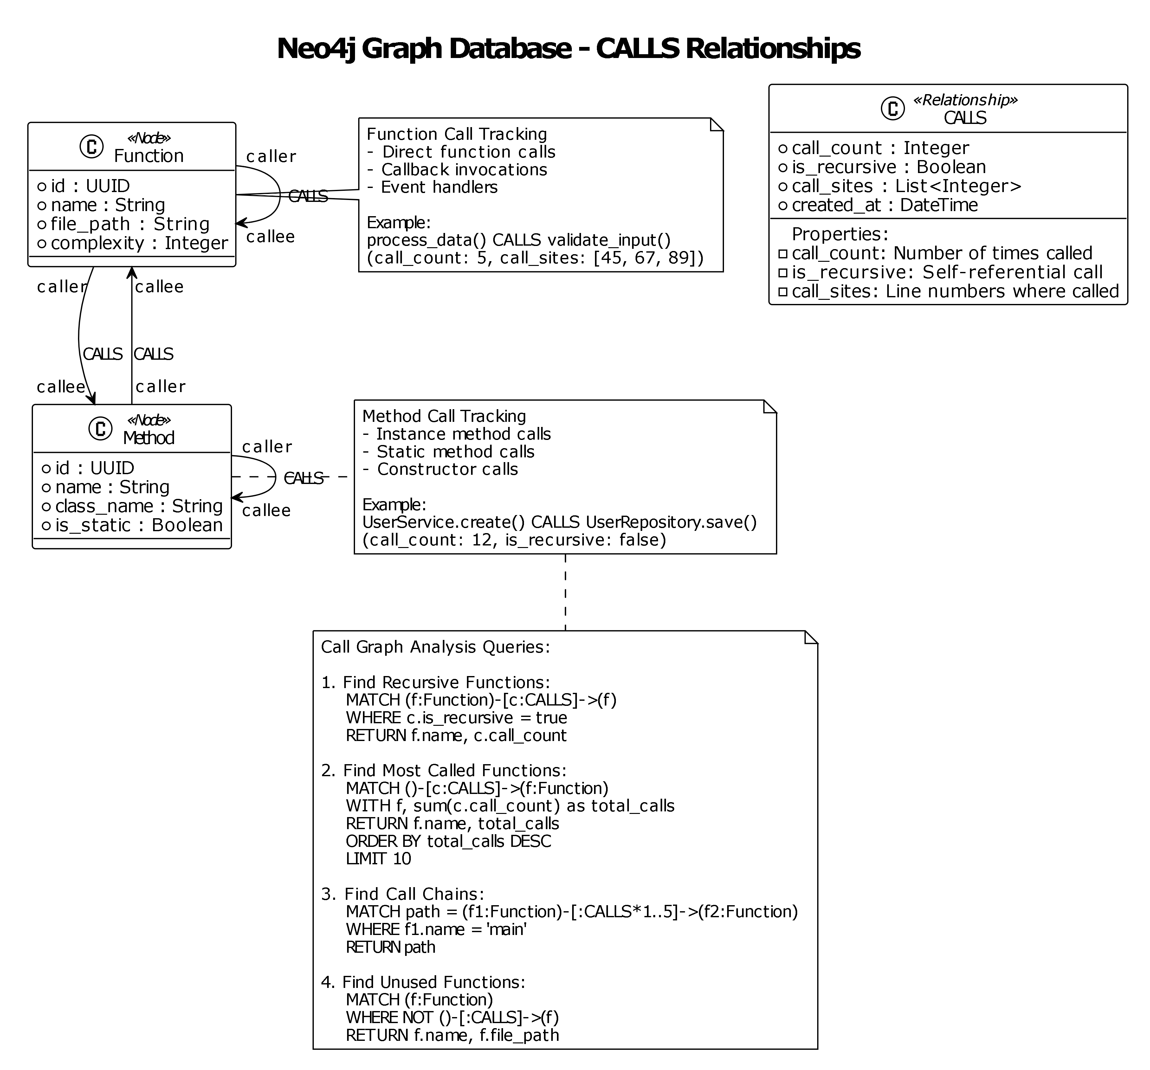

• INHERITS relationships (inheritance edges)
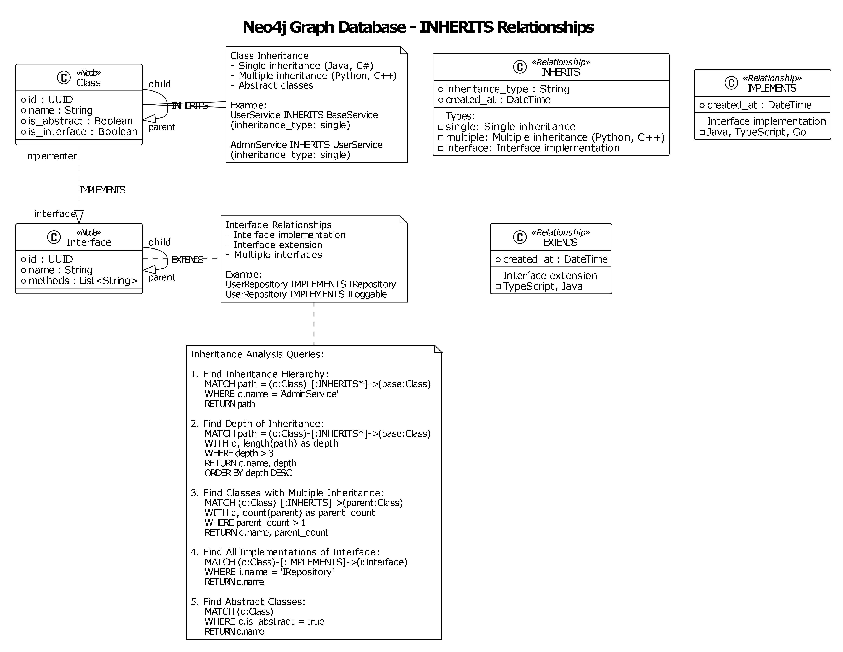

• Complete Graph Model
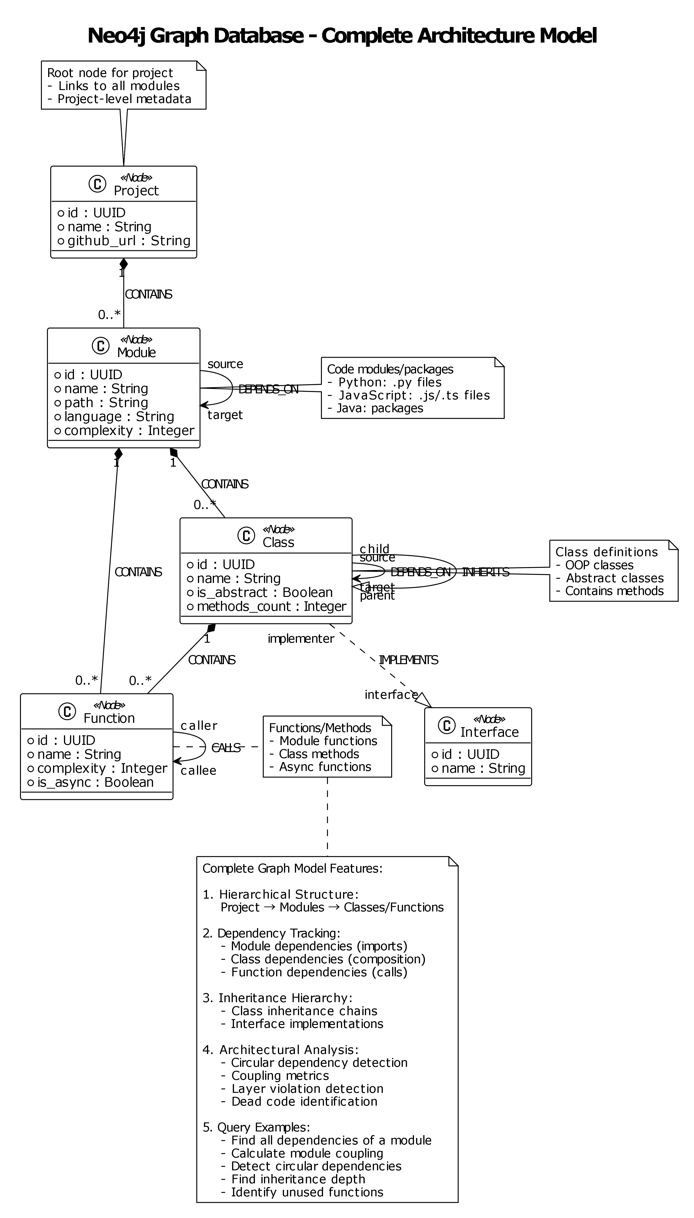

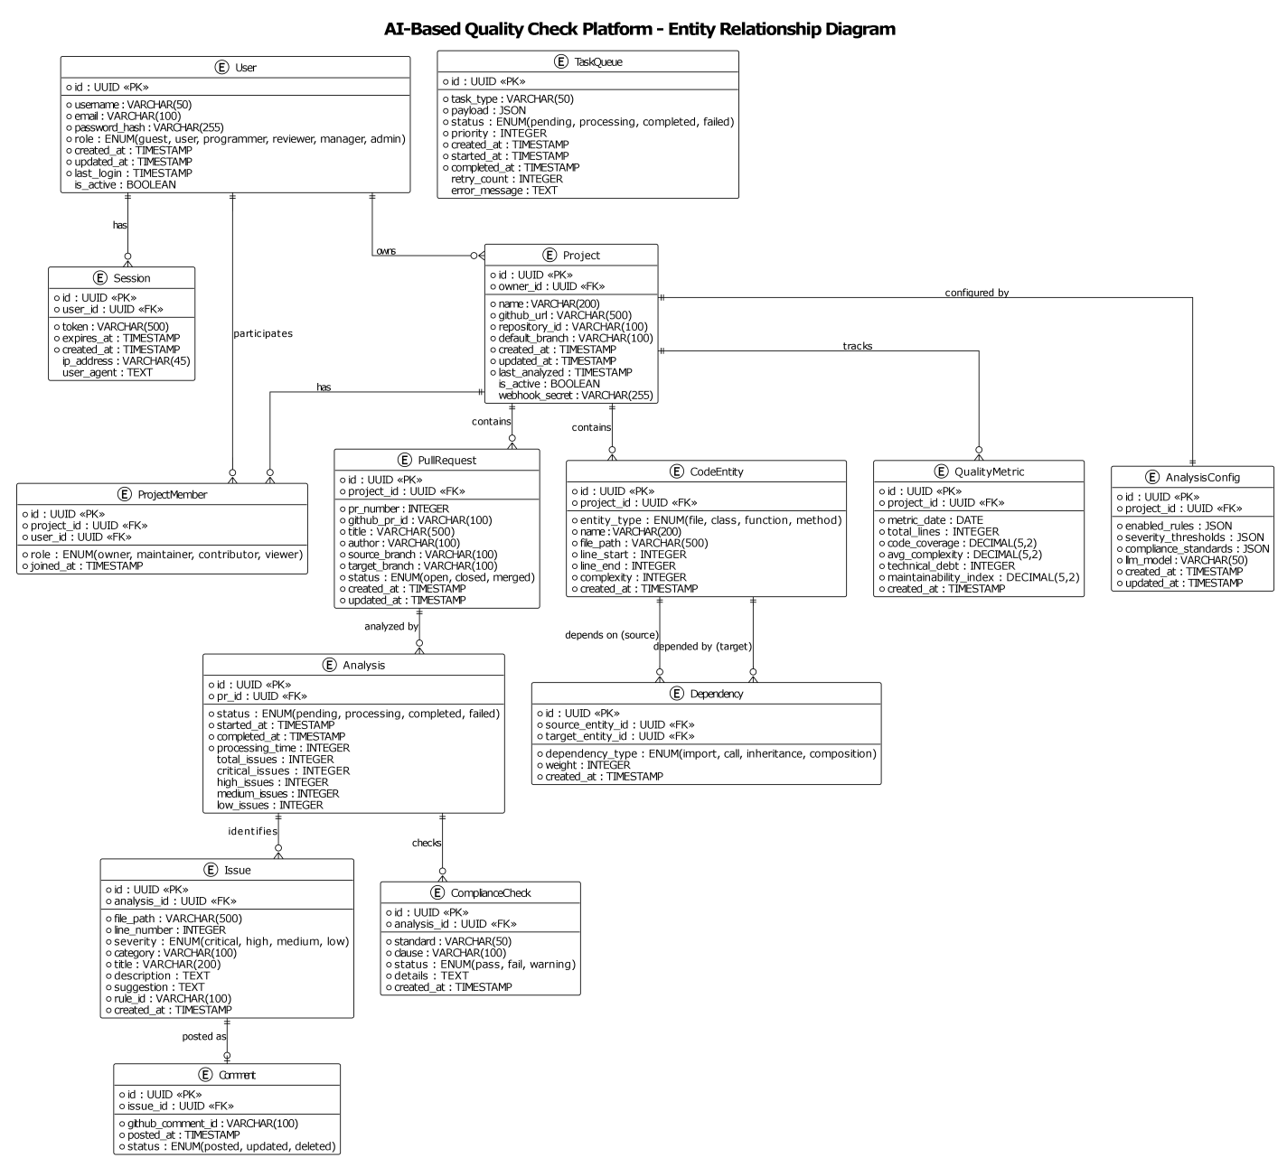

3.2 Data Dictionary
This subsection provides a detailed description of every table in the PostgreSQL database and every node/relationship type in the Neo4j graph database. For each table, all columns are listed with their data type, constraints, and a plain-English description of what the column holds.

3.2.1 PostgreSQL: Users Table
Stores one record per registered user. This is the central identity table; almost all other tables reference it.
Column | Type | Constraints | Description
id | UUID | Primary Key, auto-generated | Globally unique identifier for the user. UUIDs are used instead of sequential integers to prevent information leakage about the number of users in the system.
username | VARCHAR(50) | UNIQUE, NOT NULL | The user's login name. Must be 3–30 characters, alphanumeric plus underscore, starting with a letter.
email | VARCHAR(100) | UNIQUE, NOT NULL | The user's email address. Used for login and notifications.
password_hash | VARCHAR(255) | NOT NULL | The user's password stored as a bcrypt hash (never stored in plain text). Cost factor 12 is applied.
role | VARCHAR(20) | NOT NULL, CHECK constraint | The user's system-wide role. One of: visitor, programmer, reviewer, manager, admin. Controls what the user is permitted to do.
is_active | BOOLEAN | DEFAULT TRUE | If FALSE, the user's account is disabled and they cannot log in, even with valid credentials.
email_verified | BOOLEAN | DEFAULT FALSE | Whether the user has confirmed their email address via the verification link.
created_at | TIMESTAMP | DEFAULT NOW() | When the account was created.
updated_at | TIMESTAMP | DEFAULT NOW() | When the account record was last modified.
last_login | TIMESTAMP | NULLABLE | The timestamp of the user's most recent successful login.
failed_login_attempts | INTEGER | DEFAULT 0 | Counter of consecutive failed login attempts. Reset to 0 on successful login. When it reaches 5, the account is temporarily locked.
locked_until | TIMESTAMP | NULLABLE | If the account is locked due to too many failed login attempts, this field holds the datetime when the lockout expires.
Indexes: email (for login lookup), username (case-insensitive, for lookup), role (for bulk permission queries).

3.2.2 PostgreSQL: Sessions Table
Tracks active authentication sessions. Storing sessions in the database enables the system to detect suspicious simultaneous logins and supports forced logout.
Column | Type | Constraints | Description
id | UUID | Primary Key, auto-generated | Unique identifier for this session record.
user_id | UUID | Foreign Key → users(id), CASCADE DELETE | The user who owns this session.
access_token | VARCHAR(500) | NOT NULL | The JWT access token issued to the client.
refresh_token | VARCHAR(500) | NULLABLE | A longer-lived token that the client can use to obtain a new access token without re-authenticating.
expires_at | TIMESTAMP | NOT NULL | When the access token expires. Must be after created_at.
created_at | TIMESTAMP | DEFAULT NOW() | When the session was created.
ip_address | VARCHAR(45) | NULLABLE | The client's IP address at the time of login. Stored for security auditing.
user_agent | TEXT | NULLABLE | The client's browser or application identifier. Stored for security auditing.
is_revoked | BOOLEAN | DEFAULT FALSE | If TRUE, the session has been manually invalidated (e.g., the user logged out, or an admin force-revoked all sessions).
Indexes: user_id (to find all sessions for a user), access_token (for fast token validation), expires_at (for cleaning up expired sessions).

3.2.3 PostgreSQL: Projects Table
Stores one record per GitHub repository connected to the platform. Each project corresponds to exactly one GitHub repository.
Column | Type | Constraints | Description
id | UUID | Primary Key, auto-generated | Unique project identifier.
owner_id | UUID | Foreign Key → users(id), CASCADE DELETE | The user who connected this repository. They have full administrative rights over the project.
name | VARCHAR(200) | NOT NULL | A human-readable display name for the project (may differ from the GitHub repository name).
github_url | VARCHAR(500) | UNIQUE, NOT NULL | The full GitHub repository URL (format: https://github.com/{owner}/{repo}).
repository_id | VARCHAR(100) | NOT NULL | The GitHub-assigned internal ID for the repository. Used in API calls to GitHub.
default_branch | VARCHAR(100) | DEFAULT 'main' | The branch against which pull requests are compared when no target branch is specified.
webhook_secret | VARCHAR(255) | NULLABLE | The HMAC secret key shared with GitHub for webhook payload verification.
is_active | BOOLEAN | DEFAULT TRUE | If FALSE, the project is archived and no new analyses will be triggered.
created_at | TIMESTAMP | DEFAULT NOW() | When the project was connected to the platform.
updated_at | TIMESTAMP | DEFAULT NOW() | When the project configuration was last modified.
last_analyzed | TIMESTAMP | NULLABLE | When the most recent analysis for this project completed successfully.
Indexes: owner_id, github_url, is_active.

3.2.4 PostgreSQL: Project Members Table
Records which users have been granted access to which projects, and in what role. This table supports collaborative team workflows where multiple people work on the same project.
Column | Type | Constraints | Description
id | UUID | Primary Key, auto-generated | Unique membership record identifier.
project_id | UUID | Foreign Key → projects(id), CASCADE DELETE | The project to which access has been granted.
user_id | UUID | Foreign Key → users(id), CASCADE DELETE | The user who has been granted access.
role | VARCHAR(20) | NOT NULL, CHECK constraint | The user's role within this specific project. One of: owner, maintainer, contributor, viewer.
joined_at | TIMESTAMP | DEFAULT NOW() | When the membership was created (i.e., when the user was added to the project).
Constraints: UNIQUE(project_id, user_id) — a user can only appear once per project. Indexes: project_id, user_id.

3.2.5 PostgreSQL: Pull Requests Table
Records each GitHub Pull Request that has been submitted for analysis. The platform mirrors key PR metadata here so that it does not need to re-query the GitHub API for display purposes.
Column | Type | Constraints | Description
id | UUID | Primary Key, auto-generated | Unique PR record identifier within the platform.
project_id | UUID | Foreign Key → projects(id), CASCADE DELETE | The project (repository) to which this PR belongs.
pr_number | INTEGER | NOT NULL | The sequential PR number assigned by GitHub (e.g., PR #42).
github_pr_id | VARCHAR(100) | NOT NULL | GitHub's internal global PR identifier.
title | VARCHAR(500) | NOT NULL | The PR title as entered by the developer.
author | VARCHAR(100) | NOT NULL | The GitHub username of the person who opened the PR.
source_branch | VARCHAR(100) | NOT NULL | The feature branch being proposed for merging.
target_branch | VARCHAR(100) | NOT NULL | The branch the PR is proposed to merge into.
status | VARCHAR(20) | NOT NULL, CHECK constraint | Current PR status: open, closed, or merged.
created_at | TIMESTAMP | DEFAULT NOW() | When the PR was first received by the platform.
updated_at | TIMESTAMP | DEFAULT NOW() | When the PR record was last updated.
closed_at | TIMESTAMP | NULLABLE | When the PR was closed or merged.
Constraints: UNIQUE(project_id, pr_number). Indexes: project_id, status, author.

3.2.6 PostgreSQL: Analyses Table
Records each analysis job. A single Pull Request may be analysed multiple times (e.g., once per new commit push). This table stores the overall job status and aggregate counts.
Column | Type | Constraints | Description
id | UUID | Primary Key, auto-generated | Unique analysis job identifier.
pr_id | UUID | Foreign Key → pull_requests(id), CASCADE DELETE | The Pull Request being analysed.
status | VARCHAR(20) | NOT NULL, CHECK constraint | Current job status: pending (queued), processing (running), completed (finished successfully), failed (terminated with error).
started_at | TIMESTAMP | DEFAULT NOW() | When the analysis worker began processing.
completed_at | TIMESTAMP | NULLABLE | When the analysis finished. Required when status = completed.
processing_time | INTEGER | NULLABLE | Total duration of the analysis in seconds. Useful for performance monitoring.
total_issues | INTEGER | DEFAULT 0 | Total number of issues detected across all severity levels.
critical_issues | INTEGER | DEFAULT 0 | Number of issues with severity = critical.
high_issues | INTEGER | DEFAULT 0 | Number of issues with severity = high.
medium_issues | INTEGER | DEFAULT 0 | Number of issues with severity = medium.
low_issues | INTEGER | DEFAULT 0 | Number of issues with severity = low.
quality_score | DECIMAL(5,2) | NULLABLE | The composite quality score (0–100) computed by the Metrics Service. Higher is better.
error_message | TEXT | NULLABLE | If status = failed, this column contains the error message explaining what went wrong.
Indexes: pr_id, status, completed_at.

3.2.7 PostgreSQL: Issues Table
Stores every individual code issue detected during an analysis. This is the most detailed table in the system, as it records precise location, severity, and fix suggestions for each problem found.
Column | Type | Constraints | Description
id | UUID | Primary Key, auto-generated | Unique issue identifier.
analysis_id | UUID | Foreign Key → analyses(id), CASCADE DELETE | The analysis job that produced this issue.
severity | VARCHAR(20) | NOT NULL, CHECK constraint | How serious the issue is: critical (must fix before merge), high (should fix), medium (recommended), low (minor suggestion).
category | VARCHAR(100) | NOT NULL | The type of issue: security, performance, style, architecture, maintainability, etc.
title | VARCHAR(200) | NOT NULL | A short, human-readable title for the issue (e.g., 'SQL injection vulnerability').
description | TEXT | NOT NULL | A detailed explanation of what the issue is, why it is a problem, and what consequences it could have.
suggestion | TEXT | NULLABLE | An AI-generated recommendation for how to fix the issue, sometimes including a code example.
file_path | VARCHAR(500) | NOT NULL | The relative path within the repository of the file where the issue was found.
line_number | INTEGER | NOT NULL | The specific line number in the file where the issue occurs.
code_snippet | TEXT | NULLABLE | A short excerpt of the relevant code, for display in the UI without needing to fetch the full file.
rule_id | VARCHAR(100) | NULLABLE | If the issue was triggered by a static analysis rule (as opposed to purely AI-generated), the rule's identifier.
created_at | TIMESTAMP | DEFAULT NOW() | When the issue was recorded.
user_feedback | VARCHAR(20) | NULLABLE, CHECK constraint | Developer feedback on the issue: accept (acknowledged), dismiss (not relevant), false_positive (AI made a mistake).
feedback_comment | TEXT | NULLABLE | An optional comment explaining the developer's feedback decision.
feedback_at | TIMESTAMP | NULLABLE | When the developer submitted their feedback.
Indexes: analysis_id, severity, category, file_path.

3.2.8 PostgreSQL: Quality Metrics Table
Stores one snapshot of quality metrics per project per day. This table enables trend analysis — for example, showing whether test coverage has been improving or declining over the past three months.
Column | Type | Constraints | Description
id | UUID | Primary Key, auto-generated | Unique metric record identifier.
project_id | UUID | Foreign Key → projects(id), CASCADE DELETE | The project to which this snapshot belongs.
metric_date | DATE | NOT NULL | The date this snapshot represents (one per calendar day).
total_lines | INTEGER | NULLABLE | Total lines of code in the project on this date (excluding blank lines and comments).
code_coverage | DECIMAL(5,2) | NULLABLE | The percentage of the codebase covered by automated tests, as reported by the CI system.
avg_complexity | DECIMAL(5,2) | NULLABLE | The average cyclomatic complexity across all functions in the project. Lower is better.
technical_debt | INTEGER | NULLABLE | An estimate of the total number of hours required to fix all known issues in the codebase.
maintainability_index | DECIMAL(5,2) | NULLABLE | A composite score (0–100) reflecting how easy the codebase is to understand and modify. Derived from complexity, volume, and comment density.
created_at | TIMESTAMP | DEFAULT NOW() | When this snapshot was recorded.
Constraints: UNIQUE(project_id, metric_date) — only one snapshot per project per day. Indexes: project_id, metric_date.

3.2.9 PostgreSQL: Audit Logs Table
An immutable, append-only record of every security-relevant action performed in the system. Once written, rows in this table are never updated or deleted. This guarantees a tamper-evident audit trail for compliance and security investigation purposes.
Column | Type | Constraints | Description
id | UUID | Primary Key, auto-generated | Unique log entry identifier.
user_id | UUID | Foreign Key → users(id), SET NULL on delete | The user who performed the action. NULL for system-initiated actions (e.g., automatic token expiry).
action | VARCHAR(100) | NOT NULL | A code describing the action performed. Examples: LOGIN, LOGOUT, LOGIN_FAILED, CREATE_USER, UPDATE_USER_ROLE, CREATE_PROJECT, GRANT_ACCESS, TRIGGER_ANALYSIS, VIEW_AUDIT_LOGS.
resource_type | VARCHAR(50) | NOT NULL | The type of the resource affected (e.g., user, project, analysis, session).
resource_id | UUID | NULLABLE | The identifier of the specific resource affected.
details | JSONB | NULLABLE | Additional context stored as flexible JSON — e.g., the old and new values when a field is updated.
ip_address | VARCHAR(45) | NULLABLE | The IP address of the client that performed the action.
user_agent | TEXT | NULLABLE | The client's browser or application identifier.
timestamp | TIMESTAMP | DEFAULT NOW() | When the action occurred.
Immutability Enforcement: The API layer returns HTTP 403 Forbidden for any attempt to call UPDATE or DELETE on this table. Indexes: user_id, action, timestamp, (resource_type, resource_id) composite.

3.2.10 Neo4j: Node Properties
Each node type in the graph database has a defined set of properties. Node types correspond to structural elements of the source code.

Module Node — Represents a source code file or package
Property | Type | Description
id | UUID | Unique identifier (unique constraint enforced in Neo4j)
project_id | UUID | The platform project this module belongs to (indexed for fast per-project queries)
name | String | The module name (e.g., 'auth_service', 'validators')
path | String | The module's file system path relative to the repository root
language | String | The programming language (e.g., 'python', 'typescript', 'java')
lines_of_code | Integer | Total lines of code in this module
complexity | Integer | The average cyclomatic complexity across all functions in this module
created_at | DateTime | When this node was first added to the graph
updated_at | DateTime | When this node was last updated

Class Node — Represents a class definition
Property | Type | Description
id | UUID | Unique identifier
module_id | UUID | The ID of the Module node that contains this class
name | String | The class name
file_path | String | Source file path
line_start | Integer | The line number where the class definition begins
line_end | Integer | The line number where the class definition ends
complexity | Integer | Total cyclomatic complexity of all methods in the class
methods_count | Integer | Number of methods defined in the class
is_abstract | Boolean | Whether the class is abstract (cannot be instantiated directly)

Function Node — Represents a function or method definition
Property | Type | Description
id | UUID | Unique identifier
parent_id | UUID | The ID of the containing Module or Class node
name | String | The function or method name
file_path | String | Source file path
line_start | Integer | Start line number
line_end | Integer | End line number
complexity | Integer | Cyclomatic complexity of this function
parameters_count | Integer | Number of input parameters
is_async | Boolean | Whether this is an asynchronous function (async def in Python)

3.2.11 Neo4j: Relationship Properties
Relationship | Direction | Key Properties | Description
DEPENDS_ON | Module → Module | type (import/call/inheritance/composition); strength (1–10 usage frequency); created_at; last_updated | Indicates that the source module imports or otherwise depends on the target module. The type property records how the dependency arises.
CALLS | Function → Function | call_count (number of call sites); is_recursive (boolean); call_sites (list of line numbers) | Records that the source function calls the target function. Recursive calls are flagged explicitly.
INHERITS | Class → Class | inheritance_type (single / multiple / interface) | Records that the source class extends or implements the target class.
CONTAINS | Module → Class  Class → Function | None (structural only) | Records the containment hierarchy: a module contains its classes; a class contains its methods.

3.2.12 Neo4j: Common Query Patterns
The following query patterns are the backbone of the architectural analysis features. They are executed by the Architecture Analyser service using the Cypher query language.
Query Pattern | Purpose | Approach
Circular Dependency Detection | Find all modules that form dependency cycles (A depends on B which depends on A, etc.). | Traverse DEPENDS_ON relationships using Johnson's algorithm; find elementary cycles of length 2–10 within a project's subgraph.
Module Coupling Calculation | Identify the most tightly coupled modules (those with the most incoming and outgoing dependencies). | Count incoming and outgoing DEPENDS_ON edges per module; rank by total coupling score.
Layer Violation Detection | Find dependencies that skip architectural layers (e.g., a UI module directly importing from the database layer). | Match DEPENDS_ON edges where the source module's path pattern matches a higher layer and the target matches a lower layer, without an intermediate service-layer edge.
Dependency Graph Export | Export the full dependency graph for visualisation in the frontend. | Collect all Module nodes and their DEPENDS_ON targets; serialize as a JSON graph for D3.js rendering.

4. Detailed Design
This section provides the in-depth specification of every major component, module, and algorithm in the system. It covers class structure, service APIs, algorithm logic, exception handling, security implementation, deployment topology, performance tuning, observability instrumentation, and the architectural decision records that document why each major design choice was made.

4.1 Class Diagram (if Object-Oriented)

The system's class structure is divided into seven functional domains to keep each diagram readable. In a full diagram-supported version of this document, each domain has its own class diagram showing class attributes, method signatures, and inter-class relationships. The textual summary below captures the same information.

4.1.1 User Management Domain
- Model classes: User, Session, AuditLog — each maps to the corresponding PostgreSQL table.
- Service classes: AuthService (login/logout/token management), JWTManager (token creation and validation), PasswordHasher (bcrypt), PermissionChecker (delegates to RBACService).
- Repository classes: UserRepository, SessionRepository — abstract all database access for the domain.
- DTOs (Data Transfer Objects): RegisterDTO, LoginDTO, UserProfile, TokenPayload — define the shape of data sent between layers.
- Purpose: Handles all authentication, authorisation, session management, and audit logging.
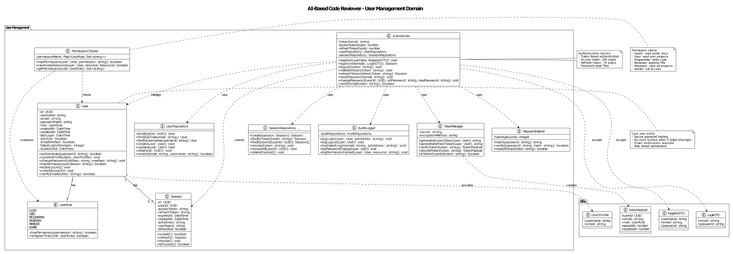
- Components: User, Session, AuthService, JWTManager, PasswordHasher, PermissionChecker
- Repositories: UserRepository, SessionRepository
- DTOs: RegisterDTO, LoginDTO, UserProfile, TokenPayload
- Purpose: Authentication, authorization, session management, audit logging

4.1.2 Project Management Domain
- Model classes: Project, ProjectMember, AnalysisConfig.
- Service classes: ProjectService (CRUD), WebhookService (GitHub webhook registration and validation), ConfigService (analysis rule configuration).
- Repository classes: ProjectRepository, ConfigRepository.
- DTOs: CreateProjectDTO, UpdateProjectDTO, ProjectConfig, QualityMetrics.
- Purpose: Manages GitHub repository connections, team membership, and analysis configuration.
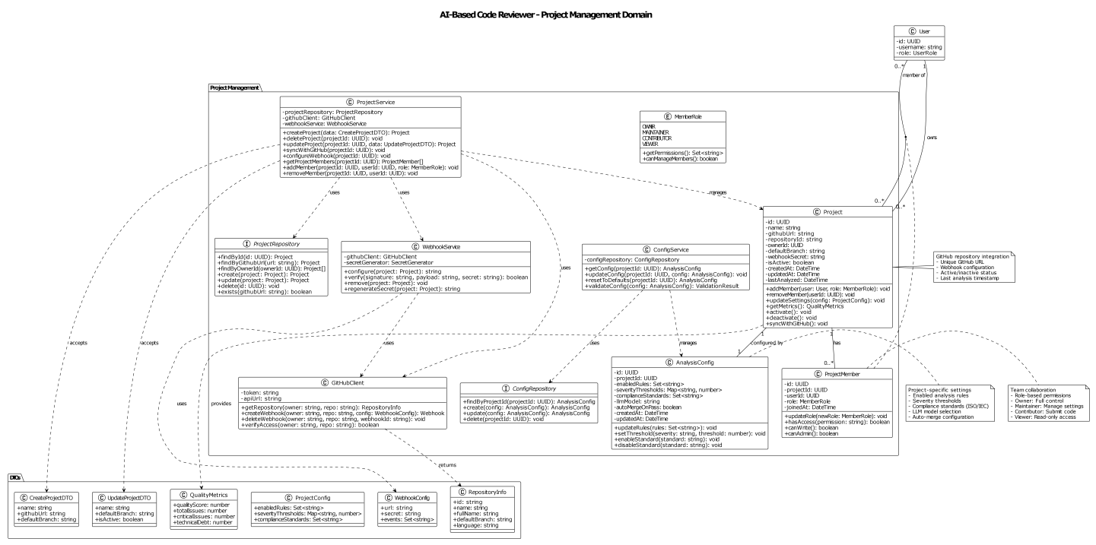
- Components: Project, ProjectMember, ProjectService, WebhookService, AnalysisConfig, ConfigService
- Repositories: ProjectRepository, ConfigRepository
- DTOs: CreateProjectDTO, UpdateProjectDTO, ProjectConfig, QualityMetrics
- Purpose: GitHub repository integration, team collaboration, project configuration

4.1.3 Code Analysis Domain
- Model classes: PullRequest, Analysis, Issue, Comment.
- Service classes: CodeReviewEngine (orchestrates analysis), ParserService (delegates to AST parser), IssueDetector (applies rules and AI results).
- Repository classes: AnalysisRepository, IssueRepository, CommentRepository.
- DTOs: AnalysisReport, IssueContext, ValidationResult, ComparisonResult.
- Purpose: Orchestrates PR analysis, issue detection, code review, and posting comments to GitHub.
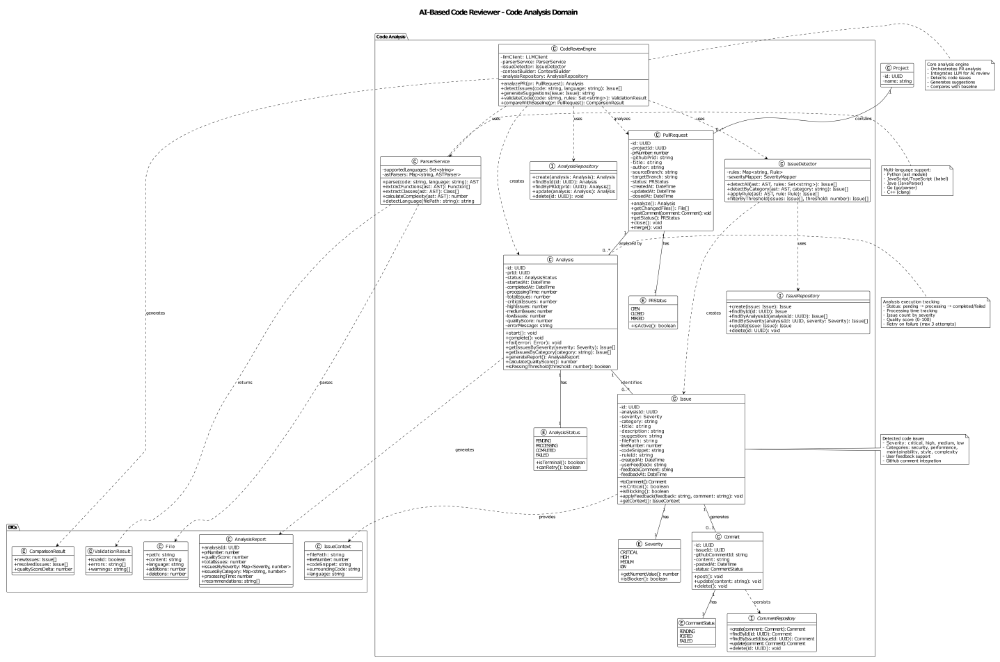
- Components: PullRequest, Analysis, Issue, Comment, CodeReviewEngine, ParserService, IssueDetector
- Repositories: AnalysisRepository, IssueRepository, CommentRepository
- DTOs: AnalysisReport, IssueContext, ValidationResult, ComparisonResult
- Purpose: PR analysis, issue detection, code review, GitHub comment integration

4.1.4 Architecture Analysis Domain
- Model classes: CodeEntity (module/class/function), Dependency.
- Service classes: ArchitectureAnalyzer (top-level orchestration), ASTParser (source code parsing), GraphBuilder (Neo4j operations), CircularDependencyDetector (cycle finding), LayerAnalyzer (layer rule enforcement).
- Repository classes: EntityRepository, DependencyRepository.
- DTOs: EntityMetrics, CouplingMetrics, DriftReport, GraphVisualization, Violation.
- Purpose: Builds the dependency graph, detects circular dependencies and layer violations, computes architectural drift.
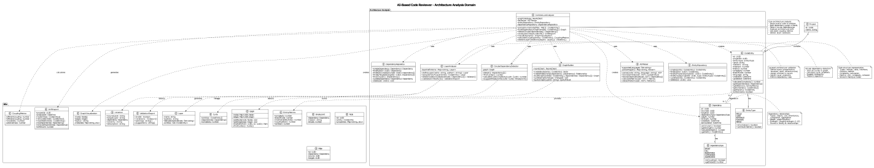
- Components: CodeEntity, Dependency, ArchitectureAnalyzer, ASTParser, GraphBuilder, CircularDependencyDetector, LayerAnalyzer
- Repositories: EntityRepository, DependencyRepository
- DTOs: EntityMetrics, CouplingMetrics, DriftReport, GraphVisualization, Violation
- Purpose: Code structure analysis, dependency graph, circular dependency detection, layer validation

4.1.5 AI Integration Domain
- Model classes: AgenticAI (top-level AI coordinator), LLMClient (provider abstraction), ContextBuilder (assembles prompt context), PromptManager (template management), ResponseParser (extracts structured data from LLM output), EmbeddingService, VectorStore.
- Support classes: RateLimiter, CacheManager, TokenCounter.
- DTOs: AIAnalysis, ReviewComment, CodeSuggestion, Pattern, Context, LLMResponse.
- Purpose: Manages LLM integration, AI-powered code review, semantic search, and prompt engineering.
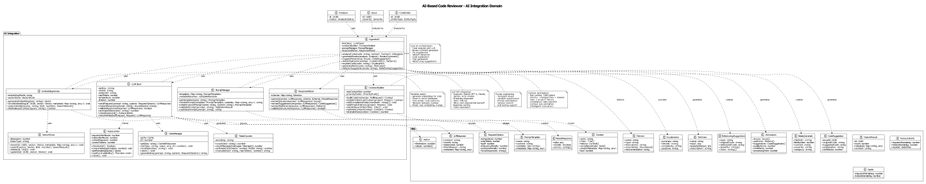
- Components: AgenticAI, LLMClient, ContextBuilder, PromptManager, ResponseParser, EmbeddingService, VectorStore
- Support: RateLimiter, CacheManager, TokenCounter
- DTOs: AIAnalysis, ReviewComment, CodeSuggestion, Pattern, Context, LLMResponse
- Purpose: LLM integration, AI-powered code review, semantic search, prompt management

4.1.6 Quality Metrics Domain
- Model classes: QualityMetric, ComplianceCheck.
- Service classes: MetricsService (orchestration), MetricCalculator, ComplexityCalculator, CoverageCalculator, TechnicalDebtCalculator.
- Analysis classes: MetricsAggregator, TrendAnalyzer, DashboardBuilder.
- Repository classes: MetricsRepository, ComplianceRepository.
- DTOs: MetricDelta, MetricTrend, Dashboard, Report, ComparisonReport.
- Purpose: Computes quality metrics, verifies compliance, generates trend data and dashboards.
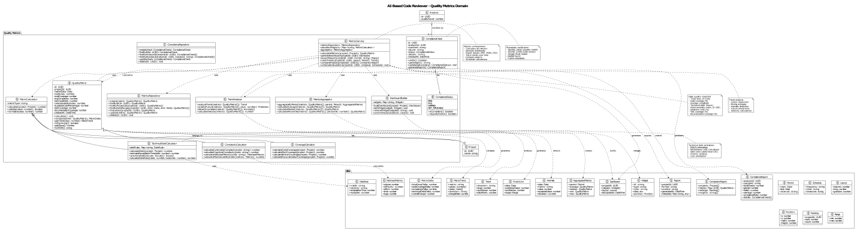
- Components: QualityMetric, ComplianceCheck, MetricsService, MetricCalculator, ComplexityCalculator, CoverageCalculator, TechnicalDebtCalculator
- Analysis: MetricsAggregator, TrendAnalyzer, DashboardBuilder
- Repositories: MetricsRepository, ComplianceRepository
- DTOs: MetricDelta, MetricTrend, Dashboard, Report, ComparisonReport
- Purpose: Quality metrics calculation, compliance verification, trend analysis, dashboard generation

4.1.7 Infrastructure Domain
- Client classes: GitHubClient, Neo4jClient, RedisClient, PostgreSQLClient, TaskQueue.
- Service classes: EmailService, LoggerService, MonitoringService, CacheService, FileStorageService.
- Support classes: WebhookHandler, RateLimiter, ConfigurationManager.
- DTOs: PRData, File, WebhookConfig, Node, Relationship, Task, HealthStatus.
- Purpose: Provides all external integrations, database client abstractions, the Celery task queue, monitoring, and caching.
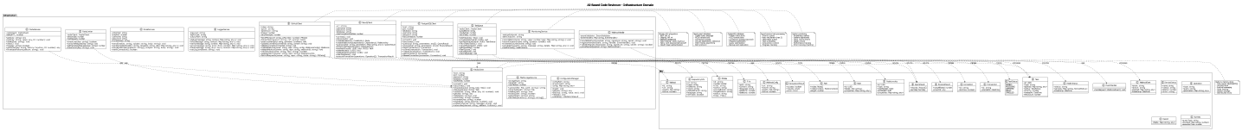
- Components: GitHubClient, Neo4jClient, RedisClient, PostgreSQLClient, TaskQueue
- Services: EmailService, LoggerService, MonitoringService, CacheService, FileStorageService
- Support: WebhookHandler, RateLimiter, ConfigurationManager
- DTOs: PRData, File, WebhookConfig, Node, Relationship, Task, HealthStatus
- Purpose: External integrations, database clients, task queue, monitoring, caching

4.1.8 Complete Class Diagram

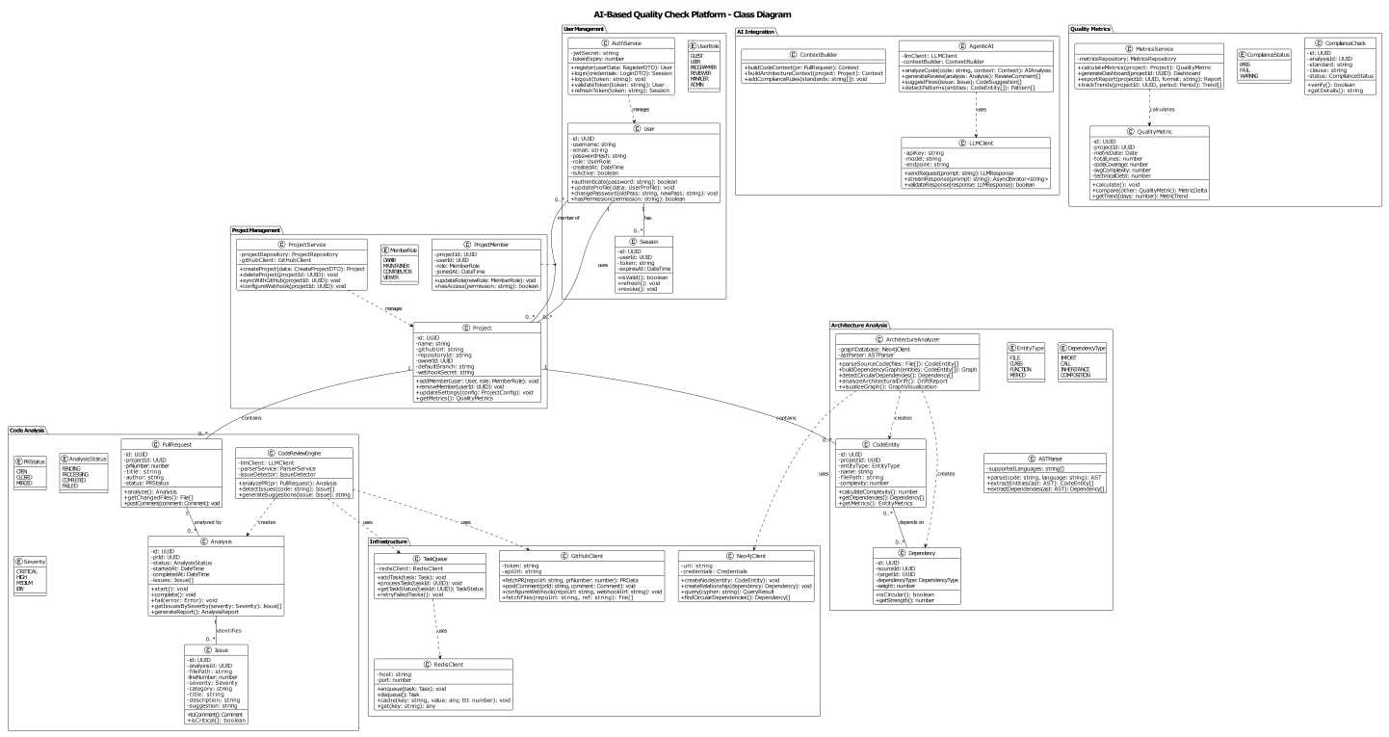

4.2 Component Design
This section provides implementation-level specifications for each major service and module, including their public interfaces, algorithms, and design decisions.

4.2.1 Authentication Service
The Authentication Service is responsible for managing user identity: verifying credentials, issuing JWT tokens, and tracking active sessions.
Attribute | Value
Technology | FastAPI, PyJWT, bcrypt, SQLAlchemy
Implementation file | enterprise_rbac_auth/services/auth_service.py
Design pattern | Stateless — all methods are @staticmethod; no instance state

Method Specifications
Method | Signature | Description
hash_password | (password: str) → str | Hashes a plain-text password using bcrypt with a newly generated salt and cost factor 12. The result is stored in the database. The original password is never stored.
verify_password | (password: str, password_hash: str) → bool | Checks whether a plain-text password matches a stored bcrypt hash. Returns True if they match, False otherwise.
generate_token | (user_id, username, role) → str | Creates a signed JWT containing: user_id, username, role, issued-at (iat), expiry (exp = iat + 24h), and a unique token ID (jti) for future revocation support.
validate_token | (token: str) → Optional[TokenPayload] | Decodes and validates a JWT. Returns the decoded payload if valid and not expired; returns None if the token is expired, tampered with, or otherwise invalid.
refresh_token | (token: str) → Optional[str] | Issues a new token if the current token is within its final 10-minute validity window. This allows the client to seamlessly refresh without re-authenticating.
login | (db, username, password, ip_address, device_info) → AuthResult | Verifies credentials, creates a Session record in PostgreSQL, updates last_login, and returns the new JWT. Returns a generic error message on failure to prevent username enumeration attacks.
logout | (db, user_id, token) → bool | Marks the specified Session as revoked (is_revoked = True) so that subsequent requests with the same token are rejected.
invalidate_all_user_sessions | (db, user_id) → bool | Marks all active sessions for the user as revoked. Used when a user changes their password or their account is deactivated.

4.2.2 RBAC Service
The Role-Based Access Control (RBAC) Service determines what each user is permitted to do. Think of it as the system's permission gatekeeper.
Attribute | Value
Technology | SQLAlchemy, Python Enum
Implementation file | enterprise_rbac_auth/services/rbac_service.py
Role hierarchy | ADMIN > MANAGER > REVIEWER > PROGRAMMER > VISITOR

Permission Matrix
A tick (✓) means the role has the permission. Empty cells mean the permission is not granted.
Permission | ADMIN | MANAGER | REVIEWER | PROGRAMMER | VISITOR
CREATE_USER | ✓
READ_USER | ✓ | ✓
UPDATE_USER | ✓
DELETE_USER | ✓
CREATE_PROJECT | ✓ | ✓ |  | ✓
VIEW_PROJECT | ✓ | ✓ | ✓ | ✓ | ✓
UPDATE_PROJECT | ✓ | ✓ |  | ✓
DELETE_PROJECT | ✓ | ✓ |  | ✓
TRIGGER_ANALYSIS | ✓ | ✓ | ✓ | ✓
VIEW_ANALYSIS | ✓ | ✓ | ✓ | ✓ | ✓
MANAGE_USERS | ✓
VIEW_AUDIT_LOGS | ✓ | ✓

Method Specifications
Method | Signature | Description
has_permission | (db, user_id, permission) → bool | Looks up the user's system-wide role and checks whether that role includes the requested permission.
get_role_permissions | (role) → list[Permission] | Returns the full list of permissions granted to a given role.
can_access_project | (db, user_id, project_id, permission) → bool | Checks project-level access: ADMIN always returns True; the project owner always returns True; other users need an explicit ProjectAccess grant.
grant_project_access | (db, project_id, user_id, granted_by) → bool | Creates a ProjectAccess record. Only the ADMIN or the project owner may call this method.
revoke_project_access | (db, project_id, user_id, revoked_by) → bool | Deletes a ProjectAccess record. Only the ADMIN or the project owner may call this method.
assign_role | (db, user_id, new_role, assigned_by) → bool | Updates the user's role. Only ADMIN may assign roles. The change takes effect immediately.
validate_role | (role: str) → bool | Checks whether a string is a valid role name (i.e., it exists in the Role enum).

4.2.3 Audit Service
The Audit Service records every security-relevant action, creating an immutable trail for compliance investigation and security analysis. All writes to the audit log are append-only — no row is ever modified or deleted.
Attribute | Value
Technology | SQLAlchemy, PostgreSQL JSONB
Implementation file | enterprise_rbac_auth/services/audit_service.py
Immutability enforcement | The API layer returns HTTP 403 Forbidden for any UPDATE or DELETE operation on the audit_logs table.

Logged Action Codes
Category | Action Codes
Authentication | LOGIN, LOGOUT, LOGIN_FAILED
User Management | CREATE_USER, UPDATE_USER, DELETE_USER, UPDATE_USER_ROLE
Project Management | CREATE_PROJECT, UPDATE_PROJECT, DELETE_PROJECT
Access Control | GRANT_ACCESS, REVOKE_ACCESS
Analysis | TRIGGER_ANALYSIS, VIEW_ANALYSIS
Configuration | UPDATE_CONFIG

4.2.4 Authorization Middleware
The Authorization Middleware intercepts every incoming HTTP request before it reaches a route handler. It validates the JWT token, loads the user from the database, and checks that the user has the necessary role or permission for the requested operation.
Attribute | Value
Technology | FastAPI dependency injection, PyJWT
Implementation file | enterprise_rbac_auth/middleware/auth_middleware.py

Middleware Decision Flow
- Request arrives → middleware extracts the Bearer token from the Authorization header.
- If no token or invalid format → return HTTP 401 Unauthorized.
- validate_token() decodes the JWT. If expired or tampered → return HTTP 401 Unauthorized.
- Load the corresponding user record from PostgreSQL. If user.is_active = FALSE → return HTTP 401 Unauthorized.
- Check the required role or permission via RBACService. If denied → return HTTP 403 Forbidden.
- If all checks pass → inject the authenticated user object into the request context and forward to the route handler.

Dependency Function | Description
get_current_user(token, db) | FastAPI dependency that validates the token and returns the active User object. Used by all authenticated endpoints.
require_role(required_role) | Dependency factory that enforces a minimum role level. Returns a dependency function that fails with 403 if the user's role is below the required level.
require_permission(permission) | Dependency factory that enforces a specific permission. More granular than require_role.
require_project_access(permission) | Dependency factory that enforces project-level access by calling RBACService.can_access_project().

4.2.5 Architecture Evaluation Tools
This is a set of static analysis tools that run against the codebase to detect architectural compliance violations. They can be executed in the CI pipeline or on demand.
Attribute | Value
Technology | Python ast module, NetworkX (graph algorithms), pytest
Implementation directory | tools/architecture_evaluation/

Module File | Responsibility
layer_analyzer.py | Detects layer violations by analysing import path patterns. Uses the layer definitions table below to classify each module.
integration_analyzer.py | Builds a complete in-memory dependency graph from the codebase and applies circular dependency detection.
system_inspector.py | Inspects the running system for compliance with the defined architectural constraints (used in integration tests).
models.py | Defines the data models used by the tools: LayerViolation, CircularDependency, ArchitectureReport.

Layer Classification Rules
Layer Name | Import Path Patterns | Allowed Dependencies
presentation | api/, routes/ | service layer only
service | services/ | data layer; middleware layer
data | models/, database/ | no other layers (leaf layer)
middleware | middleware/ | service layer; data layer
A violation occurs when a module in a higher layer (e.g., presentation) directly imports from a lower layer (e.g., data) without passing through the intermediate service layer.

4.2.6 AST Parser Module
The AST (Abstract Syntax Tree) Parser converts raw source code into a structured tree representation, making it possible to analyse the code programmatically. Think of an AST as a diagram that shows the logical structure of code — every function, class, loop, and condition becomes a node in the tree.
Attribute | Value
Module path | services/code-review-engine/src/parsers/ast_parser.py
Dependencies | Python ast (for Python code), tree-sitter (for multi-language support); internal: models.code_entity, utils.language_detector
Supported languages | Python, JavaScript, TypeScript, Java, Go

Public Interface
Method | Signature | Description
parse | (code: str, language: str) → AST | Parses the provided source code string into an AST. Raises SyntaxError if the code is invalid; raises UnsupportedLanguageError if the language is not supported.
extract_entities | (ast: AST) → List[CodeEntity] | Traverses the AST and extracts all code entities (classes, functions, variables) with their metadata (name, location, complexity).
extract_dependencies | (ast: AST) → List[Dependency] | Traverses the AST to find all import statements, function calls, and inheritance declarations, returning them as typed Dependency objects.

Processing Algorithm
- Detect the programming language if not explicitly specified (by file extension or content heuristics).
- Select the appropriate parser engine: the Python ast module for Python files; tree-sitter for other languages.
- Parse the source code into an AST. Catch and annotate syntax errors rather than aborting entirely, so that partially valid files still yield some analysis results.
- Traverse the AST to extract entities (classes, functions, methods, module-level variables).
- Traverse the AST again to extract dependencies (import statements, function call sites, inheritance declarations).
- Calculate cyclomatic complexity and nesting depth for each function.
- Return the complete structured AST with attached metadata.

Error Handling
- Syntax errors: Return a partial AST with error annotations at the problematic node. Analysis continues on the valid portions of the file.
- Unsupported language: Raise UnsupportedLanguageError with a list of supported languages in the message.
- Parsing timeout (> 30 seconds): Abort and return a timeout error. Prevents the system from hanging on pathologically large or complex files.

Performance Considerations
- Parsed ASTs are cached by the SHA-256 hash of the source file content, so unchanged files are not re-parsed on subsequent analyses.
- For large files, only the changed sections (as indicated by the Git diff) are parsed incrementally.
- AST traversal depth is limited to prevent stack overflow on deeply nested code.

4.2.7 Dependency Graph Builder Module
The Dependency Graph Builder takes the structured output of the AST Parser (a list of code entities and their dependencies) and persists this information into Neo4j, building the live dependency graph that powers architectural analysis.
Attribute | Value
Module path | services/architecture-analyzer/src/graph/graph_builder.py
Dependencies | Neo4j Python driver; internal: models.code_entity, models.dependency, database.neo4j_client

Public Interface
Method | Signature | Description
build_graph | (project_id: UUID, entities: List[CodeEntity], dependencies: List[Dependency]) → GraphMetrics | Builds the complete dependency graph for a project from scratch. Returns metrics including node and edge counts and build duration.
update_graph | (project_id: UUID, changed_files: List[str], entities: List[CodeEntity], dependencies: List[Dependency]) → GraphMetrics | Incrementally updates the graph for the files changed in a pull request. Significantly faster than a full rebuild for large repositories.
delete_entities | (project_id: UUID, file_paths: List[str]) → int | Removes all nodes and relationships associated with deleted files. Returns the number of deleted nodes.

Build Algorithm
- Open a Neo4j transaction.
- For each entity, execute a CREATE OR MERGE node operation (MERGE ensures idempotency — running the same build twice does not create duplicate nodes).
- For each dependency, execute a CREATE OR MERGE relationship operation.
- Create indexes on project_id, entity name, and file path to support fast querying.
- Calculate graph metrics (node count, edge count, graph density).
- Commit the transaction. If any step fails, roll back entirely to maintain consistency.
- Return the metrics.

Transaction Management
- All writes are wrapped in explicit Neo4j transactions for atomicity.
- Operations are batched in groups of 1,000 to balance performance and memory usage.
- Transient failures (e.g., brief network interruption) are retried up to 3 times with exponential backoff (1 s, 2 s, 4 s).

4.2.8 Circular Dependency Detector Module
This module identifies circular dependencies in the codebase — situations where Module A depends on Module B which depends back on Module A (directly or through a chain of other modules). Circular dependencies are a significant architectural problem because they create tight coupling that makes the codebase harder to understand, test, and modify.
Attribute | Value
Module path | services/architecture-analyzer/src/analysis/circular_dependency_detector.py
Dependencies | NetworkX (graph algorithms); internal: database.neo4j_client, models.circular_dependency
Algorithm | Johnson's Algorithm for finding all elementary cycles in a directed graph

Public Interface
Method | Signature | Description
detect_cycles | (project_id: UUID, max_cycle_length: int = 10) → List[CircularDependency] | Detects all circular dependency cycles in the project's dependency graph. Returns them sorted by severity (most severe first).
analyze_cycle_impact | (cycle: CircularDependency) → CycleImpact | For a given cycle, calculates its severity, identifies the weakest dependency link (the best place to break the cycle), and generates a suggested fix.

Algorithm Steps (Johnson's Algorithm)
- Query Neo4j to retrieve all DEPENDS_ON relationships for the project. Build an in-memory directed graph using NetworkX.
- Apply Johnson's algorithm to find all elementary cycles (cycles where no node is visited more than once).
- Filter out cycles longer than max_cycle_length (default: 10 modules) to keep results actionable.
- For each detected cycle: compute a severity score based on cycle length and the coupling strength of the participating modules; identify the weakest dependency (lowest strength score) as the suggested break point; generate a plain-language remediation suggestion.
- Sort cycles by severity in descending order (most critical first).
- Return the list of CircularDependency objects.

Performance Characteristics
- Time complexity: O((n + e)(c + 1)) where n = nodes, e = edges, c = number of cycles.
- Practical limit: Graphs with fewer than 10,000 nodes and 100,000 edges.
- Early termination: If more than 100 cycles are detected, the algorithm stops and reports the first 100 (sorted by severity). A warning is added to the report.
- Graph structure is cached between analyses and invalidated only when the graph changes, avoiding redundant Neo4j queries.

4.2.9 LLM Integration Module
The LLM Integration Module abstracts the communication with external AI providers (OpenAI, Anthropic) behind a unified interface. It handles prompt construction, provider selection, rate limiting, error recovery, and response parsing.
Attribute | Value
Module path | services/agentic-ai/src/clients/llm_client.py
Supported providers | OpenAI GPT-4 (primary), Anthropic Claude 3.5 Sonnet (secondary), Azure OpenAI (tertiary), rule-based fallback (no LLM)
Dependencies | openai Python SDK, anthropic Python SDK; internal: models.llm_request, models.llm_response, utils.rate_limiter

Public Interface
Method | Signature | Description
analyze_code | (code: str, context: ArchitecturalContext, analysis_type: AnalysisType) → LLMAnalysis | Sends the code and its architectural context to the LLM and returns a structured list of detected issues with severity levels, categories, and fix suggestions.
generate_fix_suggestion | (issue: Issue, code_context: str) → FixSuggestion | Given a specific issue and the surrounding code, asks the LLM to generate a concrete code fix with an explanation.

Prompt Engineering Strategy
Prompts are structured in five layers to maximise the quality and consistency of LLM responses:
- System Prompt: Establishes the LLM's role as an expert code reviewer with knowledge of software architecture and the project's compliance standards.
- Context Injection: Provides architectural context — the module's layer, its dependencies, any known violations, and the average complexity of the project.
- Code Snippet: The actual code to review, with line numbers and file path.
- Analysis Instructions: Specifies the analysis type (security / performance / architecture / style), severity thresholds, and required output format (JSON array of issues).
- Few-Shot Examples: 2–3 examples of well-structured issue reports are included at the end of the prompt to guide the model towards consistent output format.

Provider Fallback Chain
Priority | Provider | Rationale
1 (Primary) | OpenAI GPT-4 | Highest code analysis quality
2 (Secondary) | Anthropic Claude 3.5 Sonnet | Faster response times; good quality
3 (Tertiary) | Azure OpenAI | For enterprise customers requiring EU/US data residency
4 (Last resort) | Rule-based analysis only | No AI; basic static checks only; used when all LLM providers are unavailable

Rate Limits and Error Handling
Error Condition | Response
Request timeout (> 30 s) | Retry once; if still timing out, fall back to next provider in chain.
Rate limit exceeded | Queue the request in Redis; retry after the backoff period. Return HTTP 429 if queue depth exceeds 100 pending requests.
Invalid / unparseable response | Log the error; return an empty analysis result with an error flag so that the overall analysis job can continue.
API key invalid or revoked | Alert the operations team; disable the affected provider; route all traffic to the next provider in the fallback chain.

4.2.10 Architectural Drift Detection Module
Architectural drift occurs when a codebase gradually deviates from its intended design. This module detects that drift by comparing the current state of the dependency graph against a previously saved baseline snapshot.
Attribute | Value
Module path | services/architecture-analyzer/src/analysis/drift_detector.py
Dependencies | Internal: database.neo4j_client, models.architecture_baseline, models.drift_report

Public Interface
Method | Signature | Description
detect_drift | (project_id: UUID, baseline_id: UUID) → DriftReport | Compares the current architecture against the specified baseline and returns a report describing what has changed, any new violations, and a numeric drift score.
create_baseline | (project_id: UUID, description: str) → ArchitectureBaseline | Captures the current state of the dependency graph as a named baseline. The system retains the last 10 baselines per project.

Drift Detection Algorithm
- Load the baseline architecture snapshot (stored as compressed JSON in PostgreSQL).
- Load the current architecture from Neo4j.
- Compare module lists: identify new modules, removed modules, and modified modules.
- Compare dependency lists: identify new dependencies (potential coupling increase), removed dependencies (potential breaking changes), and strengthened dependencies.
- Detect layer violations: find any DEPENDS_ON edges that skip architectural layers or reverse the allowed direction.
- Compute the drift score using the weighted formula below.
- Generate plain-language remediation recommendations.
- Return the DriftReport.

Drift Score Formula
The drift score is a number from 0 (no drift) to 100 (maximum drift). Higher scores indicate that the codebase has diverged significantly from its baseline.
drift_score = (
new_dependencies_weight * new_deps_count + # weight = 1
removed_dependencies_weight * removed_deps_count + # weight = 2
layer_violations_weight * violations_count + # weight = 5
circular_dependencies_weight * cycles_count # weight = 10
) / total_modules * 100

Baseline Storage
- Baselines are stored as compressed JSON in PostgreSQL (gzip for payloads > 1 MB).
- Each baseline contains: the list of modules, the list of dependencies, the layer definitions, and the capture timestamp.
- The system retains the 10 most recent baselines per project. Older ones are automatically archived.

4.3 Core Algorithm Designs
This section describes in precise terms the key algorithms that power the system's analysis capabilities. Each algorithm is explained in plain language first, then in formal pseudocode.

4.3.1 Circular Dependency Detection — Johnson's Algorithm
Johnson's algorithm finds all elementary cycles (loops) in a directed graph. An elementary cycle is a closed path where no node is visited more than once. In this system, each node is a code module and each edge is a dependency relationship.
In plain terms: the algorithm asks, starting from each module, is it possible to follow dependency arrows and eventually return to the same module? If yes, that's a circular dependency.
function find_all_cycles(graph G, max_length):
cycles = []
for each strongly_connected_component SCC in G:
if |SCC| == 1 and no self-loop: continue // trivial component
subgraph = induced_subgraph(G, SCC)
for each vertex v in subgraph:
blocked = empty_set()
blocked_map = {}
circuit(v, v, blocked, blocked_map, [v], cycles, max_length)
return rank_by_severity(cycles)

function circuit(start, current, blocked, blocked_map, path, cycles, max_length):
if len(path) > max_length: return false
blocked.add(current)
cycle_found = false
for each neighbor of current:
if neighbor == start:
cycles.append(copy(path)) // found a cycle
cycle_found = true
elif neighbor not in blocked:
if circuit(start, neighbor, blocked, blocked_map, path + [neighbor], cycles, max_length):
cycle_found = true
if cycle_found: unblock(current, blocked, blocked_map)
else: add current to blocked_map[neighbor] for each neighbor
return cycle_found

4.3.2 Cyclomatic Complexity Calculation — McCabe's Algorithm
Cyclomatic complexity is a measure of how many independent execution paths exist through a function. A function with no branches (no if/while/for) has complexity 1. Each decision point adds 1. Higher complexity means the function is harder to test and understand.
Formula: M = E − N + 2P, where E = edges in the control-flow graph, N = nodes, P = connected components (usually 1).
Interpretation guide:
Complexity Range | Risk Level | Action
1 – 10 | Low | No action required
11 – 20 | Moderate | Consider refactoring into smaller functions
21 – 50 | High | Refactoring strongly recommended
51+ | Very High | Must refactor before merge (flagged as critical issue)

4.3.3 Layer Violation Detection Algorithm
The system enforces a strict four-layer architecture: Presentation → Application → Domain → Infrastructure. A dependency from a higher layer directly to a lower-than-adjacent layer is a violation.
Layer | Path Patterns | Allowed to depend on
1 — Presentation | api/, routes/ | Application layer only
2 — Application | services/ | Domain layer and Infrastructure layer
3 — Domain | models/, database/ | Infrastructure layer only
4 — Infrastructure | External libs, DB clients | Nothing (leaf layer)
Two violation types are detected: UPWARD_DEPENDENCY (a lower layer depending on a higher one — e.g., a database model importing a service function) and LAYER_SKIP (skipping an intermediate layer — e.g., a UI route directly importing a database model). UPWARD_DEPENDENCY is flagged as HIGH severity; LAYER_SKIP as MEDIUM.

4.3.4 Code Quality Score Formula
The overall quality score is a weighted average of five measurable dimensions. The score ranges from 0 (worst) to 100 (best).
Dimension | Weight | What is Measured
Test Coverage | 30 % | Percentage of code executed by automated tests
Complexity | 25 % | Inverse of average cyclomatic complexity (lower complexity → higher score)
Code Duplication | 20 % | Inverse of the percentage of duplicated code blocks
Issue Density | 15 % | Inverse of a weighted count of detected issues per 1,000 lines of code
Documentation | 10 % | Percentage of public functions and classes with docstrings
Issue density is weighted by severity: critical issues count 10×, high 5×, medium 2×, low 1×. This ensures that a few critical issues have a larger negative impact than many minor style suggestions.

4.3.5 LLM Prompt Engineering Algorithm
Each prompt sent to the LLM is dynamically constructed by the ContextBuilder class. The prompt follows a structured template designed to produce consistent, parseable JSON output.
The response parsing pipeline: (1) extract the JSON block from the LLM response, (2) validate it against the expected schema, (3) filter out issues with confidence score below 0.7, (4) deduplicate similar issues (cosine similarity > 0.9), (5) rank by severity and confidence, (6) return the top 20 issues.

4.4 Global Exception Handling Architecture
Robust exception handling is critical for a system that integrates with multiple external APIs (GitHub, LLM providers, Neo4j). This section describes the exception hierarchy, handling strategy at each layer, and the standard error response format returned to API clients.

4.4.1 Exception Hierarchy
All application exceptions inherit from BaseApplicationException, which carries an HTTP status code, an error type code, and a human-readable message. This makes it straightforward to map any exception to a standard HTTP response.
BaseApplicationException
├── AuthenticationException
│ ├── InvalidCredentialsException
│ ├── TokenExpiredException
│ ├── TokenInvalidException
│ └── AccountLockedException
├── AuthorizationException
│ ├── InsufficientPermissionsException
│ └── ResourceAccessDeniedException
├── ValidationException
│ ├── InvalidInputException
│ ├── SchemaValidationException
│ └── BusinessRuleViolationException
├── ResourceException
│ ├── ResourceNotFoundException
│ ├── ResourceAlreadyExistsException
│ └── ResourceConflictException
├── ExternalServiceException
│ ├── GitHubAPIException
│ ├── LLMAPIException
│ ├── DatabaseException
│ └── CacheException
├── AnalysisException
│ ├── ParsingException
│ ├── AnalysisTimeoutException
│ └── UnsupportedLanguageException
└── SystemException
├── ConfigurationException
├── InternalServerException
└── ServiceUnavailableException

4.4.2 HTTP Status Code Mapping
HTTP Status | Exception Type
400 Bad Request | ValidationException, InvalidInputException
401 Unauthorized | AuthenticationException, TokenExpiredException
403 Forbidden | AuthorizationException, InsufficientPermissionsException
404 Not Found | ResourceNotFoundException
409 Conflict | ResourceConflictException, ResourceAlreadyExistsException
422 Unprocessable Entity | SchemaValidationException (Pydantic validation errors)
429 Too Many Requests | RateLimitExceededException
500 Internal Server Error | InternalServerException, SystemException
502 Bad Gateway | ExternalServiceException (upstream failure)
503 Service Unavailable | ServiceUnavailableException
504 Gateway Timeout | AnalysisTimeoutException

4.4.3 Standard Error Response Format
All error responses follow a consistent JSON structure. This allows clients to handle errors programmatically without parsing free-text messages.
{
"error": {
"type": "RESOURCE_NOT_FOUND",
"message": "Project with ID 'abc-123' was not found.",
"details": {
"resource_type": "project",
"resource_id": "abc-123"
},
"request_id": "req_7f8a9b2c",
"timestamp": "2026-02-20T10:30:00Z",
"documentation_url": "https://docs.example.com/errors/resource-not-found"
}
}

4.4.4 Retry and Circuit Breaker Strategy
To handle transient failures (e.g., brief network interruptions when calling GitHub or LLM APIs), the system implements two resilience patterns:
Retry with Exponential Backoff
Requests to external services are retried up to 3 times. The delay between retries doubles each time (1 s → 2 s → 4 s) to avoid overwhelming a service that is struggling. Only transient error types (ConnectionError, TimeoutError, ServiceUnavailableException) trigger retries.
Circuit Breaker
The circuit breaker pattern prevents cascading failures when an external service is consistently unavailable. When 5 consecutive failures are detected, the circuit 'opens': subsequent requests fail immediately without attempting to call the service, giving it time to recover. After 60 seconds, the circuit enters a 'half-open' state and allows one test request through. If that succeeds, the circuit closes (normal operation resumes); if it fails, the circuit opens again.

4.5 Detailed Security Design
Security is implemented in six independent layers. A failure in any one layer does not expose the system, because the remaining layers continue to provide protection.

4.5.1 Security Layers Overview
Layer | Controls | Technology
1 — Network Security | WAF (Web Application Firewall), DDoS protection, TLS 1.3 encryption of all traffic | AWS Shield, AWS WAF, ACM certificates
2 — API Gateway Security | Rate limiting (100 req/min per user), request size limits (10 MB max), IP whitelisting (optional) | Kong / Nginx
3 — Authentication & Authorisation | JWT token validation, RBAC permission checking, session management | FastAPI middleware, PyJWT, bcrypt
4 — Application Security | Input validation, SQL injection prevention, XSS protection, CSRF protection | Pydantic models, SQLAlchemy ORM, bleach library
5 — Data Security | Encryption at rest (AES-256), encryption in transit (TLS 1.3), key management | AWS KMS, PostgreSQL TDE, Fernet symmetric encryption
6 — Monitoring & Audit | Security event logging, intrusion detection, immutable audit trail (7-year retention) | ELK Stack, Prometheus, Grafana, PagerDuty

4.5.2 Password Security
Policy Item | Requirement | Implementation
Hashing algorithm | bcrypt with cost factor 12 (2^12 = 4,096 iterations) | The bcrypt library is used; each password gets a unique random salt
Minimum length | 8 characters | Validated by Pydantic model with constr(min_length=8)
Complexity | Must contain uppercase, lowercase, digit, and special character | Validated by regex in the RegisterRequest Pydantic model
Common password check | Rejected if found in the common password list | Checked against COMMON_PASSWORDS set at registration time
Account lockout | 5 failed login attempts → 15-minute lockout | failed_login_attempts counter in the users table; locked_until timestamp set on lockout
Password history | Last 5 passwords cannot be reused | Hashed history stored separately; checked on password change

4.5.3 JWT Token Security
Token Property | Value | Rationale
Algorithm | HS256 (HMAC-SHA256) | Industry-standard symmetric signing; sufficient for internal service tokens
Access token expiry | 24 hours | Short enough to limit exposure if a token is leaked
Refresh token expiry | 7 days | Allows seamless re-authentication without frequent logins
Token storage (client) | httpOnly cookie | Prevents JavaScript access, protecting against XSS attacks
Token revocation | JTI (unique token ID) stored in Redis blacklist | Enables immediate revocation on logout or security incident
Payload contents | user_id, username, role, iat, exp, jti | Minimal payload; no sensitive data in the token body

4.5.4 OWASP Top 10 Protection Mapping
OWASP Risk | Protection Mechanism | Implementation Detail
A01: Broken Access Control | RBAC + project-level access control | Every endpoint uses require_role() or require_project_access() middleware
A02: Cryptographic Failures | TLS 1.3, AES-256, bcrypt | All data encrypted in transit and at rest; keys managed via AWS KMS
A03: Injection | Parameterised queries, input validation, output encoding | SQLAlchemy ORM used throughout; Pydantic validates all inputs; bleach sanitises HTML
A04: Insecure Design | Threat modelling, security requirements, secure SDLC | Architecture review and security testing as part of the development process
A05: Security Misconfiguration | Secure defaults, Infrastructure as Code | All configuration managed in code; security baselines enforced via IaC templates
A06: Vulnerable Components | Dependency scanning, automated updates | Snyk and OWASP Dependency-Check run in CI pipeline; Renovate Bot for automated updates
A07: Authentication Failures | Strong password policy, account lockout, JWT | bcrypt hashing, session management, 5-attempt lockout
A08: Software Integrity Failures | Code signing, CI/CD integrity checks | Git commit signing; artefact checksums verified before deployment
A09: Logging & Monitoring Failures | Comprehensive logging, SIEM, alerting | Structured JSON logs to ELK Stack; real-time alerts via PagerDuty
A10: Server-Side Request Forgery | URL validation, network segmentation | All outbound URLs validated against a whitelist; VPC network rules block unexpected destinations

4.6 Deployment and Network Architecture

4.6.1 Production Environment Topology
The production environment is deployed on AWS across two Availability Zones (AZs) to eliminate single points of failure. All traffic enters through Route 53 (DNS) and CloudFront (CDN for static assets), passes through an Application Load Balancer (ALB), and is routed to ECS-managed container clusters in each AZ. The data layer (PostgreSQL, Redis, Neo4j) is also deployed with multi-AZ replication.
Component | Service | Configuration
DNS | AWS Route 53 | Latency-based routing; health checks for automatic failover
CDN | AWS CloudFront | Caches static frontend assets (JS, CSS, images); 24-hour TTL; global edge locations
Load Balancer | AWS Application Load Balancer (ALB) | SSL termination (TLS 1.3); health checks every 30 s; sticky sessions for WebSocket connections
Frontend | Next.js on AWS ECS (Fargate) | 2 replicas minimum, 1 per AZ; auto-scaling based on CPU and request count
API Services | FastAPI on AWS ECS (Fargate) | 2 replicas minimum per service; auto-scaling
Analysis Workers | Celery on AWS ECS (Fargate) | Scales from 2 to 50 workers based on Redis queue depth
Relational DB | AWS RDS PostgreSQL (Multi-AZ) | Primary + synchronous standby; automated failover < 60 s; daily snapshots
Cache & Queue | AWS ElastiCache Redis (Cluster Mode) | 3-shard cluster; automatic failover; persistence enabled
Graph DB | Neo4j on AWS EC2 (Cluster) | 3-node causal cluster with automatic leader election
Object Storage | AWS S3 | Versioning enabled; server-side encryption; lifecycle policies for archival

4.6.2 Network Security Configuration
All services run inside an AWS VPC (Virtual Private Cloud) with three subnet tiers to enforce network segmentation:
Subnet Tier | Contains | Accessible From
Public subnets | ALB, NAT Gateway (for outbound traffic) | Internet (inbound on 443 only)
Private subnets | All ECS tasks (frontend, API services, workers) | ALB only (via Security Groups)
Isolated subnets | RDS PostgreSQL, ElastiCache Redis, Neo4j | Private subnet services only (via Security Groups)
Security Group rules ensure the principle of least-privilege networking: each layer only accepts traffic from the layer directly above it, and each layer can only initiate connections to the layer directly below it.

4.6.3 Container Resource Limits
Service Type | CPU Request | Memory Request | CPU Limit | Memory Limit
Frontend (Next.js) | 250m | 256 Mi | 1,000m | 1 Gi
API Services (FastAPI) | 500m | 512 Mi | 2,000m | 2 Gi
Analysis Workers (Celery) | 1,000m | 1 Gi | 4,000m | 4 Gi
Webhook Handler (FastAPI) | 250m | 256 Mi | 1,000m | 1 Gi
Metrics Service (FastAPI) | 250m | 256 Mi | 1,000m | 1 Gi

4.7 Performance Optimisation Design

4.7.1 Multi-Level Caching Strategy
Cache Level | What Is Cached | TTL | Technology
CDN Cache | Static frontend assets (JavaScript bundles, CSS, images) | 24 hours | AWS CloudFront
API Response Cache | Frequently requested read-only API responses (e.g., project list, dashboard summary) | 5 minutes | Redis
Database Query Cache | Results of expensive JOIN queries and aggregations | 1 minute | Redis
LLM Response Cache | AI analysis results, keyed by the SHA-256 hash of the analysed code | 7 days | Redis
AST Parse Cache | Parsed AST output, keyed by file content hash | Until file changes | In-memory (worker process)

Cache Invalidation Strategy
- Time-based: Each cache entry expires after its TTL.
- Event-based (write-through): When a resource is modified (e.g., a project is updated), its cache entry is immediately invalidated. This prevents stale data in the UI.
- Manual: Administrators can clear specific cache keys via a management API endpoint — useful for debugging or forcing a refresh after a deployment.

4.7.2 Database Indexing Strategy
The following indexes are created at database initialisation time. They are critical for meeting the < 100 ms query performance target.
Table | Index | Reason
users | email, username, role | Used in login lookups and permission queries
projects | owner_id, github_url, is_active | Used in project listing and webhook validation
analyses | pr_id, status, completed_at | Used in polling for analysis status and dashboard queries
issues | analysis_id, severity, category, file_path | Used in filtering and sorting issue lists
analyses | (status, completed_at) composite | Used in "show me all completed analyses in the last 7 days" queries
issues | (analysis_id, severity) composite | Used in severity-filtered issue summaries
quality_metrics | project_id, metric_date | Used in trend chart queries
audit_logs | user_id, action, timestamp, (resource_type, resource_id) | Used in security audit queries

4.7.3 Connection Pooling Configuration
Database connection pools are pre-sized to handle the expected load without exhausting database connections. The following SQLAlchemy configuration is used:
Parameter | Value | Meaning
pool_size | 20 | Maximum number of persistent connections maintained in the pool
max_overflow | 10 | Additional connections allowed above pool_size during peak load
pool_timeout | 30 s | Maximum time to wait for a connection from the pool before raising an error
pool_recycle | 3,600 s | Connections are closed and re-opened after 1 hour to prevent stale connections
pool_pre_ping | True | Before returning a connection from the pool, sends a lightweight "ping" query to verify it is still alive

4.7.4 Asynchronous Task Queue Configuration
Code analysis is a CPU-intensive operation that can take minutes. Running it synchronously in an API request would time out. The Celery task queue decouples task submission from task execution:
Parameter | Value | Rationale
Broker | Redis | In-memory speed; pub/sub support; persistence via Redis AOF
Concurrency per worker | 4 tasks | Balanced to avoid contention on a 4-vCPU worker container
Prefetch multiplier | 1 | Each worker fetches only 1 task at a time, preventing a single slow task from blocking all capacity
Task time limit (hard) | 600 s (10 min) | Kills tasks that exceed 10 minutes to prevent resource leaks
Result backend | Redis | Enables clients to poll for task status and retrieve results
Max retries | 3 | Failed tasks are retried up to 3 times with exponential backoff

4.8 Maintainability and Observability Design

4.8.1 Structured Logging
All services emit logs in structured JSON format. Each log entry includes a standard set of fields that make it easy to filter, search, and correlate events across services:
Log Field | Description | Example Value
timestamp | ISO 8601 UTC timestamp | "2026-02-20T10:30:00.123Z"
level | Log level | "INFO", "WARNING", "ERROR", "CRITICAL"
service | Name of the emitting service | "code-review-engine"
message | Human-readable description of the event | "Analysis started"
request_id | Unique ID for the HTTP request (for tracing across services) | "req_7f8a9b2c"
user_id | UUID of the acting user (if available) | "550e8400-e29b-41d4-a716"
pr_id | UUID of the pull request being processed (where applicable) | "660e9511-f30c-52e5-b827"
duration_ms | Duration of the operation in milliseconds (where applicable) | "1234"

Log Aggregation and Retention
Log Type | Retention Period | Storage
Application logs (INFO and above) | 90 days | Elasticsearch (ELK Stack)
Security audit logs | 7 years | PostgreSQL audit_logs table (immutable) + S3 archive
Debug logs | 7 days | Elasticsearch

4.8.2 Metrics and Alerting
The system exposes Prometheus-format metrics from every service. Grafana dashboards provide real-time visualisation. Alerts are routed to the on-call engineer via PagerDuty.
Metric | Type | Labels | What It Measures
http_requests_total | Counter | method, endpoint, status | Total number of HTTP requests, broken down by method, endpoint, and HTTP status code
http_request_duration_seconds | Histogram | method, endpoint | Distribution of request durations; used to compute P50, P95, P99 response times
analyses_total | Counter | status, language | Total analyses performed, broken down by outcome (completed / failed) and programming language
active_analyses | Gauge | none | Number of analysis jobs currently in progress
db_connections | Gauge | pool, state | Current count of database connections (active / idle / waiting)
llm_requests_total | Counter | provider, status | LLM API calls made, broken down by provider and outcome
queue_depth | Gauge | queue_name | Number of tasks waiting in each Celery queue

Alerting Rules
Alert | Threshold | Action
High error rate | > 5 % of requests returning 5xx for 5 minutes | Page on-call engineer immediately
Slow response times | P95 latency > 2 s for 10 minutes | Alert team Slack channel
Full connection pool | DB connection pool utilisation > 90 % for 5 minutes | Alert database administrator
Disk space | > 85 % disk usage on any instance | Alert operations team
High analysis failure rate | > 20 % of analyses failing for 15 minutes | Alert development team
LLM provider down | All providers in fallback chain unreachable | Page on-call engineer immediately

4.8.3 Health Check Endpoints
Every service exposes three standard health-check endpoints for use by Kubernetes probes:
Endpoint | Probe Type | Passes When
GET /health | Liveness probe | The service process is alive and responsive. If this fails, Kubernetes restarts the container.
GET /health/ready | Readiness probe | All downstream dependencies (database, Redis, Neo4j) are reachable. If this fails, Kubernetes stops routing traffic to this instance until dependencies recover.
GET /health/live | Additional liveness | The service can handle requests (same as /health but used by load balancer health checks).

4.9 Architecture Decision Records (ADR)
Architecture Decision Records (ADRs) document significant design choices, the context that led to them, the alternatives that were considered, and the trade-offs accepted. They exist so that future team members understand not just what was built, but why.

ADR-001: Microservices Architecture
Field | Detail
Status | Accepted
Context | The system needs to support independent scaling, deployment, and development of different functional areas (authentication, code analysis, architecture analysis, metrics). Using a single deployable unit (a monolith) would mean that scaling one component requires scaling everything.
Decision | Adopt a microservices architecture with nine separately deployable services, as documented in Section 2.2.
Rationale | Independent scaling (analysis workers scale separately from auth); fault isolation (a crashed worker does not affect the API); team autonomy (different developers can own different services).
Trade-offs | Positive: better scalability, fault isolation, and development velocity. Negative: more operational complexity (requires Kubernetes orchestration and distributed tracing). Mitigation: use managed Kubernetes (EKS) and standardise on OpenTelemetry for distributed tracing.
Alternatives Rejected | Modular monolith (simpler, but still a single deployment unit and scaling bottleneck).

ADR-002: Neo4j for Dependency Graphs
Field | Detail
Status | Accepted
Context | Dependency relationships between code entities (modules, classes, functions) are inherently graph-structured. Representing them in a relational database requires recursive CTEs or multiple self-joins, which are slow and hard to maintain.
Decision | Use Neo4j as a dedicated graph database for storing and querying the code dependency graph.
Rationale | O(1) relationship traversal (vs. O(n) in relational); native graph algorithms (shortest path, cycle detection); Cypher query language is expressive and readable; built-in graph visualisation.
Trade-offs | Positive: fast graph queries, natural data model. Negative: additional infrastructure to manage; Cypher learning curve. Mitigation: use managed Neo4j Aura service; provide pre-written Cypher query templates.
Alternatives Rejected | PostgreSQL with recursive CTEs (correct but slow for deep traversals); Amazon Neptune (vendor lock-in; less mature ecosystem).

ADR-003: Multiple LLM Provider Support with Automatic Fallback
Field | Detail
Status | Accepted
Context | LLM APIs are external services with availability constraints and rate limits. Depending on a single provider creates a single point of failure for the core review functionality.
Decision | Support three LLM providers (OpenAI GPT-4, Anthropic Claude 3.5, Azure OpenAI) with automatic fallback, plus a rule-based fallback for complete provider unavailability.
Rationale | Higher availability; cost flexibility (cheaper models for simpler analyses); enterprise compliance (Azure for data residency requirements).
Trade-offs | Positive: resilience, cost control, quality flexibility. Negative: more complex integration; response formats differ between providers. Mitigation: abstract the LLM client interface; normalise all responses to the same internal schema.
Alternatives Rejected | Single provider (simpler but high availability risk); self-hosted models (lower cost but requires ML infrastructure investment).

ADR-004: JWT for Stateless Authentication
Field | Detail
Status | Accepted
Context | The system runs multiple instances of each API service behind a load balancer. Session-based authentication requires a shared session store, adding complexity and a potential bottleneck.
Decision | Use JWT (JSON Web Tokens) for authentication with 24-hour access token expiry and a 7-day refresh token.
Rationale | Stateless: no server-side session storage; horizontally scalable without shared state; industry-standard with wide library support.
Trade-offs | Positive: horizontal scalability; no session database required. Negative: tokens cannot be revoked before expiry without a blacklist. Mitigation: 24-hour expiry limits exposure; Redis-backed JTI blacklist enables immediate revocation when needed.
Alternatives Rejected | Session-based authentication (requires shared session store, does not scale horizontally without additional infrastructure).

ADR-005: Five-Role RBAC System
Field | Detail
Status | Accepted
Context | Different users of the platform have different needs: some only need to read results, others need to configure projects, and administrators need full control. A simple admin/user binary model cannot express this nuance.
Decision | Implement a five-role RBAC system: ADMIN, MANAGER, REVIEWER, PROGRAMMER, VISITOR.
Rationale | Granular control for different user types; supports organisational hierarchies; enforces the principle of least privilege; provides clear role assignments for compliance reporting.
Trade-offs | Positive: flexible, auditable, compliance-ready. Negative: more complex than a two-role model. Mitigation: clear documentation and a permission matrix (see Section 4.2.2).
Alternatives Rejected | Two-role system (too coarse for enterprise use); Attribute-Based Access Control / ABAC (too complex for current requirements and team familiarity).

ADR-006: Celery with Redis for Asynchronous Task Processing
Field | Detail
Status | Accepted
Context | Code analysis jobs can take several minutes. Running them synchronously in an API request would cause request timeouts and a poor user experience.
Decision | Use Celery with Redis as the message broker for all asynchronous task processing.
Rationale | Celery is the de-facto standard for Python task queues; Redis provides the required in-memory speed; the combination is battle-tested in production environments; integrates natively with FastAPI.
Trade-offs | Positive: non-blocking API; horizontal worker scaling; built-in retry logic and monitoring. Negative: additional infrastructure (Redis); debugging distributed tasks is harder than debugging synchronous code. Mitigation: Flower dashboard for task monitoring; comprehensive task-level logging.
Alternatives Rejected | AWS SQS + Lambda (vendor lock-in; cold-start latency); background threads (do not scale across multiple container instances).

ADR-007: PostgreSQL as Primary Relational Database
Field | Detail
Status | Accepted
Context | The system requires a reliable, ACID-compliant database for all transactional data: user accounts, project configurations, analysis results, and audit logs.
Decision | Use PostgreSQL 13+ as the primary relational database.
Rationale | ACID compliance guarantees data integrity; JSONB support provides flexible schema for audit log details and analysis results; mature ecosystem with excellent tooling; no vendor lock-in; proven reliability at scale.
Trade-offs | Positive: strong consistency, rich feature set, open-source. Negative: vertical scaling has limits (mitigated by read replicas for reporting workloads). Mitigation: connection pooling, read replicas, query optimisation.
Alternatives Rejected | MySQL (less feature-rich JSON support); MongoDB (no ACID guarantees for transactional data); Amazon Aurora (vendor lock-in; higher cost).

5. Interface Design
This section describes the user-facing interfaces of the system: the web application screens that users interact with, and the machine-facing API endpoints that the frontend (and any third-party integrations) call.

5.1 Wireframes / Mockups
The following describes the main screens of the web application. Detailed wireframes are maintained separately in the UI design artefacts. The descriptions below define the functional requirements of each screen from a design perspective.

5.1.1 Dashboard (Home Screen)
The Dashboard is the first screen a user sees after logging in. It provides an at-a-glance overview of all projects and recent activity.
UI Element | Description
Project Cards | One card per connected repository, showing: project name, last analysis date, overall quality score (colour-coded: green ≥ 80, yellow ≥ 60, red < 60), and count of open critical issues.
Recent Analyses Feed | A chronological list of the 10 most recent analysis jobs across all projects, with links to individual analysis results.
Quick Actions | Buttons to: connect a new repository, trigger a manual analysis on any project, and navigate to the settings page.
Aggregate Metrics | Across all projects: total pull requests analysed this month, total issues detected, total issues resolved, and average quality score.

5.1.2 Repository Management Screen
Allows users to connect GitHub repositories, configure analysis settings, and manage team access.
UI Element | Description
Repository List | Table of all connected repositories with columns: Name, GitHub URL, Status (active/inactive), Last Analysed, Team Size. Supports sorting and filtering.
Connect Repository Button | Opens a modal to enter a GitHub repository URL and configure the webhook. Shows validation feedback in real time.
Repository Detail Panel | Clicking a repository expands a panel showing: analysis configuration (which rules are enabled, which LLM model is used), team members with their roles, and a toggle to activate/deactivate the repository.
Team Management | Within the detail panel, an admin or manager can add users by email, assign them a project role, and remove them.

5.1.3 Analysis Results Viewer
The primary screen where developers review AI-generated feedback on their pull request.
UI Element | Description
Issue Summary Bar | Counts of Critical, High, Medium, and Low issues displayed as colour-coded badges. Clicking a badge filters the list below to show only that severity.
Issue List | Expandable list of all detected issues. Each issue shows: severity badge, category, title, file path + line number, and the AI-generated fix suggestion. The developer can mark each issue as Accepted, Dismissed, or False Positive.
Code View | Clicking an issue opens a diff view of the affected file, with the problematic line highlighted and an inline annotation.
Quality Score Panel | Displays the overall quality score for this analysis as a circular gauge, with a breakdown by dimension (test coverage, complexity, etc.).
Analysis History | A tab showing the history of all analyses for this pull request, with timestamps and quality score trend.

5.1.4 Architecture View (Dependency Graph Visualiser)
An interactive diagram of the codebase's dependency structure, powered by D3.js.
UI Element | Description
Graph Canvas | The main visualisation area, rendering modules as circular nodes and dependencies as directed arrows. Node size reflects the module's line count; arrow thickness reflects dependency strength.
Highlight Controls | Checkboxes to highlight: circular dependencies (red), layer violations (orange), highly coupled modules (yellow), and recently changed modules (blue).
Filter Panel | Filter the graph to show only a specific architectural layer, a specific file path pattern, or modules changed in a specific date range.
Detail Panel | Clicking a node shows: module name, layer classification, lines of code, cyclomatic complexity, list of all incoming and outgoing dependencies.
Zoom and Pan | Standard D3.js pan-and-zoom interactions. A minimap in the corner shows the current viewport within the full graph.
Drift Overlay | A toggle to overlay the difference between the current graph and the selected baseline, showing added and removed dependencies in distinct colours.

5.1.5 Metrics Dashboard
Shows quality metric trends over time for a selected project.
UI Element | Description
Date Range Selector | Allows the user to select a time range (last 7 days, 30 days, 90 days, or a custom range) for all charts on the page.
Quality Score Trend | Line chart showing the daily overall quality score over the selected date range.
Test Coverage Trend | Line chart showing daily test coverage percentage.
Complexity Trend | Line chart showing average cyclomatic complexity per day.
Issue Volume Stacked Bar Chart | Stacked bar chart showing the daily count of issues by severity level.
Technical Debt Estimate | Area chart showing the estimated hours of technical debt over time.
Compliance Checklist | A table showing the status of each ISO/IEC 25010 quality characteristic (conformant / partially conformant / non-conformant) based on the most recent analysis.

5.1.6 Settings Screen
Allows users to configure their personal preferences and (for administrators) system-wide settings.
UI Element | Description
Profile Settings | Update display name, email address, and password. Shows last login time and active sessions; allows the user to revoke individual sessions.
Notification Preferences | Toggle email notifications for: analysis completed, new critical issues found, weekly quality report.
Analysis Rules Configuration (Admin / Manager) | Enable or disable specific static analysis rules and compliance checks per project. Configure severity thresholds.
LLM Model Selection (Admin) | Choose the primary LLM provider and model. View current rate limit usage. Enable or disable the fallback chain.
User Management (Admin only) | List all users, create new users, update roles, deactivate accounts.
Audit Log Viewer (Admin / Manager) | Searchable, filterable view of the audit_logs table. Export to CSV.

5.2 API Endpoints
The system exposes a RESTful HTTP API. All endpoints require a valid JWT Bearer token in the Authorization header except where noted. All requests and responses use JSON encoding. The API version prefix is /api/v1/.

5.2.1 Authentication Endpoints
Method | Endpoint | Auth Required | Description
POST | /api/v1/auth/register | No | Create a new user account. Request body: { username, email, password }. Returns the new user's profile.
POST | /api/v1/auth/login | No | Authenticate with username and password. Returns JWT access token and refresh token. Request body: { username, password }.
POST | /api/v1/auth/logout | Yes | Revoke the current session. The JWT is blacklisted in Redis.
POST | /api/v1/auth/refresh | Yes (refresh token) | Issue a new access token using a valid refresh token.
GET | /api/v1/auth/me | Yes | Return the currently authenticated user's profile.

5.2.2 User Management Endpoints (Admin only)
Method | Endpoint | Description
GET | /api/v1/users | List all users. Supports pagination and filtering by role.
GET | /api/v1/users/{user_id} | Get a specific user's profile.
PATCH | /api/v1/users/{user_id} | Update a user's profile or role.
DELETE | /api/v1/users/{user_id} | Deactivate a user account (soft delete; sets is_active = FALSE).
POST | /api/v1/users/{user_id}/role | Assign a new system-wide role to a user.

5.2.3 Project Endpoints
Method | Endpoint | Required Permission | Description
GET | /api/v1/projects | VIEW_PROJECT | List all projects the authenticated user has access to.
POST | /api/v1/projects | CREATE_PROJECT | Connect a new GitHub repository. Request body: { name, github_url }.
GET | /api/v1/projects/{project_id} | VIEW_PROJECT | Get a project's details and configuration.
PATCH | /api/v1/projects/{project_id} | UPDATE_PROJECT | Update a project's configuration (name, active status, analysis rules).
DELETE | /api/v1/projects/{project_id} | DELETE_PROJECT | Disconnect a repository (soft delete).
POST | /api/v1/projects/{project_id}/members | UPDATE_PROJECT | Add a team member and assign their project role.
DELETE | /api/v1/projects/{project_id}/members/{user_id} | UPDATE_PROJECT | Remove a team member.

5.2.4 Analysis Endpoints
Method | Endpoint | Required Permission | Description
POST | /api/v1/projects/{project_id}/analyses | TRIGGER_ANALYSIS | Manually trigger a new analysis for the project's latest commit on the default branch. Returns a task ID for polling.
GET | /api/v1/analyses/{analysis_id} | VIEW_ANALYSIS | Get the status and results of a specific analysis job. Returns status, quality score, and aggregate issue counts.
GET | /api/v1/analyses/{analysis_id}/issues | VIEW_ANALYSIS | List all issues from a specific analysis. Supports filtering by severity and category, and pagination.
PATCH | /api/v1/analyses/{analysis_id}/issues/{issue_id} | VIEW_ANALYSIS | Submit developer feedback on an issue (accept / dismiss / false_positive).

5.2.5 Architecture Graph Endpoints
Method | Endpoint | Required Permission | Description
GET | /api/v1/projects/{project_id}/graph | VIEW_PROJECT | Return the full dependency graph for a project as a JSON object suitable for D3.js rendering. Includes all nodes and edges with their properties.
GET | /api/v1/projects/{project_id}/graph/cycles | VIEW_PROJECT | Return a list of detected circular dependencies, sorted by severity.
GET | /api/v1/projects/{project_id}/graph/violations | VIEW_PROJECT | Return a list of detected layer violations.
POST | /api/v1/projects/{project_id}/baselines | UPDATE_PROJECT | Create a new architecture baseline from the current graph state.
GET | /api/v1/projects/{project_id}/baselines | VIEW_PROJECT | List all saved baselines for the project.
GET | /api/v1/projects/{project_id}/drift/{baseline_id} | VIEW_PROJECT | Compute and return the architectural drift report comparing the current state to the specified baseline.

5.2.6 Metrics Endpoints
Method | Endpoint | Required Permission | Description
GET | /api/v1/projects/{project_id}/metrics | VIEW_PROJECT | Return daily quality metric snapshots for the project. Supports ?start_date and ?end_date query parameters. Used to power trend charts.
GET | /api/v1/projects/{project_id}/metrics/latest | VIEW_PROJECT | Return the most recent quality metric snapshot.

5.2.7 Webhook Endpoint
Method | Endpoint | Auth Required | Description
POST | /api/v1/webhooks/github | GitHub HMAC signature | Receives GitHub webhook events (pull_request.opened, pull_request.synchronize, pull_request.closed). Validates the X-Hub-Signature-256 header. Enqueues an analysis task for opened/synchronize events. No JWT required; authentication is via the HMAC webhook secret.

5.2.8 System Endpoints
Method | Endpoint | Auth Required | Description
GET | /health | No | Basic liveness check. Returns { "status": "healthy" }. Used by Kubernetes liveness probe.
GET | /health/ready | No | Readiness check — verifies database, Redis, and Neo4j connectivity. Returns HTTP 200 if all checks pass; HTTP 503 if any check fails. Used by Kubernetes readiness probe.
GET | /api/v1/audit-logs | Yes (ADMIN or MANAGER) | Query the audit log. Supports filtering by user_id, action, resource_type, and date range, with pagination.

