[AI-Based Reviewer on Project Code and Architecture] - Software Requirement Specification (SRS)
Version: [ v0.4]
Date: [07/02/2026]
Document History
Version | Date | Author | Reviewer | Changes
V0.1 | 2026-02-07 | BaiXuan Zhang | Dr. Siraprapa | Initial draft
V0.2 | 2026-02-13 | BaiXuan Zhang | Dr. Siraprapa | Complete revision with proposal alignment, added use cases
V0.3 | 2026-02-16 | BaiXuan Zhang | Dr. Siraprapa | Added NFR, completed all use cases, added RTM, API specs
V0.4 | 2026-02-19 | BaiXuan Zhang | Dr. Siraprapa | Added Section 10 Acceptance Criteria, Section 11 Appendices; aligned roles with enterprise_rbac_auth implementation (5 roles: Admin, Manager, Reviewer, Programmer, Visitor)

Contents
[AI-Based Reviewer on Project Code and Architecture] - Software Requirement Specification (SRS) 1
1. Introduction 3
2. Overall Description 6
2.2 User Characteristics 7
3. User Requirement Specification (URS) 8
4. Software Requirement Specification (SRS) 10
5. Non-Functional Requirements (NFR) 12
5.1 Performance Requirements 12
5.2 Security Requirements 13
5.3 Availability and Reliability 14
5.4 Usability Requirements 15
5.5 Maintainability Requirements 16
5.6 Compatibility Requirements 16
5.7 Compliance Requirements 17
6. Specific Requirements (Use Cases) 18
6.1 Use Case Diagram 18
6.2 Use Case Descriptions 20
6.3 Activity Diagram 37
7. Data Validation Rules 45
7.1 User Input Validation 45
7.2 Business Logic Validation 45
7.3 Data Sanitization Rules 46
8. Acceptance Criteria 47
8.1 Feature Acceptance Criteria 47
9. Appendices 48

1. Introduction

1.1 Purpose
This Software Requirement Specification (SRS) document defines all functional and non-functional requirements for the "AI-Based Project Code and Architecture Review Platform". It serves as the single authoritative reference for the system's design, development, testing, and acceptance, ensuring every stakeholder shares a common, unambiguous understanding of what the platform must do and how well it must perform it.
This document is intended for software developers, system architects, quality assurance engineers, project managers, and any other parties involved in developing or evaluating the platform. It does not cover implementation details (addressed in the Software Design Document), test scripts (covered in the Test Plan), or deployment procedures (covered in the Project Plan).

1.2 Scope
This SRS covers all core requirements of the AI-Based Reviewer platform. The platform automatically reviews GitHub code repositories by integrating Abstract Syntax Trees (AST), dependency graphs, and Large Language Models (LLMs) to assess code quality and architectural compliance in real time.
Core Functionality: Automatic review of GitHub code repositories by integrating Abstract Syntax Trees (AST), Dependency Graphs, and Large Language Models (LLMs) to analyze code quality and architectural compliance.
User Requirements: Support for real-time feedback during code submission, automated detection of architectural deviations, and visual dashboards for project quality monitoring.
- Key Features Description:
  - Feature #1: Code Review - Automated quality control for pull requests with LLM code analysis
Description: Automated code quality assessment via LLM integration. System analyzes pull request code using AST parsing and LLM deep learning models to identify syntax errors, static semantic errors (such as type mismatch), and compilation errors. Provides instant inline comments with severity ratings so developers can understand issues directly in their PR workflow.
  - Priority: Must Have
  - Feature #2:Graph-based Architecture Analysis - Real-time monitoring of architectural drift using Neo4j
Description: Real-time architectural monitoring through Neo4j graph database integration. System continuously tracks dependency relationships, detects architectural drift patterns, identifies circular dependencies, and validates structural compliance against defined architecture standards. Dashboard visualization shows architecture health metrics in real-time for team visibility.
  - Priority: Must Have
  - Feature #3: Authenticated System - Role-based access control (RBAC) for enterprise security
Description: Enterprise-grade security with role-based access control. Ensures secure access control and audit compliance with comprehensive logging.
  - Priority: Must Have
  - Feature #4: Project Management - Lifecycle management of code analysis tasks
Description: Comprehensive repository and analysis task management. Provides dashboard for monitoring analysis queue, project health, and quality metrics over time.
  - Priority: Should Have

1.3 Acronyms and Definitions

1.3.1 Acronyms
Acronym | Definition
API | Application Programming Interface
AST | Abstract Syntax Tree - A tree representation of the abstract syntactic structure of source code
CFG | Control Flow Graph - A representation of all paths that might be traversed through a program during execution
CI/CD | Continuous Integration/Continuous Deployment
GDPR | General Data Protection Regulation
HIPAA | Health Insurance Portability and Accountability Act
JWT | JSON Web Token - Compact, URL-safe means of representing claims between two parties
LLM | Large Language Model - AI system trained on vast text data for understanding and generating text
LOC | Lines of Code
NFR | Non-Functional Requirement
OWASP | Open Web Application Security Project
PR | Pull Request - Proposed code change submitted for review before merging
RBAC | Role-Based Access Control - Access control paradigm where permissions associate with roles
REST | Representational State Transfer
SDLC | Software Development Life Cycle
SOC 2 | Service Organization Control 2 - Auditing standard for service organizations' security
SRS | Software Requirements Specification
TLS | Transport Layer Security
URS | User Requirements Specification

1.3.2 Definitions
Term | Definition
Architectural Drift | Progressive deviation of a software system's actual structure from its intended design, typically accumulating through small incremental changes that individually appear harmless but collectively compromise architectural integrity.
Agentic AI | Artificial intelligence system capable of autonomous reasoning, decision-making, and action execution within defined parameters, characterized by goal-directed behavior and contextual adaptation.
Baseline Configuration | Formally reviewed and agreed-upon specification serving as the basis for further development, changeable only through formal change control. In this system, architectural baselines define expected structural patterns against which drift is measured.
Coupling Anomaly | Unauthorized or unexpected dependency relationship between software modules that violates architectural constraints, potentially compromising modularity, testability, or maintainability.
Cyclic Dependency | Circular reference pattern where Module A depends on Module B, which depends on Module C, which depends back on Module A, creating a dependency cycle that compromises system modularity and testing isolation.
Dependency Graph | Directed graph structure representing relationships between software components, where nodes represent modules/classes and edges represent dependencies (imports, function calls, inheritance).
Explainable AI (XAI) | AI techniques producing decisions, recommendations, or predictions accompanied by human-interpretable reasoning, enabling users to understand why the AI reached a particular conclusion.
Graph Database | Database management system using graph structures with nodes, edges, and properties to represent and store data, optimized for querying relationships and traversing connected data patterns.
Layer Violation | Architectural anti-pattern where code in one tier bypasses the immediately adjacent tier to access functionality in a non-adjacent tier, compromising separation of concerns (e.g., presentation layer directly accessing data layer).
Quality Gate | Automated checkpoint in the development pipeline validating code against predefined quality criteria (test coverage, complexity metrics, security vulnerabilities) and blocking deployment if thresholds are not met.
Static Analysis | Automated examination of source code without executing the program, identifying potential defects, security vulnerabilities, code smells, and compliance violations through pattern matching and rule-based evaluation.
Technical Debt | Implied cost of future refactoring work caused by choosing quick/easy solutions now instead of better approaches that would take longer, accumulating maintenance burden over time.
Webhook | HTTP callback mechanism enabling real-time event notifications from one system to another, where the receiving system provides an endpoint URL that the sending system calls when specified events occur.

2. Overall Description

2.1 Product Perspective
The AI-Based Reviewer is a web-based application accessible from any device that supports a modern web browser. It integrates with GitHub repositories via webhooks and REST APIs to provide automated code review and architectural analysis without requiring any additional tooling on the developer's machine. The system is composed of five logical layers, each with clearly defined responsibilities:
• Frontend Layer: React/Next.js-based progressive web application delivering responsive, server-side rendered user interfaces. Provides interactive dashboards with real-time updates via WebSocket connections, supporting both desktop and mobile browser access. Implements component-based architecture with Tailwind CSS for consistent visual design.
• Backend API Layer: FastAPI-powered RESTful services providing asynchronous request processing with automatic OpenAPI documentation. Orchestrates business logic including user authentication, repository management, analysis task scheduling, and result aggregation. Implements horizontal scaling through stateless microservices architecture.
• Data Persistence Layer: Hybrid database architecture combining Neo4j graph database for relationship-intensive architectural data (AST nodes, dependency edges, call graphs) with PostgreSQL for transactional relational data (user accounts, audit logs). Redis in-memory store provides caching and message queue functionality for asynchronous task processing via Celery workers.
• AI Reasoning Layer: Integration with multiple Large Language Model APIs providing contextual code analysis, architectural reasoning, and natural language suggestion generation. Implements fallback mechanisms and rate limiting. Enriches LLM prompts with structural context from graph database, enabling architectural impact analysis.
• Integration Layer: GitHub webhook receivers for real-time PR event notifications with automated comment posting via GitHub REST API. OAuth 2.0 authentication flow for repository access authorization. Supports webhook signature verification for security.

2.2 User Characteristics
The platform defines five user roles arranged in a permission hierarchy from lowest to highest access. Every role inherits the permissions of all roles below it, with the Administrator having full system access.
Role | Access Level | Responsibilities
Visitor | Read-only access to projects explicitly granted by an Administrator or project owner. | Can view project details and analysis results for granted projects; cannot create projects, submit PRs, or modify any data.
Programmer | Read/write access to own projects. | Submits code via pull requests, creates and manages own projects, reads AI review feedback, implements suggested fixes, and provides accept/dismiss feedback on review comments.
Reviewer (Pull Request Reviewer) | Read/write access for code review and analysis functions. | Executes code reviews, accepts or rejects AI suggestions, validates architectural compliance, and provides structured feedback to programmers.
Manager | Read-only comprehensive access plus project management capabilities. | Monitors dashboards, generates and exports quality metric reports, reviews team performance, oversees compliance, and creates new projects.
Administrator | Full system access. | Manages all user accounts and roles, configures system-wide settings, sets compliance standards, monitors platform health, configures integrations, and enforces security policies.

2.3 Constraints

2.3.1 Technical Constraints
- The system must integrate with the GitHub REST API v3 and GitHub webhooks.
- Source code analysis must support Python, JavaScript, TypeScript, Java, and Go.
- The system must operate within the rate limits imposed by external APIs (GitHub, OpenAI, Anthropic).
- The front-end must support modern browsers: Chrome 90+, Firefox 88+, Safari 14+, Edge 90+.
- All services must be containerised using Docker 20.10+ and deployable on Kubernetes 1.21+.

2.3.2 Regulatory Constraints
- User personal data must be handled in compliance with GDPR (EU) and CCPA (California).
- Enterprise deployments must comply with SOC 2 Type II security controls.
- All web-facing endpoints must implement OWASP Top 10 security controls.
- Audit logs must be retained for a minimum of seven years to satisfy compliance requirements.
- The user interface must meet WCAG 2.1 Level AA accessibility standards.

2.3.3 Business Constraints
- The initial release must support up to 100 concurrent users.
- Automated analysis must complete within 2 minutes for repositories containing fewer than 50,000 lines of code.
- The system must achieve a 99.5% uptime SLA.
- The initial release must provide an English-language interface; internationalisation is deferred to a future release.

3. User Requirement Specification (URS)
User requirements describe what end-users need to be able to do with the system, expressed as user stories with measurable acceptance criteria. Each requirement is mapped to a Feature and given a priority label.

ID | Priority | User Story | Acceptance Criteria
Feature 1: Code Review – Automated quality control for pull requests with LLM code analysis
URS-03 | Must Have | As a User, I want to add a GitHub repository by providing its URL, so that the repository can be analysed by the platform. | 1. System validates the GitHub URL format.  2. OAuth authorisation flow is initiated if required.  3. Webhook is configured automatically on the repository.  4. Repository appears in the user's project list.
URS-04 | Must Have | As a Programmer, I want to receive automated code review feedback when I submit a pull request on GitHub, so that I can improve code quality before merging. | 1. Analysis begins within 30 seconds of PR creation.  2. Review comments are posted directly to the GitHub PR.  3. Issues are categorised by severity (Critical, High, Medium, Low).  4. Suggestions are specific and actionable.
Feature 2: Graph-based Architecture Analysis – Real-time monitoring of architectural drift using Neo4j
URS-05 | Should Have | As a Reviewer, I want to view interactive dependency graphs and architecture evolution, so that I can understand the system structure and identify risks. | 1. Dependency graph renders within 5 seconds.  2. Graph supports zoom, pan, and entity-type filtering.  3. Circular dependencies are highlighted visually.  4. Historical architecture changes are accessible.
Feature 3: Authenticated System
URS-01 | Must Have | As a Guest, I want to register by providing a username, email address, and password, so that I can create an account and access the platform. | 1. Registration form validates all input fields in real time.  2. System sends an email confirmation after registration.  3. Account is created with the default 'Visitor' role.  4. User is redirected to the login page upon success.
URS-02 | Must Have | As a User, I want to log in using valid credentials, so that I can access my projects and analysis results. | 1. System validates credentials against stored records.  2. A JWT access token is generated with a 24-hour expiry.  3. User is redirected to the main dashboard.  4. Failed login attempts are logged for security monitoring.
URS-07 | Must Have | As an Administrator, I want to configure analysis settings and compliance standards, so that I can customise platform behaviour to suit our project needs. | 1. Settings are saved immediately and take effect on new analyses.  2. Changes apply to new analyses (not retroactively).  3. Supports ISO/IEC 25010 and Google Style Guide standards.  4. All configuration changes are recorded in the audit log.
Feature 4: Project Management – Lifecycle management of code analysis tasks
URS-06 | Should Have | As a Manager, I want to view a code quality metrics dashboard with exportable reports, so that I can track team performance and demonstrate compliance. | 1. Dashboard loads within 3 seconds.  2. Shows quality trend data over configurable time periods.  3. Supports export to PDF and CSV formats.  4. Includes quality score, issue counts, and technical debt metrics.

4. Software Requirement Specification (SRS)
URS-01: visitor shall be able to register by providing username, email, and password.
SRS-001:System shall verify user identities and protect user access credentials throughout the full authentication lifecycle
Acceptance Criteria:- User access sessions have a clearly defined valid period after successful authentication- Extended session credentials have a pre-set maximum valid duration- User access credentials are protected via industry-standard secure storage methods- Access sessions contain core user identification and corresponding permission level information.
URS-02: User shall be able to login using valid credentials.
URS-03: User shall be able to add GitHub repository by providing repository URL.
SRS-003:System shall support secure identity integration with third-party code repository platforms
Acceptance Criteria:- Secure identity verification flow is implemented for third-party platform integration- Credentials for third-party platform access are stored in a secure manner- System supports renewal of third-party platform access permissions- System supports full revocation of third-party platform access permissions at any time
SRS-004:System shall configure GitHub webhooks for pull request events
Acceptance Criteria:- Webhook URL: /api/webhooks/github<br>- Events: PR opened, synchronized, closed<br>- Signature verification<br>- Retry failed deliveries up to 3 times
SRS-005:System shall validate GitHub repository URLs before adding
Acceptance Criteria:- Format: https://github.com/{owner}/{repo}<br>- Checks repository exists via API<br>- Verifies user has admin access<br>- Prevents duplicate additions
SRS-006:System shall support repository synchronization
Acceptance Criteria:- Fetches latest commits<br>- Updates branch information<br>- Syncs PR list<br>- Runs on-demand or scheduled

URS-04: User shall receive automated code review feedback when pull request is submitted on github.
SRS-007:System shall parse source code to generate abstract syntax trees and extrac
Acceptance Criteria:dependencies - Supports Python, JavaScript, TypeScript, Java, Go<br>- Extracts imports, function calls, class inheritance<br>- Handles syntax errors gracefully<br>- Generates AST
SRS-008:System shall integrate with AI language models for code analysis - Sends
Acceptance Criteria:code with architectural context<br>- Implements rate limiting<br>- Fallback to secondary model on failure<br>- Timeout after 30 seconds
SRS-009:System shall categorize issues by severity (Critical, High, Medium, Low)
Acceptance Criteria:- Critical: Security vulnerabilities, data loss risks<br>- High: Logic errors, performance issues<br>- Medium: Code smells, maintainability<br>- Low: Style violations, minor improvements
SRS-010:System shall post review comments to GitHub pull requests
Acceptance Criteria:- Comments include file path, line number, description<br>- Grouped by severity<br>- Includes suggested fixes<br>- Posted after analysis completion
SRS-011:System shall capture user feedback (Accept/Dismiss) on review comments
Acceptance Criteria:- Feedback stored in database<br>- Used for model refinement<br>- Aggregated in analytics dashboard<br>- Supports bulk actions
URS-05: User shall be able to view interactive dependency graphs and architecture evolution.
SRS-012:System shall store dependency graphs in graph database
Acceptance Criteria:- Nodes: Modules, Classes, Functions<br>- Relationships: DEPENDS_ON, CALLS, INHERITS<br>- Properties: name, path, complexity, timestamp<br>- Indexed by project_id and entity_name
SRS-013:System shall detect architectural drift by identifying cyclic dependencies, coupling anomalies, and layer violations
Acceptance Criteria:- Cyclic dependencies detected using graph algorithms<br>- Coupling measured by dependency count<br>- Layer violations checked against defined architecture<br>- Results stored with severity rating
SRS-014:System shall render interactive dependency graphs - Supports
Acceptance Criteria:zoom <br>- Pan with mouse drag<br>- Filter by entity type, severity<br>- Export as PNG/SVG<br>- Loads within 5 seconds for graphs < 1000 nodes
URS-06: Manager shall be able to view code quality metrics dashboard with exportable reports.
URS-07: Administrator shall be able to configure analysis settings and compliance standards.
SRS-002:System shall implement role-based access control with pre-defined user roles to manage system access permissions.
Acceptance Criteria:- Access permissions are consistently enforced across all system functions in line with the user's assigned role- System supports 5 hierarchical user roles, ordered by permission scope from lowest to highest: Visitor, Programmer, Reviewer, Manager, Administrator- Unauthorized access attempts are blocked, with the user notified of insufficient access rights- All user access attempts (successful and failed) are permanently recorded for audit purposes
SRS-015:System shall verify compliance
Acceptance Criteria:- Checks: Functionality, Reliability, Usability, Efficiency, Maintainability, Portability<br>- Generates compliance report<br>- Highlights violations<br>- Provides remediation guidance
SRS-016:System shall verify compliance with ISO/IEC 23396 architectural standards
Acceptance Criteria:- Validates layered architecture<br>- Checks separation of concerns<br>- Verifies interface contracts<br>- Reports architectural anti-patterns
SRS-017:System shall verify compliance with Google Style Guides
Acceptance Criteria:- Language-specific rules (Python PEP 8, JavaScript Standard)<br>- Naming conventions<br>- Documentation requirements<br>- Configurable rule sets

5. Non-Functional Requirements (NFR)

5.1 Performance Requirements
ID | Requirement | Target | Measurement Method
NFR-001 | API endpoints shall respond within acceptable time limits | - GET requests: < 500ms (P95)<br>- POST requests: < 1s (P95)<br>- Analysis tasks: < 2min for <50K LOC | Application Performance Monitoring (APM)
NFR-002 | System shall handle concurrent analysis requests | - 10 concurrent analyses<br>- 100 concurrent API requests<br>- 1000 concurrent dashboard users | Load testing with JMeter
NFR-003 | System shall scale horizontally to handle increased load | - Add workers without downtime<br>- Linear performance scaling up to 50 workers<br>- Auto-scale based on queue depth > 20 | Kubernetes HPA metrics
NFR-004 | Analysis workers shall operate within resource limits | - CPU: < 2 cores per worker<br>- Memory: < 4GB per worker<br>- Disk I/O: < 100 MB/s | Container resource monitoring

5.2 Security Requirements
ID | Requirement | Implementation | Verification
NFR-005 | System shall enforce strong password policies | - Min 8 characters<br>- Uppercase, lowercase, number, special char<br>- Password history (last 5)<br>- Account lockout after 5 failed attempts | Automated security tests
NFR-006 | System shall implement least privilege access control | - Role-based permissions<br>- Resource-level access control<br>- API endpoint authorization<br>- Audit all access attempts | Penetration testing
NFR-007 | System shall encrypt sensitive data at rest and in transit | - TLS 1.3 for all connections<br>- AES-256 for database encryption<br>- Encrypted environment variables<br>- Secure key management (AWS KMS) | Security audit
NFR-008 | System shall validate and sanitize all user inputs | - SQL injection prevention<br>- XSS protection<br>- CSRF tokens<br>- Rate limiting (100 req/min per user) | OWASP ZAP scanning
NFR-009 | System shall log all security-relevant events | - Authentication attempts<br>- Authorization failures<br>- Data modifications<br>- Configuration changes<br>- Retention: 7 years | Log analysis tools
NFR-010 | System shall be scanned for vulnerabilities regularly | - Weekly dependency scans<br>- Monthly penetration tests<br>- Automated CVE monitoring<br>- Patch within 30 days of disclosure | Snyk, OWASP Dependency-Check

5.3 Availability and Reliability
ID | Requirement | Target | Measurement
NFR-011 | System shall maintain high availability | - 99.5% uptime (43.8 hours downtime/year)<br>- Planned maintenance windows: 4 hours/month<br>- Unplanned downtime: < 2 hours/month | Uptime monitoring (Pingdom)
NFR-012 | System shall handle component failures gracefully | - Database failover: < 30 seconds<br>- Service restart: < 10 seconds<br>- No data loss on failure<br>- Automatic retry for transient errors | Chaos engineering tests
NFR-013 | System shall backup data regularly | - Database backups: Daily full, hourly incremental<br>- Retention: 30 days<br>- Recovery Time Objective (RTO): 4 hours<br>- Recovery Point Objective (RPO): 1 hour | Disaster recovery drills
NFR-014 | System shall handle errors gracefully | - User-friendly error messages<br>- Detailed logs for debugging<br>- Automatic error reporting<br>- Graceful degradation | Error tracking (Sentry)

5.4 Usability Requirements
ID | Requirement | Criteria | Validation
NFR-015 | System shall provide intuitive user interface | - Consistent design language<br>- Responsive layout (mobile, tablet, desktop)<br>- Accessibility (WCAG 2.1 Level AA)<br>- Loading indicators for async operations | Usability testing
NFR-016 | System shall provide comprehensive documentation | - User guide<br>- API documentation (OpenAPI)<br>- Administrator manual<br>- Inline help and tooltips | Documentation review
NFR-017 | New users shall be productive within 30 minutes | - Onboarding tutorial<br>- Sample projects<br>- Video tutorials<br>- Context-sensitive help | User testing
NFR-018 | System shall provide clear, actionable error messages | - Plain language (no technical jargon)<br>- Specific problem description<br>- Suggested resolution steps<br>- Link to documentation | User feedback

5.5 Maintainability Requirements
ID | Requirement | Implementation | Verification
NFR-019 | Codebase shall maintain high quality standards | - Test coverage: > 80%<br>- Code complexity: < 10 cyclomatic complexity<br>- Documentation: All public APIs<br>- Linting: Zero warnings | CI/CD quality gates
NFR-020 | System shall be modular and loosely coupled | - Microservices architecture<br>- Clear service boundaries<br>- API-based communication<br>- Independent deployment | Architecture review
NFR-021 | System shall provide comprehensive monitoring | - Application metrics (Prometheus)<br>- Log aggregation (ELK)<br>- Distributed tracing (Jaeger)<br>- Alerting (PagerDuty) | Monitoring dashboard
NFR-022 | System shall support automated deployment | - CI/CD pipeline (GitHub Actions)<br>- Infrastructure as Code (Terraform)<br>- Blue-green deployment<br>- Rollback capability | Deployment tests

5.6 Compatibility Requirements
Category | Requirement | Supported Versions | Testing
Browser Compatibility | System shall support modern web browsers | - Chrome 90+<br>- Firefox 88+<br>- Safari 14+<br>- Edge 90+ | Cross-browser testing
Programming Languages | System shall analyze multiple programming languages | - Python 3.8+<br>- JavaScript ES6+<br>- TypeScript 4.0+<br>- Java 11+<br>- Go 1.16+ | Language-specific tests
Integration | System shall integrate with external services | - GitHub API v3<br>- OpenAI API v1<br>- Anthropic API v1<br>- Neo4j 4.4+<br>- PostgreSQL 13+ | Integration tests

5.7 Compliance Requirements
ID | Requirement | Standard | Audit Frequency
NFR-026 | System shall comply with data protection regulations | - GDPR (EU)<br>- CCPA (California)<br>- Data retention policies<br>- Right to deletion | Annual
NFR-027 | System shall comply with security standards | - SOC 2 Type II<br>- OWASP Top 10<br>- CWE Top 25<br>- ISO 27001 | Bi-annual
NFR-028 | System shall comply with accessibility standards | - WCAG 2.1 Level AA<br>- Section 508<br>- Keyboard navigation<br>- Screen reader support | Quarterly

6. Specific Requirements (Use Cases)

6.1 Use Case Diagram

6.1.1 Feature 1
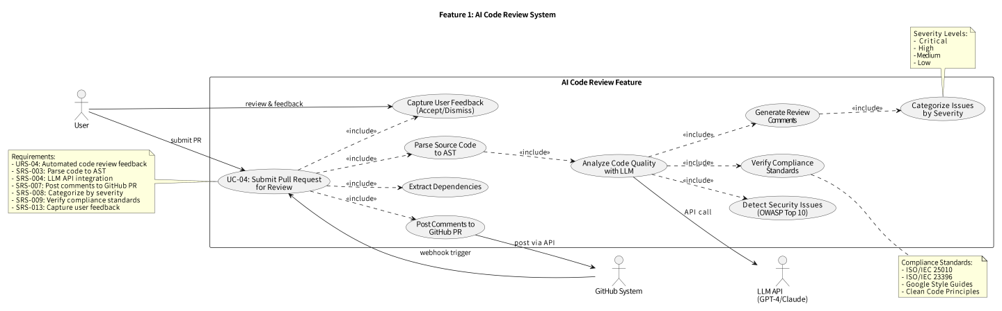

6.1.2 Feature 2
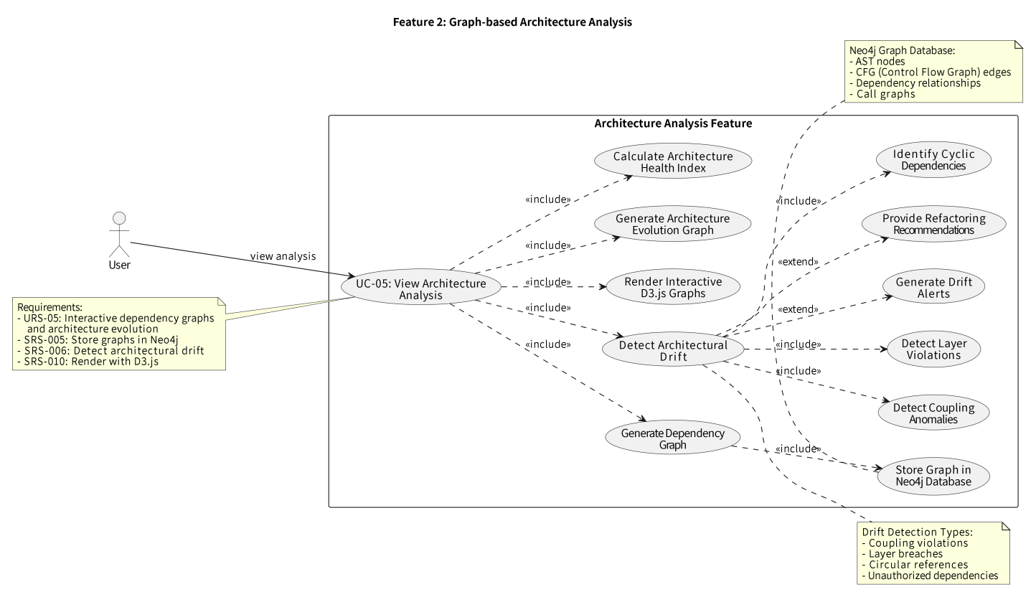

6.1.3 Feature 3
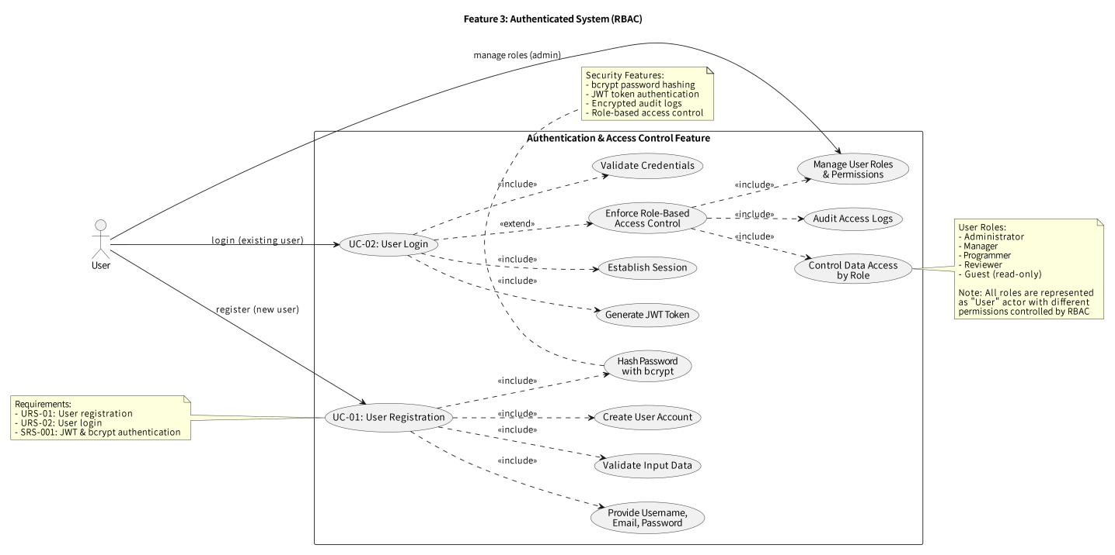

6.1.4 Feature 4
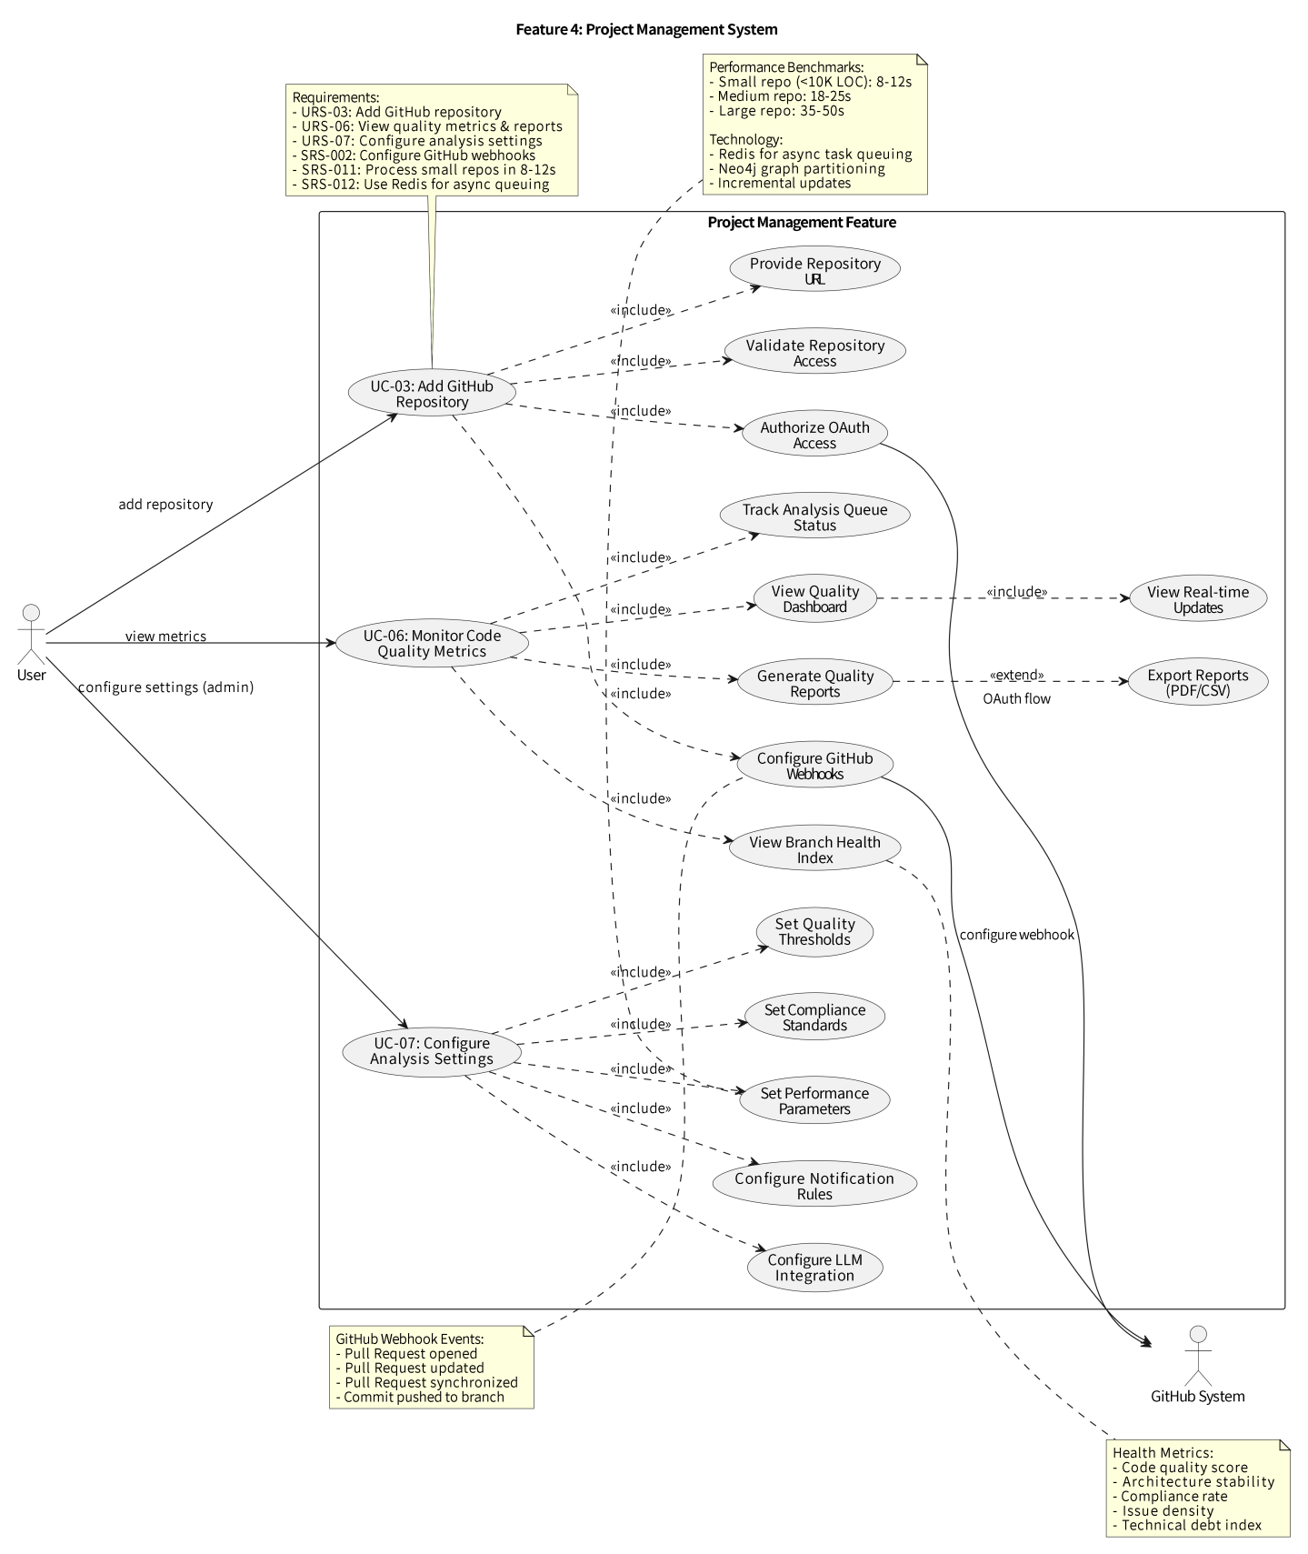

6.2 Use Case Descriptions

UC-01 User Registration
Use Case ID |  | UC-01
Use Case Name |  | User Registration
Created By | BaiXuan Zhang | Last Update By |  | BaiXuan Zhang
Date Created | 07/02/2026 | Last Revision Date |  | 07/02/2026
Actors | Guest
Description | Allows a guest user to create a new account on the AI-Based Reviewer platform to access code review and architecture analysis features.
Trigger | Guest clicks the 'Register' button on the landing page.
Preconditions | 1. Guest is on the registration page.  2. Guest has a valid email address.

Use Case Input Specification
Input | Type | Constraint |  | Example
Username | String | 3-30 characters, alphanumeric and underscore only |  | john_dev123
Email | Email | Valid email format |  | john@example.com
Password | String | Minimum 8 characters, must contain uppercase, lowercase, number, and special character |  | SecurePass@123
Postconditions | New user account is created in the database, confirmation email is sent, and guest is redirected to login page.
Normal Flows | User |  | System
 | 2. User enters username, email, and password.  4. User clicks 'Register' button. |  | 1. System displays registration form.  3. System validates input format in real-time.  5. System checks for duplicate username/email.  6. System encrypts password.  7. System creates user record in PostgreSQL.  8. System sends confirmation email.  9. System displays success message and redirects to login.
Alternative Flow | 3A. If username/email already exists: System displays error message 'Username/Email already taken' and prompts user to choose different credentials.
Exception Flow | E1. If password does not meet complexity requirements: System displays specific validation errors.  E2. If email service is unavailable: System creates account but flags for manual email verification.
Note | Passwords are hashed.

UC-02: User Login
Use Case ID |  | UC-02
Use Case Name |  | User Login
Created By | BaiXuan Zhang | Last Update By |  | BaiXuan Zhang
Date Created | 07/02/2026 | Last Revision Date |  | 07/02/2026
Actors | Guest, User
Description | Allows a guest to authenticate and access the AI-Based Reviewer platform using valid credentials.
Trigger | Guest clicks the 'Login' button on the landing page or navigates to the login URL.
Preconditions | 1. User has already registered an account.  2. Guest is on the login page.  3. User is not currently logged in.

Use Case Input Specification
Input | Type | Constraint |  | Example
Email or Username | String | Must match registered account |  | john@example.com
Password | String | Must match stored hashed password |  | SecurePass@123
Postconditions | User is authenticated, JWT token is generated and stored, user is redirected to dashboard with active session.
Normal Flows | User |  | System
 | 2. User enters email/username.  4. User enters password.  6. User clicks 'Login' button. |  | 1. System displays login form.  3. System validates email/username format.  5. System masks password input.  7. System validates credentials against database.  8. System retrieves user record from PostgreSQL.  9. System verifies password comparison.  10. System generates token with user_id and role.  11. System sets token expiration (24 hours).  12. System returns token to client.  13. System redirects to dashboard.  14. System logs successful login event.
Alternative Flow | 7A. If email/username not found: System displays error 'Invalid credentials' without revealing which field is incorrect (security best practice).  9A. If password is incorrect: System displays error 'Invalid credentials' and increments failed login counter.  9B. If account is locked (after 5 failed attempts): System displays 'Account locked. Please reset password or contact support.'  12A. If user selects 'Remember me': System extends token expiration to 30 days.
Exception Flow | E1. If database connection fails: System displays 'Service temporarily unavailable. Please try again later.'  E2. If too many concurrent login attempts from same IP: System implements rate limiting and displays 'Too many login attempts. Please wait 5 minutes.'
Note | Password is never logged or transmitted in plain text. Failed login attempts are logged for security monitoring.

UC-03 Add GitHub Repository
Use Case ID |  | UC-03
Use Case Name |  | Add GitHub Repository
Created By | BaiXuan Zhang | Last Update By |  | BaiXuan Zhang
Date Created | 07/02/2026 | Last Revision Date |  | 07/02/2026
Actors | Programmer, Manager
Description | User connects a GitHub repository to the platform for automated code review and architecture monitoring.
Trigger | User clicks 'Add Repository' button in the project management dashboard.
Preconditions | 1. User is authenticated and logged in.  2. User has access to the GitHub repository.  3. GitHub OAuth token is configured (if using private repos).

Use Case Input Specification
Input | Type | Constraint |  | Example
Repository URL | URL | Valid GitHub repository URL (https://github.com/owner/repo) |  | https://github.com/user/my-project
Branch | String | Valid branch name (optional, defaults to 'main') |  | develop
Webhook Secret | String | Optional secret for webhook security |  | webhook_secret_123
Postconditions | Repository is added to the system, GitHub webhook is configured, initial repository analysis is queued, and repository appears in user's project list.
Normal Flows | User |  | System
 | 2. User enters GitHub repository URL.  4. User optionally specifies target branch.  6. User clicks 'Connect Repository' button. |  | 1. System displays 'Add Repository' form.  3. System validates URL format.  5. System checks repository accessibility via GitHub API.  7. System creates webhook on GitHub repository for PR events.  8. System clones repository to temporary storage.  9. System initializes AST parsing and dependency graph extraction.  10. System stores repository metadata in PostgreSQL.  11. System queues initial analysis task in Redis.  12. System displays success notification with repository ID.
Alternative Flow | 5A. If repository is private and OAuth token is not configured: System prompts user to authenticate with GitHub OAuth.  7A. If webhook creation fails: System logs error but still allows manual PR analysis via URL submission.
Exception Flow | E1. If repository URL is invalid or inaccessible: System displays error 'Cannot access repository. Check URL and permissions.'  E2. If repository is too large (>1GB): System displays warning and asks for user confirmation to proceed.  E3. If GitHub API rate limit is exceeded: System queues request for retry after cooldown period.
Note | Webhook events: pull_request (opened, synchronize, reopened). Initial analysis may take 8-50 seconds depending on repository size.

UC-04 Submit Pull Request for Review
Use Case ID |  | UC-04
Use Case Name |  | Submit Pull Request for Review
Created By | BaiXuan Zhang | Last Update By |  | BaiXuan Zhang
Date Created | 07/02/2026 | Last Revision Date |  | 07/02/2026
Actors | Programmer
Description | Programmer creates a pull request on GitHub, triggering automated AI-based code review and architectural analysis.
Trigger | Programmer creates or updates a pull request in a connected GitHub repository.
Preconditions | 1. Repository is connected to the platform with active webhook.  2. Pull request contains code changes.  3. LLM API is available and configured.

Use Case Input Specification
Input | Type | Constraint |  | Example
Pull Request Event | JSON | GitHub webhook payload containing PR metadata and diff |  | { pr_number: 42, action: 'opened', ... }
Code Diff | Text | Git diff format showing changes |  | +console.log('new feature');
Postconditions | Code review results are posted as comments on GitHub PR, analysis data is stored in database, and architectural changes are reflected in Neo4j graph.
Normal Flows | User |  | System
 | 1. Programmer creates pull request on GitHub.  8. Programmer views AI review comments on GitHub PR. |  | 2. GitHub webhook triggers platform endpoint.  3. System extracts PR metadata and code diff.  4. System generates AST for changed files.  5. System queries Neo4j for architectural context.  6. System sends code + context to LLM for analysis.  7. System receives LLM analysis results.  9. System categorizes issues by severity (Critical/High/Medium/Low).  10. System checks for security vulnerabilities (OWASP Top 10).  11. System verifies compliance with ISO/IEC 25010 and ISO/IEC 23396.  12. System posts formatted review comments to GitHub PR via API.  13. System updates dependency graph in Neo4j.  14. System stores analysis results in PostgreSQL.  15. System sends notification email if critical issues found.
Alternative Flow | 6A. If LLM API timeout occurs: System retries up to 3 times with exponential backoff.  12A. If GitHub API fails to post comment: System stores review results internally and flags for manual posting.
Exception Flow | E1. If code diff is too large (>10,000 lines): System splits analysis into chunks and aggregates results.  E2. If LLM API returns error: System falls back to rule-based static analysis and logs error for investigation.  E3. If architectural drift detection fails: System proceeds with code review only and logs graph database error.
Note | Analysis time: 8-50 seconds depending on PR size and complexity. LLM models: GPT-4 or Claude 3.5 Sonnet.

UC-05 View Architecture Analysis
Use Case ID |  | UC-05
Use Case Name |  | View Architecture Analysis
Created By | BaiXuan Zhang | Last Update By |  | BaiXuan Zhang
Date Created | 07/02/2026 | Last Revision Date |  | 07/02/2026
Actors | Reviewer, Manager, Programmer
Description | User views interactive dependency graph and architecture evolution to understand project structure and detect architectural drift.
Trigger | User navigates to 'Architecture' tab in project dashboard.
Preconditions | 1. User is authenticated and has access to the project.  2. Repository has been analyzed at least once.  3. Dependency graph data exists in Neo4j database.

Use Case Input Specification
Input | Type | Constraint |  | Example
Project ID | Integer | Valid project identifier |  | 12345
View Filter | Enum | Options: All, Services, Modules, Classes, Functions |  | Services
Time Range | Date Range | Optional date range for evolution view |  | 2025-01-01 to 2026-02-07
Postconditions | User sees interactive graph visualization with ability to zoom, filter, and export. Architectural issues are highlighted.
Normal Flows | User |  | System
 | 2. User selects project from project list.  4. User clicks 'Architecture' tab.  6. User applies filters (e.g., view by service).  9. User clicks on nodes to view details.  11. User exports graph as PNG/SVG. |  | 1. System displays project dashboard.  3. System loads project metadata from PostgreSQL.  5. System queries Neo4j for dependency graph data.  7. System renders interactive graph using D3.js/Cytoscape.  8. System highlights circular dependencies in red.  10. System displays node details panel showing dependencies, metrics, and historical changes.  12. System generates graph image file.  13. System provides download link.
Alternative Flow | 5A. If no graph data exists: System displays message 'No architecture data available. Trigger initial analysis.' with button to start analysis.  8A. If user enables 'Evolution View': System displays timeline slider showing graph changes over selected time range.
Exception Flow | E1. If graph is too large to render (>5000 nodes): System offers clustered view by default and warns about performance.  E2. If Neo4j query times out: System displays cached graph data with timestamp indicating staleness.  E3. If export fails: System displays error and suggests reducing graph complexity via filters.
Note | Graph visualization uses force-directed layout. Color coding: Green=healthy, Yellow=moderate coupling, Red=circular dependency or architectural violation.

UC-06 Monitor Code Quality Metrics
Use Case ID |  | UC-06
Use Case Name |  | Monitor Code Quality Metrics
Created By | BaiXuan Zhang | Last Update By |  | BaiXuan Zhang
Date Created | 07/02/2026 | Last Revision Date |  | 07/02/2026
Actors | Manager, Reviewer
Description | Manager views comprehensive dashboard showing code quality trends, defect density, compliance status, and team performance metrics.
Trigger | Manager navigates to 'Metrics' or 'Dashboard' section.
Preconditions | 1. Manager is authenticated with appropriate role permissions.  2. At least one repository has been analyzed.  3. Historical analysis data exists in PostgreSQL.

Use Case Input Specification
Input | Type | Constraint |  | Example
Date Range | Date Range | Start and end dates for metrics period |  | 2025-12-01 to 2026-02-07
Repository Filter | Array | List of repository IDs (optional) |  | [101, 102, 105]
Team Filter | String | Team name or developer username |  | frontend-team
Postconditions | Manager sees visual charts and tables with metrics, can drill down into specific issues, and can export reports.
Normal Flows | User |  | System
 | 2. Manager selects date range using date picker.  4. Manager optionally filters by repository or team.  7. Manager clicks on specific metric to view details.  10. Manager exports report as PDF/CSV. |  | 1. System displays metrics dashboard.  3. System queries PostgreSQL for analysis history.  5. System aggregates data by time period.  6. System renders charts: line graphs (trends), bar charts (defects by severity), pie charts (issue categories).  8. System displays drill-down view with list of specific issues.  9. System calculates KPIs: defect density, MTTR, code churn, architectural health score.  11. System generates report document.  12. System provides download link.
Alternative Flow | 6A. If no data exists for selected period: System displays message 'No analysis data found for this period' and suggests expanding date range.  9A. If user requests compliance report: System generates detailed compliance matrix showing ISO/IEC 25010 and ISO/IEC 23396 conformance by module.
Exception Flow | E1. If database query is slow (>5 seconds): System displays loading indicator and fetches data asynchronously.  E2. If export fails due to large dataset: System offers to email report when ready.  E3. If calculated metrics show anomalies: System flags outliers and suggests data verification.
Note | Metrics updated in real-time as new PRs are analyzed. Charts are interactive with tooltips and clickable elements.

UC-07 Configure Analysis Settings
Use Case ID |  | UC-07
Use Case Name |  | Configure Analysis Settings
Created By | BaiXuan Zhang | Last Update By |  | BaiXuan Zhang
Date Created | 07/02/2026 | Last Revision Date |  | 07/02/2026
Actors | Administrator, Manager
Description | Admin configures analysis rules, severity thresholds, LLM model selection, and compliance standards for the project.
Trigger | Admin navigates to 'Settings' > 'Analysis Configuration'.
Preconditions | 1. User has Administrator or Manager role.  2. User is authenticated.  3. Project exists in the system.

Use Case Input Specification
Input | Type | Constraint |  | Example
LLM Model | Enum | Options: GPT-4, Claude-3.5-Sonnet, Custom |  | Claude-3.5-Sonnet
Severity Thresholds | JSON | Numeric thresholds for categorizing issues |  | { critical: 90, high: 70, medium: 40 }
Compliance Standards | Array | List of enabled standards |  | ['ISO/IEC 25010', 'OWASP Top 10']
Auto-merge Rules | Boolean | Enable/disable auto-merge for passing PRs |  | false
Postconditions | Configuration is saved and applied to future analyses. Existing analyses are not retroactively affected.
Normal Flows | User |  | System
 | 2. Admin selects LLM model from dropdown.  4. Admin adjusts severity threshold sliders.  6. Admin enables/disables compliance standards.  8. Admin clicks 'Save Configuration'. |  | 1. System displays current configuration settings.  3. System validates model selection and API availability.  5. System validates threshold values (0-100).  7. System validates compliance standard compatibility.  9. System updates configuration in PostgreSQL.  10. System clears Redis cache for affected projects.  11. System displays success notification.  12. System logs configuration change in audit log.
Alternative Flow | 3A. If selected LLM model requires additional API key: System prompts for API key input and validation.  9A. If user enables 'Apply to existing analyses': System queues re-analysis of recent PRs with new settings.
Exception Flow | E1. If configuration validation fails: System highlights invalid fields and prevents save.  E2. If database update fails: System displays error and retains previous configuration.  E3. If compliance standard is deprecated: System displays warning but allows save with user confirmation.
Note | Configuration changes are logged for audit compliance. Default settings follow industry best practices.

6.3 Activity Diagram
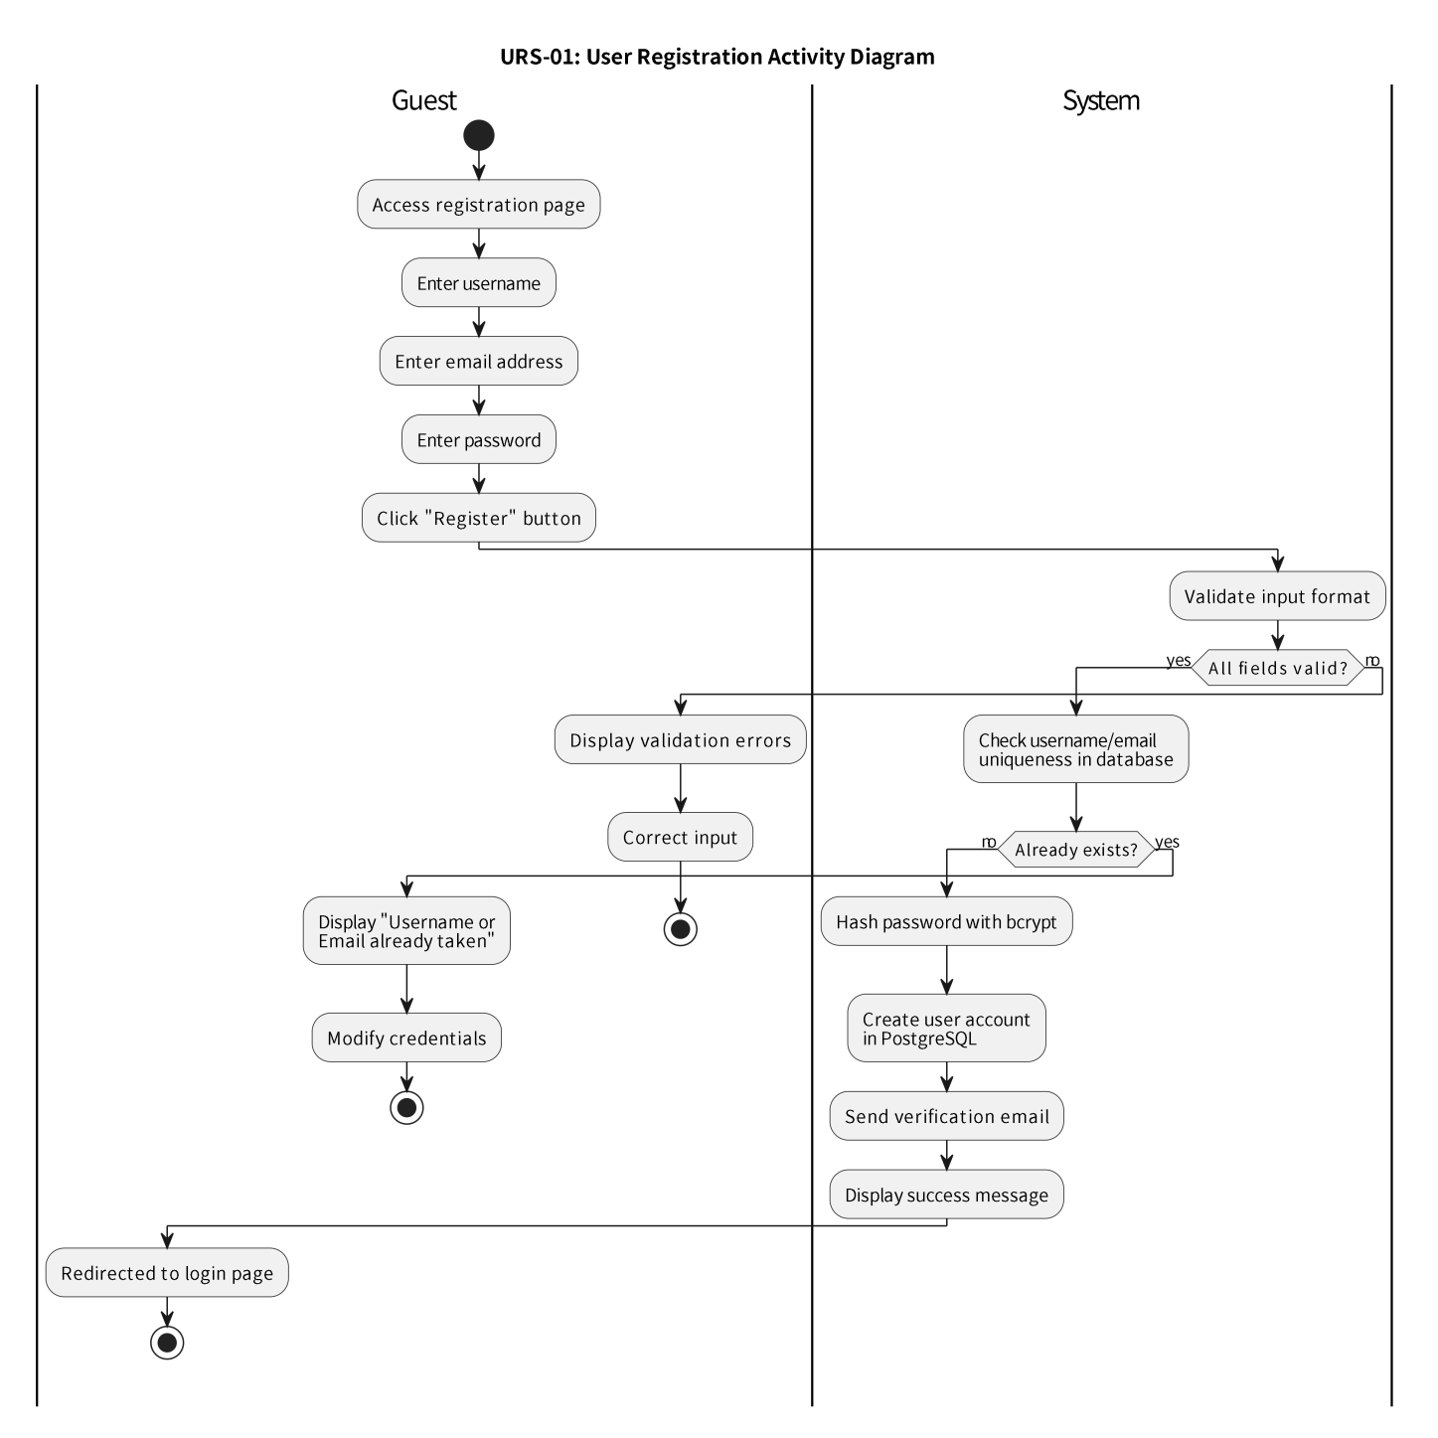
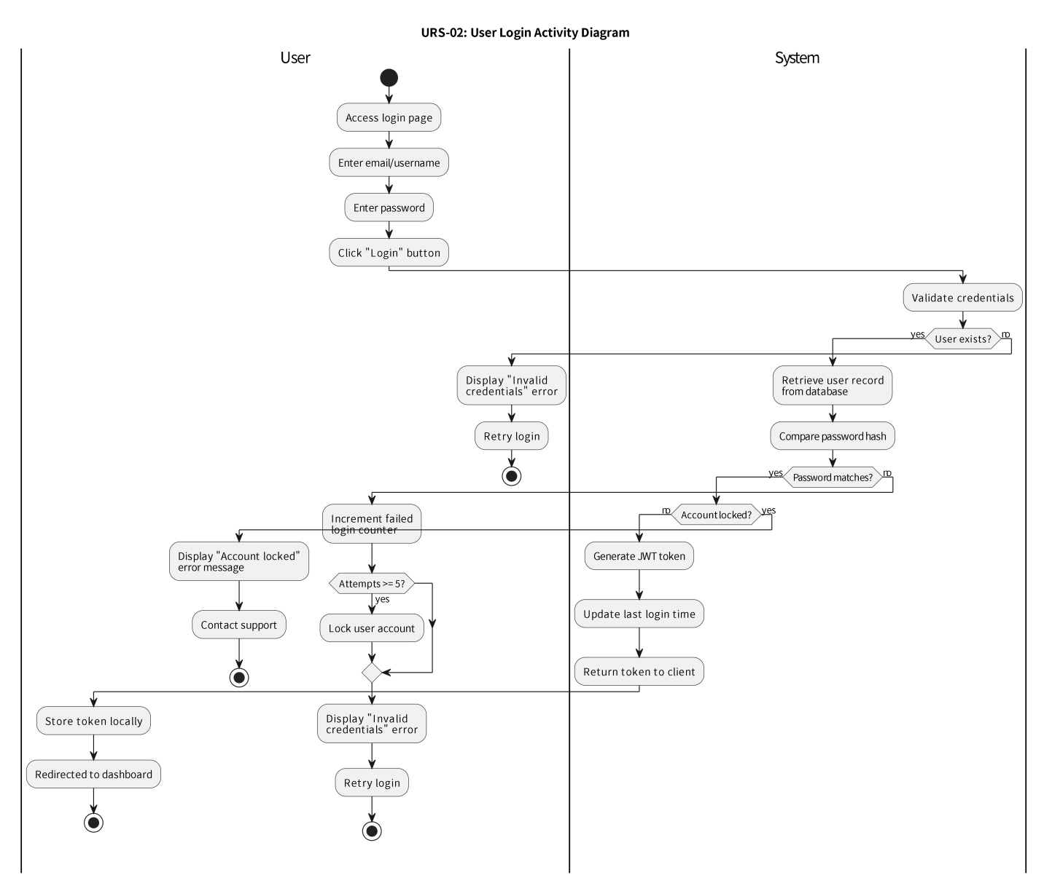
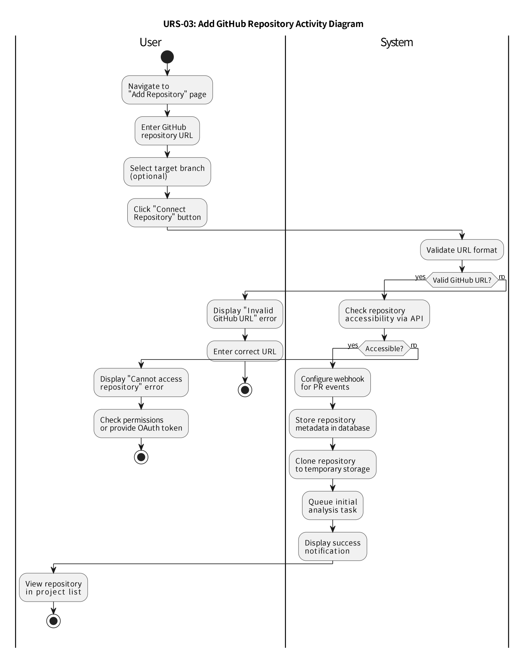
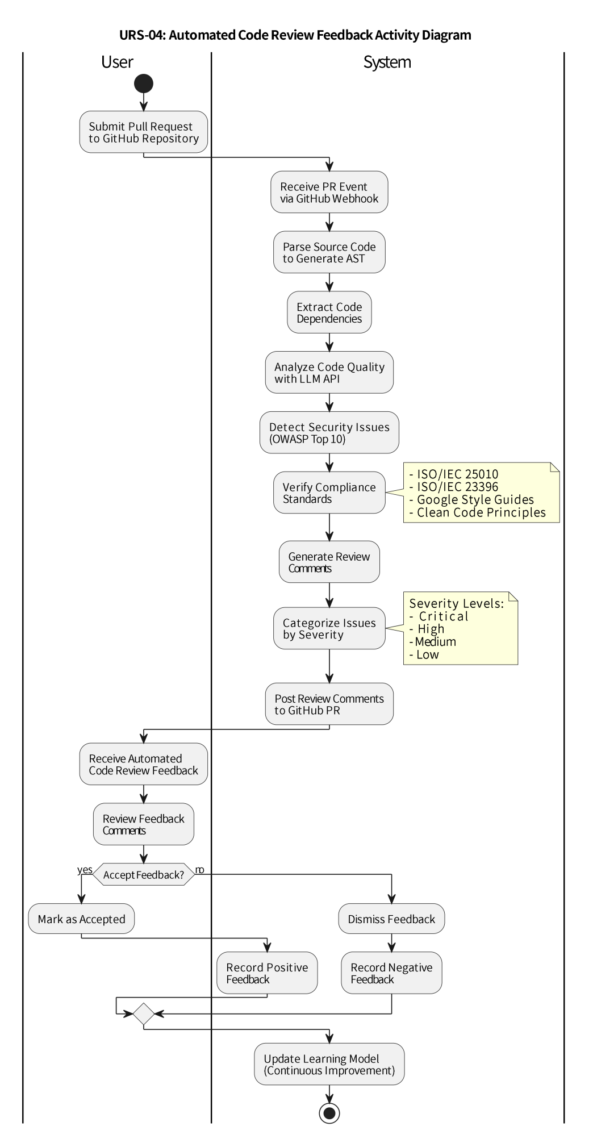

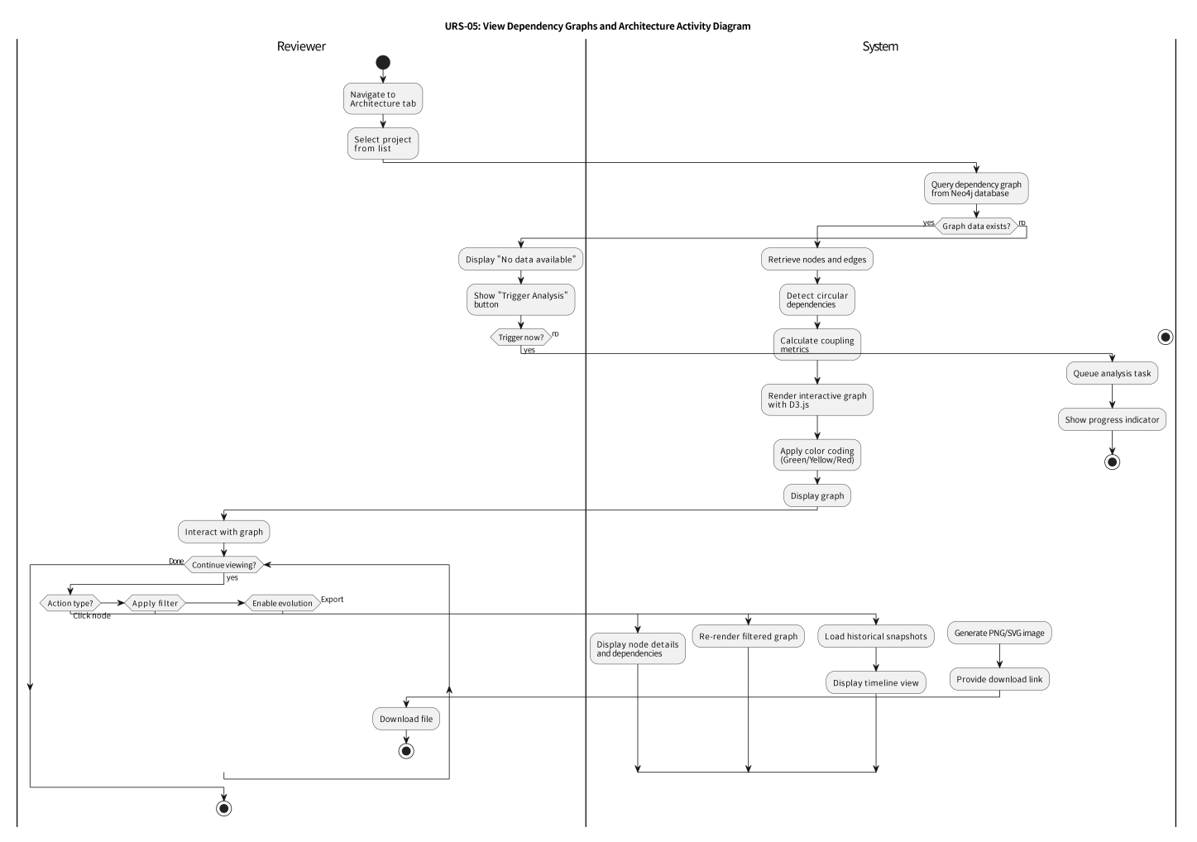
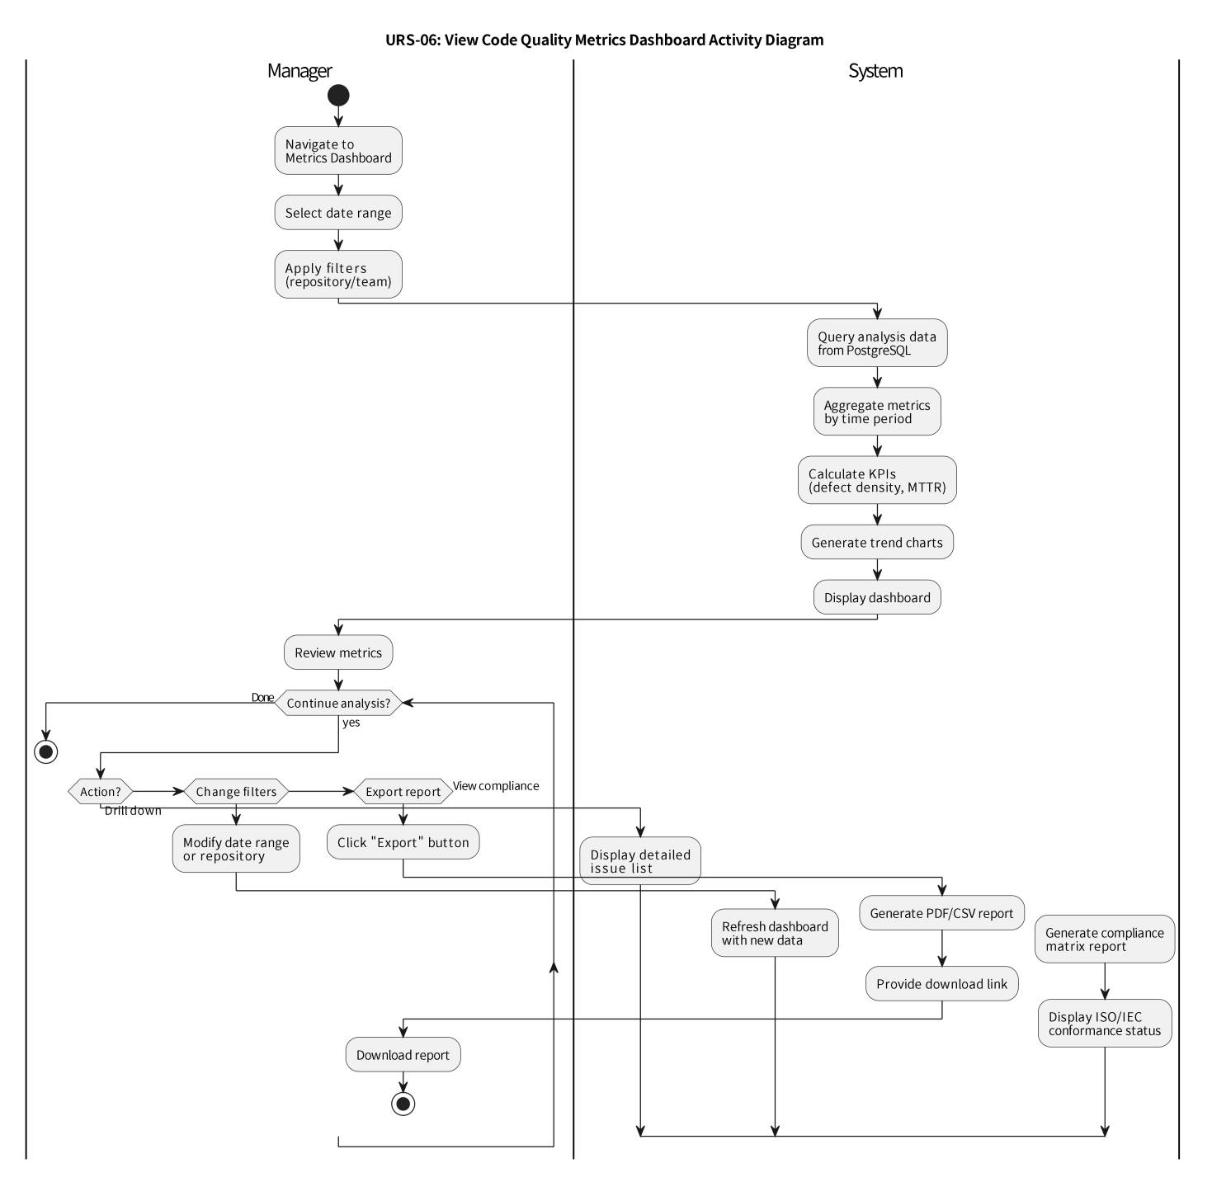
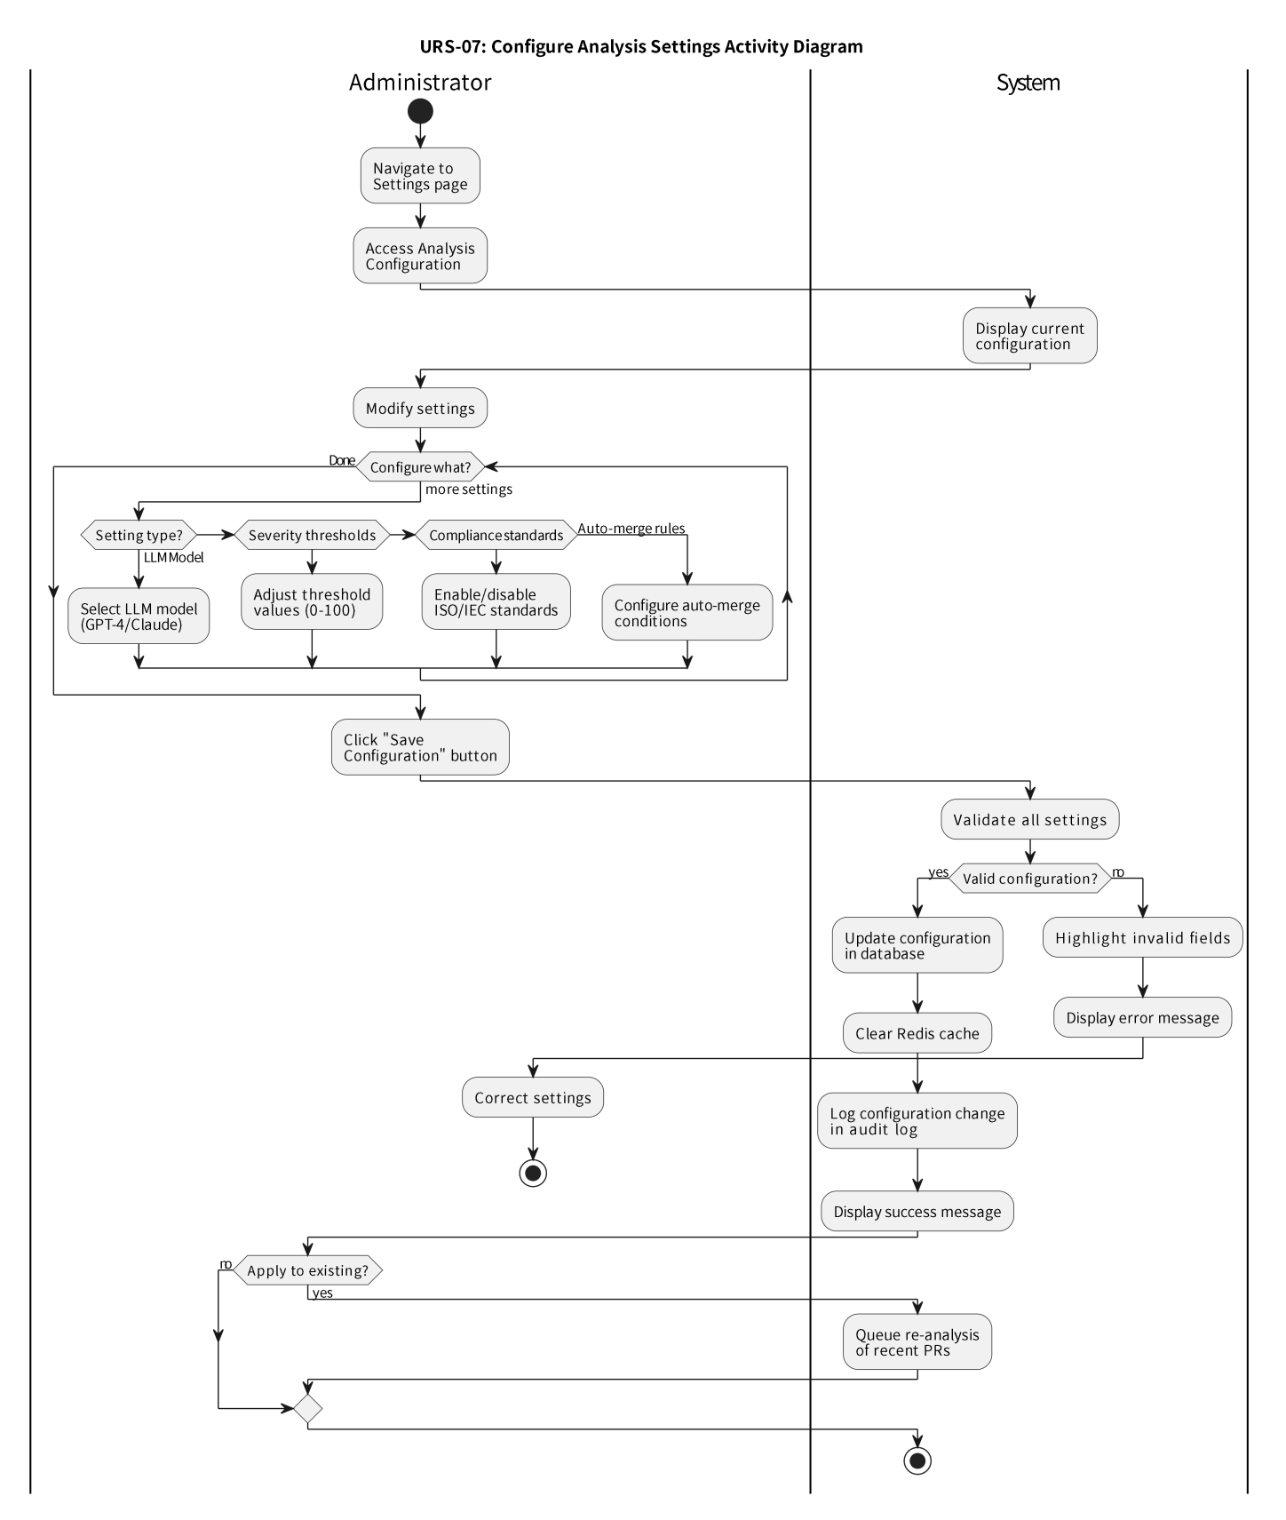

7. Data Validation Rules

7.1 User Input Validation
Field | Data Type | Validation Rules | Error Message
Username | String | - Length: 3-30 characters<br>- Alphanumeric and underscore only<br>- Must start with letter<br>- Case-insensitive uniqueness | "Username must be 3-30 characters, start with a letter, and contain only letters, numbers, and underscores"
Email | String | - Valid email format<br>- Max 100 characters<br>- Case-insensitive uniqueness<br>- No disposable email domains | "Please enter a valid email address"
Password | String | - Min 8 characters<br>- Max 128 characters<br>- At least 1 uppercase<br>- At least 1 lowercase<br>- At least 1 number<br>- At least 1 special char (!@#$%^&*) | "Password must be 8-128 characters with uppercase, lowercase, number, and special character"
GitHub URL | URL | - Format: https://github.com/{owner}/{repo}<br>- Owner: 1-39 chars, alphanumeric + hyphen<br>- Repo: 1-100 chars, alphanumeric + hyphen/underscore/dot | "Please enter a valid GitHub repository URL"
Project Name | String | - Length: 3-200 characters<br>- Alphanumeric, spaces, hyphens, underscores<br>- Trim whitespace | "Project name must be 3-200 characters"

7.2 Business Logic Validation
Rule ID | Validation Rule | Implementation | Error Handling
BV-01 | Email must be unique across all users | Database unique constraint + application-level check | Return 409 Conflict with message "Email already registered"
BV-02 | Username must be unique (case-insensitive) | Database unique index (lowercase) + application check | Return 409 Conflict with message "Username already taken"
BV-03 | Repository URL must be unique per platform instance | Database unique constraint on github_url | Return 409 Conflict with message "Repository already connected"
BV-04 | User must have GitHub admin access to add repository | GitHub API permission check before webhook creation | Return 403 Forbidden with message "Admin access required"
BV-05 | Analysis cannot be triggered for closed PRs | Check PR status before queuing analysis | Return 400 Bad Request with message "Cannot analyze closed PR"
BV-06 | JWT token must not be expired | Check exp claim in token | Return 401 Unauthorized with message "Token expired"
BV-07 | User role must have required permission for action | RBAC permission matrix check | Return 403 Forbidden with message "Insufficient permissions"
BV-08 | File size must not exceed 10MB for analysis | Check file size before parsing | Skip file with warning "File too large for analysis"
BV-09 | Analysis queue must not exceed 1000 pending tasks | Check queue depth before adding task | Return 429 Too Many Requests with message "Analysis queue full"
BV-10 | Webhook signature must be valid | HMAC-SHA256 verification | Return 401 Unauthorized with message "Invalid webhook signature"

7.3 Data Sanitization Rules
Input Type | Sanitization Method | Purpose
User-generated text (comments, descriptions) | HTML entity encoding, strip script tags | Prevent XSS attacks
SQL query parameters | Parameterized queries, ORM escaping | Prevent SQL injection
File paths | Path normalization, directory traversal prevention | Prevent path traversal attacks
GitHub URLs | URL parsing and validation, whitelist domain | Prevent SSRF attacks
JSON payloads | Schema validation, type checking | Prevent injection and type confusion
Code snippets | Syntax highlighting escaping, no execution | Safe display of code

8. Acceptance Criteria

8.1 Feature Acceptance Criteria
Feature 1: Code Review
[ ] System analyzes PR within 30 seconds of creation
[ ] Analysis completes within 2 minutes for repositories < 50K LOC
[ ] Issues are categorized into 4 severity levels
[ ] Comments are posted to GitHub PR with file path and line number
[ ] LLM provides actionable suggestions for each issue
[ ] User can accept/dismiss feedback
[ ] System handles syntax errors gracefully
[ ] When the primary intelligent analysis model is unavailable, the system needs to automatically switch to the backup model to ensure that the code analysis function is not interrupted.
Feature 2: Architecture Analysis
[ ] The system needs to persistently store the code dependency graph, and support fast query and update of the graph.
[ ] Circular dependencies are detected and highlighted
[ ] Graph renders within 5 seconds for < 1000 nodes
[ ] User can zoom, pan, and filter graph
[ ] Layer violations are identified
[ ] Coupling metrics are calculated
[ ] Graph can be exported as PNG/SVG
Feature 3: Authentication System
[ ] User can register with email and password
[ ] Password meets complexity requirements
[ ] Tokens expire after 24 hours
[ ] Refresh tokens work for 7 days
[ ] RBAC enforces permissions
[ ] Account locks after 5 failed attempts
[ ] The system needs to support the integration of third-party identity authentication with GitHub to achieve rapid authorization of repository permissions.
Feature 4: Project Management
[ ] User can add GitHub repository
[ ] Webhook is configured automatically
[ ] Repository list displays quality metrics
[ ] Dashboard shows trends over time
[ ] Settings can be configured per project
[ ] Audit log records all changes

9. Appendices
Appendix A: References
ISO/IEC 25010:2011 - Systems and software Quality Requirements and Evaluation (SQuaRE)
ISO/IEC 23396:2020 - Software and systems engineering — Architectural design
OWASP Top 10 - 2021
GitHub REST API Documentation - https://docs.github.com/en/rest
OpenAI API Documentation - https://platform.openai.com/docs
Neo4j Graph Database Documentation - https://neo4j.com/docs/
JWT RFC 7519 - https://tools.ietf.org/html/rfc7519
Appendix B: Document Conventions
Must Have: Critical requirement for MVP release
Should Have: Important but not critical for MVP
Could Have: Desirable but can be deferred
Won't Have: Out of scope for current release

