实验七
assume cs:code,es:table,ss:stack

data segment
db '1975','1976','1977','1978','1979','1980','1981','1982','1983'
db '1984','1985','1986','1987','1988','1989','1990','1991','1992'
db '1993','1994','1995'
；84字节
dd 16,22,382,1356,2390,8000,16000,24486,50065,97479,140417,197514
dd 345980,590827,803530,1183000,1843000,2759000,3753000,4649000,5937000
；84字节
dw 3,7,9,13,28,38,130,220,476,778,1001,1442,2258,2793,4037,5635,8226
dw 11542,14430,15257,17800
data ends
；42字节
table segment
db 21 dup ('year summ ne ?? ')
table ends

stake segment
db 21 dup(0)
stake ends

codesg segment

start: mov ax,data
mov ds,ax
mov ax,stake
mov ss,ax
mov sp,21h
mov ax,table
mov es,ax

mov ax,0
mov si,0
mov bx,0
mov si,0
mov cx,21
s:
push cx
mov cx,2

s0: mov ax,ds:[si+bx]
mov es:[si],ax
mov ax,ds:[bx+si+84]
mov es:[si+5],ax
add si,2
loop s0

mov ax,ds:[di+168]
mov es:[si+10],ax
mov ax,ds:[si+5]
mov dx,ds:[si+7]
div word ptr es:[10]
mov es:[si+13],ax

add di, 2
add bx,4
mov ax, es
inc ax
mov es,ax
pop cx
loop s

mov ax,4c00h
int 21h
code ends
end start

实验八
答：能运行
因为首先程序从start开始进入s之后的四行代码作用是将s2处的指令复制到s开头处的两条nop指令上，但由于复制的为机器码，在debug中s2处的指令“jmp short s1”机器码为EBF6，即往回跳转10个字节，复制后用debug观察s处的指令转变成了“jmp 0000”即跳到程序的开头位置，执行“mov ax,4c00h，int 21h"指令返回。

实验九
assume cs:code, ds:data

data segment
db 'welcome to masm!'
db 02h,24h,71h
data ends

stack segment
dw 8 dup(0)
stack ends

code segment
start:mov ax,data
mov ds,ax
mov ax,stack
mov ss,ax
mov sp,10h
mov ax,0B800h
mov es,ax
mov ax,0
mov cx,3
mov bx,16
mov di,0a40h

s: mov ah,ds:[bx]
push cx
push bx
mov cx,16
mov bx,0
mov si,0

s0:mov al,ds:[si]
mov es:[bx+di],ax
add bx,2
inc si
loop s0

pop bx
pop cx
inc bx
add di,0a0h
loop s

mov ax,4c00h
int 21h
code ends

end start

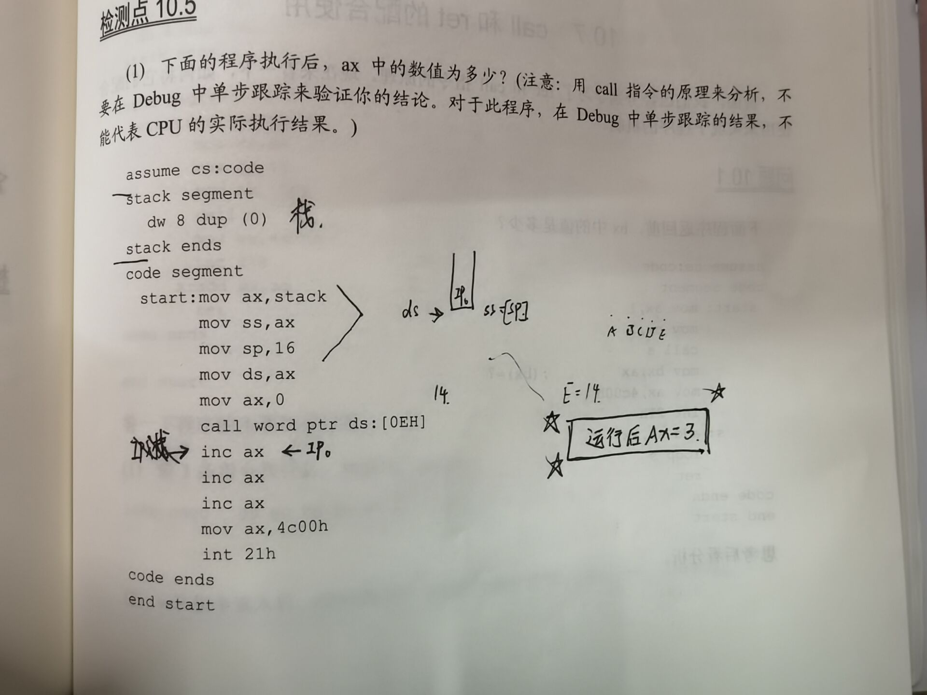

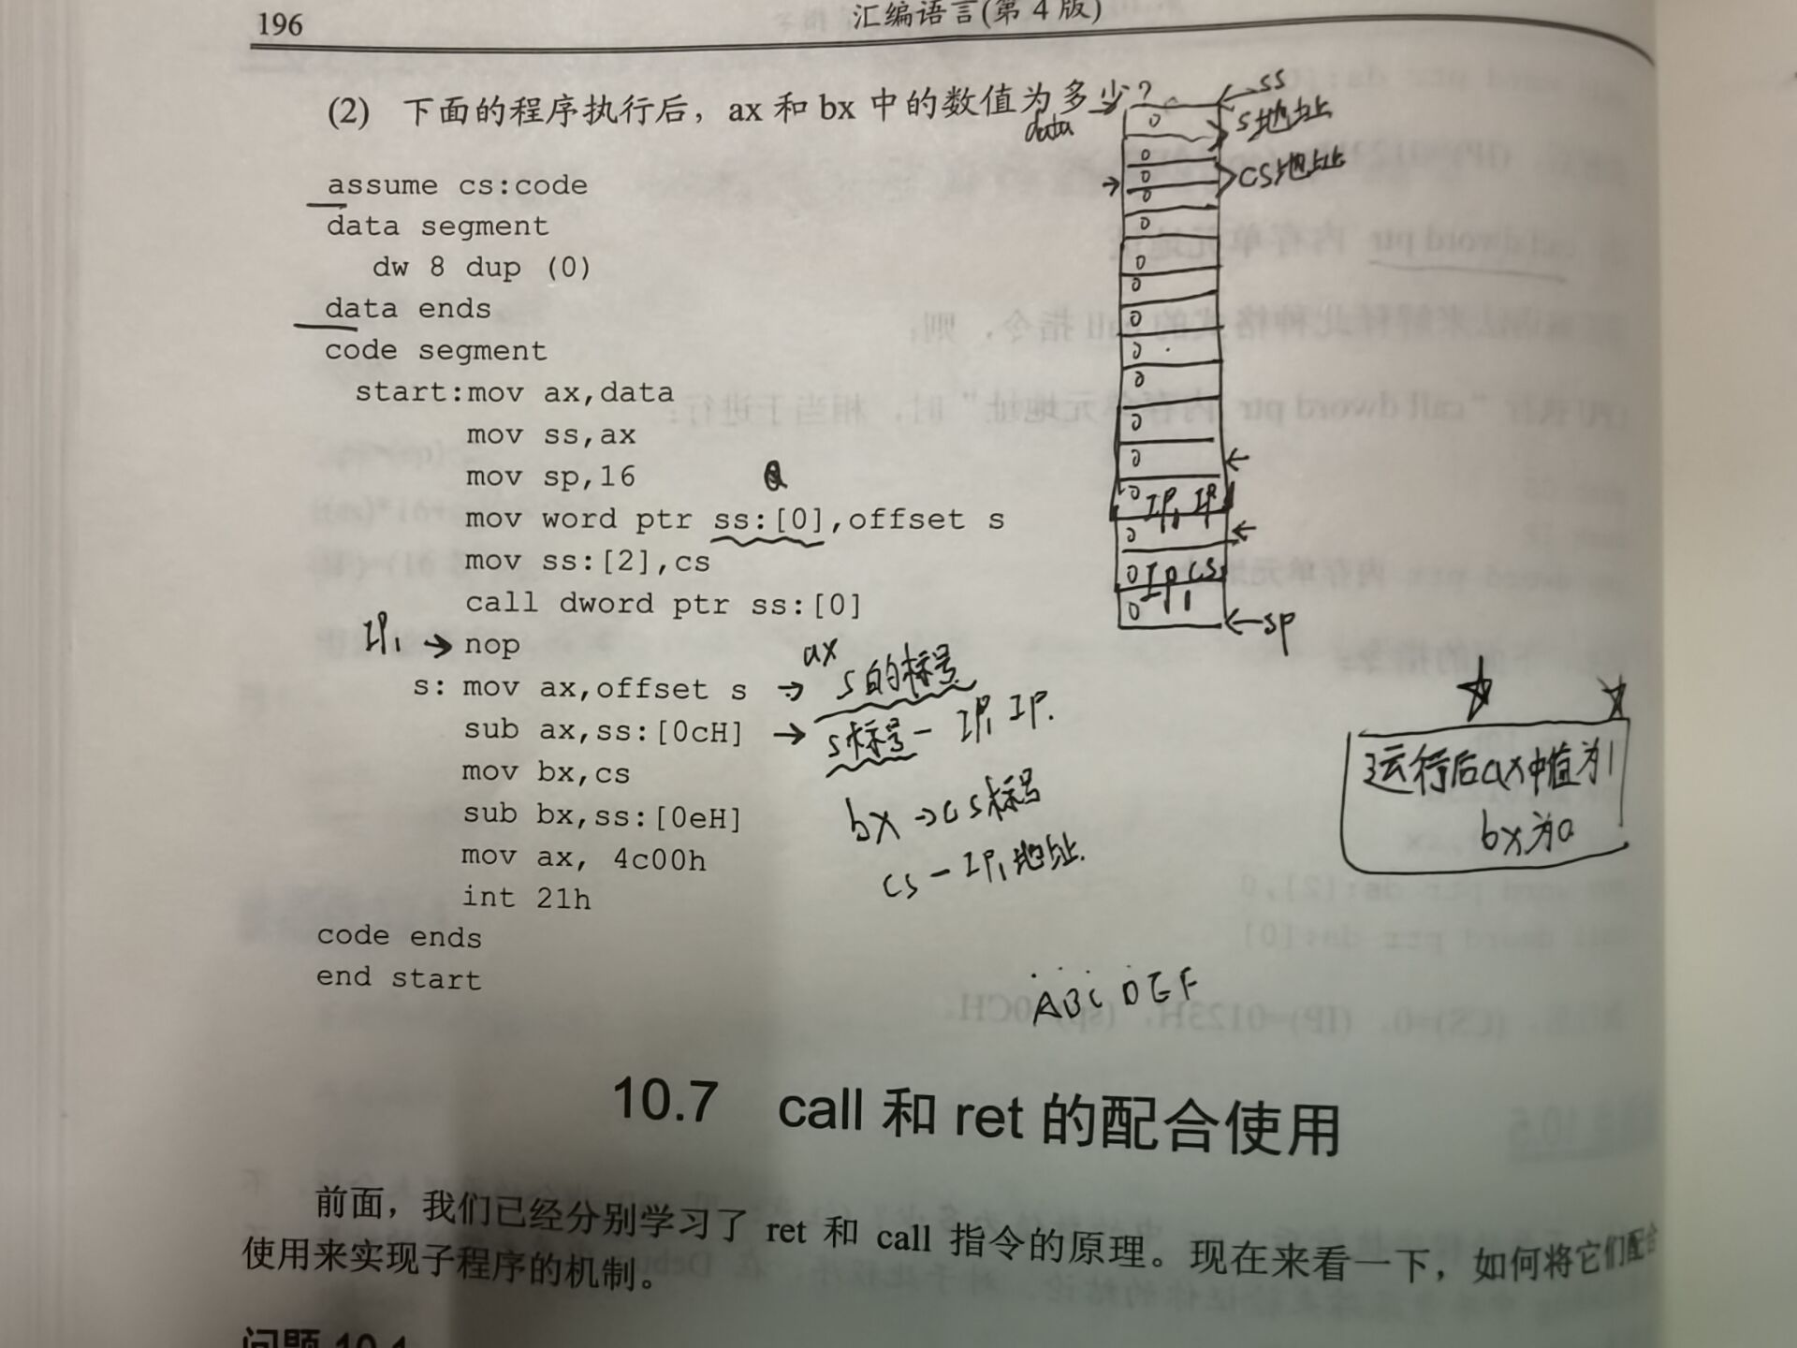

实验十（1）
assume cs:code
data segment
db 'Welcome to masm!',0
data ends

stack segment
dw 8 dup(0)
stack ends

code segment
start: mov dh,8
mov dl,3
mov cl,2
mov ax,data
mov ds,ax
mov si,0
call show_str

mov ax,4c00h
int 21h
show_str:
push ax
push bx
push cx
push dx
push es
push si
push di
mov ax,0B800h
mov es,ax
mov al,160
mul dh
mov bx,ax
mov al,2
mul dl
add bx,ax

mov al,cl

help:
mov cl,ds:[si]
jcxz exit
mov es:[bx+di],cl
mov es:[bx+di+1],al
inc si
add di,2
jmp short help

exit:
pop di
pop si
pop es
pop dx
pop cx
pop bx
pop ax
ret
code ends
end start

code ends

end start

实验十（2）

assume cs:code
stack segment
db 8 dup(0)
stack ends

code segment
start: mov ax,4240H
mov dx,000FH
mov cx,0AH
call divdw

mov ax,4c00h
int 21h

divdw:
push ax
mov ax,dx
mov dx,0
div cx
mov bx,ax
pop ax
div cx
mov cx,dx
mov dx, bx

ret
code end
ends start

实验十（3）

assume cs:code

data segment
db 10 dup(0)
data ends

code segment
start: mov ax,12666
mov bx,data
mov ds,bx
mov si,0
call dtoc
mov dh,8
mov dl,3
mov cl,2
call show_str

dtoc:
mov dx,0
mov bx,10
mov si,0
div bx
push dx
inc si
mov cx,ax
jcxz ok
jmp short dtoc

ok: mov cx,si
mov si,0

s: pop bx
add bx,30H
mov ds:[si],bx
inc si
loop s
mov [si], cl
mov si,0
ret

show_str:
push ax
push bx
push cx
push dx
push es
push si
push di
mov ax,0B800h
mov es,ax
mov al,160
mul dh
mov bx,ax
mov al,2
mul dl
add bx,ax

mov al,cl

help:
mov cl,ds:[si]
jcxz exit
mov es:[bx+di],cl
mov es:[bx+di+1],al
inc si
add di,2
jmp short help

exit:
pop di
pop si
pop es
pop dx
pop cx
pop bx
pop ax
ret
code ends
end start

