In the first project, it requires to find a dataset and learn a linear classification for the dataset. I find a dataset of the Breast Cancer Wisconsin(Diagnostic) Data set. This data set have 30 attributes except the label and patient ID. The link to the dataset is https://archive.ics.uci.edu/ml/datasets/Breast+Cancer+Wisconsin+%28Diagnostic%29 from UCI machine learning repository. My aim is to use the attribute to predict whether the patient has a canser.

In this project, I do not use any machine learning package. I wrote all the learning algorithm by hand. I preprocess the data by delete patients’ ID which are unrelated to the learning algorithm and separate the attributes and labels.

In my code, there is a getData function to import the labels and attributes as matrices. A test function which has parameters w, xTe and yTe to compute the test error of the model. A pla function to implement perceptron learning algorithm. The step of pla is listed in the following figure.

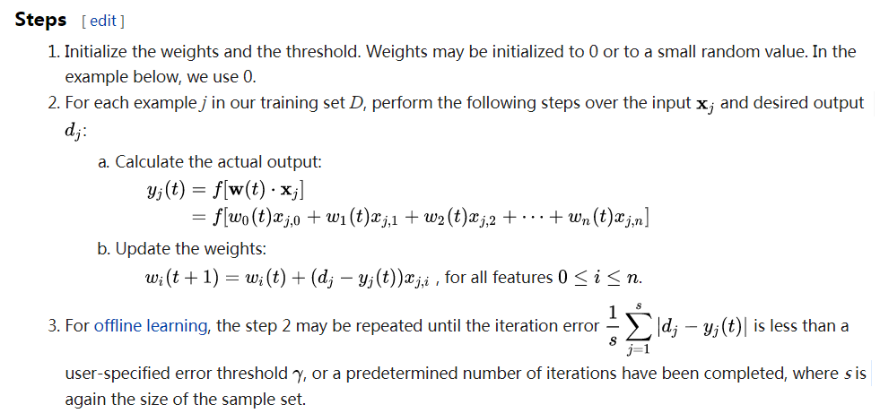

The last function is the crossvalidation function. This function combines test and pla. It use a 10-fold cross validation to get the mean accuracy . Using this dataset, I get a 88.03% accuracy using pla algorithm. I think I construct a reasonable model for this dataset, since I get a good result.

