Milestone 3
In this project, I choose to use scikit learn to implement PCA to do the dimension reduction.
Principle component analysis (PCA) is one such method.
• This is a powerful, popular and perhaps the simplest dimensionality reduction method that has various applications. It can also be viewed as a feature selection method, but not in a conventional way.
• To understand PCA, consider a simple example of a set of 2D data {(x1, y1),(x2, y2), · · · ,(xn, yn)}. DM: PCA, SVD and LSA
• Two main ideas are behind PCA: – Adjust (linearly) the view point so that the direction of the major variance becomes one of the coordinate. – Or, PCs are the coordinates along which the data vary the most. – Compress the data by taking fewer coordinates. Pros: less data to store or transmit. Cons: los of information. – The second idea can also be considered as feature selection in the transformed space

Using PCA, I compress the data from 31 attributes to 3 attributes which is easy to visualize. Figure 1 is the 3D data points after implementing PCA. As we can see, there is a obvious boundary between 2 type of data. This means I may get better performance using data after implementing PCA.
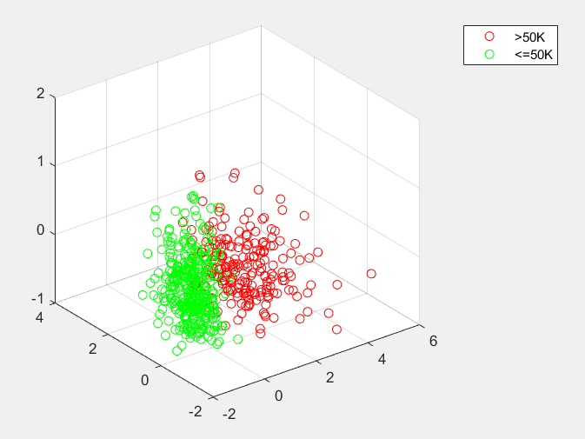
Figure 1

Then I use a linear classification on to classify the data. I get a surprisingly 95.7% accuracy using 10-fold validation. It is much better than milestone 1 and milestone 2. linear classification after PCA is the best model I have ever gotten. Then I reserve 4 attributes instead of 3 which contains more than 80% of the information, I get 96.8 accuracy which is even better. In this case, I find that PCA is a great method to reduce the noise and it seriously increase the performance of the classifier. When there too many attributes and most of them do not influence the classification very much, we can use PCA to remove those unrelated attributes and reserve most of the information at the same time. PCA also have many other applications
• Applications
- Many possibilities in various areas
- Data compression and noise removal;
– Factor analysis;
– Anomaly or outlier detection;
– Data visualization;
– Initial data exploration to identify possible hidden patterns.

