1. Program structure and flow:

Main process:

The process of this game is: First, generate the solvable puzzle then print it out. Second, it comes a loop that ask player to use “u”, “d”, “l”, “r” (up, down, left, right)to move the number, test the direction whether it is legal, move the numbers and print out the new table. Finally, if player reach the final goal(solve the puzzle), he or she will win. And player can enter “r” to restart the puzzle.

1. Python objects:
2. numbers: the list of numbers (global)
3. position: the position of “ ” (global)
4. total_moves : the total legal moves (global)
5. criterion: the final goal/the list that is sorted.
6. key: the key that player input
7. x: the parity of the permutation of all 9 numbers

(Some objects are easy to understand so are not listed here)

1. Functions:
2. create_numbers(): This function generates a solvable 8-puzzle by judging the parity of the permutation of all 9 numbers to determine whether it is solvable or not.
3. Show_numbers(): This function prints the puzzle.
4. Test_direction(): This function prompts further direction by test the position of “ ”.
5. Move():This function moves the number by change the position and it also counts the total legal moves.
6. Game_loop(): This function control the game process(when to move the numbers and How to stop the game if win).
7. Output:

Strat part:

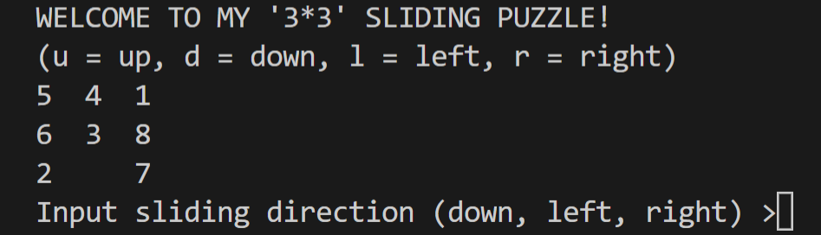

Game part：

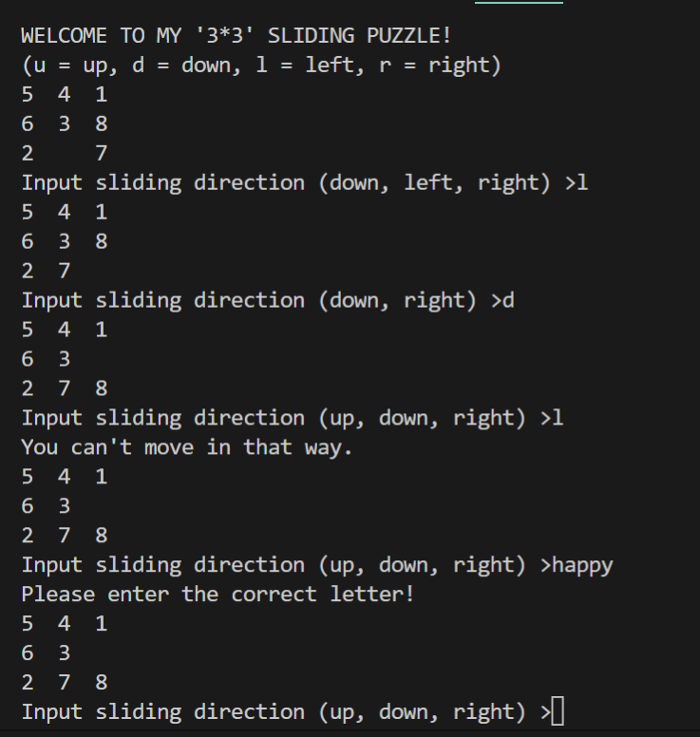

If player enter the wrong direction, it will print: “You can’t move in that way.”

If player enter other letters not in [‘u’, ‘d’, ‘l’, ‘r’], it will print: “Please enter the correct letter!”

Finish part:

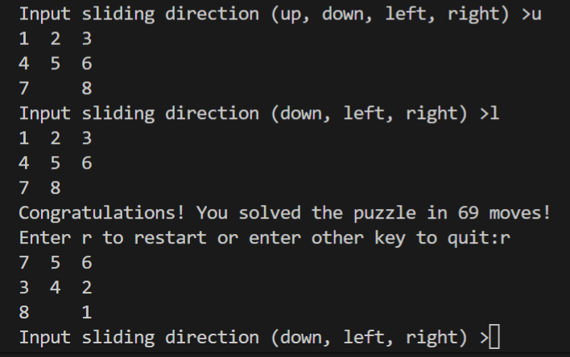

If player wins, it will print congratulations and the total moves that player made.

And player can enter ‘r’ to restart the game.