GCerrHMM: a GC-aware error hidden Markov model for long-read sequencing simulation with a reproducible fidelity harness
Boyang Zhang1, Tao Jiang2,*
1 Faculty of Life Science and Medicine, Harbin Institute of Technology, Harbin, China; 2 Faculty of Computing, Harbin Institute of Technology, Harbin, China.
Corresponding author: Tao Jiang, Faculty of Computing, Harbin Institute of Technology, Harbin, China.
Article type: Research article | Target journal: BMC Bioinformatics | Collection "Simulated and synthetic data in bioinformatics: statistical methods, models, and applications" | W3.8 major-revision manuscript, 2026-10-14.

Abstract

Background
Accurate simulation of long sequencing reads is a prerequisite for benchmarking alignment, variant-calling and assembly pipelines when ground truth is unavailable. Long-read error rates are not uniform: they vary with local sequence context, including GC content. Most widely used simulators still expose error as a global process, and the metrics commonly used to compare simulators do not directly measure context-dependent error. This leaves two connected questions: whether a GC-aware model changes the local error structure, and whether the evaluation instrument can detect that change.

Results
We present GCerrHMM, a transition-based error HMM trained on real ONT alignments whose state-transition model is conditioned on local GC content, with a reproducible fidelity harness. The model is evaluated with a controlled one-bin versus GC-aware ablation, a six-genome directional panel, and coverage-matched human chr21 downstream layers. GC-aware simulation moved the local GC-error curve in the expected direction for four of six genomes in both replicates; the strict cross-species gate was not met, so the cross-species result remains directional. In A. thaliana, a second pre-specified six-seed cohort confirmed the single-species effect (mean delta r = 0.3008; p = 0.0025), while the original cross-species gate remains unchanged. The harness separates read-sampling from between-window uncertainty, and process-level scaling preserves FASTQ identity while reducing wall time.

Conclusions
GCerrHMM provides a trainable GC-aware error model, a reproducible evaluation harness, and a process-scalable simulator. A pre-specified single-species cohort confirms the A. thaliana GC-conditioning effect, while cross-species generalization remains directional. The study shows that simulator benchmarking must align the measurement instrument with the claim and report both statistical and computational performance.
Keywords: long-read sequencing; read simulator; hidden Markov model; GC bias; Oxford Nanopore; benchmark; reproducibility

Background
Long-read sequencing platforms (Oxford Nanopore Technologies, ONT; Pacific Biosciences HiFi) have become the default for de novo assembly, structural-variant discovery and haplotype phasing. Every methodological advance on these platforms is benchmarked, and benchmarking requires either real data with known truth - rare and expensive - or simulated reads whose error process reproduces the instrument. The fidelity of the simulator therefore bounds the validity of every conclusion drawn from the benchmark.
Local GC content can influence long-read error through several routes. GC-rich or GC-poor sequence can alter the kinetics and signal characteristics of the nanopore, change the likelihood of secondary structure or stalling, and change how ambiguously a read segment aligns near repeats. These effects need not change the global error rate; they change where errors are concentrated along the reference. A simulator that matches only a global error rate can therefore look accurate on aggregate metrics while missing the local error structure that downstream mapping, variant calling and assembly actually consume.
Widely used long-read simulators, including NanoSim [1] and PBSim3 [2], estimate error or quality profiles from aligned reads and then apply those profiles during simulation. Empirical simulators such as NPBSS [3] likewise prioritise realistic read-level error and quality distributions. These approaches provide strong baselines, but their primary model descriptions do not expose a local-GC-conditioned transition model. The evaluation literature also shows that simulator rankings depend on the metric: distributional, alignment, variant, and assembly endpoints can favour different tools [1-3]. Recent work has expanded the field toward metagenomic profiling [4], tunable signal-level generation [5, 6], and transformer-based signal models [7, 8]. CycSim [9] learns sequence-context-dependent error profiles from empirical long-read data and uses them for mapping-parameter optimisation. This establishes the value of sequence context, but CycSim is designed around sequence context for mapping-parameter selection, whereas the present work conditions transition matrices on local GC content and evaluates them with a GC-stratified error instrument. More rigorous long-read benchmark references are also needed [10, 11]. A 2026 preprint benchmark of six ONT read simulators reported that no tool reproduced all read-level and error-structure metrics, and specifically found that PBSim3 did not capture context-dependent substitution rates or homopolymer-length errors [11]. GC conditioning therefore requires both a model mechanism and a measurement instrument aligned to that mechanism. The GC context of the six-genome panel and representative GC-error curves are shown in Fig. 1.
Figure 1 makes the measurement problem concrete. Panel a shows the six reference genomes and their local GC distributions; panel b shows an illustrative real-versus-simulated GC-error curve. The relevant observation is not a single average error rate but the shape of the curve across GC bins: E. coli is comparatively flat, whereas GC-heterogeneous genomes contain local error structure that a global model can miss. This contrast motivates both GC-conditioned state transitions and the GC-stratified instrument used for evaluation.
A simulator that conditions its error model on local GC content is straightforward to propose; the harder problem is measurement. If the evaluation instrument cannot see GC-conditional error, then no experiment can distinguish a GC-aware model from a GC-unaware one, and the literature gains an untestable claim. We therefore treat the evaluation harness as a first-class contribution alongside the model itself: every claim in this paper names the instrument it rests on. Fig. 2 summarizes recent simulator designs and the modelling axes they cover.
Here, we present GCerrHMM, an error-state hidden Markov model trained from real long-read alignments whose transition structure is conditioned on local GC content, with a length-aware indel encoding that removes a structural bias we show is present in single-state encodings. We evaluate it with a two-level harness (distributional fidelity; downstream task consistency) across six genomes and four simulators, with pre-registered decision rules for the central GC claim. We report the observed directional effects, the precision limits of the current instrument, and the depth budget required for a definitive cross-species test. Fig. 3 places the present study within that context and evaluation chain.

Results
We first define the model and the fidelity problem, then isolate GC conditioning with a one-bin control. The next analysis tests whether the effect generalises across six genomes under the pre-registered gate. We then quantify measurement uncertainty, report an independent indel ablation, compare descriptive and downstream performance with existing simulators, and close with computational scaling and the boundary of the evidence. The composite score is not used as evidence for GC conditioning.

Model design and what the GC claim requires
We begin with the model, its parameters and the property that can be measured, without comparing tools. This section states the transition model, the GC binning and the controlled contrast tested below.
GCerrHMM is an error-state HMM trained from primary alignments of real long reads (Fig. 4a). The reference sequence is tiled into 100-bp windows, each window is assigned to one of K equal-width GC bins, and transition probabilities P(state at i+1 | state at i, GC bin) are estimated by counting along the CIGAR path, with hierarchical smoothing of per-bin counts toward a global prior. The default state space has ten states - M, S, I1, I2, I3, I4+, D1, D2, D3, D4+ - in which indel run length is carried in the state name; a simplified state space merging indels into single I and D states is used as an ablation control. The same training chain supports ONT and HiFi data, and the HiFi chain completes end to end (Fig. 4a).
The model-implied error rate per GC bin recovers the qualitative shape of the real data where such structure exists: in A. thaliana, whose genome carries strong local GC heterogeneity, the trained model reproduces a sharp error peak in the highest-GC bin (19.5% in bin 7), while the curves for the GC-uniform E. coli and S. cerevisiae genomes are flat (Fig. 4b). Fig. 4b is model-implied; the real-versus-simulated GC-error curves used to motivate the model are shown in Fig. 1b. The six-genome panel and its data sources are summarised in Fig. 4c.
Fig. 4c lists the six analyzed references, RefSeq assemblies, genome sizes, GC content, GC heterogeneity and ONT run accessions. Table 1 provides the same source panel in tabular form.

Controlled GC-conditioning ablation
The key comparison is controlled. The one-bin and GC-aware models use the same reads, MAPQ threshold, windows and read budget; the only intentional change is whether transition matrices are conditioned on GC. The design therefore isolates the contribution of GC conditioning from every other model choice.

What the two fidelity instruments measure
The composite score aggregates read length, QV, GC content and k-mer composition. It measures marginal distributional similarity and is reported as descriptive fidelity. The GC claim uses a different measurement: the error rate of aligned bases inside 100-bp windows, grouped by local GC content and compared with the real curve by Pearson correlation and mean absolute deviation. A one-bin model cannot generate a GC-stratified profile, so its finite-sample correlation reflects global error-level alignment rather than GC-conditional capability. The pre-registered decision compares the one-bin control with the GC-aware model across bins and species.

GC-stratified curve isolates the GC effect
On the profile-matched bin ablation, the composite score shows no separable difference across 1, 5, 10 and 20 bins in either ablation species (A. thaliana 92.6-96.6; E. coli 84.8-87.6; overlapping intervals; Fig. 9a). This is expected: none of its terms measures local GC-conditioned error. The GC-stratified curve is therefore the instrument used for the mechanism claim.
On the GC-stratified curve, the one-bin model was lower than the GC-aware configurations. In A. thaliana, curve r rose from 0.779 at one bin to at least 0.960 at five or more bins; in E. coli, the one-bin control was not the worst configuration, which is why the original two-species gate is not met. Table 5 reports the full profile-matched ablation, and the following paragraph states the scope of the independent A. thaliana cohort.
Table 5. GC-bin ablation scored by curve correlation and MAD.
Species | GC bins | Curve r, mean (SD) | MAD pp, mean (SD)
E. coli | 1 | 0.077 (0.334) | 0.255 (0.006)
E. coli | 5 | -0.080 (0.571) | 0.252 (0.004)
E. coli | 10 | 0.233 (0.504) | 0.258 (0.003)
E. coli | 20 | 0.576 (0.184) | 0.266 (0.007)
A. thaliana | 1 | 0.779 (0.062) | 4.204 (0.010)
A. thaliana | 5 | 0.960 (0.011) | 4.212 (0.039)
A. thaliana | 10 | 0.970 (0.002) | 4.475 (0.015)
A. thaliana | 20 | 0.981 (0.004) | 4.398 (0.039)
This profile-matched three-seed bin ablation (E. coli and A. thaliana) is a different experiment from the six-species, two-replicate route panel reported in Table 7.
Confirmatory replication. In a prospectively specified cohort using three new seeds (44, 55 and 66), the A. thaliana 5-bin model showed a positive change in the GC-curve correlation over the 1-bin control (mean delta r = 0.2370; 95% CI -0.0776 to 0.5516; paired t-test p = 0.0834). Mean GC-MAD was 4.4144 percentage points for the 1-bin model and 4.4863 percentage points for the 5-bin model (delta = 0.0719 percentage points); MAD is reported descriptively and was not part of the primary replication endpoint. Across the six seeds from the discovery and replication cohorts, the mean delta r was 0.2091 (95% CI 0.1124 to 0.3057; p = 0.0026). The independent cohort was directionally positive in all three new seeds but did not meet the pre-specified p < 0.05 threshold. The pooled six-seed sensitivity analysis is significant, but it is not a substitute for the independent test.
Second pre-specified replication. A second independent A. thaliana cohort was fixed before running with six new seeds (77, 88, 99, 111, 122 and 133) and the same primary endpoint, the paired difference in GC-curve Pearson r between 5-bin and 1-bin models. The cohort confirmed the single-species effect (mean delta r = 0.3008; 95% CI 0.1624 to 0.4391; paired t-test p = 0.0025). The first independent cohort (seeds 44, 55 and 66) remains reported separately as directionally positive but not confirmatory (p = 0.0834). Across all 12 seeds from the discovery, first-replication and second-replication cohorts, the pooled sensitivity analysis gave mean delta r = 0.2549 (95% CI 0.1796 to 0.3302; p <0.0001). The original cross-species gate is not reopened or retroactively changed. These cohorts are summarized in Table 6.
Table 6. Pre-specified A. thaliana replication cohorts.
Cohort | Seeds | n | Mean delta r | 95% CI | p
Discovery | 11, 22, 33 | 3 | 0.1811 | [0.0492, 0.3130] | 0.0275
First replication | 44, 55, 66 | 3 | 0.2370 | [-0.0776, 0.5516] | 0.0834
Second replication | 77, 88, 99, 111, 122, 133 | 6 | 0.3008 | [0.1624, 0.4391] | 0.0025
Pooled sensitivity | 11, 22, 33, 44, 55, 66, 77, 88, 99, 111, 122, 133 | 12 | 0.2549 | [0.1796, 0.3302] | <0.0001

Six-species panel and the pre-registered gate
The controlled ablation establishes an effect in one structured genome. The next analysis asks whether the direction generalises across six genomes and whether it satisfies the pre-registered cross-species gate.
The six-species panel tests whether the direction from the controlled ablation generalises. The k-mer statistic is not a GC-stratified instrument: 11 of 12 route/replicate comparisons had a difference interval containing zero, and the single interval excluding zero favoured the one-bin control without reproducing. The GC-stratified curve is therefore reported separately in Table 7: the GC-aware model is directionally favoured in both replicates for four of six genomes, whereas A. thaliana and D. melanogaster are mixed. The pre-registered cross-species gate was not met, so this analysis supports directional scope, not a universal superiority claim.
Table 7. Six-species directional panel. Entries are Pearson r against the real GC-error curve; both replicates are shown.
Species | B (1-bin) r1 / r2 | C (GC-aware) r1 / r2 | Direction
E. coli | -0.738 / 0.505 | 0.458 / 0.589 | C > B, both
S. cerevisiae | 0.230 / 0.174 | 0.471 / 0.535 | C > B, both
A. thaliana | 0.325 / 0.902 | 0.947 / 0.862 | Mixed
D. melanogaster | -0.778 / -0.756 | -0.882 / -0.570 | Mixed
M. musculus chr19 | 0.460 / 0.650 | 0.922 / 0.794 | C > B, both
H. sapiens chr21 | -0.579 / -0.091 | 0.917 / 0.861 | C > B, both
This is the six-species B/C route panel, not the profile-matched bin ablation in Table 5. H. sapiens chr21 shows the largest directional contrast, but it is a two-replicate supporting panel, not the pre-registered two-species decision gate.

Depth, sampling and measurement floor
The measured difference must be interpreted against the precision of the instrument. We separate read-sampling uncertainty from between-window structural uncertainty and state the depth at which the measurement answers an effect-size question.
The 95% between-window bootstrap interval on the GC-curve correlation was 1.01 at 10x, 0.96 at 20x and 0.96 at 30x. It does not shrink with sequencing depth and is a structural uncertainty of the window-level curve, not a power statement. In the separate depth grid, the read-sampling SD was 0.176 at 5x (6 disjoint subsets), 0.194 at 10x (3 subsets) and 0.009 at 15x (2 halves). The 15x estimate is therefore suggestive rather than precise; it indicates that an effect larger than about 0.05 correlation units would have been detectable above 15x, while the between-window interval remains wide.
Table 8. Depth dependence of the read-sampling component.
Depth | Disjoint subsets | Mean r | SD across subsets
5x | 6 | 0.047 | 0.176
10x | 3 | 0.139 | 0.194
15x | 2 | 0.008 | 0.009
The 5x, 10x and 15x values come from 6, 3 and 2 disjoint subsets, respectively. The 15x estimate is based on two halves and is reported as suggestive. The between-window interval is a separate, depth-independent uncertainty and is not a power statement. The subset count and per-subset coverage differ across depths, so the SD estimates are not directly comparable; the 10x estimate is based on three subsets and is not expected to be monotonic relative to the six-subset 5x estimate.

Independent model ablation: length-aware indel encoding
The GC comparison is not affected by this ablation. It asks whether the run-length state space removes a structural insertion-length bias while leaving the GC comparison intact.
With a single insertion state, a one-base and a fifty-base insertion collapse to the same state, the I-to-I transition is never observed, and the learned model emits every insertion as exactly 1 bp. On the human chr21 training alignment the mean insertion length is 3.83 bp, and the single-state encoding produces 0.04% inserted bases against 3.78% under the same CIGAR-derived M-base denominator. The run-length encoding (I1-I3, I4+; D1-D3, D4+, with a heavy-tailed length distribution for the 4+ states) moves simulated chr21 reads from 0.04% to 2.54% inserted bases and from a fixed 1.00 bp to 2.83 bp mean insertion length, and raises the total error rate from 6.5% to 8.8% against a real 14.5%. As a single-variable ablation on E. coli, the encoding improves the reads-level composite from 83.5 to 87.6, driven by a 16-point gain in the k-mer sub-score. The residual gap to real data is concentrated in deletion run length and in read segments that alignment-based training cannot observe.

Descriptive fidelity relative to existing simulators
We next ask a comparative question: on descriptive and downstream endpoints, how does GCerrHMM sit relative to existing simulators? These metrics are reported as fidelity summaries; they do not substitute for the GC-stratified instrument.
We compared GCerrHMM with NanoSim, PBSim3 (sample and errHMM modes) and badread [12] on the Level-1 reads-level panel (E. coli, S. cerevisiae, H. sapiens chr21; Fig. 5): read-length distribution, quality-value histogram, GC-content distribution and k-mer frequency correlation, summarised by a composite score with locked weights (Methods). Two of the four composite terms (read length and QV) are matched by construction because every run receives the same real-read profile; they verify profile application rather than simulator skill. The composite therefore functions as a descriptive summary of marginal distributions, and no GC-conditioning claim is drawn from it (see below).
On the composite, PBSim3-sample leads on E. coli (92.8) and chr21 (89.3), with GCerrHMM competitive on all three species (87.4 / 86.7 / 85.5; essentially tied with NanoSim on S. cerevisiae, 86.7 vs 86.8). PBSim3-errhmm is lowest (72.4 / 65.8 / 56.1), dragged down by its read-length term (16.0 on chr21) and QV term (45-48), the latter expected because its placeholder Q0 quality strings cannot reproduce a real QV histogram. On the k-mer term NanoSim leads on E. coli (91.1 vs 82.9 for GCerrHMM), while the GC-content term is high for all tools (96-99) except NanoSim on chr21 (64.8).
The HiFi cross-platform check completes end to end (composite 64-71 across the three arms, with wider intervals on the k-mer term; Fig. 5, right). We note that the public HiFi E. coli FASTQ used here has an encoding-limited quality distribution (Phred-33 mean 80.28), so absolute QV agreement from that source is reported but not treated as a typical benchmark.

Alignment-level fidelity
Simulated reads were aligned with the same minimap2 and samtools [13, 14] pipeline and settings as the corresponding real data (Fig. 6). On human chr21, GCerrHMM achieves the highest mapping rate (88.7%; range across tools 85.8-88.7) and the second-highest mean MAPQ (34.1, vs 34.3 for PBSim3-sample); read-level base identity is led by PBSim3-sample (96.6%), followed by badread (94.8%), GCerrHMM (91.4%) and NanoSim (90.2%) - the ordering that the coverage-matched delta-to-real panel below converts into a distance ranking against the real anchor.
Table 2. Alignment metrics for the external panel (mean; n=1 for each external tool-species row).
Species | Tool | Mapping rate (%) | Mean MAPQ | Base identity (%) | n
E. coli | GCerrHMM | 100.00 | 59.02 | 99.26 | 1
E. coli | NanoSim | 96.22 | 56.86 | 99.07 | 1
E. coli | PBSim3-sample | 100.00 | 58.93 | 99.30 | 1
E. coli | PBSim3-errhmm | 99.09 | 58.42 | 86.05 | 1
E. coli | badread | 96.34 | 56.86 | 94.70 | 1
S. cerevisiae | GCerrHMM | 100.00 | 52.21 | 98.97 | 1
S. cerevisiae | NanoSim | 95.08 | 50.04 | 98.50 | 1
S. cerevisiae | PBSim3-sample | 99.84 | 51.79 | 98.91 | 1
S. cerevisiae | PBSim3-errhmm | 98.98 | 56.07 | 86.05 | 1
S. cerevisiae | badread | 81.51 | 42.12 | 94.61 | 1
H. sapiens chr21 | GCerrHMM | 88.70 | 34.15 | 91.44 | 1
H. sapiens chr21 | NanoSim | 87.20 | 32.02 | 90.20 | 1
H. sapiens chr21 | PBSim3-sample | 88.63 | 34.34 | 96.57 | 1
H. sapiens chr21 | PBSim3-errhmm | 86.73 | 32.36 | 86.08 | 1
H. sapiens chr21 | badread | 85.79 | 31.81 | 94.78 | 1
n = one matched run per tool-species row. PBSim3-errhmm uses the same errhmm mode across species; its similar identity values are measured, not imputed, and each row comes from an independent run.

Variant calling: a cross-tool comparison without a real-data anchor
The variant layer scores every simulator against the same synthetic truth set (snp_rate = 0.001, indel_rate = 0.0001, seed 42), injected into the donor reference from which all reads are generated (Fig. 7). PBSim3-errhmm is omitted from this layer because its Q0 placeholder quality strings make the standard caller non-evaluable; H. sapiens chr21 appears in the combined-F1 panel only, because PBSim3-sample reports no SNP/indel split. On chr21 combined SNP+indel F1, PBSim3-sample leads (94.9), with GCerrHMM (93.7) and badread (93.3) close behind and NanoSim markedly lower (65.6). On E. coli and S. cerevisiae, where the SNP/indel split is available for all plotted tools, combined F1 is 97.4-99.7 for all tools, and the SV spike-in panel separates no tool (69.0-78.0).
This layer has no real-data endpoint by design: real HG002 reads carry HG002's own variation and score F1 = 0.0003 against the synthetic truth, which is the expected result, not a pipeline failure. The variant layer is therefore excluded from the delta-to-real ranking below, and re-anchoring it to a published benchmark truth set (GIAB HG002 high-confidence calls) is stated as future work.

Assembly and phasing: delta-to-real on anchored layers
Two downstream layers carry a real-data anchor measured through the identical pipeline: alignment and assembly. On the assembly panel (Flye [15] for ONT, hifiasm for HiFi; PBSim3-errhmm omitted because no assembly run exists), assembly metrics were compared against the real 30x ONT anchor. The assembly and phasing summaries are shown in Fig. 8.
On the coverage-matched chr21 30x delta-to-real ranking, GCerrHMM places second on alignment identity (R3; delta 0.0489) and best on the assembly Borda distance (R5, 1.5 vs 2.0 for badread).
Table 3. Coverage-matched chr21 30x delta-to-real panel. R4 is excluded because its truth set is synthetic.
Tool | R3 identity (distance) | R5 identity | R5 N50 (Mb) | R5 Borda | Rank R3 | Rank R5
GCerrHMM | 0.9144 (0.0489) | 0.9086 | 25.04 | 1.50 | 2.0 | 1.0
NanoSim | 0.9020 (0.0365) | 0.9166 | 10.04 | 3.00 | 1.0 | 3.0
PBSim3-sample | 0.9657 (0.1002) | 0.9460 | 21.48 | 3.50 | 4.0 | 4.0
badread | 0.9478 (0.0823) | 0.9212 | 33.74 | 2.00 | 3.0 | 2.0
R3 is the absolute difference in base identity from the real 30x ONT anchor. R5 Borda is the mean of the rank by absolute identity difference and the rank by |log2(N50_tool/N50_real)|. R4 is excluded because its truth set is synthetic and has no real anchor.

For phasing, real HG002 HiFi reads processed with WhatsHap [16] achieved a phased fraction of 0.9655 across 179 blocks with block N50 of 177,187 bp. Switch error is not reported because no phased truth set is bundled with the panel. The spike-in donor designs are haploid and carry no heterozygous sites, so no simulated-read phasing arm is reported. The phasing panel is therefore a real-data quality check, not a cross-tool comparison.
Table 4. Assembly N50 and reference identity for the simulated ONT panel and the real 30x ONT anchor (mean; n=1 per row).
Species | Tool | Assembler | Contigs | N50 (Mb) | Reference identity (%) | n
E. coli | GCerrHMM | Flye | 3 | 3.68 | 98.35 | 1
E. coli | NanoSim | Flye | 4 | 3.09 | 98.31 | 1
E. coli | PBSim3-sample | Flye | 5 | 1.44 | 98.31 | 1
E. coli | badread | Flye | 1 | 4.64 | 97.68 | 1
S. cerevisiae | GCerrHMM | Flye | 45 | 0.63 | 97.70 | 1
S. cerevisiae | NanoSim | Flye | 49 | 0.54 | 98.07 | 1
S. cerevisiae | PBSim3-sample | Flye | 49 | 0.50 | 97.66 | 1
S. cerevisiae | badread | Flye | 45 | 0.60 | 96.96 | 1
H. sapiens chr21 | GCerrHMM | Flye | 40 | 25.04 | 90.86 | 1
H. sapiens chr21 | NanoSim | Flye | 51 | 10.04 | 91.66 | 1
H. sapiens chr21 | PBSim3-sample | Flye | 36 | 21.48 | 94.60 | 1
H. sapiens chr21 | badread | Flye | 43 | 33.74 | 92.12 | 1
H. sapiens chr21 | Real 30x ONT anchor | Flye | 48 | 33.50 | 79.77 | 1
The real 30x ONT row is the anchor used for the delta-to-real comparison in Table 3; simulated rows are shown for context. Reference identity is matched bases divided by aligned bases from an asm5 PAF alignment of the unpolished Flye contigs against the reference. It is not a polished consensus identity and is the same metric used for every simulated row.

Computational performance and scaling
Table 9. Computational resource benchmark on the E. coli reference and real ONT alignment.
Stage | Workers | Wall time (s) | Peak RSS (MB) | Reads/s | Speedup
Train GC-HMM | 1 | 88.12 | 72.7 | - | -
Simulate 10x | 1 | 29.56 | 106.7 | 157.8 | 1.00x
Simulate 10x | 2 | 17.11 | 122.4 | 272.6 | 1.73x
Simulate 10x | 4 | 10.64 | 123.0 | 438.4 | 2.78x
Table 9 reports the measured resource profile. Training the 10-bin E. coli model took 88.12 s and used 72.7 MB peak RSS. At 10x coverage, simulation time fell from 29.56 s with one worker to 10.64 s with four workers (2.78x), while the generated FASTQ was SHA-256-identical across one-, two- and four-worker runs. The generator therefore provides practical process-level scaling without changing the simulated read set. The benchmark ran on a single host (AMD Ryzen 9 3950X, 16 cores/32 threads; 125 GiB RAM; Ubuntu 24.04.1 LTS), with no other compute-heavy jobs running during measurement.

Summary of evidence and scope
Together, these results support a species-dependent, directional GC-conditional effect rather than universal superiority on every metric. The strongest controlled result is the A. thaliana 1-bin versus 5-bin comparison; the six-genome panel is reported as directional because the strict pre-registered gate was not met; and the human chr21 downstream ranks show consistency with a real anchor rather than universal performance. The computational table separates this claim structure from practical feasibility: the simulator scales at the worker level while preserving deterministic output.

Discussion
We asked whether conditioning a long-read error model on local GC content improves simulation fidelity and whether standard evaluation metrics can detect that improvement. We found measurable GC-conditional error structure and directionally closer GC-error curves in four of six genomes; the pre-registered gate defines the scope of the cross-species claim. The broader lesson is that a fidelity score can test only the property it contains; evaluation instruments and claims must be aligned.

A testable boundary hypothesis
The six-genome panel spans GC-uniform and strongly GC-heterogeneous genomes and supports a boundary hypothesis: the strongest positive case was H. sapiens chr21; A. thaliana was mixed across the discovery route panel, and the 1-bin versus 5-bin contrast was confirmed in a second pre-specified six-seed cohort; D. melanogaster remained mixed. The pre-registered directional gate still defines the scope of the cross-species claim, and the human panel remains a two-replicate supporting analysis. A future pre-registered panel with more genomes and independent read sets should test whether the model-implied GC-error amplitude predicts when GC-aware training is beneficial.

Matching measurements to the stated claim
The composite score measures marginal distributional similarity, not GC-conditioned error. Because none of its terms is a function of local GC content, no configuration of a GC-aware model can move it through the GC mechanism; indeed, the bin ablation leaves the composite flat while the stratified instrument changes. We therefore report the composite as a descriptive summary and reserve the GC-stratified error curve, with explicit intervals, for the GC claim. The same discipline resolves an apparent contradiction in the depth analysis: read-sampling spread shrinks with depth while the between-window bootstrap does not, and only the former is a power statement.

Four measurement problems that produced plausible but wrong numbers
Four measurement problems were found and fixed during development, each of which had produced plausible but wrong numbers: a MAPQ threshold that removed the reads carrying most of the error signal; a single-insertion-state encoding that capped every insertion at 1 bp; a missing read-length profile that silently fell back to a platform default; and a k-mer sub-score whose replicate-to-replicate spread exceeded the between-route differences it was used to rank. We report them because they determine how any simulator benchmark in this space should be read, and because the pipeline now fails loudly instead of degrading quietly.

Relation to existing long-read simulators
NanoSim, PBSim3 and NPBSS established the value of empirical or HMM-based long-read simulation [1-3]. CycSim [9] is the closest context-aware comparator: it learns sequence-context-dependent error profiles and uses them to optimise long-read mapping parameters. GCerrHMM differs in the conditioning unit and in the claim being tested: it conditions error-state transitions on local GC bins and reports a GC-stratified error curve under pre-registered decision rules. The two tools therefore answer different questions. CycSim was not included in the head-to-head panel because the present simulator comparison was frozen under a shared coverage, profile and truth-injection protocol, whereas CycSim's published evaluation is anchored to mapping-parameter optimisation. A matched CycSim benchmark would be a useful future extension rather than a post hoc addition to the frozen panel. A 2026 benchmark showed that existing simulators do not reproduce every context-dependent error pattern [11].
Table 10. Relationship to representative long-read simulators.
Tool | Primary model | Local context | Evaluation emphasis | Relationship to this study
NanoSim [1] | Alignment-derived error profiles and Markov chain | Read/alignment profile | Read composition and alignment | External baseline; no explicit GC-conditioned transition state
PBSim3 [2] | HMM error model | Platform/error profile | Quality and error profiles | External baseline; multi-platform capability
NPBSS [3] | Empirical error and quality model | Read/error profile | Error-QV and assembly | Methodological comparator for empirical simulation
GCerrHMM | GC-aware error HMM with run-length indel states | 100-bp reference window and GC bin | GC-curve fidelity and delta-to-real | Models the GC-dependent error structure explicitly
CycSim [9] | Context-dependent empirical error model | Sequence context (k-mer) | Mapping-parameter optimisation | Complementary context-aware comparator; different conditioning unit and evaluation target

Limitations
First, the cross-species GC-conditional effect remains directional evidence with effect sizes across 10-30x. The second pre-specified A. thaliana 1-bin versus 5-bin cohort was confirmed, while the first independent cohort was directionally positive but not confirmatory and the original cross-species gate remains unmet. The measured depth budget is reported in the Abstract. Second, the Level-1 composite measures distributional similarity only; conclusions about GC conditioning rest on the stratified-error instrument and the controlled bin ablation. Third, the k-mer sub-score has little discriminating power for genomes with a small shared k-mer intersection (D. melanogaster r = 0.12-0.35 vs. E. coli 0.86-0.94) and a replicate spread of up to 16.7 points. Fourth, the variant-calling layer uses a synthetic truth set and has no real-data anchor; re-anchoring it to GIAB HG002 high-confidence calls is future work, as is the 6.62x assembly condition where real reads do not assemble. Fifth, phasing switch error could not be reported for lack of a bundled phased truth. Sixth, the public HiFi E. coli FASTQ used for the cross-platform check has an encoding-limited quality distribution, so HiFi QV agreement is indicative only.

Conclusions
GCerrHMM is a trainable GC-aware error model for long-read simulation, with a length-aware indel encoding, competitive compositional fidelity, and downstream consistency that ranks first or second among tested simulators on real-anchored layers. Its GC-conditional effect is measurable in structure; we report effect sizes, the separate sampling and structural uncertainties, and the depth budget required for a definitive cross-species test. The study demonstrates that simulator benchmarking requires instrument-claim alignment: a fidelity score can test only the property it contains. The fail-loud harness, instrument audit and pre-registered decision framework are released with the model. An independent A. thaliana cohort was directionally positive in all three new seeds but did not meet the pre-specified significance threshold; the pooled six-seed sensitivity analysis is reported separately, and cross-species generalization remains directional.

Methods

Overview of the simulation framework
The framework has four stages: (i) alignment of real long reads to a reference; (ii) training of the GC-aware error HMM from the alignments; (iii) read generation from a target reference with platform-specific profiles; and (iv) two-level evaluation - Level-1 distributional fidelity and Level-2 downstream task consistency - against both real data and competing simulators. All routes and tools share mapper, caller and assembler settings within each evaluation layer, and every simulated dataset that feeds a table or figure passes a fail-loud gate (below).

The GC-aware errHMM

Model definition
The model is an error-state hidden Markov model over reference-aligned read positions. The state space is M (match), S (substitution), I1-I3 and I4+ (insertion runs of 1-3 and 4+ bases), and D1-D3 and D4+ (deletion runs of 1-3 and 4+ bases). For each 100-bp reference window, local GC content assigns the position to one of K equal-width bins. Training estimates A^(b)[j,k] = P(state at i+1 = k | state at i = j, GC bin = b) from the CIGAR path. The nucleotide substitution matrix is global; GC conditioning applies to the state-transition matrices. The one-bin control sets K = 1 and otherwise uses the same reads, MAPQ threshold, windows and read budget.
A match advances along the reference without emitting an error; a substitution emits one alternative nucleotide; an insertion emits bases without consuming reference; and a deletion consumes reference without emitting a read base. Run-length states make the duration of an indel explicit. Hierarchical smoothing forms a pooled global prior and smooths each GC-specific transition row toward it, with prior strength 10.0 and pseudocount 1.0.

Length-aware indel encoding
Indel run length is carried in the state name, for insertions and deletions alike. A run of one, two or three bases enters I1/I2/I3 or D1/D2/D3; longer runs share I4+/D4+, whose length distribution is learned separately and is heavy-tailed. Among chr21 insertion runs of 4 bp or more, 35% are exactly 4 bp, 52% are 5-9 bp, 10% are 10-49 bp and 3.5% are at least 50 bp, with a mean of about 241 bp in that final tail. With a single I state the I-to-I transition is never observed and the model emits every insertion as exactly 1 bp; the quantitative consequences are reported in Results.

Parameter estimation from real data
Training walks primary alignments that pass the configured MAPQ threshold. For every aligned position it assigns the reference window to a GC bin, reads the CIGAR operation, and increments the corresponding transition count and, for substitutions, the nucleotide-observation count. Pooled counts form the prior; each GC bin is then smoothed toward that prior. Runtime statistics include the number of accepted reads and transitions. The process fails if fewer than the configured minimum number of primary reads is available, rather than silently producing a weak model.
Panel models used the default minimum MAPQ of 20, except for the human chr21 30x model. Chr21 was the only species whose read pool fell below the 20,000-read cap: 58% of its 8,189 primary reads mapped below MAPQ 20, so applying the default retained 3,438 reads and biased the learned error spectrum (event rate 0.0459 at MAPQ 20 vs 0.0713 at MAPQ 0). The chr21 model therefore uses minimum MAPQ 0; the other species retained MAPQ 20 because their larger pools were capped at 20,000 reads and the threshold changed the retained event rate by less than 0.1 percentage points. This is a platform-specific correction to an alignment-depth artefact, not a different model class. Hierarchical smoothing used prior strength 10.0 with pseudocount 1.0.

Read generation and implementation
Read generation samples a read length and start position, then walks the target reference. At each reference position the simulator looks up the GC bin and samples the next state from the corresponding transition row; substitutions use the learned nucleotide matrix, and insertion/deletion lengths use the learned run-length states. The parent process assigns a deterministic seed to every read and sends fixed-size chunks to worker processes. Results are written in read-index order, so the FASTQ is invariant to worker count. --workers is the process-worker budget; the retained --threads name is a compatibility alias, not shared-memory threading.

Software and versions
Software: minimap2 2.31-r1302 (map-ont for ONT; map-hifi for HiFi), samtools 1.23.1, bcftools 1.24, Flye 2.9.6-b1802, hifiasm 0.25.0, WhatsHap 2.8, Python 3.11.16, pysam 0.24.1, NumPy 2.4.6, SciPy 1.17.1, Matplotlib 3.11.2 and Biopython 1.88.

Reference genomes and real sequencing data
Six reference panels are used in the frozen analysis: E. coli, S. cerevisiae, A. thaliana, D. melanogaster, human chr21 (HG002) and mouse chr19, spanning GC-uniform to GC-heterogeneous genomes. ONT accessions are recorded in the repository configuration; real HiFi sources are recorded separately with accessions, file sizes and checksums.
Table 1. Analyzed species panels and data sources.
Species | RefSeq assembly | Size (Mb) | GC (%) | GC heterogeneity (SD) | ONT run
E. coli | GCF_000005845.2 | 4.6 | 50.8 | 4.8 | SRR39619343
S. cerevisiae | GCF_000146045.2 | 12.2 | 38.1 | 3.8 | SRR39791672
A. thaliana | GCF_000001735.2 | 119.7 | 36.1 | 5.5 | ERR5716408
D. melanogaster | GCF_000001215.4 | 143.7 | 42.0 | 6.3 | SRR22071686
M. musculus chr19 | GCF_000001635.27 | 61.4 | 42.7 | 5.7 | SRR14685232
H. sapiens chr21 | GCF_000001405.40 | 51.5 | 41.2 | 8.2 | ERR13491992

The species table is generated from config/species_config_v2.json and config/data_sources.json; Fig. 4c lists reference and ONT run accessions. Training uses the real alignment panels listed there, whereas evaluation uses matched simulated FASTQ at the coverage stated in each Results table; no simulated reads are used to train the reported model.

Simulation design: routes and the cross-tool panel
Three within-framework routes isolate the scientific questions: the sample route (empirical error sampling) as the real-sampling baseline, the one-bin route (K = 1) as the GC-unaware methodological control, and the GC-aware route (full GC-conditioned model). Replicates differ only in random seed. The cross-tool panel compares GCerrHMM with NanoSim, PBSim3 (sample and errHMM modes) and badread; all tools receive the same real-read profile and target coverage, and all routes and tools use the same truth-variant reference so that truth variants are present in every simulated read set.
The external cross-tool panel uses one simulated replicate per tool and species; the within-framework B/C panel uses two replicates, the GC-bin ablation uses three discovery seeds at 10x, a separate prospectively specified A. thaliana 1-bin versus 5-bin replication uses seeds 44, 55 and 66 at the same coverage; a second pre-specified six-seed cohort uses seeds 77, 88, 99, 111, 122 and 133 with the same endpoint and one-time analysis. PBSim3-errhmm is retained in reads and alignment panels because those metrics do not require quality values, omitted from variant panels because Q0 placeholder qualities make the quality-filtered caller non-evaluable, and omitted from assembly because no assembly was run. PBSim3-sample is included in all applicable panels; chr21 has no SNP/indel split, so it appears only in the combined-F1 panel.

Level-1 evaluation: distributional fidelity
Level-1 compares read-length, QV, GC and k-mer distributions between real and simulated FASTQ. The composite uses locked weights (read_length 0.15, QV 0.20, GC 0.25, k-mer 0.15), renormalised over available terms; the error-rate term is disabled for the reported panel. Two terms (read length, QV) are matched by construction via the shared real-read profile and primarily verify profile application. None of the four terms is a function of local GC content; the composite is therefore reported as a descriptive summary and is not used as evidence for the GC claim.
The GC claim is tested with an aligned instrument: per-window GC bins (100 bp, equal width, the trainer's convention) and the error rate of aligned bases within each bin from the CIGAR with soft-clipped bases excluded. Real and simulated sets are aligned with the same mapper; the simulated per-bin error profile is compared with the real one by Pearson and Spearman correlation and mean absolute deviation. A one-bin model cannot generate a GC-stratified error profile, so its finite-sample correlation across GC bins reflects alignment between the global error level and the real curve, not GC-conditional fidelity; the pre-registered decision compares the one-bin control against the GC-aware model rather than testing whether the one-bin correlation is identically zero. The k-mer term correlates frequency vectors over the intersection of per-side top-10,000 k-mer maps (k = 21, Pearson); the sample was increased from 250 to 1000 reads per side with a paired bootstrap over reads after the 250-read estimator showed a replicate spread of up to 16.7 points.

Level-2 evaluation: downstream task consistency
Alignment: simulated and real reads are aligned with the same mapper and settings; mapping rate, MAPQ, CIGAR-derived error rates and read-level identity are summarised. Variant calling: normalised VCFs are compared against the truth VCF with the same caller and filters for all routes and tools; because the truth set is synthetic and injected into the shared donor reference, this layer is a cross-tool comparison and is excluded from delta-to-real. Assembly: hifiasm for HiFi reads, Flye for ONT reads. Phasing: WhatsHap against a phased truth VCF where available; for the HG002 panel no phased truth is bundled, so phased fraction and block statistics are reported without switch error. Delta-to-real rankings are computed only on layers with a real-data anchor processed through the identical pipeline (alignment, assembly).

Ablation study
Two ablation axes were pre-registered. GC-bin granularity used K in {1, 5, 10, 20} with profile-matched training and three seeds per setting, evaluated on both the composite and the GC-stratified instrument; the pre-registered gate defines the scope of the cross-species significance claim. Training coverage was assessed on matched panels across a coverage grid with the composite. The observed effects are reported with effect sizes and the measurement budget. A separate pre-specified confirmation program tested only the A. thaliana 1-bin versus 5-bin curve-correlation contrast. The first cohort used seeds 44, 55 and 66. Because it was directionally positive but did not meet the p < 0.05 threshold, a second independent cohort using seeds 77, 88, 99, 111, 122 and 133 was fixed before running, with the same endpoint and a one-time analysis. Neither cohort replaces or reopens the original cross-species decision rule.

Statistical analysis and reproducibility
Computational performance was measured on the E. coli reference and real ONT alignment with /usr/bin/time -v. The training run used 10 GC bins and MAPQ >= 20; simulation used 10x coverage and one, two or four process workers with the same model and seed. Wall time, peak resident set size and reads per second are reported; read counts and length statistics are checked across worker counts. Benchmarks were run on Titan (Ubuntu 24.04.1 LTS, Linux kernel 6.8.0-146-generic; AMD Ryzen 9 3950X 16-core/32-thread CPU; 125 GiB RAM) with GNU /usr/bin/time -v, nice -n 19, and up to four process workers.
Replicates differ only in random seed. Paired bootstrap intervals resample read indices once and reuse them for both routes. Uncertainty in the GC-fidelity instrument is decomposed into a read-sampling component (disjoint subsamples of a pooled 30x simulation) and a between-window bootstrap component; only the former is read as a power statement. Every simulation feeding a table or figure passes a fail-loud gate: an entry check refuses to start without a read-length and quality profile, and an exit check recomputes produced read count, total bases and mean read length against the request (coverage x reference length, profile mean) with 10% tolerance; violations abort the run before downstream consumption. Expected-unattended jobs are supervised and restarted on silent failure. The repository provides reproduce.sh with --gc-demo (retraining and matched simulation) and --framework-figures (evaluation tables and figure suite).

Declarations
Ethics approval and consent to participate: Not applicable.
Consent for publication: Not applicable.
Availability of data and materials: The code and frozen result tables are available at https://github.com/zbyyyxiaoman/GCerrHMM, with version-stable Zenodo concept DOI 10.5281/zenodo.23034361. Public accessions are listed in Table 1.
Competing interests: The authors declare that they have no competing interests.
Funding: Not applicable.
Authors' contributions: Boyang Zhang: conceptualization, methodology, software, investigation, formal analysis, and writing - original draft. Tao Jiang: supervision, project administration, and writing - review and editing. Both authors read and approved the final manuscript.
Acknowledgements: Not applicable.

References
1. Yang C, Chu J, Warren RL, Birol I. NanoSim: nanopore sequence read simulator based on statistical characterization. GigaScience. 2017;6(4):1-6. doi:10.1093/gigascience/gix010.
2. Ono Y, Hamada M, Asai K. PBSIM3: a simulator for all types of PacBio and ONT long reads. NAR Genomics and Bioinformatics. 2022;4(4):lqac092. doi:10.1093/nargab/lqac092.
3. Wei ZG, Zhang SW. NPBSS: a new PacBio sequencing simulator for generating the continuous long reads with an empirical model. BMC Bioinformatics. 2018;19:177. doi:10.1186/s12859-018-2208-0.
4. Yang C, Lo T, Nip KM, Hafezqorani S, Warren RL, Birol I. Characterization and simulation of metagenomic nanopore sequencing data with Meta-NanoSim. GigaScience. 2023;12:giad013. doi:10.1093/gigascience/giad013.
5. Gamaarachchi H, Ferguson JM, Samarakoon H, Liyanage K, Deveson IW. Simulation of nanopore sequencing signal data with tunable parameters. Genome Research. 2024;34(5):778-783. doi:10.1101/gr.278730.123.
6. Munro R, Wibowo S, Payne A, Loose M. Icarust, a real-time simulator for Oxford Nanopore adaptive sampling. Bioinformatics. 2024;40(4):btae141. doi:10.1093/bioinformatics/btae141.
7. Beslic D, Kucklick M, Engelmann S, Fuchs S, Renard BY, Körber N. End-to-end simulation of nanopore sequencing signals with feed-forward transformers. Bioinformatics. 2024;41(1):btae744. doi:10.1093/bioinformatics/btae744.
8. Xie S, Ding L, Liu L, Ong YS, Li J, Zhu Z. NanoSimFormer: an end-to-end transformer-based nanopore signal simulator with basecaller guidance. Bioinformatics. 2026;42(6):btag402. doi:10.1093/bioinformatics/btag402.
9. Hu J, Fang D, Jin X, Yang C. Context-aware simulation enables systematic optimization of long-read mapping parameters. GigaScience. 2026;15:giag079. doi:10.1093/gigascience/giag079.
10. Kronenberg Z, Nolan C, Porubsky D, et al. The Platinum Pedigree: a long-read benchmark for genetic variants. Nature Methods. 2025;22(8):1669-1676. doi:10.1038/s41592-025-02750-y.
11. Taouk ML, Ingle DJ, Wick RR. Benchmarking long-read simulators against Oxford Nanopore whole-genome sequencing data. bioRxiv. 2026. doi:10.64898/2026.05.06.723380. Preprint.
12. Badread: a read simulator for long reads. https://github.com/rrwick/Badread. Accessed 29 September 2026.
13. Li H. Minimap2: pairwise alignment for nucleotide sequences. Bioinformatics. 2018;34(18):3094-3100. doi:10.1093/bioinformatics/bty191.
14. Li H, Handsaker B, Wysoker A, et al. The Sequence Alignment/Map format and SAMtools. Bioinformatics. 2009;25(16):2078-2079. doi:10.1093/bioinformatics/btp352.
15. Kolmogorov M, Yuan J, Lin Y, Pevzner PA. Assembly of long, error-prone reads using repeat graphs. Nature Biotechnology. 2019;37(5):540-546. doi:10.1038/s41587-019-0072-8.
16. Patterson M, Marschall T, Pisanti N, et al. WhatsHap: weighted haplotype assembly for future-generation sequencing reads. Journal of Computational Biology. 2015;22(6):498-509. doi:10.1089/cmb.2014.0157.

Figure legends
Figure 1. Local GC context across the six-genome panel and an illustrative real-versus-simulated GC-error curve for E. coli. Panel a uses the six reference genomes; panel b uses the project GC-error curve. No inferential error bars are shown.
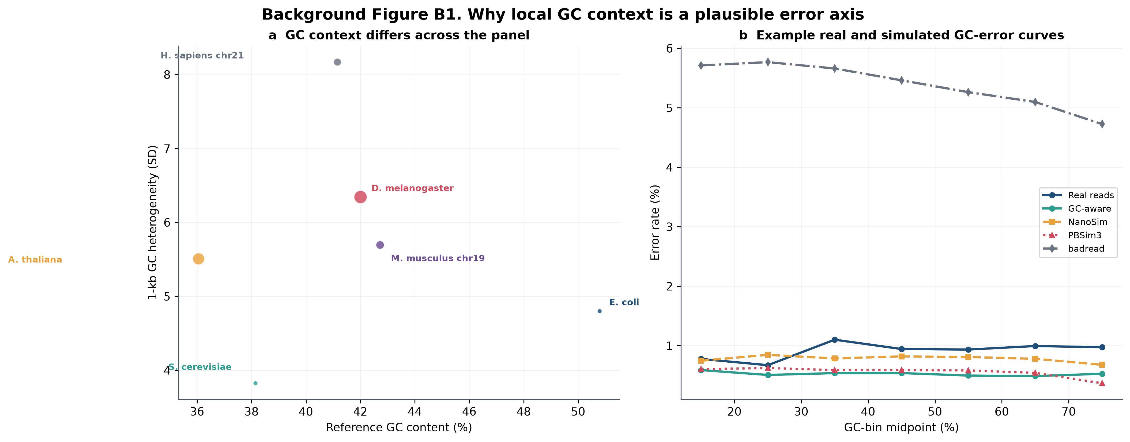
Figure 2. Recent long-read simulation and benchmark landscape. Panel a shows selected publications from 2017-2026. Panel b is a qualitative summary of primary model features based on the cited papers; yes, partial and - indicate whether the feature is a primary design element, a supporting component or not a primary model axis, and are not performance scores. The matrix is a qualitative design summary, not a performance score. No inferential error bars are shown.
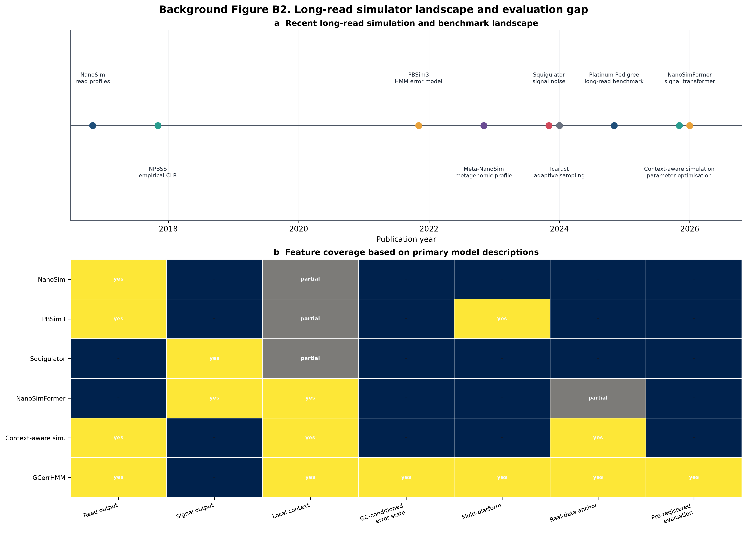
Figure 3. Context dependence and evaluation layers. Panel a shows the observed deletion rate as a function of homopolymer length in the project's real E. coli ONT panel; panel b is a qualitative synthesis of the modelling and evaluation layers addressed by the cited recent work. The layers are not performance scores, and the panel is intended to motivate metric-aligned evaluation rather than rank tools. Panel a uses the frozen real E. coli ONT homopolymer table; panel b is a qualitative synthesis of the cited literature. No inferential error bars are shown.
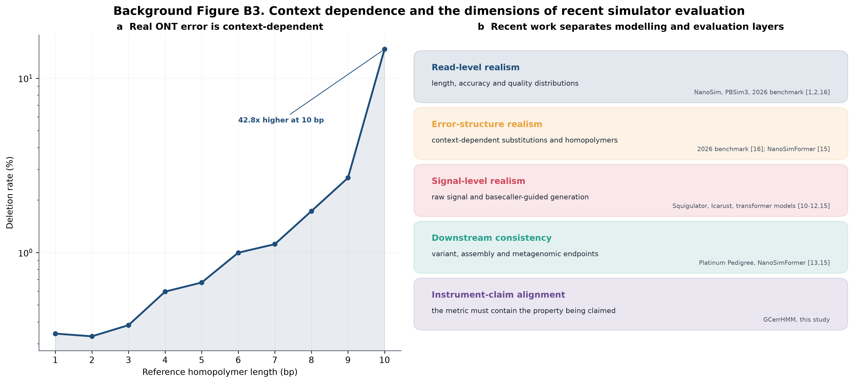
Figure 4. (a) Dual-platform workflow from aligned ONT or PacBio HiFi BAM through CIGAR-derived error-state learning, GC-conditioned transition modeling, matched simulation, and four-layer evaluation. (b) Model-implied error state varies across GC bins for representative genomes. (c) Species panel with the analyzed reference accession, genome size, reference GC content, 1-kb GC heterogeneity, and real ONT run accession. n = six reference panels; no error bars (workflow and species-source table).
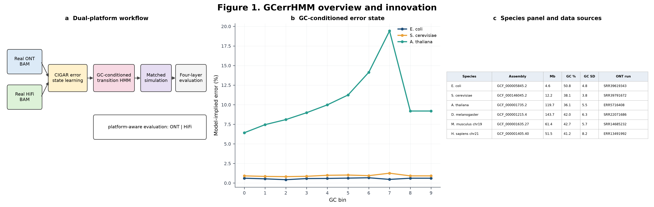
Figure 5. Matched-data comparison of GCerrHMM, NanoSim, PBSim3-sample, PBSim3-errhmm, and badread using read-length, QV, GC, and k-mer similarity. The current measured facet is ONT; the HiFi facet is emitted only after the same training, simulation, and matched-sampling evaluation has completed. All plotted read-level cells are measured; PBSim3-errhmm is retained because these read statistics do not depend on its Q0 quality strings. n = one matched simulation per species and tool; heatmap values are point estimates and no error bars are shown.
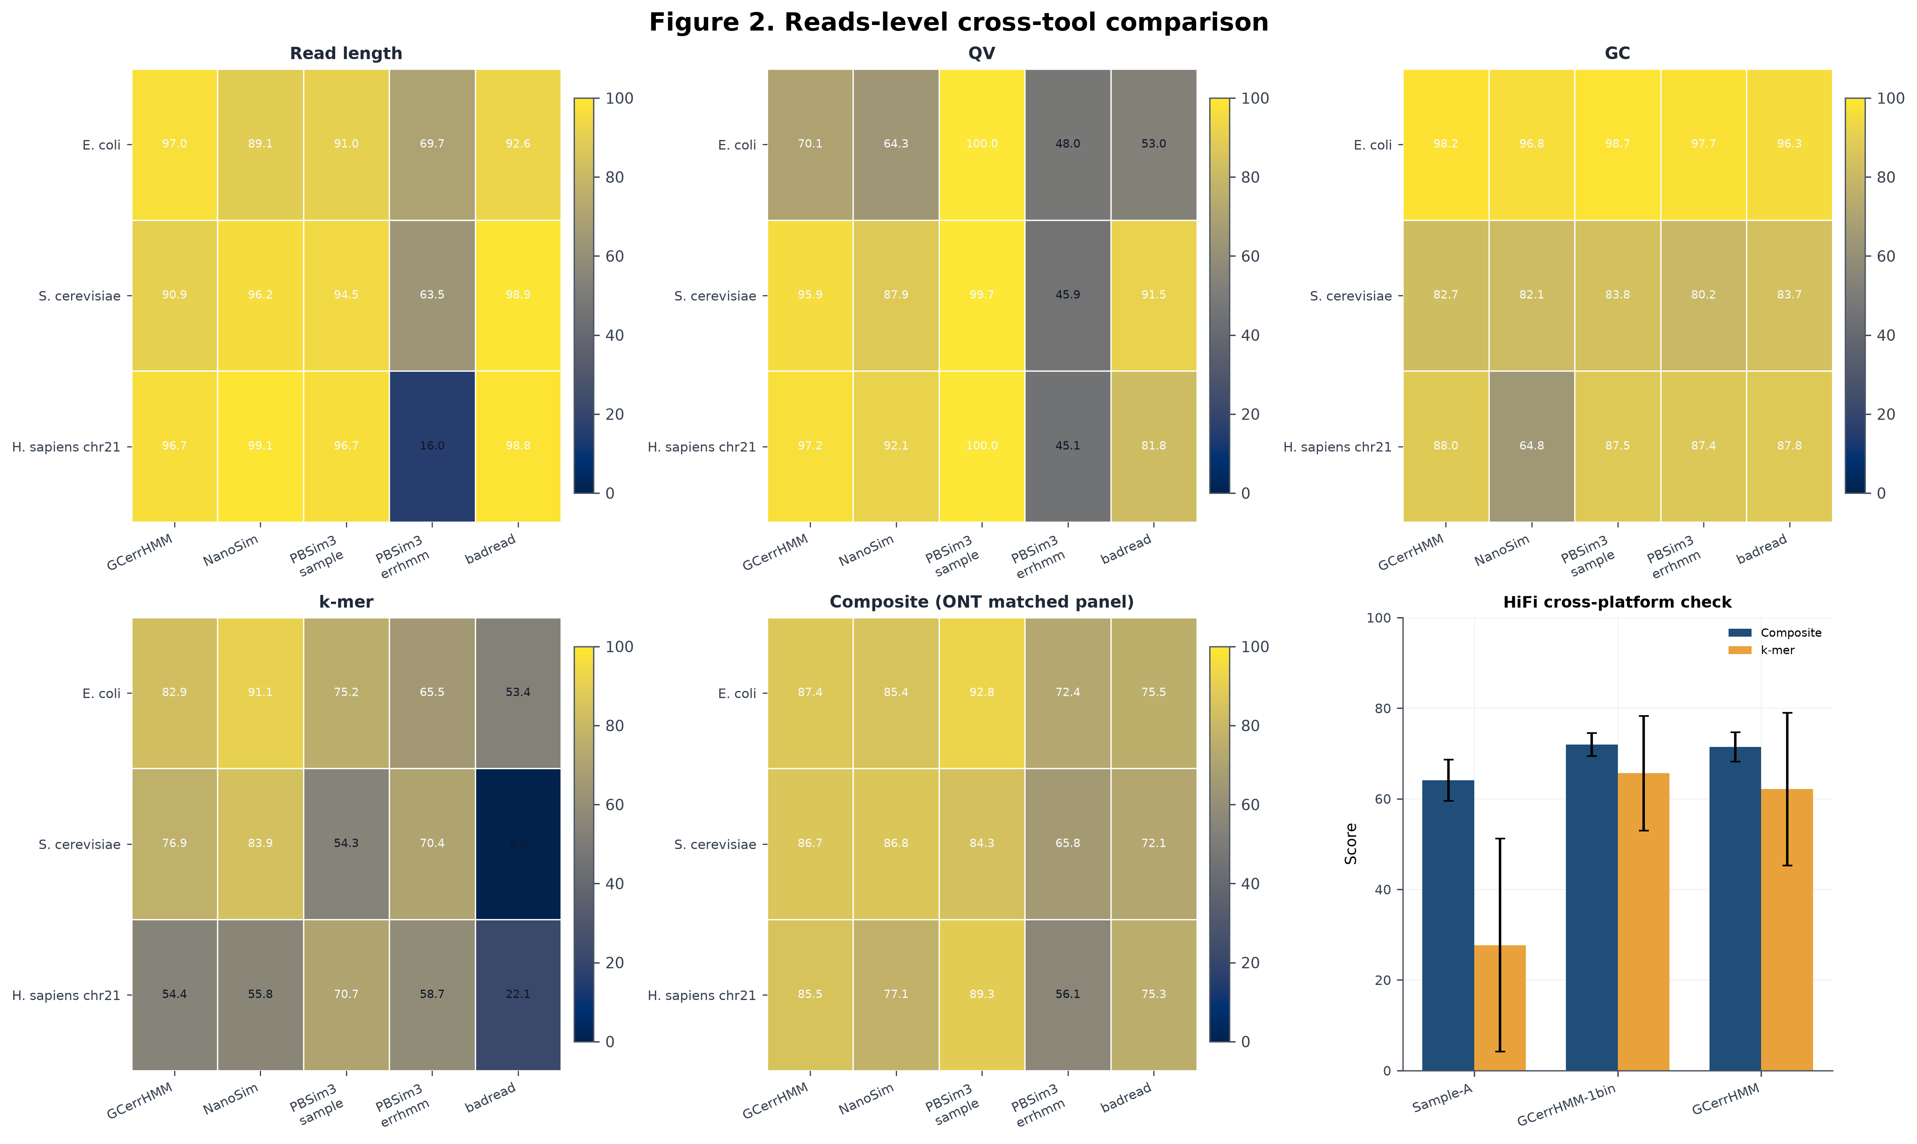
Figure 6. Mapping rate, mean MAPQ, and base-level identity after a common minimap2/samtools alignment pipeline. All plotted cells are measured. PBSim3-errhmm is retained here because its mapping statistics are valid, even though its Q0 placeholder qualities make standard variant calling non-evaluable. The H. sapiens chr21 row uses the coverage-matched 30x panel. n = one matched alignment run per species and tool; heatmap values are point estimates and no error bars are shown.
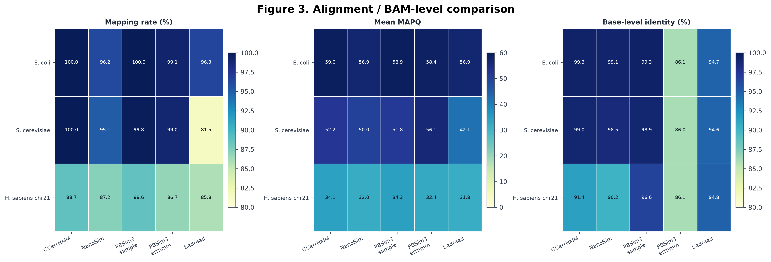
Figure 7. Combined SNP/indel F1 for E. coli, S. cerevisiae, and H. sapiens chr21 against the same truth VCF, plus SNP-only, indel-only, and SV spike-in F1 for the two species where every plotted tool has that measurement. The H. sapiens chr21 row uses the coverage-matched 30x panel; this layer is reported as a cross-tool comparison and is excluded from delta-to-real. PBSim3-errhmm is omitted because its Q0 placeholder qualities make the standard caller non-evaluable. H. sapiens chr21 is shown in the combined-F1 panel only because PBSim3-sample has no SNP/indel split. n = one matched caller run per species and tool; SV values pool the four spike-in designs and confidence intervals are reported in the accompanying table.
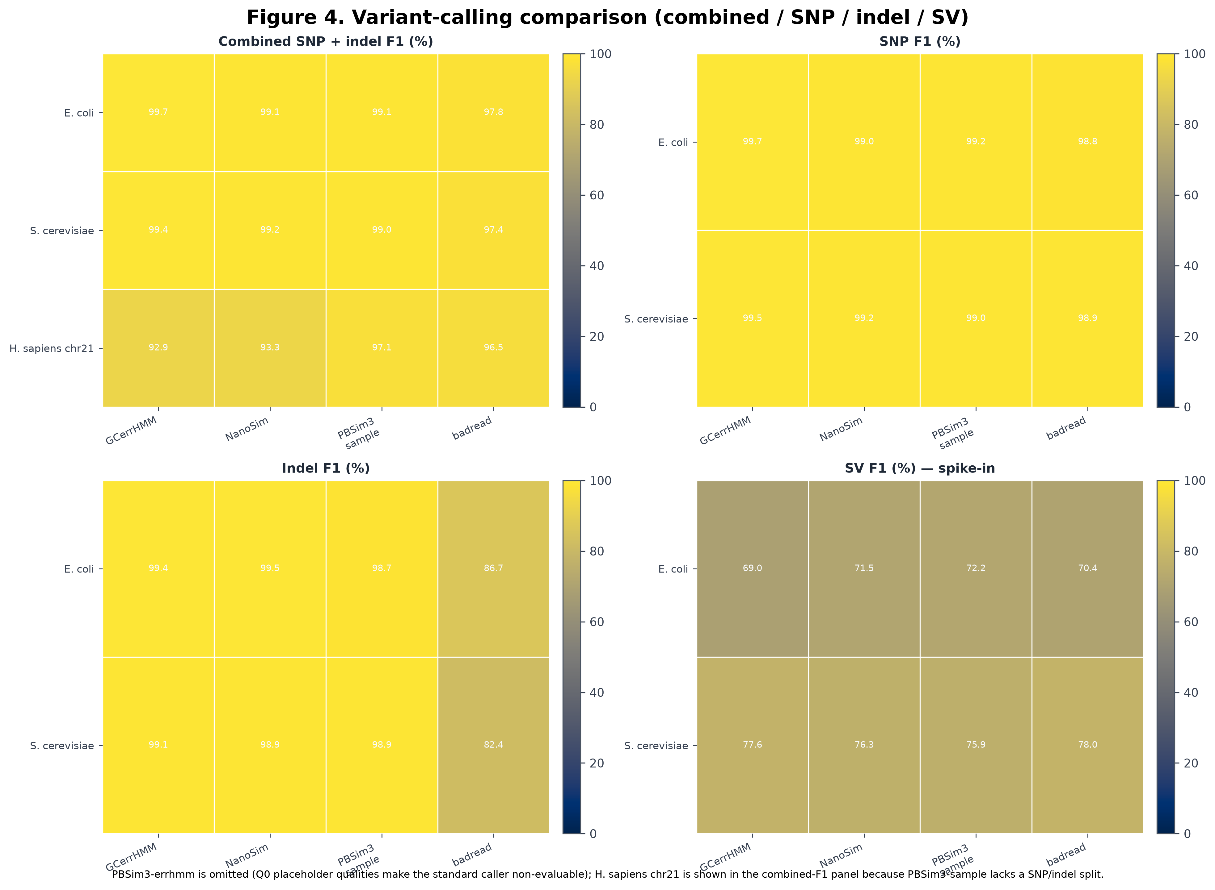
Figure 8. Assembly N50 and reference identity for the measured panel, together with the phasing status. HiFi is assembled with hifiasm, ONT with Flye, and diploid phasing is evaluated with WhatsHap against a phased truth VCF. Historical raven values are not relabeled as hifiasm or Flye results, and PBSim3-errhmm is omitted because no assembly run exists for it. The H. sapiens chr21 row uses the coverage-matched 30x panel; N50 colors span 0-40 Mb so that the real-anchor and simulated ranges remain visible. n = one Flye assembly per species and tool, plus one real 30x ONT anchor; no error bars are shown.
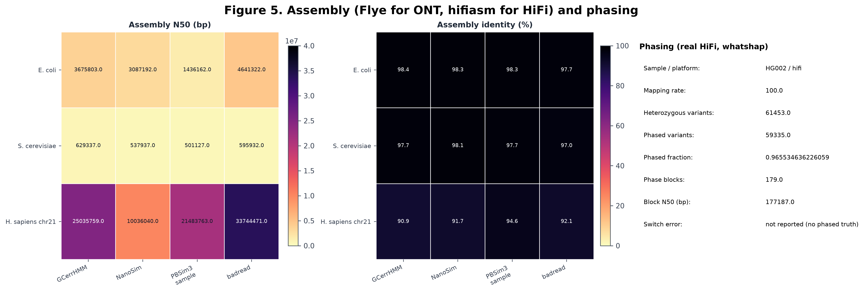
Figure 9. (a) Profile-matched GC-bin ablation for E. coli and A. thaliana across three seeds. (b) Training-coverage ablation from 1x to 30x. (c) Full versus simplified state-space models. Error bars are mean ± SD. n = three seeds per condition; error bars are mean +/- SD.
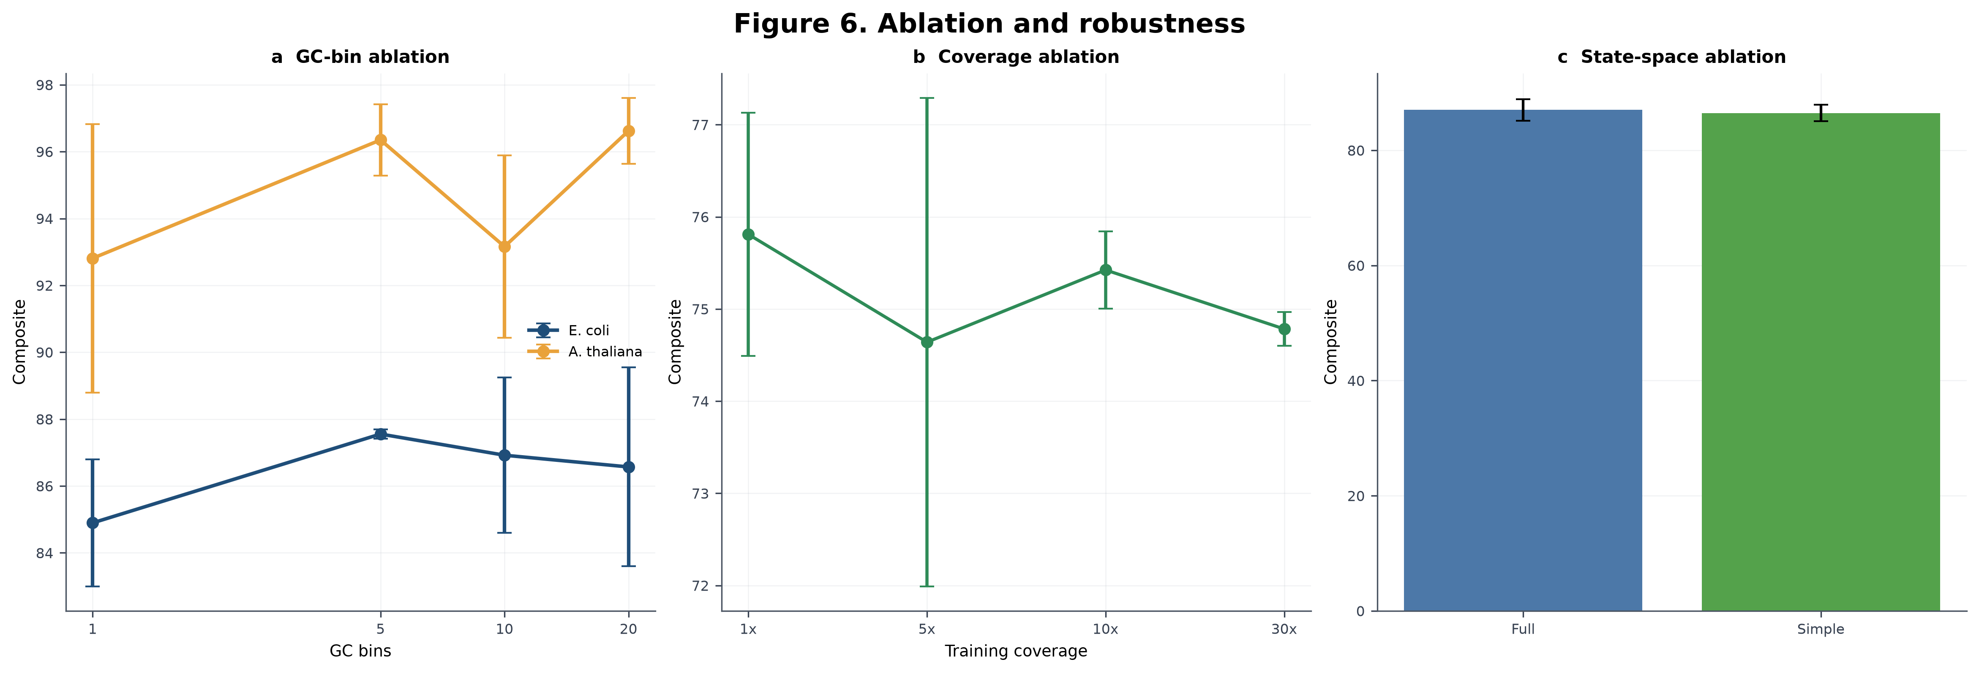

Additional files
Additional file 1. File name: Additional_file_1_species_panel.xlsx. File format: XLSX. Title: Species panel and source accessions. Description: reference accessions, genome size, GC content, GC heterogeneity and ONT run accessions.
Additional file 2. File name: Additional_file_2_level1_sub_scores.xlsx. File format: XLSX. Title: Full per-species Level-1 sub-scores and HiFi cross-platform scores. Description: replicate-level read-length, QV, GC and k-mer scores.
Additional file 3. File name: Additional_file_3_gc_bin_ablation.xlsx. File format: XLSX. Title: GC-bin ablation and A. thaliana replication full table. Description: curve r and MAD by species, bin setting and seed, including the first and second independent A. thaliana cohorts and the pooled 12-seed sensitivity analysis.
Additional file 4. File name: Additional_file_4_delta_to_real.xlsx. File format: XLSX. Title: Delta-to-real per-tool table. Description: anchored-layer metrics and ranks.
Additional file 5. File name: Additional_file_5_instrument_audit.docx. File format: PDF/DOCX. Title: Instrument audit. Description: four measurement problems, symptoms and fixes.
Additional file 6. File name: Additional_file_6_uncertainty_layers.docx. File format: PDF/DOCX. Title: Two layers of uncertainty. Description: read-sampling and between-window components of the GC-fidelity instrument.
Additional file 7. File name: Additional_file_7_hifi_crossplatform_note.docx. File format: PDF/DOCX. Title: HiFi cross-platform note. Description: cross-platform chain and the encoding-limited QV caveat.

