Only consider top 10,000 sensitive mRNAs in 231 patients.

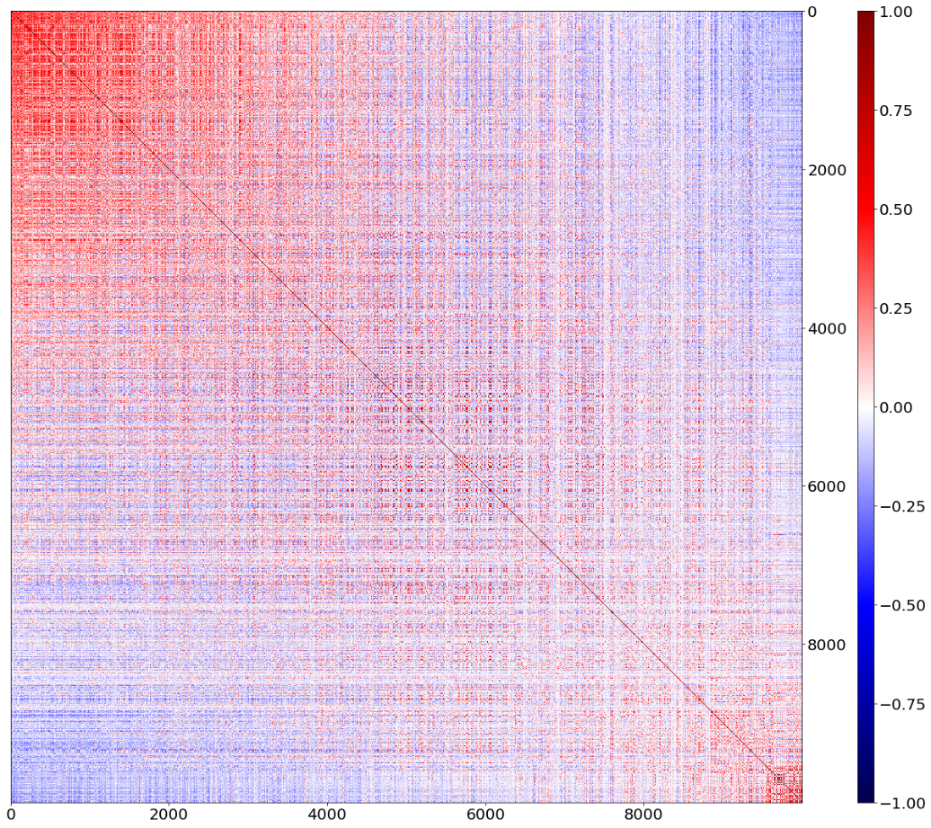

Fig 1.  Heatmap of Pearson coefficient (of the 231 patients’ mRNA value) among the 10,000 mRNAs, sorting with descending order of mean value.

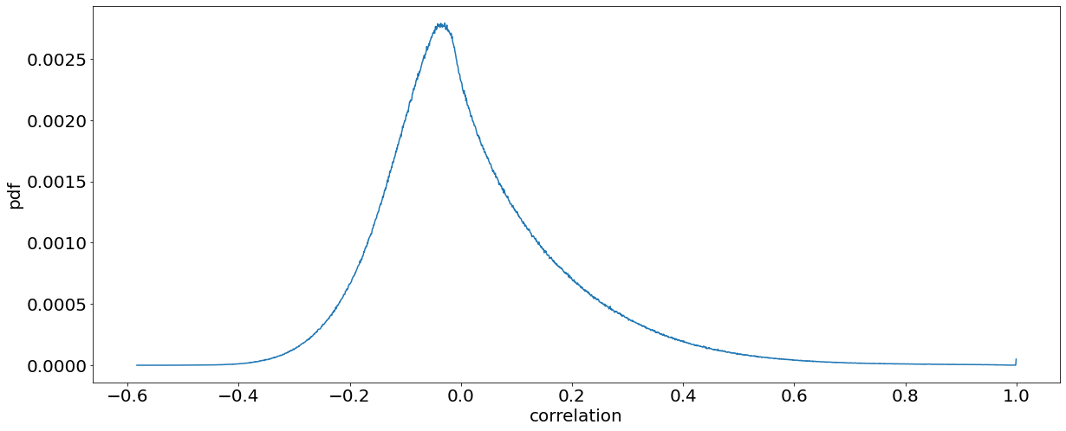

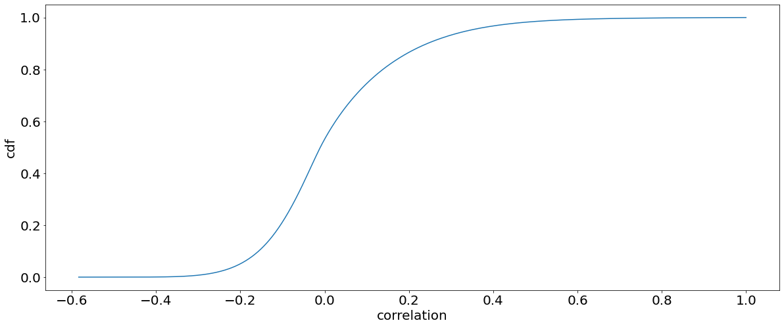

Fig 2.  TOP:  Probability distribution function of Pearson correlation between all pairs of mRNAs. BOTTOM: Cumulative distribution function.

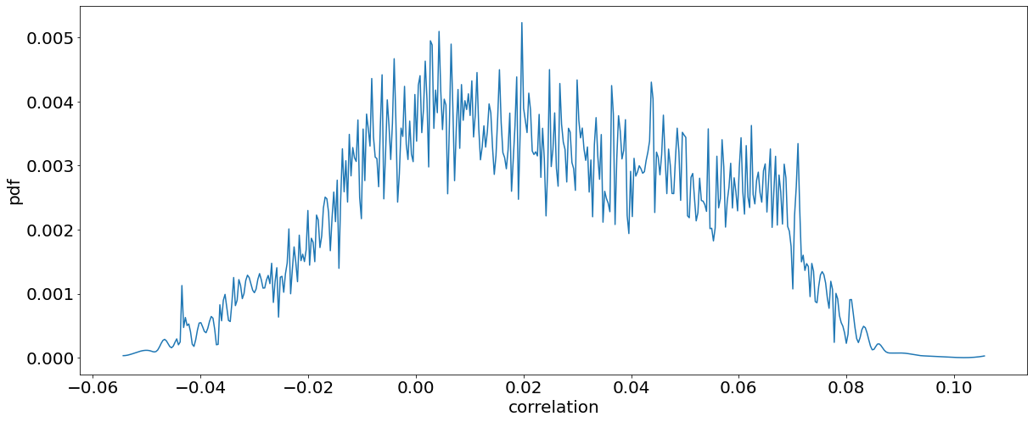

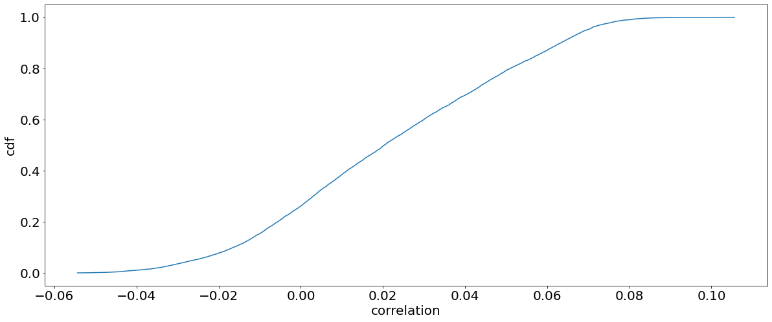

Fig 3.  TOP:  Probability distribution function of average of Pearson correlation between each of the 10,000 mRNAs and all other mRNAs. BOTTOM: Cumulative distribution function.