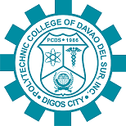

Polytechnic College of Davao Del Sur, Inc.

MacArthur Highway, 8002 Digos City, Philippines

Tel. No. (082) 553-3441 Telefax no. (082) 553-1662

Website: WWW.PCDS.EDU.PH

**---------------------------------------------------------------------------------------------------------------------------------------**