Universal Mart (ISP Final Project)

Members:

Loi Ha - 33%

* CSS Styling/ HTML Formatting
* Coupon Code System
* Created Universal Mart logo

Allan Nash Jr. - 33%

* User Cart Logic and Database Implementation
* Creation of the Presentation

Zach Becker - 33%

* User Log-In/Log-Off Logic and Database Implementation
* User New Listings/View Listings Logic and Database Implementation

Implementation:

Universal Mart is an online ecommerce website created by Allan, Loi, and Zach for our Internet Systems Programming final project. This project was written primarily in PHP, HTML, and CSS. Bootstrap was used to add additional styling features and easier implementation. It was then connected to our MySQL database that holds user information, along with our products. We used WAMP, a server application to host our site, and all files are in the local root directory. The first page for our site is “welcome.php”. The user will be prompted to log in on first access to the site, if they do not have an account they may register one. Once they are logged in, their user information is saved to our database and they can view our main page. Our main page displays the list of products available for purchase, and at the top you can add a product, view your listings, or change password and logout. Products are displayed from our mySQL database, and also keeps track of your cart. During the checkout process, you may enter coupon codes that are available (freeFive & 20Off), and they will apply to your total. Upon entering the wrong coupon code, it will tell you that the code is invalid. The site is intended to be used as an ecommerce website that will allow users to purchase and sell any type of item they would like, similarly to a Craigslist or EBay.

**Database Implementation:**

****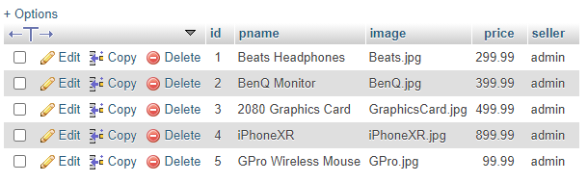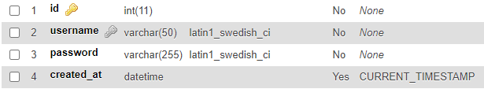

**PHP Files:**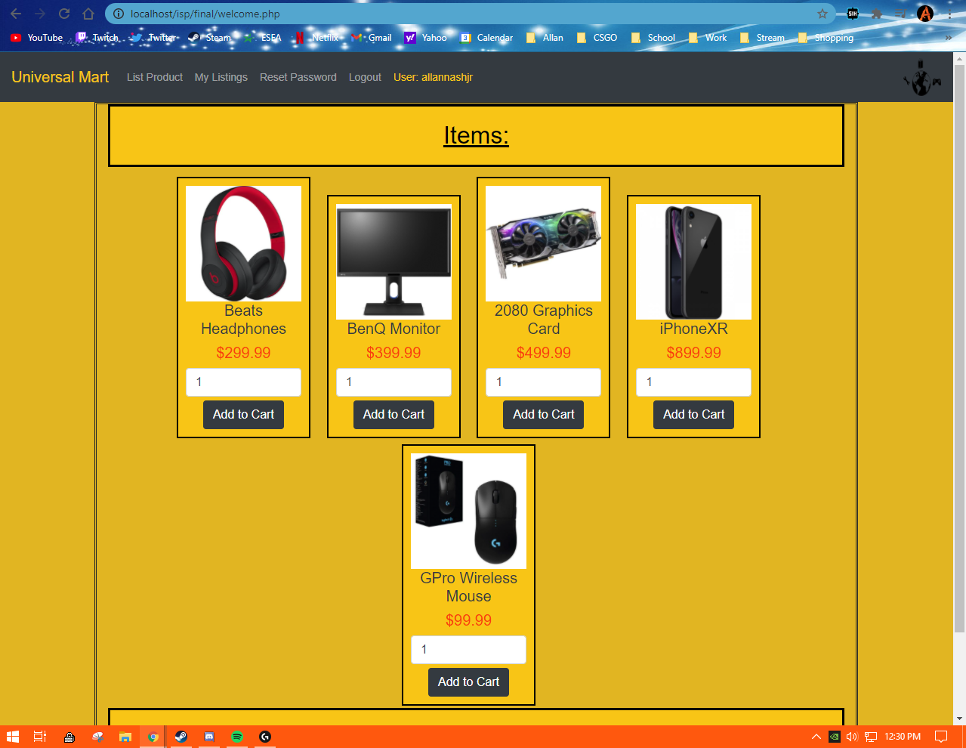

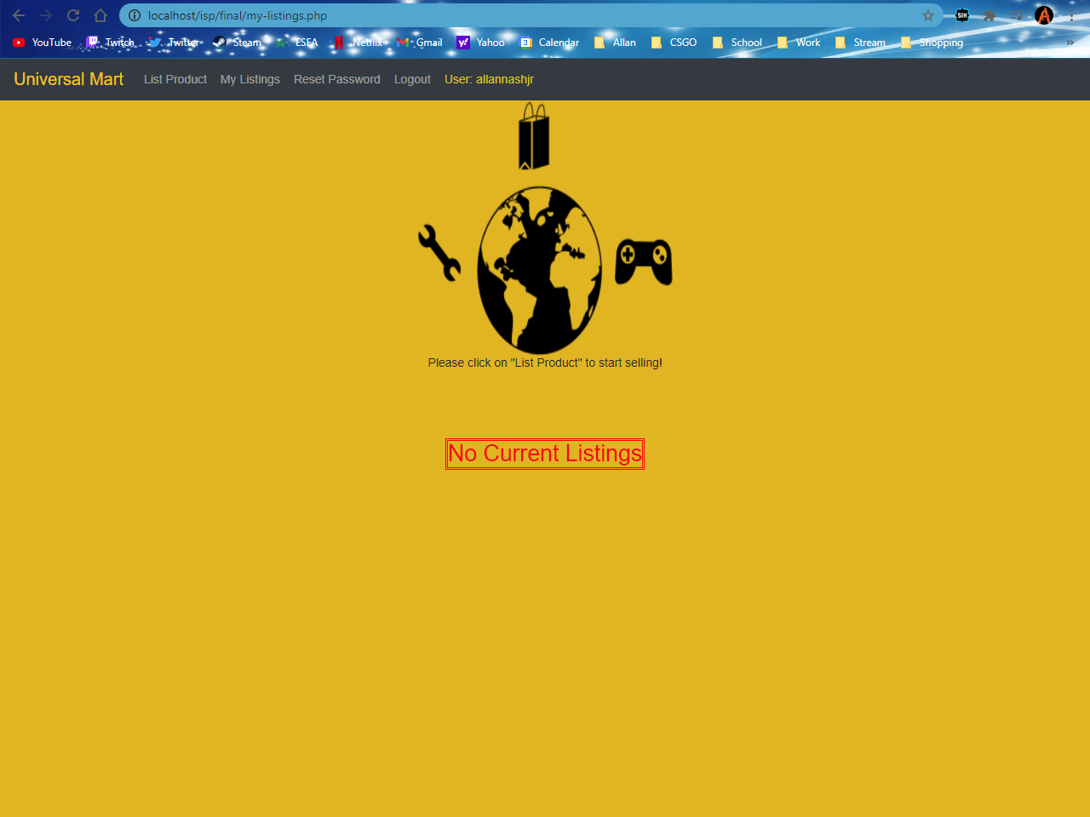

Cart.php

My-Listings.php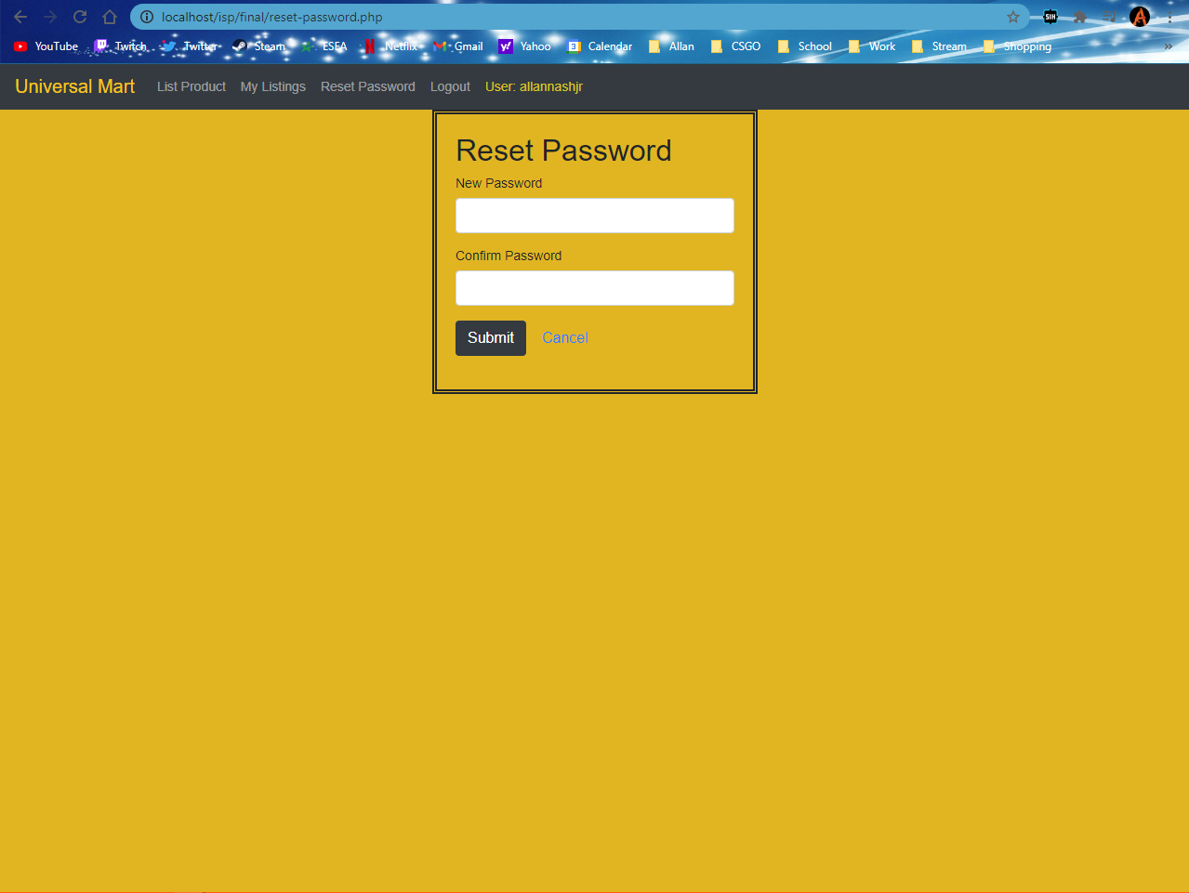

List-Product.php Login.php

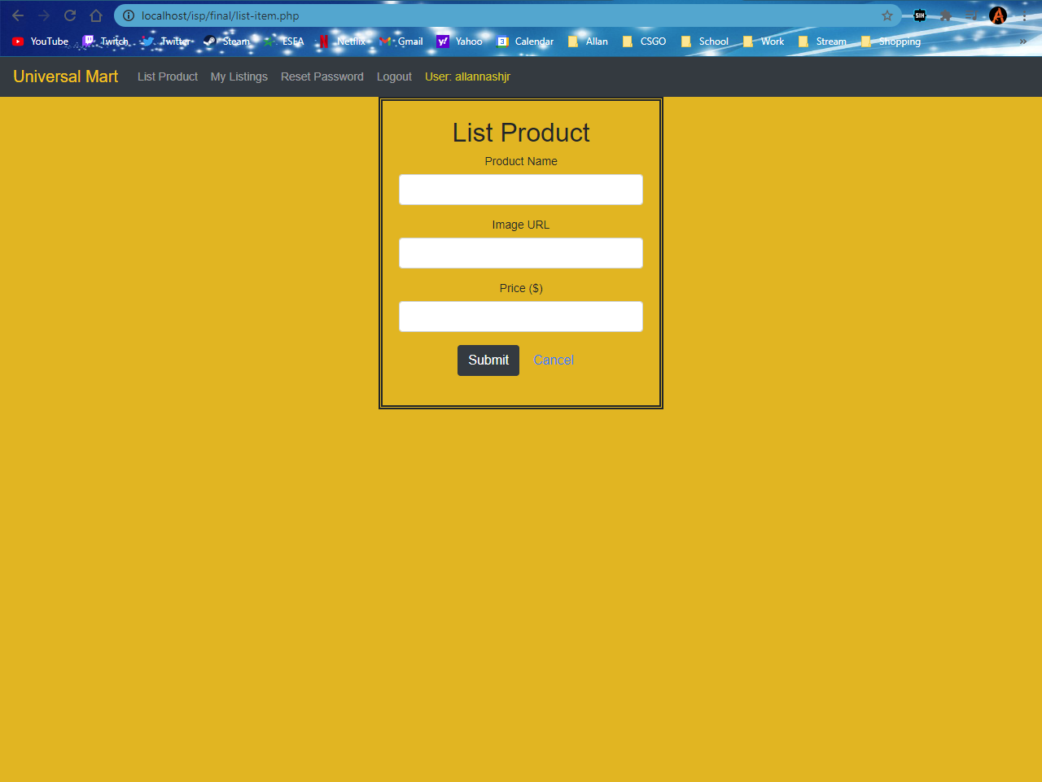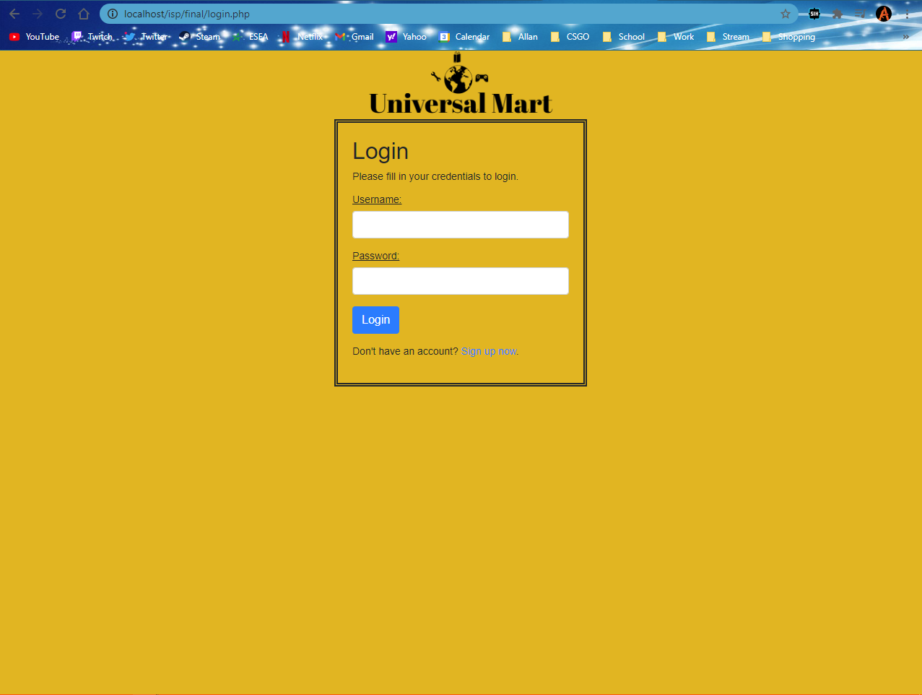

Reset-Password.php