|  |  |  |  |
| --- | --- | --- | --- |
| **INPUT** | **EXPECTED OUTPUT** | **ACTUAL OUTPUT** | **PASS/FAIL** |
| 2014 Employee Wonderland,Allison 2000  2015 Salesman Aaron,Hank 3000 100000  2014 Executive Bush,George 5000 55  2015 Employee Abbey,Edward 1500  2014 Salesman Ace,Jane 10000 4000000  2015 Executive Trump,Donald 23000 21.32  2014 Employee Ramirez,Manny 1000  2015 Salesman Rand,Ayn 1000 404091874  2014 Executive Rometty,Ginni 10000 123.54  2015 Employee Stein,Ben 1132  2014 Salesman Stalin,Joseph 0 54000000  2015 Executive Gates,Bill 15000 -10  2014 Employee Tagore,Rabindranath 1300  2015 Salesman Tennyson,Alfred 1800 200000000  2014 Executive Nooyi,Indra 7050 132.5  2015 Employee Thant,U 1357.45  2014 Salesman Watts,Alan 2345 123456789  2015 Executive Bezos,Jeff 3000 1632.21  2014 Employee Nijinsky,Vaslav 5376.34  2015 Salesman Morales,Evo 1467.74 9837482 | ------- Employee Data for 2014 -------  Total Salary: $678856.08  Average Salary: $67885.61  <<Employee>>  Name: Wonderland, Allison  Annual Salary: $24000.00  <<Executive>>  Name: Bush, George  Annual Salary: $90000.00  Stock Price: $55.00  <<Salesman>>  Name: Ace, Jane  Annual Salary: $140000.00  Annual Sales: $4000000.00  <<Employee>>  Name: Ramirez, Manny  Annual Salary: $12000.00  <<Executive>>  Name: Rometty, Ginni  Annual Salary: $150000.00  Stock Price: $123.54  <<Salesman>>  Name: Stalin, Joseph  Annual Salary: $20000.00  Annual Sales: $54000000.00  <<Employee>>  Name: Tagore, Rabindranath  Annual Salary: $15600.00  <<Executive>>  Name: Nooyi, Indra  Annual Salary: $114600.00  Stock Price: $132.50  <<Salesman>>  Name: Watts, Alan  Annual Salary: $48140.00  Annual Sales: $123456789.00  <<Employee>>  Name: Nijinsky, Vaslav  Annual Salary: $64516.08  ------- Employee Data for 2015 -------  Total Salary: $719086.28  Average Salary: $71908.63  <<Salesman>>  Name: Aaron, Hank  Annual Salary: $38000.00  Annual Sales: $100000.00  <<Employee>>  Name: Abbey, Edward  Annual Salary: $18000.00  <<Executive>>  Name: Trump, Donald  Annual Salary: $276000.00  Stock Price: $21.32  <<Salesman>>  Name: Rand, Ayn  Annual Salary: $32000.00  Annual Sales: $404091874.00  <<Employee>>  Name: Stein, Ben  Annual Salary: $13584.00  <<Executive>>  Name: Gates, Bill  Annual Salary: $180000.00  Stock Price: $0.00  <<Salesman>>  Name: Tennyson, Alfred  Annual Salary: $41600.00  Annual Sales: $200000000.00  <<Employee>>  Name: Thant, U  Annual Salary: $16289.40  <<Executive>>  Name: Bezos, Jeff  Annual Salary: $66000.00  Stock Price: $1632.21  <<Salesman>>  Name: Morales, Evo  Annual Salary: $37612.88  Annual Sales: $9837482.00 | run:  ------- Employee Data for 2014 -------  Total Salary: $678856.08  Average Salary: $67885.61  <<Employee>>  Name: Wonderland, Allison  Annual Salary: $24000.00  <<Executive>>  Name: Bush, George  Annual Salary: $90000.00  Stock Price: $55.00  <<Salesman>>  Name: Ace, Jane  Annual Salary: $140000.00  Annual Sales: $4000000.00  <<Employee>>  Name: Ramirez, Manny  Annual Salary: $12000.00  <<Executive>>  Name: Rometty, Ginni  Annual Salary: $150000.00  Stock Price: $123.54  <<Salesman>>  Name: Stalin, Joseph  Annual Salary: $20000.00  Annual Sales: $54000000.00  <<Employee>>  Name: Tagore, Rabindranath  Annual Salary: $15600.00  <<Executive>>  Name: Nooyi, Indra  Annual Salary: $114600.00  Stock Price: $132.50  <<Salesman>>  Name: Watts, Alan  Annual Salary: $48140.00  Annual Sales: $123456789.00  <<Employee>>  Name: Nijinsky, Vaslav  Annual Salary: $64516.08  ------- Employee Data for 2015 -------  Total Salary: $719086.28  Average Salary: $71908.63  <<Salesman>>  Name: Aaron, Hank  Annual Salary: $38000.00  Annual Sales: $100000.00  <<Employee>>  Name: Abbey, Edward  Annual Salary: $18000.00  <<Executive>>  Name: Trump, Donald  Annual Salary: $276000.00  Stock Price: $21.32  <<Salesman>>  Name: Rand, Ayn  Annual Salary: $32000.00  Annual Sales: $404091874.00  <<Employee>>  Name: Stein, Ben  Annual Salary: $13584.00  <<Executive>>  Name: Gates, Bill  Annual Salary: $180000.00  Stock Price: $0.00  <<Salesman>>  Name: Tennyson, Alfred  Annual Salary: $41600.00  Annual Sales: $200000000.00  <<Employee>>  Name: Thant, U  Annual Salary: $16289.40  <<Executive>>  Name: Bezos, Jeff  Annual Salary: $66000.00  Stock Price: $1632.21  <<Salesman>>  Name: Morales, Evo  Annual Salary: $37612.88  Annual Sales: $9837482.00  BUILD SUCCESSFUL (total time: 0 seconds) | PASS |

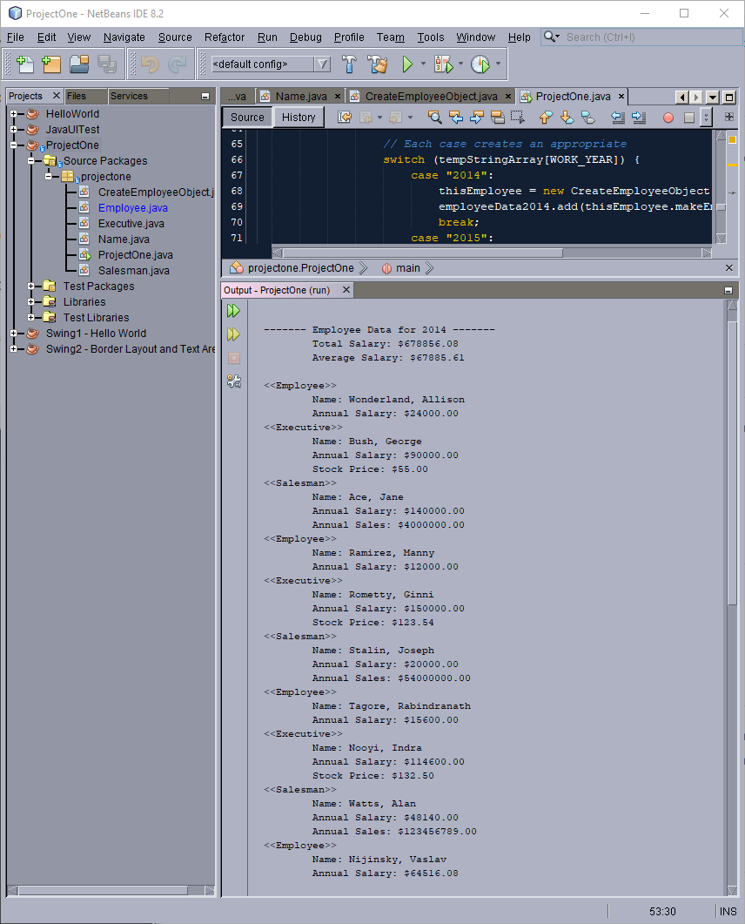Output Screen Capture 1-2

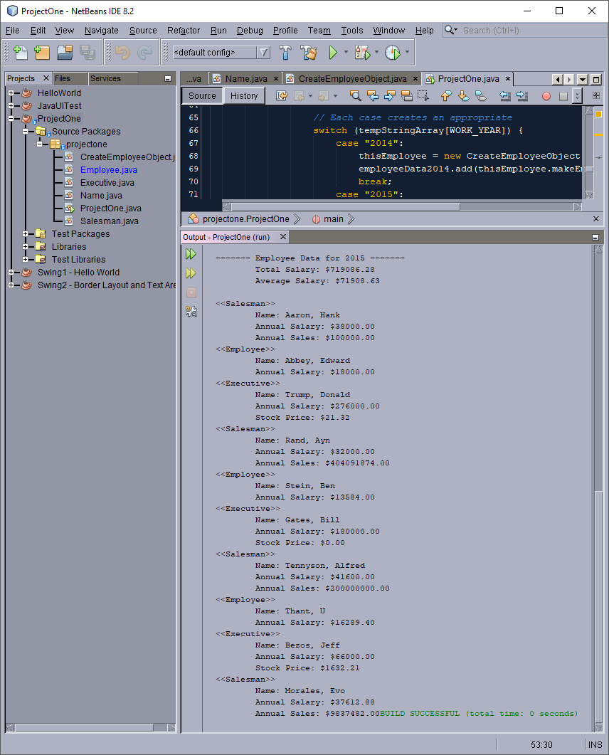Output Screen Capture 2-2