Files : 2

Original files : 2

Codes : 2

Outputs: 2

Explication conception 3

Step N°1: split_text 3

Step N°2: remove_character 3

Step N°4: time format treatment 4

Step N°5: row fusion according to “scientific_title” or “title” column 4

Step N°6: data replacement for “journal” column 5

Step N°7: create new database based on individual word by the cleanded dataset obtained in the step N°6 5

Step N°8: improve the database obtained from the step N°7 5

Drugs quotes detection 6

# Files :

## Original files :

* 1.clinical_trials.csv
* 1.drugs.csv
* 1.pubmed.csv
* 1.pubmed.json
* 1.test_python.pdf

## Codes :

* pipeline.py : script executable
* conception.ipynb : conception of the pipeline.py

## Outputs:

* cleaned_data/clinical.csv: cleaned format of 1.clinical_trials.csv

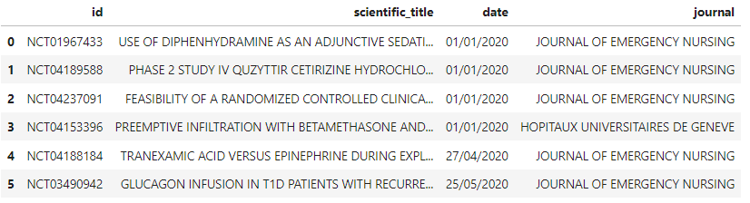

* cleaned_data/pubmed.csv: cleaned format of 1. pubmed.csv

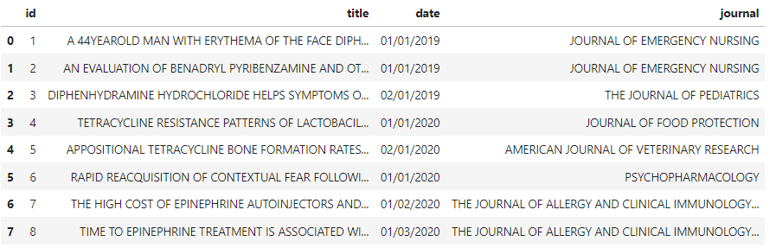

* cleaned_data/drugs_in_clinical.csv: database of words in clinical.csv

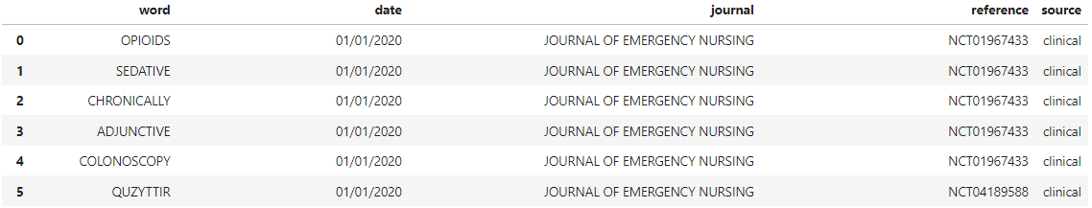

* cleaned_data/drugs_in_pubmed.csv: database of words in pubmed.csv

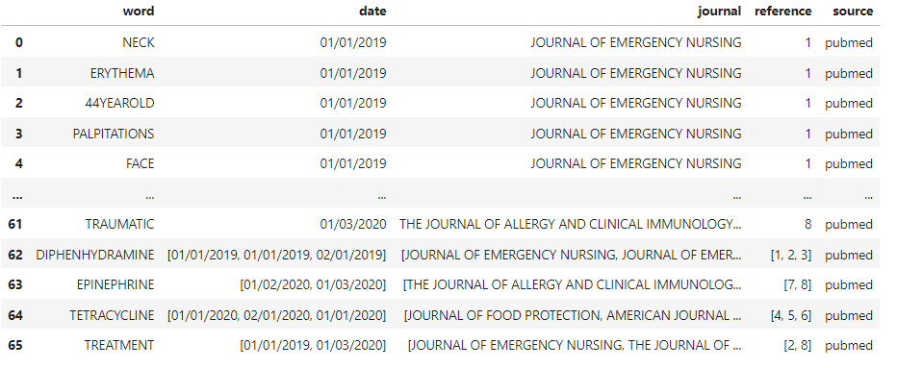

* results/ search_drugs_inclinical.csv: drugs quoted by 1.drugs.csv in drugs_in_clinical.csv

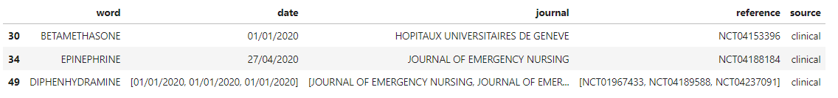

* results/ search_drugs_inpubmed.csv: drugs quoted by 1.drugs.csv in drugs_in_pubmed.csv

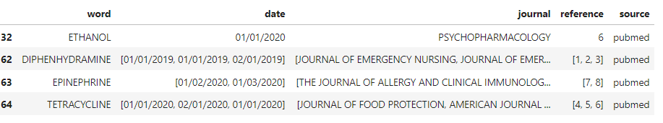

# Explication conception

The data processing is composed of 8 steps and returns 2 dataframe (cleaned data + database : word – date – journal – reference – source)

## Step N°1: split_text

* Standardize the string in upper and no accent format
* Slice string into word list

## Step N°2: remove_character

* Remove all characters in each word if there are some
* Before:



* After:



### Step N°3: drop_useless_row

* It is supposed that if the “scientific_title” or “title” is empty, there is no need to keep this row in dataset

## Step N°4: time format treatment

* Special case supplementary treatment: 1 January 2020 => 1 JANUARY 2020 => 1 01 2020
* Re-arrange all time data to one format in string: dd/mm/yyyy
* Before:

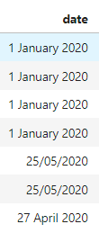

* After:

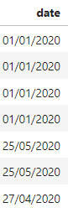

## Step N°5: row fusion according to “scientific_title” or “title” column

* If several rows concern the same article title, it needs to fusion them into only one row
* Similarity between 2 strings calculated by TfidfVectorizer

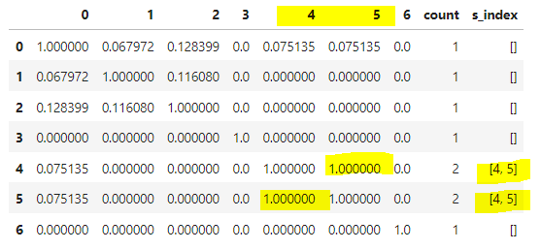

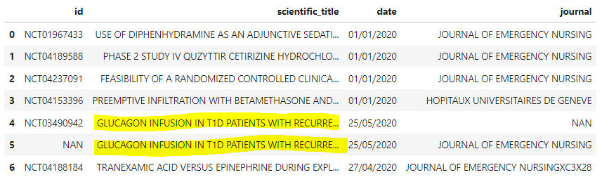

* If the similarity > 0.9: fusion

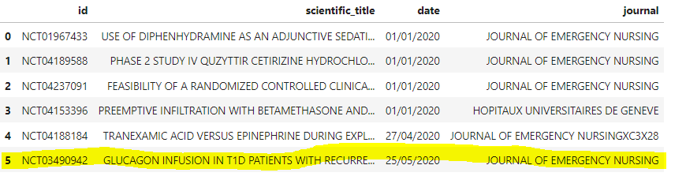

## Step N°6: data replacement for “journal” column

* Polluted data:

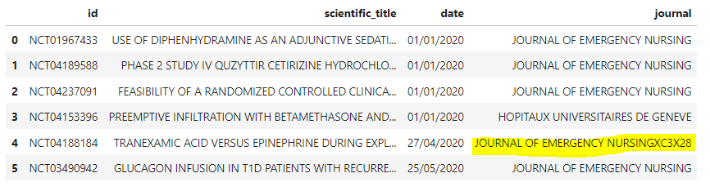

* Different than the step N°5 which is possible to merge different data, in this case, some wrong data has to been corrected
* The idea is firstly detecting the similar journal name by SequenceMatcher
* For a group of journal names who are considered similar, their names will be changed to the name of the majority:

example: ['Apple', 'Apple', 'Apple', 'Aapple', 'Apples'] => ['Apple'] x5

* Output: cleaned final dataset

## Step N°7: create new database based on individual word by the cleanded dataset obtained in the step N°6

* Firstly, remove all stop words: ‘OF’, ‘AN’, ‘A’, …
* Secondly: remove all “digital” words: ‘2’, ‘3’, …
* Create the database like following

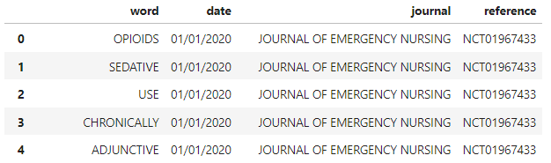

* Remove all duplicates

## Step N°8: improve the database obtained from the step N°7

* One word could be quoted at different time and in different journal, the aim of this step is to grouped them together
* Example:

Before: DIPHENHYDRAMINE quoted in 3 different articles (different references) at the same time in the same journal

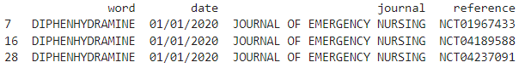

After: in one row



# Drugs quotes detection

Once the 2 databases corresponding to clinical_trial and pubmed have been done, it needs a simple filtration to search the drug names’ quotes:

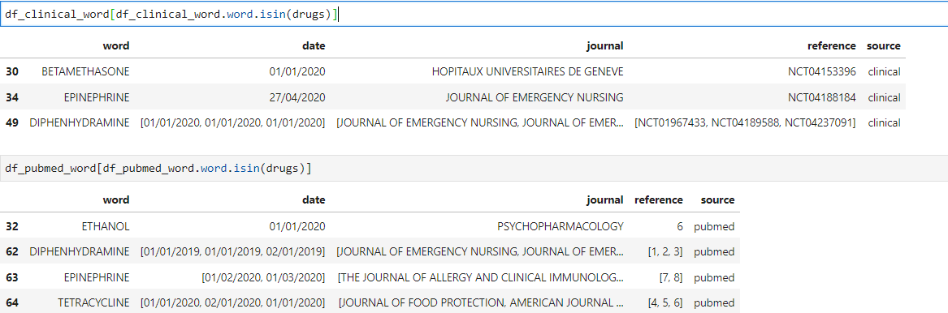

* Run the script pipeline.py
* Results in csv files could be founded in folder “results”

