Embodiment and Subjectivity of the Advertisement in 1935

Charles Zhang

ART 272: Embodiment and Subjectivity in Later Chinese Art

February 7, 2020

Semicolon

 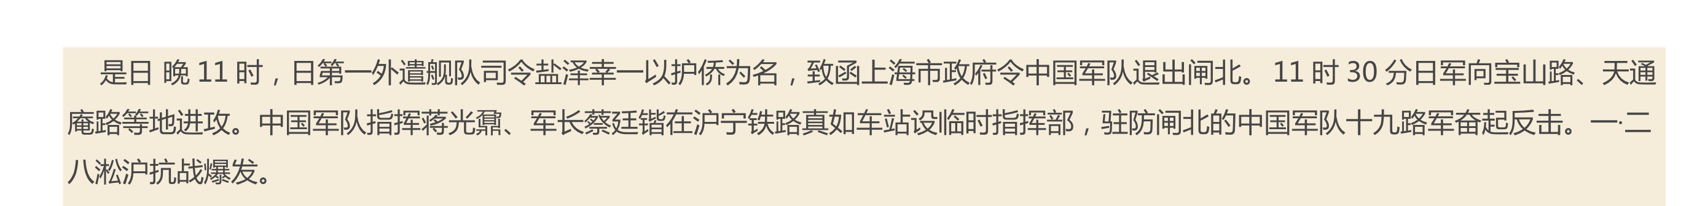

1935  

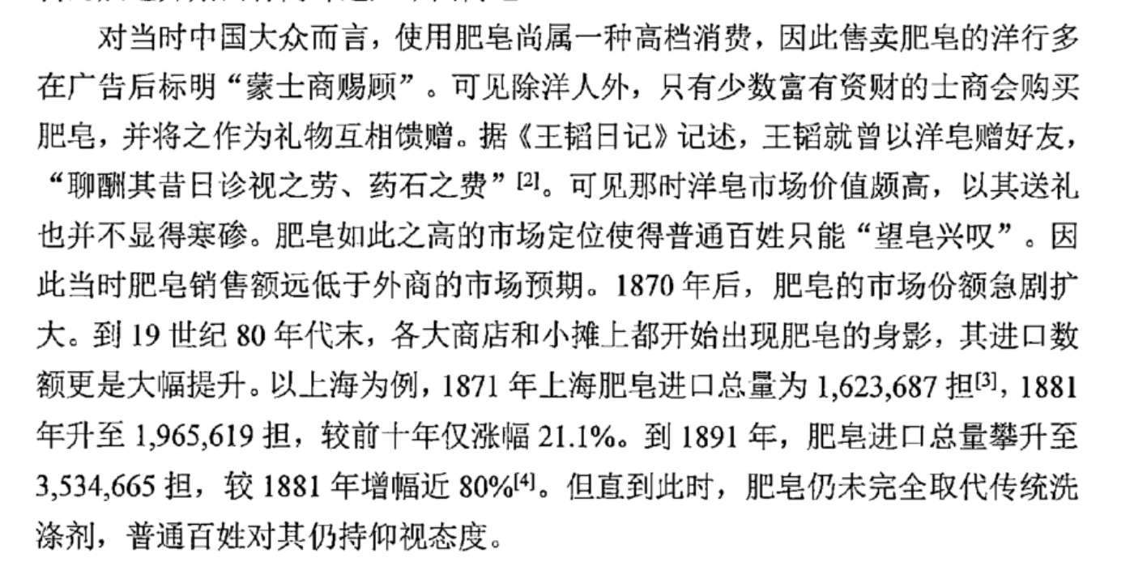

With dark yellow as the main color frame, two women in qipao are playing golf in an advertising poster for a Shanghai soap company in 1935.1 The Chinese brand of the soap was “Baiyushuang”, which is the name of a famous opera actress in Shanghai in 1930s. However, the English brand of this soap, “Victoria”, was from Europe, and the manufacture factory was from Japan.2 This poster perfectly recreates the image of women and unveils the multicultural society in modern Shanghai. Therefore, this paper will discuss these women and their clothes, and indicate how elements in this advertisement embody the identities about women in Shanghai.

This poster was made in the first decade of the Republic of China. After the 1911 Revolution which ended Manchu rule, and influenced by the Western lifestyles and ideas, clothing changed and complicated styles were replaced. With most fashion and global trade taking place in Shang, Shanghai became the place where bred the new development of Chinese dress including qipao. Moreover, Shanghai was experiencing an economic growth at that time. By 1888, the modern industry began to appear in China. Subsequently, Shanghai gradually became the center of industry with its unique industrial advantages and treaty port.

Qipao, the iconic garment by which Chinese women are still known throughout the world, is the symbol of the evolution of the modernization in China. Besides, influenced by the Western thought, the emergence of qipao was also an evolution of the Chinese fashion and opening up. In 1930s, qipao was considered a daring style, elegantly revealing the shape of a woman’s bewitching figure.

Just as clothing styles changed at the start of Manchu rule, again clothing changed and complicated styles were replaced. During the first decade of the Republic of China (1912-1949), influenced by new lifestyles and ideas, as well as Western garb, the Han-style women's dress and cheongsam, two totally different styles, both exhibited change. Becoming simple in terms of design, wardrobes began to more show off the female form, an intention manifested in varying designs. And so was raised the curtain on a new style of cheongsam.

vvvv

Qipao:

“At the time it was considered a very daring style, revealing the shape of a woman’s figure as never before ”

“Women with style copied the permanent wave favored by Shanghai movie stars. ”

“With their glamorous poses, wavy hair, arched eyebrows, and coy looks, their influence was pervasive ”

“During the 1930s, hemlines dropped to the ankle, and by the middle of the decade they covered the feet in some cases (Figs. 297, 299–301). Gradually, the cheongsam became quite a fitted garment. Some, worn by very fashion-conscious women, had side slits reaching right up to the thigh. These styles were provocative and accentuated a woman’s sexuality, emphasized by legs clad in silk stockings (a recent innovation) and high heels.”

Excerpt From: Valery Garrett. “Chinese Dress.” Apple Books.

vvvv

Qipao:

“At the time it was considered a very daring style, revealing the shape of a woman’s figure as never before ”

“With most fashion activities taking place in Shanghai, it was not surprising that the next development in Chinese dress should take place there.”

“ the iconic garment by which Chinese women are still known throughout the world, and which provides constant inspiration for fashion designers in the West. ”

“Women with style copied the permanent wave favored by Shanghai movie stars. ”

“With their glamorous poses, wavy hair, arched eyebrows, and coy looks, their influence was pervasive ”

“During the 1930s, hemlines dropped to the ankle, and by the middle of the decade they covered the feet in some cases (Figs. 297, 299–301). Gradually, the cheongsam became quite a fitted garment. Some, worn by very fashion-conscious women, had side slits reaching right up to the thigh. These styles were provocative and accentuated a woman’s sexuality, emphasized by legs clad in silk stockings (a recent innovation) and high heels.”

Excerpt From: Valery Garrett. “Chinese Dress.” Apple Books.