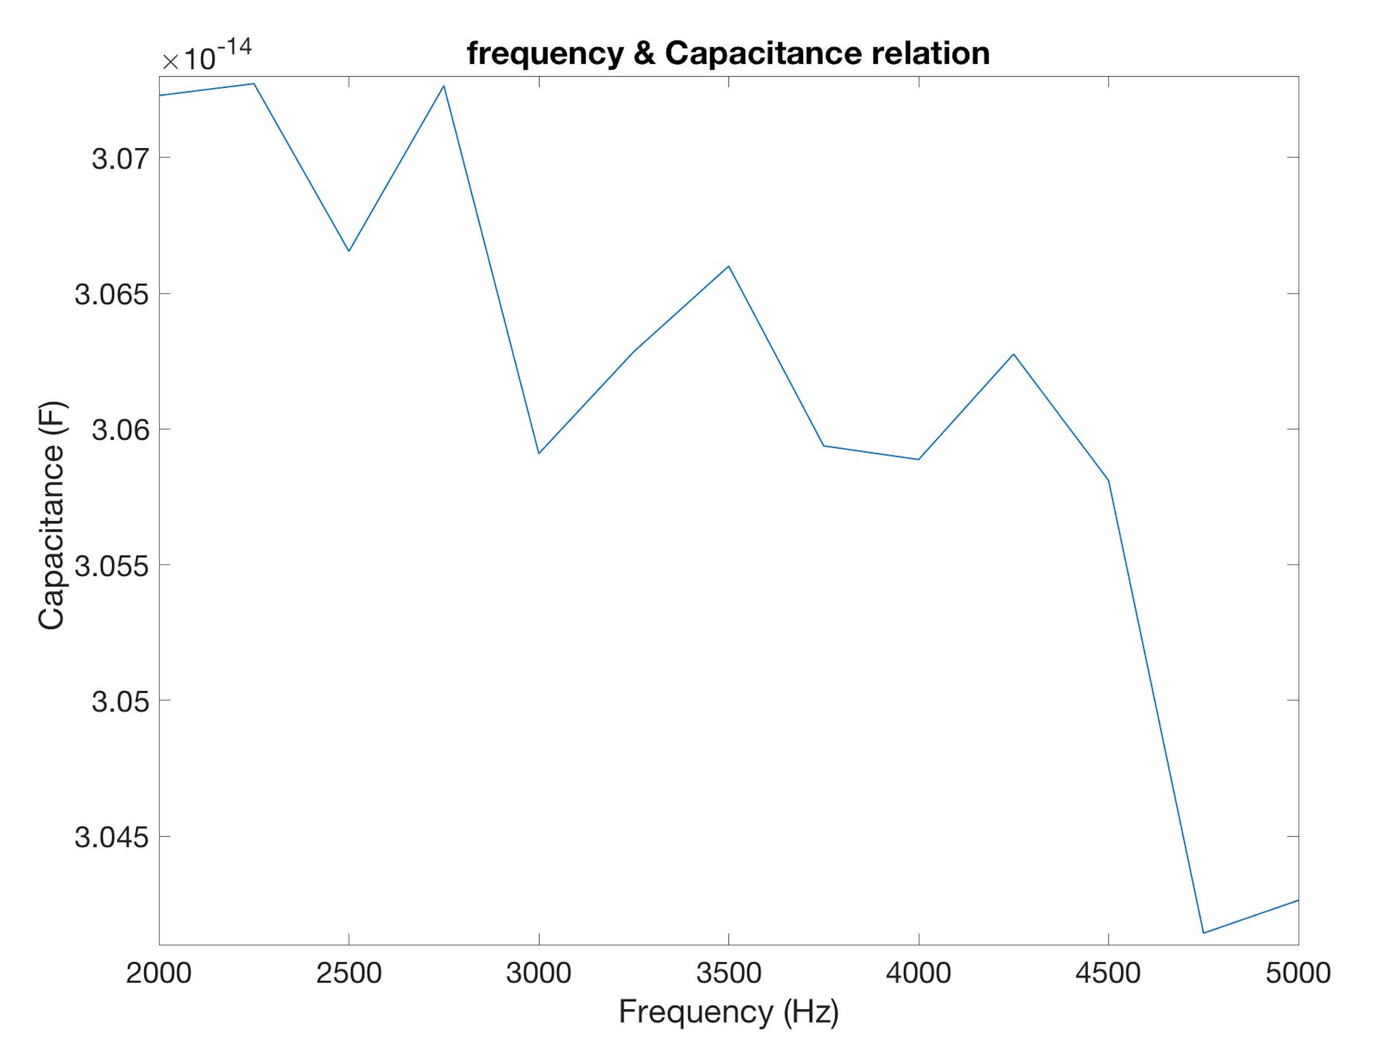

*Fig.8 The Capacitances at different frequencies ranged from 2000 Hz to 5000 Hz*

After applying a 10N force to the device, it makes the displacements at frequencies ranged from 2000 Hz to 5000 Hz. If applying these displacements as the change of the overlap distance, the capacitance can be modified, which was showed the relation in *Fig. 7*.