今天在搞echarts图表的时候发现：
$.jsPanel({
//定位
position: {my: "center-top", at: "center-top", offsetY: 15},
//主题
theme: "rebeccapurple",
contentSize: {width: 600, height: 450},
headerTitle: "环形图",
content: "<div id='wrap1' style='height:450px'></div>",
//插入document后操作面板
callback: function () {
setTimeout(function(){
$('.jsPanel').css({'z-index':'1000','cursor':'pointer'});
},20);
var myChart=echarts.init(document.getElementById("wrap1"));
option = {
tooltip: {
trigger: 'item',
formatter: "{a} <br/>{b}: {c} ({d}%)"
},
legend: {
orient: 'vertical',
x: 'left',
data:['直接访问','邮件营销','联盟广告','视频广告','搜索引擎']
},
series: [
{
name:'访问来源',
type:'pie',
radius: ['50%', '70%'],
avoidLabelOverlap: false,
label: {
normal: {
show: false,
position: 'center'
},
emphasis: {
show: true,
textStyle: {
fontSize: '30',
fontWeight: 'bold'
}
}
},
labelLine: {
normal: {
show: false
}
},
data:[
{value:335, name:'直接访问'},
{value:310, name:'邮件营销'},
{value:234, name:'联盟广告'},
{value:135, name:'视频广告'},
{value:1548, name:'搜索引擎'}
]
}
]
};
myChart.setOption(option);
}
});
在jq的浮动框插件jsPanel中使用jq的$来查找元素（echarts.init($("wrap1"));
）时会报错，
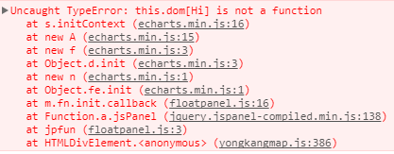
同时，浮框显示为空：
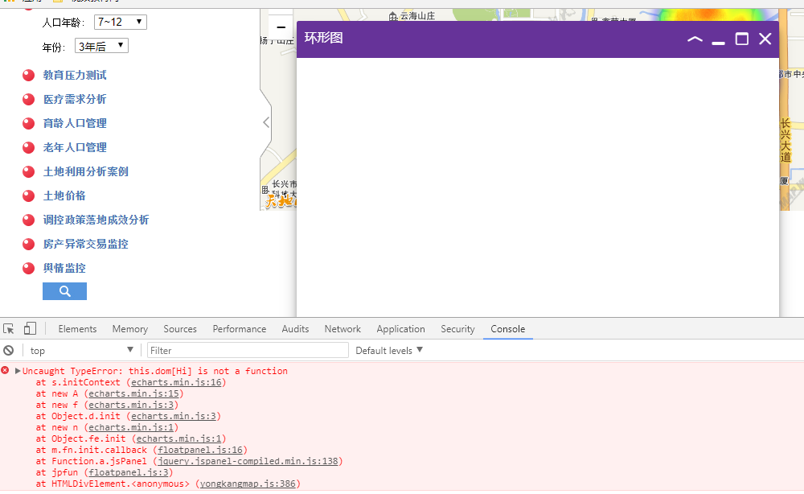
修改尝试之后发现是，echarts.init($("wrap1")有问题，当改成用原生js来查找元素时就没事了（echarts.init(document.getElementById("wrap1")），即echarts与jQuery有冲突。

