Applied machine learning system ELEC0132 19/20 report
16053203

Abstract

This report evaluates the use of machine learning algorithms for binary and multiclass classification problems based on human features. The introduction will run through the motivation behind carrying out this machine learning assignment and consequently explaining the architecture of some of the state-of-the-art machine learning algorithms. Support Vector Machine (SVM) was applied for binary classification problems Convolution Neural Network for multiclass classification problems. With the implementation of the SVM on gender detection and smiling detection, the training accuracies achieved were 96.5% and 93.1% respectively. The performance of the model was further validated with an explicit test dataset, accomplishing test accuracies of approximately 90.8% and 89.7% respectively. On the other hand, CNN successfully carried out face shape detection and eye colour detection with training accuracies of 96.8% and 84.9% respectively. The testing accuracies achieved are roughly 93.8% and 82.8% respectively. Further research and methodologies will be looked into, to enhance the reliability of these machine learning models.

- Introduction

This assignment revolves around tackling classification problems using machine learning. The tasks are broken down into binary classification and multiclass classification. The topics for binary classification are gender and smiling expressions whereas the multiclass features that are required to be detected are face shapes and eye colours.

Motivation: The need for differentiating between gender, smiling expression, face shape, eye colour and any other human features in general could be important for statistics, governmental monitoring and contribution to future research. Sex, love, care and reproduction are the fundamental dimensions of life. Henceforth, distinguishing gender could be vital for gender research purposes. Similarly, smiling or not smiling expressions can be at times very subjective, and with machine learning, a more accurate detection as such could help psychology researchers. On the other hand, face shapes are an interesting feature to inspect, as it is correlated to for instance, the most prominent features of the face, the area of the forehead or cheeks and so on so for. It was also used to study the correlation between face shapes and personality of a person. Eye colours reflect on the level of pigmentation, and hence providing an explanation to the sensitivity of one’s eyes to harmful ultraviolet rays of sunlight and optical problems. In the science of superstitions, it is believed to be the “window to the soul” hence indicating a person’s talent and unique traits. Interestingly, it is also taken as a factor for judging a person’s sexual attractiveness.

Machine Learning in a Nutshell: There are a plethora of machine learning algorithms, classified into various types such as Regression algorithms (Linear Regression and Logistic Regression), Bayesian algorithms (Naive Bayes and Bayesian Network), Artificial Neural Network algorithms (Multilayer Perceptrons and Back-Propagation) and many more. In this assignment, we shall focus on explaining the use of an Instance based algorithm: SVM in Tasks A1 and A2 as well as the Deep Learning algorithm: CNN for Tasks B1 and B2. [1]

SVM Description: One of the commonly used instance-based learning model that builds a database of example training data and compare to the new data using a similarity measure to find the best match and make an accurate prediction. The concept The Support Vector Machine is a supervised machine learning algorithm, used for the classification of datasets, applied widely for binary problems. Uses the kernel argument to transform the data to find optimal boundary between the possible outputs. It works effectively for small training datasets as it does not rely on the entire data. However, SVM will notably struggle to deal with larger training datasets due to its computationally intensive nature and noisier datasets due to overlapping classes.
CNN Description: This form of deep neural networks is better known as regularised version of multilayer perceptrons, which usually are fully connected networks. CNN is less susceptible to overfitting of data due to its ability of taking hierarchical patterns in data and assembling complex patterns with simpler patterns. It takes inspiration from neurons connectivity and is highly applicable in image classification problems. In B1 and B2 tasks, VGG-16 Neural Networks are used specifically, which is a derivative of AlexNet, which championed the ImageNet Large Scale Visual Recognition Challenge.

- Literature survey

Before going through the crux of the assignment, this section will provide some information through some of the existing and ongoing research that utilises machine learning for classification.

2.1 Feature Extraction Techniques using Support Vector Machines (SVM) in Disease Prediction
This journal places emphasis on the usage of SVM in the healthcare industry, specifically how it predicts common diseases like diabetes, cancer and heart diseases. It subsequently aims to select the most essential features as a step to reduce the number of input features into SVM. Several feature extraction methods are trialled, namely F-score, Genetic Algorithm, K-means and other two other methodologies. It then further discussed each of these algorithms and how they differ from each other, before carrying out the extraction of tumour features to predict the probability of breast cancer in women. Next, a tabulation of accuracy of all the feature extraction techniques used, to conclude that the input features to SVM should be cut down, and that Support Vector Machine - Recursive Feature Elimination (SVM-RFE) achieved the highest accuracy of 97% to aid prediction of tumour for breast diagnosis, whilst K-means found to be the most simplistic implementation for a high accuracy of 96%. The paper ended with future considerations on enhancements of K-means for improvement in handling breast cancer dataset. [2]

2.2 A Practical Guide to Support Vector Classification
This paper proposes an appropriate procedure of SVM for predicting the target values with the given test data attributes. It explains that the data should be pre-processed, firstly via transformation of data to the SVM package format, to then conduct simple scaling on data. It was theoretically proven that feature scaling is a good technique to avoid dominance of one of the features in comparison to others. It also calls for the consideration of RBF kernel due to its numerical simplicity and following that using cross validation and grid search to find best parameter C and gamma, to prevent overfitting. It suggests to then select the best parameters based on the cross-validation results to train the whole training set prior to experimenting with the machine learning algorithm on a completely new test dataset. The accuracy achieved particular proposed procedure was compared to that of the general method deployed by machine learning beginners, sequentially, on three different problems, and was eventually proved to be much higher. [3]

2.3 Random Search for Hyper-Parameter Optimisation
This research aims to present the effectiveness of random search in determining the optimal hyperparameters for neural networks. It carried out studies to make separate comparisons between random search against manual search, adaptive search as well as the well-known exhaustive method, grid search. It began with stating how the manual search and grid search are conventionally used hyper-parameter optimisation, however it stated that there is almost no technical explanation to manual search method. It also pointed out that grid search is a simple method to implement, however its drawbacks are that it drains too much computational power and time to seek out the best parameters, and is only effective for spaces with low dimensionality, which was validated within this research paper as well. Meanwhile, adaptive search algorithms are more demanding with the code infrastructure. It then proceeded to demonstrate trials on how random search is more accurate in estimating generalisation and the fundamental statistics, which are key performance of machine learning algorithms. Finally, the paper summarised the convenience of random search, namely its ability to stop the experiment at any point of time and how it is related to the statistical independence of the trials. Nevertheless, it suggested that future work could consider the sequential combination of manual search and grid search. [4]

2.4 DeepFood: Automatic Multi-Class Classification of Food Ingredients Using Deep-Learning
This study focuses on the application of food image classification using deep learning techniques. It aims to reduce human inspection for qualified food ingredients and labelling processes. Hence, it introduces a new framework called DeepFood, to extract the essential features from food ingredient images to improve the average classification accuracy. This was done with 41 classes of food ingredients and 100 images from each class. By comparing the accuracy of different deep learning models, it was concluded that the DeepFood framework complemented by the combination of ResNet deep feature sets, Information Gain (IG) feature selection and Sequential Minimisation (SMO) classifier, it achieved the highest accuracy, experimentally. [5]

3. Description of models

A1 and A2: Support Vector Machine
Technique: SVM was built to be challenge difficult classification problems before attending to the easier ones. Its objective is to use separation of hyperplane to maximise margin of data of each category. With that, the optimal separating hyperplane will not only classify the dataset as accurately as possible whilst predicting the class of the unseen data.

Hyperparameter: Hyperparameters are configurations external to the model which values cannot be estimated from the data, and they require tuning for a given predictive modelling problem. There are various ways to carry out tuning of hyperparameters, in order for the machine learning algorithm to achieve the ‘ideal’ performance.
Kernel. Where SVM was used, it can be differentiated with the parameter, kernel. In tasks A1 and A2, Linear, Radial Basis Function(RBF) and Polynomial kernels are used to take in data and transform them into their respective form by using different mathematical functions. [6]
Regularisation constant C. This constant decides on the trade-off between classification accuracy and maximisation of decision function’s margin. A lower C value implies a larger margin and thus a simpler decision function, impeding the training accuracy. [7]
Kernel coefficient gamma. This parameter justifies the influence of a single training example, also seen as the inverse of the radius of influence of samples chosen by the model as support vectors. The lower its values, the further the influence. [8] [9]
Polynomial degree. Manipulates the decision boundary by using different orders of the polynomial, in simple terms.

B1 and B2: Convolutional Neural Network (CNN)
Technique: With Keras’s ImageDataGenerator, the framework has an in-built package for image augmentation which includes translation, rotation, flipping and lighting condition to allow generated data to be diversifiable. CNN comprises an input and output layer, whilst sandwiching multiple hidden layers. The convolution Conv2D occurs throughout these hidden layers through dot products, which utilises a set of learning filters to identify the specific features in the input images. The activation function, Rectified Linear Unit (ReLU), is a node in between layer converts all negative inputs to zero and does not saturate within the positive region, which is computationally efficient. In MaxPooling2D, these are the pooling layers that function to reduce the number of the maximum parameter and computation in the network, to control overfitting by sampling down the network’s spatial size. The output post MaxPooling is (N-F)/S+1, where N is the dimension of pooling layer’s input whereas F is the filter dimension and S is the stride, which is the size of the step the convolutional filter moves each time. [10]

Hyperparameter: Similarly, there are several parameters required to be tuned according to the nature of the dataset given and to achieve the anticipated results. These kernels are defined by the height and width.
Batch size defines the number of random samples taken from the data, prior to running through the internal model parameters. It can be explained as iterations of making predictions, which will be used to be compared with the expected output variables, hence deriving the training and validation errors. The model has an update algorithm to learn from this error and further improve the model whilst moving down along the error gradient. It is instrumental in controlling the accuracy of the estimate of the error gradient when training neural networks. Smaller batch sizes are noisy hence creating a regularisation effect and low generalisation error, hence fitting one batch worth of training data in memory easier. Batch Gradient Descent is where batch size is set to the total number of examples in the training dataset, enabling the average over all the gradients of training data to be done in a single step. In this classification task, the Stochastic Gradient Descent is used on the test dataset, where batch size = 1. Mini-Batch Gradient Descent is for the batch size is set larger than 1 but less than the total size of training set. There is a correlation between this parameter and the speed and stability of the learning process.
Convolutional blocks. To achieve a more fine-scale feature extraction, extra convolutional blocks are stacked with higher number of filters, all of which are values of powers of 2. For instance, Conv2D (16…) implies 16 filters are learnt following each kernel being convolved with the input volume. [11]
Kernel size. Specification of the height versus width of the 2D convolution window. Which is set as 3 by 3. The MaxPooling on the other hand creates a 2 by 2 matrix based on the maximum values obtained in the convolution layer preceding it.
Epochs. Changed due to volatility of error or even possibly the lack of changes in model error, where the number of epochs is set to an integer between 1 to infinity. There is no theory as to what the optimal number of epochs is and can only be done experimentally. This should increase, to be traditionally large enough for the error to be minimized. One training epoch means the learning algorithm has made one pass through the training dataset, where examples were separated into randomly selected groups of batch size. To explain this better, a sample data of 320 and a batch size of 32 implies 10 batches of data are being taken from the training dataset and fed, each with 32 samples. For epoch number of 25, it accumulates to a total of 250 batches of training data. These are subsequently used to estimate the error gradient before the model weights are updated.
Flatten. The “flatten” layer prepares a vector for the fully connected layers.
Softmax. This function transforms the vectors from the CNN output before the loss computation by squashing a vector in the range of (0,1), and all resulting elements will add up to 1.
ADAM optimiser. For the compilation of the model, this optimiser allows learning rate to saturate over time, and categorical cross entropy was chosen as the loss function due to tasks B1 and B2 being multiclass. [12]

4. Implementation
A1 and A2
4.1 Data Pre-processing
The landmarks file consist of feature extraction function imported using keras.preprocessing, cv2 and dlib. Keras is the neural network library, an extension from Tensorflow that provides high level Application Programming Interface (API) only. Cv2, released by OpenCV provides various computer vision applications. It was used in the landmark file to convert the primary colours to grayscale. Dlib on the other hand is a C++ tool kit that consists of machine learning algorithms to solve real world problems, allowing high quality facial recognition. It was necessary to detect and loop all 68 landmark features of the human face.

All the csv file have been deliberately corrupted with unnecessary elements, in this scenario, ‘t’ was the delimiter. The split() and replace() function within the landmark file can carry out data cleansing.

4.2 Reshaping X and Y inputs
In the getData function, X and Y are retrieved as landmark features and features labels respectively. These inputs are reshaped into a format suitable for Support Vector Classifier (SVC).

4.3 Training, Validating and Testing
Various tools were such as train_test_split and SVC were imported from sklearn too. Various tools were such as train_test_split and SVC were imported from sklearn too. In this case, the data was split into training and validation data at a ratio of 7:3, to select the best kernel and carry out cross validation, whilst the model will be evaluated by testing against an external test dataset.

4.4 Inputting classifier parameters
Range of hyperparameters’ values were parsed through manually for all three different kernels. For all three kernels, C value was set as 0.1 and 1, whilst the rbf kernel has an extra parameter gamma, set at scale, which is basically 1/(n_features * X.var()). As for the polynomial kernel, the degree parameter is varied from 1 to 4. As shown in the code exported to Github, the combination that gave the best accuracy was when C = 1, and a quartic polynomial kernel for A1 while that for A2 is C =1 and a cubic polynomial.

4.5 Hyperparameter optimisation method
A1 and A2. RandomSearch function. This is compared to using GridSearch. GridSearch functions by doing a parameter sweep across a cartesian product of a subset of these parameters, to then select the best estimator. As it fits C and gamma across the same set of data, it can be easily parallelised. As mentioned in the Literature Survey section, RandomSearch can reduce computational time. By entering a parameter range for C between 0.1 to 10, gamma from 0.0001 to 0.01 and degree from 1 to 4, random values are selected at each instance, giving the most optimal parameter possible. It ended up with a polynomial kernel with 3.5 degree and a C value of 6.35. [13]

4.6 Kernel selection method
Learning curve uses accuracy score against number of training examples to describe the performance of the SVM model. Theoretically, the performance increases with training and validation or test accuracy, but decreases with Mean Square Error (MSE), which can be visualised by the gap between the training and validation curves. Typically, the training curve reduces with increasing training examples as it has very little problem classifying a small number of data points. Since this would imply that there is likely to be an overfitting problem to those small sample of data points, the validation score begins at a relatively low point. It is also pointless to increase training examples when both the training and validation score has converged to a low accuracy value. [14]

Based on the A1’s graph below, the rbf kernel shows the least irreducible errors with the smallest gap, whilst both the training curve and validation curve has converged at a relatively high values, compared to the linear and polynomial kernels. As for A2, the rbf kernel shows a training accuracy of nearly 1 consistently and a validation curve that converges close enough to the training curve. Moreover, the additional justification for rbf to be used is due to localised and finite response along the entire x-axis.

A1 Learning Curves
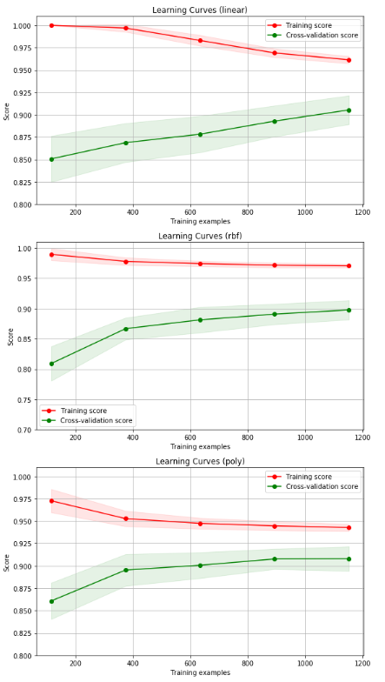

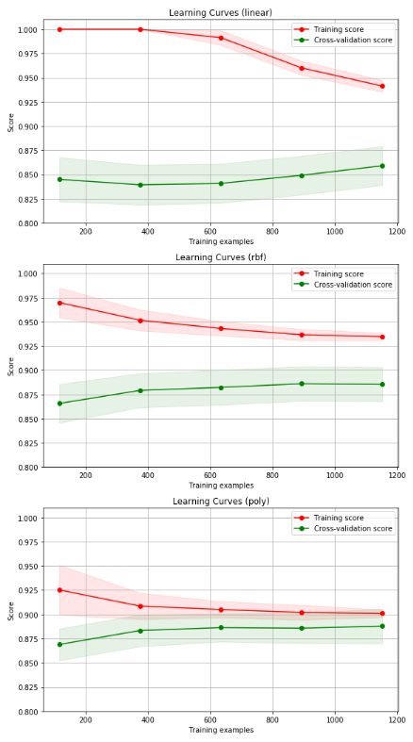
A2 Learning Curves

B1 and B2
4.1 Data Pre-processing
Similar to Tasks A1 and A2, there were delimiters within the csv files. The approach in these two tasks, however, are slightly different. It took the column of interest (face shape and eye colour) according to the respective tasks, in which the values store are used as the training and validation data. The image data were rescaled at a default factor 255.

4.2 Training, Validating and Testing
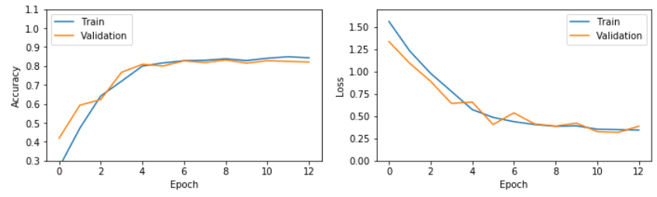
The data is split into train (x) and test (n-x). Validation dataset (x-y)% is a subset of the training dataset to carry out cross validation. The purpose of the training dataset is to train the model to learn from this abundant data, whereas the validation dataset is for an unbiased evaluation of a model fit on the training dataset whilst tuning the model hyperparameters, usually done using k-fold cross validation, where k is the number of equal sized subsamples. The test dataset finally is to give an unbiased evaluation of a final model fit on the training dataset. In this scenario, the sample data was divided into training data (90%) and test data (10%). The validation dataset (20%) is a subset, drawn from the training dataset to carry out cross validation. [15]

4.3 Inputting model hyperparameters
Input shape. The input shape was set as 32x32 for task B1 and 64x64 for task B2. Notice that the dimensions creates square grids across the images, and these dimensions are consistent with the target blocks as well. In B2, the attributes extracted is more specific and hence more grids are created to allow feature extraction with greater detail.
Batch size. Recommended batch sizes are typically at 32, 64 and 128. In both B1 and B2, batch sizes of 128 are used after comparing among the plotted loss curves. With bigger batch sizes, the higher the confidence in the direction of descent of the error surface. Furthermore, it is experimentally proven that bigger batch size shows bigger optimal learning rate and has an inverse relationship with noise or learning rate error.
Convolutional filters. The number of filters used are in
powers of 2, and increases for every sequential layer, from 16, 32, 64 to 128. [16]
Padding layers. The padding is set as same, meaning there are p number of padding layers to ensure that the input dimensions equal to that of the output.
Epoch. There is no secret formula or theory for the right epoch to be used, and this can be only be experimented over and over. An arbitrary epoch values of 25 was used, then both lower and higher epoch values in the range of approximately 10 to 60 have been trialled out thus far to define the optimal number of epochs.
This is done firstly by explaining the learning curve for training and validation accuracy, underfitting is when training score and validation score are still increasing, hence the data could be trained further. Overfitting on the other hand is when the two curves have already saturated and starts to gradually decrease. In the curves plotted below for tasks B1 and B2, it can be seen that both curves achieve a high accuracy score parallelly and has capped at some point, respectively at 0.96 and 0.84. This demonstrates that the estimator is working alright at the respective epoch values. [17][18]
The trickier one is the interpretation of validation loss along with training loss curves. A continually decreasing training and validation loss curve implies an underfit, meaning the training process is still immature. A continuous decrement in training losses but an increasing validation loss after decreasing to a point shows an overfitted dataset. For a good fit, it should ideally decrease then stabilise after a certain number of epochs, along with the training curve. Based on the plots shown below, the inspection shows that at epoch value of 11, the validation loss curve in task B1 and B2 stabilises at a relatively low value along with the training loss curve. [19] [20]

Learning Curve B1

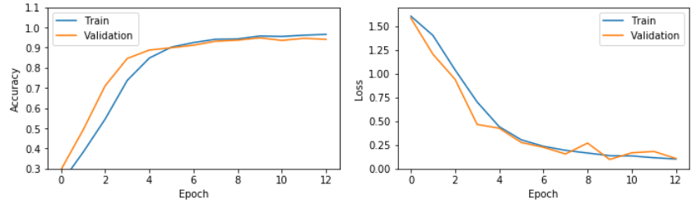

Learning Curve B2

5. Experimental Results and Analysis

This table is a relatively simple visualization method to understand, to show how good the classification model is, with the test accuracies all printed out. True positives (TP): Predicted 1’s correctly True negatives (TN): Predicted 0’s correctly. False positives (FP): Predicted 1’s wrongly (Type I error). False negatives (FN): Predicted 0’s, wrongly. (Type II error). This can be similarly projected on a multiclass problem. The classification report is more detailed matrix to display the precision, recall and f1-score. The precision, known otherwise as specificity is formulated by true positive/(true positive + false positive). The recall, also known as sensitivity, equates to true positive/(true positive + false negative). f1-score or F measure is calculated by (2*recall*precision)/(recall + precision). [21] [22]

In task A1, the confusion matrix below is in accordance with the labelling as follow: 0 - Female, 1 - Male.
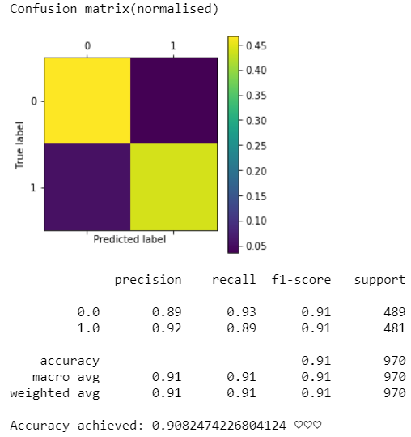

In task A2, the labelling is as such: 0 - Not smiling, 1 - Smiling.

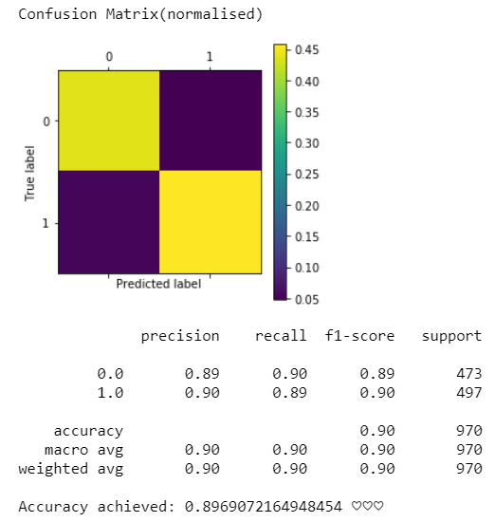

The rationale behind A1 having better prediction for female (true positives) than male (true negatives) images could be due to the number of female images with appropriate quality or orientation exceeds that of male. This could be the same for the smiling (true negatives) against not smiling (true positives).

In task B1, the five different face shapes corresponding to the labels are believed to be: 0 - Diamond, 1 - Square, 2 - Heart, 3 - Oval, 4 - Oblong.

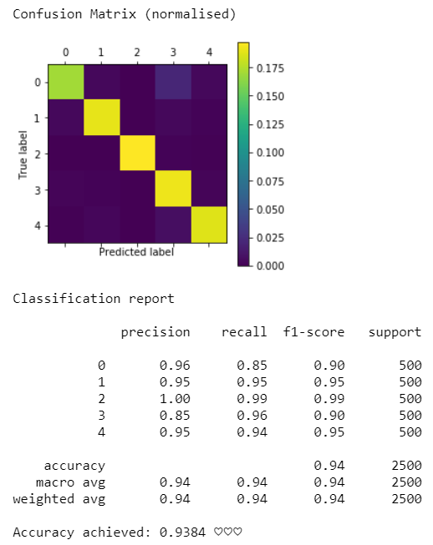

Lastly in task B2, the five different iris colours are: 0 - Brown, 1 -Blue, 2 - Green, 3 - Gray, 4 - Black.

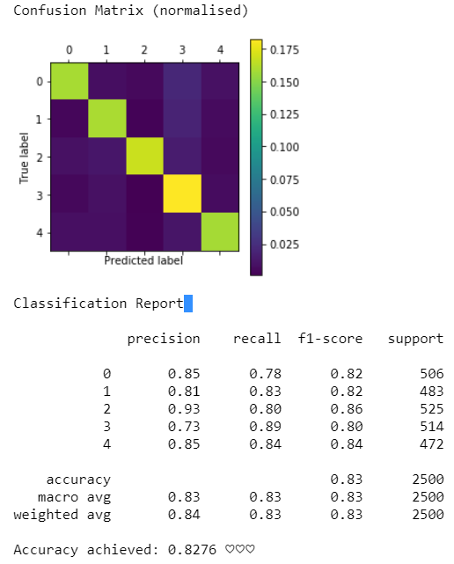

In all confusion matrices displayed, it can be seen that the True positives and the true negatives are at a much higher value than the false positives and false negatives. This can be easily visualise using the colour bar, where the diagonal square boxes are representative of the true positives and true negatives, henceforth indicating the great accuracy of the machine learning models.

Task | Model | Train Acc | Val Acc | Test Acc
A1 | SVM (rbf) | 0.96516 | 0.90903 | 0.90825
A2 | SVM (rbf) | 0.93121 | 0.90139 | 0.89691
B1 | CNN (VGG-16) | 0.96777 | 0.94404 | 0.9384
B2 | CNN (VGG-16) | 0.84877 | 0.82814 | 0.8276

6. ConclusioN

To conclude, the results displayed mainly through confusion matrix and different learning curves in both binary and multiclass detection problems can clearly highlight the performance of the machine learning algorithms, comparatively in different parameter settings. As the training accuracy scores are slightly higher in gender classification compared to that for smiling, it could be interpreted that smiling would need only specific feature points. This issue is similar for classification of eye colours. Nevertheless, one of the future steps that could be taken would be trialing out random search function iteratively with different range of parameters, thereby verifying the most optimal kernel and parameters by inspecting the training and validation learning curves. It is also recommended that cropping of facial features are done prior to feeding feature points into the SVM or CNN model, to potentially improve the models’ accuracies.

7. References

- VanderPlas, J. (2016). Python Data Science Handbook. [ebook] O'Reilly Media. Available at: https://jakevdp.github.io/PythonDataScienceHandbook/05.07-support-vector-machines.html?fbclid=IwAR3ul70Wo4OB_ODx2EC-aFnhfyC_iRTK6_-A9y1oVzFSykjMavWHNRsP9l8 [Accessed 5 Jan. 2020].

- Kaur, S. and Kalra, D. (2016). FEATURE EXTRACTION TECHNIQUES USING SUPPORT VECTOR MACHINES IN DISEASE PREDICTION. [ebook] Guru Nanak Dev University RC, Jalandhar (India). Available at: https://pdfs.semanticscholar.org/3c77/d10b16f5e3d5dc3cf0bbd2817c966479f698.pdf [Accessed 10 Jan. 2020].

- Hsu, C., Chang, C. and Lin, C. (2003). A Practical Guide to Support Vector Classification. [ebook] National Taiwan University, Taipei 106, Taiwan. Available at: https://www.csie.ntu.edu.tw/~cjlin/papers/guide/guide.pdf?fbclid=IwAR3hBhvsx9M_BYnQ1vSQmDSXbUu4ROYqVVERlKWR86AMWHk4slMplXKqwj0 [Accessed 17 Dec. 2019].

- Bergstra, J. and Bengio, Y. (2012). Random Search for Hyper-Parameter Optimization. [ebook] Montreal, Canada: Departement d’Informatique et de recherche operationnelle Universite de Montreal. Available at: http://www.jmlr.org/papers/volume13/bergstra12a/bergstra12a.pdf [Accessed 4 Jan. 2020].

- Pouyanfar, S., Pan, L., Chen, S. and Chen, H. (2017). DeepFood: Automatic Multi-Class Classification of Food Ingredients Using Deep Learning. [ebook] Hunan, China: IEEE 3rd International Conference on Collaboration and Internet Computing. Available at: https://www.researchgate.net/publication/319944339_DeepFood_Automatic_Multi-Class_Classification_of_Food_Ingredients_Using_Deep_Learning [Accessed 7 Jan. 2020].

- Eads, D. (n.d.). PolySVC Documentation. [online] Svm.sourceforge.net. Available at: http://svm.sourceforge.net/docs/3.00/api/PolySVC.html?fbclid=IwAR0Ex95a-IUcqrFRk5ASmJxkj4UqXyHPi96z8WXsOsuzIGBPCJnrivTkE_k [Accessed 8 Jan. 2020].

- Jain, R. (2017). Simple Tutorial on SVM and Parameter Tuning in Python and R. [Blog] HackerEarth. Available at: https://www.hackerearth.com/blog/developers/simple-tutorial-svm-parameter-tuning-python-r/?fbclid=IwAR2psuZhEjLdD18ssZabLNWKEJqPu7VP4tCVqRGwMrkiXh5mChAfxA24F3M [Accessed 2 Jan. 2020].

- Ben Fraj, M. (2018). In Depth: Parameter tuning for SVC. [online] Medium. Available at: https://medium.com/all-things-ai/in-depth-parameter-tuning-for-svc-758215394769 [Accessed 3 Jan. 2020].

- Patel, S. (2017). Chapter 2 : SVM (Support Vector Machine) — Theory. [online] Medium. Available at: https://medium.com/machine-learning-101/chapter-2-svm-support-vector-machine-theory-f0812effc72 [Accessed 2 Jan. 2020].

- Keras.io. (n.d.). Convolutional Layers - Keras Documentation. [online] Available at: https://keras.io/layers/convolutional/?fbclid=IwAR3q6YnhTF5WMP-0DL9GDFAg52bHsa_KouXGiw1kIOS77AQTkUIeY0NIJIA [Accessed 3 Jan. 2020].

- Rosebrock, A. (2018). Keras Conv2D and Convolutional Layers - PyImageSearch. [online] PyImageSearch. Available at: https://www.pyimagesearch.com/2018/12/31/keras-conv2d-and-convolutional-layers/?fbclid=IwAR3Cmz-dFWMMvUG0tWs0UtqGRPog6tAbYeP5lgikbbe2pTvNdWbk4n_WF7Q [Accessed 2 Jan. 2020].

- Cornelisse, D. (2018). An intuitive guide to Convolutional Neural Networks. [online] freeCodeCamp.org. Available at: https://www.freecodecamp.org/news/an-intuitive-guide-to-convolutional-neural-networks-260c2de0a050/?fbclid=IwAR0_aFHXS3x1va-fZFuRgi4p0Hz92CGBznKl37GuGdU-kUOkBdDPuR522I8 [Accessed 3 Jan. 2020].

- Worcester, P. (2019). A Comparison of Grid Search and Randomized Search Using Scikit Learn. [Blog] The Journal Blog. Available at: https://blog.usejournal.com/a-comparison-of-grid-search-and-randomized-search-using-scikit-learn-29823179bc85 [Accessed 4 Jan. 2020].

- Scikit-learn.org. (2019). Plotting Learning Curves — scikit-learn 0.22.1 documentation. [online] Available at: https://scikit-learn.org/stable/auto_examples/model_selection/plot_learning_curve.html?fbclid=IwAR3dd2bBUwVvFU4yVJek9s20Fei7P8BGusf6fcikz26tzvL6yeLECAD1XmY [Accessed 3 Jan. 2020].

- Shah, T. (2017). About Train, Validation and Test Sets in Machine Learning. [online] Medium. Available at: https://towardsdatascience.com/train-validation-and-test-sets-72cb40cba9e7 [Accessed 26 Dec. 2019].

- Medium. (2019). Building a Custom Convolutional Neural Network in Keras. [online] Available at: https://medium.com/@ODSC/building-a-custom-convolutional-neural-network-in-keras-48171163aa7f [Accessed 7 Jan. 2020].

- Michaus, M. (2017). Visualizing Learning rate vs Batch size. [online] Miguel-data-sc.github.io. Available at: https://miguel-data-sc.github.io/2017-11-05-first/?fbclid=IwAR1R7bBWsZNH5NPcAoiR5zboX1_7FXKnBru1kiXj5uaPtggNdXiMBKIctG0 [Accessed 6 Jan. 2020].

- Brownlee, J. (2019). How to Control the Stability of Training Neural Networks With the Batch Size. [online] Machine Learning Mastery. Available at: https://machinelearningmastery.com/how-to-control-the-speed-and-stability-of-training-neural-networks-with-gradient-descent-batch-size/?fbclid=IwAR3cDoSweIn14xmthIRum1zYeH6KUwBR_jlQgqLB2eclQKjxzp4UO7D4XC4 [Accessed 11 Jan. 2020].

- Brownlee, J. (2019). How to use Learning Curves to Diagnose Machine Learning Model Performance. [online] Machine Learning Mastery. Available at: https://machinelearningmastery.com/learning-curves-for-diagnosing-machine-learning-model-performance/?fbclid=IwAR0C0F_19yAVhS9wCPe0tkN6tb2_-EDM5pUjyQsB1Yu88tvdkGNIObf6_pg [Accessed 8 Jan. 2020].

- Olteanu, A. (2018). Tutorial: Learning Curves for Machine Learning in Python for Data Science. [online] Dataquest. Available at: https://www.dataquest.io/blog/learning-curves-machine-learning/?fbclid=IwAR1BnGOOJ5XL-o5VWipByg48oVPba4g-MgDhaIZ_4spg9dqS12jGiNTp60E [Accessed 11 Jan. 2020].

- Scikit-learn.org. (2019). Confusion matrix — scikit-learn 0.22.1 documentation. [online] Available at: https://scikit-learn.org/stable/auto_examples/model_selection/plot_confusion_matrix.html?fbclid=IwAR3ul70Wo4OB_ODx2EC-aFnhfyC_iRTK6_-A9y1oVzFSykjMavWHNRsP9l8 [Accessed 29 Dec. 2019].

- Qian, K. (2020). Simple guide to confusion matrix terminology. [online] Data School. Available at: https://www.dataschool.io/simple-guide-to-confusion-matrix-terminology/?fbclid=IwAR3OhJHFQTjIOrqO37vq0Mv_sAcDiDEsHnvCiqXnevxM1fZcRDMKMwBT_8Y [Accessed 8 Jan. 2020].

