Project 2 - Proposal for Strange Lil’ Plant

Zoe Chalk

CMST 386 7381 - Fall 2023

**Strange Lil’ Plant - Topic**

Stange Lil’ Plant is a company for a business owner, separate from the developer. The goal of the company is to help people branch out from the same houseplants you see in many homes, through education and commerce. The website will help individuals identify plants they come across in stores or in the wild. The company also sells exotic plant seeds and fully-grown plants. There is also a company-run blog with articles on plant care.

**Stange Lil’ Plant - The Client**

This website is for a plant enthusiast who has always wanted to create a business around exotic plants. I have discussed what the website would focus on and entail with this client over the past few years. At first, the idea was to simply be an Etsy store selling plants, but as a team, we realized many people needed help with plants they already had. Many plant owners are sold exotic plants without identification or any idea of how to take care of them. Without the essential knowledge of how to care for them, these plants often die. As the website grows, the client would like to shift the identification process to AI but is comfortable for now with a manual review of submissions. It was also extremely important to the client to be able to post additional information on plant care they have learned in their years taking care of plants. The client would like this business to be their primary revenue stream, but their main goal is to help more plants thrive in new homes.

**Strange Lil’ Potion - Testing**

Unit testing will not be conducted on this website as the JavaScript will not be extensive. The two primary channels of testing will be done by the developer and by users. The developer will check user flow at every point of development to ensure the process remains functional through all changes. This includes navigating to pages, browsing and clicking through products and blog posts, and form validation. This will be conducted in 3 browsers: Chrome, Firefox, and Safari. Mobile development will not be pursued in this iteration. User testing will entail sending the page to 5 testers and asking them to complete a series of tasks on the page. The users will then fill out a web form to communicate issues they may face for the developer to review before sending the end product to the client.

**Strange Lil’ Potion - Description**

Strange Lil’ Potion is a business surrounding exotic plant identification, cultivation, and education. The website will have 3 main components. The first component is an identification service, users will be able to submit a form including photos of their plant to the business owner for identification. The company will then respond with the name of the plant and basic plant care information about it. The second component is at home cultivation of plants. Users will be able to purchase seeds, cuttings, or full-grown plants. Each of these products will include information on how to successfully cultivate that specific plant. The last component is education, which will take the form of a company-run blog. This blog will have articles on specific plants, cultivation, humidity, etc. This blog will be accessible to anyone, regardless of whether or not they have ever used other services at Strange Lil’ Potion.

The primary user audience will be young to middle-aged adults in the middle class in America who own plants. This demographic is primarily females with a college education. Although this iteration of the website will be desktop-friendly only, we expect the primary audience to be phone users and will add mobile responsiveness to the first published version. The target audience has a large disparity in knowledge about plant care. Some plant owners do extensive research on plant care and will likely not need to utilize our identification service, but still may enjoy the ability to read articles and purchase new plants. The other part of the audience has little knowledge about plants but has enthusiasm and love for the plants they have and therefore a drive to become more educated plant owners. All components of the website will be useful and impactful to this group of users.

For this iteration, most of the content will be developer-written. Information about the plants will be pulled from web sources on plant care and images will be sourced from stock photo sites. Once the website is in production, all information and photos will be sourced from the company. The information on the site will need to be updated at a high frequency. Anytime a plant comes into stock or is sold out, the store will need to be updated. Additionally, the blog will likely need new posts once a month at minimum.

**Strange Lil’ Plant - Growth**

This website already has plans on how to grow over time. There are three main steps the website will need to be production-ready: AI, mobile responsiveness, and a database. AI will be used for plant identification as the company grows. Depending on the size, it is not feasible for one person to check all submissions in a timely fashion. Mobile responsiveness will be vital to ensure the company reaches all users in the target audience. Most young adults use their phones for most of their internet browsing. It would present a great barrier to use if the website were to remain desktop-facing only. Lastly, the website will require a database. This database will allow for a functional login feature, for users to check their order status and previous identifications. It will also serve as the storage for blog posts made by the company as well as the e-commerce storage. Maintenance will entail regular checks for bugs/issues and frequent updates to the site’s content. The developer will thoroughly comment code to ensure future teams will easily be able to work within the code base. The developer will also create a company interface for the site in the production version, so blog posts/ products can easily be updated from the front end rather than requiring developer intervention regularly.

**Stange Lil’ Plant - Organization**

The goal for the organization will be to separate the website into its three main components: identification, education, and cultivation. The website will have a main navigation that consists of “Home”, “About”, “Identification”, “Blog”, and “Shop”. The Identification page will have a subpage that contains the submission form, this form will be accessible from a submenu. The Blog page will have subpages for each blog post. The Shop page will have subpages for each category and each product. The categories will be accessible from a submenu. 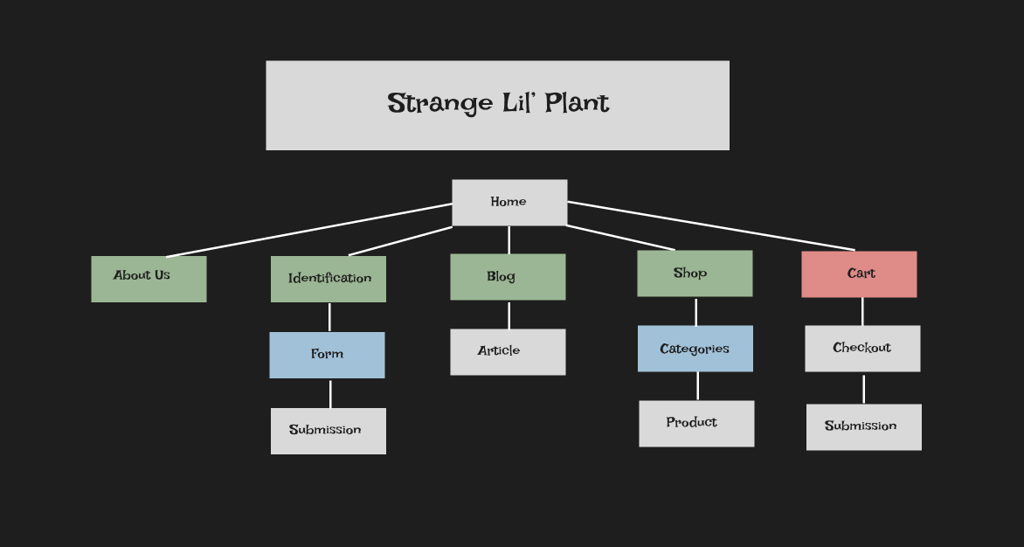

***Figure 1. Site Map***

Figure 1 refers to the site map. Green boxes indicate navigation items, Blue boxes indicate sub-navigation fields and Red boxes indicate header icons.

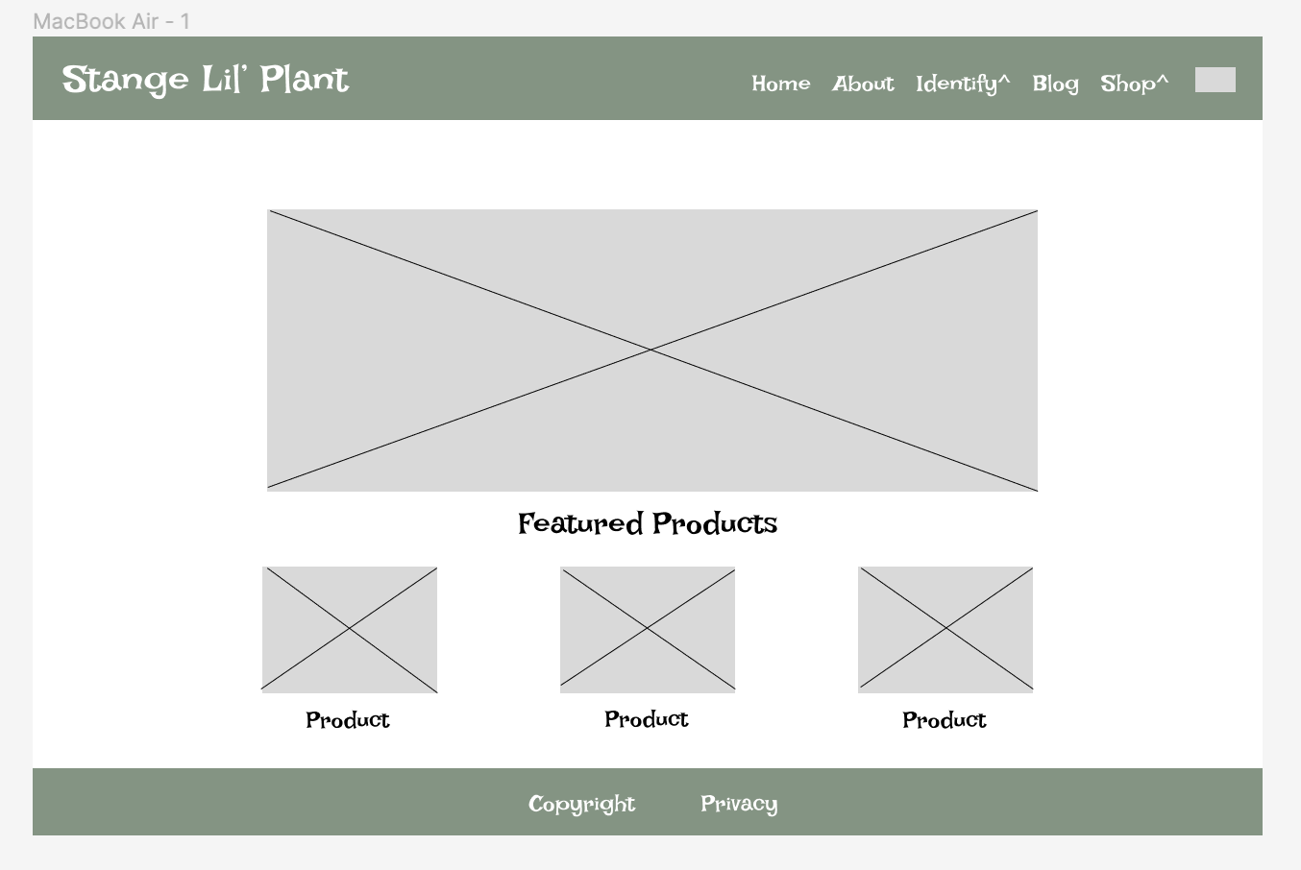

***Figure 2. Home Page Wireframe***

Figure 2 shows a wireframe for the home page. The home page will include a jumbo graphic as well as a display of some featured products to entice users into the shopping feature. It also shows the header and footer each with its prospective navigation menus. The Privacy link will only exist in the footer, whereas the main navigation links will exist solely in the header. The ^ denotes drop-down menus and the box denotes the shopping cart.

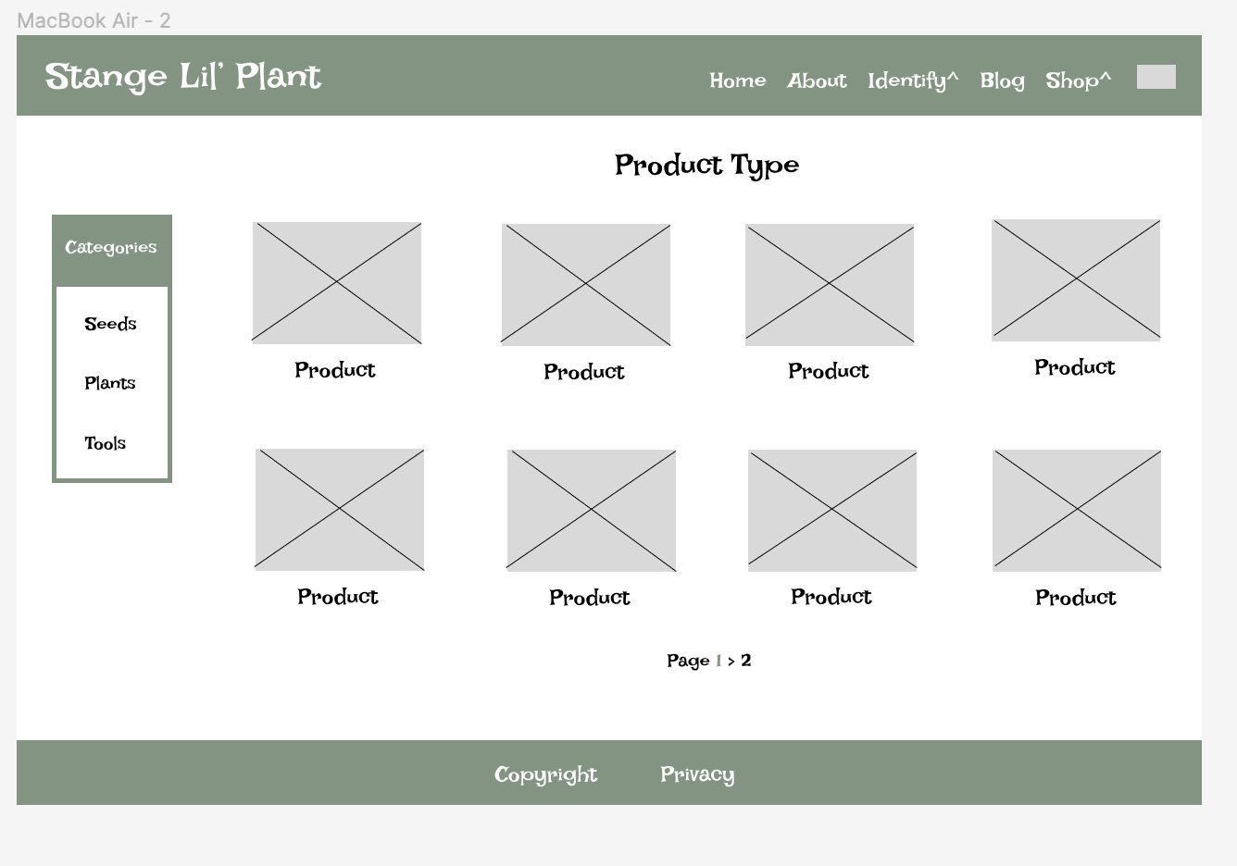

***Figure 3. Shopping Page Wireframe***

Figure 3 illustrates the shopping page wireframe. It is reusing the same header, footer, and product layouts as the home page for design consistency. This page also includes an aside menu to navigate between categories easily.

**Stange Lil’ Plant - Security**

This website will eventually utilize both e-commerce and user accounts. Whenever these components are included in a website, it opens up the business to an amount of risk if information is lost or security is breached. The developer recommends utilizing third-party services like Auth0 and Shopify to handle these components rather than leave them in the hands of the company. This is for two main reasons: one, the company size, and two, the mitigation of risk. The company’s current size does not afford for an extensive development team to stay on retainer, likely the development will be handled by contractors and maintained by a sole developer. This does not offer much room for extensive security handling by the development team. It is better to leave the heavy lifting to a company whose sole purpose is securing data. Utilizing these third-party services also mitigates a tremendous amount of risk for the company. If a data breach were to occur, it would lie in the third-party companies making them responsible for collateral and solving the issues. The main responsibility the company will face is maintaining a secure domain.

**Stange Lil’ Plant - Web Hosting**

The website will be hosted under the domain stangelilplant.com. This domain is the exact name of the company which leads to better usability for the user. The web hosting service will be chosen based on cost and growth. The initial cost needs to be relatively low while the company is gaining a customer base. However, it is extremely important to be able to grow into an option that can conduct a lot of traffic. The e-commerce aspect of the site will be handled by a third-party service like Shopify so that must also be supported. To easily connect the database, Azure web services will be recommended by the developer. This service will help support split-end development so each part of the website can exist separately leading to less catastrophic failure. The database hosting service will likely be No-SQL like Mongodb. The hosting service will need to support HTML, CSS, JS, Node, Express, and Mongoose. Though only the first three technologies will be present in this iteration, the latter will be needed for production. Azure can handle all of these.

**Strange Lil’ Plant - Marketing**

The website will be marketed through Google as well as social media on production. Places like Instagram and Facebook will be vital to gaining the attention of the target audience for the majority of resources should be allocated to those routes. Developing a company Instagram and Tiktok would also be a viable lower-cost alternative to gain attention. Google ads should be mainly focused on targeted searches like “plant identification” or “buy exotic plants”.