Assignment: 2

ENSF 594

Ziad Chemali

26/7/2020

# Q1) Money Change:

Greedy choice is to take all the 10s first, then take all the 5s then all the 1s

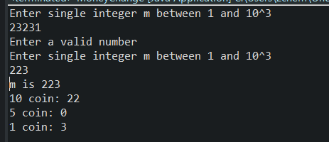

# Q2) Max Value of the Loot:

Efficient algorithm is to get value/weight ratio of all the elements, then sort them in descending order.

Fill the bag with the first ratio’s weight, then move to second highest ratio and use all the weight of this ratio, keep doing this until the bag has reached max capacity.

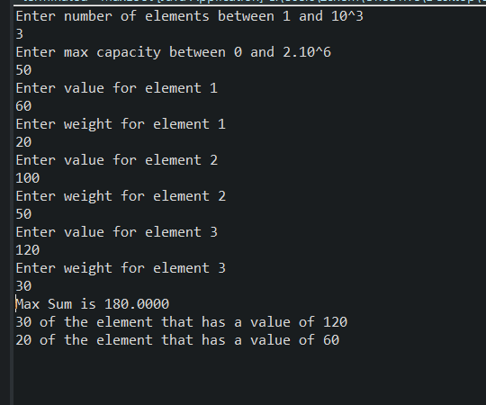

# Q3) Max Advertisement Revenue

Sort both arrays (a and b arrays), then loop through the array and multiply the indexes, this will be the max ad revenue.

