Assignment: 3

ENSF: 594

Ziad Chemali

30/07/2020

# Q1) Binary Search:

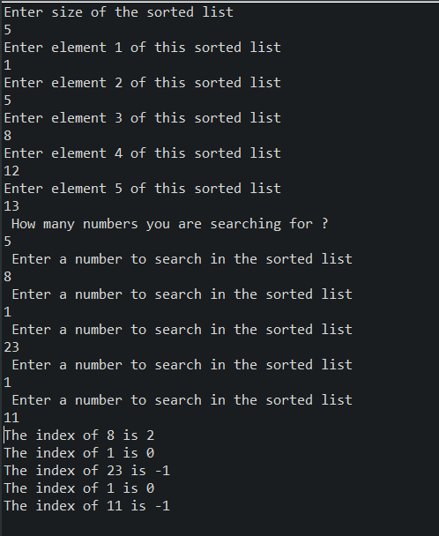

# Q2) Majority Element:

