Assignment:1

ENSF 594

Ziad Chemali

# Question 1: Fibonacci number

## Java Code:

import java.util.ArrayList;

import java.util.Scanner;

/**

* This class calculates the Fibonacci of n that the user choose

* **@author** Ziad Chemali

*

*/

public class Fibonacc {

///creating variables

ArrayList<Double> fibList;//n

ArrayList<Double> fn;//Fn

Double answer;

/**

* This is constructor where the

*/

public Fibonacc() {

fibList=new ArrayList<Double>();

fn=new ArrayList<Double>();

fn.add((double) 0);

fn.add((double) 1);

fibList.add((double) 0);

fibList.add((double) 1);

}

/**

* This method use recursive call to find the Fibonacci of n

* **@param** n users choice

* **@return** Fn=F(n-1)+F(n-2)

*/

public double getF(int n) {

for (int i=0 ;i<fibList.size();i++)

{

if (n == fibList.get(i)) {

return fn.get(n);

}}

answer= (double) (getF(n-1)+getF(n-2));

fibList.add((double) n);//adding n to array

fn.add(answer);//adding Fn to array

return answer;

}

public static void main(String[] args) {

double time=System.currentTimeMillis();

Fibonacc fib =new Fibonacc();

boolean check=true;

while (check) {

Scanner scanner =new Scanner(System.in);

System.out.println("Enter n between 0 and 45");

int n=scanner.nextInt();

if (n>=0 && n<=45) {

System.out.println("Fibonacci of "+n+" is: "+fib.getF(n));

}

else {

System.out.println("Choose n between 0 and 45");

}

System.out.println("Do you want to calculate another n Yes/No");

String answr;

answr=scanner.next();

if (!answr.equalsIgnoreCase("Yes")) {

check=false;

}

}

}

}

## Result:

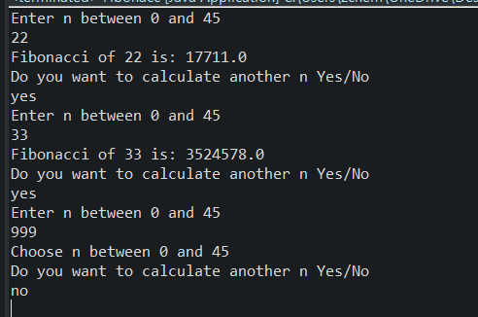

# Question 2: GCD

## Java Code:

import java.util.Scanner;

/**

* This class calculates the GCD of two numbers using efficient algorithm

* **@author** ziad chemali

*

*/

public class GCD {

/**

* This method divide a/b if remainder is zero then return b

* else

* recursive the method with b/remainder

* **@param** a numerator

* **@param** b denominator

* **@return** denominator if remainder of a/b is zero

*/

public static int getGCD(int a,int b)

{

if(a%b==0)

return b;

return getGCD(b,a%b);

}

public static void main(String[] args) {

int a,b;

Scanner scanner =new Scanner(System.in);

boolean check=true;

while (check) {

System.out.println("Enter two Integers a,b between 1 and 2*10^9");

a=scanner.nextInt();

b=scanner.nextInt();

if(a>=1 && a<=2*Math.pow(10, 9) || (b>=1 && b<=2*Math.pow(10, 9))) {

System.out.println("GCD for a and b is : "+GCD.getGCD(a,b));

}

else {

System.out.println("Please enter a valid a,b numbers berween 1 and 2 *10^9");

}

System.out.println("Do you want to continue?");

String ans;

ans=scanner.next();

if(!ans.equalsIgnoreCase("Yes"))

{

check=false;

}

}

}

}

## Result:

