**Results of initial simulation**

After relaxing gRNA and dCas9 structures without solvent, I added solvent and ions back into the system. The system had a net negative charge, probably the RNA, and I had to 49 sodium ions into the system to neutralize the charge. I still need to check if something was amiss with the original structure.

A dodecahedron unit cell was used as the periodic boundary condition as that allowed the whole system + waters to be approximately 200e3 atoms. The protein and RNA were made to be around 1nm (10 A) from the box edges.

The dodecahedron shape was chosen because an equivalent cubic unit cell would have ~300e3 atoms total. If water was not used as solvent, the system would be about 23e3 atoms.

After minimizing and equilibrating with nvt and npt, the overall structure looks and hydrogen bond contacts on RNA look fine too. The protein generally closed around the RNA molecule.

I ran a 10ns simulation on the system to see how it would go. Nothing interesting happened, which is what I expected. A video of it is attached.

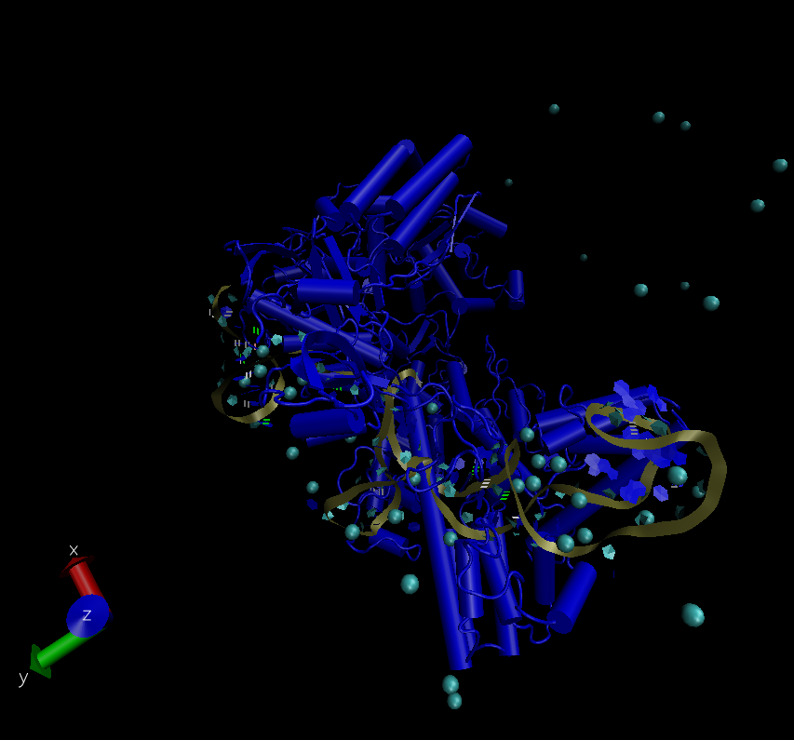

Cyan balls are sodium ions. The gold ribbon is the RNA. Protein is colored. This visualization is not great and I am looking into ways to make it better.

The major challenge is still interpreting the trajectory information and figuring out what exactly I want to measure with this information.

Some things I need help with:

1. Did I properly release the position restraints on the gRNA and protein? I am still trying to understand how the posre.itp files work
2. How do I measure or find interactions between specific protein and RNA residues? Is there a good way to measure contact forces between residues on two molecules?
3. I want to see if the gRNA might shift into an alternate binding pocket in response to some mutational changes. However, this probably is not possible without metadynamics or gaussian accelerated molecular dynamics (gaMD). Is it worth my time to try to approach?
4. Are there better ways to set up metadynamics for measuring binding strengths to specific parts of the protein?