INSTRUCTIONS

1. Setting up the Raspberry Pi

a. Take the MicroSD card and insert it into the computer, using a full-size SD adapter if necessary.

b. Using a text editor (like Notepad or TextEdit), open the included file "wpa_supplicant.conf"

c. Replace <<network_name>> and <<network_password>> with your WiFi network name and password.

d. Save and close the file, then copy it to the microSD card's "boot" directory.

e. Eject the MicroSD card and insert it into the Raspberry Pi (there is a small slot on the underside, near the indicator lights).

f. Using the already attached velcro, place the Raspberry Pi on the back of the clock.

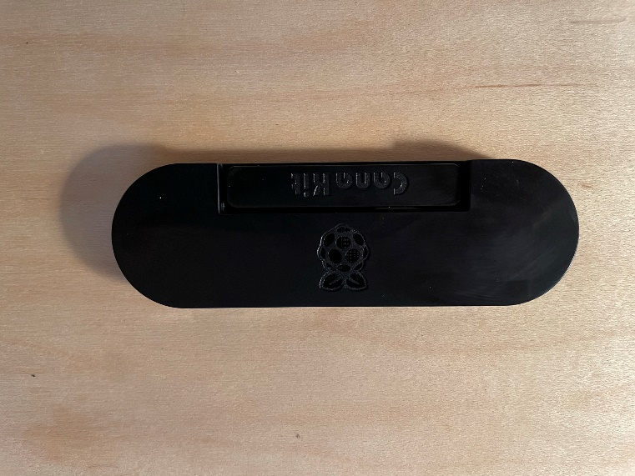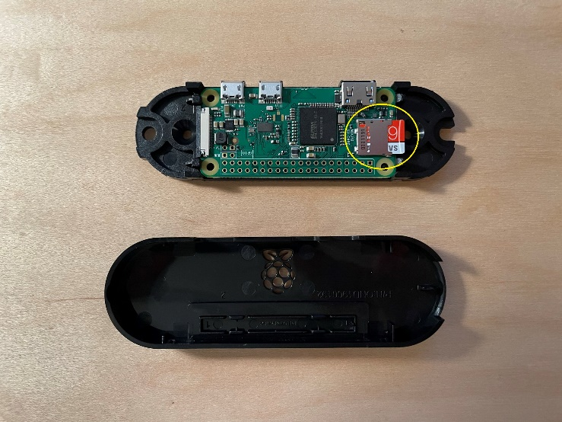

2. Starting Up

a. Plug in the clock and the Raspberry Pi.

b. Wait for the indicator light on the side of the clock to change from red to blue.

This may take a few minutes.

c. The Raspberry Pi is now connected to the clock over Bluetooth and running a local server over WiFi.

3. Accessing the control panel

a. Launching applications for Mac and Windows are provided to find the Raspberry Pi's IP address and open a control panel for the clock in your default browser.

b. As an alternative to the launchers, we can ping the Raspberry Pi to find its IP address.

On Windows:

Open Command Prompt or Windows PowerShell and type or paste:

*ping -4 -n 1 raspberrypi.local*

Press enter to find the IP address.

On Mac:

Open Terminal and type or paste:

*ping raspberrypi.local -c 1*

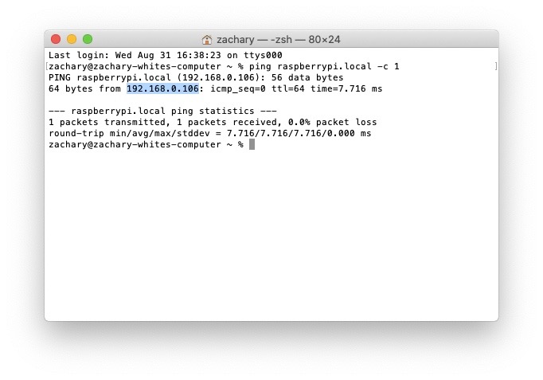Press enter to find the IP address.

c. Open a browser and type the Raspberry Pi’s IP address in the address bar, followed by “:5000”

(e. g., 192.168.0.106:5000). Press enter to access the control panel.

4. Using the Control Panel

POWER deactivates the clock's display, but does not power off the whole device.

START begins the timer, STOP stops it.

RESET sets the clock to 00:00:00.

SET allows you to manually enter a number to display on the clock. START will then count upwards from this number.

RUN begins at a given time, counts upwards until another time is reached, then resets the clock to zero.

CYCLE behaves like run, except that after resetting the count will restart, and repeatedly count upwards from zero to the maximum time.

All times must be entered in format HHMMSS (eg, 23:30:59 should be entered as 233059).

If RUN or CYCLE are manually interrupted, they cannot be automatically resumed. Instead, re-start the operation using the desired start and end times.