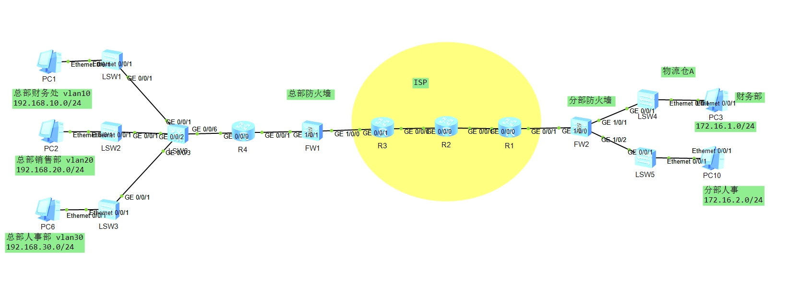
防火墙账号密码admin Admin!123
说明：

某公司有总部和分部。两个分部，总部和分部都需要访问外网，同时为了使得能够和两个分部之间的财务部能够相互访问，需要部署配置IPSEC VPN完成该需求，使得总部分别互通

IP地址规划如下
部门 | VLAN | IP地址 | 子网掩码 | 网关
总部财务部 | 10 | 192.168.10.0 | 255.255.255.0 | 192.168.10.254
总部销售部 | 20 | 192.168.20.0 | 255.255.255.0 | 192.168.20.254
总部人事部 | 30 | 192.168.30.0 | 255.255.255.0 | 192.168.30.254
分部财务部 | / | 172.16.1.0 | 255.255.255.0 | 172.16.1.1
分部人事部门 | / | 172.16.2.0 | 255.255.255.0 | 172.16.2.1

设备接口IP地址规划
设备 | 接口 | IP地址 | 子网掩码
R4 | G0/0/0 | 192.168.0.1 | 255.255.255.252
R4 | G0/0/1 | 192.168.0.9 | 255.255.255.252
R6 | G0/0/0 | 192.168.0.5 | 255.255.255.252
R6 | G0/0/1 | 192.168.0.13 | 255.255.255.252
FW1 | G1/0/0 | 202.102.0.2 | 255.255.255.0
FW1 | G1/0/1 | 192.168.0.10 | 255.255.255.252
FW1 | G1/0/2 | 192.168.10.14 | 255.255.255.252
FW1 | G1/0/3 | 192.168.100.1 | 255.255.255.0
FW2 | G1/0/0 | 202.102.1.2 | 255.255.255.0
FW2 | G1/0/1 | 172.16.1.1 | 255.255.255.0
FW2 | G1/0/2 | 172.16.2.1 | 255.255.255.0

总部内部结构主要运用了以下：VLAN access trunk OSPF

Vlan，在LSW5 创建整个内网的vlan 10 20 30，在各个接入层设备上配置相应的单独的vlan即可。将与PC端相连的接口配置为access 口，将与交换机互联的接口配置为trunk口，并放行相应的vlan
以LSW5 LSW1为例：

LSW5：

vlan batch 2 10 20 30 40 50
#
interface GigabitEthernet0/0/1
port link-type trunk
port trunk allow-pass vlan 10
#
interface GigabitEthernet0/0/2
port link-type trunk
port trunk allow-pass vlan 20
#
interface GigabitEthernet0/0/3
port link-type trunk
port trunk allow-pass vlan 30
#

LSW1配置如下：
vlan batch 10
#
interface Ethernet0/0/1
port link-type access
port default vlan 10
stp edged-port enable
#
interface GigabitEthernet0/0/1
port link-type trunk
port trunk allow-pass vlan 10
#
interface GigabitEthernet0/0/2
port link-type trunk
port trunk allow-pass vlan 10
#

配置网关，三层核心交换机配置如下
LSW6配置

interface Vlanif10
ip address 192.168.10.254 255.255.255.0
#
interface Vlanif20
ip address 192.168.20.254 255.255.255.0
#
interface Vlanif30
ip address 192.168.30.254 255.255.255.0
#

OSPF 配置OSPF目的使得全网路由互通：
防火墙配置如下
ospf 1 router-id 1.1.1.1
default-route-advertise always
area 0.0.0.0
network 192.168.0.10 0.0.0.0
network 192.168.0.14 0.0.0.0
network 192.168.100.0 0.0.0.255
#
R5配置如下
ospf 1 router-id 1.1.1.2
area 0.0.0.0
network 192.168.0.1 0.0.0.0
network 192.168.0.9 0.0.0.0
#

LSW5配置
ospf 1 router-id 1.1.1.4
silent-interface Vlanif10
silent-interface Vlanif20
silent-interface Vlanif30
area 0.0.0.0
network 192.168.0.2 0.0.0.0
network 192.168.10.0 0.0.0.255
network 192.168.20.0 0.0.0.255
network 192.168.30.0 0.0.0.255

以防火墙为例：
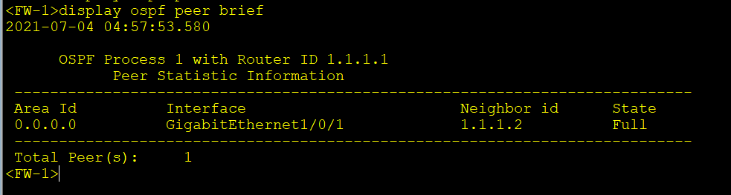

OSPF邻居关系建立正常后，在防火墙上查看OSPF所学到路由如下
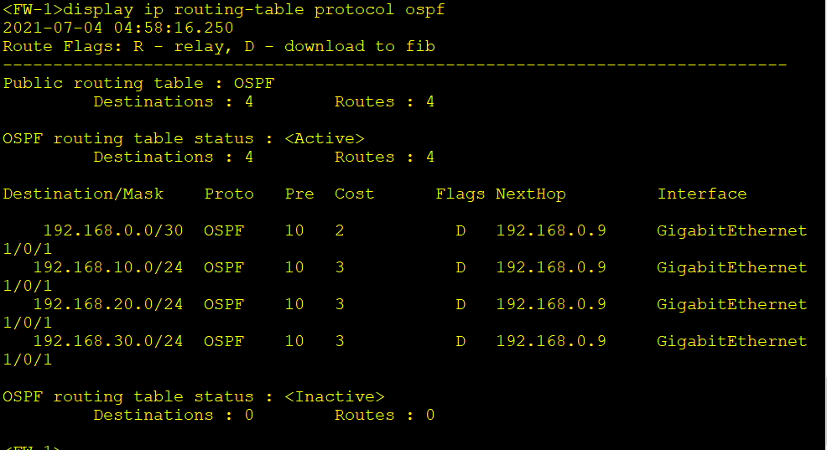

防火墙配置如下:
1,首先按照IP地址规划表配置IP地址，并将接口划分到区域。并配置默认路由。以FW1为例：

interface GigabitEthernet1/0/0
ip address 202.102.0.2 255.255.255.0
service-manage ping permit
#
interface GigabitEthernet1/0/1
ip address 192.168.1.1 255.255.255.0
service-manage ping permit
#
firewall zone trust
add interface GigabitEthernet1/0/1
#
firewall zone untrust
add interface GigabitEthernet1/0/0
#
ip route-static 0.0.0.0 0.0.0.0 202.102.0.1
#

配置NAT策略，允许访问外网
nat-policy
rule name NAT
source-zone trust
destination-zone untrust
action source-nat easy-ip
#

配置安全策略，放行内部到外部的流量
security-policy
rule name OUT
source-zone trust
destination-zone untrust
action permit

配置完成后，测试访问外网，以销售部访问ISP的R2为例
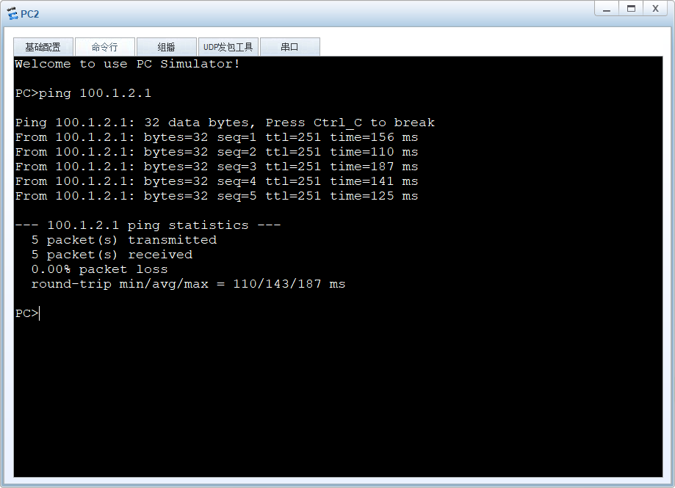
防火墙上查看NAT转换信息
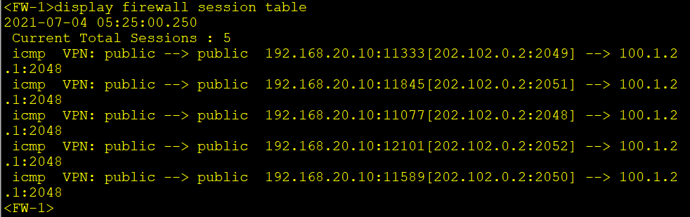

分部防火墙配置
interface GigabitEthernet1/0/0
undo shutdown
ip address 202.102.1.2 255.255.255.0
service-manage ping permit
#
interface GigabitEthernet1/0/1
undo shutdown
ip address 172.16.1.1 255.255.255.0
service-manage ping permit
#
interface GigabitEthernet1/0/2
undo shutdown
ip address 172.16.2.1 255.255.255.0
service-manage ping permit
#
firewall zone trust
set priority 85
add interface GigabitEthernet0/0/0
add interface GigabitEthernet1/0/1
add interface GigabitEthernet1/0/2
#
firewall zone untrust
set priority 5
add interface GigabitEthernet1/0/0
#
配置NAT策略，允许访问外网
nat-policy
rule name NAT
source-zone trust
destination-zone untrust
action source-nat easy-ip
#

配置安全策略，放行内部到外部的流量
security-policy
rule name OUT
source-zone trust
destination-zone untrust
action permit

分部人事部访问ISP路由器R2
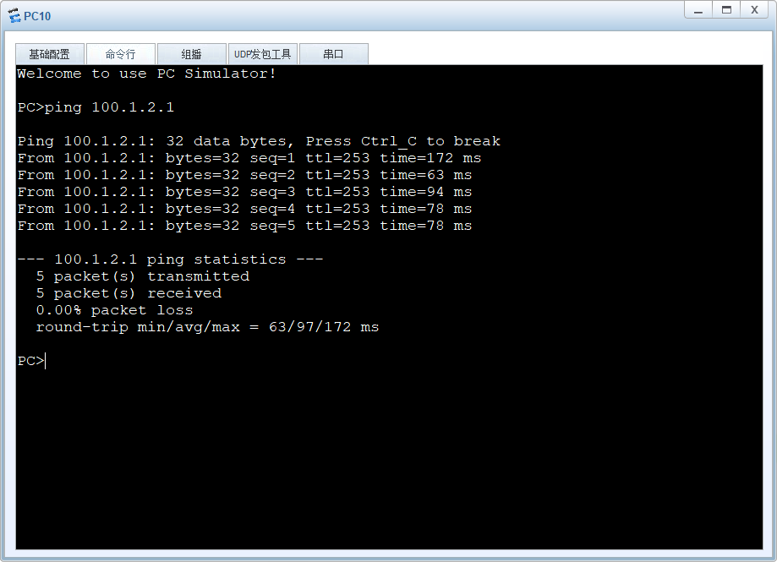
配置VPN部分。

FW1配置如下:

- 定义需要加密的数据流：
配置高级ACL 3000，定义总部到分支机构A的数据流
acl number 3000
rule 5 permit ip source 192.168.10.0 0.0.0.255 destination 172.16.1.0 0.0.0.255

配置IPSec安全提议，定义了esp加密算法，在IPSEC第二阶段用到，两端需要一致
ipsec proposal ipsec_SEC
esp authentication-algorithm sha2-256
esp encryption-algorithm aes-256
#
配置IKE提议，在IPSEC第一阶段，需要协商加密，验证，完整性等算法，两端需要保持一致
ike proposal 10
encryption-algorithm aes-256
dh group14
authentication-algorithm sha2-256
authentication-method pre-share
integrity-algorithm hmac-sha2-256
prf hmac-sha2-256
#
配置IKE 对等体，这一步配置共享密钥，远端IP，以及关联上面配置的IKE 提议
ike peer Branch_A
pre-shared-key Admin@1234
ike-proposal 10
remote-address 202.102.1.2

配置IPSec策略组ipsec_policy的序号为1的IPSec策略
这一步关联加密的数据流即ACL, 关联IKE对等体，关联IPSec 安全提议
ipsec policy ipsec_policy 1 isakmp
security acl 3000
ike-peer Branch_A
proposal ipsec_SEC

在接口下调用IPSEC策略ipsec_policy
interface GigabitEthernet1/0/0
ipsec policy ipsec_policy
#

配置NAT策略：如果不配置该步骤，则访问分支机构的流量会被NAT。
nat-policy 进入NAT策略配置模式
rule name ipsec 定义NAT规则名称
source-zone trust 定义源安全区域
destination-zone untrust 定义目的安全区域
source-address 192.168.10.0 mask 255.255.255.0 定义源地址
destination-address 172.16.1.0 mask 255.255.255.0 定义目的地址
action no-nat 定义NAT动作
rule name ipsec2
source-zone trust
destination-zone untrust
source-address 192.168.10.0 mask 255.255.255.0
source-address 172.16.1.0 mask 255.255.255.0
action no-nat

配置安全策略: 配置安全策略允许IPSec相关流量穿越，到达防火墙
security-policy 进入安全策略配置模式
rule name policy_1 定义安全策略名称
source-zone local 定义源安全策略
destination-zone untrust 定义目的安全策略
source-address 202.102.0.2 mask 255.255.255.255定义源地址
action permit 定义动作
rule name policy_2
source-zone untrust
destination-zone local
destination-address 202.102.0.2 mask 255.255.255.255
action permit
以上两个策略允许防火墙接受和发起IPSEC VPN连接

rule name policy_3
source-zone trust
destination-zone untrust
source-address 192.168.10.0 mask 255.255.255.0
destination-address 172.16.1.0 mask 255.255.255.0
action permit
rule name policy_4
source-zone untrust
destination-zone trust
source-address 172.16.1.0 mask 255.255.255.0
destination-address 192.168.10.0 mask 255.255.255.0
action permit
以上两个策略允许总部访问分部，分部访问总部的流量

FW-2配置如下
文字描述类似，不作重复说明了，只给代码：
acl number 3000
rule 5 permit ip source 172.16.1.0 0.0.0.255 destination 192.168.10.0 0.0.0.255
#
ipsec proposal ipsec_SEC
esp authentication-algorithm sha2-256
esp encryption-algorithm aes-256
#
ike proposal 10
encryption-algorithm aes-256
dh group14
authentication-algorithm sha2-256
authentication-method pre-share
integrity-algorithm hmac-sha2-256
prf hmac-sha2-256
#
ike peer ZongBU
pre-shared-key Admin@1234
ike-proposal 10
remote-address 202.102.0.2
#
ipsec policy ipsec_policy 1 isakmp
security acl 3000
ike-peer ZongBU
proposal ipsec_SEC
#
security-policy
rule name policy_1
source-zone untrust
destination-zone local
source-address 202.102.0.2 mask 255.255.255.255
destination-address 202.102.1.2 mask 255.255.255.255
action permit
rule name policy_2
source-zone local
destination-zone untrust
source-address 202.102.1.2 mask 255.255.255.255
destination-address 202.102.0.2 mask 255.255.255.255
action permit
rule name policy_3
source-zone trust
destination-zone untrust
source-address 172.16.1.0 mask 255.255.255.0
destination-address 192.168.10.0 mask 255.255.255.0
action permit
rule name policy_4
source-zone untrust
destination-zone trust
source-address 192.168.10.0 mask 255.255.255.0
destination-address 172.16.1.0 mask 255.255.255.0
action permit
#
nat-policy
rule name ipsec
source-zone trust
destination-zone untrust
source-address 172.16.1.0 mask 255.255.255.0
destination-address 192.168.10.0 mask 255.255.255.0
action no-nat
#
interface GigabitEthernet1/0/0
ipsec policy ipsec_policy
#

配置完成，测试总部财务访问分部财务
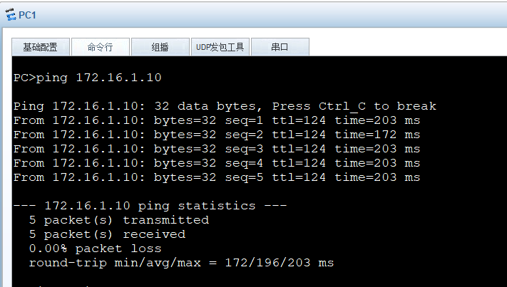
在防火墙上查看IKE信息，以总部防火墙FW1为例
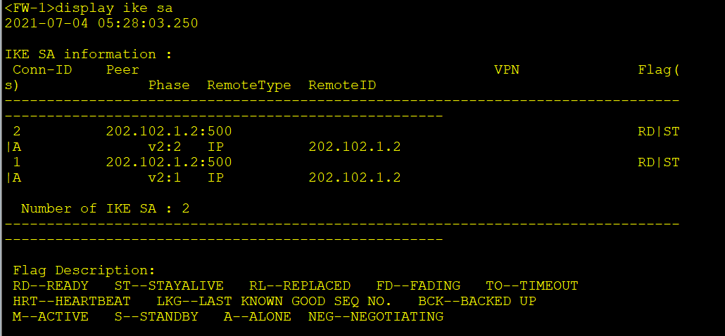

查看IPSEC SA信息
