1. 给出职工中所有男性的所有信息

select\* from Employee where sex=’男’;

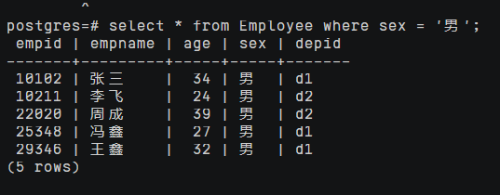

1. 统计“李”性职工信息，按年龄降序排序

select \*

from Employee

where empname like ‘李%’;

order by age desc;

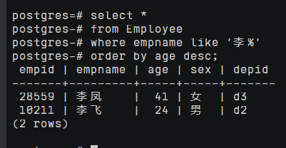

1. 给出每位职员参与项目的最高预算和最低预算

select e.empname,a.highestbudget,a.lowestbudget

from Employee e,(

select empid,max(budget) as highestbudget,min(budget) as lowestbudget

from(

select empid,budget

from Workson,Project

where Workson.proid=Project.proid)

group by empid) a

where e.empid=a.empid

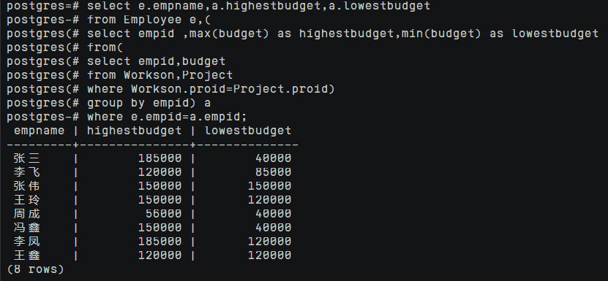

1. 给出所有项目超过一个的员工的id和参加的项目个数

select empid,count(\*) as num

from Workson

group by empid

having count(\*)>1;

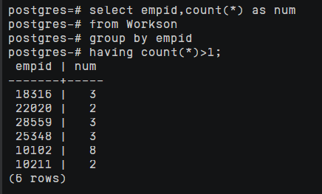

5. 给出项目种类号为“c2”且预算最多的项目

select proid,projectname,budget

from Project

where catid='c2' and budget>=all(

select budget

from Project p

where p.catid='c2');

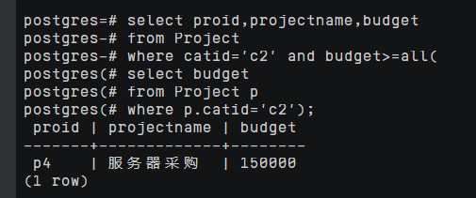

6给出参加“产品推广”项目，但不担任职位的员工的信息

select e.empid,e.empname,e.age,e.sex,e.depid

from Employee e

where e.empid in(

select Workson.empid

from Project,Workson

where Workson.job is null and Workson.proid=Project.proid and Project.projectname=’产品推广’);

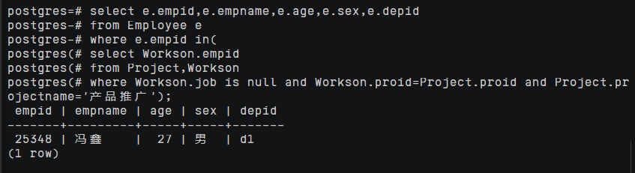

7. 给出工号为“10102”的员工每类项目的参加总数，若没有参加过某类项目，则参加项目总数显示为0

select catid,count(empid) as pronum

from (

select empid,catid

from Workson,Project

where Workson.proid=Project.proid And empid='10102')

group by catid;

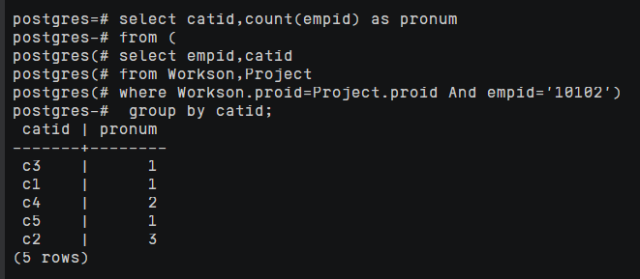

8. 给出没有参与“软件类”项目女性职工的信息

select p.empid,p.empname,p.age,p.sex,p.depid

from Employee p,(

select w.empid

from Workson w,(

select p.proid

from Project p,Category c

where p.catid not in(

select c2.catid

from Category c2

where c2.catname='软件类' ) and p.catid=c.catid) a

where a.proid=w.proid and w.job='职员'

group by empid) b

where p.empid=b.empid and p.sex='女';

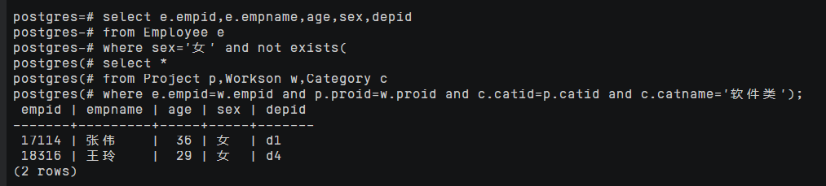

1. 给出有30岁以上男性员工的地点名称和该地男员工最大年龄，结果按最大年龄升序排序

select a.location,max(a.age) AS maxage

from (

select empid,location,age

from Department,Employee

where Department.depid=Employee.depid AND employee.sex='男') a

group by a.location;

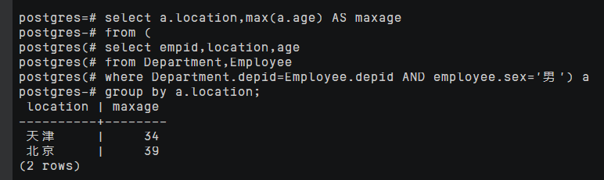

1. 给出在广州工作的、参加“'产品推广'”项目的职员id、姓名及他们参加的项目个数

select Employee.empid,empname,b.procnt

from Employee,(select Workson.empid,count(Workson.proid) AS procnt from Workson,(

select empid from Workson where proid = 'p1' AND job ='职员') a

where Workson.empid=a.empid

group by Workson.empid) b

where Employee.empid=b.empid AND Employee.depid in

(select depid from Department where location='广州');

