
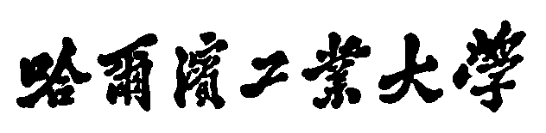

Harbin Institute of Technology
课程报告

课程名称： Digital Image Processing
论文题目： Fruits Recognition
院 系： School of Electronic and Information Engineering
班 级： Information Engineering
设 计 者： Changle Zhang (15S158746)
Tiantian Zhang (15S058443) Siyue Xu(15S058481)
时 间： 2016-05-09

哈尔滨工业大学
Task of Group Members:
Changle Zhang is the leader of group who undertaking the algorithm design and programming for watershed ROI extraction method, minimum euclidean distance (MED) classfication in HSV and RGB space, K-means clustering and in-group scale-invariant feature transform (SITF) recognition.
Tiantian Zhang programed the basic algorithm of SIFT and test the samples.
Siyue Xu made the testing of classifcation and recognition.
Programe list:
Programe was developed in the condition of Windows as well as Linux server, programming language is Matlab (www.mathworks.com).
Classify.m, Kmeans.m: function for K-means clustering.
main_Kmeans.m: main function for K-means clustering.
HSVfeatureExtraction.m: extracting the HSV features for a picture.
HSVfeatureSorting.m: sorting the extracted HSV features.
HSVMED.m, HSVMED_accuracy.m: making the MED classifcation in hsv space and calculate its classfication accuracy.
sift.m, match.m, showkeys.m: function for SIFT algorithm.
Main G1 G3 G5.m: making recognition among specific groups and calculating its recognition accuracy (by 100 times examine).
Methodology:
The 100 images are from 10 kinds of fruits and each fruit contains 10 images. First we dicided to use SIFT algorithm for all of the fruits recognition but the images are too big to process, even on super computer server provided by Sun Yat-sen University. Hence, we decided to make an advance classification by colors then apply SIFT among the same groups.
Full algorithm flow diagram is as follows:
颜色特征提取
颜色聚类
类内SIFT识别

Fig1. Algorithm flow diagram
Firstly, perior to the color feature extraction, region of interest (ROI) extraction is the basic step for image processing, here we applied an edge detection method called watershed. Algorithm of watershed is a segement method based on topology theory. The basic concept is regarding the image as a landform of a map, altitude is defined by the gray level at that pixel. Local minimal value and its related region called catchment basin and its boundry called watershed. More specific, sketch map was shown in Fig.2:
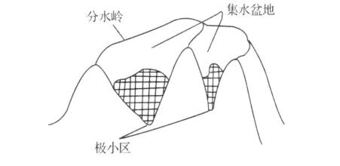
Fig.2 Sketch map of watershed
To calculate the watershed in an image, iterative algorithm should be applied; core algorithms are sorting and submerging. Firstly gray levels of each pixel are sort in the forward direction. Then ‘wate’r was ‘poured’ on the image and watershed will appear. ROI extraction was taken place in Hue of HSV space and the extraction result is shown in Fig.3:
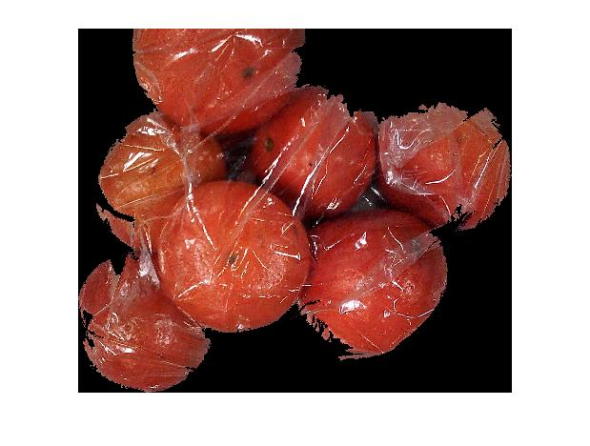
Fig.3 ROI extraction result of watershed method
As we can see in Fig.3, watershed method can derive feasible results.
RGB color space was firstly applied for the color classfication feature, however, result by this feature was bad and then we decided to do the calssfication in HSV space.
By extracting the HSV features, we can draw these features of each picture in HSV color space and calculated the mean feature of each group:
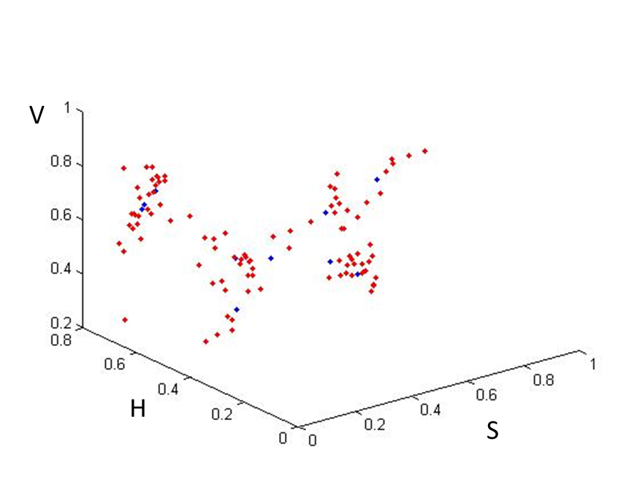
Fig.4 HSV features of images and groups in HSV space
As is shown in Fig.4, red points represent the HSV feature of each image and blue points represent the HSV feature of each group. We can conclude that pictures in same group are in correlation with each other and have difference from pictures form different groups. Then MED was applied for each images and try to assign them into specific group.
Fig.5 Classifcation with MED in HSV color space
However, final classification result was not feasible, only 67% pictures are assigned in to right catalog. Then we decided to expand the size of groups and try to make the classification perfect as well as less members in groups for a better performance of post-SIFT process.
K-means clustering method was applied to those pictures, firstly the number of seed points was two and we can get the correct result but each group has 40 and 60 pictures which can cause lots of trouble in further SIFT process. So the number of seed points started to grow until clustering error happens, finally we can get five groups contain different kinds of fruits:
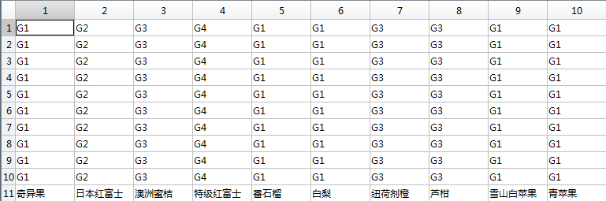
Fig.6 Results of fruits classfication in HSV color space
After classification, Group2 and Group 4 contain only one kind of fruit which means classification can get 100% accuracy for the recognition of these two fruits, and Group1 and Group3 contain three kinds of fruits and Group 5 contain 2 kinds of fruits.
In the folder ‘/testsample’, G1-G4 only left one picture for giving the example and G5 are the ROIs of different two kinds of fruits which is ‘番石榴’ and ‘青苹果’, in order to indentify these two kinds of fruits of similar color, SIFT was applied.
SIFT is the algorithm which aims at detecting local features, by detecting the interest points of one image and descriptors of scale and orientation then making the match among different pictures, a feasible result can be obtained.

建立尺度空间
LoG寻找关键点
特征点筛选
给特征点128方向的参数
利用SIFT进行匹配

Fig.7 Flow diagram of SIFT matching
By examing SIFT in the same groups to obtain the accuracy, test samples were generated by random and other pictures are used for training sampls. After 100 time of random checkout, the highest identification probability can be 93%, which is acceptable for our daily use.
Furter works can aim at the better efficiency of ROI extraction and grouping, plastic bags are terrible for texture feature extraction, testing on texture generated a bad result. If we can remove the influence of plastic bags, I think texture features will give us some interesting results.
Reference:
《数字图像处理（Matlab版）》 第二版 冈萨雷斯
Lowe SIFT 原文：
http://www.cs.ubc.ca/~lowe/papers/ijcv04.pdf
MATLAB 应用Sift算子的模式识别方法：http://blog.csdn.net/abcjennifer/article/details/7372880
SIFT算法讲解：
http://blog.csdn.net/abcjennifer/article/details/7639681
K-means 算法讲解：
http://www.cnblogs.com/moondark/archive/2012/03/08/2385770.html
分水岭分割算法：
http://blog.csdn.net/zd0303/article/details/6703068

