The Final output of our dashboard looks like :
Pg. no.1:
    - Shows total courses , total subscribers , avg rating , total reviews , avg price.
    - Filters ,minimum rating fixation drag box.
    - Top 15 courses by subscribers and difference between the number of user accessing free courses vs paid course
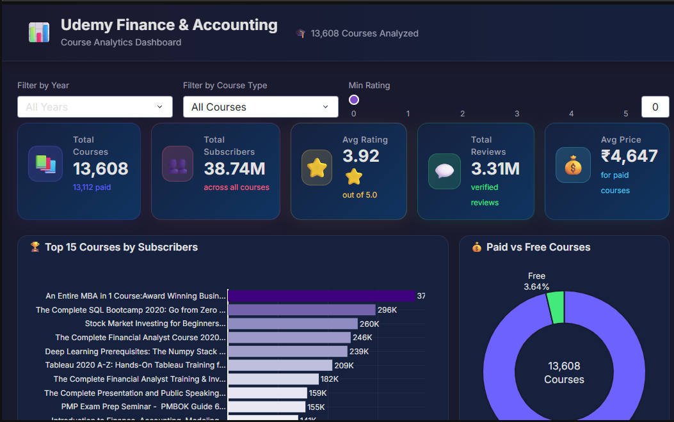

Pg.no.2:
- In this page we get to see the number of course generated with respect to time and line graph depicts increase and decrease in trend of creating courses.
- Other graph depicts users experience rating distribution on udemy courses and it UI.

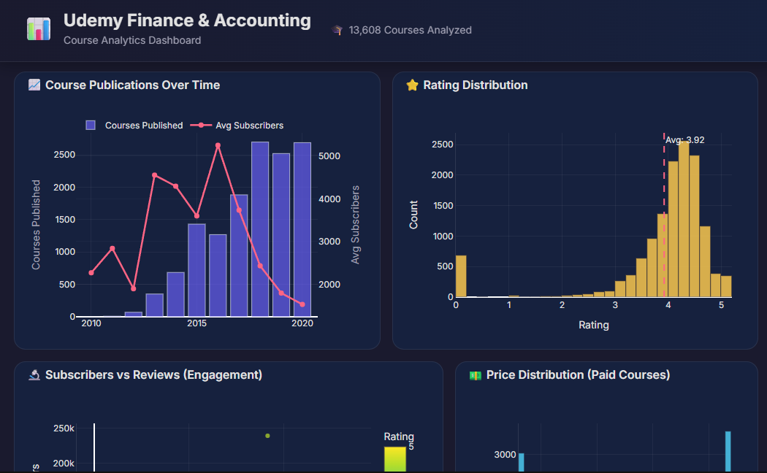

Pg.no.3:
- This page contains the 2 graphs first one contains the number for subscribers vs number of reviews, the colour intensity increases number of stars in rating increases.
- Second graph depicts the price distribution of paid courses with number of users count.
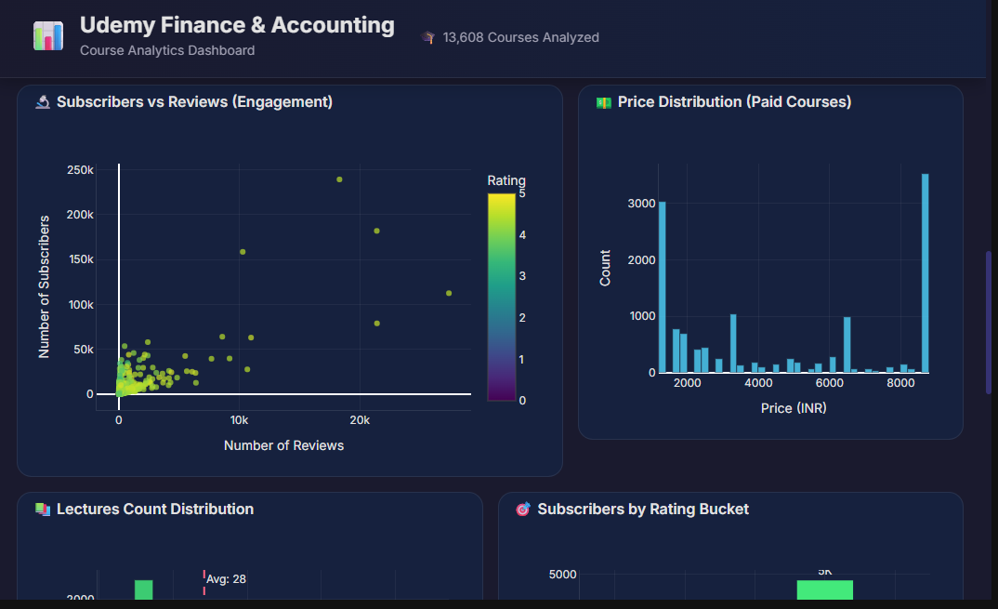

Pg.no.4:
- In this page we get pictorial difference between the number of lectures and count of number of average students joining the leacture.
- On the other hand we get the distribution of average subscriber and rating bucket the highest peak at rating we received is 5k while lowest is 2k.
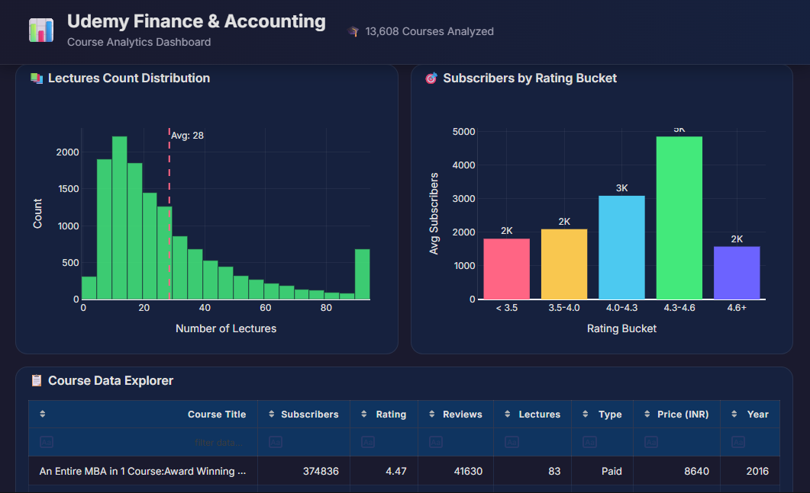

Pg.no.5:
- At last we get to the tabular collection of all records for the lectures like the title , publish date , subscriber , rating , etc for each course.

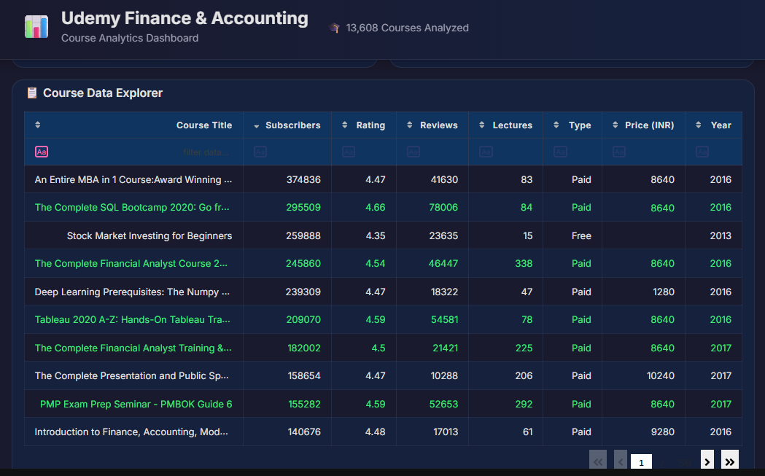

Summary:
By considering all the points and viewing each pictorials we conclude that dashboard is useful for view , understanding the churn report data of the udemy , for the easier growth implementation , uncovering the hidden insights out of rough data set for better understanding and analyse and decision making.

