NOBEL
&
TCL

Email Marketing
Sample-Proposal

Version 1.1
05/11/08

Muhammad Yaqoob

Email Marketing Solution Provider
About Sloan
Sloan Email Marketing Solution Providers is extensively engaged in providing email marketing services and technology that enables organizations to create, deliver and measure email newsletters and campaigns with simplicity and sophistication.

At SLOAN we have professional email marketers that are managing more than nine million email addresses database, which comprise all the business companies of Pakistan and few other countries i.e. USA, UK, Iran, India, Afghanistan, Azerbaijan, and UAE.

We work closely with our valuable clients to plan and develop email marketing strategies that achieve maximum results within less time and dirt-cheap rates.

With a talented email marketing professionals and access to millions of email databases, Sloan can meet the marketing requirements of any business company.

We focus on assisting business companies to achieve business objective and strong relationship building between the business and clients.

SLOAN also offers email marketing consulting services to help develop breakthrough email campaigns and refine email marketing strategies.

INTERNET MARKETING

The Internet has provided us with ways on how to market cost effectively. It has given virtual tools which can deliver hard results which can be comparable to the results that one can achieve using the more popular forms of marketing.

The electronic mail or “email” is one of the most effective and widely used tools in Internet marketing. Other people employ affiliate programs, links, free items and other gimmicks to market through the Internet, but most of these marketers have utilized email marketing in one instance or another.

Email provides a marketer with a whole new spectrum in using the Internet as a marketing medium. Millions of people now rely on email to receive information quickly. However, although email is a good way to market a certain product or a service, one should be cautious in using it to market. Ethics also apply to the use of Internet media to be able to convey a marketing message to a targeted audience.

Let’s say that one has a great product that he wants to sell through the Internet. He had laid down the foundations such as the development of a website to be the portal on which he would receive orders and display much needed information about the product. The website contained attractive and sleek graphics and useful information. The only problem was, no one was visiting the website. Aside from employing other techniques for Internet viral marketing, he also tries email marketing in the hopes of getting hits and transforming these hits into sales.

EMAIL MARKETING:
Email marketing is now a day sexy enough to communicate your product / services to your prospects or clients.
- It’s easy, affordable, friendly to use, and dirt-cheap.
- its personalized, direct, and time saving.
- It communicates effectively, and it has been found very immediate in response. One can enter to any company CEOs’ office without any permission in the form of popup window and deliver whatever information you want.
- All you need is to have a self collected or subscribed list, and an email marketing software tool, that is easily available in the market.
- Company can spread its newsletters updates, messages, offers, intimations, notices, circulars, memos, to its clients and prospects in a very short time.
- A survey finds people are more attentive to an email than a direct mail letter or other marketing mediums.

Why is email marketing important?
Email marketing is vastly important, especially to small and medium sized businesses. When you compare the different ways a company can spend its marketing budget, whether it’s through advertisements in newspapers/magazines, direct mail, or trying to get better search engine rankings – it doesn’t matter, email marketing is the best way to market to existing and potential customers.

Compared to other marketing avenues, email marketing is the most:
o rapid
o scalable
o measurable
o cost effective

Email marketing is a strategy businesses can use to increase revenue through:
o generating more website traffic
o gaining and maintaining customer loyalty
o saving time and precious marketing dollars
o educating people about your products or services
o better understanding of your target market
Why you need email marketing?
Email can help you achieve your business goals
Want more customers? More leads? More sales? E-commerce is booming and a well-planned email marketing campaign can generate high response rates, allow you to get the word out about offers and discounts, and create opportunities to cross-sell and up-sell. The measurability of the medium means, that those benefits can be demonstrated in tangible terms.

Brand awareness and credibility
Creative email campaigns can help you engage your customers in an informative and entertaining way – but always follows guidelines and don’t overdo it.

Customer intelligence
Email marketing is highly measurable and each campaign gives you the chance to analyze customer feedback to see which offers and products individual customers are interested in.

It benefits your website
As well as providing you with data that can help you improve the usability and conversion rates on your website, email campaigns can help direct more traffic to your site (and more of the right kind of traffic).

Engage with consumers on their terms
Consumers are increasingly using rich media and new technologies to access information and entertain themselves on the web. Text messaging, video emails and RSS campaigns can help you engage with them more effectively and differentiate yourself from your competitors.

Most Popular Online Activity at Work and Home
Email is the most widely used Internet application and the number one online activity. There are now 553 million Internet users worldwide and almost 90% of them send and receive email. Please see the chart below:
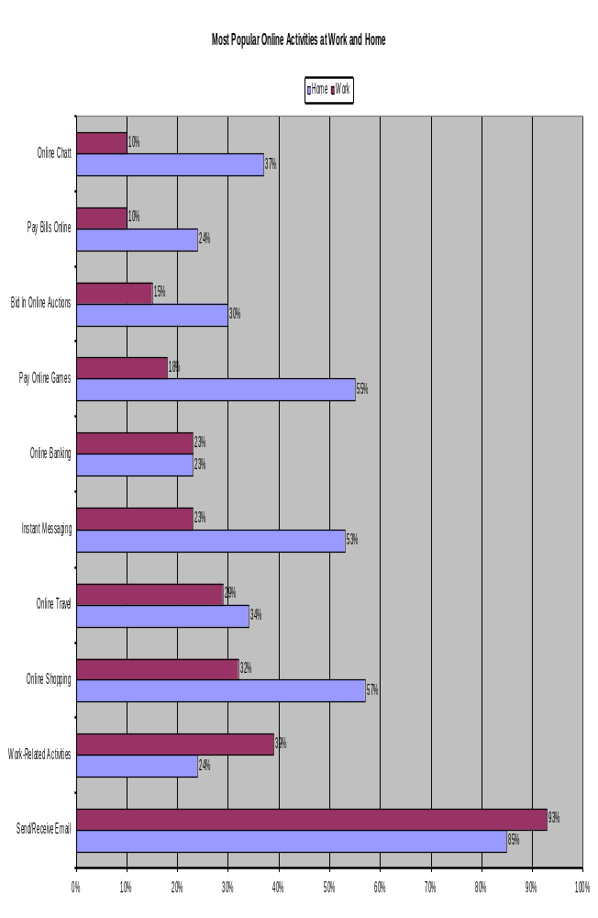

Our prices are guaranteed to be the lowest among all the other marketing mediums.

Pricing
Amount of Email | Price Per Email Sent  In Cents (PK) | Total Cost  In (PKR) | Consultancy Fee (If required)
9,000,000 | 0.01 | Rs. 90,000 | Rs. 7000  (One Time)
5, 000,000 | 0.01 | Rs. 50,000 | Rs. 7000  (One Time)
1, 000,000 | 0.03 | Rs. 30,000 | Rs. 7000  (One Time)
500,000 | 0.04 | Rs. 20,000 | Rs. 7000  (One Time)

NOTE: SLOAN will not be responsible for the designing of the email message. The email message should be provided by the company acceptable in any format.

Please find few Email-Subject-Lines as under:
- We never close
- I am NOBEL
- It’s NOBEL
- NOBEL & TCL Newsletter
- Greetings from NOBEL
- NOBEL is different
- “-Your-motto-”
- NOBEL Trends

Viral opportunities
A recent survey by Sharpe Partners found that almost 90% of adult Internet users share content with others via email. And the respondents are forwarding frequently—three out of five said they shared content at least once a week and 25% reported doing so even more frequently.

