**Report of Deep Learning for Natural Langauge Processing**

Zengchang Qin

zengchang.qin@gmail.com

**Abstract**

This is a Report of Deep Learning for Natural Langauge Processing

**Introduction**

ChatGPT is so popular and everyone is talking about it, all are talking about it but not coding for it …

**Methodology**

There are models of my research.

**M1: DL Model**

The description of the first model.

**M2: NLP Model**

The description of the second model.

**M3: DL-NLP Model**

The description of the third model.

**Experimental Studies**

The figures shows it works so well

Table 1: this is the table 1

|  |  |  |  |
| --- | --- | --- | --- |
| New Table |  |  |  |
| M1 |  |  |  |
| M2 |  |  |  |
| M3 |  |  |  |

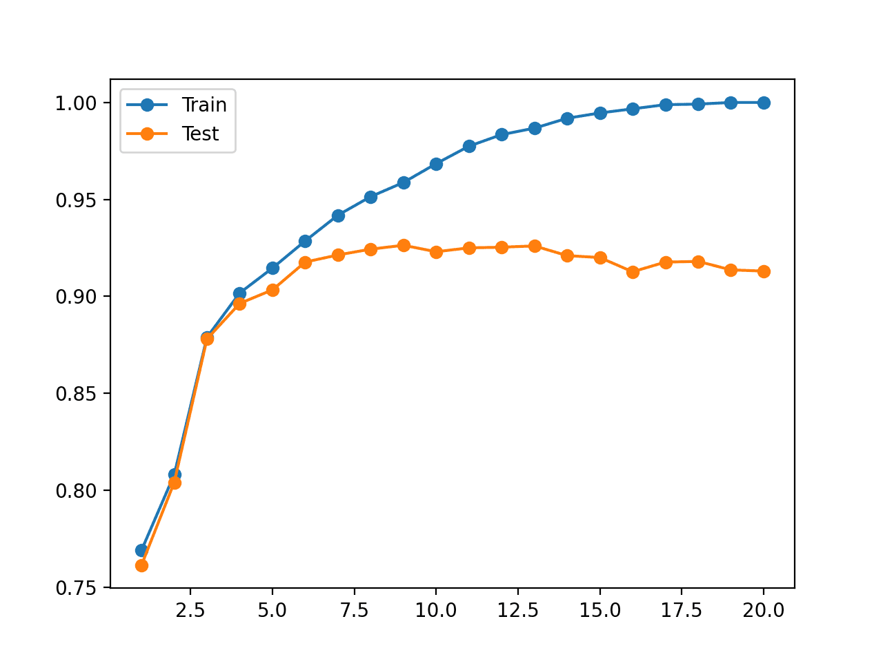

Figure 1：this is obviosuly overfit

**Conclusions**

By good scientific writing in right format, it can express you idea of research clearly to others, therefore, we need to learn how to write a good report and even a paper.

**References**

[1] Zenchang Qin and Lao Wang (2023)，How to learn deep learning? Journal of Paper Writing, Vol. 3: 23: pp. 1-12.

[2] ….